CS-308-2014 Final Report
Product Sorter
Siddharth Patel, 120050001
Abhinav Gupta, 120050029
Dheerendra Rathor, 120050033
Anant Gupta, 120050086

Table of Contents

1. Introduction 3
2. Problem Statement 3
3. Requirements 3
3.1 Functional Requirements 3
3.2 Non-Functional Requirements 3
3.3 Harwdare Requirements 3
3.4 Software Requirements 3
4. System Design 3
5. Working of the System and Test results 3
6. Discussion of System 4
7. Future Work 4
8. Conclusions 4
9. References 4

1. Introduction

Times are changing and people in developed and developing countries are becoming more and more dependent on packaged food. With rising demand of packeged food there is a demand of automation in the manufacturing process of the food.
And in the chain of manufacturing and packing of the food, one of the most critical steps is to separate acceptable edible units of food from the bad units (rejected/ not very suitable for consumption). This sorting is mostly done manually which requires huge manpower and is not very reliable. So an automatic sorting machine here will remove the bad units from the final collection. And we have implemented a subset of general sorter, so our setup sorts only potato chips. So it sorts out the burnt, over fried chips from the final lot.

2. Problem Statement
The aim of this project is to build a setup to detect and remove bad over cooked potato chips from the good ones from the production chain. This is usually done on a conveyer belt and chips are removed using an air gun but we will use a static belt and a mechanical arm to remove the bad chips.

3. Requirements

3.1 Functional Requirements
- Capture image using USB camera
- Light LED Red and move servo motor for bad chip
- Light LED Green and don’t move the motor for good or no chip

3.2 Non-Functional Requirements
- Keep the algorithm generic enough to be aplicable to other proucts

3.3 Harwdare Requirements
-Conveyer Belt
-Motor and Arm
-USB camera
-Raspberry Pi
-TIVA
-LED
-Resistor

3.4 Software Requirements
-Raspbian OS
-Python for Raspberry Pi
-CV2 library for Raspberry Pi
-CCS for TIVA

4. System Design

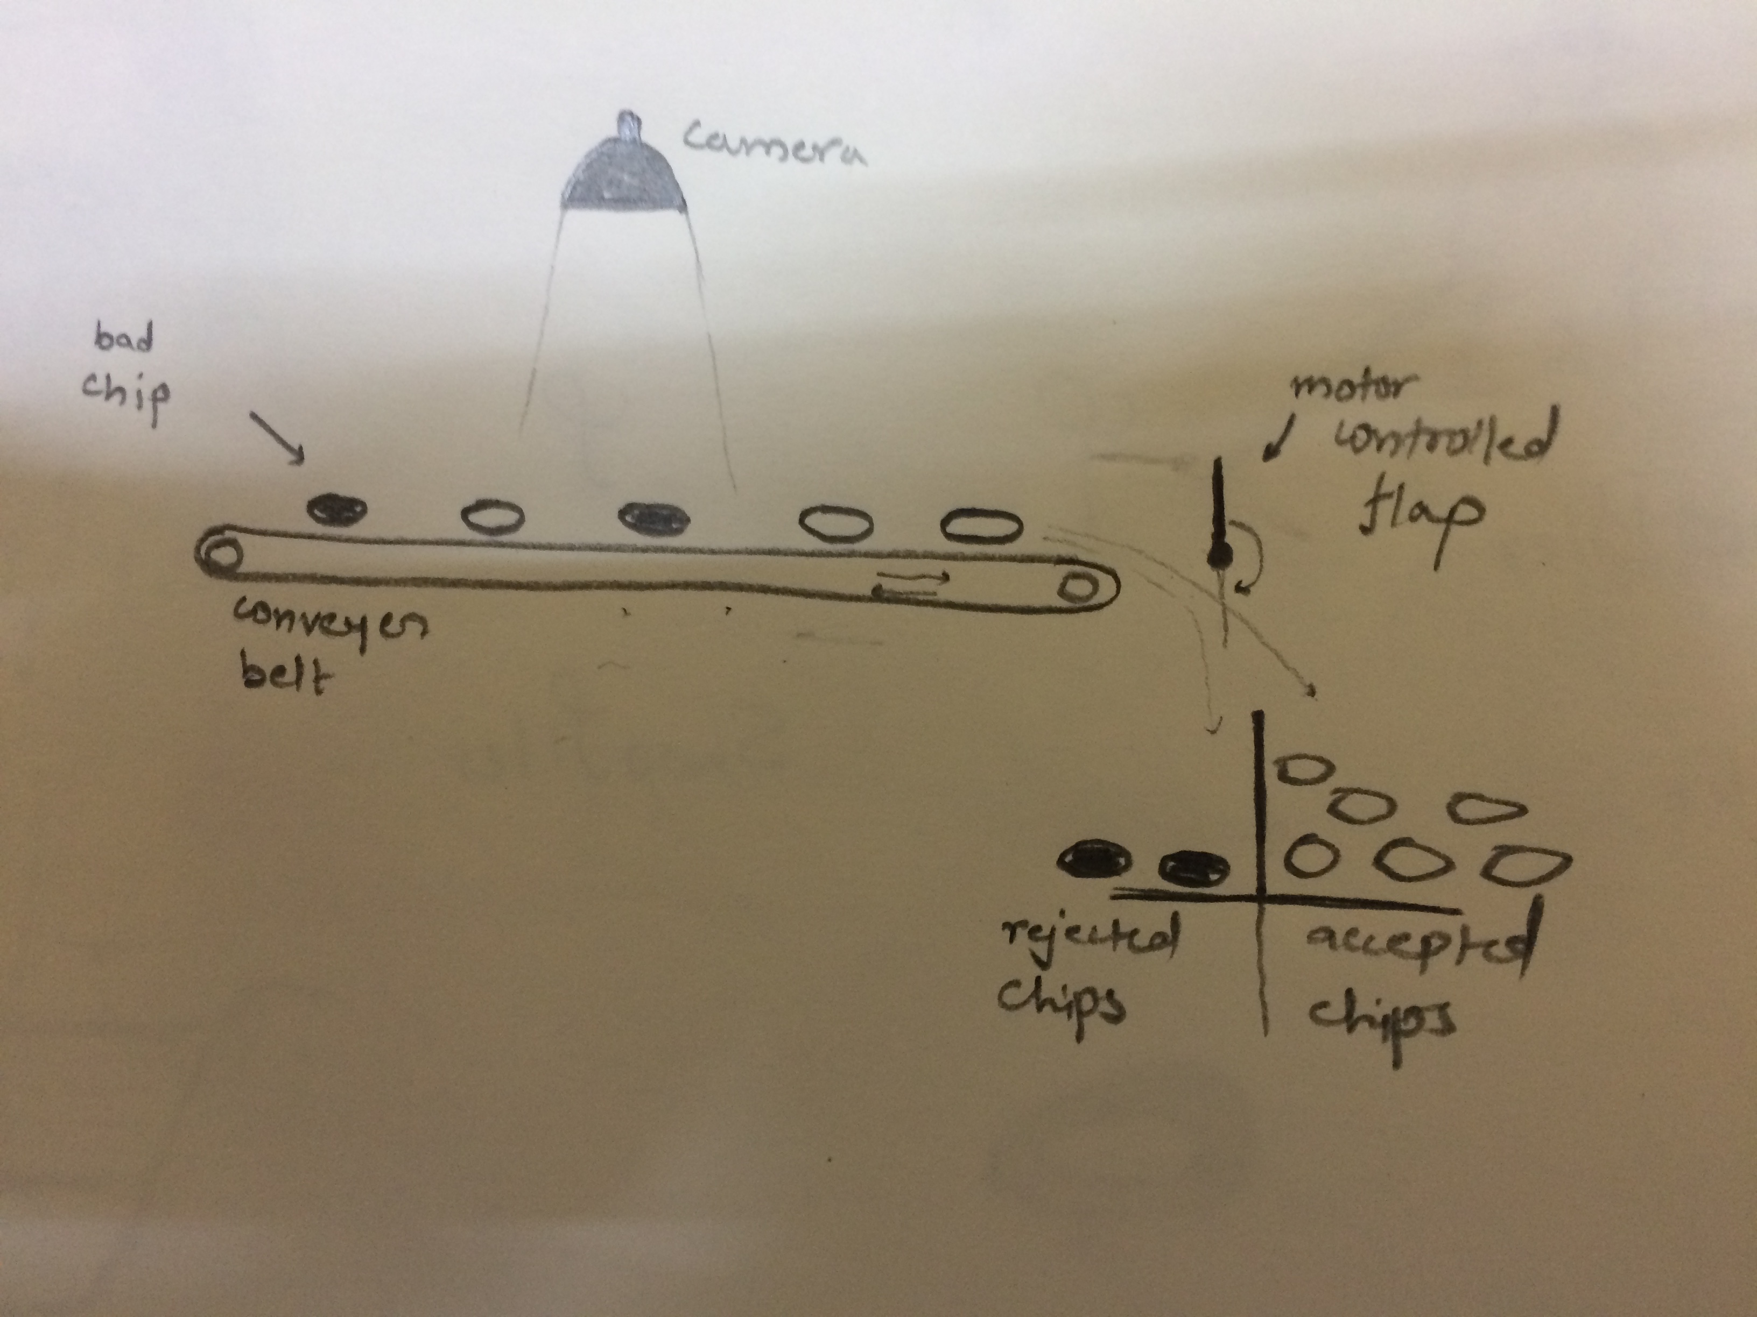
In the above diagram, there is a camera, conveyer belt with chips on it, and a motor controlled flap.
The flap will turn 180 degrees everytime the camera detects a bad chip. This will make the bad chips fall in a separate compartment from the good ones.
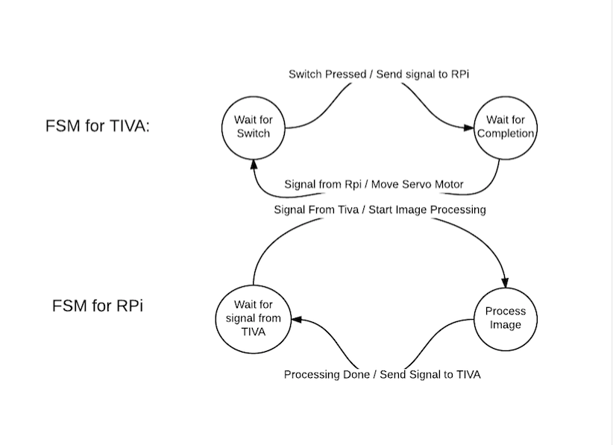

5. Working of the System and Test results
Working:

The process begins with the switch SW1 being manually pressed on TIVA.

TIVA, via UART, sends a signal to Raspberry Pi to click a picture.

On receiving the UART signal, the Rpi takes a photo using the USB Camera and processes it to determine if there’s a bad chip underneath it

It sends the appropriate response via UART to TIVA (the angle by which to move the servo motor, 0 in case of a good chip or no chip), and then the angle 0 to bring the motor back

Upon receiving the angles, the TIVA executes the action on the servo motor using PWM
Tests:
We used real potato chips for testing. We created defective chips by burning parts of normal chips. We used a blue background when detecting the chip.
We used multiple normal chips to calibrate the model and cross-validated our results.
We also tested the working of the system for various degrees of burning in burnt chips.

6. Discussion of System

a) What all components of your project worked as per plan?
-the mechanical arm was the only component that worked exactly as we planned.
-camera didn’t work as per the plan as the images taken were sensitive to background color and surrounding lighting
-and the raspberry pi processed the images way slower then we expected

b) What we added more than discussed in SRS?

c) Changes made in plan from SRS:
-Initially we planned to use a working conveyer belt but because of the slow image processing done by the raspberry pi, it was difficult to work the design on a moving conveyer belt. If the processor would have been faster which is the case in actual machines then our setup would have worked perfectly.

7. Future Work

-We have used a raspberry pi which processes image really slow, instead if we use a better processor then it could have been very efficient.
-In our setup the camera was working in a variable lighting environment which resulted in errors detecting the bad chips which could have been avoided if we use a well covered system with a steady light source.
-This project has a wide variety of applications. It can be used in any type of visual sorting, for example in sorting out unripe/ over ripe vegetables/fruits from the perfectly ripe ones. Other then this there is a wide variety of fried products similar to potato chips example cheeze balls, fried rings, etc where this type of sorting can be useful.

8. Conclusions

Our project is the one with many applications. Visual sorting can be used in most industries and it can help improve the quality of the finished products. With change in living standards of the people there will be a rise in demand for such automated machines which can reduce the manual labour as much as possible to avoid human errors.

9. References
https://www.cse.iitb.ac.in/~erts/
https://www.raspberrypi.org
https://electrosome.com/uart-raspberry-pi-python/
http://docs.opencv.org

