CS-308-2014 Final Report

Safe Overtake

Team : 21

Venkata Gangadhar K (120050078)

Kiran Y (120050049)

Sai Kiran M (120050068)

Shashank B (120050076)

**Table of Contents**

1. Introduction 3

2. Problem Statement 3

3. Requirements 3

3.1 Harwdare Requirements 3

3.2 Software Requirements 4

4. System Design 4

5. Working of the System and Test results 7

6. Discussion of System 7

7. Future Work 8

8. Conclusions 8

9. References 8

## **1. Introduction**

Most of the road accidents occurs while overtaking or diverging. Vehicles coming in the opposite direction may not be visible to the driver who is about to overtake.

According to the latest report on road accidents, over 48,000 people died in crashes caused due to overtaking and 'diverging' during 2014.

It would be easier for the driver, if there is a module which senses the danger and gives an alert. Samsung has already introduced a system for large trucks which displays the the road infront of it on its back side. But this design is costly and tough to maintain because of the vulnerable LCD display.

This limitation has become the motivation for our project. Here, we come up with a system which senses the danger of overtaking and alerts the driver. This is a low-price product and easy to maintain. This helps while overtaking in straight lanes especially on highways.

## **2. Problem Statement**

The aim of the project is to sense the vehicle coming in the opposite direction and send the danger information to the vehicle behind.

The vehicle behind should make decision whether to overtake or not depending on the signal sent by the vehicle in the front.

The field of experiment is similar to Indian roads - 2 lane roads. And the road is assumed to be straight while the vehicle is overtaking.

## **3. Requirements**

### **3.**1 **Harwdare Requirements**

1. FireBirdV : 3 bots

bot 1 : bot going in the same lane

bot 2 : overtaking bot

bot 3 : bot coming in the opposite lane

2. Xbee : 2 modules (1 sender + 1 receiver)

3. IR sharp sensors : 3 sensors

- 2 sensors for sensing the bot coming in the

opposite direction.

- 1 sensor for detecting the bot in the side lane

### **3.**2 **Software Requirements**

1. Code Blocks(AVR Studio) : loading instructions in the bot

## **4. System Design**

architecture.png

**FSM for BOT1 :**

Bot1.png

**FSM for BOT2 :**

Bot2.png

Pictures of Hardware mechanical parts :

1. XBEE

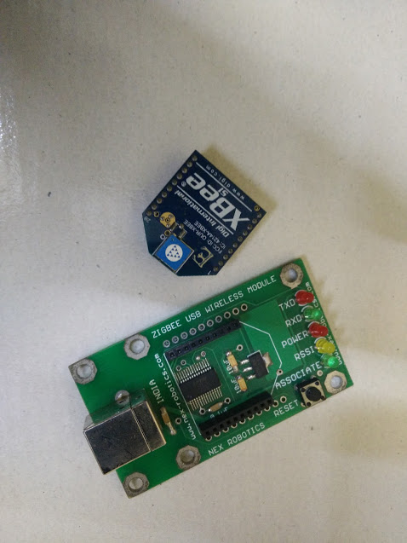

2) BOT

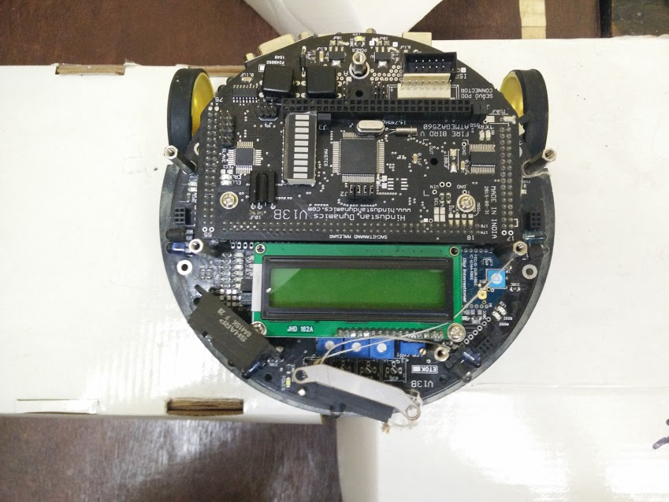

3) Sharp Sensor

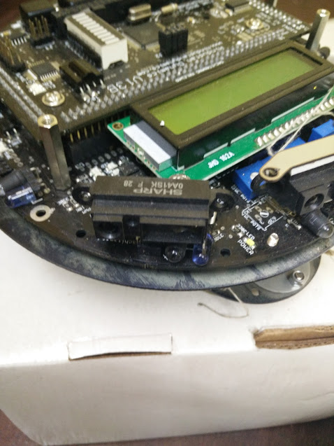

## **5. Working of the System and Test results**

**Working of Bot 3:**

Bot 3 goes in a straight line with constant velocity .

**Working of Bot 1:**

Bot 1 also has a straight line motion. It also senses the vehicle in the next lane within 100 cm and sends this signal to Bot 2 using Xbee wireless communication. If there is an obstacle very close to it (infront of it) , then the bot stops and starts moving when there is no obstacle infront of it.

**Working of Bot 2 :**

Bot 2 goes in straight line with its maximum velocity if there is no obstacle in its way. If it senses any obstacle within 50 cm infront of it then it slows down. It continously receives the wireless signal from Bot 1.

**CASE 1:** If there isn’t any danger signal within 200 ms it assumes that there is no obstacle for overtaking. Then it switches to the next lane and it increases its speed to maximum . After crossing the Bot 1 it switches to the previous lane and continues the same protocol as above.

**CASE 2:** If there is atleast one danger signal within 200 ms , it assumes that there is a possible danger and it denies the idea of overtaking at that moment.

If there is any obstacle within 10 cm , it stops moving . It again starts moving if there is no obstacle infront of it.

## **6. Discussion of System**

**A) What are worked as per plan?**

Xbee wireless transmission and IR sharp range sensors worked as per plan. Through Xbee, signlas are sent and recieved comfortably. IR sharp sensors are detecting the object within 100cm range which is sufficient for our design.

**B) Changes made in plan** :

Previously signalling of danger by Bot 1 is planned to be done by blinking a red LED in the backside of the Bot 1. This is changed to send wireless signal to communicate the danger.

## **7. Future Work**

* This project can be extended to sense the danger while vehicle is taking a turn.
* If there are 3 lane roads this can be extended to neglect the danger present in 3rd lane and allowing the vehicle to overtake from 2nd lane.
* This can be extended to cover the possibility of danger from vehicles coming from the back which poses the danger if you are switching the lane without seeing the vehicle coming from the back.
* This module can be embeeded into Auto-driving vehicle mechanisms.

## **8. Conclusions**

Driver should always check for the danger info sent by the front vehicle and decide to overtake or not. He should not overtake if he gets danger signal from vehicle in the front. Once he gets free signal it is assumed to be free with respect to the vehicle in the front and its up to the driver to decide whether to overtake or not.

## **9. References**

E-Yantra and Firebird tutorials from

<https://drive.google.com/folderview?id=0BwLmQGS-3ITBdzE2dXo5TXF4U0E&usp=sharing>