CS-308-2016 Final Report

Smart Cart

Manik Dhar (Team Leader)

1

Manik Dhar (120050006)

Bijoy Singh Kochar (120050087)

Nishanth Koushik (120050041)

Ranveer Aggarwal (120050020)

**Table of Contents**

1. Introduction 3

2. Problem Statement 3

3. Requirements 3

3.1 Functional Requirements 3

3.2 Non-Functional Requirements 3

3.3 Harwdare Requirements 3

3.4 Software Requirements 3

4. System Design 3

5. Working of the System and Test results 3

6. Discussion of System 4

7. Future Work 4

8. Conclusions 4

9. References 4

## **1. Introduction**

*<Abstract description of the system - name, motivation, what it does, where it is useful>*

Shopping is something we spend a lot of our time doing. How many of us have had the frustrating experience where even when purchases a few items, we have to stand in long queues. So we created a smart cart, which lets to securely add content which you wish to buy and purchase from your phone itself. We present the SMART CART project. #NoMoreLines

## **2. Problem Statement**

*<Detailed description - what you are supposed to achieve, what problem is your work solving>*

The SMART CART will let you create a purchase by doing the following:

* Phone scans the RFID card of your cart
* The Microcontroller now gets assigned to your order
* You can order Content my tapping an RFID card to the RFID sensor of the cart
* Your phone should detect this item
* Your cart should now have the weight of the cart and send information till it detects changes.
* The server maintains if the cart weight is indeed correct or not.
* Tapping multiple times increases the count.
* The count can be changed in the application
* You can login using Google Account

## **3. Requirements**

*<All functional and non-functional reqmts mentioned in the final revision of your SRS document>*

### **3.1 Functional Requirements**

* + 1. - RFID tap should detect ID
    2. - Wifi Module should send information
    3. - The weight cell should detect weight
    4. - The application should login
    5. - The server should handle responses

### **3.2 Non-Functional Requirements**

* The force cell should have a box

*<List of all hardware and software requirements>*

### **3.3 Harwdare Requirements**

* + 1. - TIVA Launchpad
    2. - TIVA Wifi Shield CC3100
    3. - HX 711
    4. - Force Cell
    5. - RDIF RC522
    6. - Android Phone
    7. - Server (Local will do)

### **3.4 Software Requirements**

- Android Studio

- Python Installation

- Django

- Energia Library

## **4. System Design**

*<Show an architecture diagram describing the components of the system and their relationships>*



*<Talk about overall design of your system and include all diagrams related to your work - FSMs, Statecharts, Circuit Diagrams, Snapshots of the mechanical parts etc.>*

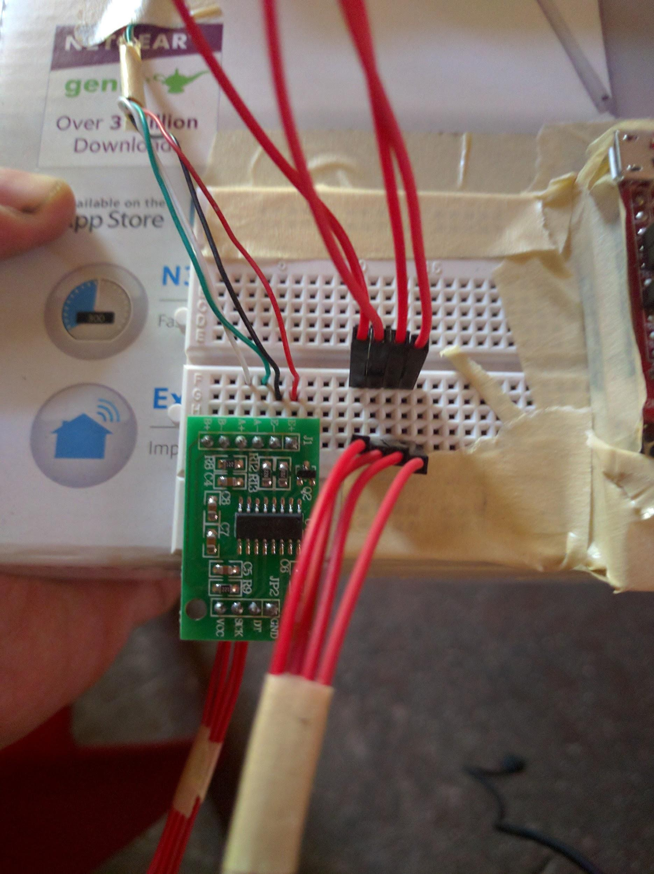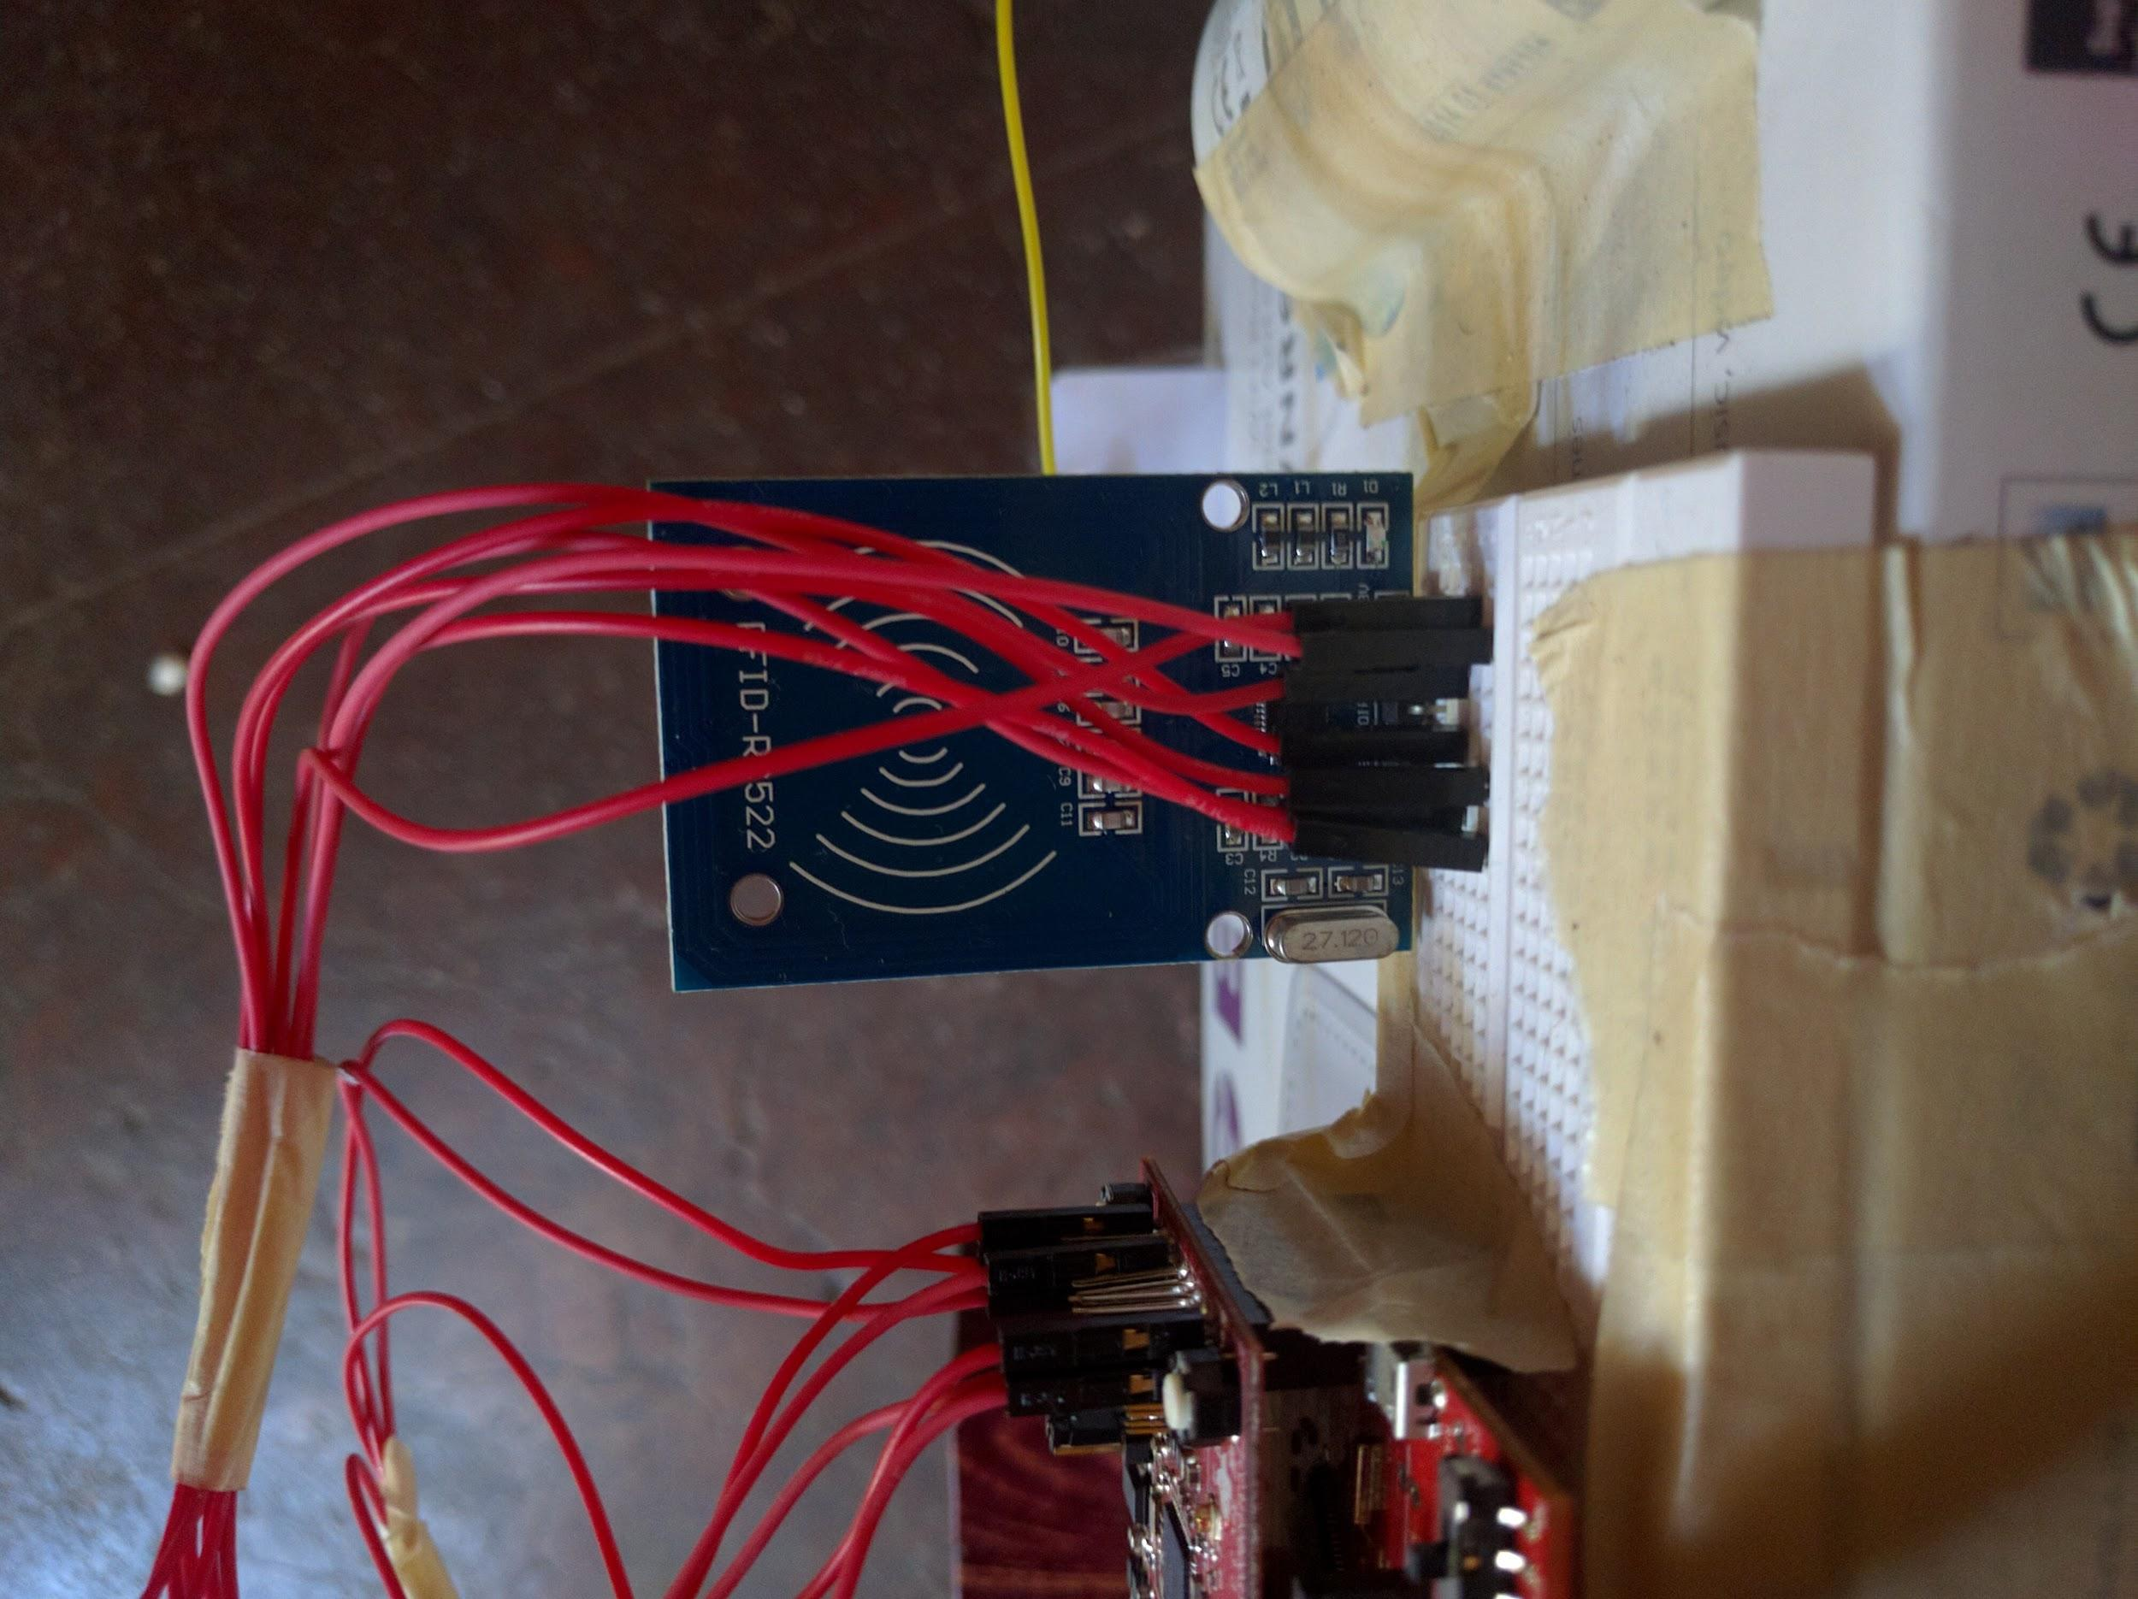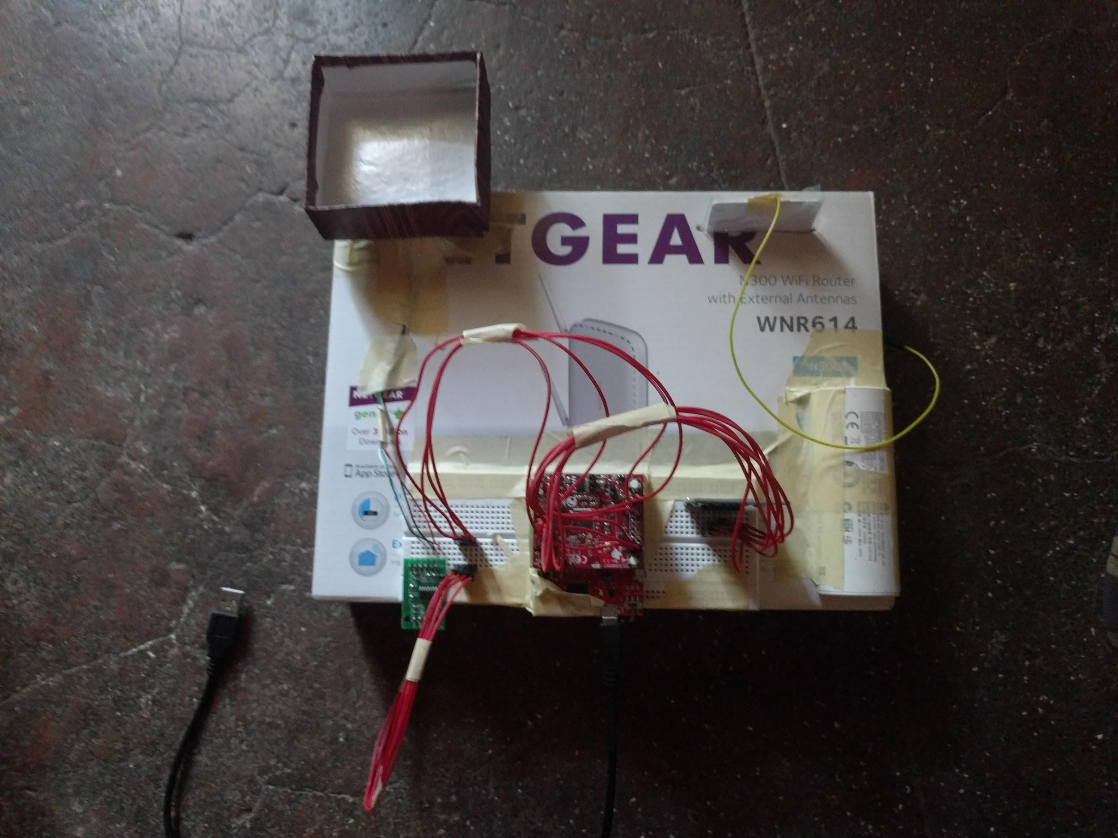

## **5. Working of the System and Test results**

*<Provide an in-depth discussion about the working of your system, making use of suitable figures>*

- Open App

- Scan the RFID

- Your order gets started

- Use RFID and scan on RFID scanner

- Wait for Blue LED on tap

- Your order should be added on phone

- Add item of corresponsing weight on the force cell

- You should get a confirmation on the phone

A number of tests can be done, add items without swiping, adding less items, more items, remove the item from the phone, increase the quantitiy. etc.

*<For each functional requirement mentioned in the SRS, mention how you tested it to ensure the functionality worked properly.>*

* We rigorously tested each item by multiple iterations of different RFID items, different WIfi routers, Wifi pings, weight objects.

## **6. Discussion of System**

a) What all components of your project worked as per plan?

* All : RFID, TIva, WIfi, HX711, Force Cell, Android, Server

b) What we added more than discussed in SRS?

We added a number of things on the android side like, Authentication, notifications etc.

c) Changes made in plan from SRS:

We removed the LCD after discussing with prof, because it was a better idea wrt battery consumption and user experience.

*<Enumerate changes and include reasoning to why there was a change>*

## **7. Future Work**

*<Mention about re-usable components and list out possible extensions to your work>*

The Force Cell weight calibration etc needs to be refined

The TIVA is an overkill, needs to be refined by using custom controller.

## **8. Conclusions**

- We are confident that this product can help the people to save a lot of their shopping time. Given enough refinement, investment and motivation this can be incorportated and can be used in a number of shops.

## **9. References**

Energia : http://energia.nu/

Android Studio : http://developer.android.com/sdk/index.html

Django : https://www.djangoproject.com/

PyCharm : https://www.jetbrains.com/pycharm/