

**SUMMER TRAINING REPORT EVALUATION SYSTEM**

**Final Report**

Instructor: Eray Tüzün

Teaching Assistant(s): Muhammad Umair Ahmed, Yahya Elnouby

**Group Name: Quokka**

Berkay AKKUŞ - 21903321

İdil ATMACA - 22002491

Emre Melih GÜVEN - 22003944

Mehmet Emre KANTAŞ - 22003693

Yusuf ÖZYER - 21903339

Deniz SUN - 22003981

May 29, 2023

**Table of Contents**

**1.Introduction 3**

**2.Lessons Learned 4**

**3.User’s Guide 4**

**4.Build & Execution Instructions 6**

**5.Work Allocations 7**

**6.Appendix 13**

# 

# 

# 

# 

# 

# 

# 

# 1. Introduction

The Summer Training Report Evaluation System is a full-featured piece of software made to make the evaluation process for summer training classes easier and better. The final version of the software was made to meet the needs of students, summer training coordinators, course instructors, teaching assistants, and department secretaries. It has different screens and functions for each user role. This software program combines a number of important features and ideas to make sure that customer standards are met. By using the system's features, everyone involved in the summer training program can handle and keep an eye on the different stages of the evaluation process. The department secretary plays a key role in the system so that user control is easier. The department secretary is able to add summer training coordinators, course teachers, and teaching assistants to the system through the "Manage Users" page. This feature makes sure that the right people are involved in the review process. This makes for a more organized and smooth workflow. When a student signs up for a summer training course, the department secretary pairs them with a teacher and a teaching helper. This step makes sure that students get the help and direction they need during their training. When a person registers, their login information is sent to their email address automatically. This makes it easier for them to communicate and use the system. Administrative assistants are a key part of the system because it is their job to send student company evaluation forms. The instructors will then decide when the summer training reports are due. After that, students can share their reports, which starts the process of evaluating them. Instructors have the tools they need to look over and grade the summer training papers that students turn in. If revisions are needed, instructors can ask for specific changes and give students detailed comments and annotated files to help them improve. This iterative method gives students the chance to improve their reports and show how they have grown and changed. Both students and teachers have access to a full report history, which lets them see how far they've come and look back at what they've already turned in. Students can make changes to their reports based on the comments they get and then reupload them. Lastly, teachers grade the reports, and based on how well the students did, they decide whether the students pass or fail. The software's announcement tool also makes it easier for people to talk to each other and share information. Administrative assistants, people in charge of summer training, and teachers can all make announcements to let everyone know about important changes and goals. Also, a "Notifications" page lets all kinds of users receive and look at important notifications. This makes sure that important information gets to the right people.In short, the Summer Training Report Evaluation System is a strong and effective way to manage how summer training programs are evaluated. By giving each user job its own screens and functions, the system lets students, summer training coordinators, course instructors, teaching assistants, and department secretaries actively take part in and keep track of the different stages of the evaluation process. With its wide range of features, this software application changes the way summer training program reviews are done in a way that makes them more efficient and useful for everyone involved.

# 2. Lessons Learned

Several important lessons were learned while working on this software project. These lessons helped with both the technical and management parts of the development process. These lessons have given us ideas and suggestions for future projects, and they have also helped us learn more about how to make software that works well. One of the most important things we learned is how important it is to start out with clear and well-defined requirements. When requirements are not clear or keep changing, they can lead to misunderstandings and delays, which can affect the total project timeline. In the future, we will spend more time and energy making sure that our requirements are complete and that they have been carefully reviewed and passed by everyone who has a stake in the project. For software development to go well, team members need to be able to communicate with each other and work together well. We found that having regular ways to talk, like daily stand-up meetings or weekly reports on progress, helped make sure everyone was on the same page and that any problems were dealt with quickly. We will put open and honest conversation at the top of our list for future projects so that we can work together better. Combining together Spring, a strong Java framework, and React, a famous JavaScript library, was a chance to learn. We found that clear contact between the backend and frontend teams was very important for integration to go smoothly. In future projects, we'll make it a priority to create well-defined APIs and use good guidance to make it easier to work together and speed up the integration process. Axios, a promise-based HTTP client, turned out to be a good way to handle data retrieval between the frontend and the server that happened at different times. But we learned that it's important to handle errors and asynchronous processes in the right way if you want reliable data communication. In future projects, we will pay more attention to how we handle errors and put in place ways to handle edge cases and network problems better. Using React's component-based design, we were able to make UI parts that could be used over and over and were easy to change. In future projects, we will focus on organizing the code and sticking to well-known techniques to make development faster and more efficient. Using the version control tool Github was a key part of making it possible for team members to work well together. We learned how important it is to use branching strategies to manage work in parallel and make code merges easier. A more efficient development process was also helped by regularly reviewing the code and keeping the file structure clean and well-organized. As we move forward, we will continue to put a high priority on effective ways to work together and keep track of different versions of files. By thinking about the things we've learned, we've learned a lot about the challenges and successes we faced while using Spring, React, and Axios in this software project. By using these lessons in our future work, we'll be able to improve our processes, work together better, and give our clients better software solutions.

# 

# 3.User’s Guide

## 3.1 Administrative Assistant

The information of the administrative assistant account is hard-coded into the database. So administrative assistant accounts cannot be created or the administrative assistant role cannot be given by any user.

Adding a user to the system and binding accounts to roles are the administrative assistant’s main duty. Administrative assistants need to sign in, click on the student list from the sidebar. In the student list page, administrative assistants Then they should press the plus sign in the top right corner. After clicking add user from pop up, the add user screen will be displayed. Administrative assistant is responsible for adding accounts to the system and binding them to a role. If the role is student, administrative assistants can choose which teaching assistant and instructor will be binded to the student. Also administrative assistants can send announcements to all of the department. In their “Profile” page, user information of the administrative assistants displayed.

## 3.2 Instructor

Instructors can login to the system after an administrative assistant adds them. Instructor can view students who are assigned to him/her. They open submissions in order to get summer training reports from students. After a student uploads a report, the instructor can give a grade or ask for revision by assigning a new deadline. When revision is asked, an annotated feedback file or feedback comment must be supplied. While evaluating the revised report, the instructor can see the report history of the student. Also, the instructor can make announcements to students who are assigned to him/her. Making an announcement is done on the “Notifications” page and the instructor can see his/her notifications on this page.

## 3.3 Teaching Assistant

Teaching Assistants can login to the system after an administrative assistant adds them to the system. They can view students they are assigned from the “Student List” page. When they click a student’s name that page will be directed to the student’s evaluation page. In this page a teaching assistant can view the report and feedback history of the student and also give feedback to the student’s report. In the “Notifications” page, teaching assistants can send announcements to students they are assigned to and view announcements sent to them. In their “Profile” page, user information of the teaching assistant is displayed.

## 3.4 Student

Students can login to the system after they are added by administrative assistants to the system. The students can upload their reports on the "Upload Report" page. Students have a “Reports” page and they are able to see their uploaded reports after their instructor open submission, feedbacks. They can see the announcements and notifications that are for them on the “Notifications” page. In their “Profile” page, user information of the student is displayed.

## 3.5 Summer Training Coordinator

Summer Training Coordinators can login to the system after an administrative assistant adds them to the system. They can view and send announcements to all users in their department in “Notification”. In their “Profile” page, user information of the teaching assistant is displayed.

# 4.Build & Execution Instructions

* Download MySQL: <https://www.mysql.com/>
* Clone repository: <https://github.com/CS319-Quokka/CS319-Internship-Management-System.git>
* Open IntelliJ and build the project using Maven
* Select the java folder as the source root
* Right click the pom.xml file and select *Add as Maven Project*
* Enable Lombok dependencies
* In the MySQL Workbench, create a new database called quokka_db
* Inside the application properties, alter the spring.datasource.password to your MySQL database
* Open the terminal and go to the internship-management-system directory
* Write npm install
* Download Postman : https://www.postman.com/
* Create a new workspace and open up a new request
* Write <http://localhost:8080/account> for the URL
* Go to Body, select raw and JSON
* Write the wanted user in the following way:

{

"firstName": "Begüm",

"lastName": "Çınar",

"email": "begum@cs",

"department": "CS"

}

* Choose the Post option and press send. If it is successfully added to the system, you will get the "true" response.
* Press GET in the same URL. Copy the randomly generated password
* Write <http://localhost:8080/administrative_assistant> in the URL and enter the account id, press post
* Inside the internship-management-system directory, write npm start
* On the Login page, use the previous info to get into the system.
* Follow the instructions in 3.1 Administrative Assistant under the User's Guide to add other users to the system.
* In case of an issue, please get in touch with our group via Slack.

# 5.Work Allocations

**Emre Melih Güven**

Implementation:

* I worked as a Backend developer.
* Installed and created dependencies for Spring Boot with backend team
* After work sharing on back end, I wrote the first version of Profile Controller, Account Controller, Profile Service, Account Service in the backend
* I coded the first version of JPARepository and it’s methods
* After the first work sharing, I co-wrote entity classes with backend team
* Later than work sharing, I coded and redesigned all backend except Report, Feedback, Announcement including services and controllers with Berkay
* Connected Notification and Announcement pages to backend with Berkay
* Connected ManageUserAdd page to backend with Berkay
* Controlled and displayed student status with Berkay
* The system design that involves inheritance by User is made by me, I deleted profile entity, service, controller classes since it is UI and distributed those attributes into different classes with Berkay.
* All mappings has been re-coded by me and Berkay
* All requests except for the classes report, feedback and announcement is coded by me with Berkay
* Nearly all functions on services has been rebased based on using requests and using optional parameters by me with Berkay
* Connected change password to backend with Berkay
* Sending announcements and notifications are connected to front-end by me with Berkay
* The functionality of administrative assistant which is adding users has been connected to front-end and updated with base cases in back-end by me with Berkay
* I corrected the exceptions on classes, services, controllers and front end side with Berkay
* 7 different possibilities and corner cases on the functionality that Administrative Assistant adding user have been handled by me and Berkay
* ManageUsersAdd page’s functionality of displaying different course codes and instructors, TA’s has been connected with front-end by me

Design Report:

* Co-drew Subsystem Decomposition diagram with all team members.
* Co-drew Final Object Design Diagram with all team members.
* Co-drew Web Server Layer with back-end team
* Drew all of the Database Diagram

Analysis Report:

* The actors section is explained by me and Emre
* Co-drew state diagrams with Emre and explained it
* Explained some parts of Use Case Model
* Co-wrote functional requirements with back-end team

Final Report:

* Co-wrote User’s Guide with Berkay and Yusuf

**Berkay Akkuş**

Implementation:

* I work as a Backend developer.
* Installed and created dependencies for Spring Boot with the backend team.
* Designed mapping for entities and created the database tables with Melih.
* Co-implemented all entity, controller, service and request classes with Melih except for Report and Feedback .
* Wrote the backend for Notification and Announcement.
* Connected Notification and Announcement pages for all users to the backend with Melih.
* Connected ManageUserAdd page to backend which allows administrative assistants to add users manually with Melih.
* Controlled and displayed student status with Melih.
* Connected change password to backend.
* Connected users sheet upload to backend.

Design Report:

* Co-drew Subsystem Decomposition diagram with all team members.
* Co-drew web server layer with backend team.
* Co-drew final object design diagram with all team members.
* Drew entity diagram.
* Wrote strategy pattern parts with Emre.

Analysis Report:

* Determined use cases and actors with all team members.
* Wrote functional requirements part in the first iteration with Emre and Melih which is removed from the report later.
* Wrote non-functional requirements part with Yusuf.
* Wrote pseudo requirements part with Yusuf.
* Wrote use case textual descriptions with all team members.
* Drew object and class model diagram with Yusuf.

Final Report:

* Co-wrote User’s Guide with Berkay and Yusuf

**Yusuf Özyer**

Implementation:

* I work as a Backend developer.
* Installed and created dependencies for Spring Boot with the backend team.
* After the first work sharing, I co-wrote entity classes with the backend team.
* Implemented mail sender and its methods.
* Implemented auto-generate password.
* Connected add user with lack of some attributes.
* Connected user list with Emre.

Analysis Report:

* Determined use cases and actors with all team members.
* Wrote use case textual descriptions with all team members.
* Wrote proposed system part.
* Wrote non-functional requirements part with Berkay.
* Wrote pseudo requirements part with Berkay.
* Drew object and class model diagram with Berkay..

Design Report:

* Co-drew Subsystem Decomposition diagram with all team members.
* Co-drew web server layer with backend team.
* Co-drew final object design diagram with all team members.

Final Report:

* Wrote introduction part.
* Wrote lessons learned part.
* Co-wrote User’s Guide with Berkay and Melih.

**İdil ATMACA**

Implementation:

* I worked as Full Stack.
* Installed and created dependencies for Spring Boot with the backend team.
* Installed and created dependencies for React.
* Made the Sidebar and connected all pages to it corresponding to the user type
* Handled Login and Logout in the frontend side
* Made the Frontend for the pages: File Submission, Profile, and all the List classes (GraderProgress,ManageUsers, StudentOperations,StudentList)
* Organized the classes with a Popup that is used for ManageUsersAdd, CompanyEvalution, Reassign, etc.
* Wrote the backend for feedback and report
* I looked at uploading a report file with Emre
* Connected upload report file to the Frontend
* I handled the download and get methods for the report. Connected them to the Frontend
* Connected the all the feedback actions to Frontend
* Handled the operations and corner cases of uploading report files and an instructor giving feedback to it.
* Handled the iteration process with the states. Made the functionalities for revision required button, satisfactory button
* Connected List pages to the Frontend and enabled the transitions when a specific user is clicked
* Handled the option menu actions for the Lists
* Connected Company form upload, get, and downloads
* Connected the Profile page

Requirement Report:

* Drew the use case diagram and wrote some of the explanations
* Wrote Introduction
* Co-drew mockup paged with Deniz

Design Report:

* Co-drew System Decomposition and made the corrections
* Wrote Hardware-software mapping and drew the deployment diagram
* Wrote persistent data management and access control security
* Drew the access control matrix
* Co-drew user interface management layer with Deniz
* Wrote Façade pattern

Final report:

* Wrote build & execution instructions

**Deniz Sun**

Analysis Report

* Wrote the Current System section.
* Determined use cases and actors with all team members.
* Wrote the use case textual descriptions for the Student actor.
* Drew the activity diagrams for 3 different operations.
* Took the screenshots for the User Interface sections.
* Co-drew and designed mockup pages with İdil.

Design Report

* Wrote the Purpose of the System.
* Wrote the Design Goals.
* Co-drew the diagram for boundary conditions with Emre.
* Wrote the boundary conditions section with Emre.
* Wrote the object design trade-offs.
* Co-drew System Decomposition with all team members.
* Co-drew User Interface Management layer with İdil.
* Co-drew the Final Object Class Diagram with all team members.
* Wrote the User Interface Layer class interface explanations.
* Wrote the Decorator Pattern section.
* Added the references section.

Implementation

* I worked as a Frontend developer.
* Installed and implemented the React component library, Material UI.
* Made the user interfaces for the login and password recovery pages.
* Made the revision history and report status page for students.
* Made the report evaluation page with grade forms for instructors.
* Implemented functions to handle the frontend of the report assessment process.
* Implemented text area validator to use in many pages.
* Made the notifications and announcements page for all user roles.
* Implemented a change password function and handled its Frontend operations.
* Wrote functions to display and fetch instructors and teaching assistants for the ManageUserAdd.
* Made a profile selection page for different types of user roles.
* Made the reassign instructor page.
* Made the statistics page for instructors and administrative assistants.
* Made the teaching assistant feedback page and connected it with Emre.
* Made the Not Found page for nonexistent pages.
* Added built-in React libraries to handle some operations in most pages and to fix some UI errors.
* Added alerts to handle errors and success messages for the user interface.

Final Report

* Wrote work allocation for herself.
* Edited an introduction for our demo video.

**Mehmet Emre Kantaş**

Analysis Report

* Helped enhance the Use Case Model with the group.
* Wrote some parts of Use Case Textual Descriptions.
* Updated Object and Class Model according to the changes made in the implementation.
* Drew State Diagram with Melih.
* Wrote actors section with Melih.
* Wrote functional requirements part in the first iteration with Berkay and Melih which is removed from the report later.
* Improved the appearance of State Diagram for the second iteration of Analysis Report.
* Modified State Diagram Description according to the changes.
* Did format, typo and grammar check before uploading the Analysis Report with Deniz.

Design Report

* Helped drawing Subsystem Decomposition with the group.
* Created the states and shift conditions for Boundary Conditions with Deniz.
* Drew Boundary Conditions with Deniz.
* Wrote Boundary Conditions Descriptions with Deniz.
* Drew Final Object Class Diagram with my group.
* Drew Web Server Layer Diagram with backend team.
* Updated Entity Diagram according to the changes made in implementation.
* Wrote Strategy Pattern for Design Patterns part.
* Did format, typo and grammar check before uploading the Design Report with Deniz.

Implementation

* Worked as a Backend developer.
* Added nearly all custom exceptions
* Made changes to Report and Feedback entities and added ReportFile and FeedbackFile entities.
* Created file upload functionality with İdil.
* Made significant modifications to User and UserAccount entities with Berkay and Melih. Also, Integrated them with the frontend.
* Created JpaRepositories and designed table and column logic with the backend team.
* Created some of the Request files.
* Created backend implementation of change password and recover password functionalities in AccountController.
* Created FeedbackService and FeedbackController with İdil, also with little help with all backend team.
* Implemented ReportService and ReportController with İdil.
* Created initial version of all parts of UserManagementService and UserManagementController, which includes all roles. Then, with the backend team and İdil, we made further modifications according to the needs of the system, which emerged as we created more of the system.
* Integrated File Submission for Students to frontend with İdil.
* Integrated Teaching Assistant feedback file upload functionality with Deniz.
* Helped fixing bugs and handling corner cases for manage users add functionality.
* Created manage users remove functionality in backend and integrated it to frontend.
* Implemented backend part of reassigning students to instructors functionality and integrated it to frontend with Deniz.

Final Report:

* Did appendix part.

# 6.Appendix

**A. Login & Change Password View**

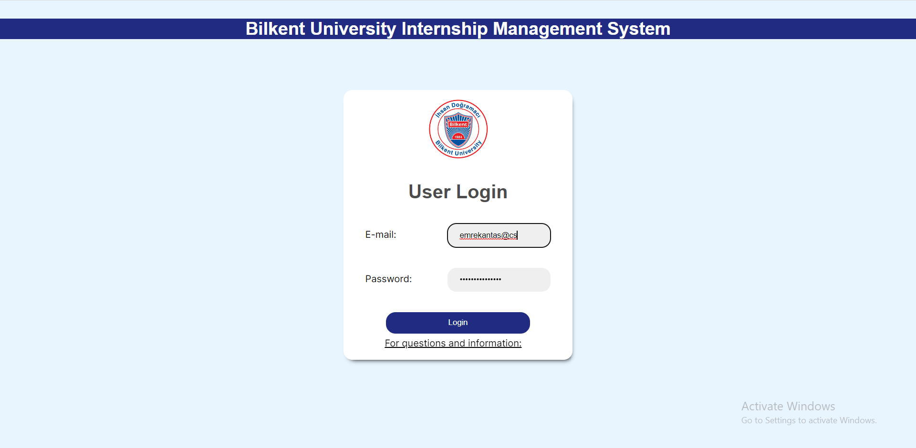

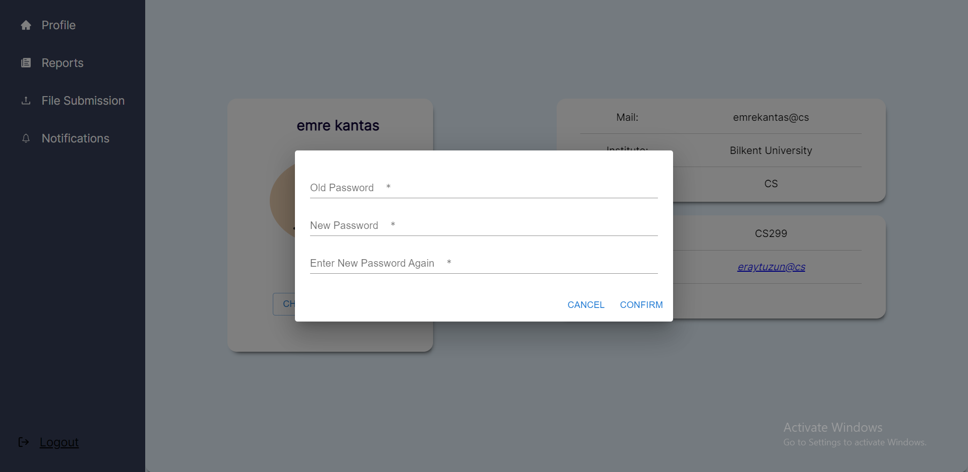

**B. Student View**

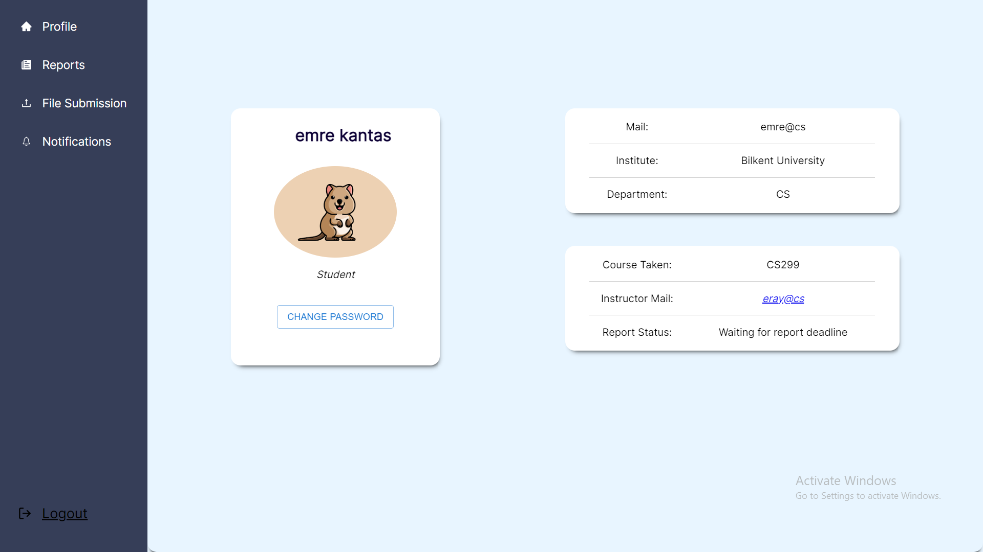

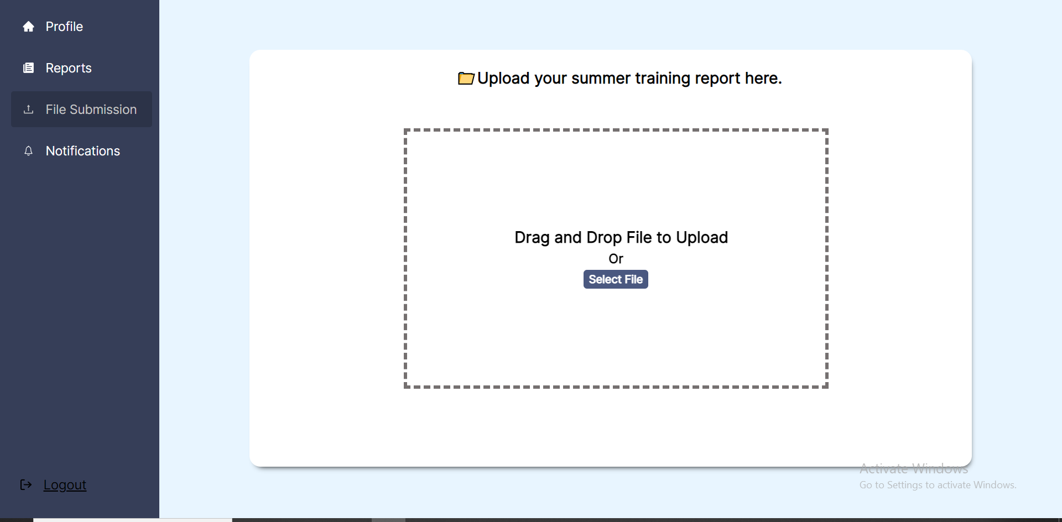

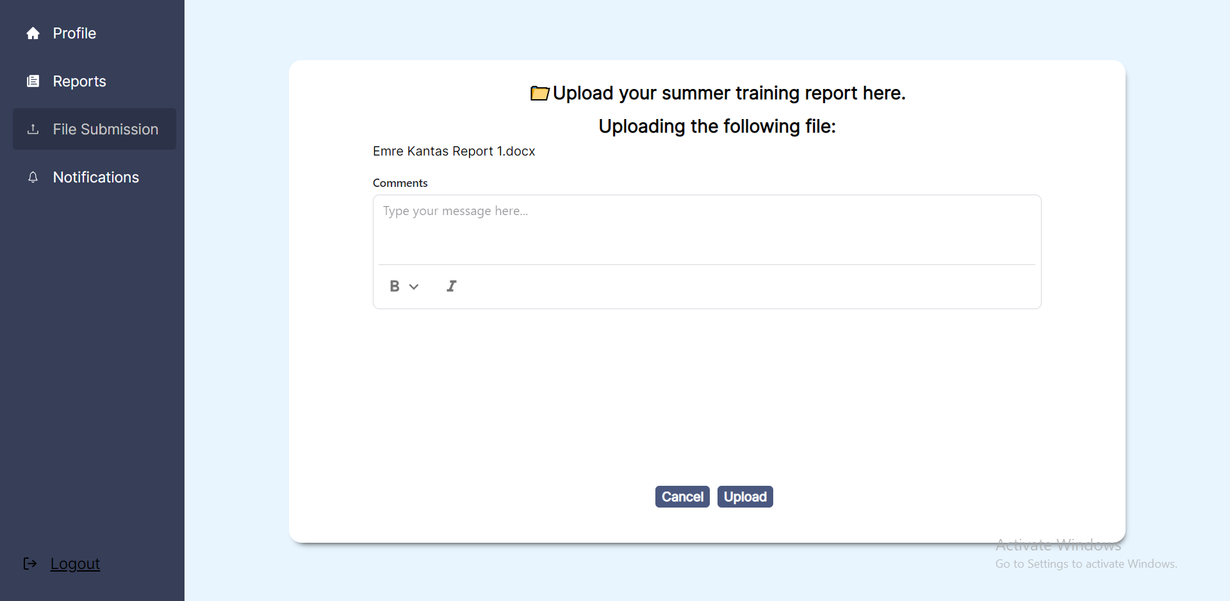

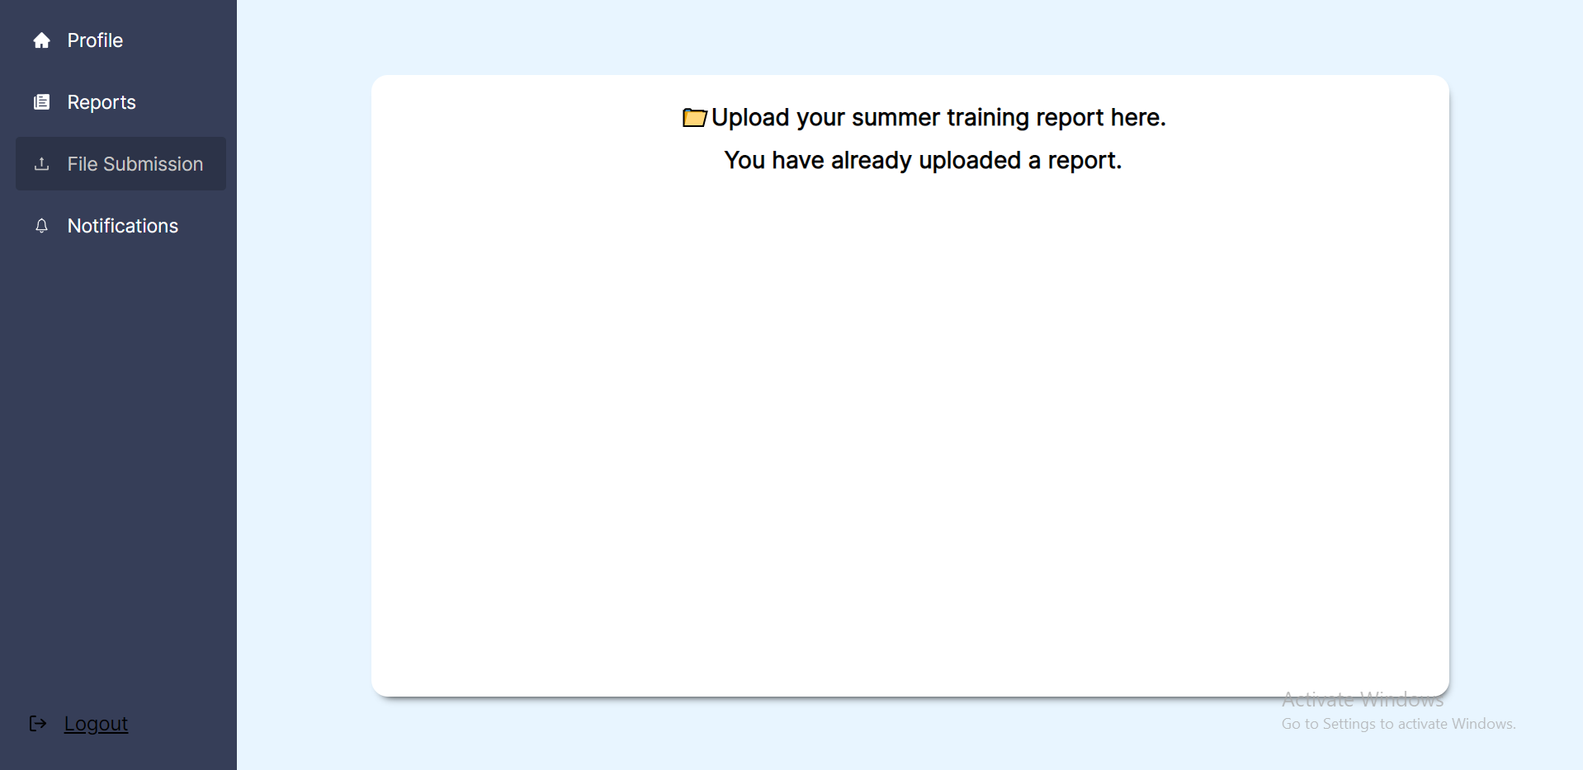

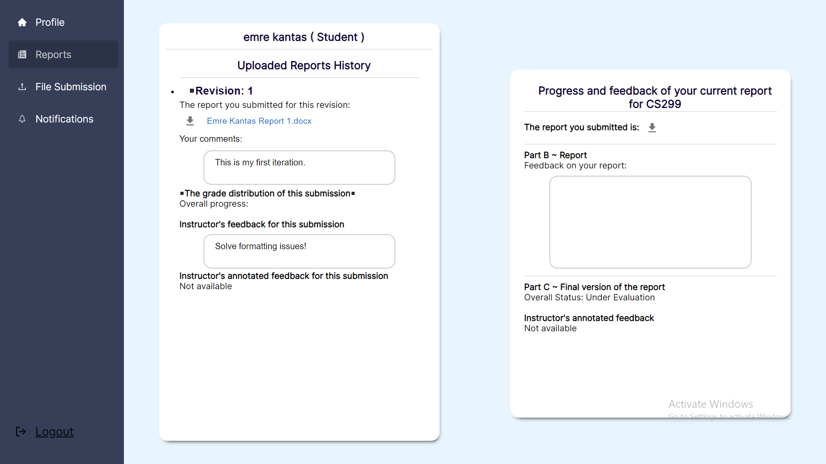

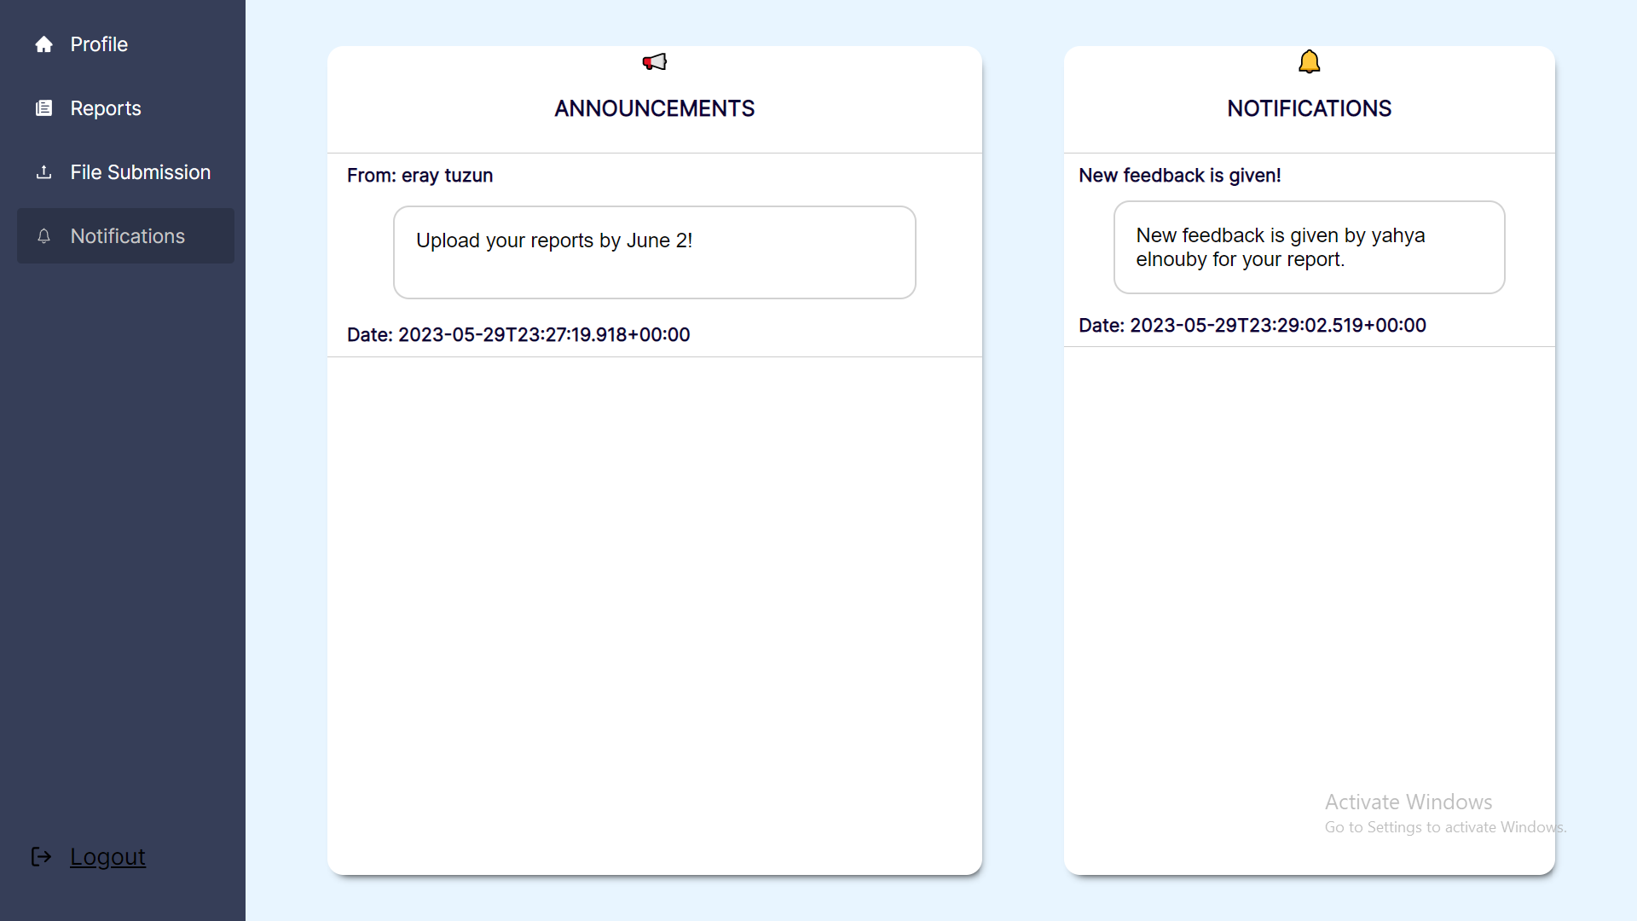

**C. Teaching Assistant View**

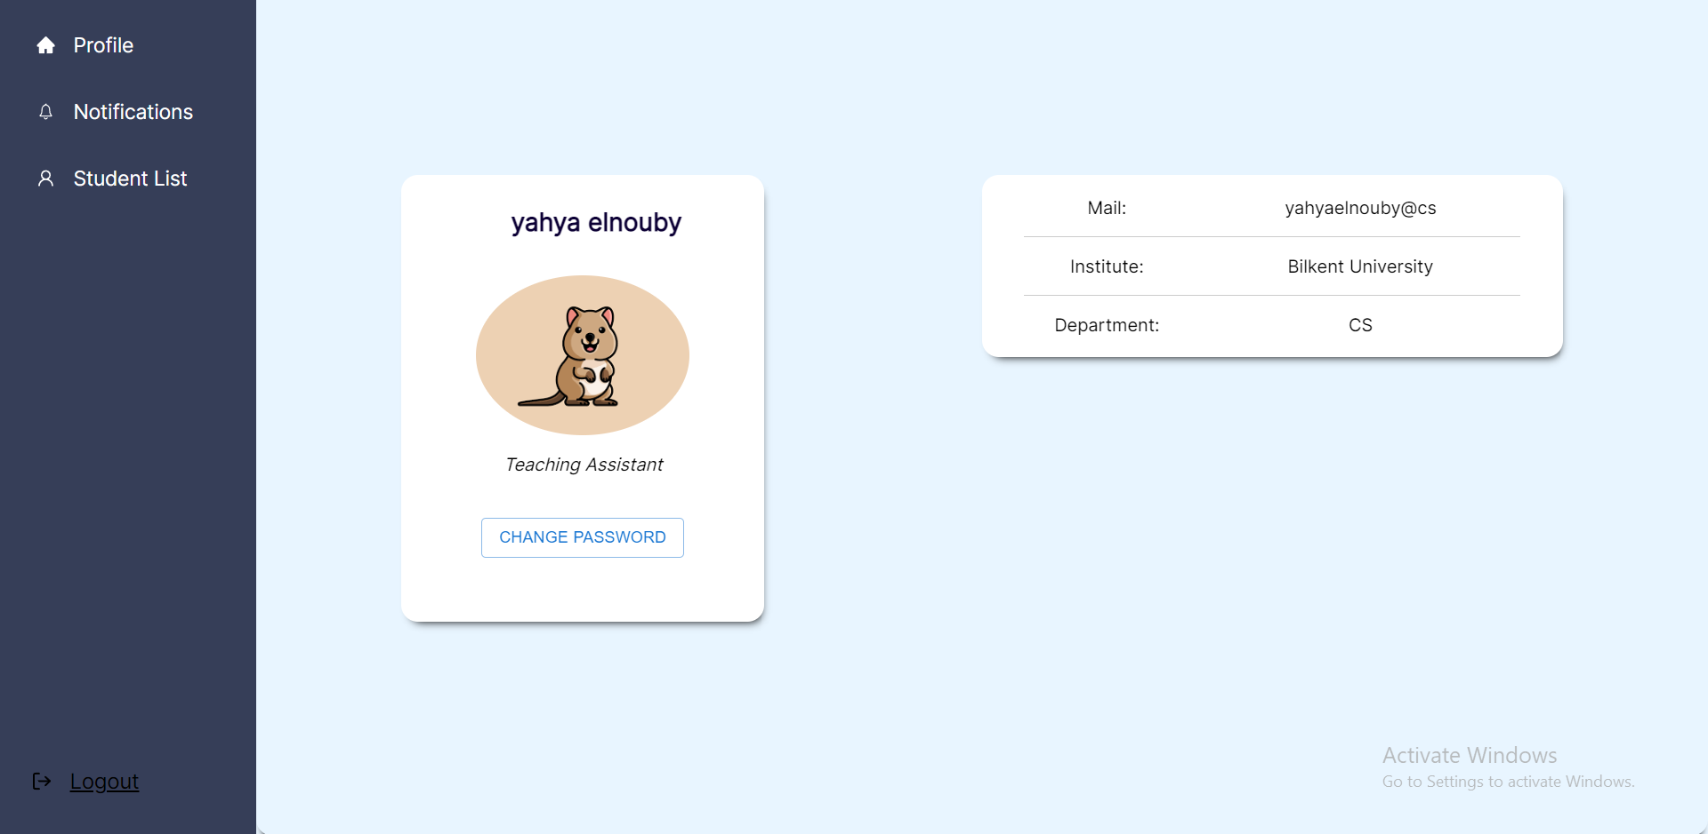

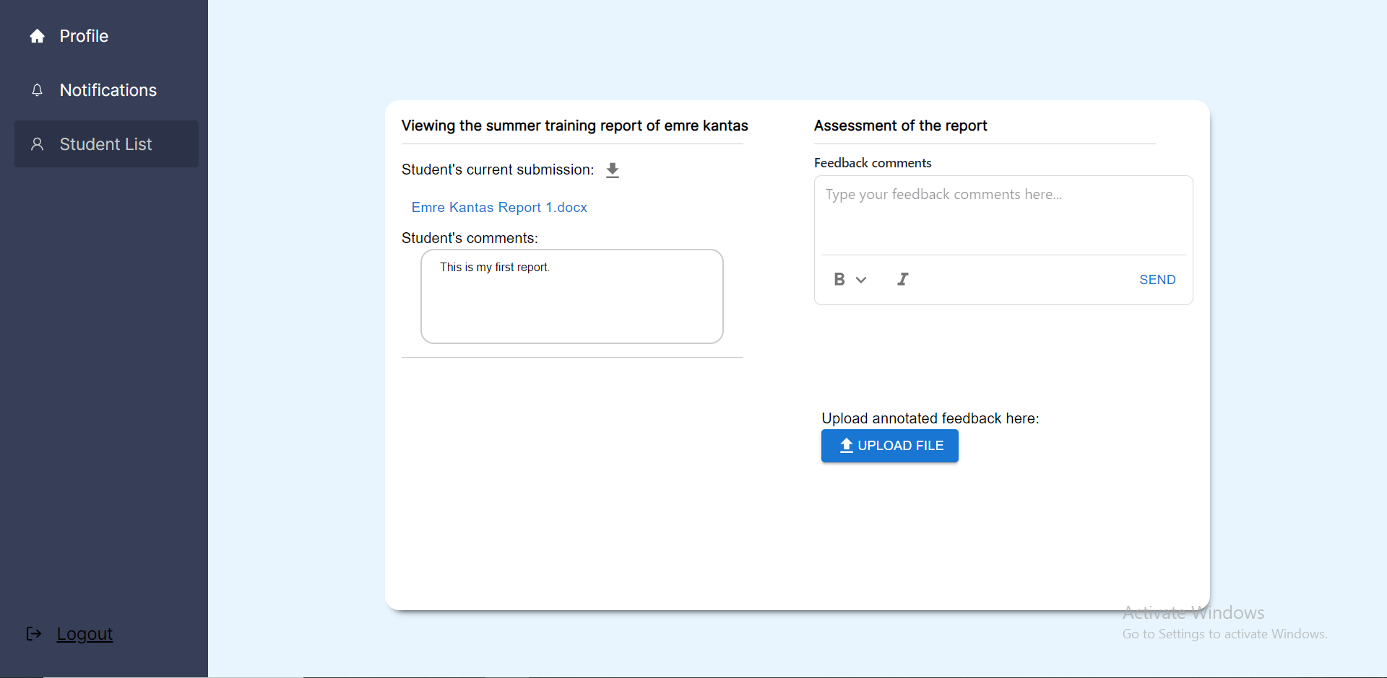

**D. Instructor View**

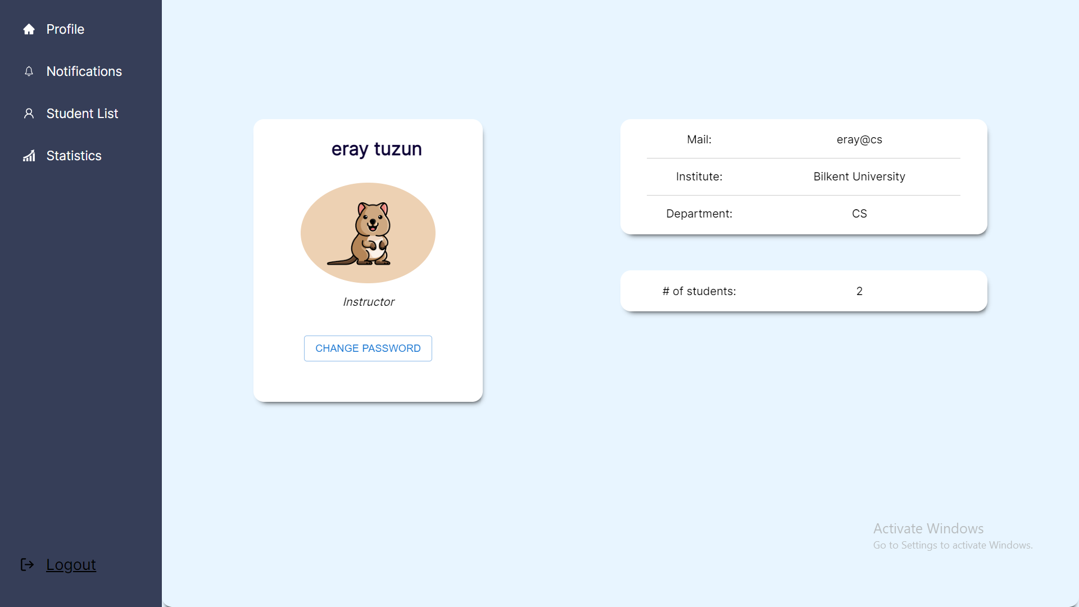

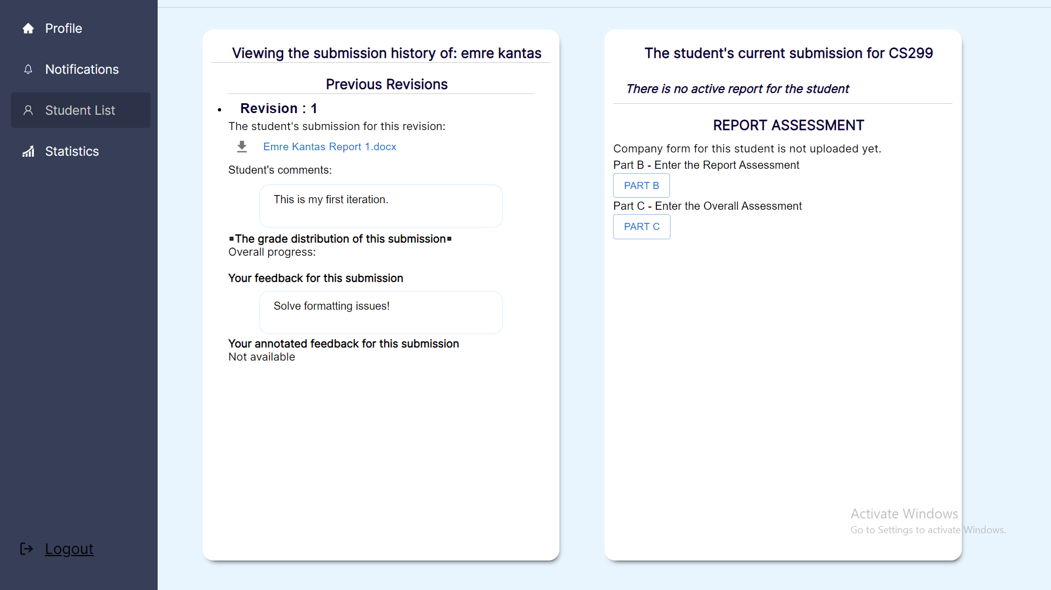

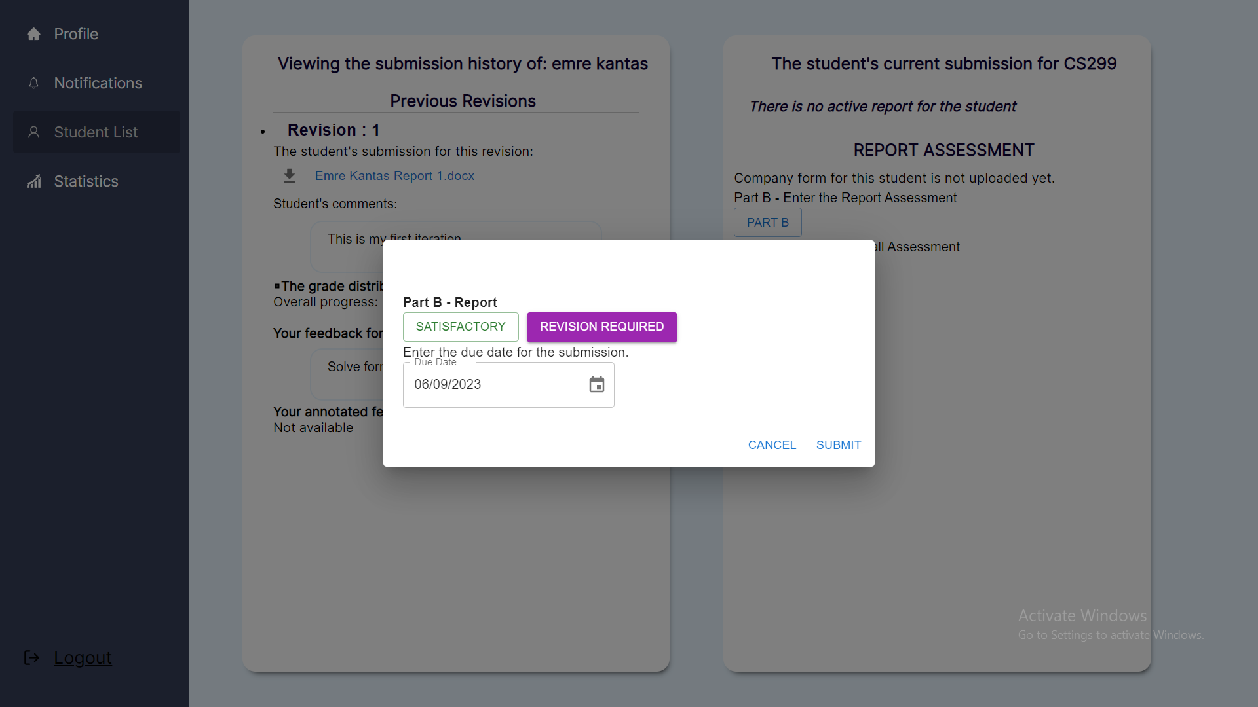

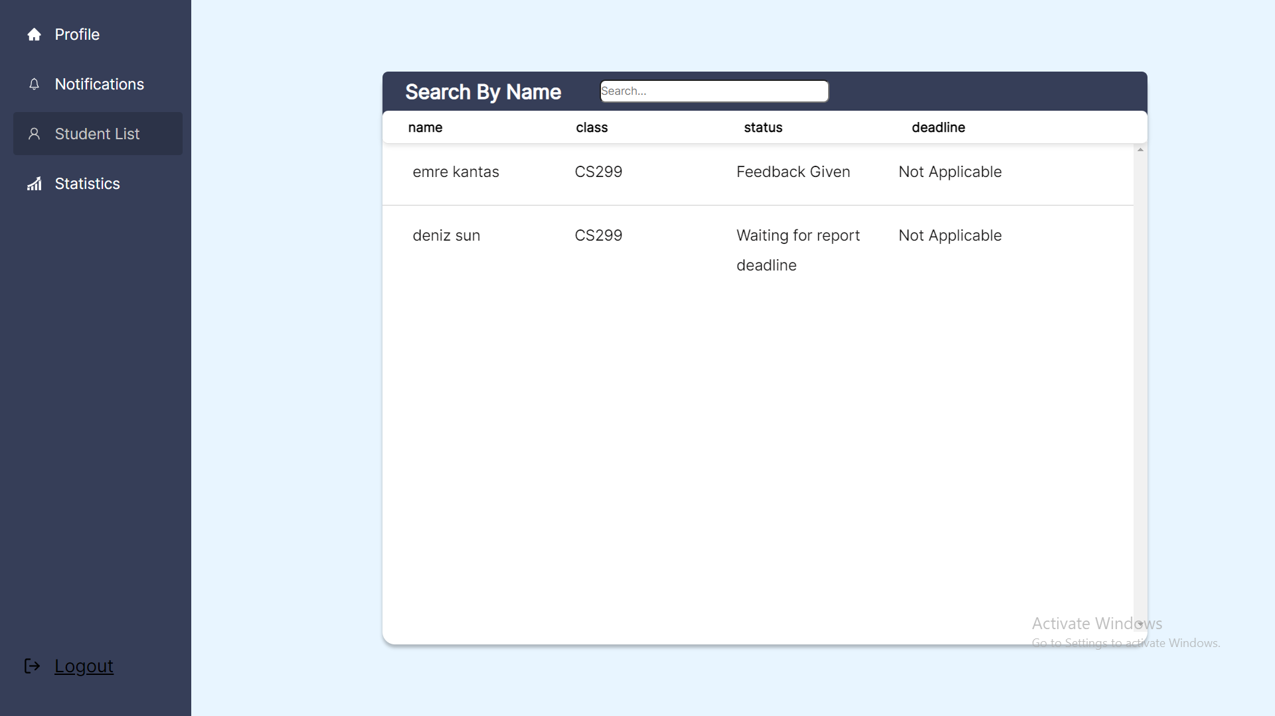

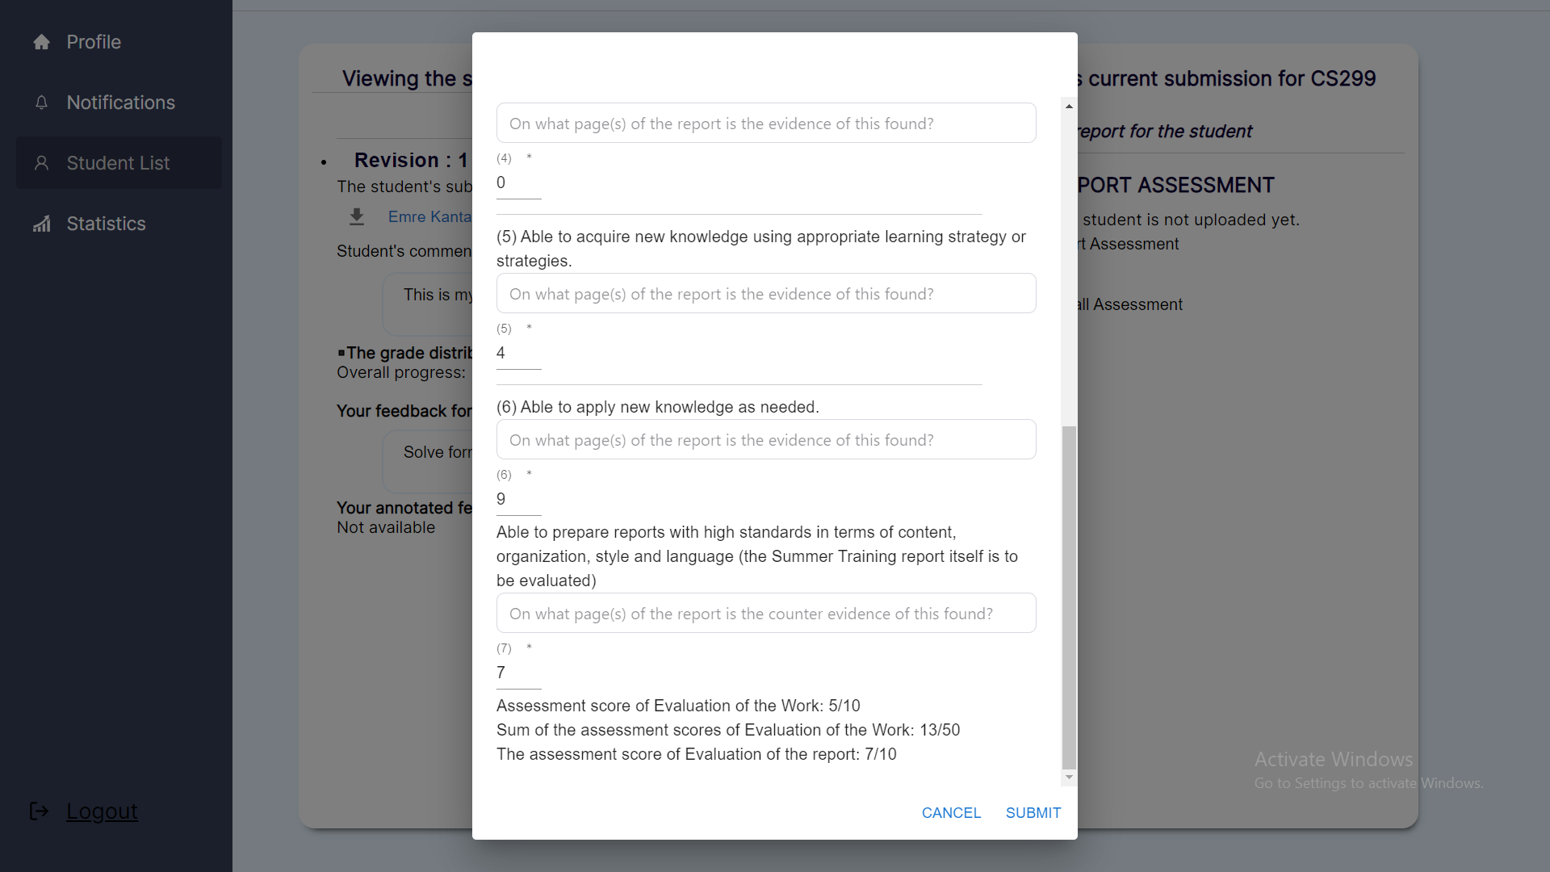

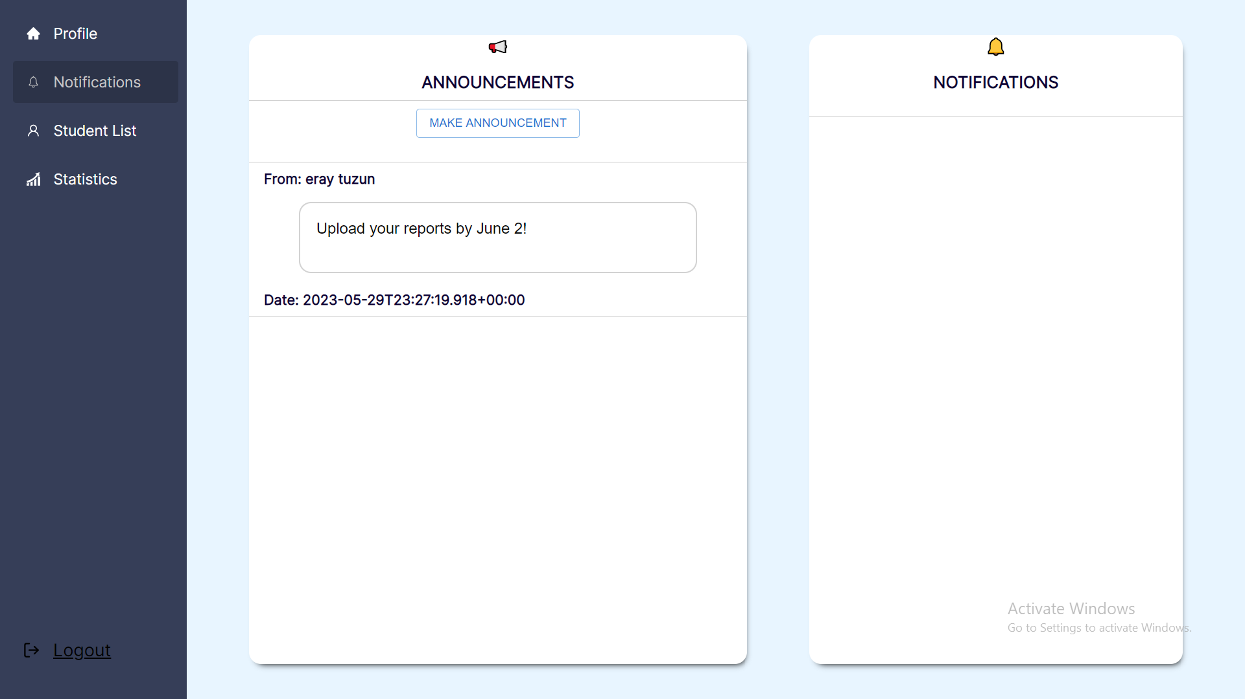

**E. Summer Training Coordinator View**

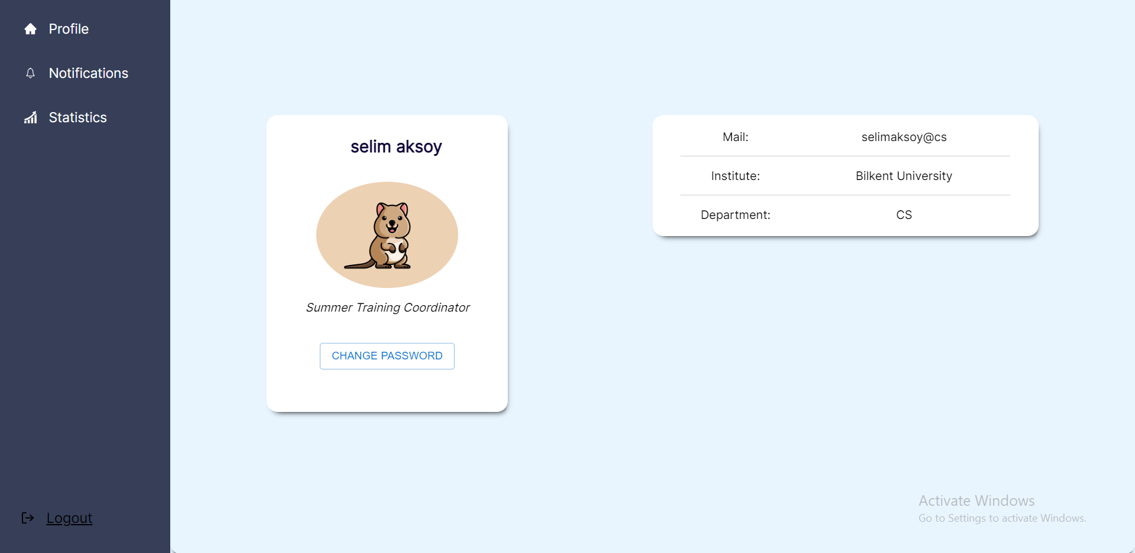

**F. Administrative Assistant View**

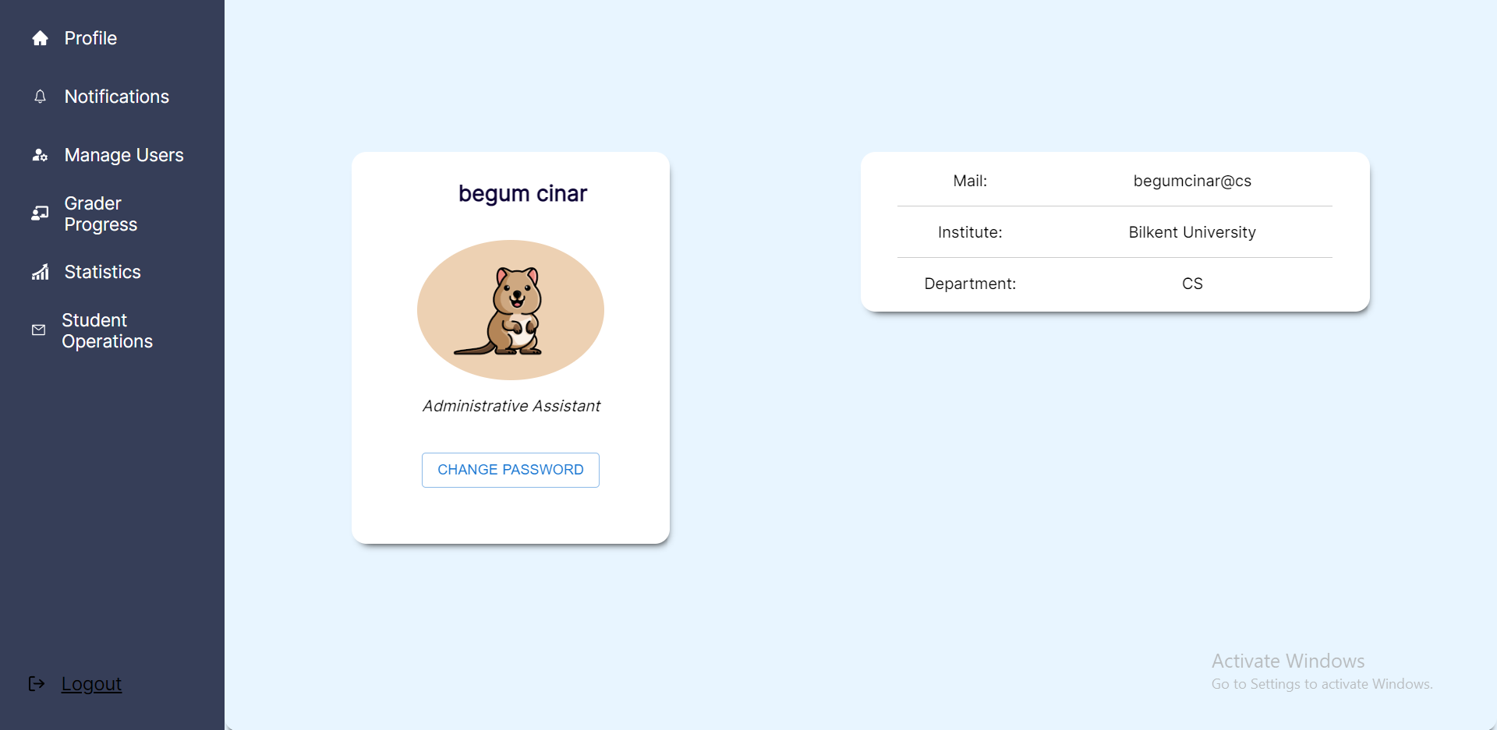

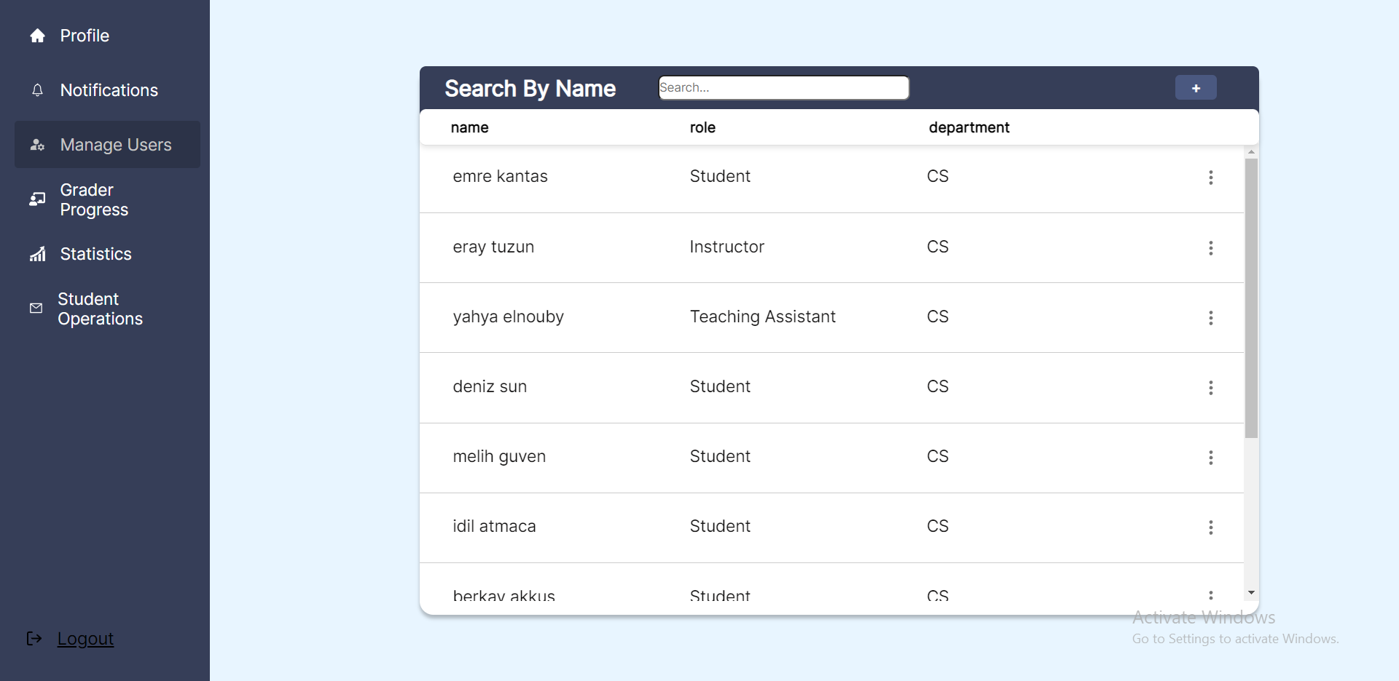

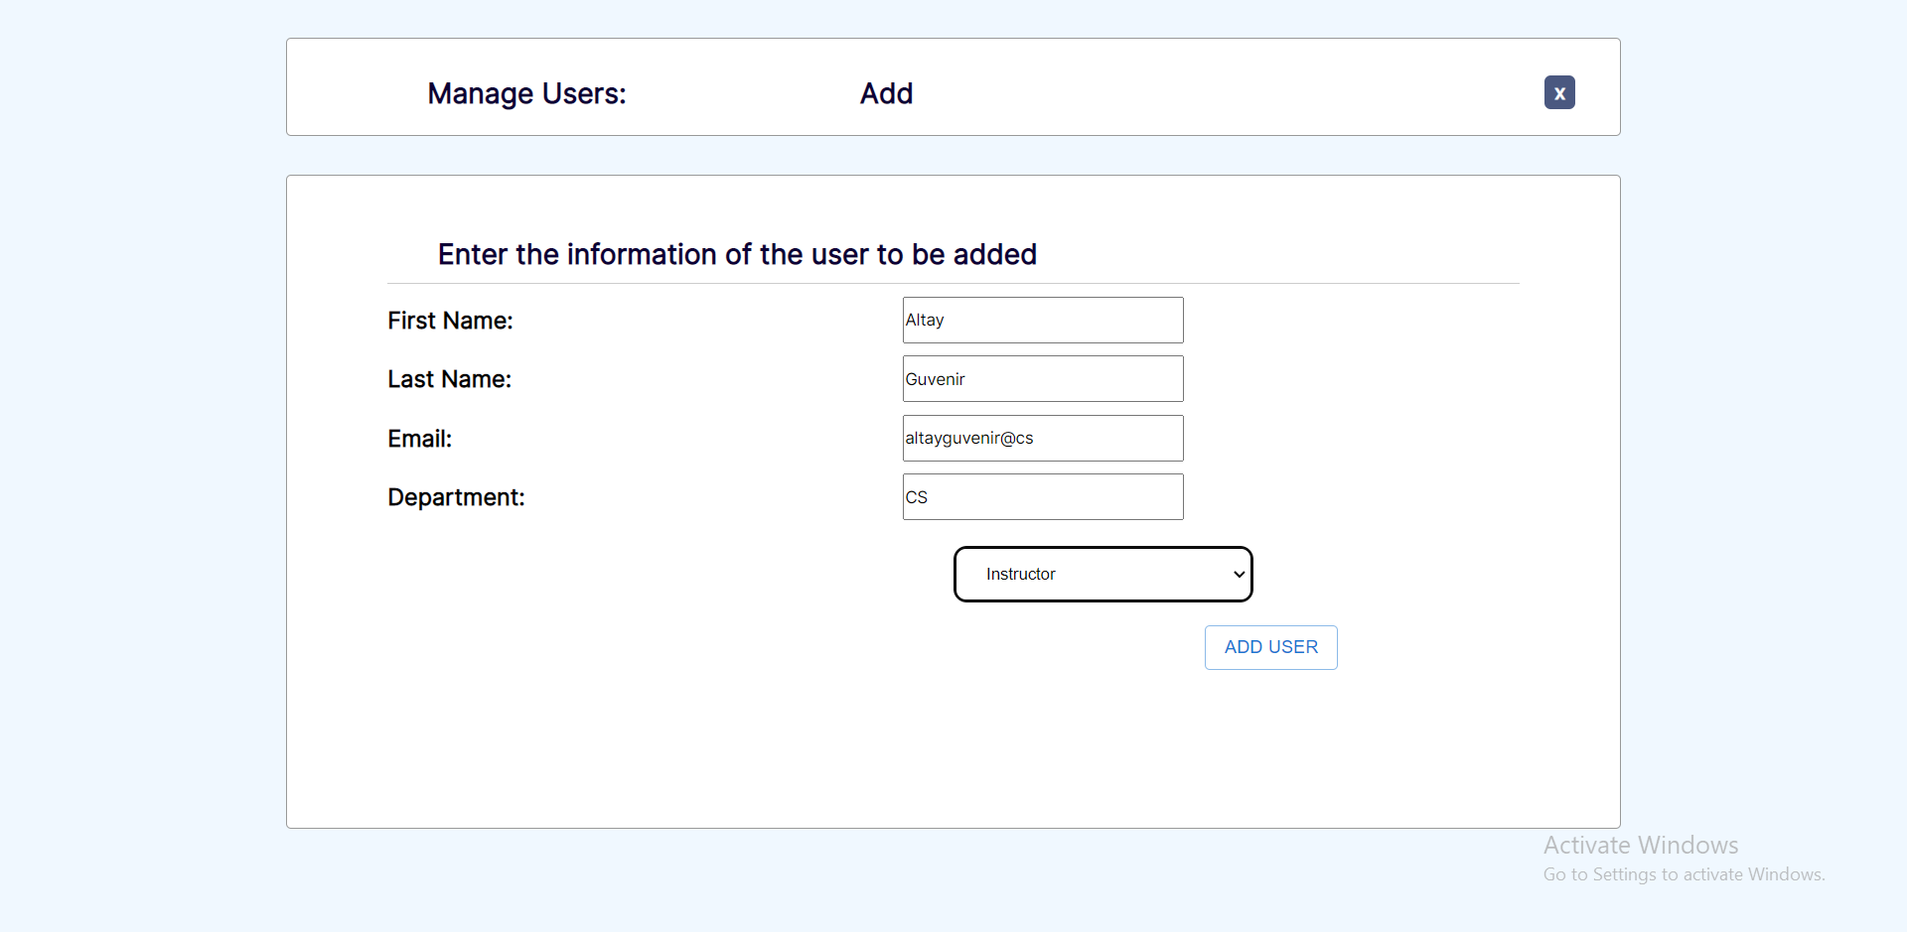

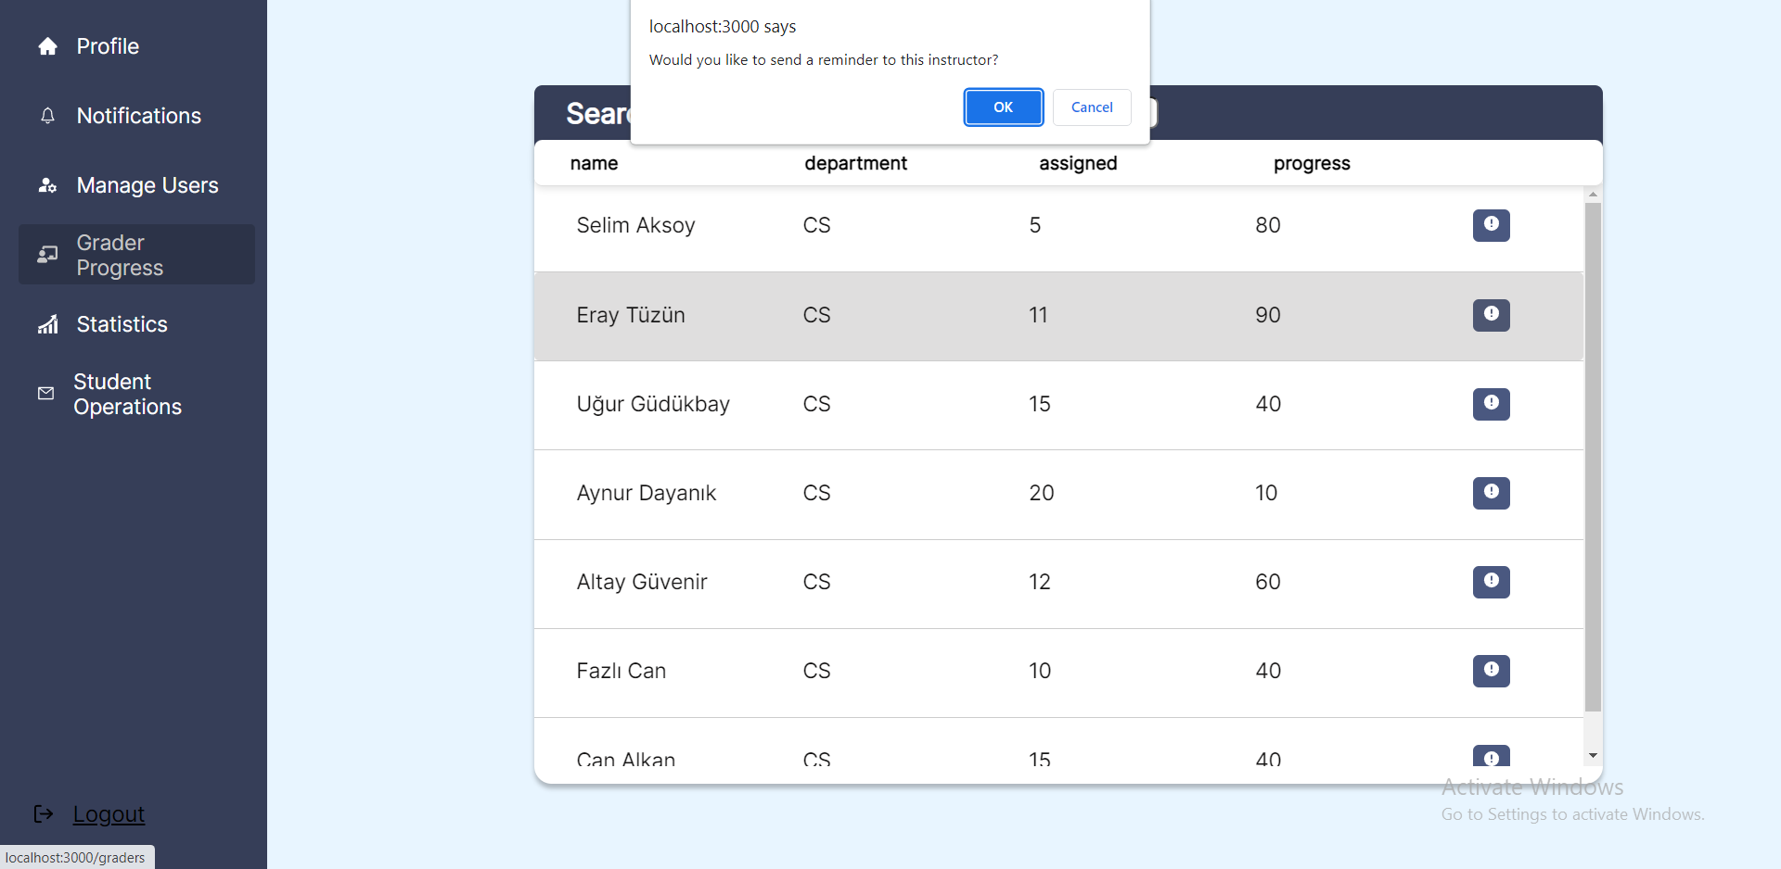

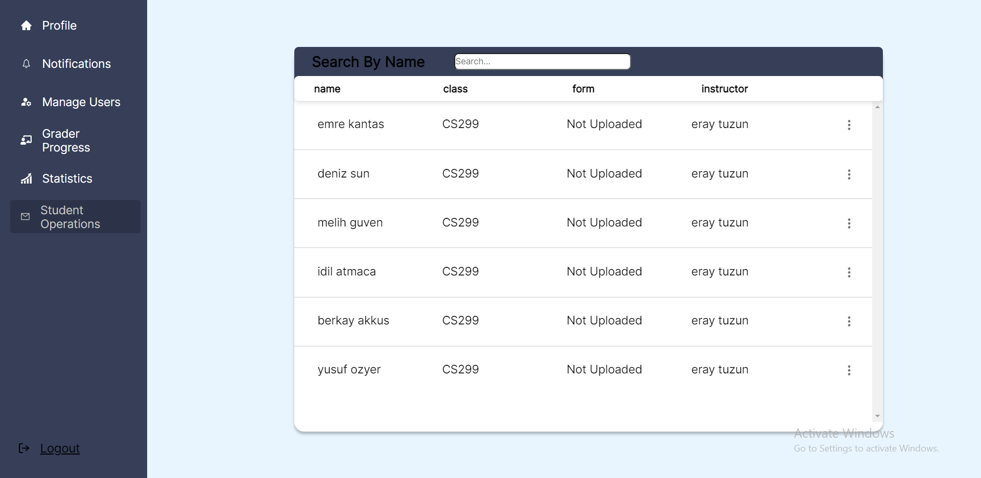

**G. Notifications View for Teaching Assistant, Summer Training Coordinator and Administrative Assistant**

