*CS3354 Software Engineering Final Project*

*Deliverable 1*

**Readary**

(An App for Book Lovers)

**The Group Members**

Aisha Ashfaque

Dante Moreno

Emily Wojciechowski

Joel Francis

Junaid Hashmi

Priscilla Adomako

**Date**

March 15, 2019

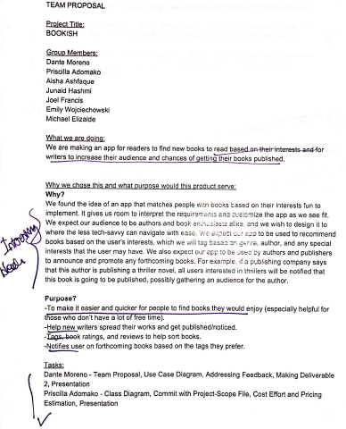

# 

# Feedback on Project Draft comments:

Our proposal was approved without a recommendation for any change. However, our plan will be adjusted based on the fact that one of our team members, Michael Elizalde, has joined another project team and is no longer part of our team.

Based on the comments we received, we surveyed and found several similar apps already in use. The most surprising discovery was to find an app named *Bookish*, our proposed app name. Consequently, we have renamed our product to *Readary.* Other than reshuffling of responsibilities due to loss of a team member, this is the biggest change we incorporated.

Since we found similar products already in use, we will do a detailed comparison as part of our final project report. For now, we would like to mention an additional feature to be included in our project in order to distinguish it from other similar products in the market.

* 1. Addition to previously stated purpose

We will incorporate a MUTE function in the app to allow users to silence notifications as follows:

* + 1. Audio notification may be turned on/off in application setup
    2. Notification messages may be muted (turned on/off in application setup)
    3. Notification messages may be muted until a future date provided by user

***NOTE:*** URL for our project GitHub is: <https://github.com/CS3354-Readary>

# Task Delegation:

|  |  |
| --- | --- |
| Name | Task Delegation |
| Dante Moreno | Team Proposal, Create GitHub Repository and Add Team Members, Software Requirements, Addressing Feedback, Presentation |
| Aisha Ashfaque | Team Proposal, Software Requirements, Cost Effort and Pricing Estimation, Software Test Plan, Presentation |
| Junaid Hashmi | Commit README, Architectural Design, Project scheduling, Citing references, Presentation |
| Joel Francis | Team Proposal, Class diagram, Project Scheduling, Software Requirements, Software Test Plan, Presentation |
| Priscilla Adomako | Team Proposal, Sequence Diagram, Cost Effort and Pricing Estimation, Comparison and Conclusion, Presentation |
| Emily Wojciechowski | Project Scope file, Use Case Diagram, Citing References, Comparison and Conclusion, Presentation |

# Software Process Model:

The software process model that will be employed with this project is the spiral model. The spiral model contains development cycles, in which risk management is considered before employing an addition to a prototype. Since Readary’s architecture features multiple systems interacting with a database, it would make sense any risks are considered before implementing to ensure that no additional feature negatively affects the database.

# Software Requirements:

Functional Requirements

1. A user holding an author account shall be able to submit book titles along with one summary and cover of that book to be added to the repository.
2. A user shall be able to search for books solely on genre, author, reviews and ratings, or other tags or a combination of the four.
3. A user shall be able to add and remove genres, authors, or other tags and interests from their book preferences.
4. The system shall generate each day, for each user, a new list of books based on each user’s preferences and the books each user has tagged.
5. Each user shall be uniquely identified by their member ID.
6. A user shall be able mute notifications until a specified date or indefinitely.

Non-functional

1. **Product Requirements**
   1. **Usability**
      1. Users shall be able to access all functions from the main menu in less than 3 clicks.
      2. 95% of users will be able to search for a book and add a new interest tag by the third attempt without requiring assistance.
      3. The system shall be accessible to users with vision needs, specifically, users shall be able to increase the font size for the entire user interface.
   2. **Efficiency**
      1. **Performance**
         1. Responses to actions shall take no longer than 5 seconds

to load on to the screen.

* + - 1. The system shall be able to process a single notification in

less than 1 second.

* + 1. **Space**
       1. The system shall not require more than 1 GB of space when downloaded on the users device.
  1. **Dependability**
     1. In the case of system failure, less than 0.1% of data shall be lost.
     2. The system shall be operational 95% of the time
     3. In case of system failure, down time shall be 2 hours or less.
  2. **Security**
     1. User account passwords must be at least 8 characters long.

1. **Organizational Requirements**
   1. **Environmental**
      1. The system shall be compatible with both iOS and Android.
   2. **Development**
      1. The system shall be developed using the programming language Java.
2. **External Requirements**
   1. **Legislative**
      1. The system shall implement and abide by copyright laws for each book that is requested to be submitted to the repository.

# Use Case Diagram:

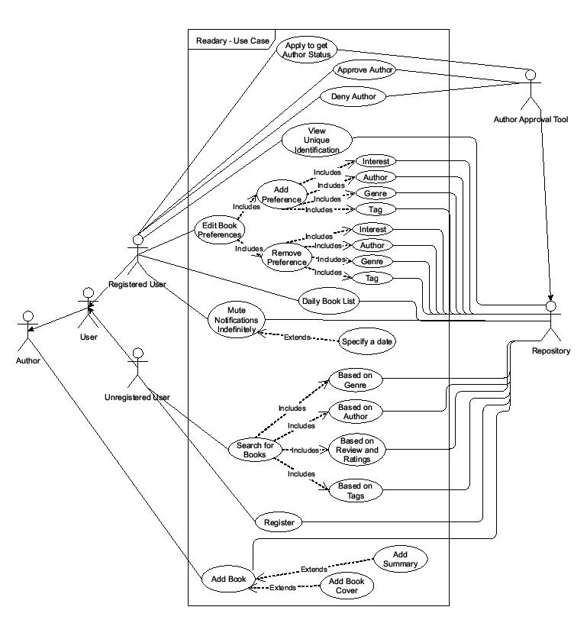

# Sequence Diagram:

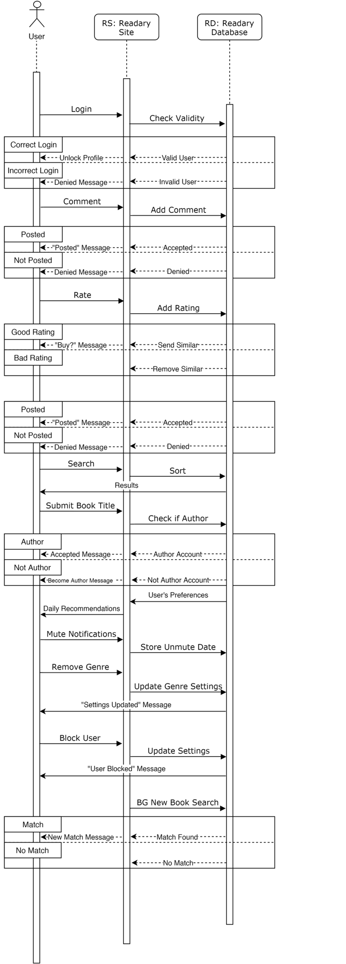

# Class Diagram:

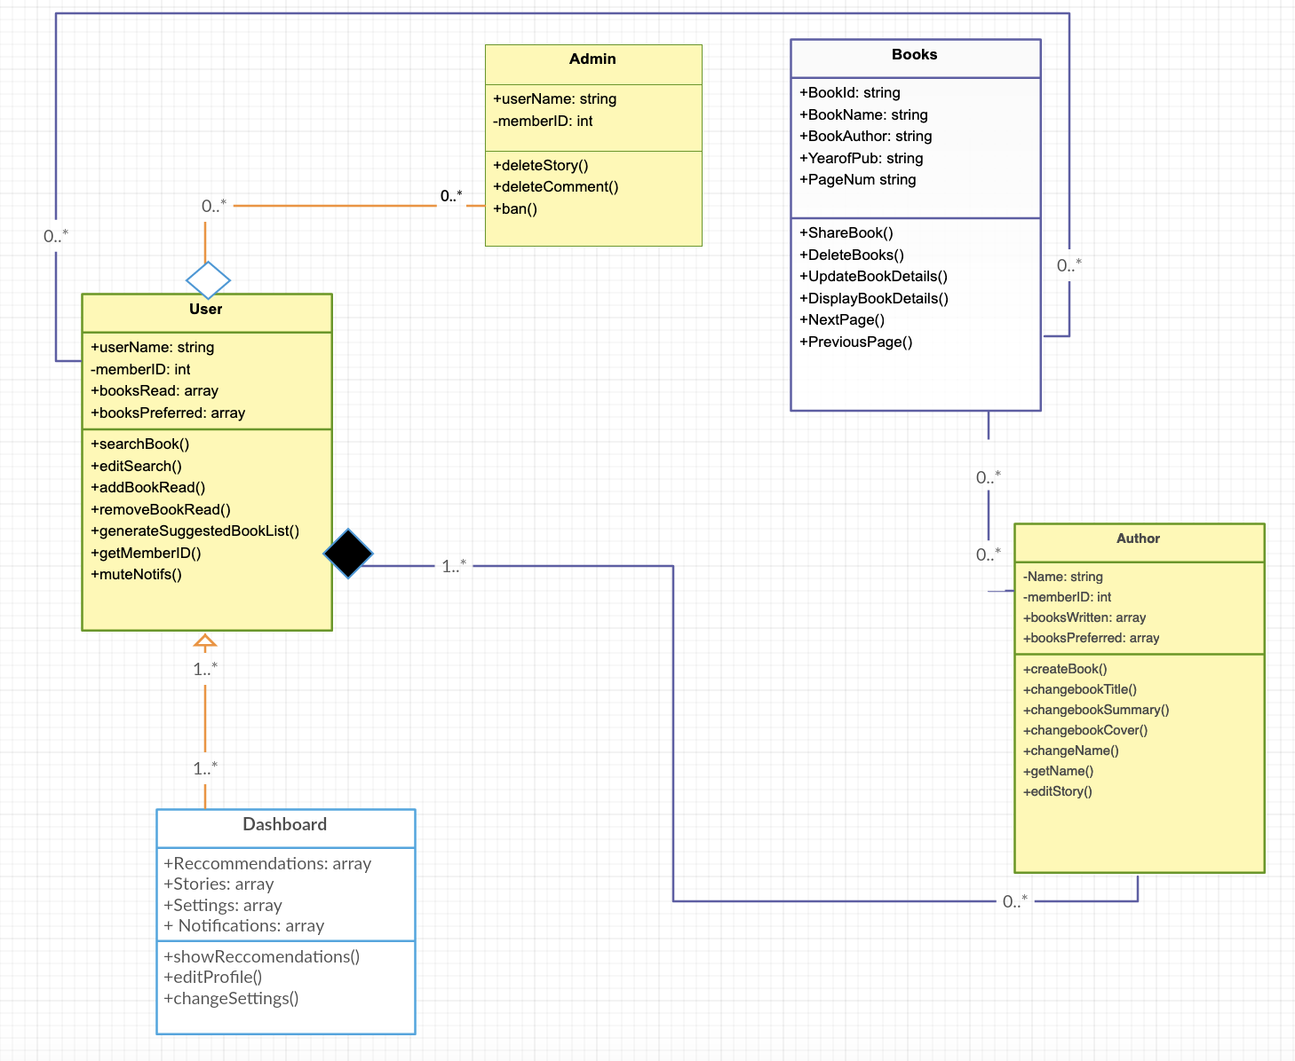

# Architectural Design:

The central part of Readary is a centralized DBMS. Therefore, our architectural choice is a central repository pattern. A high level architecture is shown below:

