Champion Document: Power-Up & Ability System
Name: ____________________ Feature: TL3 Power-Up & Ability System Mark: ____ / 30
Project: Escape the 90s (CS3383), a 6-developer Unity (C#) side-scroller for PC

1. Brief Introduction
My feature is TL3's Power-Up & Ability System for Escape the 90s. As the level scrolls, TL2's level generator calls PowerUpManager.SpawnPowerUp(position, type) to place a pickup in the world. My code creates a PowerUpItem at that position with a look that is unique to its type (Speed Boost, Shield, or Magnet) and keeps track of it until the player collects it.
When the player touches an item, my code detects the pickup, selects the matching effect, and applies it. Temporary effects (Speed Boost for 6 seconds, Magnet for 8 seconds) first save a snapshot of the one stat they change and restore that value when their timer runs out. The permanent effect (Shield) applies once and never expires. My code also manages stacking: a repeat Speed Boost adds a stack up to a maximum of 3, a repeat Magnet only refreshes its timer, and every successful pickup raises OnPowerUpCollected exactly once.
What my feature does NOT do. It does not own player movement or health; that is TL6's feature. It never writes player stats directly; it only calls TL6's documented PlayerController.SetSpeedMultiplier() and PlayerHealth.Heal(), and how the player reacts (clamping health, drawing a shield bar) is TL6's decision. It does not decide where pickups appear; TL2's level generator chooses the position and type. It does not draw the HUD or change the game state; TL1's UI/HUD subscribes to OnPowerUpCollected instead. It has no dependency on TL4's enemies or TL5's save data, which matches the project plan's architectural overview.
Completion criteria. At least three visually distinct power-up types (Speed Boost, Shield, Magnet) work correctly, including stacking behavior, and every contract test in Section 3.6 passes.

2. Use Case Diagram with Scenario
Use Case Diagrams
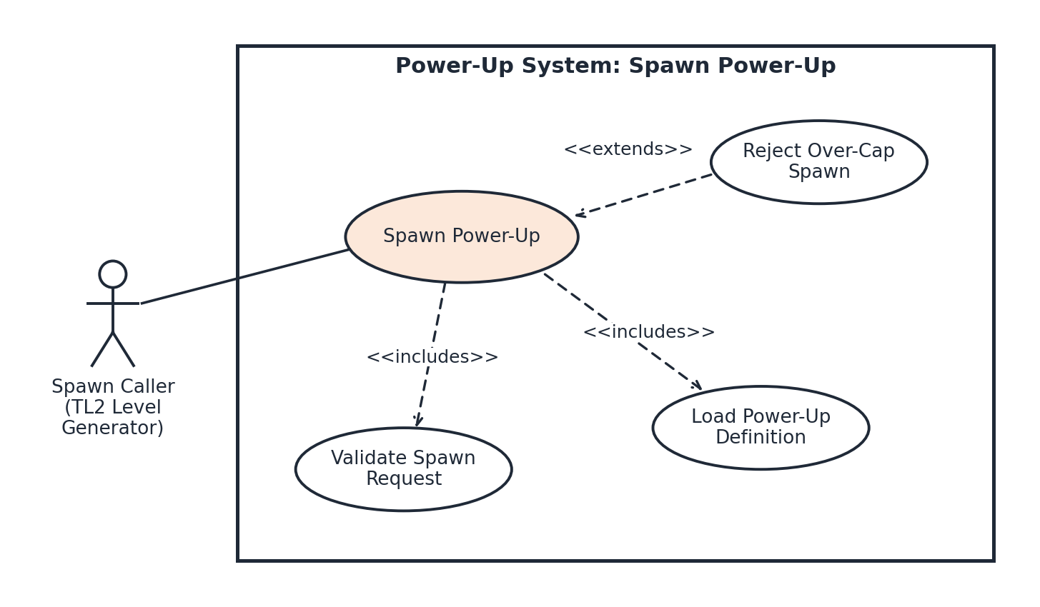
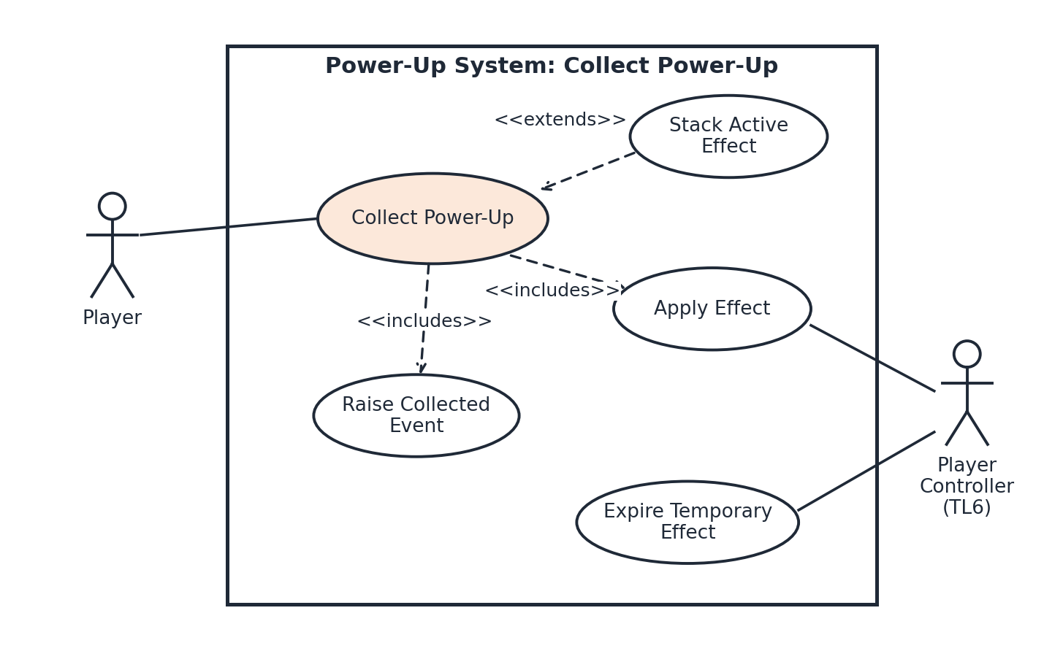
Scenarios
Scenario 1 (first use case diagram)
Name: Spawn Power-Up
Summary: TL2's level generator asks for a power-up at a position; the request is validated, the type's definition is loaded, and a collectible item is placed in the world.
Actors: Spawn Caller (TL2's LevelGenerator, which places pickups in the chunks it generates)
Preconditions: The PowerUpManager is active in the scene and the three PowerUpDefinition assets have loaded and passed validation.
Basic sequence:
Step 1: TL2's LevelGenerator invokes SpawnPowerUp(position, type) while populating a chunk.
Step 2: The request is validated: every component of position is finite and type is a defined PowerUpType value.
Step 3: The active item count is checked against the cap of 200.
Step 4: The PowerUpDefinition for the type is looked up to get its model, color, and particle effect.
Step 5: A PowerUpItem is instantiated at the position with that type's visuals.
Step 6: The item is added to the Active Items list and becomes collectible.
Exceptions:
Step 2a: The position contains NaN or Infinity, or the type is not a defined value. SpawnPowerUp throws ArgumentException (position) or ArgumentOutOfRangeException (type); no item is created and the sequence ends.
Step 3a: The <<extends>> case. 200 items are already active. The spawn is rejected, one warning naming the position and type is logged, no exception is thrown, and the sequence ends without Step 4.
Post conditions: Exactly one new collectible item exists at the requested position, or none exists and the reason was reported.
Priority: 1 (must have)
ID: PU1
Scenario 2 (second use case diagram)
Name: Collect Power-Up
Summary: The player touches a power-up; its effect is applied through TL6's interface, listeners are notified, and temporary effects are later restored.
Actors: Player (primary); TL6's PlayerController and PlayerHealth (secondary, receive effect calls)
Preconditions: At least one PowerUpItem is active and the player object has a collider tagged "Player".
Basic sequence:
Step 1: The player's collider enters a PowerUpItem trigger.
Step 2: The item marks itself collected (so it cannot be picked up twice) and reports the pickup to PowerUpManager.
Step 3: The manager looks up the effect strategy registered for the item's type.
Step 4: The type is not already active, so the effect creates a snapshot of the stat it will change and the manager stores it (Memento).
Step 5: The effect's Apply() runs and calls PlayerController.SetSpeedMultiplier() or PlayerHealth.Heal() on TL6's interface, or changes the pickup radius.
Step 6: The effect is added to Active Effects with its full duration on the timer.
Step 7: OnPowerUpCollected is raised once and the item is destroyed in the same frame.
Step 8: When the timer reaches 0, Remove() runs and the saved snapshot value is restored (for Speed Boost, through SetSpeedMultiplier()).
Exceptions:
Step 1a: The collider is not tagged "Player" (for example, an enemy). The contact is ignored, the item stays active, and no event is raised.
Step 2a: A second trigger for the same item arrives in the same frame. The item is already marked collected, so the second contact is ignored and only one event is raised.
Step 3a: No strategy is registered for the type. An error is logged, the item is destroyed, no effect is applied, and no event is raised. The sequence ends.
Step 4a: The <<extends>> Stack case. The same type is already active. If its stack count is below MaxStacks, the count goes up by 1 and Apply() runs again; otherwise only the timer is refreshed. No new snapshot is taken, so the original value is kept. The sequence resumes at Step 7.
Step 4b: The effect is permanent (Shield). No snapshot is taken, Apply() runs once, and Steps 6 and 8 are skipped.
Step 6a: The effect's duration is 0 seconds. Remove() runs in the same frame, the snapshot is restored, and the sequence resumes at Step 7.
Post conditions: The item is gone, OnPowerUpCollected has been raised once, and the player's stats are either boosted with a running timer or back to their pre-pickup values.
Priority: 1 (must have)
ID: PU2

3. Interface Contract
This section lists everything other features may rely on. Each clause has a concrete type and a check that a test can pass or fail. Anything not listed here is internal and may change.

3.1 Inputs
Input | Type | Valid values | Test check
position (SpawnPowerUp) | Vector3 (world units) | x, y, z all finite. World bounds are the caller's responsibility. | NaN or Infinity throws ArgumentException; item count unchanged.
type (SpawnPowerUp) | enum PowerUpType { SpeedBoost = 0, Shield = 1, Magnet = 2 } | Defined values only. | (PowerUpType)99 throws ArgumentOutOfRangeException; item count unchanged.
Pickup contact | Unity trigger: Collider via OnTriggerEnter | Collider tagged "Player". | Enemy collider: item stays, 0 events.
Frame time | float Time.deltaTime (seconds) | 0 or greater. | Each timer drops by exactly deltaTime per Update (within 0.001 s).
PowerUpDefinition (one asset per type) | ScriptableObject: Duration float, IsPermanent bool, MaxStacks int, Magnitude float | Duration >= 0, MaxStacks >= 1, Magnitude > 0. | An invalid asset fails validation at load with an error naming the bad field.

Default definitions for the three required types
Type | Visual | Effect when applied | Duration | Max stacks | Repeat pickup
Speed Boost | Yellow bolt, yellow trail | SetSpeedMultiplier(1.0 + 0.5 x stacks) | 6.0 s | 3 | Add a stack (cap 2.5x) and refresh timer
Shield | Blue hexagon, blue ring | Heal(25) | Permanent | 1 | Each pickup applies on its own
Magnet | Red horseshoe, red sparks | Pickup radius 1.5 to 6.0 units | 8.0 s | 1 | Refresh timer only

3.2 Outputs
Output | Type | Guarantee | Test check
Spawned item | PowerUpItem (MonoBehaviour) in the scene | Exactly one per valid call, within 0.01 units of position, with its type's visuals. | Item count +1; position and Type field match the call.
Spawn cap | int, at most 200 active items | Call 201 is rejected with one warning and no exception. | Count stays 200; exactly 1 warning logged.
PlayerController.  SetSpeedMultiplier(float) | Call to TL6 | Value is always in [1.0, 2.5]. When the last Speed Boost expires, the value sent equals the pre-boost value exactly. | Mock records every value; none out of range; last value = 1.0.
PlayerHealth.  Heal(int) | Call to TL6 | Exactly one call with amount 25 (int) per Shield pickup. | Mock call count equals Shield pickups; every amount is 25.
Pickup radius | float (world units) | 1.5 normally, 6.0 while Magnet is active, back to 1.5 on expiry. | Value read before, during, and after the effect.
Collected item | Destroyed GameObject | Removed in the same frame as the pickup and never collected twice. | Two triggers in one frame give 1 event and 1 effect.

3.3 Events
public event Action<PowerUpCollectedEventArgs> OnPowerUpCollected;

public readonly struct PowerUpCollectedEventArgs {
public PowerUpType Type { get; } // type that was collected
public Vector3 Position { get; } // where the item was
public int StackCount { get; } // count after this pickup
public float RemainingSeconds { get; } // 0 when IsPermanent
public bool IsPermanent { get; }
}
Event rule | Test check
Raised exactly once per successful pickup, after Apply() has finished. | 100 pickups give 100 events; the mock shows the Apply call before the event.
Never raised for rejected spawns, ignored colliders, or types with no strategy. | 0 events in each of those cases.
StackCount is the count after this pickup (1 to MaxStacks). Shield always reports 1. | The 4th Speed Boost pickup in a row reports 3.
RemainingSeconds equals the full Duration after an apply or refresh; 0 when IsPermanent is true. | Values match within 0.001 s.
Raised on the main thread in the same frame. A subscriber that throws is caught and logged; other subscribers still run and the effect stays applied. | A throwing test subscriber does not stop a second subscriber from being called.

3.4 Dependencies
My only outside dependency is TL6's documented interface from the project plan: PlayerController.SetSpeedMultiplier(float mult) and PlayerHealth.Heal(int amount). The effects reach them through a small adapter, IPowerUpTarget, so tests can swap in a mock. I never read player stats from TL6. My feature is the only caller of SetSpeedMultiplier, so the adapter remembers the last multiplier it sent (starting at 1.0) and exposes it as the read-only SpeedMultiplier property; snapshots read that remembered value. The pickup radius belongs to my feature, so the adapter's SetPickupRadius(float) writes a field I own and PickupRadius reads it back. Inbound, TL2 calls SpawnPowerUp and TL1 subscribes to OnPowerUpCollected.
Open items to settle before the Week 5 interface freeze. (1) Spawn caller: the project plan says pickups are placed by the level, so this document shows TL2's LevelGenerator calling SpawnPowerUp, but TL2's specification does not yet list that call as a dependency. (2) Magnet range: TL5's MagnetRangeUpgrade raises magnet range, but TL6's interface has no magnet setter and the pickup radius is owned by my feature, so TL5 and I need to agree on a documented way for that upgrade to reach PowerUpManager.

3.5 Internal Structure (behind the contract)
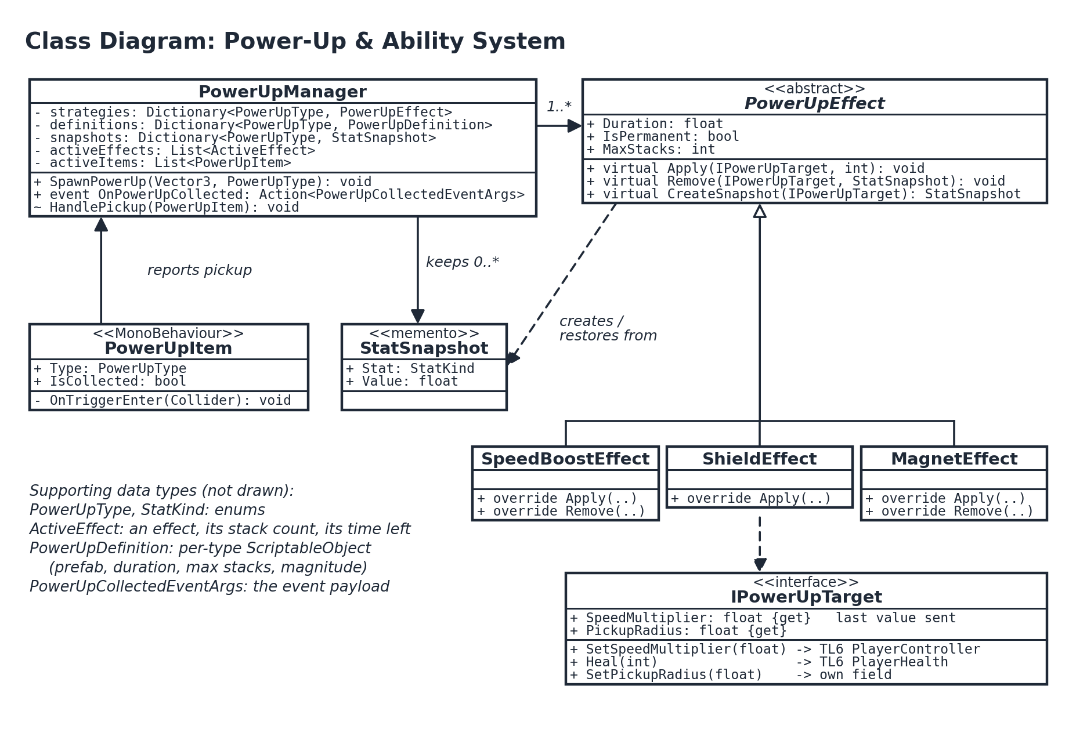
Class hierarchy and dynamic binding. PowerUpEffect is abstract and declares Apply() and Remove() as virtual. The base versions do only the generic work (update the stack count and log the pickup). SpeedBoostEffect, ShieldEffect, and MagnetEffect each override Apply() with their own behavior. SpeedBoostEffect and MagnetEffect also override Remove() to restore their saved stat; ShieldEffect is permanent, so it keeps the base Remove(). The manager always calls through a PowerUpEffect reference. If virtual were removed, every call would bind to the base method and all three pickups would behave identically. A unit test calls Apply() through the base reference and checks that each subclass produces a different mock call.
Strategy (choosing the effect). PowerUpManager is the client (the role GoF calls the context), PowerUpEffect is the abstraction, and the three subclasses are the implementations. The manager holds a Dictionary<PowerUpType, PowerUpEffect>, so choosing an effect is a lookup, not a switch statement. Adding a fourth power-up means one new subclass and one dictionary entry.
Memento (saving and restoring stats). PowerUpEffect is the originator: before a temporary effect applies its first stack, CreateSnapshot(target) reads the current value from the adapter and returns a StatSnapshot (the memento) holding the one stat it is about to change and that value. PowerUpManager is the caretaker: it keeps every live snapshot in its snapshots collection, one per active temporary type, never reads inside them, and hands each one back to that effect's Remove() when the timer ends. Later stacks do not overwrite the saved snapshot, so the original value is what gets restored. Snapshots are per stat on purpose: if one snapshot held every stat, a Magnet picked up during a Speed Boost would save the boosted speed and could restore it after the boost had already ended.
GRASP. Polymorphism: the three effect subclasses replace type checks. Indirection: items never reference the player and the player never references items; PowerUpManager sits between them. Low Coupling: my feature depends on two TL6 methods behind one interface, accepts one call from TL2, and talks to TL1 only through OnPowerUpCollected.

3.6 Contract Tests
All tests run in Unity Test Framework (Edit Mode for effects, Play Mode for pickup and stress) against MockPowerUpTarget, which records every call and value.
Test | Setup | Pass bound
Effect unit tests | Apply() then Remove() for Speed Boost and Magnet; Apply() only for Shield (permanent), all on the mock. | Recorded calls exactly match the defaults table; after Remove() every restored value equals its snapshot.
Zero duration boundary | Speed Boost with Duration = 0. | Applied and restored in the same frame; final multiplier 1.0; exactly 1 event.
Max stack boundary | 4 Speed Boost pickups in a row. | Multipliers sent: 1.5, 2.0, 2.5, 2.5. StackCount: 1, 2, 3, 3. One restore to 1.0 at expiry.
Overlap order | Speed Boost then Magnet; expire in both orders. | Both orders end at multiplier 1.0 and radius 1.5.
Stress | Spawn 200 items, collect 100 in one frame; repeat for 50 rounds. | 0 exceptions; events equal pickups; all values back to baseline after expiry; frame time rises by less than 2 ms (Unity Profiler).
Visual distinctness | All 3 types side by side; screenshot sent to TL4 without labels. | Reviewer names 3 of 3 types correctly.

4. Data Flow Diagrams
The context diagram shows Escape the 90s as a single process (0) and the three things outside it. Diagram 0 decomposes Process 0 into the six features from the project plan; process numbers match TL numbers, so my feature is Process 3. I then zoom into Process 3 and give a decision-tree process description for primitive process 3.3. All diagrams use Gane-Sarson symbols: rounded rectangles with an ID band for processes, open-ended rectangles for data stores, and shaded rectangles for external entities (a corner stroke marks a duplicated entity).
Context Diagram
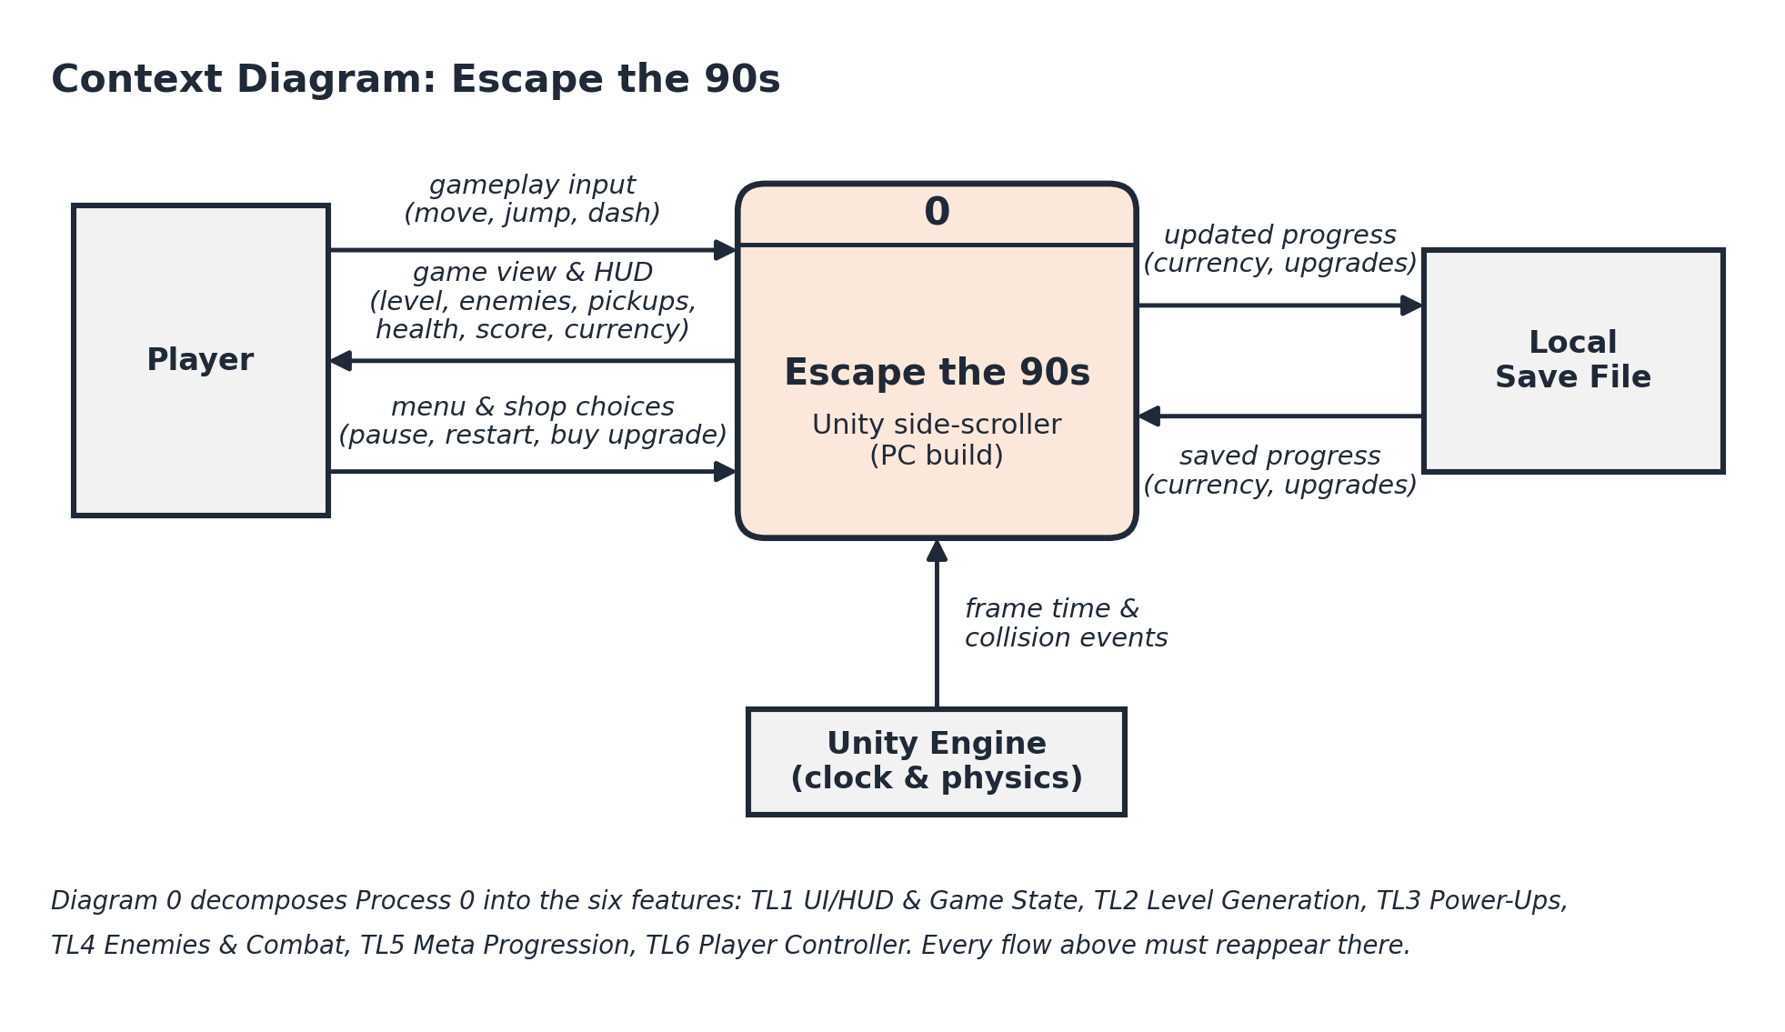
Enemies, the level, and pickups do not appear here because they are created inside the game; they appear in Diagram 0 as the features that own them. The player sees them through the game view & HUD flow.

Diagram 0
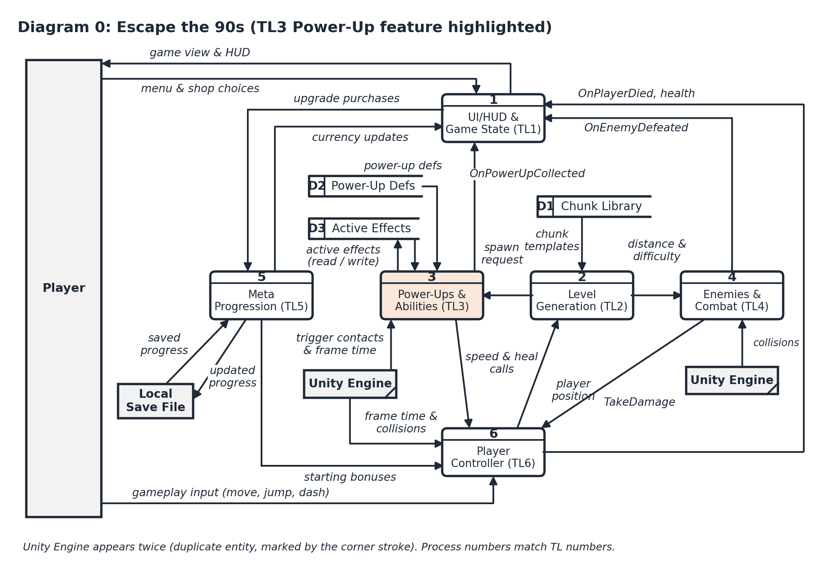
Balancing with the context diagram: gameplay input enters 6; menu & shop choices enter 1 and game view & HUD leaves 1; saved and updated progress connect 5 to the save file; frame time and collisions reach 3, 4, and 6. Feature-to-feature flows follow the plan's public interfaces (SpawnPowerUp, GetCurrentDistance, GetPosition, SetSpeedMultiplier, Heal, TakeDamage, and the events TL1 subscribes to).

Diagram 3 (zoom of Process 3)
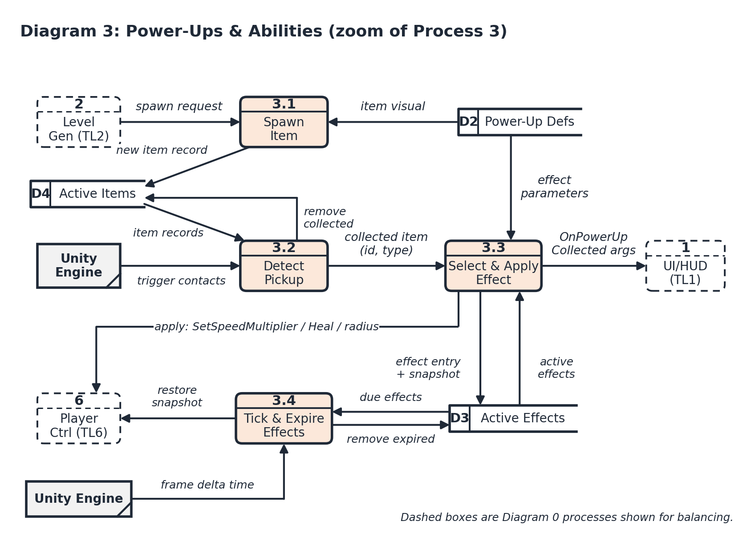
Balancing and black hole / miracle check
Every flow touching Process 3 in Diagram 0 appears in Diagram 3. Spawn request from Process 2 arrives at 3.1. Power-up defs split into item visual (3.1) and effect parameters (3.3). Trigger contacts & frame time split into trigger contacts (3.2) and frame delta time (3.4). Speed & heal calls split into apply (3.3) and restore snapshot (3.4), both going to Process 6. Active effects (read / write) splits into effect entry + snapshot and active effects (3.3) plus due effects and remove expired (3.4). OnPowerUpCollected leaves 3.3 for Process 1. D4 Active Items is used only inside Process 3, so it appears only in the zoom. In the class diagram, D3 Active Effects is held as two collections on PowerUpManager: activeEffects (timers and stack counts) and snapshots (the mementos), and D4 Active Items is the activeItems list.
Process | Inputs | Outputs
3.1 Spawn Item | spawn request, item visual | new item record
3.2 Detect Pickup | trigger contacts, item records | collected item, remove collected
3.3 Select & Apply Effect | collected item, effect parameters, active effects | apply calls, OnPowerUpCollected args, effect entry + snapshot
3.4 Tick & Expire Effects | frame delta time, due effects | restore snapshot, remove expired
Each process has at least one input and at least one output, and every output can be produced from its inputs, so the diagram has no black holes and no miracles. The same check holds for all six processes in Diagram 0.
Process Description: 3.3 Select & Apply Effect
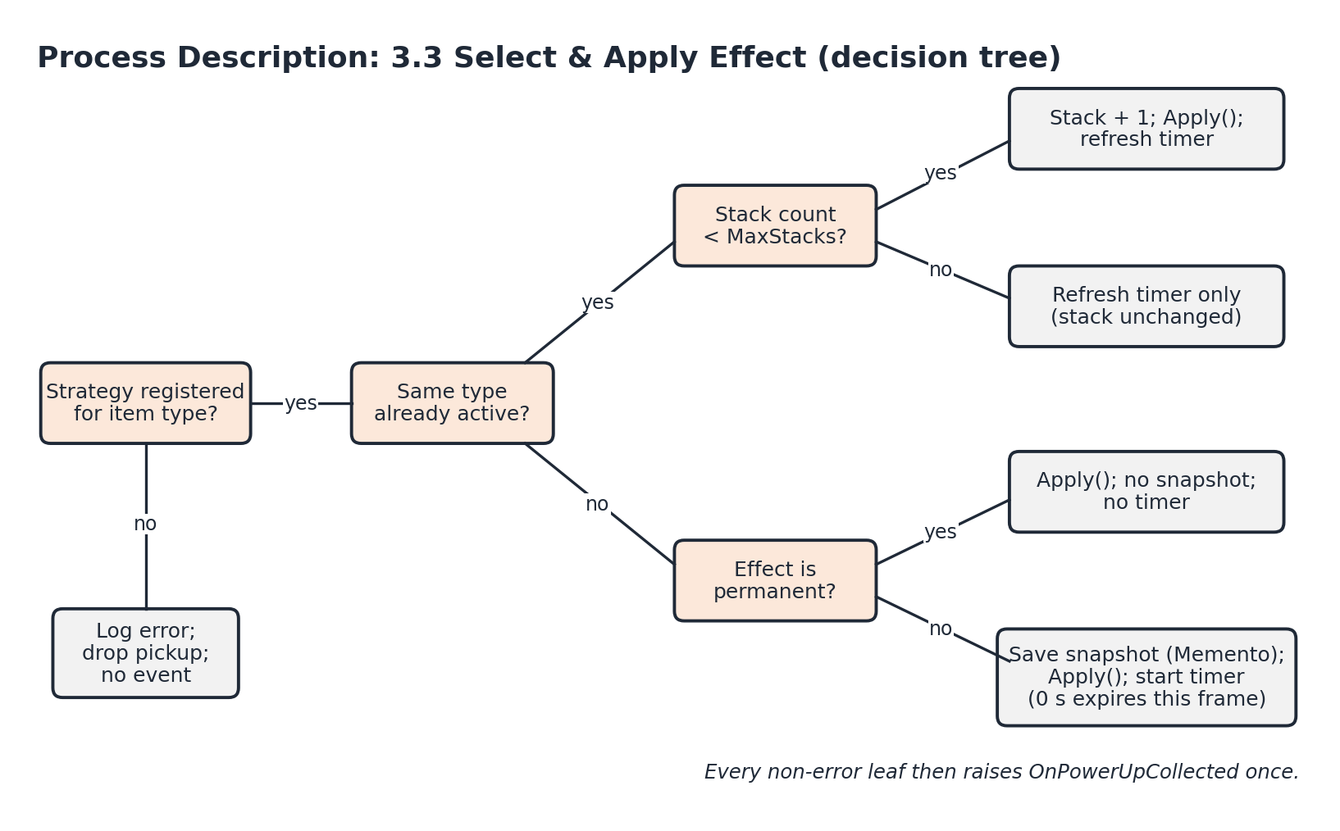

5. Timeline
The nine parent tasks are the TL3 row of the project plan's Gantt chart, one per week from Week 4 to Week 12. Each parent is broken into subtasks with hour estimates, and the subtasks add up to the plan's effort budget: Design 9 h, Coding 25 h, Testing 10 h, and Documentation 8 h, for 52 hours. Within a parent, I work the subtasks in the order listed.
Work items
ID | Work item | Category | Plan week | Hours | Predecessors
P1 | Power-up skeleton | Parent | Wk 4 | 6 | none
1.1 | Class hierarchy & interface contract | Design |  | 3
1.2 | Manager, item & base-class skeleton | Coding |  | 3
P2 | SA prep + effect diagram | Parent | Wk 5 | 4 | P1
2.1 | SA slides & effect/class diagram | Documentation |  | 2
2.2 | Power-up definition table | Design |  | 2
P3 | Strategy setup | Parent | Wk 6 | 8 | P2
3.1 | Strategy & stacking rules design | Design |  | 3
3.2 | Strategy lookup & effect selection | Coding |  | 2
3.3 | Champion document & DFDs | Documentation |  | 3
P4 | Effects functional | Parent | Wk 7 | 13 | P3
4.1 | SpeedBoostEffect | Coding |  | 3
4.2 | ShieldEffect | Coding |  | 2
4.3 | MagnetEffect | Coding |  | 2
4.4 | Pickup detection, event & visuals | Coding |  | 3
4.5 | Effect unit tests (mock target) | Testing |  | 3
P5 | Midterm + light bug fixes | Parent | Wk 8 | 1 | P4
5.1 | Fix bugs found by effect tests | Coding |  | 1
P6 | Memento snapshot logic | Parent | Wk 9 | 7 | P5
6.1 | Per-stat snapshot design check | Design |  | 1
6.2 | Snapshot create & restore | Coding |  | 4
6.3 | Snapshot tests (overlap order) | Testing |  | 2
P7 | Integration support | Parent | Wk 10 | 3 | P4, P6
7.1 | Wire into TL1 / TL2 / TL6 test scene | Coding |  | 1
7.2 | Integration notes for TL1 / TL2 / TL6 | Documentation |  | 2
P8 | Stacking edge cases | Parent | Wk 11 | 7 | P6
8.1 | Duration timers & stacking fixes | Coding |  | 3
8.2 | Boundary tests (0 s, max stack) | Testing |  | 2
8.3 | Stress test | Testing |  | 2
P9 | Oral prep + final polish | Parent | Wk 12 | 3 | P7, P8
9.1 | Final visual polish | Coding |  | 1
9.2 | Visual distinctness review | Testing |  | 1
9.3 | Oral exam prep notes | Documentation |  | 1
Total | Design 9, Coding 25, Testing 10, Documentation 8 |  |  | 52

PERT diagram
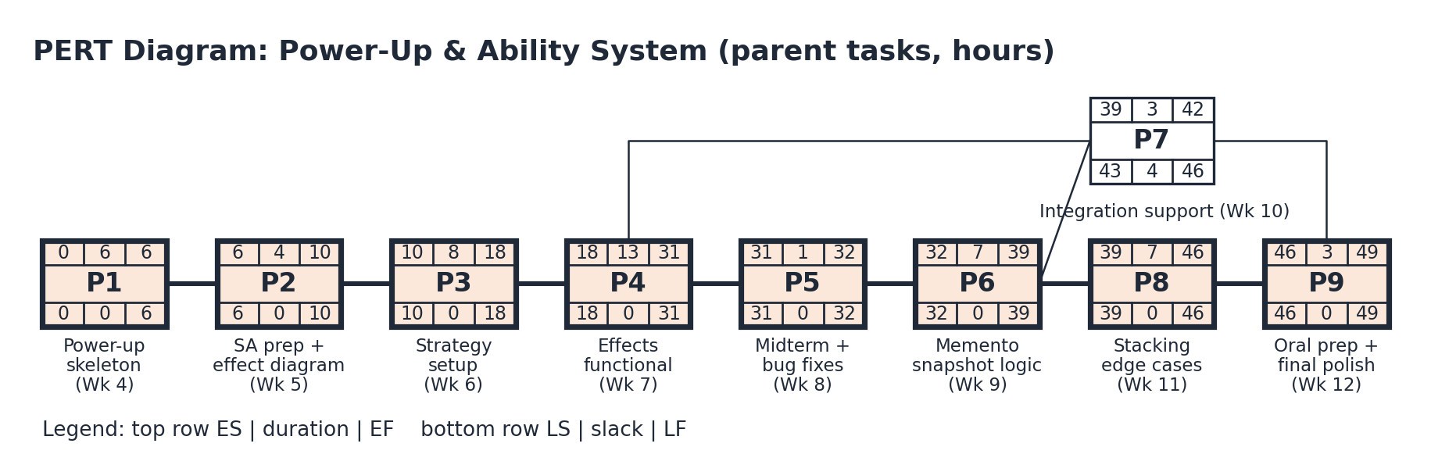
The PERT diagram is drawn at the parent-task level. The critical path is P1 → P2 → P3 → P4 → P5 → P6 → P8 → P9, totaling 49 hours. P7 (Integration support) needs P4 and P6 finished, but only P9 depends on it, so it is the one parent with slack (4 hours). Every other parent has zero slack.
Honest reading of these numbers. The 49-hour span assumes P7 could run alongside P8. I am one developer, so the real effort is the full 52 hours in the table, and those are the hours TL4 tracks me against at the plan's time-log check-ins (Weeks 7, 9, 10, 11, and 12). P4 (Effects functional, Week 7) is the heaviest week at 13 hours, and P5 (Week 8) is budgeted at only 1 hour because of the midterm. The riskiest estimates are P6 (Memento snapshot logic) and P8 (Stacking edge cases), both on the critical path, because overlapping effects are where snapshot bugs show up. If either runs over, P7's 4 hours of slack is the first buffer, and the Week 8 bug-fix slot is the second.
Gantt timeline
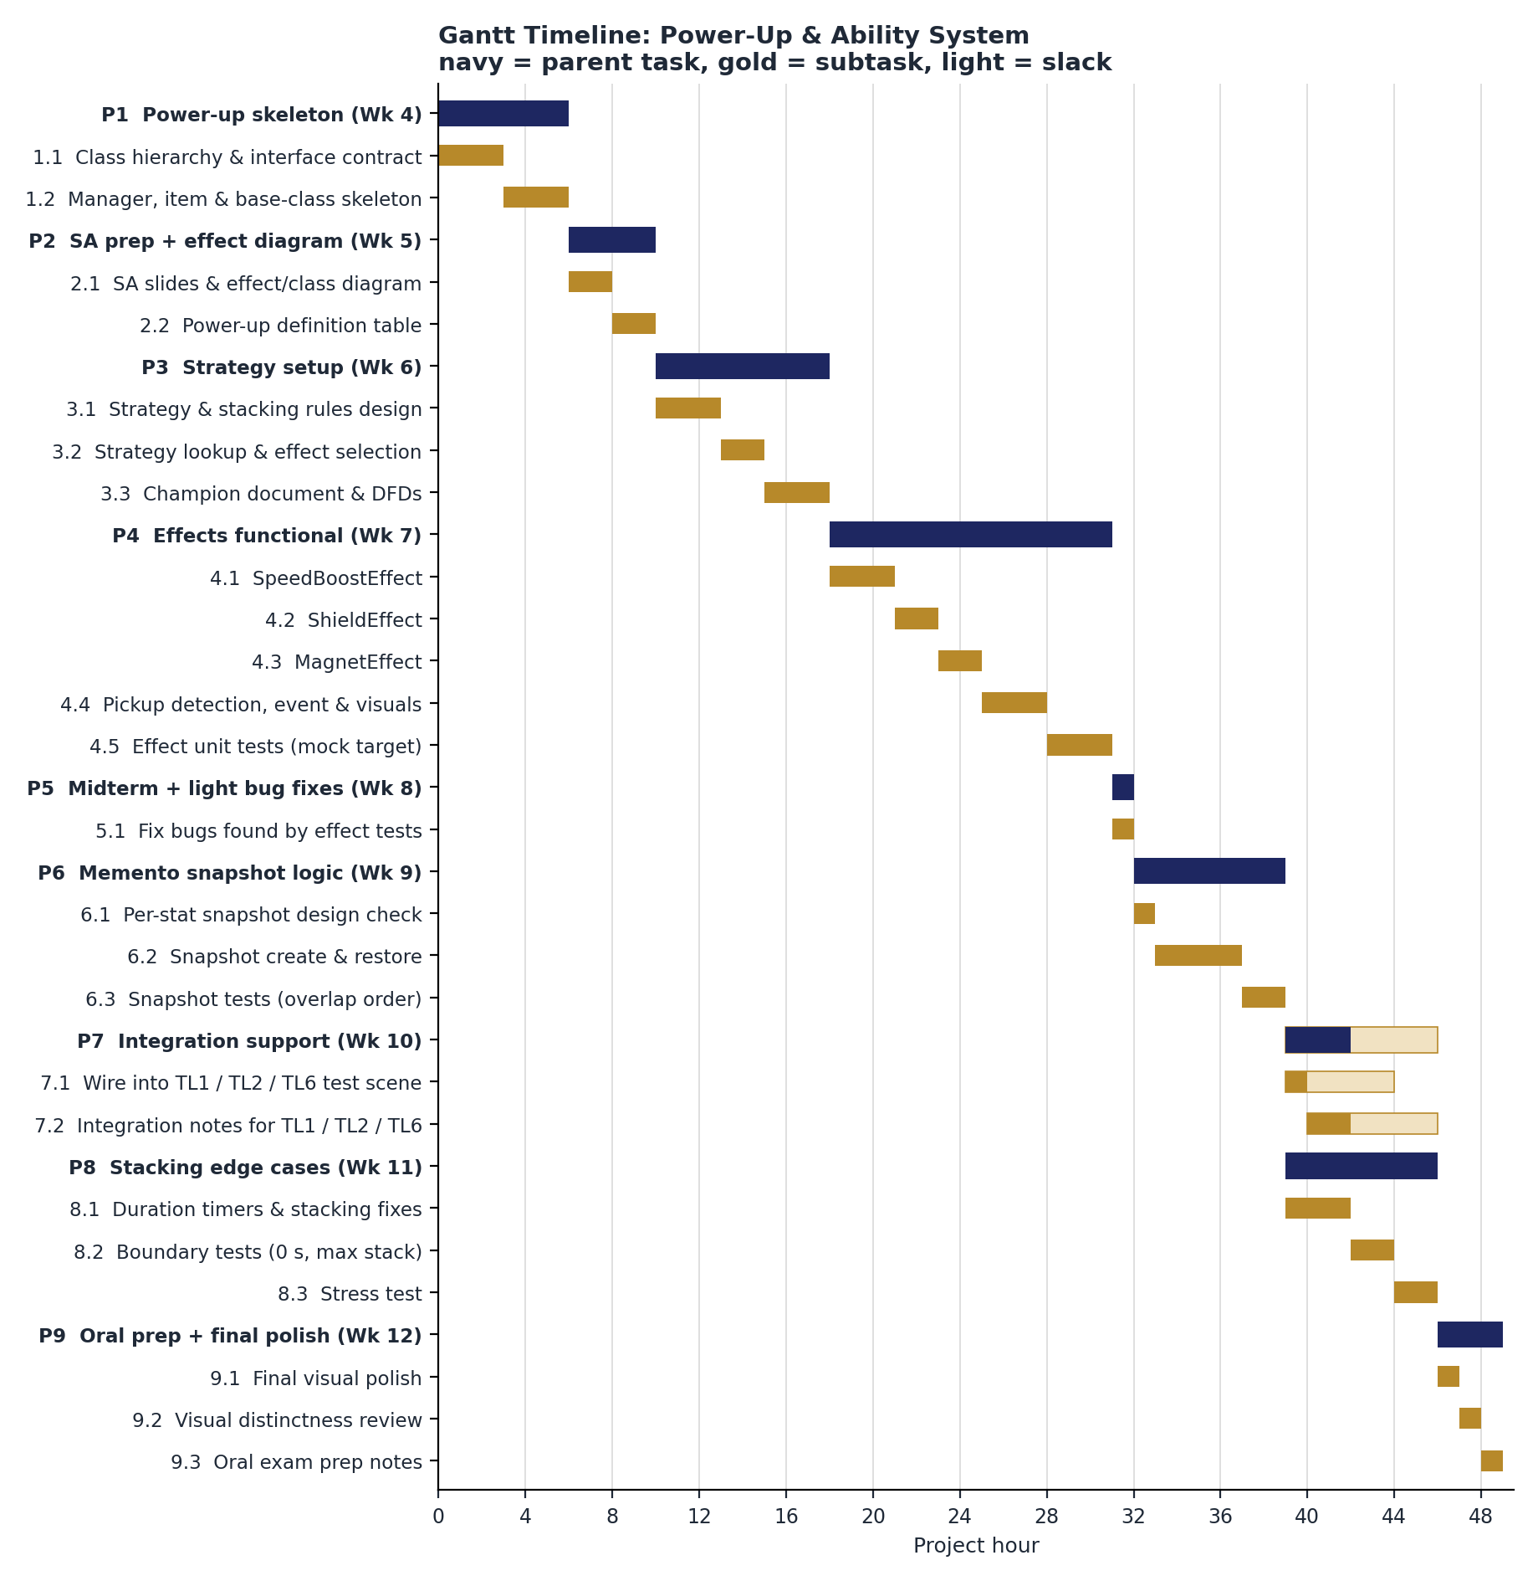

AI Question Log: Summary
[Complete this section yourself before submitting: describe which sections you drafted with AI, what you changed and why, and where your full question log is saved.]

