Champion Document TL6
Name: Matteo Coppola Feature: Player Controller and Side Scrolling System Mark: ____ / 30
FEATURE CHAMPION. This document defines the behavior, boundary contracts, data flows, and 52-hour implementation plan for TL6. Exceptions branch from numbered use-case steps, every interface has a concrete type and observable result, and the DFDs balance from context to feature detail.

1 Brief Introduction
My feature owns the player-facing runtime loop that the rest of the game depends on. It reads movement input, selects and executes running, jumping, or dashing behavior, applies movement physics, resolves terrain collisions, exposes the player's world position, and keeps the camera scrolling with the player. PlayerHealth also owns hit points, clamps healing and damage, and triggers game over by publishing OnPlayerDied when health reaches zero.
The movement code uses the State pattern. PlayerController is the GRASP Controller, PlayerHealth is the Information Expert for HP, and MovementState polymorphism keeps PlayerController from branching on every movement mode. Other features interact only through typed methods, a position getter, and the death event, which keeps coupling low.
This feature does not calculate enemy damage, decide when hazards attack, generate terrain, score the run, spawn enemies, play audio, or build the game-over screen. Those systems may call TakeDamage, Heal, or SetSpeedMultiplier and may subscribe to OnPlayerDied, but they remain responsible for their own rules and presentation.

2 Use Case Diagrams with Scenarios
Use Case Diagram 1
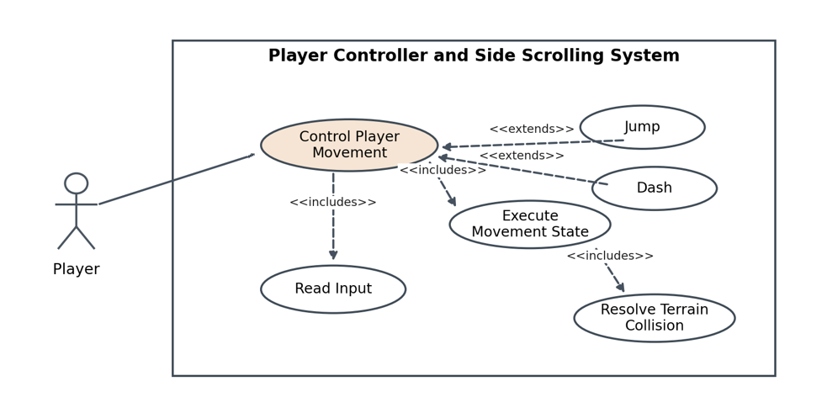
Figure 1. Control Player Movement use-case diagram

Scenario 1 first use case diagram
Name: Control Player Movement
Summary: The player supplies movement input; the controller selects a movement state, executes physics, resolves terrain collision, updates position, and advances the camera.
Actors: Player; Terrain and Physics system
Preconditions: The player object, input actions, movement configuration, collider, and camera exist; PlayerHealth reports the player is alive.
Basic sequence:
Step 1: The Player provides a horizontal input value and optional jump or dash action.
Step 2: PlayerController reads the typed input snapshot for the current physics tick.
Step 3: PlayerController selects RunningState, JumpingState, or DashingState from the current state, grounded flag, action request, and dash availability.
Step 4: PlayerController dynamically dispatches MovementState.Execute for the selected state.
Step 5: The selected state calculates velocity using the configured speed multiplier and movement constants.
Step 6: Unity physics applies movement and returns terrain collision contacts.
Step 7: PlayerController stores the resolved position and CameraScroller follows the horizontal position without moving backward.
Exceptions:
Step 3a: Dash is requested while dash is unavailable. The request is ignored for this tick, the current valid state remains active, and the sequence resumes at Step 4.
Step 3b: Jump is requested while the player is not grounded. JumpingState is not entered; airborne motion remains under JumpingState, and the sequence resumes at Step 4.
Step 6a: A terrain contact blocks the proposed motion. Physics removes the blocked velocity component, stores the nonpenetrating position, and the sequence resumes at Step 7.
Postconditions: The player has a finite, collision-safe position; exactly one movement state is active; and the camera has advanced to its valid follow position.
Priority: 1 must have
ID: PM1
Use Case Diagram 2
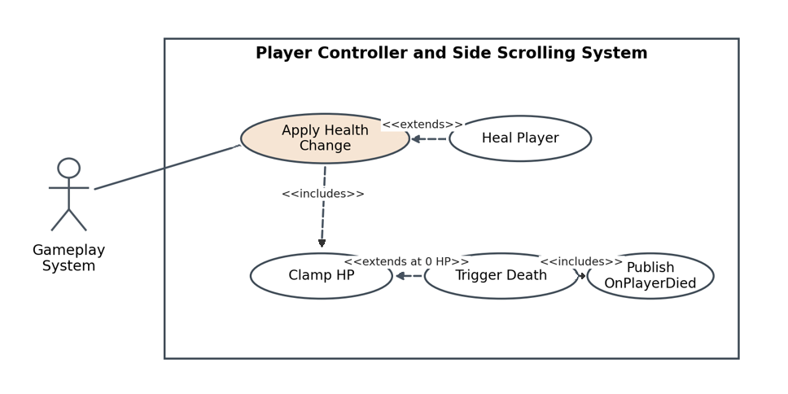
Figure 2. Change Player Health and Trigger Death use-case diagram

Scenario 2 second use case diagram
Name: Change Player Health and Trigger Death
Summary: A gameplay system applies damage or healing; PlayerHealth clamps HP and publishes one death event when a living player reaches zero HP.
Actors: Gameplay system such as Combat, Hazard, or Pickup
Preconditions: PlayerHealth is initialized with maxHealth greater than zero and currentHealth within 0 through maxHealth.
Basic sequence:
Step 1: A gameplay system calls TakeDamage(amount) with a nonnegative Int32 amount.
Step 2: PlayerHealth subtracts amount from currentHealth and clamps the result to the inclusive range 0 through maxHealth.
Step 3: PlayerHealth evaluates whether the update caused a transition from alive to zero HP.
Step 4: When HP remains above zero, PlayerHealth stores the new value and returns control to the caller.
Step 5: The next movement tick exposes the unchanged public position while movement continues normally.
Exceptions:
Step 1a: The caller passes a negative amount. PlayerHealth throws ArgumentOutOfRangeException; HP and death state remain unchanged.
Step 1b: A gameplay system calls Heal(amount) instead. PlayerHealth adds the nonnegative amount, clamps HP to maxHealth, and resumes at Step 3.
Step 3a: The update causes the alive-to-dead transition. PlayerHealth stores 0 HP, marks the player dead, invokes OnPlayerDied exactly once, and the game-over subscriber handles presentation.
Step 3b: The player is already dead when TakeDamage is called. HP remains 0 and OnPlayerDied is not invoked again.
Postconditions: HP is within 0 through maxHealth. The death event has fired once if and only if this update produced the alive-to-dead transition.
Priority: 1 must have
ID: PH1

3 Interface Contract
The contract below defines values at the feature boundary. Invalid numeric input is rejected before state changes, returned positions contain only finite components, and event cardinality is explicit so each item can be unit-tested.

Inputs
Member or source | Type | Valid domain | Observable contract
PlayerHealth.TakeDamage(amount) | int | 0 to Int32.MaxValue | Subtract from HP; clamp at 0. Negative input throws ArgumentOutOfRangeException and changes nothing.
PlayerHealth.Heal(amount) | int | 0 to Int32.MaxValue | Add to HP; clamp at maxHealth. Negative input throws ArgumentOutOfRangeException and changes nothing.
PlayerController.SetSpeedMultiplier(mult) | float | Finite, 0.0 through 4.0 | Store mult for subsequent state execution. NaN, infinity, or out-of-range input throws ArgumentOutOfRangeException.
Movement input action | float | -1.0 through 1.0 | Supplies horizontal intent once per physics tick; values are clamped before use.
Jump and dash actions | bool | true or false per tick | A true edge requests the matching transition; holding true does not create repeated edges.
Terrain collision contact | Collision2D | Valid Unity contact set | Blocked velocity components are removed and the resolved transform does not penetrate terrain.

Outputs
Member or output | Type | Guaranteed result | Test oracle
PlayerController.GetPosition() | Vector3 | Current resolved world position; x, y, and z are finite. | Equals transform.position after the physics tick within 0.001 world units per component.
Player transform | Vector3 position and Vector2 velocity | One collision-safe transform update per physics tick. | No overlap with terrain above 0.001 world units after resolution.
Camera follow position | Vector3 | Tracks player x after configured smoothing; never scrolls backward during continuous rightward play. | Follow error is at most 0.05 world units after settling; backward delta is no less than -0.01.
Player health state | int currentHealth and bool IsDead | HP remains in 0 through maxHealth; IsDead is true exactly when HP equals 0. | Boundary assertions at 0, 1, maxHealth, and overkill or overheal amounts.

Events
Event | Type | Emission rule | Test oracle
PlayerController.OnPlayerDied | event Action | Forwarded after PlayerHealth commits the first alive-to-dead transition; no payload; no repeat while already dead. | Attach a counter: exactly 1 invocation after lethal damage and still 1 after any later damage call.

Internal Design Contract
Class | Role and ownership | Coupling rule
PlayerController MonoBehaviour | GRASP Controller; owns the current MovementState and coordinates input, movement, and exposed position. | Calls the MovementState abstraction; exposes only the documented setter, getter, and event.
PlayerHealth | Information Expert; owns maxHealth, currentHealth, dead state, clamping, and the death transition. | Does not know game-over UI, scoring, enemies, or hazards.
MovementState abstract | State-pattern base; declares virtual void Execute(). | Receives only the movement context needed for a physics tick.
RunningState / JumpingState / DashingState | Polymorphic states; each overrides Execute with mode-specific physics. | No caller checks concrete state type to select behavior.
CameraScroller | Reads the resolved player position and advances the camera. | Does not mutate player movement or health.
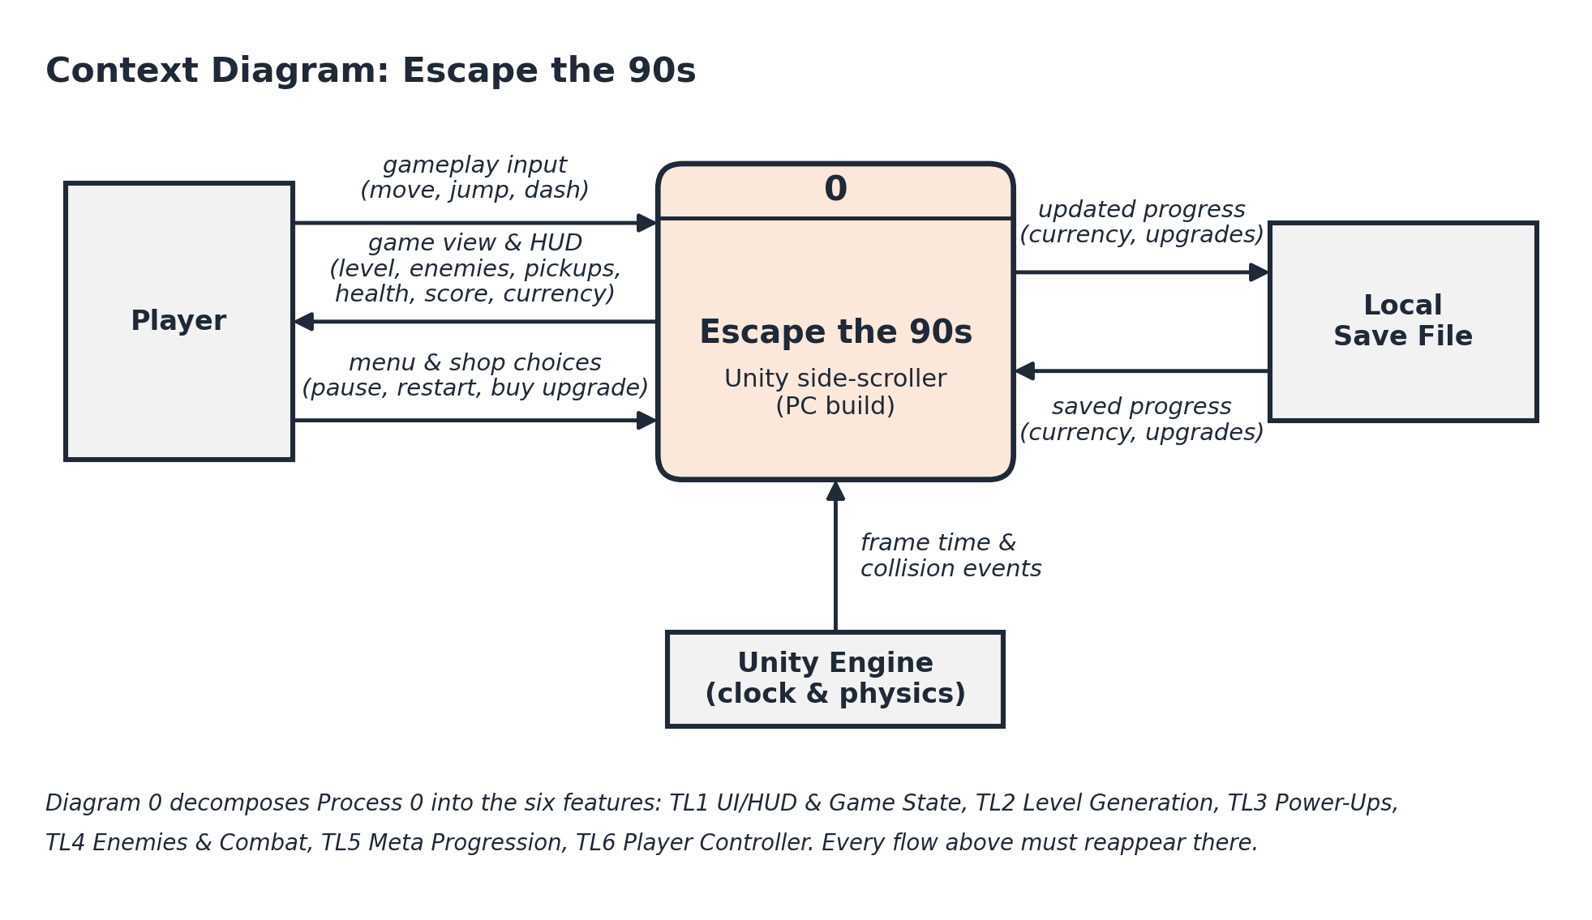
Figure 3. MovementState hierarchy and dynamic binding

Verification Strategy
Test | Runs | Pass condition
Mocked input state transitions | Each legal transition 100 times | Expected concrete state is active after the next physics tick; 0 unexpected transitions.
Health boundaries | 0, 1, maxHealth, Int32.MaxValue, lethal and repeated lethal calls | HP always remains in range; death counter is exactly 1 after the first lethal transition.
Speed multiplier validation | -0.01, 0, 1, 4, 4.01, NaN, positive infinity | 0 through 4 are stored; every invalid value throws and preserves the previous multiplier.
Rapid switching stress | 1,000 alternating run jump and dash requests | No exception, no NaN or infinity, and exactly one valid movement state on every tick.
Camera endurance | 10 minutes at 60 physics ticks per second | 36,000 ticks complete; settled follow error at most 0.05 units and no backward delta below -0.01.
Completion requires smooth configured run, jump, and dash behavior; death at 0 HP with one event; collision-safe positions; and camera scrolling that meets the endurance bounds above.

4 Data Flow Diagrams
Diagram 0 treats TL6 as one process and shows every external input and output. Diagram 1 preserves those boundary flows while decomposing the feature into five processes and two data stores. Primitive process 1 is then described with a decision diagram.
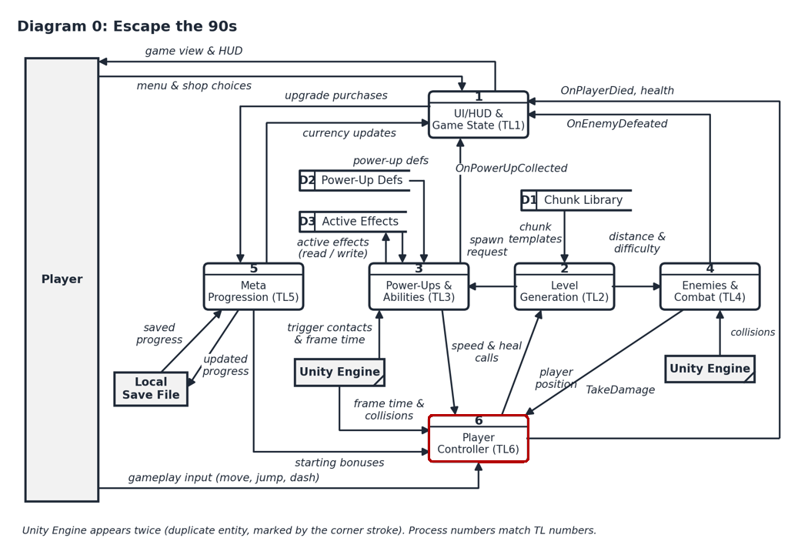
Figure 4. Diagram 0 context DFD in Gane Sarson notation

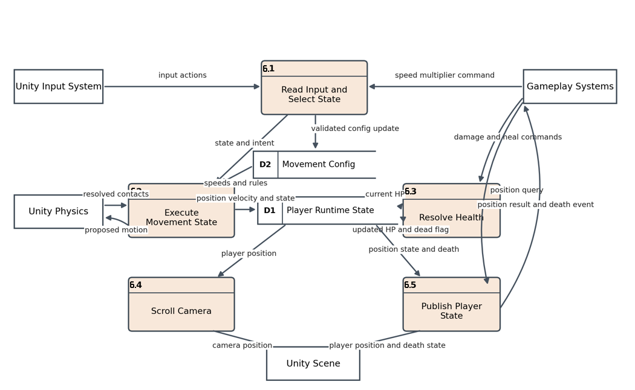
Figure 5. Diagram 1 zoomed TL6 DFD in Gane Sarson notation
Process Description 1 Read Input and Select State
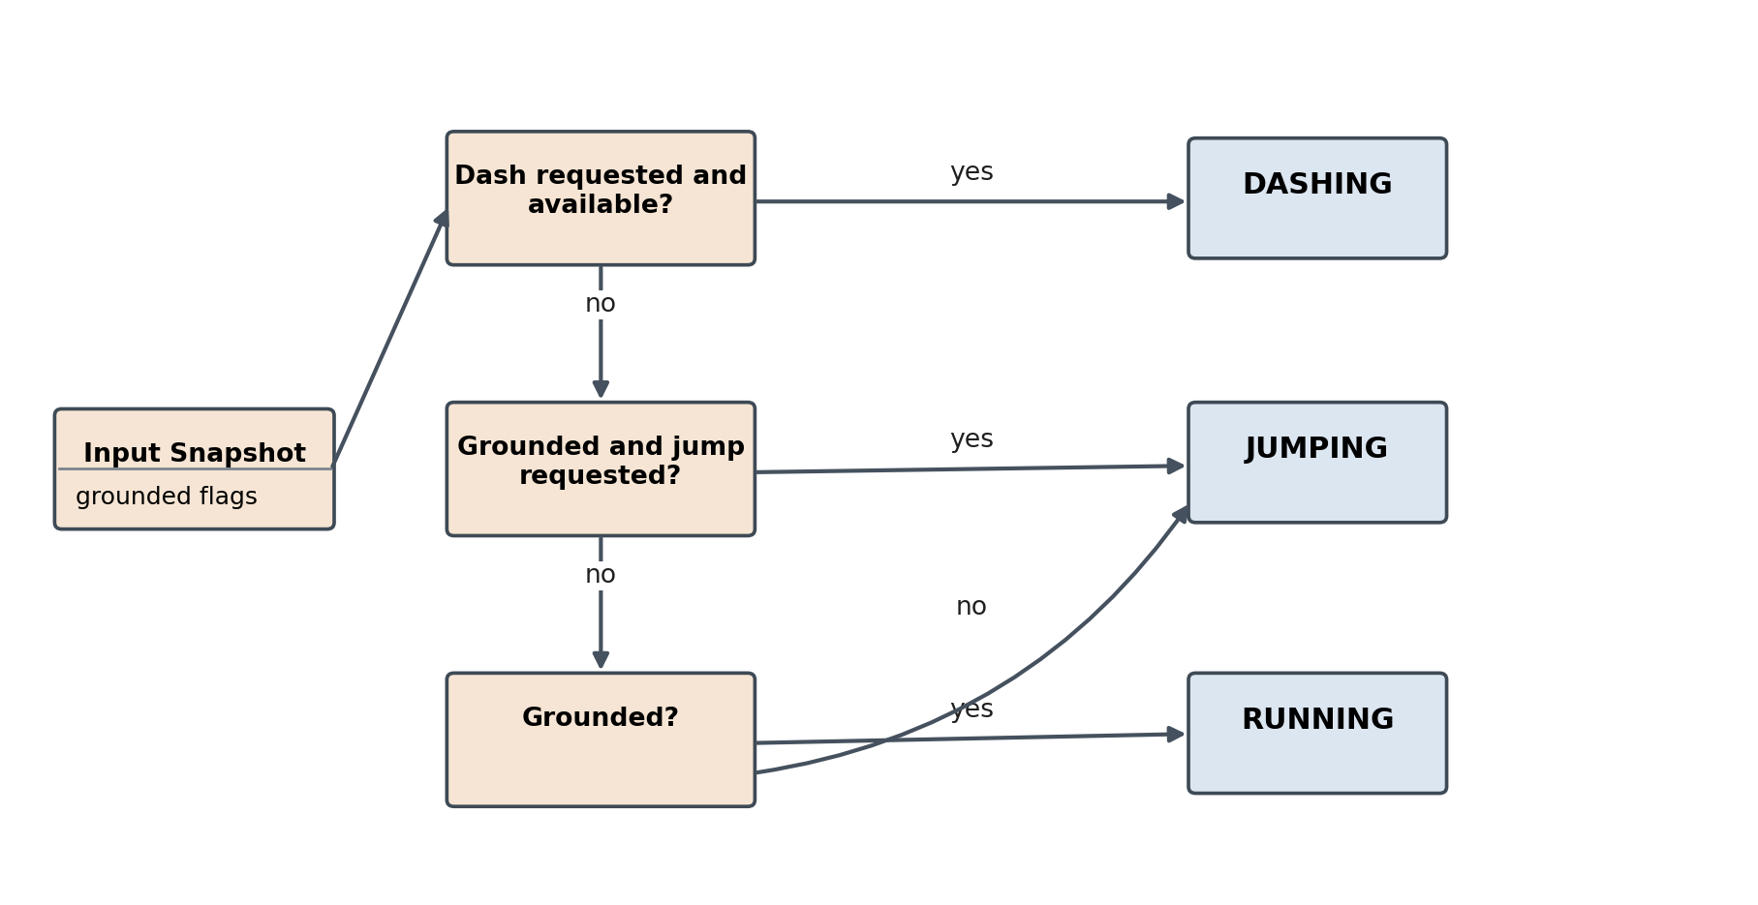
Figure 6. Primitive-process decision description for movement-state selection

5 Timeline
The estimate is 52 developer hours: 10 design, 24 coding, 10 testing, and 8 documentation. The dependency network shows what may logically proceed in parallel, but the Gantt chart schedules the work sequentially because one developer owns TL6. TL4 progress should therefore be compared with cumulative hours completed, not the shorter 33-hour logical critical path.
Work Items
Task | Category | Hours | Predecessor tasks
1 Requirements and interface contract | Design | 4 | None
2 State pattern and class design | Design | 6 | 1
3 PlayerController input and coordination | Coding | 5 | 2
4 Running physics and terrain collision | Coding | 4 | 3
5 JumpingState implementation | Coding | 4 | 3 and 4
6 DashingState implementation | Coding | 4 | 3
7 PlayerHealth and death event | Coding | 3 | 1
8 CameraScroller implementation | Coding | 4 | 3
9 Mocked-input state transition tests | Testing | 4 | 4 5 and 6
10 Health boundary and event tests | Testing | 3 | 7
11 Rapid-switch and camera stress tests | Testing | 3 | 8 9 and 10
12 Public API and diagram documentation | Documentation | 5 | 2 7 and 8
13 Final test report and champion document | Documentation | 3 | 11 and 12

PERT Diagram
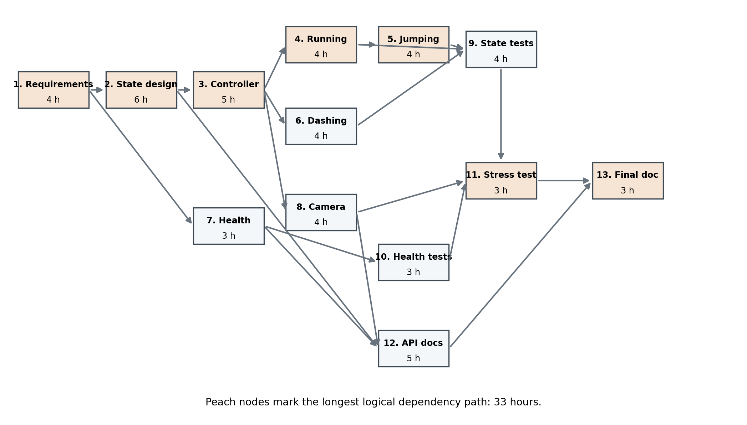
Figure 7. PERT dependency network with duration in hours
The longest logical dependency path is 1 to 2 to 3 to 4 to 5 to 9 to 11 to 13, totaling 33 hours. The full single-developer labor estimate remains 52 hours because parallel-ready work still consumes the same developer's time.
Gantt Timeline
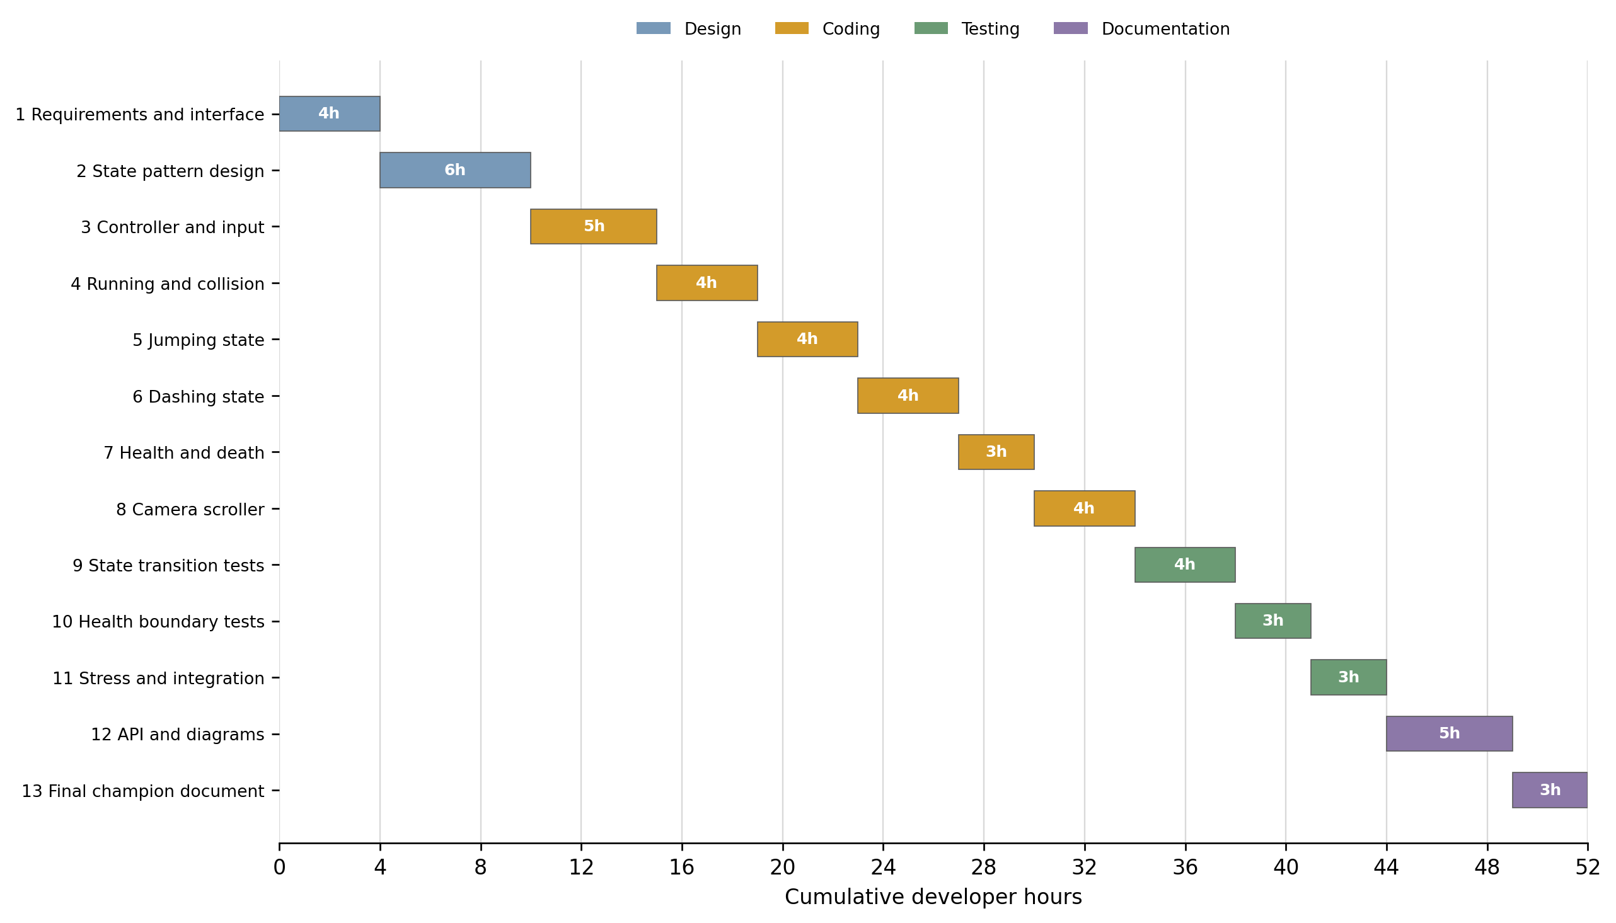
Figure 8. Resource constrained Gantt timeline totaling 52 developer hours

AI Question Log
I used ChatGPT to draft my champion document. I think it did pretty well on it’s own, but I did make a few changes. First, one of the graphs had an arrow where there wasn’t supposed to be an arrow, so I took it into paint.net and just removed the arrow myself. Second, I added in my teams context diagram and diagram 0, since chatgpt did not have access to those and could not put them in the document itself.

