Prompt 1 ChatGPT:
Use the sample file as the structure to create a champion document based on the following requirements to ensure the diagrams found in the sample are included for my feature.
Five parts:
Introduction —what your feature does, and what it does NOT do.
Use Case — actors + numbered basic sequence; exceptions branch from a step (“Step 3a”).
Interface Contract — inputs / outputs / events, each typed and testable (not vague).
DFD — Gane–Sarson, context → your feature's zoom; no black holes or miracles.
Timeline — work items + honest hour estimates (TL4 tracks you against these).
Feature Requirements:
TL5 — Meta Progression & Persistent Upgrade System
Purpose: Tracks currency earned per run and lets the player spend it on permanent upgrades between runs.
Responsibilities: Currency tracking, save/load persistence, upgrade-shop logic, applying starting bonuses each run.
Public interface:
MetaProgressionManager.AddCurrency(int amount)
MetaProgressionManager.GetUpgradeLevel(UpgradeType type) : int
MetaProgressionManager.PurchaseUpgrade(UpgradeType type)
MetaProgressionManager.ApplyStartingBonuses(GameObject player)
Internal classes: abstract UpgradeNode, HealthUpgrade, SpeedUpgrade, MagnetRangeUpgrade, SaveDataManager, MetaProgressionManager.
Class hierarchy / dynamic binding: UpgradeNode.GetEffectValue() is virtual; each subclass overrides it. Removing virtual makes every upgrade grant an identical generic bonus.
GOF pattern: Two small patterns — Singleton (SaveDataManager) and Private Class Data (encapsulating raw save fields so only SaveDataManager touches them).
GRASP: Information Expert (UpgradeNode knows its own effect), Protected Variations (new upgrade types addable), High Cohesion (SaveDataManager does persistence only).
Dependencies: Calls TL6's public setters at run start to apply bonuses — documented interface only.
Testing strategy: Unit-test save/load round-trip with mock data; boundary tests at 0 currency and max upgrade level; stress test rapid purchase spam.
Completion criteria: Currency persists across sessions; at least 3 upgrade types purchasable and correctly applied at run start.
Effort: Design 10h · Coding 24h · Testing 10h · Documentation 8h = 52h

Prompt 2 ChatGPT:
Refine this champion document using the feature document included and this is our context diagram make sure all diagrams meet the arrow convention
Included the following images and my team feature document.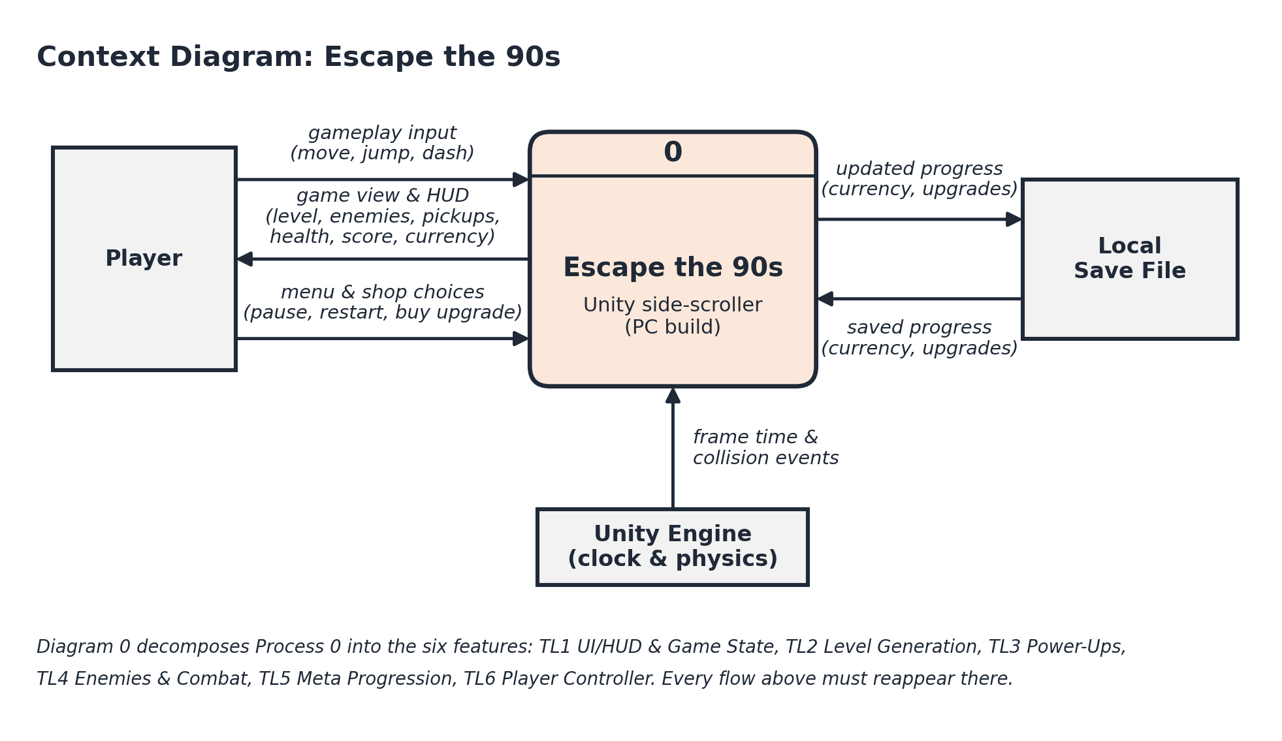
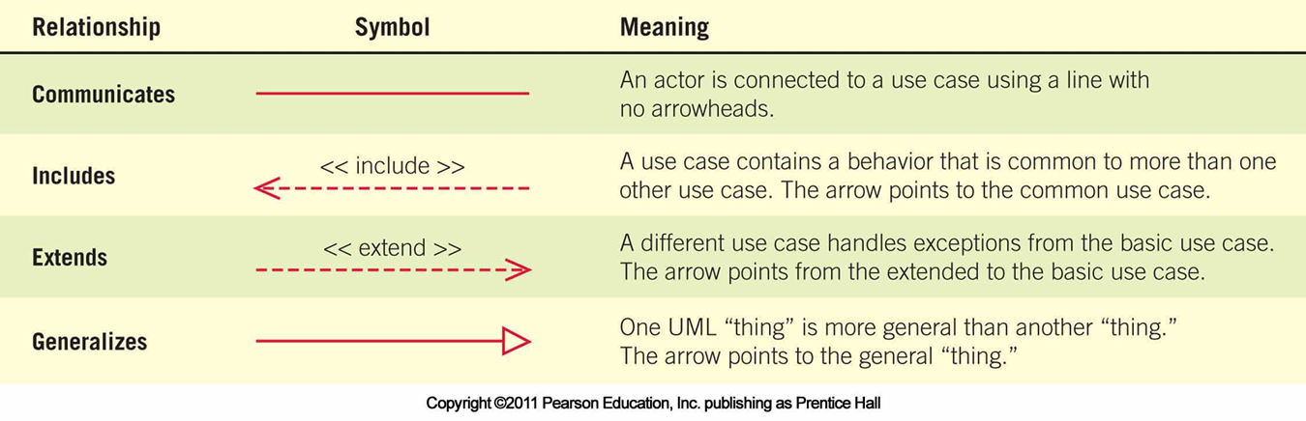

Prompt 3 Claude:
Can you clean up this document and add a diagram 0

Prompt 4 Claude:
Replace the diagram 0 with this diagram and update the other diagrams to match but do NOT change the context diagram
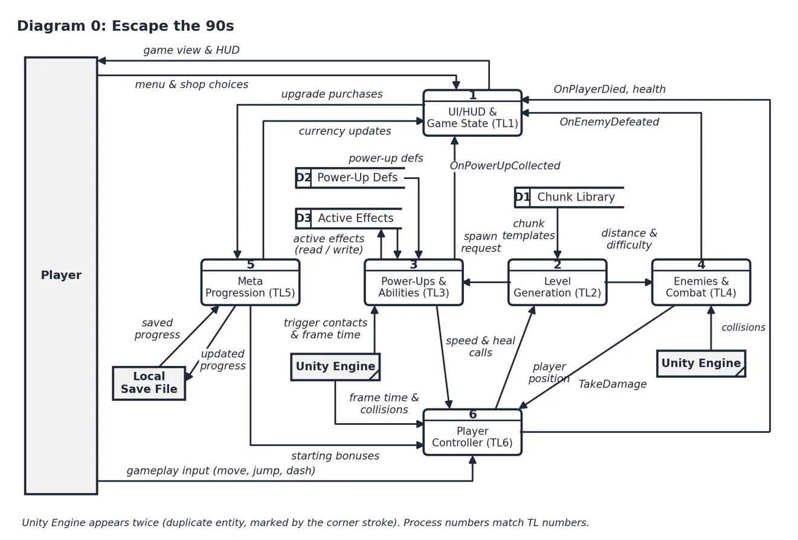

Prompt 5 ChatGPT:
Can you add another use case diagram relevant to the feature do NOT change anything only add.

Prompt 6 ChatGPT:
Can you make the description the same format as use case 2.3

Prompt 7 ChatGPT:
can you fix this diagram so the boxes do not overlap
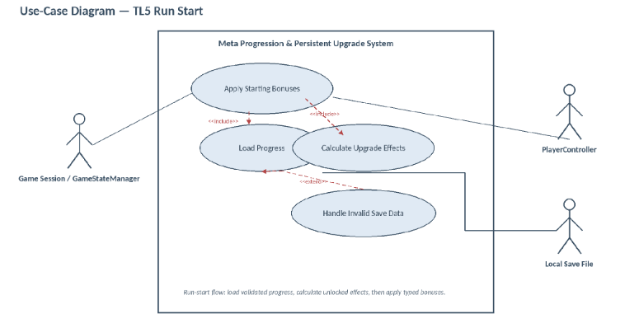

Prompt 8 ChatGPT:
The local save file line should connect to load progress

Prompt 9 ChatGPT:
keeping the content the same can you improve the readability of this diagram
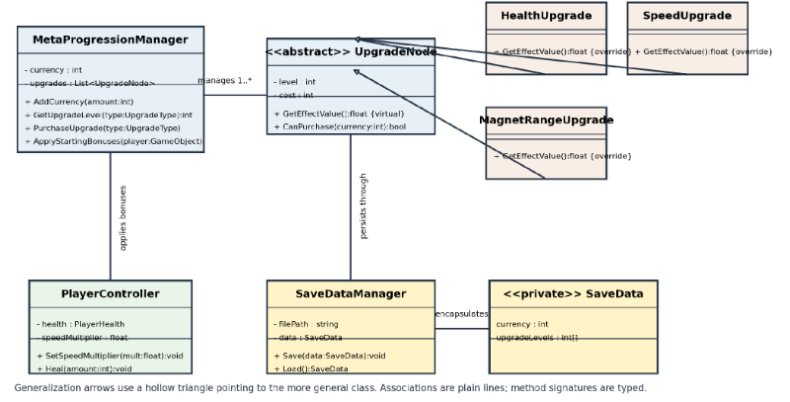

Prompt 10 ChatGPT:
The bottom three connections should be a solid line no arrow and speed upgrade should connect to Upgrade Node

Prompt 11 ChatGPT:
The sequence diagram is missing the boxes in the graph found in standard sequence diagrams
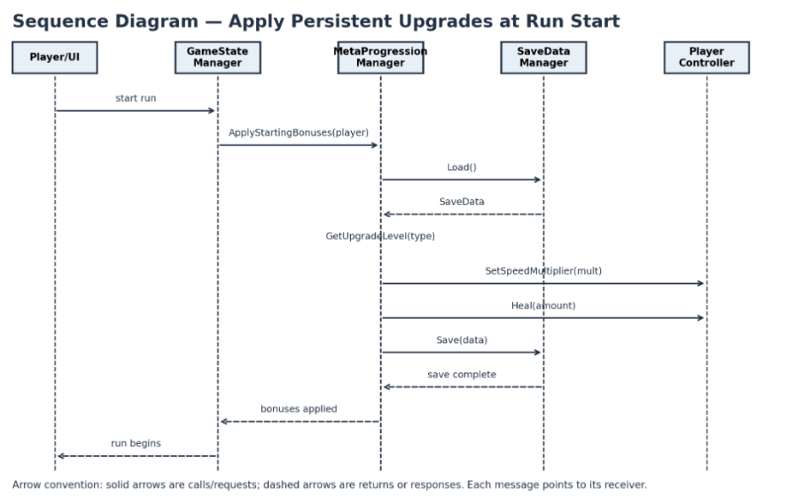

Prompt 12 Claude:
Can you update the style and formatting of the document to be consistent throughout. DO NOT change any of the content.

