Champion Document
Enemy / Hazard & Combat System
Name: Tyler Osso Feature: Enemy/Hazard & Combat System — “Escape the 90s” (TL4) Mark: ____ / 30

1. Introduction
My feature for Escape the 90s is the Enemy/Hazard & Combat System. As new level chunks are generated ahead of the player, my code reads the enemy archetype table (Ground, Flying, Turret) and the level's current difficulty, decides how many enemies of which archetype appear in each chunk, and validates that no enemy spawns inside terrain or on top of the player.
At runtime, my code owns each enemy's behavior loop: patrol a waypoint route until the player enters the archetype's aggro radius with line of sight, then pursue and attack on a cooldown. When collision damage lands, I call the Player Controller's public TakeDamage() method rather than modifying player state directly. When an enemy's own HP reaches zero, my code fires an OnEnemyDefeated event, plays a death behavior, and despawns the body within 2 seconds.
My feature deliberately does NOT do the following: it does not generate level geometry or chunk layout — that belongs to Procedural Level & Obstacle Generation (TL2), from which I only read a read-only distance/difficulty value. It does not own player health, movement, or the camera — that belongs to the Player Controller (TL6); I only call its documented TakeDamage() method. It does not create or apply power-ups — that belongs to the Power-Up & Ability System (TL3). And it does not decide what the HUD displays, how score/currency accrue, or how saves persist — those belong to the UI/HUD (TL1) and Meta Progression (TL5) features, which may subscribe to my OnEnemyDefeated event but receive no direct calls from my code.

2. Use Case

Use Case Diagrams
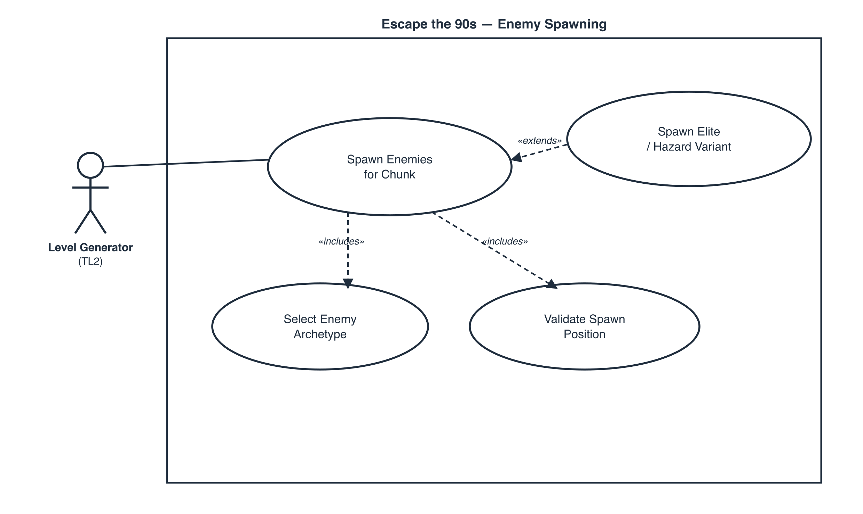
Use case diagram 1 — spawning, actor: Level Generator (TL2)

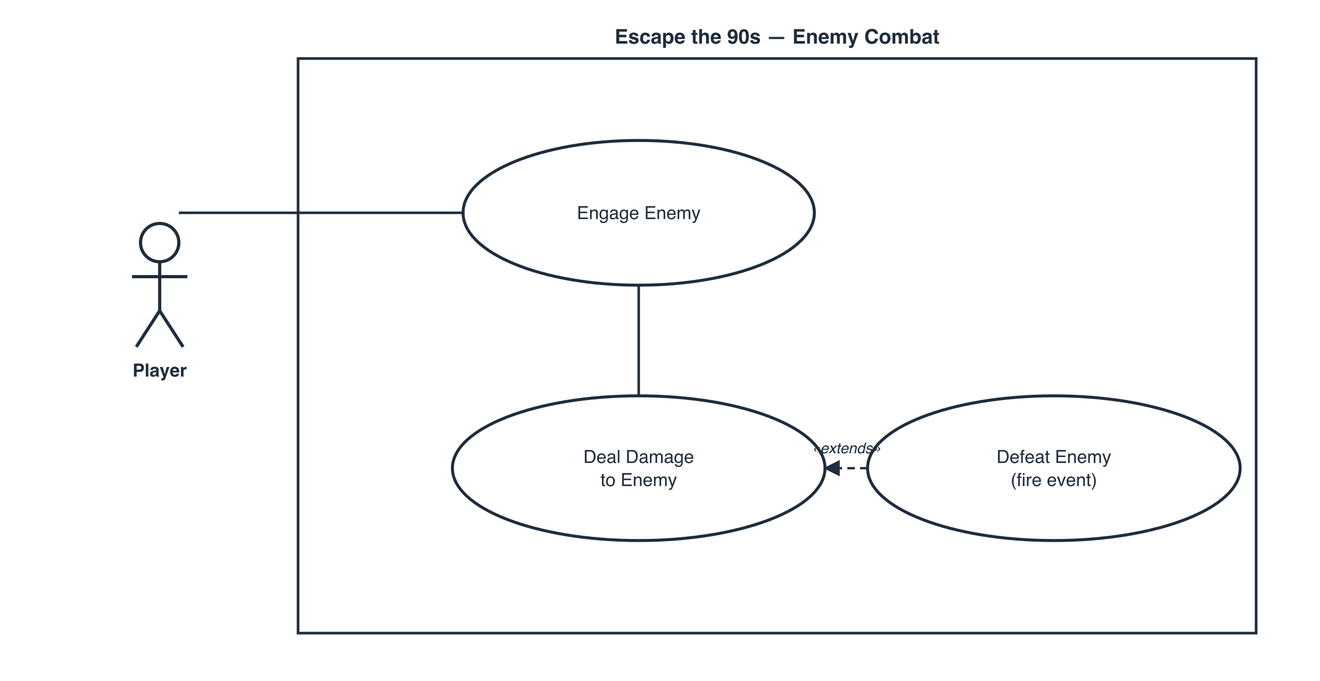
Use case diagram 2 — combat, actor: Player

Scenario 1 (first use case diagram)
Name: Spawn Enemies for Chunk
Summary: When a new level chunk is generated, the spawner requests enemies for it; archetypes are chosen from the difficulty band and placed at validated positions.
Actors: Level Generator feature (TL2), via its OnChunkSpawned event
Preconditions: The chunk's bounds are valid; the enemy archetype table has loaded; SetSpawnRate(float) has been configured for the run.
Basic sequence:
Step 1: LevelGenerator.OnChunkSpawned fires with the new chunk's bounds.
Step 2: EnemySpawner reads LevelGenerator.GetCurrentDistance() to determine the active difficulty band.
Step 3: EnemySpawner computes an enemy count for the chunk from the configured spawn rate and difficulty band.
Step 4: For each enemy slot, EnemySpawner selects an archetype (Ground, Flying, or Turret) weighted by difficulty.
Step 5: Each candidate spawn position is validated against chunk geometry and a minimum distance from the player.
Step 6: Validated enemies are instantiated via the archetype's Factory Method and registered for behavior updates.
Exceptions:
Step 4a: Difficulty crosses the elite threshold. An elite/hazard variant (e.g., a Turret) is selected instead, and its stats are scaled by the elite multiplier before Step 5.
Step 5a: A candidate position fails validation (overlaps geometry or is too close to the player). A new position is drawn; after 10 failed draws for one slot, that slot is skipped and a warning is logged. The sequence resumes at Step 6.
Post conditions: The chunk contains only validly placed enemies, each registered for behavior updates.
Priority: 1 (must have)
ID: EN1

Scenario 2 (second use case diagram)
Name: Engage and Damage the Player
Summary: An active enemy detects, pursues, and attacks the player on cooldown; if the enemy's HP reaches zero, it fires a defeated event and despawns.
Actors: Player
Preconditions: An enemy is active and registered (post EN1); the player is on-screen in the same chunk.
Basic sequence:
Step 1: EnemyBase.Move() runs every frame; the Track Player sub-process checks distance and line of sight.
Step 2: If the player is within the archetype's aggro radius with line of sight, the enemy transitions from PATROL to PURSUE and moves toward the player.
Step 3: Once within attack range, the enemy transitions to ATTACK and, on its attack cooldown, calls PlayerHealth.TakeDamage(int amount) on the Player Controller.
Step 4: The enemy repeats from Step 2 until it is defeated or the player leaves its detection range.
Step 5: When EnemyBase.TakeDamage(int amount) reduces the enemy's own HP to 0, EnemySpawner.OnEnemyDefeated fires and the enemy despawns.
Exceptions:
Step 2a: Line of sight is lost during PURSUE. The enemy transitions to SEARCH at the player's last known position and returns to PATROL after 5 seconds without reacquiring the player.
Step 3a: The player's invulnerability window (i-frames) is active. The TakeDamage() call is suppressed — no HP change occurs — and the sequence resumes at Step 4 on the enemy's normal attack cooldown.
Post conditions: The player's HP reflects any unsuppressed damage; the enemy is patrolling, searching, or despawned, and OnEnemyDefeated has fired if it died.
Priority: 1 (must have)
ID: EN2

3. Interface Contract
Every input this feature reads and every method/event it exposes is typed and paired with a concrete, numeric pass/fail test — no member is described only in prose.

Inputs consumed by this feature
Source | Signature | Type | Test / verification
Level Generation (TL2) | LevelGenerator.GetCurrentDistance() : float | float, read-only, non-decreasing | Mock a fixed sequence of distances; the computed difficulty band must match the expected bucket for every value — exact match, 0 mismatches allowed.
Level Generation (TL2) | LevelGenerator.OnChunkSpawned(Rect2 bounds) : event | event, payload Rect2 | Raise the event with a known Rect2; exactly one spawn pass runs over it and 0 enemies spawn outside its bounds.
Player Controller (TL6) | PlayerController.GetPosition() : Vector3 | Vector3, read-only | Feed a scripted path of 100 positions; computed distance-to-player must be within 0.01 units of ground truth at every sample.

Outputs / public interface this feature exposes
Member | Signature | Direction | Test / verification
Spawn rate | EnemySpawner.SetSpawnRate(float rate) : void | Input, rate ∈ [0,1] | rate=0 → 0 enemies over 100 chunk passes; rate=1 → per-chunk cap reached in ≥95% of 100 passes.
Enemy defeated | EnemySpawner.OnEnemyDefeated(EnemyType type, Vector3 pos) : event | Output event | Scripted kill of 50 enemies fires exactly 50 events — 0 duplicates, 0 drops.
Enemy damage | EnemyBase.TakeDamage(int amount) : bool | Input int ≥0; returns true iff HP≤0 after the call | HP=10: TakeDamage(10) returns true, fires OnEnemyDefeated once; 9× TakeDamage(1) return false, the 10th returns true.
Movement pattern | EnemyBase.Move() : void (virtual) | Internal, overridden per archetype | Regression test with virtual removed: all 3 archetypes collapse to identical movement — confirms dynamic binding is load-bearing.

Calls this feature makes into other features (documented interface only)
Call | Target | Type | Test / verification
Damage the player | PlayerHealth.TakeDamage(int amount) (TL6) | Output call, int amount > 0 | Scripted collision at a fixed ≥0.5s cooldown triggers exactly 1 call per window; 0 calls fire during the player's i-frame window.

4. Data Flow Diagrams
The Context Diagram shows the whole game as a single system (Process 0) against three external entities: Player, Local Save File, and the Unity Engine — Unity Engine appears a second time in Diagram 0 (marked with the duplicate-entity corner fold) because it feeds the frame clock and physics/collision events into more than one feature independently. Diagram 0 decomposes Process 0 into the team's six features, numbered to match each developer's TL number; Process 4 (Enemies & Combat) is mine. I then zoom into Process 4 and give a decision-tree process description for primitive process 4.3. Every process has at least one labeled input and one labeled output — no black holes (outputs with no source) and no miracles (inputs from nowhere) — and every flow touching Process 4 in Diagram 0 reappears, correctly routed, in my zoom below.
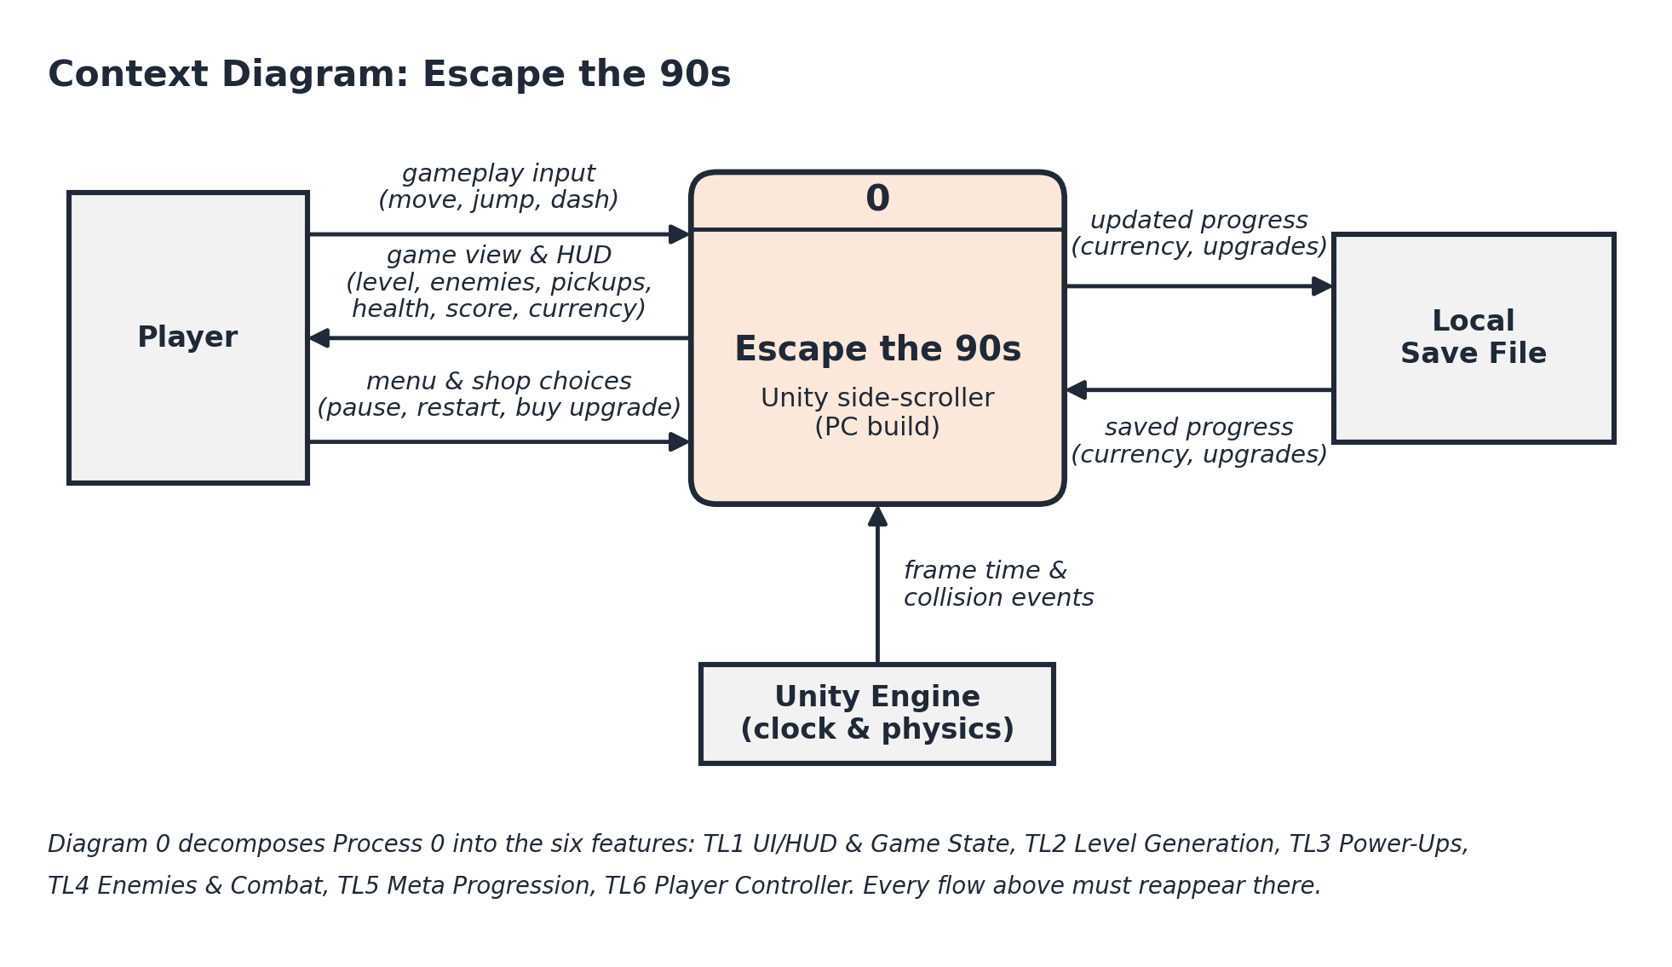
Context Diagram — Escape the 90s (whole system)

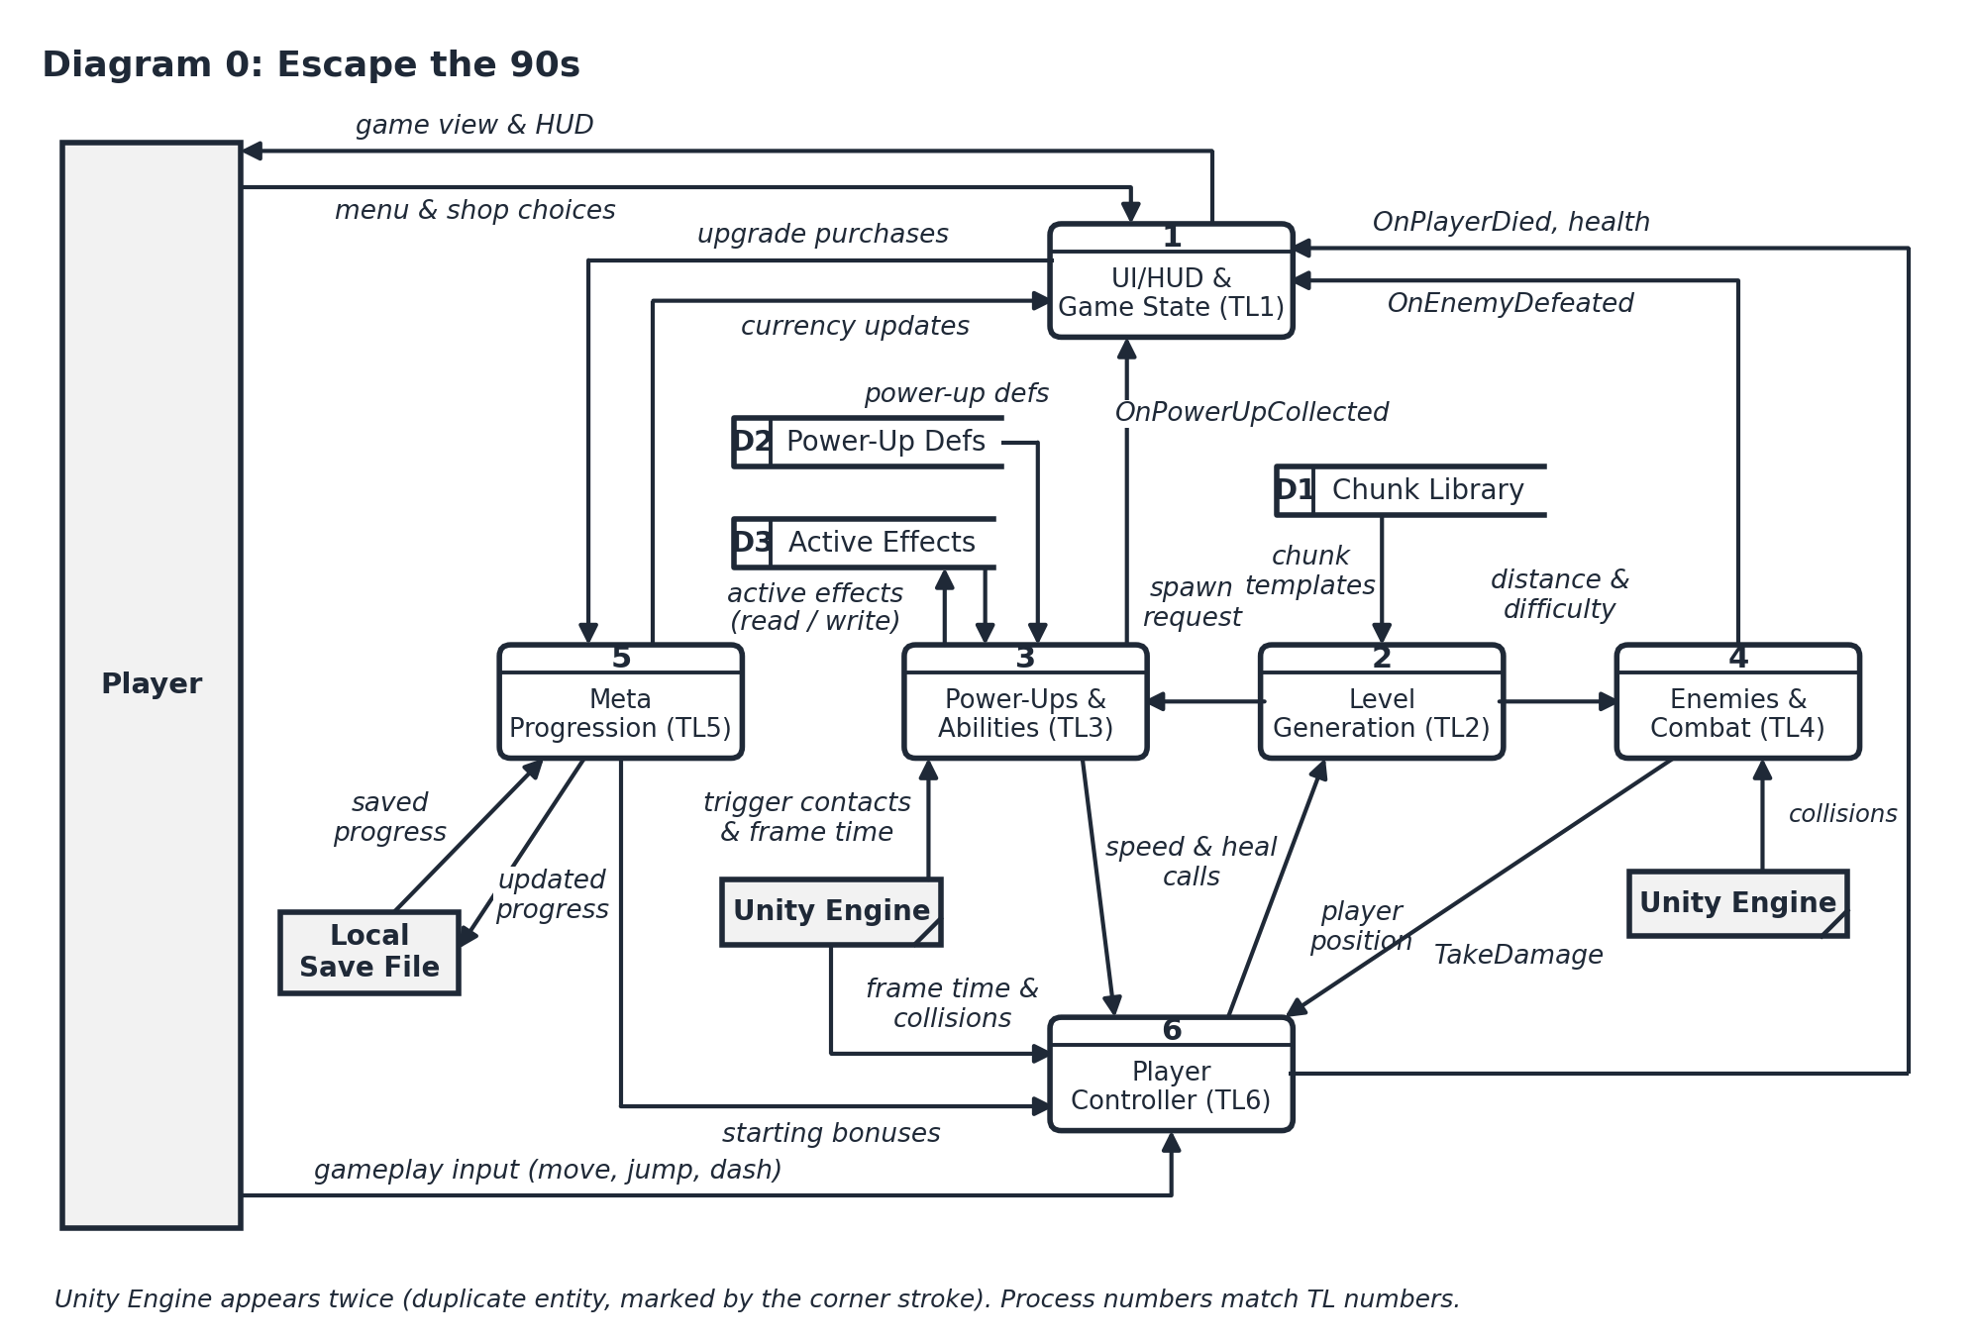
Diagram 0 — Escape the 90s, decomposed into the six team features (Process 4 = mine)

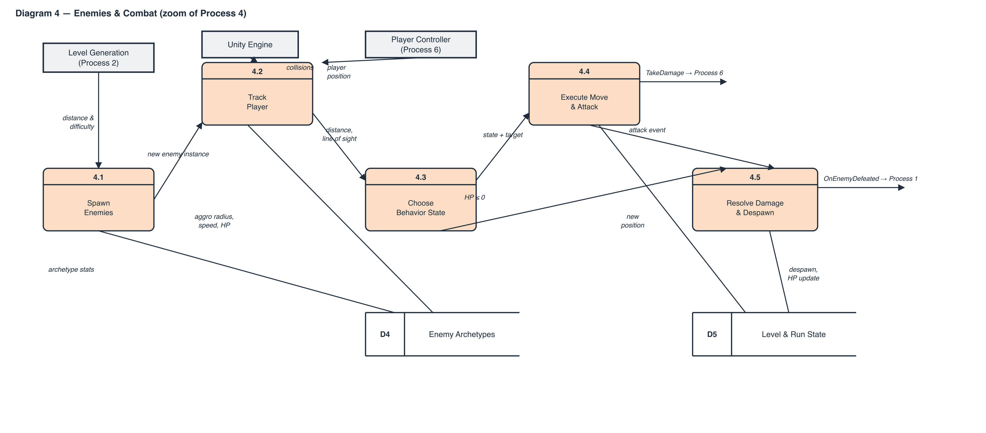
Diagram 4 — zoom of Process 4 (Enemies & Combat)

Process Description — 4.3 Choose Behavior State
Process 4.3 is a primitive process (it is not further decomposed), so it is described here as a decision tree rather than a lower-level DFD, per the assignment's requirement that leaf processes get a process description instead of another diagram.
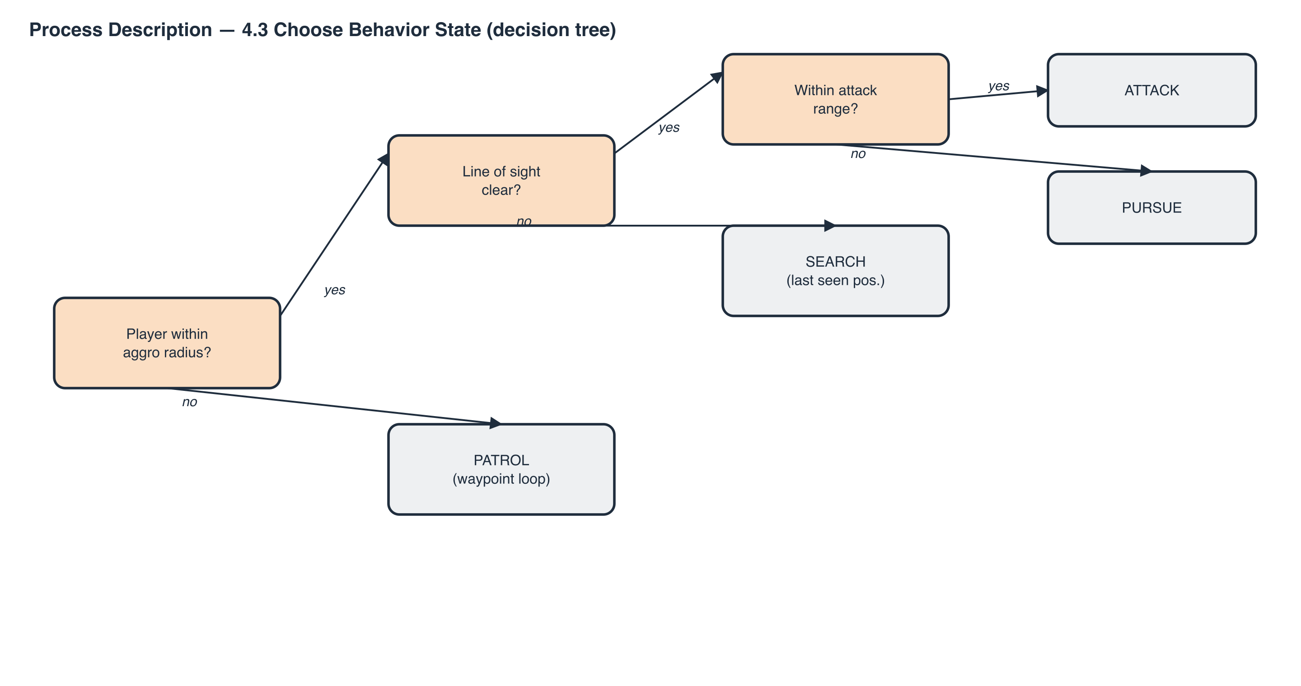
Process description — 4.3 Choose Behavior State (decision tree)

5. Timeline

Work items
Task | Duration (hours) | Predecessor(s)
1. Enemy archetype & stats table design | 4 | —
2. EnemyBase abstract class + Factory Method spawner | 6 | 1
3. Ground & Flying enemy movement/attack states | 6 | 2
4. Turret hazard + difficulty-scaled spawn rate | 5 | 2
5. Damage/collision integration (calls TL6 TakeDamage) | 4 | 3, 4
6. Despawn & OnEnemyDefeated event wiring | 3 | 5
7. Unit + stress testing | 10 | 6
8. Documentation (interface contract, DFDs) | 8 | 6
9. SA prep / diagram design | 6 | —
10. Enemy sprite & animation art | 5 | —

Design (tasks 1, 9) = 10h · Coding (tasks 2–6) = 24h · Testing (task 7) = 10h · Documentation (task 8) = 8h — 52 hours total, matching my share of the team's project plan.

PERT diagram
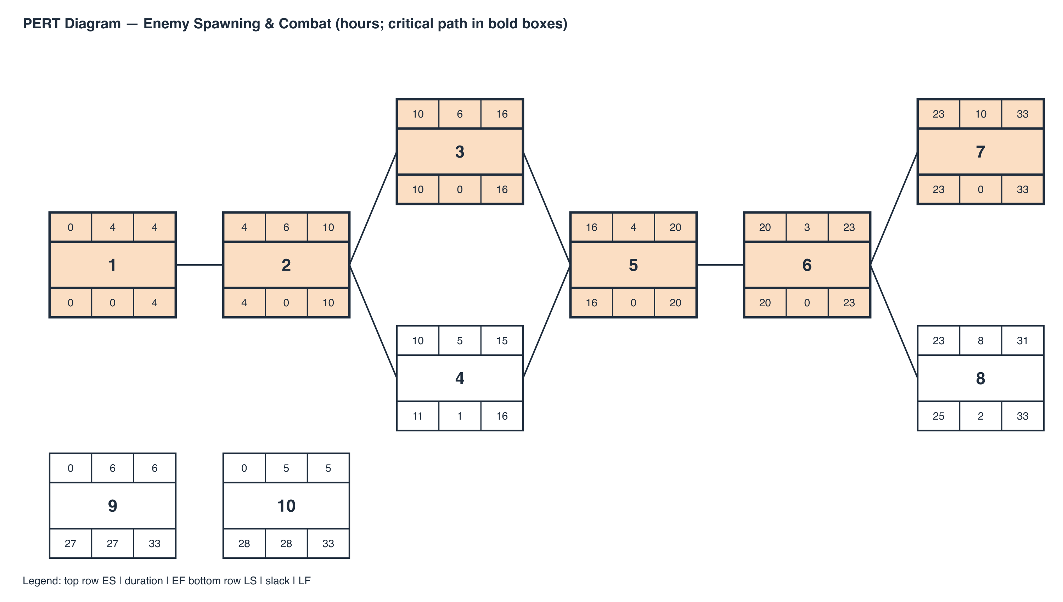

The critical path is 1 → 2 → 3 → 5 → 6 → 7, totaling 33 hours. Task 4 (Turret & difficulty scaling) carries 1 hour of slack; task 8 (Documentation) carries 2 hours. Tasks 9 (SA prep/diagrams) and 10 (sprite/animation art) are not on the critical path and can run any time in parallel, with 27 and 28 hours of slack respectively.

Gantt timeline
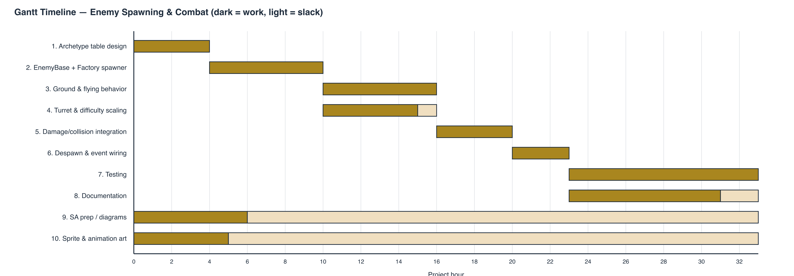

6. Feature Requirements (TL4 only)
This is my feature's official specification from the team's approved project plan (Section 3, TL4 — Enemy/Hazard & Combat System), reproduced here as my Champion feature requirements.
Purpose: Populates the level with threats that challenge and damage the player.
Responsibilities: Enemy spawning tied to difficulty, enemy movement/attack behavior, collision damage, enemy removal.
Public interface:
- EnemySpawner.SetSpawnRate(float rate)
- EnemySpawner.OnEnemyDefeated (event)
Internal classes: abstract EnemyBase, GroundEnemy, FlyingEnemy, TurretHazard, EnemySpawner.
Class hierarchy / dynamic binding: EnemyBase.Move() is virtual; subclasses override movement/attack patterns. Removing virtual makes every enemy move like a ground enemy regardless of type.
GOF pattern: Factory Method (large) — EnemySpawner creates the correct enemy subtype.
GRASP: Creator (EnemySpawner), Information Expert (EnemyBase knows its own threat/attack logic), Protected Variations (new enemy types don't touch spawner code).
Dependencies: Calls TL6's TakeDamage() on collision; reads TL2's GetCurrentDistance()/difficulty for spawn scaling — both read-only/documented.
Testing strategy: Unit-test each enemy type in isolation; boundary tests at spawn rate 0 and max; stress test many enemies on-screen at once.
Completion criteria: At least 2 enemy/hazard types active, correctly damage the player, spawn rate scales with difficulty.
Effort: Design 10h · Coding 24h · Testing 10h · Documentation 8h = 52h

7. Design Pattern & Dynamic Binding Analysis
This section answers the follow-up design questions for my feature: which classes carry the required dynamic binding, whether MonoBehaviour's own dispatch satisfies that requirement, which classes implement my GOF pattern, and how that pattern compares to the canonical form.

Which classes is my dynamic binding in?
The dynamic binding lives on the product side of my hierarchy. EnemyBase is an abstract class that declares Move() as virtual; GroundEnemy, FlyingEnemy, and TurretHazard each override Move() with their own movement/attack pattern. A caller holding an EnemyBase reference and invoking Move() gets the archetype-specific behavior resolved at runtime, not at compile time — that is the dynamic binding the assignment requires. Per the team's plan, removing the virtual keyword collapses every enemy to ground-enemy movement regardless of its actual subtype, which is exactly the regression test in Section 3's Interface Contract table.

Does MonoBehaviour already handle this, or do I need to do it manually?
Both are true, for two different things. EnemyBase itself inherits from MonoBehaviour so each enemy can live in the Unity scene, run every frame, and use physics/collision callbacks — that is Unity's own message-dispatch system (Update(), OnCollisionEnter(), etc.), which Unity invokes by name/reflection, not through C# virtual-method dispatch. That mechanism does NOT satisfy the assignment's dynamic-binding requirement, because I am not authoring an override relationship for it — Unity is. The dynamic binding I am responsible for is the separate, hand-written virtual Move() method on EnemyBase, called from inside my own Update(). So the structure is: EnemyBase : MonoBehaviour (gives me the Unity lifecycle), and EnemyBase.Move() : virtual (gives me the manual dynamic binding the rubric is asking about). The two are independent — one is Unity's, one is mine.

Which classes are involved in my design pattern, and what does the class diagram look like?
My GOF pattern is Factory Method: EnemySpawner (Creator) is responsible for constructing the correct enemy subtype from an EnemyType parameter, returning it typed as the abstract EnemyBase (Product). GroundEnemy, FlyingEnemy, and TurretHazard are the Concrete Products. The diagram below puts my feature's classes side by side with the canonical Factory Method structure from sourcemaking.com.
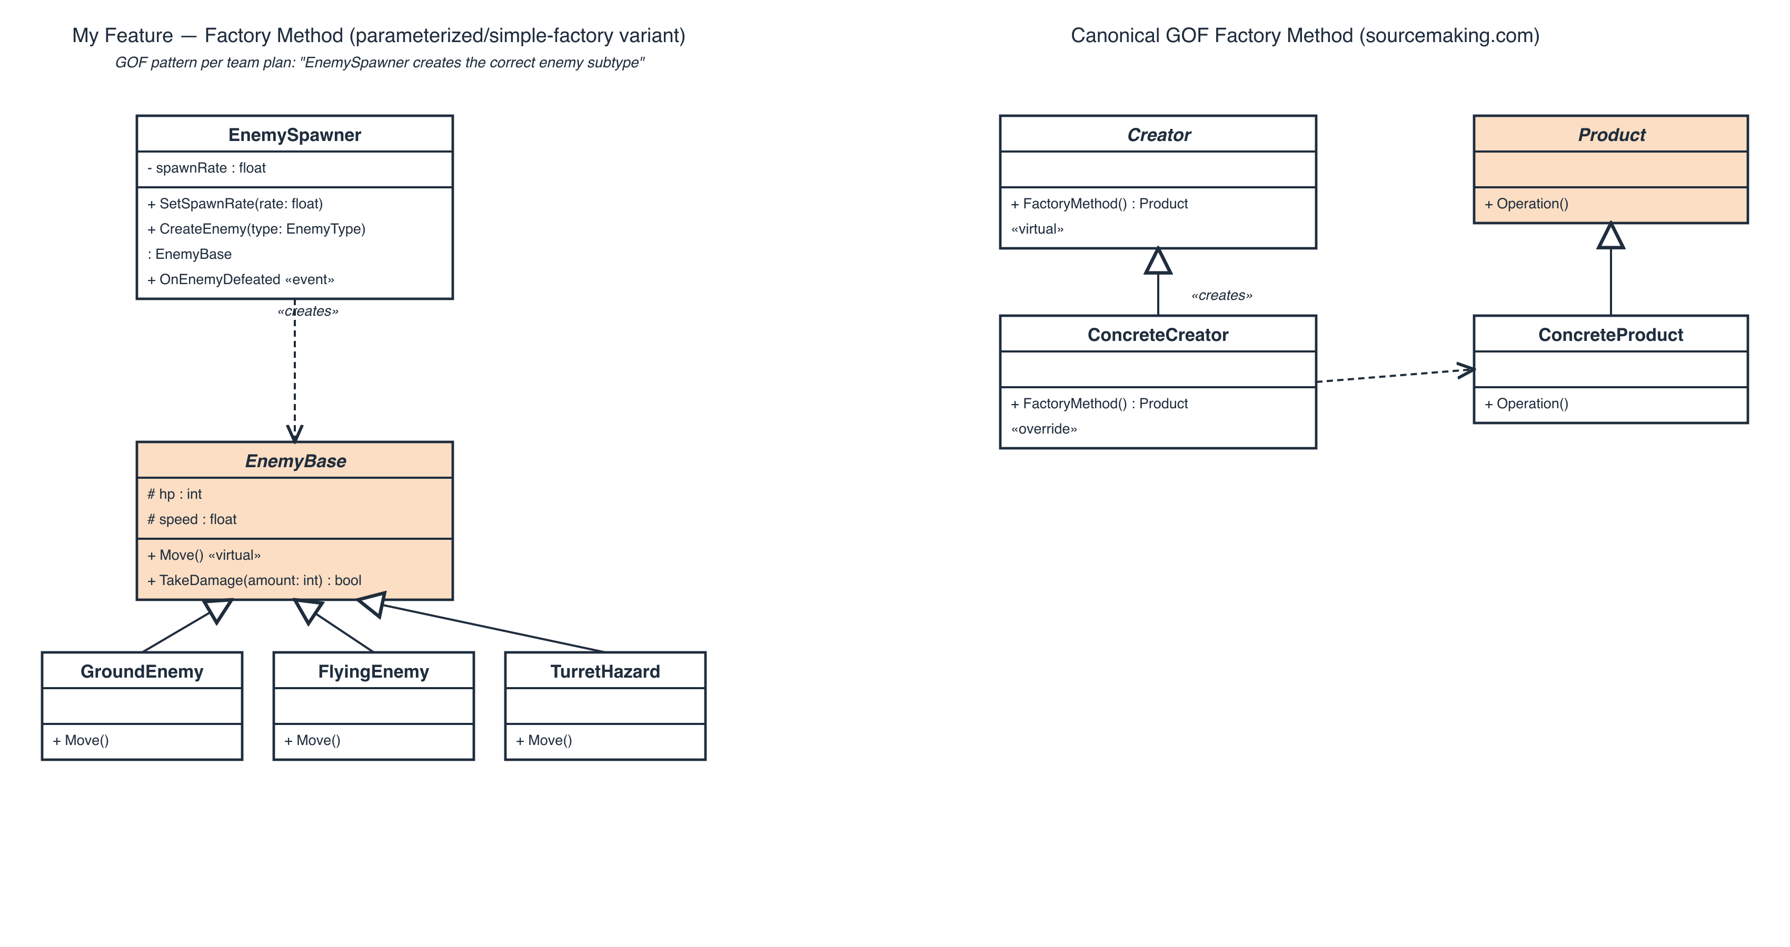
My Factory Method classes (left) vs. the canonical GOF structure (right)

Comparison to sourcemaking.com's canonical Factory Method
The Product side matches the canonical pattern exactly: Product ↔ EnemyBase (abstract), ConcreteProduct ↔ GroundEnemy/FlyingEnemy/TurretHazard, each pair linked by ordinary inheritance.
The Creator side is a deliberate simplification. The canonical pattern puts the polymorphism on the creator too — an abstract Creator declares a virtual FactoryMethod(), and each ConcreteCreator subclass overrides it to return one specific product. My team's plan defines only a single EnemySpawner class (no Creator/ConcreteCreator split), which instead branches on an EnemyType parameter inside one CreateEnemy(type) method. This is the common real-world variant usually called a Simple Factory (or parameterized Factory Method) rather than a textbook Factory Method, because the creator-side selection is a switch/parameter instead of virtual dispatch. I'm keeping this variant rather than forcing a full creator hierarchy, because a spawner that already knows every enemy type from the archetype table has no second creator subclass to justify — inventing one would be exactly the "forced/artificial GOF pattern usage" our team's risk log warned against. The part of the pattern that actually needs runtime polymorphism in my feature — selecting archetype-specific behavior — is handled correctly by EnemyBase.Move(), not by the creator.

8. Sequence Diagram
This models Scenario EN2 (Engage and Damage the Player, Section 2) end to end, across four lifelines: the Player actor and three classes — EnemyBase (shown as its concrete GroundEnemy subtype, to make the dynamic binding on Move() visible), EnemySpawner, and PlayerHealth (TL6).
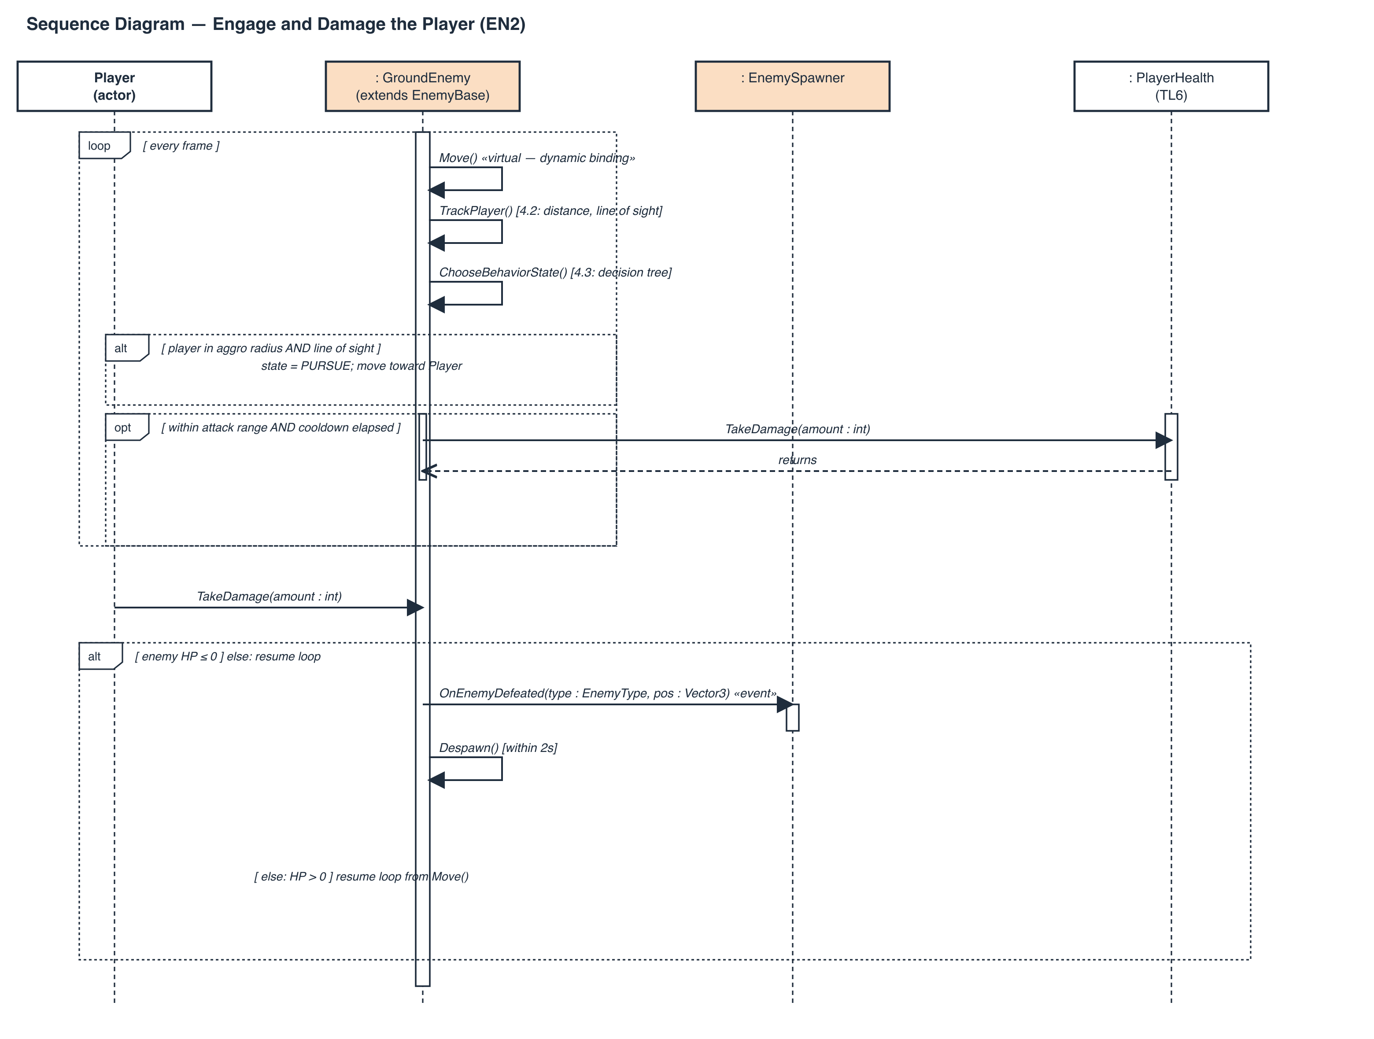

The loop frame is the enemy's own per-frame update (Move() is the virtual call whose override depends on the concrete subtype). The nested alt covers the aggro/line-of-sight branch from Step 2 of EN2, and the nested opt covers the attack-cooldown call to PlayerHealth.TakeDamage() from Step 3. The Player's own attack lands on the enemy via EnemyBase.TakeDamage() (Step 5's trigger), and the outer alt covers the HP ≤ 0 branch: EnemySpawner.OnEnemyDefeated fires and the enemy despawns within 2 seconds, matching the Interface Contract and Completion Criteria in Sections 3 and 6.

9. Class Diagram
The full class diagram for the feature: my five classes (EnemySpawner, EnemyBase, GroundEnemy, FlyingEnemy, TurretHazard, plus the EnemyType enum) with every field and method from the Interface Contract and Feature Requirements, and the three external classes (dashed borders) I depend on or call into — LevelGenerator (TL2) and PlayerController/PlayerHealth (TL6). No relationship here is invented: each dashed dependency arrow corresponds to a row in Section 3's Interface Contract tables.
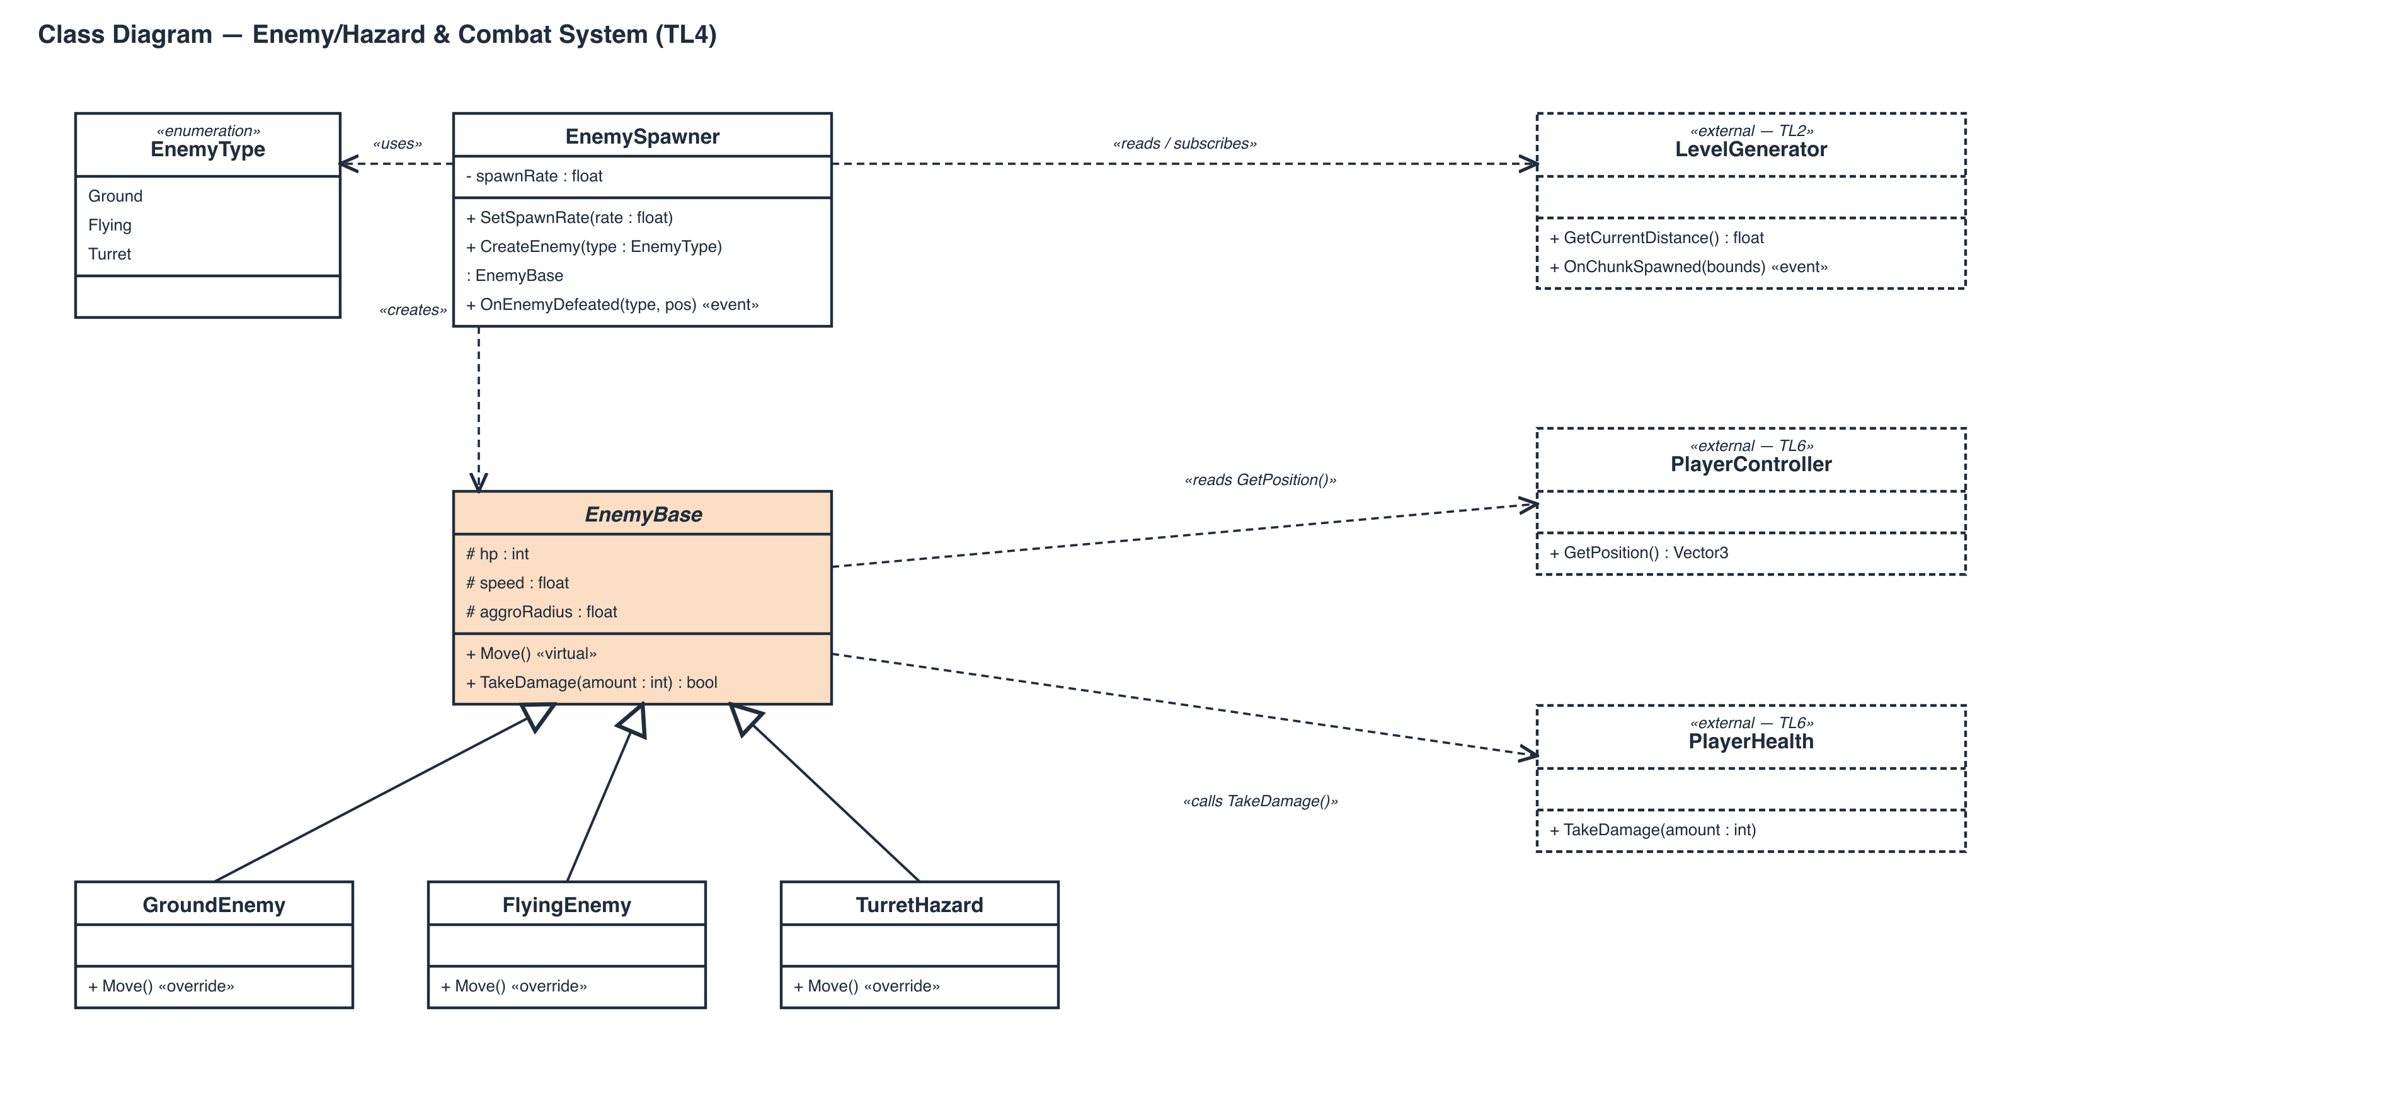

10. Fine-Grained Time Requirements
Section 5's 10 work items broken into trackable subtasks. Each group's subtask hours sum to that work item's total from Section 5, so this is a finer WBS on the same 52-hour (+11h SA-prep/art) budget — not a new estimate.
ID | Subtask | Hours
Task 1 — Enemy archetype & stats table design (4h)
1.1 | Research/list archetype stats needed (HP, speed, aggro radius, damage) | 1
1.2 | Build the archetype data table (Ground/Flying/Turret rows) | 2
1.3 | Review stats against the difficulty curve targets | 1
Task 2 — EnemyBase abstract class + Factory Method spawner (6h)
2.1 | Define abstract EnemyBase (fields, virtual Move(), TakeDamage()) | 2
2.2 | Implement EnemySpawner.CreateEnemy(type) factory switch | 2
2.3 | Wire SetSpawnRate() + per-chunk spawn-count calculation | 1.5
2.4 | Smoke-test: manually spawn one of each archetype | 0.5
Task 3 — Ground & Flying enemy movement/attack states (6h)
3.1 | GroundEnemy.Move() (patrol/pursue/attack logic) | 2
3.2 | FlyingEnemy.Move() (patrol/pursue/attack, aerial movement) | 2
3.3 | Shared aggro-radius / line-of-sight check helper | 1
3.4 | Manual playtest of both archetypes | 1
Task 4 — Turret hazard + difficulty-scaled spawn rate (5h)
4.1 | TurretHazard.Move() (stationary fire behavior) | 1.5
4.2 | Difficulty-band lookup from LevelGenerator.GetCurrentDistance() | 1.5
4.3 | Weighted archetype selection by difficulty | 1.5
4.4 | Manual playtest of difficulty scaling across a run | 0.5
Task 5 — Damage/collision integration, calls TL6 TakeDamage (4h)
5.1 | Collision/trigger detection on enemy attack | 1.5
5.2 | Attack-cooldown timer + TakeDamage() call wiring | 1.5
5.3 | Player i-frame suppression check (Step 3a) | 1
Task 6 — Despawn & OnEnemyDefeated event wiring (3h)
6.1 | EnemyBase.TakeDamage() HP≤0 branch | 1
6.2 | OnEnemyDefeated event + 2s despawn timer | 1.5
6.3 | Manual playtest of a full kill | 0.5
Task 7 — Unit + stress testing (10h)
7.1 | Spawn validity test harness (1,000 chunk populations) | 3
7.2 | Archetype distribution test | 1.5
7.3 | State-machine test (pursue/search/patrol timing) | 2
7.4 | Damage-call & event-count regression test (50 scripted kills) | 2
7.5 | Stress test: 25+ concurrent enemies, frame-time check | 1.5
Task 8 — Documentation: interface contract, DFDs (8h)
8.1 | Interface Contract tables (Section 3) | 2
8.2 | DFDs: context, zoom, decision tree (Section 4) | 3
8.3 | Use case scenarios + diagrams (Section 2) | 2
8.4 | Final proofread/formatting pass | 1
Task 9 — SA prep / diagram design (6h)
9.1 | Draft use-case diagrams | 1.5
9.2 | Draft DFD diagrams (context + zoom) | 2
9.3 | Draft PERT/Gantt | 1.5
9.4 | SA presentation slides/notes | 1
Task 10 — Enemy sprite & animation art (5h)
10.1 | Ground enemy sprite + walk/attack frames | 2
10.2 | Flying enemy sprite + flight/attack frames | 2
10.3 | Turret hazard sprite + fire animation | 1

63 hours total across all subtasks — 52h core (design/coding/testing/documentation) plus 11h SA-prep/art, unchanged from Section 5.

