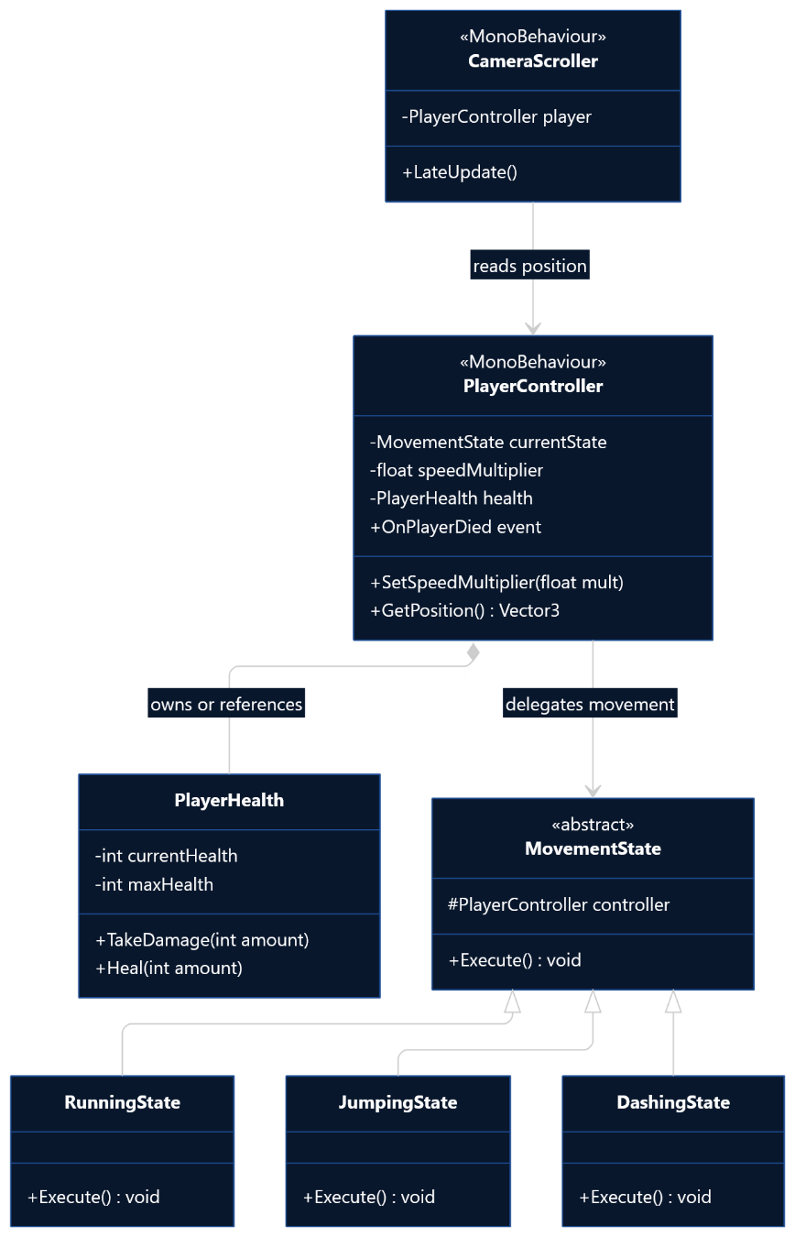
- I will be implementing the state design pattern. This seems like the best method to differentiate between the different types of movement states.
- My abstract MovementState and the child classes RunningState, JumpingState, and DashingState are what I will be using for my dynamic binding, since it keeps changing depending on the different states.

