Champion Document
TL5 — Meta Progression & Persistent Upgrade System
Name: Will Wotherspoon | Escape the 90s | Unity / C# PC Build
Contents
1. Introduction 1
2. Use Case 2
2.1 Actors 2
2.2 Main Use Cases 2
2.3 Use-Case Description: Purchase Upgrade 3
2.4 Additional Use-Case Diagram: Run Start and Starting Bonuses 5
2.4.1 Use-Case Description: Run Start and Starting Bonuses 5
3. Interface Contract 6
3.1 Events / Observable Outputs 7
4. Data Flow Diagrams 7
4.1 Context Diagram (Process 0) 7
4.2 Diagram 0 — System Decomposition 8
4.3 Diagram 5 — TL5 Meta Progression (Decomposition of Process 5.0) 10
4.4 Diagram 5.2 — Decomposition of Process 5.2 10
4.4.1 Primitive Process Description: 5.2.2.1 Update Upgrade Level 11
5. Class Design, Dynamic Binding, and Patterns 11
5.1 Classes 11
5.2 Dynamic Binding 12
5.3 Design Patterns and GRASP 12
6. Sequence Diagram 13
6.1 Sequence Description 13
7. Testing and Acceptance Criteria 14
8. Dependencies and Integration Rules 14
9. Completion Criteria 15
10. Time Requirements 15
10.1 Work Breakdown and Effort Estimates 15
10.2 Suggested Schedule Timeline 17
10.3 Critical Path and Assumptions 18

1. Introduction
The Meta Progression & Persistent Upgrade System tracks currency earned during a run, allows the player to purchase permanent upgrades between runs, saves progress locally, loads progress at startup, and applies the player’s unlocked bonuses when a new run begins.
The feature is responsible for:
- Tracking run currency and the persistent currency balance.
- Displaying and validating upgrade purchases.
- Tracking upgrade levels for at least three upgrade types: health, speed, and magnet (pickup) range.
- Saving and loading persistent progress through a dedicated persistence class.
- Applying starting bonuses to the player through documented Player Controller methods.
The feature does not:
- Control player movement, physics, health ownership, or camera scrolling.
- Generate levels, spawn enemies, or manage power-up pickups.
- Own the overall menu/game-state machine or draw the HUD.
- Directly access another feature’s private fields; all cross-feature communication uses public methods or documented events.

2. Use Case

2.1 Actors
Actor | Type | Responsibility
Player / UI | Primary actor | Views currency and upgrade levels; requests purchases.
Game Session / GameStateManager | Supporting actor | Requests progress loading and starting-bonus application at run start.
PlayerController | External system interface | Receives typed starting-bonus calls such as speed, healing, or other documented setters.
Local Save File | External data store | Stores and returns serialized currency and upgrade-level data.

2.2 Main Use Cases
- View Currency — the player/UI requests the current persistent currency balance.
- View Upgrade Levels — the player/UI requests the current level of an upgrade type.
- Purchase Upgrade — the player/UI requests an upgrade purchase; the system checks currency and maximum level, deducts cost, and updates the level.
- Save Progress — the system serializes currency and upgrade levels and writes them to the local save file.
- Load Progress — the system reads the local save file and restores valid progress data.
- Apply Starting Bonuses — at the beginning of a run, the system reads unlocked upgrade levels, calculates effect values, and calls the PlayerController’s documented methods.
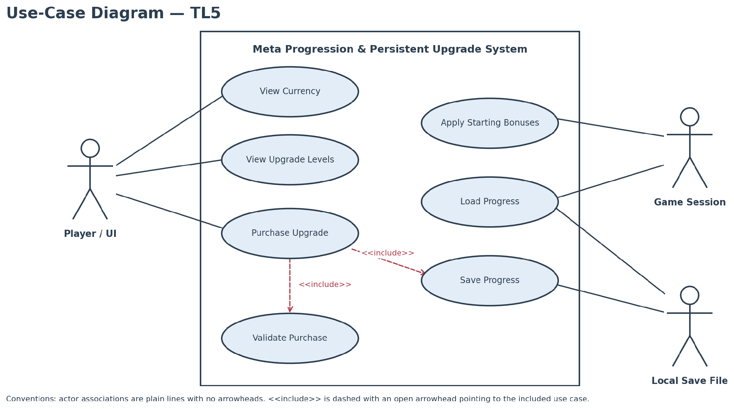
Figure 1. TL5 use-case diagram.
Use-case convention note: actor-to-use-case associations are plain lines without arrowheads. The reusable validation behaviour is modelled as an <<include>> relationship directed toward the included use case, as is the save step that every successful purchase reuses. Any exception use case added later must use a dashed <<extend>> arrow pointing from the exception to the base use case.

2.3 Use-Case Description: Purchase Upgrade
Name: Purchase Upgrade
Summary: When the player selects an upgrade in the shop, the Meta Progression system checks that the player has enough persistent currency and that the upgrade is not already at its maximum level, deducts the cost, increases the upgrade level by one, publishes the updated values for the UI to display, and saves the progress. If a check fails, the purchase is rejected and nothing changes; if the save fails, the failure is reported rather than hidden.
Actors:
- Player / UI (primary actor) — selects an upgrade type, requests the purchase, and displays the updated currency and upgrade level.
- Local Save File (external data store) — receives the updated currency and upgrade levels.
Preconditions:
- The shop UI is open and the player can select an upgrade type.
- MetaProgressionManager and SaveDataManager are initialised and available.
- Currency and upgrade levels have been loaded, from a valid save file or from safe default progress.
Basic sequence:
- Player selects an upgrade type in the shop UI.
- UI calls MetaProgressionManager.PurchaseUpgrade(type).
- MetaProgressionManager retrieves the current level, cost, available currency, and maximum-level rule.
- The system validates that the player has sufficient currency and that the upgrade is not already at its maximum level.
- The system deducts the cost and increments the selected upgrade level.
- The system publishes the updated currency and upgrade-level information for the UI to display.
- The system saves the updated progress through SaveDataManager.
Exceptions:
- Step 4a — Insufficient currency: reject the purchase, leave currency and upgrade level unchanged, and return a failure result/message. The use case ends without a purchase.
- Step 4b — Maximum level reached: reject the purchase, leave data unchanged, and return a maximum-level result/message. The use case ends without a purchase.
- Step 7a — Save failure: preserve the in-memory state, report the persistence failure, and prevent the UI from claiming that the save completed successfully. The use case ends.
Post conditions:
- After a successful purchase, currency has decreased by exactly the upgrade cost and the selected upgrade level has increased by exactly one.
- After a rejected purchase (insufficient currency or maximum level), currency and all upgrade levels are unchanged.
- After a successful purchase, the updated values have been published to the UI and written to the save file, unless the save failed, in which case the in-memory state is preserved and the failure is reported.
Priority: 1 (must have) — stored currency cannot be spent, and upgrades cannot be unlocked, without it.
ID: PU1

2.4 Additional Use-Case Diagram: Run Start and Starting Bonuses
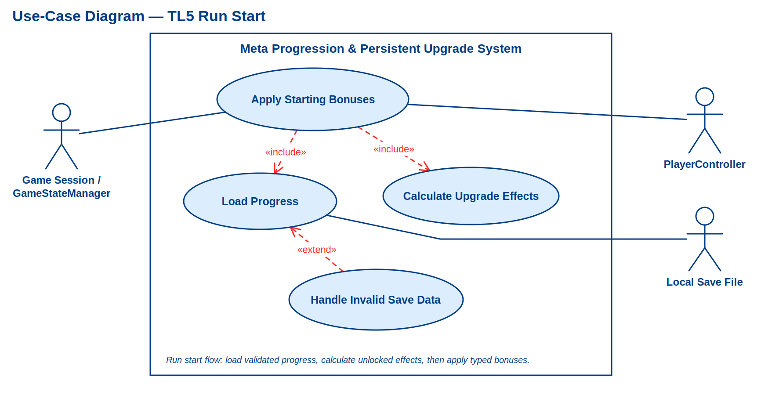
Figure 2. TL5 run-start use-case diagram.

2.4.1 Use-Case Description: Run Start and Starting Bonuses
Name: Apply Starting Bonuses (run-start scenario)
Summary: At the start of each run, the Game Session asks the Meta Progression system to load the saved progress, calculate the effect of every unlocked upgrade, and apply the resulting health, speed, and magnet-range bonuses to the player through documented PlayerController methods. If the save data is missing or invalid, safe defaults are used so the run still starts.
Actors:
- Game Session / GameStateManager (primary actor) — starts the run and requests the starting bonuses.
- PlayerController (external system interface) — receives the typed starting-bonus calls.
- Local Save File (external data store) — supplies the saved currency and upgrade levels.
Preconditions:
- A new run is starting and GameStateManager holds a reference to the player object.
- MetaProgressionManager and SaveDataManager are initialised and available.
- The PlayerController’s documented health, speed, and magnet-range methods can be called.
- A valid save file is not required; a missing or invalid file is handled by Step 4a.
Basic sequence:
- Game Session / GameStateManager starts a new run.
- GameStateManager calls MetaProgressionManager.ApplyStartingBonuses(player).
- MetaProgressionManager requests saved progress from SaveDataManager.Load().
- SaveDataManager returns validated SaveData or safe default progress when no valid save file exists.
- MetaProgressionManager reads the unlocked upgrade levels and calculates each upgrade effect value.
- MetaProgressionManager calls the PlayerController’s documented methods to apply the resulting health, speed, and magnet-range bonuses.
- MetaProgressionManager returns control to GameStateManager.
- GameStateManager begins the playing state.
Exceptions:
- Step 4a — Handle Invalid Save Data — the <<extend>> case: the save file is missing, unreadable, or fails validation. The extending use case Handle Invalid Save Data uses safe default progress, reports the condition as documented, and continues the run-start flow without crashing. The sequence resumes at Step 5, using the default data.
- Step 6a — Level 0 or no unlocked upgrades: apply no upgrade bonus and allow the run to continue with the player at the default starting values. The sequence resumes at Step 7.
Post conditions:
- The player’s starting health, speed, and magnet range reflect the unlocked upgrade levels, or the default starting values when nothing is unlocked.
- Currency and upgrade levels are unchanged, and nothing is written to the save file.
- Control has returned to GameStateManager and the playing state has begun.
Priority: 1 (must have) — persistent upgrades have no effect on gameplay unless they are applied at run start.
ID: RS1

3. Interface Contract
The following interfaces are typed, testable, and limited to the public boundary described in the supplied TL5 feature specification.
Member | Type / Signature | Direction | Contract
AddCurrency | void AddCurrency(  int amount) | Input | Increases the persistent/in-memory currency balance by amount. The amount must be non-negative.
GetUpgradeLevel | int GetUpgradeLevel(  UpgradeType type) | Output | Returns the stored level for the requested upgrade type; returns a defined default such as 0 when no level exists.
PurchaseUpgrade | PurchaseResult PurchaseUpgrade(  UpgradeType type) | Input / Output | Validates currency and max level; on success deducts cost and increments exactly one level; on failure leaves state unchanged.
ApplyStartingBonuses | void ApplyStartingBonuses(  GameObject player) | Input | Reads unlocked upgrade levels, computes effects, and calls only documented PlayerController methods.
Save | void Save(SaveData data) | Input | Serializes currency and upgrade levels to the local save file; reports failure if the write cannot complete.
Load | SaveData Load() | Output | Returns validated saved data; if no valid file exists, returns default progress without crashing.

3.1 Events / Observable Outputs
- OnCurrencyChanged(int newAmount) — emitted after a successful currency change.
- OnUpgradePurchased(UpgradeType type, int newLevel) — emitted after a successful purchase.
- OnProgressLoaded(SaveData data) — emitted after valid data is loaded.
- OnPersistenceError(string message) — emitted or returned when save/load fails.
These event names are proposed refinements of the public boundary. If the team has already frozen different event names, the names should be changed consistently across the document and implementation; the data types and postconditions should remain testable.

4. Data Flow Diagrams
The data-flow model is presented at three levels: the context diagram fixes the system boundary, Diagram 0 decomposes the system into its six top-level processes, and Diagram 5 decomposes the TL5 process. Every arrow is directional; two-way interactions are drawn as two separate labelled flows.

4.1 Context Diagram (Process 0)
The supplied context diagram establishes Process 0, Escape the 90s, and shows the external entities Player, Local Save File, and Unity Engine.
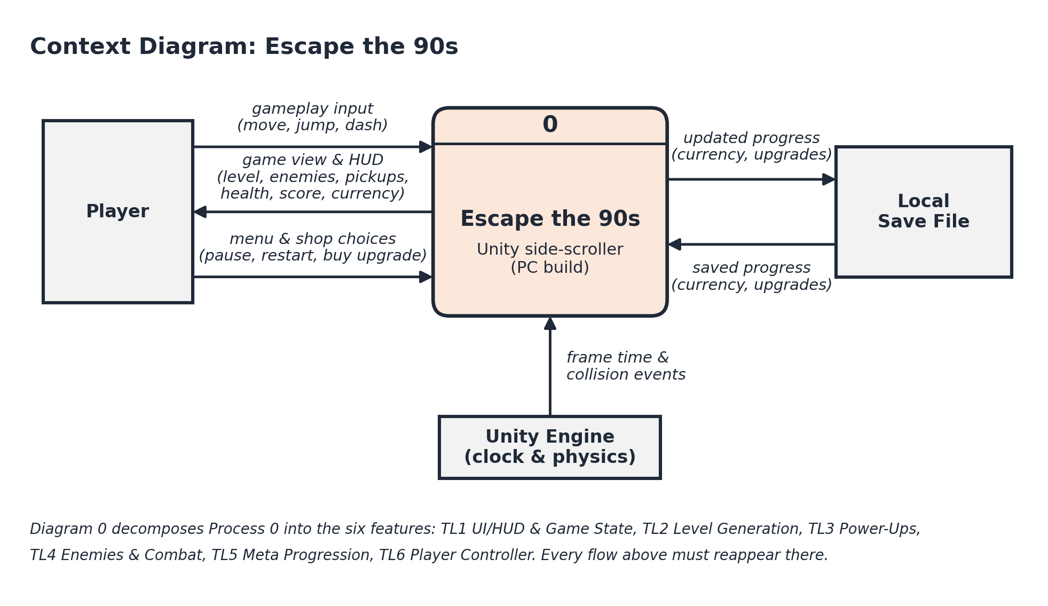
Figure 3. Context diagram — Process 0 and its external entities.
Context DFD interpretation: Player → Process 0 carries gameplay, menu, and shop input. Process 0 → Player carries the game view and HUD. Process 0 → Local Save File carries updated progress. Local Save File → Process 0 carries saved progress. Unity Engine → Process 0 carries frame-time and collision events.

4.2 Diagram 0 — System Decomposition
Diagram 0 decomposes Process 0 into the six top-level processes that make up the game. Process numbers are fixed to match TL numbers, so TL5 is Process 5.0 and everything inside it is expanded in Diagram 5. Unity Engine appears twice, once for each part of the engine that a process reads from directly; the duplicate is marked with a corner stroke rather than drawn as a single entity with crossing lines.
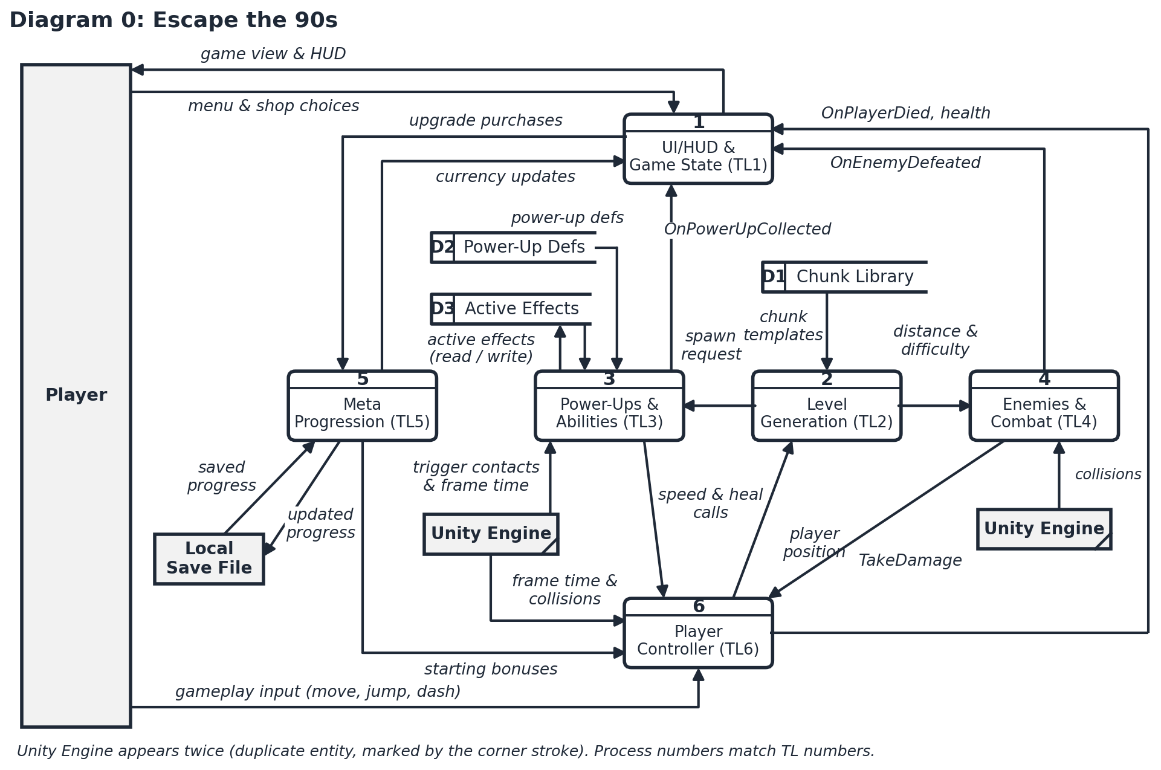
Figure 4. Diagram 0 — decomposition of Process 0 (supplied by the team).
- 1.0 UI/HUD & Game State (TL1) — draws the HUD and shop screens, owns the menu and run lifecycle, and is the single point of contact between the Player and the other five processes.
- 2.0 Level Generation (TL2) — builds the level from D1: Chunk Library and reports distance and difficulty to Enemies & Combat.
- 3.0 Power-Ups & Abilities (TL3) — reads D2: Power-Up Defs and reads/writes D3: Active Effects; applies speed and heal effects to the Player Controller.
- 4.0 Enemies & Combat (TL4) — spawns and drives enemies, detects collisions, and calls TakeDamage on the Player Controller.
- 5.0 Meta Progression (TL5) — the TL5 feature: currency, upgrade purchases, persistence, and starting-bonus calculation. Decomposed in Diagram 5.
- 6.0 Player Controller (TL6) — movement, physics, and health; receives starting bonuses from TL5 and effect calls from TL3/TL4.
D1–D3 are already assigned to other features (Chunk Library to TL2; Power-Up Defs and Active Effects to TL3), so TL5’s own in-memory progress data is numbered D4 in Diagram 5 to avoid a clash. It is internal to Process 5.0 and, like the other features’ internal stores, is not shown at the Diagram 0 level.
Boundary flows into Process 5.0. Diagram 0 shows exactly five flows crossing the Process 5.0 boundary: “upgrade purchases” in from 1.0 and “currency updates” back out to 1.0; “saved progress” in and “updated progress” out with the Local Save File; and “starting bonuses” out to 6.0. Diagram 5 must balance against exactly these five — no more, no fewer.

4.3 Diagram 5 — TL5 Meta Progression (Decomposition of Process 5.0)
Process 5.0 is decomposed into currency management, upgrade management, starting-bonus application, and persistence. D4 represents in-memory progress data owned by TL5. The neighbouring processes 1.0 and 6.0, and the external Local Save File, are carried over from Diagram 0 so the two diagrams balance: the single “upgrade purchases”/“currency updates” pair at the parent level fans out to the currency and upgrade-level flows shown here.
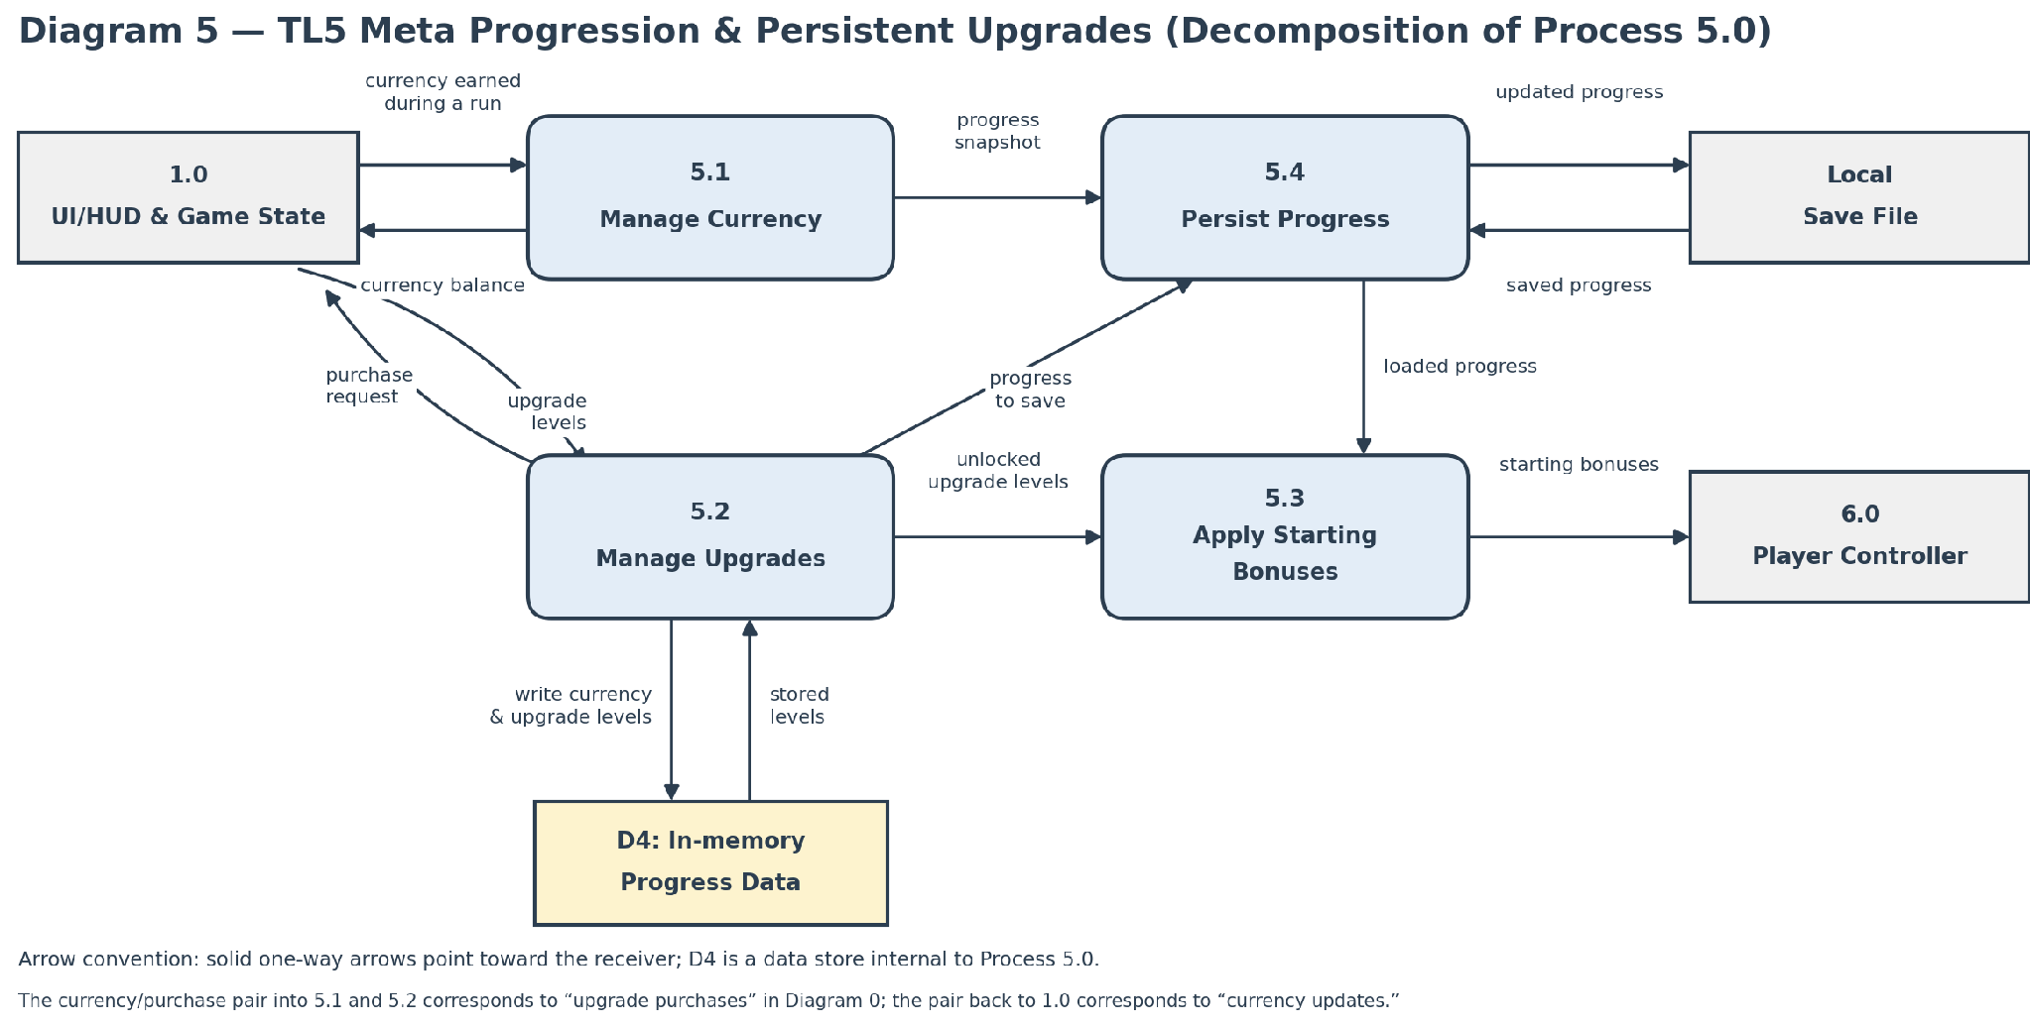
Figure 5. Diagram 5 — decomposition of Process 5.0 (TL5).

4.4 Diagram 5.2 — Decomposition of Process 5.2
Process 5.2 (Manage Upgrades) is further decomposed into purchase validation, purchase commitment, and a primitive level-update process. The decomposition preserves the upgrade-purchase input, currency/level result output, and D4 as the internal progress data store.
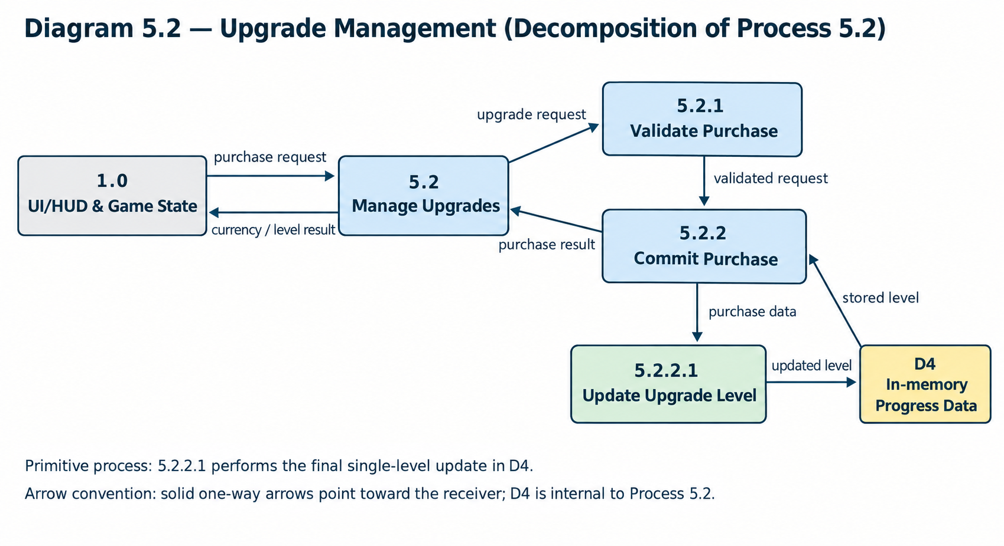
Figure 6. Diagram 5.2 — decomposition of Process 5.2 (Manage Upgrades).

4.4.1 Primitive Process Description: 5.2.2.1 Update Upgrade Level
The primitive process performs the final single-level update after the purchase request has already passed validation.
Pseudocode:
BEGIN
INPUT Upgrade_Type
READ Current_Level FROM D4
SET NEW_LEVEL = Current_Level + 1
WRITE New_Level TO D4
RETURN New_Level
END

5. Class Design, Dynamic Binding, and Patterns
TL5 is built around a single controller class, a small polymorphic upgrade hierarchy, and a persistence service that owns all file access. The classes and their relationships are listed below and shown in Figure 7.

5.1 Classes
- MetaProgressionManager — controller and public façade for currency, purchases, levels, and starting bonuses.
- UpgradeNode — abstract base class defining shared upgrade state and virtual GetEffectValue().
- HealthUpgrade, SpeedUpgrade, MagnetRangeUpgrade — concrete upgrade types that override GetEffectValue().
- SaveDataManager — persistence service responsible only for serialization, file access, validation, and version handling.
- SaveData — private data class containing raw save fields such as currency and upgrade-level values.
- PlayerController — external TL6 interface receiving starting-bonus calls through public methods
Class Diagram — TL5
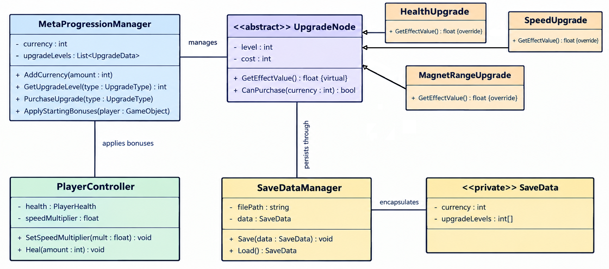
Figure 7. TL5 class diagram.

5.2 Dynamic Binding
Dynamic binding occurs through UpgradeNode.GetEffectValue(). MetaProgressionManager can work with an UpgradeNode reference while the runtime dispatches to HealthUpgrade, SpeedUpgrade, or MagnetRangeUpgrade. Each subclass calculates its own effect value. Removing virtual/override behaviour would cause the manager to lose subtype-specific upgrade behaviour and would force generic bonus logic.

5.3 Design Patterns and GRASP
Pattern / Principle | Application | Reason
Singleton | SaveDataManager, if one persistence coordinator is required | Prevents competing save coordinators from writing the same file. Use cautiously and keep the API narrow.
Private Class Data | SaveData encapsulates raw save fields | Prevents gameplay classes from directly manipulating serialized fields or file details.
Polymorphism | UpgradeNode subclasses override GetEffectValue() | Allows new upgrade types to be added without rewriting purchase/application logic.
Controller | MetaProgressionManager coordinates requests | Keeps UI and PlayerController from owning persistence or purchase rules.
Information Expert | UpgradeNode knows its own effect value; SaveDataManager knows persistence | Places behaviour near the data and responsibility it belongs to.
Protected Variations | UpgradeNode and SaveDataManager boundaries | Protects the manager from changes to individual upgrade formulas or file representation.

6. Sequence Diagram
The sequence below shows the run-start flow in which persistent data is loaded and the resulting upgrade effects are applied to the player. Solid arrows represent calls; dashed arrows represent returns or responses.
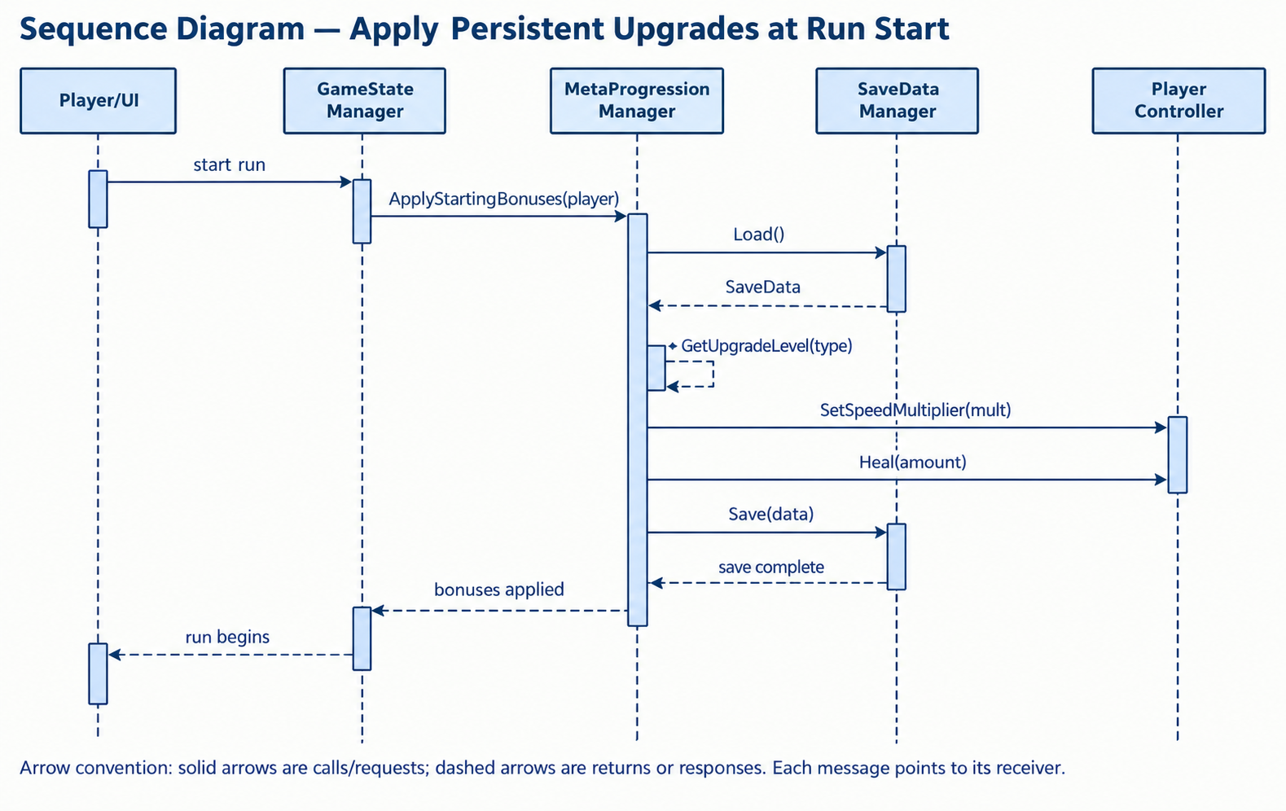
Figure 8. Run-start sequence — loading progress and applying upgrades.

6.1 Sequence Description
- GameStateManager starts a new run.
- GameStateManager calls MetaProgressionManager.ApplyStartingBonuses(player).
- MetaProgressionManager requests saved progress from SaveDataManager.Load().
- SaveDataManager returns validated SaveData.
- MetaProgressionManager reads upgrade levels and computes each UpgradeNode effect value using dynamic binding.
- MetaProgressionManager calls the PlayerController’s documented methods to apply the resulting health, speed, and magnet-range bonuses.
- MetaProgressionManager saves or confirms the current progress state, then returns control to GameStateManager.
- GameStateManager begins the playing state.

7. Testing and Acceptance Criteria
Test Area | Test | Expected Result
Currency | Add 0, add positive amount, attempt negative amount | Zero is a no-op; positive values increase balance; negative input is rejected or handled by a defined validation rule.
Purchase | Purchase with sufficient currency | Currency decreases by exact cost and selected level increases by one.
Purchase boundary | Purchase with insufficient currency or maxed upgrade | Operation fails and all persistent values remain unchanged.
Persistence | Save then load a round-trip | Currency and all upgrade levels match the saved values.
Missing / corrupt file | Load when file is absent or invalid | System returns safe default progress and reports the condition without crashing.
Dynamic binding | Call GetEffectValue() through UpgradeNode references | Correct subclass formula executes for each upgrade type.
Starting bonuses | Apply level 0 and nonzero levels to a mock PlayerController | No bonus is applied at level 0; correct typed setters are called for unlocked levels.
Stress | Rapid purchase requests and repeated save/load operations | No duplicated deductions, corrupted data, or inconsistent levels occur.

8. Dependencies and Integration Rules
- TL5 may call only documented PlayerController methods from TL6 to apply starting bonuses.
- TL5 must not access TL6 private fields or manipulate PlayerHealth directly.
- TL1 may read TL5 currency/upgrade outputs for HUD and shop display through a public interface or events.
- SaveDataManager owns file I/O and save schema/versioning; no other feature writes the save file.
- Public method signatures and event payloads should be frozen before integration to avoid cross-feature rework.
- The local save file is treated as untrusted input: loaded values must be validated against non-negative currency, valid enum values, and legal upgrade ranges.

9. Completion Criteria
- Currency persists across sessions using a local save file.
- At least three upgrade types are purchasable and maintain independent levels.
- Purchases reject insufficient currency and maximum-level attempts without mutating state.
- Starting bonuses are applied correctly at the beginning of a run.
- The persistence layer handles missing or invalid save data safely.
- The public interfaces are documented, typed, and testable.
- All diagrams use consistent notation and directional arrow conventions, and each child diagram balances with its parent.

10. Time Requirements
The estimates below cover the TL5 feature only. They are planning figures derived from the scope in Sections 1–9, not measurements, and should be recalibrated once Phase A is complete and the team has one phase of actual velocity to compare against.

10.1 Work Breakdown and Effort Estimates
Phase | ID | Task | Depends on | Est. (h)
A. Setup | A1 | Freeze public method signatures, event names, and payload types | — | 1.5
A. Setup | A2 | Define UpgradeType enum plus cost and max-level data table | A1 | 1.5
A. Setup | A3 | Create MetaProgressionManager skeleton and scene wiring | A1 | 2.0
B. Currency | B1 | Implement AddCurrency with non-negative validation | A3 | 1.0
B. Currency | B2 | Persistent balance field and OnCurrencyChanged event | B1 | 1.5
B. Currency | B3 | Unit tests: zero, positive, and negative amounts | B2 | 1.5
C. Upgrade model | C1 | UpgradeNode abstract base with virtual GetEffectValue() | A2 | 1.5
C. Upgrade model | C2 | HealthUpgrade, SpeedUpgrade, MagnetRangeUpgrade overrides | C1 | 2.5
C. Upgrade model | C3 | Level storage and GetUpgradeLevel accessor | C1 | 1.0
C. Upgrade model | C4 | Unit tests: dynamic binding through UpgradeNode references | C2, C3 | 1.5
D. Purchase flow | D1 | PurchaseUpgrade validation of currency and maximum level | B2, C3 | 2.0
D. Purchase flow | D2 | Cost deduction, level increment, OnUpgradePurchased event | D1 | 1.5
D. Purchase flow | D3 | PurchaseResult type and failure paths | D1 | 1.5
D. Purchase flow | D4 | Boundary and rapid-request stress tests | D2, D3 | 2.5
E. Persistence | E1 | SaveData class, serialization schema, and version field | A1 | 2.0
E. Persistence | E2 | SaveDataManager.Save with write-failure reporting | E1 | 2.5
E. Persistence | E3 | SaveDataManager.Load with validation of untrusted values | E1 | 3.0
E. Persistence | E4 | Missing and corrupt file handling with safe defaults | E3 | 2.0
E. Persistence | E5 | Save/load round-trip and corruption tests | E2, E4 | 2.5
F. Starting bonuses | F1 | Read unlocked levels and compute effect values | C2, E3 | 2.0
F. Starting bonuses | F2 | Call documented PlayerController methods (TL6) | F1 | 2.0
F. Starting bonuses | F3 | Level-0 no-op and mock PlayerController tests | F2 | 2.0
G. Integration | G1 | TL1 HUD and shop wiring through public events | D2 | 2.5
G. Integration | G2 | GameStateManager run-start hook | F2 | 1.5
G. Integration | G3 | End-to-end run: earn, purchase, save, restart, apply bonuses | G1, G2, E5 | 3.0
G. Integration | G4 | Defect fixing and rework buffer | G3 | 4.0
H. Handoff | H1 | Update diagrams to match the shipped code | G3 | 1.5
H. Handoff | H2 | Document the public boundary for other features | G3 | 1.5
H. Handoff | H3 | Demonstration preparation | G4 | 1.0

Totals. Phase subtotals are A 5.0, B 4.0, C 6.5, D 7.5, E 12.0, F 6.0, G 11.0, and H 4.0, giving a base estimate of 56.0 hours. Applying a 15% contingency at project level rather than padding individual tasks gives a planning figure of 64.5 hours.

10.2 Suggested Schedule Timeline
Week | Focus | Exit criteria | Hours
Week 1 | Interface freeze and currency (A, B) | Signatures frozen; currency balance is testable in isolation | 9.0
Week 2 | Upgrade model and purchase flow (C, D) | Three upgrade types purchasable with validation enforced | 14.0
Week 3 | Persistence (E) | Round-trip survives a missing or corrupt save file | 12.0
Week 4 | Starting bonuses and first integration (F, G1, G2) | Bonuses applied at run start through documented TL6 methods | 10.0
Week 5 | End-to-end integration and handoff (G3, G4, H) | All completion criteria in Section 9 are met | 11.0

Figure 9 places the tasks from Section 10.1 on a single timeline in working hours, with each task starting as soon as its dependencies allow. Black bars are on the critical path (zero slack); gray bars have slack.
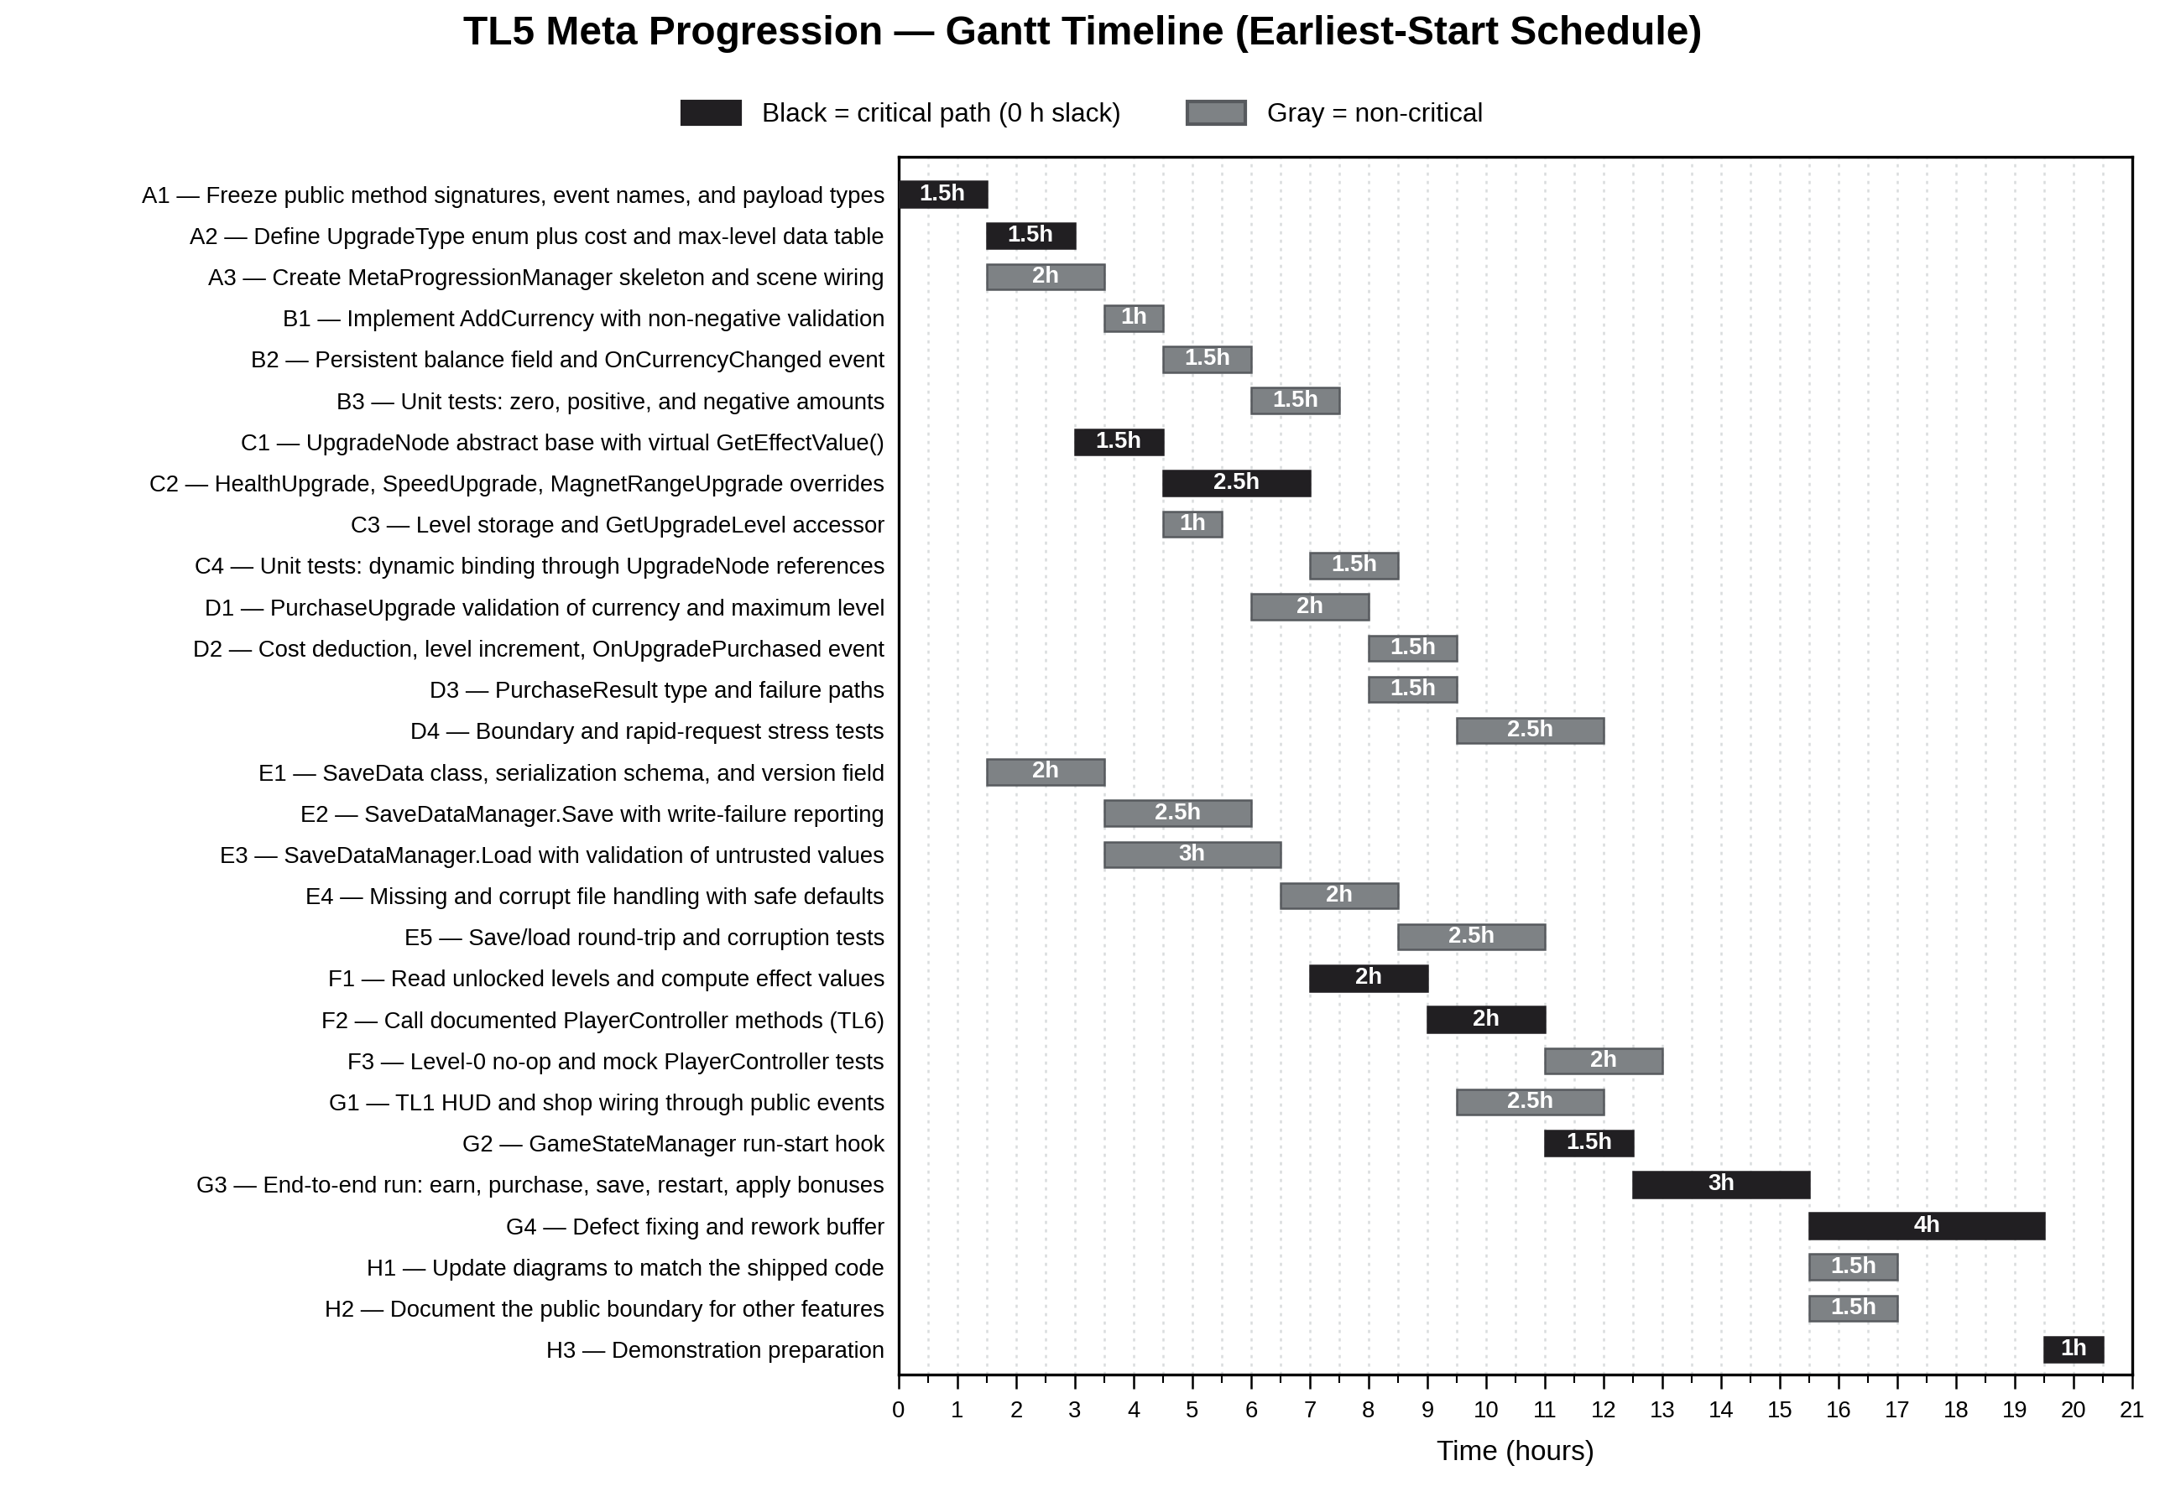
Figure 9. Gantt timeline — earliest-start schedule for tasks A1–H3.

10.3 Critical Path and Assumptions
The critical path runs A1 → A2 → C1 → C2 → F1 → F2 → G2 → G3 → G4 → H3 and totals 20.5 hours. The upgrade model sits on it because the starting-bonus calculation in F1 cannot begin until the UpgradeNode overrides in C2 are complete. Persistence is close behind: E3 finishes at 6.5 hours against 7.0 hours for C2, so the E1 → E3 chain has only 0.5 hours of slack and would join the critical path if it overran. Tasks within a phase are mostly sequential, so adding a second developer to TL5 would compress the schedule less than the raw hour count suggests.
- Estimates assume one developer working on TL5. They are implementation hours and exclude team meetings, review time by other members, and merge resolutions.
- TL6 must publish its PlayerController setters before F2 can begin; a delay there moves the critical path rather than consuming slack.
- Phase E carries the most uncertainty, because bounding the work for corrupt-file handling is difficult before the schema is fixed. If any phase overruns, expect it to be this one.
- The 15% contingency is held at project level so that slack is visible and can be reallocated, rather than hidden inside individual task estimates.
Figure 10 shows the task network for the dependencies listed in Section 10.1, read from top to bottom. Each box gives the task ID, duration and slack; tasks and links on the critical path (zero slack) are outlined in red.
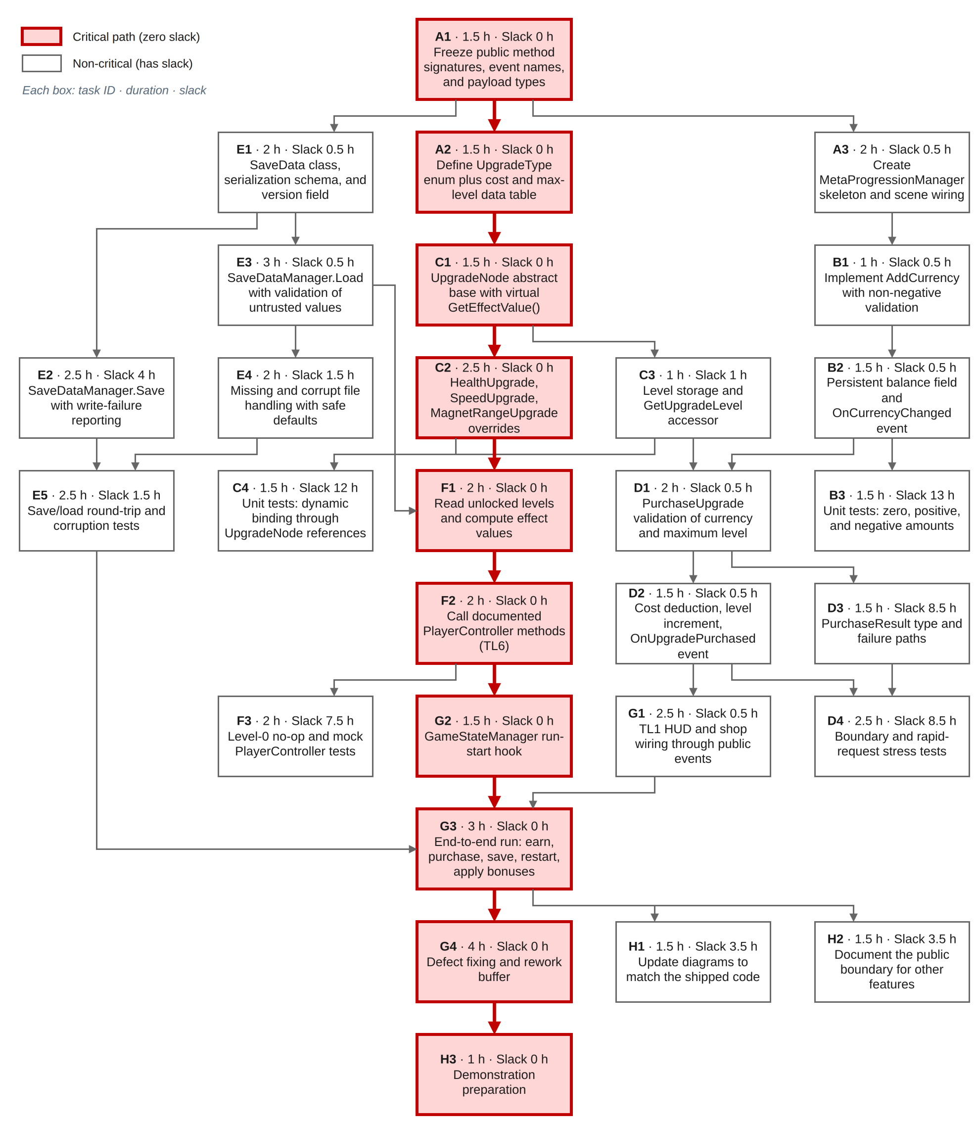
Figure 10. PERT diagram — task network with durations and slack.

