Jose Herrera

Jh1958

24 Sep 2019

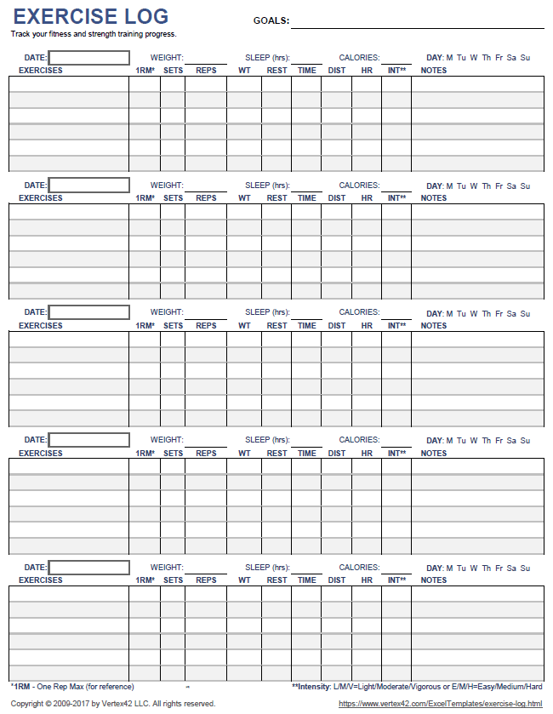

I found this first. Its functionality should be mirrorable in our app.

Then i found these open source examples

<https://opensource.com/life/16/9/fitness-apps-android>