Tourist Program

Group number: 5

Group members:

Hind Assouli

435000700

Joanna Assaeedi

435001041

Analysis

Input:

Name, ID, Country, City, Car, Hotel.

It starts by asking the user for his information (Name, ID)

Then it displays a list of countries(Country) for the user to choose from.

After that it gives the user the choice of entering the (City) by zip code or name.

Then, it gives the user a list of (hotels) from that city and their prices.

And Finally the user chose a (Car) from the list of cars and their prices.

Output:

A report.

The report will contains everything the user entered beside a list of places the user can visit if he wanted.

Objective:

Help people when they want to travel somewhere by giving them cars options and hotels options and Areas to visit.

The Problem:

Sometimes when we want to travel somewhere it’s a bit hard to go looking through the internet for information about the place we want to visit.

Role of each student in group :

Joanna:

- Class regions

- Customer

- Tourist_Program

- Cars

Hind:

- Class Hotel

* SubHotel
* TouristArea
* subArea

screen shots of the output:

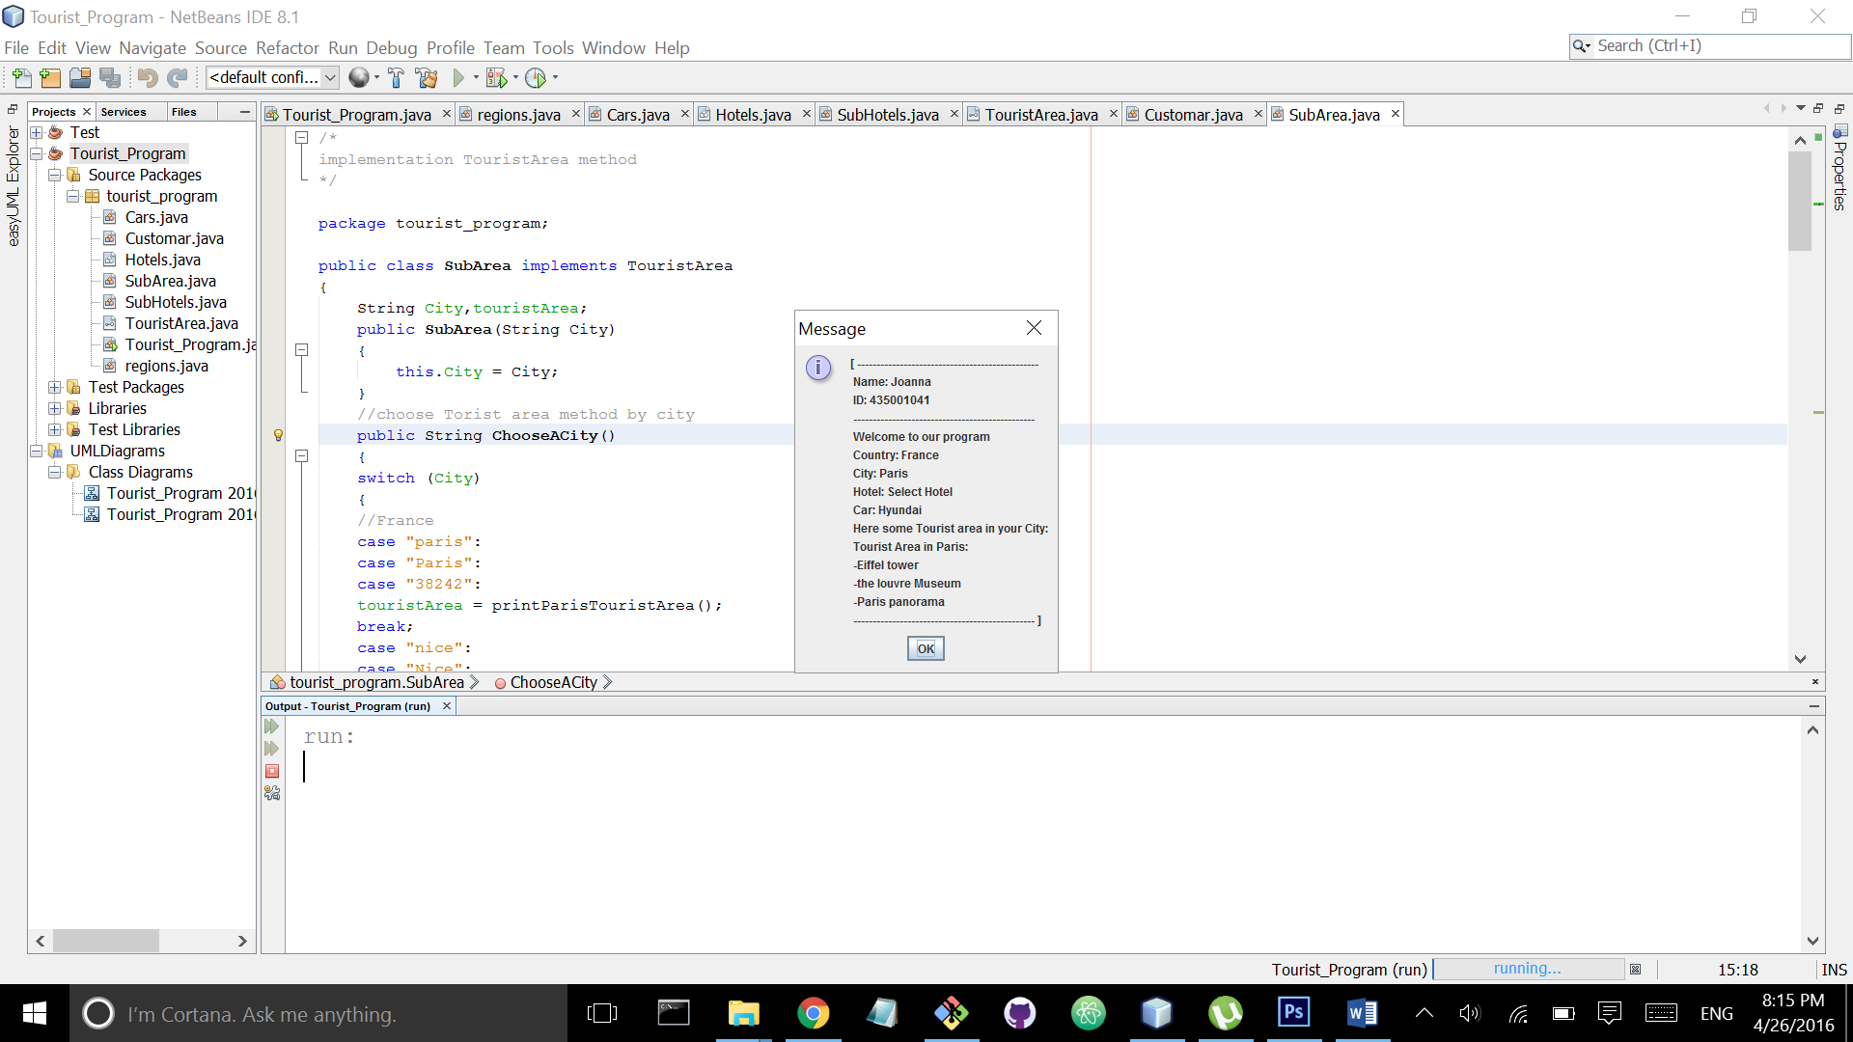

Class Diagram

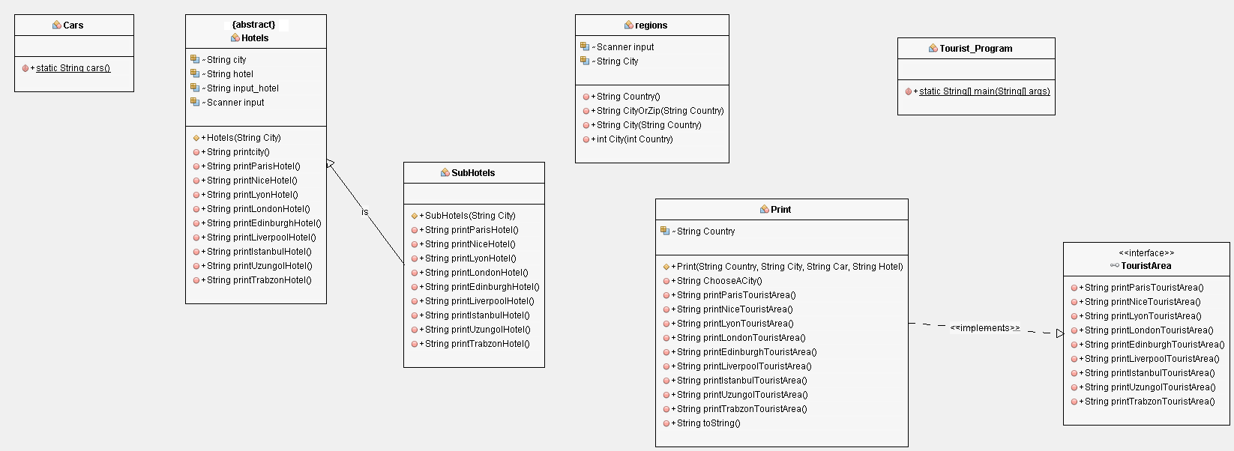

Use Case

