Name____Jorge L Mendoza______ Mark _____________________/50

## Brief introduction __/3

The main feature I am in charge of the HUD. Some of the smaller components that will be part of this will be load save options as well as main menu and help screen.

## Use case diagram with scenario __14

### Use Case Diagrams

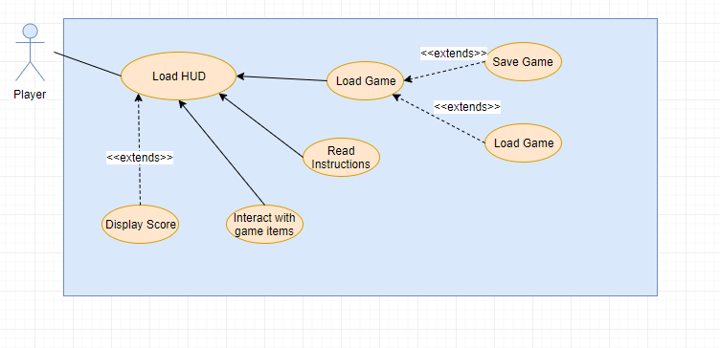

### Scenarios

**User Information**

**Name:** Load Game

**Summary:** The main task will be to save the game like items being carried and score the ability to load the game for future continue of play.

**Actors:** Player.

**Preconditions:** Game has been initialized.

**Basic sequence:**

**Step 1:** Start the Game.

**Step 2:** Options include save or load game.

**Step 3:** Load the Game from Previous saved data.

**Step 4:** start the game with the items that where loaded form before.

**Exceptions:**

**Step 1:** Check old saved games if none is found let the user know.

**Step 2:** If the exit bottom is pressed ask if player wants to save the game.

**Post conditions:** The player is informed about its status.

**Priority:** 2*

**ID:** C01

*The priorities are 1 = must have, 2 = essential, 3 = nice to have.

**User Information**

**Name:** Interact with items

**Summary:** Let the be informed on the HUD which items or score information on real time while game play.

**Actors:** Player.

**Preconditions:** Game has been initialized.

**Basic sequence:**

**Step 1:** Displays Main Menu with options.

**Step 2:** Start a new or load game.

**Step 3:** Display score from new game or the previously status of the old game.

**Step 4:** Display the items as the player obtains more items or drops them.

**Post conditions:** The player is informed about current items.

**Priority:** 2*

**ID:** C01

*The priorities are 1 = must have, 2 = essential, 3 = nice to have.

## Data Flow diagram(s) from Level 0 to process description for your feature _______14

[Get the Level 0 from your team. Highlight the path to your feature]

Example:

### Data Flow Diagrams

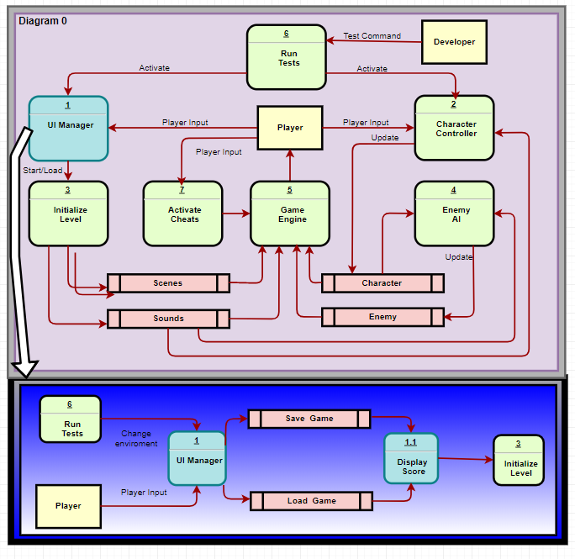

### Process Descriptions

HUD Save/Load

While the game is running display the HUD

END

**\*Notes**: Yours should be much longer. You could use a decision tree or decision table instead if it is more appropriate.

## Acceptance Tests ________9

Ensure that the first screen shows the main menu as the first start of the game. Make sure that the save and load feature work how they are intended by making sure the state of the game was saved. For example, the score of the game and the items.

**Save/load feature**

Run feature 100 times sending output to a file.

The output file will have the following characteristics:

* Json object
* Music on/off
* Items
* Score
* Location of the player

## Timeline _________/10

[Figure out the tasks required to complete your feature]

Example:

### Work items

|  |  |  |
| --- | --- | --- |
| Task | Duration (PHrs) | Predecessor Task(s) |
| 1. Requirements Collection | 6 | - |
| 2. Screen Design | 6 | 1 |
| 3. Prototype Design | 10 | 1 |
| 4. Database Construction | 8 | 2, 3 |
| 5. Coding/Documentation | 8 | 4 |
| 6. Programming | 12 | 4 |
| 7. Testing | 7 | 6 |
| 8. Game Completion | 3 | 5, 7 |

### Pert diagram

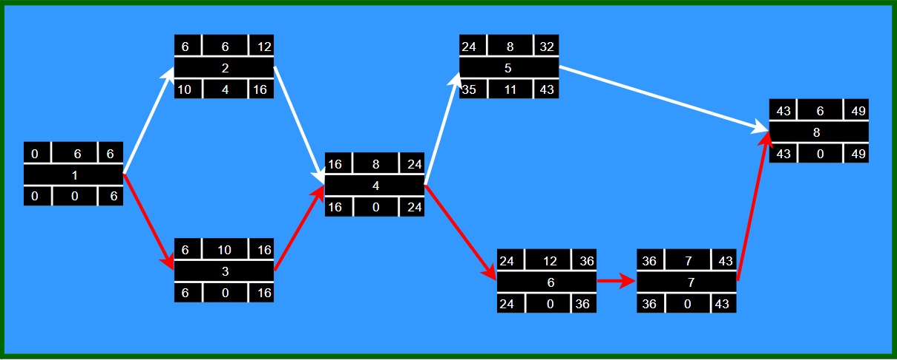

### Gantt timeline

