Name_Tyler Felps_______________ Mark _____________________/50

## Brief introduction __/3

My features include the level design including: traps, doorways, and level creation. Another feature being the sound effects and music.

## Use case diagram with scenario __14

### Use Case Diagrams

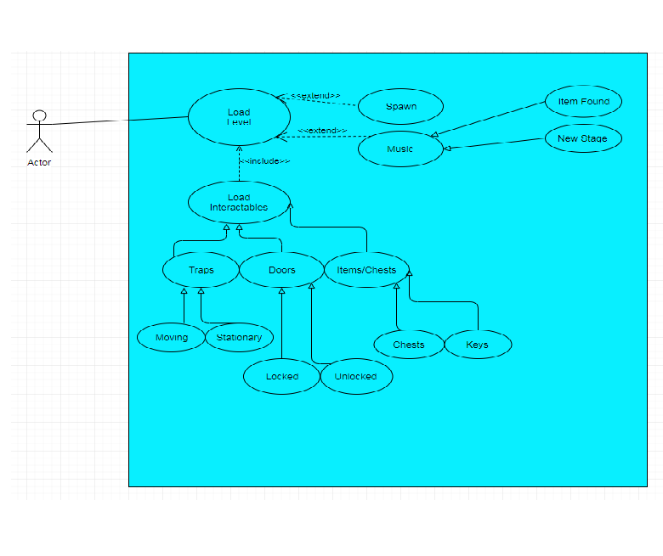

### Scenarios

**Name:** Load Interactable Content

**Summary:** The level should load in various game interactable content

**Actors:** Player

**Preconditions:** The Game has been initialized.

**Basic sequence:**

**Step 1:** Load base level design including level music.

**Step 2:** Load second layer including items/doors/traps/chests.

**Step 3:** Accept how the player will interact with each piece.

**Step 4:** Level’s puzzle and overall design should be playable.

**Exceptions:**

**Step 1:** Level loads before player model, no movement until after player loads in.

**Step 2:** Ignore all input until level has finished loading.

**Post conditions:** Level is finished being displayed.

**Priority:** 1*

**ID:** LVL

*The priorities are 1 = must have, 2 = essential, 3 = nice to have.

## Data Flow diagram(s) from Level 0 to process description for your feature _______14

### Data Flow Diagrams

### C:\Users\Tyler\Downloads\Dataflow Diagram.png

### Process Descriptions

Assign rooms*:

WHILE teacher in two places at once OR two classes in the same room

Randomly redistribute classes

END WHILE

**\*Notes**: Yours should be much longer. You could use a decision tree or decision table instead if it is more appropriate.

## Acceptance Tests ________9

**Level Rendering**

When the game is started, the layout of the first level should render. Start game five or more times, the game should have the first section of level one load first.

**Character Interactions**

Once game has loaded enough, let bot run through levels and ensure that player can pass through doors (loading more level), pick up items, and confirm other player interactions. Run this test multiple times to ensure each piece works.

**Sound Implementation**

Go through each menu and level, ensuring each has some sort of music to go along with it. Walk through multiple doors to ensure each has sound effect. Pick up items and pass through traps checking for each respective sound.

## Timeline _________/10

### Work items

|  |  |  |
| --- | --- | --- |
| Task | Duration (Hours) | Predecessor Task(s) |
| 1. Requirements Collection | 10 | - |
| 2. Layout Per Level | 15 | 1 |
| 3. Doors and Traps | 15 | 1,2 |
| 4. Item Placement | 10 | 1,2 |
| 5. Music Discovery | 10 | - |
| 6. Programming | 20 | 2,3,4,5 |
| 7. Testing | 5 | 6 |
| 8. Installation | 5 | 5, 7 |

### Pert diagram

### C:\Users\Tyler\Downloads\Pert Diagram.png

### Gantt timeline

|  |  |  |  |  |  |  |  |  |  |  |  |  |  |  |  |  |  |  |  |  |  |  |  |  |
| --- | --- | --- | --- | --- | --- | --- | --- | --- | --- | --- | --- | --- | --- | --- | --- | --- | --- | --- | --- | --- | --- | --- | --- | --- |
| 1 |  |  |  |  |  |  |  |  |  |  |  |  |  |  |  |  |  |  |  |  |  |  |  |  |
| 2 |  |  |  |  |  |  |  |  |  |  |  |  |  |  |  |  |  |  |  |  |  |  |  |  |
| 3 |  |  |  |  |  |  |  |  |  |  |  |  |  |  |  |  |  |  |  |  |  |  |  |  |
| 4 |  |  |  |  |  |  |  |  |  |  |  |  |  |  |  |  |  |  |  |  |  |  |  |  |
| 5 |  |  |  |  |  |  |  |  |  |  |  |  |  |  |  |  |  |  |  |  |  |  |  |  |
| 6 |  |  |  |  |  |  |  |  |  |  |  |  |  |  |  |  |  |  |  |  |  |  |  |  |
| 7 |  |  |  |  |  |  |  |  |  |  |  |  |  |  |  |  |  |  |  |  |  |  |  |  |
| 8 |  |  |  |  |  |  |  |  |  |  |  |  |  |  |  |  |  |  |  |  |  |  |  |  |
|  | 5 | 10 | 15 | 20 | 25 | 30 | 35 | 40 | 45 | 50 | 55 | 60 | 65 | 70 | 75 | 80 | 85 | 90 | 95 | 100 | 105 | 110 | 115 | 120 |