Design Documentation Deliverable

# Date 28 March 17

# Group Name/Number Group 16

|  |  |  |
| --- | --- | --- |
| **Student ID** | **Student Name** | **Signature** |
| **16118928** | **Matthew Riley Neil Timothy Paul McCarthy Richard O’Connell** |  |

Please use the checklist below to ensure that your report contains all the items required.

* **Purpose of the website (a brief introduction)**
* **User Types**
* **Justification of Functionality**
* **Detailed Description**
* **Appendices:** 
  + **Web Pages (mock ups of main pages)**
  + **Process Descriptions**
  + **Table Design**
* **Technologies**

**Proofreading Website**

1. **Purpose of Website**

The purpose of NAME is to provide an interactive web platform to facilitate proofreading services for students. The service is available for all academic papers, such as theses, dissertations, assignments, research papers etc.

Currently if students wish to avail of a proofreading/review services, they are may find themselves restricted in their ability to do so; either financially or by subject specialisation. By creating a dedicated proofreading platform, users can utilise the benefits of a repertoire of subject specialists with an interest in helping their peers.

In it’s simplest form, NAME will offer a registered user the ability to upload a sample of the paper to be reviewed to the website by a (registered) user and added to the list of available tasks

* 1. **User Types**
     1. Students (basic user). Once registered, students will have the ability to browse all available or unclaimed documents

Students. Once registered

Students. Once registered, students will have the ability browse available or unclaimed tasks that have been published by other students. The tasks will be displayed/ordered in a way that

Moderators. After accumulating the required ‘score’ from feedback, such users then have the added functionality associated with becoming a moderator. Fu

Administrator. Administrators will have the required permissions allowing them to alter/change any aspect of the site’s appearance, functionality

**1.1.1 Visitor**

.

...

**1.2 Justification of Functionality**

*Use existing websites, articles, ... to provide you with ideas, justification and so forth for the functionality that will be afforded by the proposed system*

...

**1.3 Potential Ramifications**

*Potential ramifications of such a site on intended users/audience and how potential adverse consequences will be addressed in the proposed system.*

...

**2.0 Detailed Description**

*Description of how proposed system will work. Include flowcharts to describe overall process; individual processed etc.*

*Referring to information in three Appendices - Processes, Web pages, Tables.*

When the Home Page of the proposed site is launched an image similar to that shown in Figure 1 is displayed..........

To produce this page several processes are executed. Process **P1** is executed to produce a unique list of restaurant names that are displayed at three locations on this webpage (so that a user can select a restaurant when he/she wishes to write a review, when he/she opts to read reviews, and when he/she chooses to visit a restaurant home page).

**P2** is executed to display the reviews for a restaurant.

**.....................................................................................................**

**.....................................................................................................**

**.....................................................................................................**

**4.0 Technologies**

*You should describe what kind of technologies, e.g. operating system, PHP libraries, frameworks and so forth you wish to use.*

...

**Appendix 1: Web Pages**

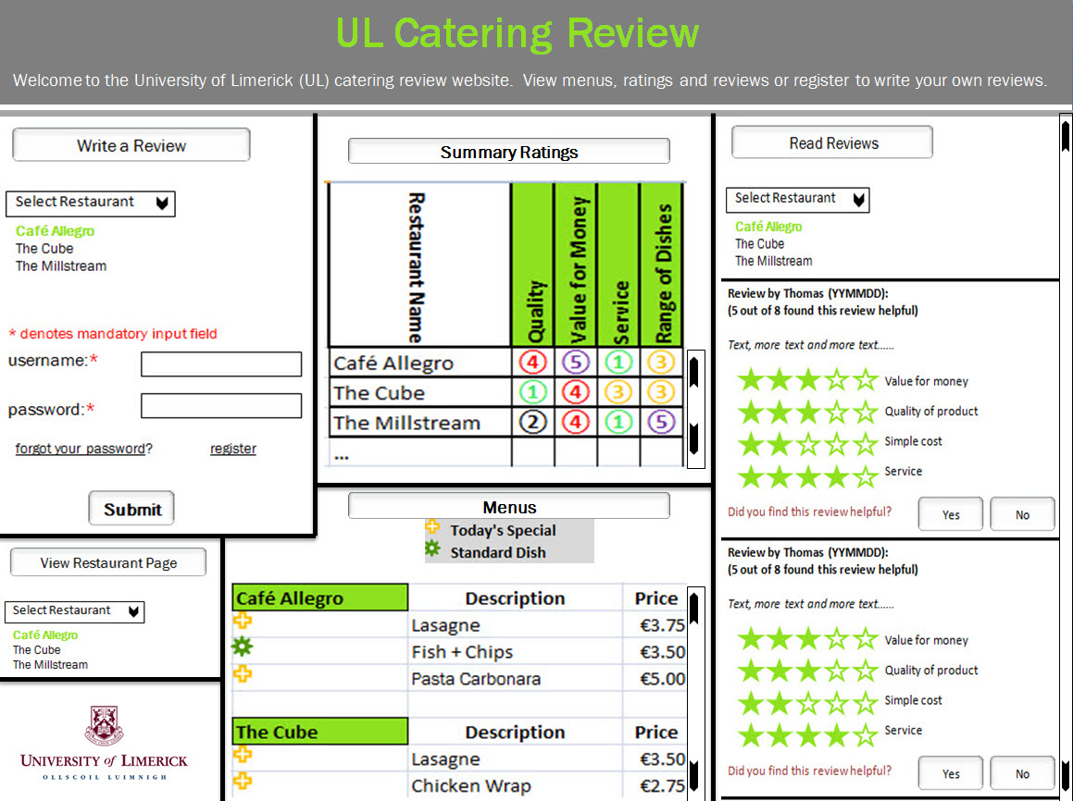

**Figure 1:** Home Page of UL Catering Review Website

**Appendix 2: Tables**

*For each table state its name and its primary identifier. In addition for each attribute state its name, its data type, its length and any constraints.*

**Table Name:** Restaurant

**Primary ID:** RestaurantID

**Description:** The Restaurant table stores for each restaurant its name, the restaurant manager's name, a brief description of the restaurant, its location, its opening hours and the name of the image file to display for this restaurant.

|  |  |
| --- | --- |
| a1.jpg | * **RestaurantID** each restaurant is uniquely identified by a number, permissible numbers are in the range 1 to n where n is the number of restaurants * **RestaurantManagerName** each restaurant is managed by a manager, a manager may manage more than one restaurant. This attribute is alphabetic and up to 30 characters in length   ... |

***Table 2 details***

***Table 3 details***

***Table 4 details***

***Table 5 details***

***Table 6 details***

***Table n details***

**Show relationships between tables**

|  |  |
| --- | --- |
| Many reviews can be written for the same restaurant. A Review is written for a restaurant, each Review is assigned a ReviewID, a review happens on a particular date and is written by a reviewer. Each review has a helpfulness indicator and a not helpfulness indicator. A Review may have Review Text and a Review must have rating of quality, value for money, service and range of dishes.  ...  ... | a1.jpg |

**Appendix 3: Processes**

|  |  |
| --- | --- |
| **Process Number** | P1 |
| **Process Title** | Unique list of restaurant names |
| **Brief Description** | Retrieve a unique list of restaurant names |
| **Inputs** | No user input. A query is issued to the **Restaurant** table. |
| **Detailed Description** | A query is issued to the **Restaurant** table to retrieve a unique list of restaurant names. |
| **Output** | A unique list of restaurant names. |

|  |  |
| --- | --- |
| **Process Number** | P2 |
| **Process Title** | Collate Restaurant Reviews |
| **Brief Description** | Retrieve information, collate it and produce a list of reviews for a restaurant. |
| **Inputs** | The user must select a restaurant name from a dropdown list. |
| **Detailed Description** | A query is issued that involves three tables: **Review**, **ReviewText** and **ReviewRating** that selects the review information for the restaurant chosen by the end user. Most recent reviews are displayed first. |
| **Output** | A list of review details for a restaurant ordered by date. |