CCSU Journalism Site

User Manual

CS 410 | Dr. Stan Kurkovsky

For CCSU Journalism Department Under Guidance of Dr. Vivian Martin

Team One: John O’Kelly, Owen Morrissey, Steve Lesicka, Chris Kobierowski

Install

To install and use our system, you must first acquire hosting and install WordPress on the server. The hosting provider should provide a guided setup process for the install.

After installing WordPress on the server, create an Administrator account. Keep the password for this account safe, as it will be key to further setting up the site.

We must first place our theme into the themes directory for the WordPress install. Extract the contents of ‘CCSUJournalism.zip’ to the theme directory on the server: ‘\wp-content\themes’

Base Directory



/wp-content/

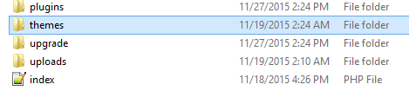

/wp-content/themes/

Place the folder here, in the themes folder. When complete, it should look like this:

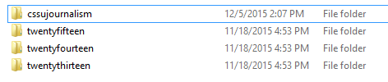

WordPress Settings

Go through each of the following settings:

General, Writing, Discussion

And configure as desired. Modify settings outside of these sections and the ones below at your own risk, be sure to remember what you changed just in case something breaks. We could not test every possible configuration.

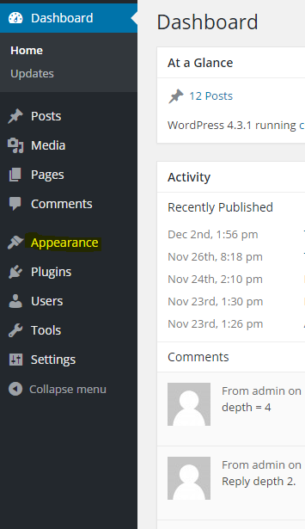

On this page, select the ccsujournalism theme and press ‘activate’. 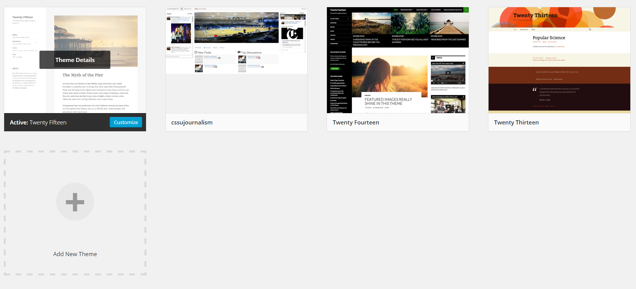

The theme should now be activated and ready for use on the site.

Theme Configuration and Setup

**Dynamic Sidebars**

In order to have the theme display correctly, there are some steps that must be performed beforehand.

In the WordPress dashboard, again navigate to ‘Appearance’ and select the sub-menu Widgets. On this page, we will be able to configure the two sidebars that are present on the desktop version of the site.

The sidebars are 100% user customizable and can display a wealth of information. To start, we can have them display Twitter and Facebook embeds for the CCSU Journalism site.

The widgets page will look something like this when we are finished:

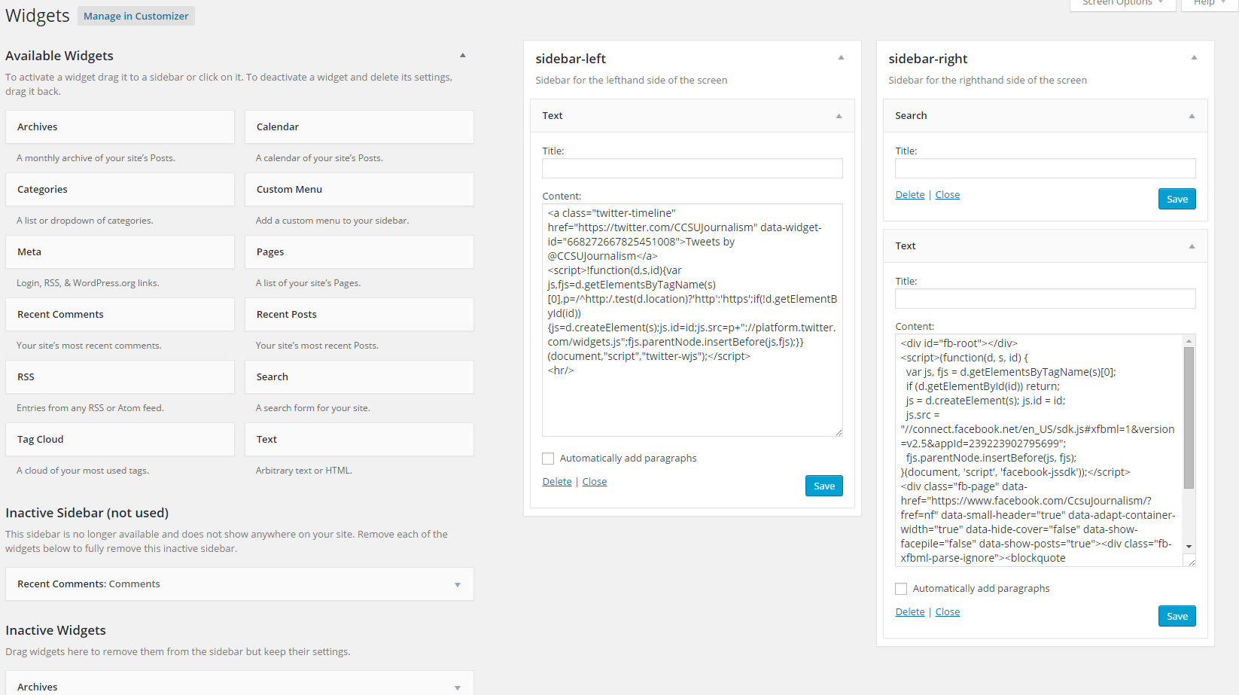

1 Final Widgets Page

To start, Begin by removing any widgets that may have been assigned to the left and right sidebars by default. You can do this by clicking and dragging the widgets off of the sidebar on this screen.

When both sidebars are empty, we can add embeds. In the root theme directory **[\wp-content\themes\cssujournalism\]** there are two files: sidebar-left.txt and sidebar-right.txt. Open these using any text editor. These files contain the embed codes for the widgets so they can easily be pasted in. They are already configured for CCSU Journalism’s accounts.

First, drag over a ‘text’ field from the available widgets category into the sidebar-left field. When this is complete, it should look like the left image at first. Then, copy the contents of the sidebar-left.txt into the ‘Content’ box. After, it should look like the image on the right.

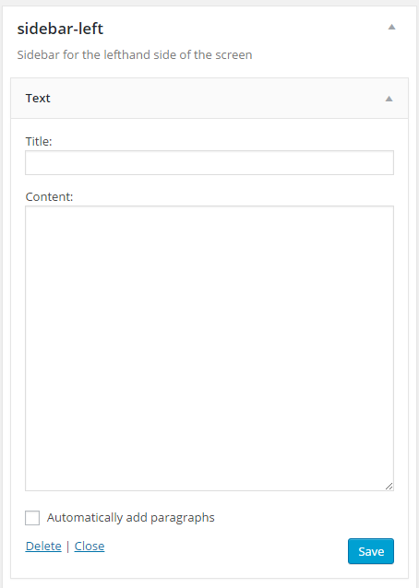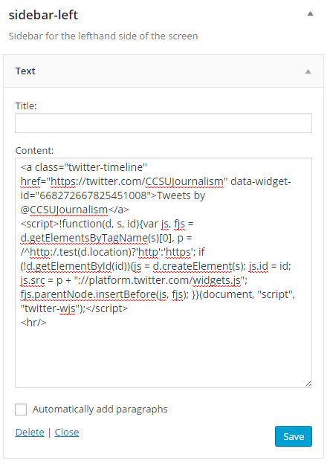

Now, press save. The configuration is saved in the background.

Repeat this process, but for the right sidebar and using the sidebar-right.txt file for the Facebook embed. For the right sidebar, it will be nice to add a search bar. In order to do this, simply drag over the ‘Search’ widget. Leave the title empty, as it looks best without an added title (It defaults to Search). The widgets will display in the same order as they are presented in this view.

Refer to the above image *Final Widgets Page* for an example of what the final settings will look like.

When these steps are completed, the left and right sidebars should appear on the site.

**Categories**

There are a few key categories that must be present for the theme to work properly.

|  |
| --- |
| **Required Categories** |
| Top Stories |
| Videos |

Navigate to **Posts > Categories** in the WordPress Dashboard. The page should contain the following to add categories:

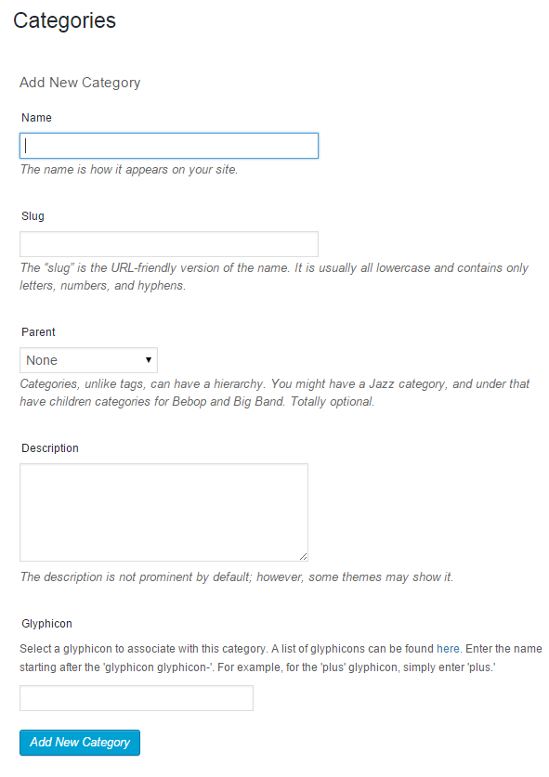

For the name, enter ‘Top Stories’ (without quotes, exactly as written.) Leave the ‘slug’ field blank and ‘parent’ none. You may provide a description and a custom Glyphicon for the field. When finished, press ‘Add New Category.’

Repeat those steps for the ‘Videos’ category. After adding these categories you are free to add as many or as little categories as desired.

**Custom Theme Options**

In the WordPress dashboard, navigate to **Settings > Theme Options.** On this page, we can enable live coverage and pick the order in which categories appear on the homepage. To do this, simply click and drag the categories into the desired order and press ‘Save Changes.’ The order will be updated.

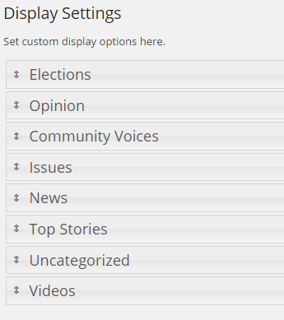

On this page we can also enable live coverage. This just adds a notification to the navigation bar that indicates that live coverage is currently going on. For more on live coverage, see the live coverage section. When not enabled, the navbar looks like this:



Enabled:



Remember to enable it when beginning coverage and disable when complete.

***Setting Up Live Coverage***

In order to set up for live coverage, you must first obtain an account on one of the various livestreaming websites. Our example used UStream, but any streaming provider that allows for embedded streams (most likely all of them) will work.

From the WordPress dashboard, select **Pages>Add New**.

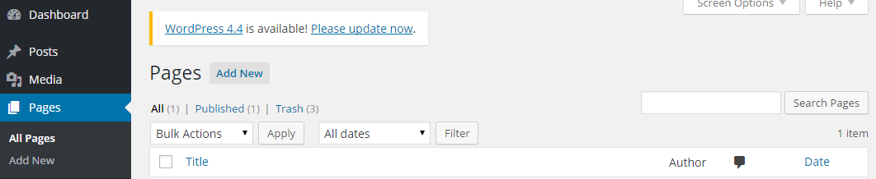

The resulting page looks similar to adding a regular post, except there are a few steps we must take here.

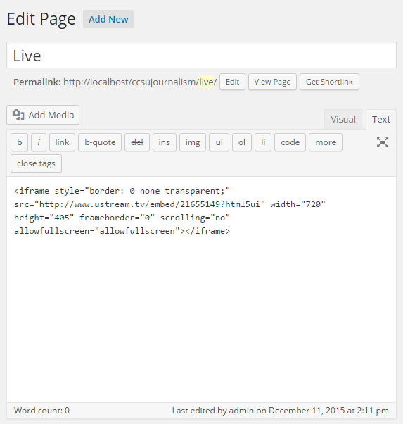

Set the title to whatever you would like. Here we chose ‘Live’. Be sure to set the editor mode to “Text” rather than visual when pasting in the embed code for the live stream into the editor.

**Finally, set the pages ‘slug’ to ‘live’. This is regardless of the chosen title.**

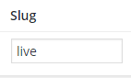

Posting and Content Management

*Initial Setup*

On the sidebar in the Dashboard, select Posts > Add New.

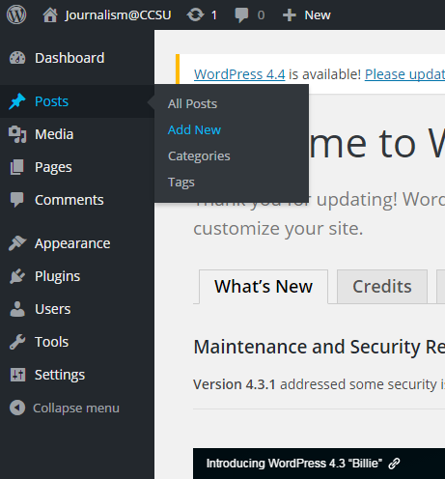

In the top right-hand side of the screen, select “Screen Options”



Ensure all of the items under “Show on screen” are checked.

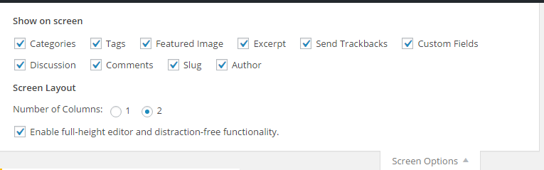Now we are ready to post content.

Post Fields

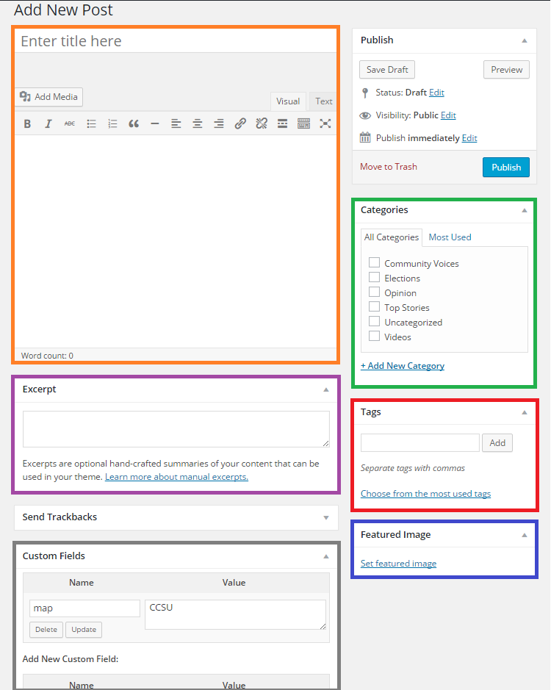

***Post Title / Post Body***

These fields specify the title and text body of the post.

***Category Selection***

Here we can select which category or categories to assign a post to. If the post is in the category ‘Top Stories’ or ‘Videos’, special properties are assigned to those posts. Top Stories are displayed on the carousel and videos are shown in the video category.

**Tags**

Here we can set the tags for the post. There are a few important tags that serve functionality for the site. They are:

|  |  |  |
| --- | --- | --- |
| **Key Tags** | **Glyph Tags** | Glyph tags are used to signal that a post should have a media glyph assigned to it. The media glyphs are displayed everywhere the post is referenced: |
| Campus | Video |
| Community | Audio |
| State | Image |
| Nation |  |

Posts assigned to the key tags are organized into these displays on the homepage, respectively:

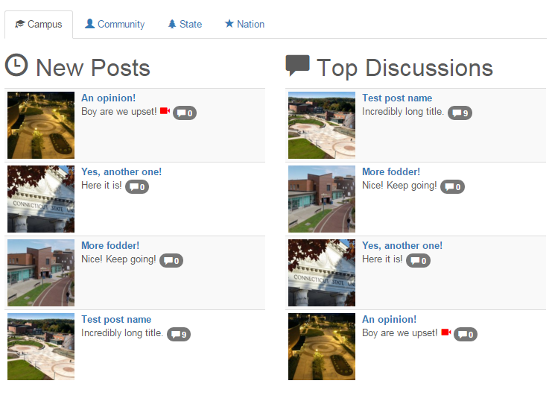

A post can have as many tags as desired, including any combination of the ones above.

Featured Image a.k.a Thumbnail / Carousel Image

In this field we can set the thumbnail for the post as well as the carousel image (they will be the same if the post is in the carousel. The images will resize automatically.) After clicking to select an image, the website’s media library will appear. Here you can manage all the media for the site:

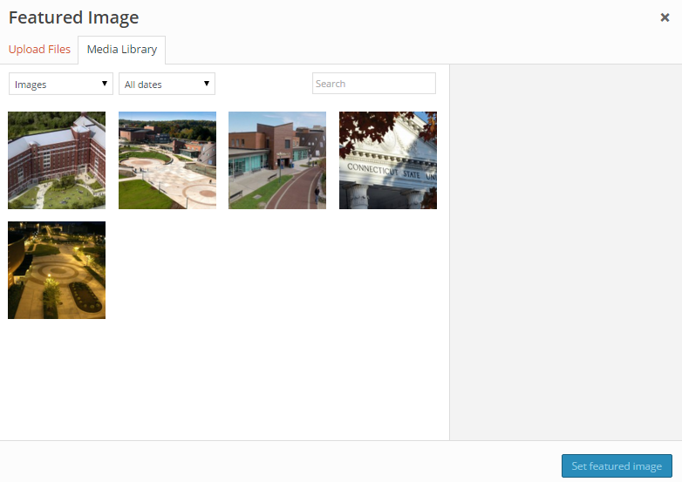

Select ‘Upload Files’ at the top of the screen to add files to the media library. This process is fairly straightforward. Click an image from the library and press “Set featured image” to assign that thumbnail to that post. The largest version is automatically selected for the carousel, so do not worry about the thumbnail size.

For the carousel, an image size of at least 600x400 is reccomended. Thumbnails are 100x100 and resized automatially.

**Excerpt**

Set the post synopsis here. This text is what is displayed next to the post title on the main page and category display page; so be sure to set it to something catchy ☺

Custom Fields

Here we can set the parameters to display a map associated with a post. Simply add a new custom field named ‘map’ and type in any address (it goes through Google; so names of places also work. E.g. “CCSU” will display a map with a pin on CCSU.)

Here is what a map with the field set to “CCSU” looks like:

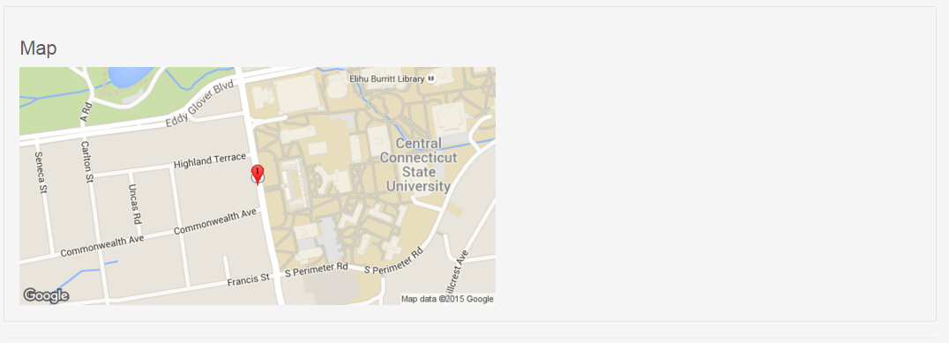

Leftovers

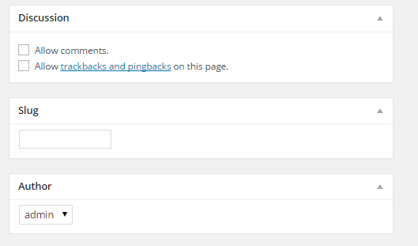

The Discussion field allows you to set comments on or off for a post. The slug post can be ignored – it is used to modify the display URL of a post. And finally, the Author section allows you to select and assign an author to a post.

Closing

Recommended Plugins

*Social Media Feather*

<https://wordpress.org/plugins/social-media-feather/>

A lightweight social media button plugin. Well made, nice icons, good display persistence with minimal setup. Excellent mobile compatibility. Configure it’s settings in **Settings > Social Media** after installation.

Testing Mobile View

If you wish to preview what an article or the site looks like in mobile view, use google chrome and press F12 to open up the developer’s console. When open, press the following button:

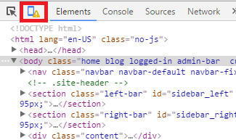

Configure what device you want to emulate along the top here:

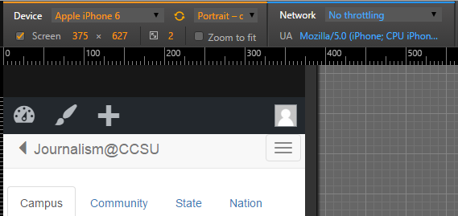

Make sure to refresh the page after opening the emulator so the User Agent (the string that tells the webserver what kind of device is accessing it) updates and the correct page is delivered.

Credits for Framworks/Libraries

*Tax Meta Class*

*Ohad Raz*

Allows custom options to be added to categories.

*Bootstrap*

Twitter, inc.

Front-end design framework.

*JQuery*

The JQuery Foundation

JavaScript library for front end design.