**Use Case Scenarios**

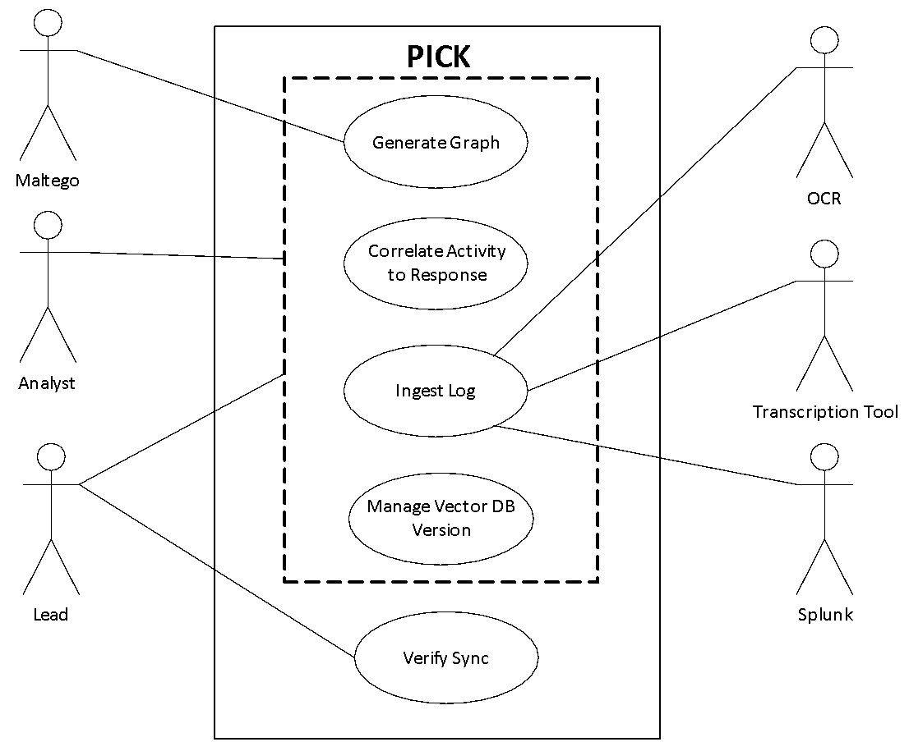

**Ingest Log Use case**

**Scenario 1: Ingest a Log File**

**Trigger:** The user activates the ingestion process.

**Preconditions:** The paths need to have been configured for the project in the directory configuration window.

**Postconditions:** The log files have been cleansed and ingested as validated log entries.

**Actors:** User, OCR, Transcription Tool, Splunk

**Scenario Flow:**

1. The system intakes the log file from the directory specified in the configuration.
2. The system cleanses the log file by checking if the file is empty. (**ALT 1**)
3. The system validates the log file by checking the timestamp is bound by the timestamp specified in the configuration (**ALT 2**)
4. The system extracts data from multimedia log files. (**ALT 3)**
5. The system once more cleanses the log file to see if the file does not contain blank lines, blank rows, and unwanted characters. (**ATL 1**)
6. The system validates the log files that are not validated. (**ALT 2**)
7. The system sends the log file into Splunk, for the transformations of log entries.
8. End of Scenario.

**Alternatives:**

**ALT 1:** The system checks for any blank spaces.

Alt 1-1: System checks for blank lines in log files.

Alt 1-2: System checks for unwanted characters if the log file is of type TMUX.

Alt 1-3: System checks for blank rows if the file is of type CSV.

**ALT 2:** System checks for the timestamp.

ALT 2-1: System ensures that each log entry contains a timestamp per line.

Alt 2-2: System ensures timestamps are bounded by start and end date specified in the event configuration.

Alt 2-3: System ensures CSV files are within a range limit.

Alt 2-3-1: System checks for limit range of minus 23 hours and 59 mins.

Alt 2-3-2: System checks for limit range of plus 23 hours and 59 mins.

**ALT 3:** System checks for the file type.

Alt 3-1: System sends log file to OCR if it is an image.

Alt 3-2: System sends log file to transcriber if it is type audio.