Prevent, Mitigate, and Recover (PMR) Insight Collective Knowledge System (PICK)
Test plan
Version 1.5
04/28/20
Document Control
Approval
The Guidance Team and the customer shall approve this document.
Document Change Control
Initial Release: | 0.1
Current Release: | 1.5
Indicator of Last Page in Document: | *
Date of Last Review: | 04/13/20
Date of Next Review: | 04/27/20
Target Date for Next Update: | 04/28/20
Distribution List
This following list of people shall receive a copy of this document every time a new version of this document becomes available:
Guidance Team Members:
Dr. Steven Roach
Jake Lasley

Customer(s):
Dr. Oscar Perez
Vincent Fonseca
Herandy Denisse Vasquez
Baltazar Santaella
Florencia Larsen
Erick De Nava

Software Team Members:
Ricardo Alvarez
Daniela Garcia
Matthew Iglesias
Jessica Redekop
Diego Rincon
Change Summary
The following table details changes made between versions of this document

Version | Date | Modifier | Description
0.1 | 4/13/20 | Diego Rincon | Added initial test case T1 in Section 4
0.2 | 4/13/20 | Ricardo Alvarez | Added initial version of Section 2
0.3 | 4/14/20 | Jessica Redekop | Began creating Test Suites for Section 3.
0.4 | 4/14/20 | Matthew Iglesias | Section 1.1 – 1.6: Introduction
0.5 | 4/15/20 | Daniela Garcia | Added second test case T2 in section 4
0.6 | 4/26/20 | Jessica Redekop | Added Tests T10 - T13
0.7 | 4/26/20 | Ricardo Alvarez | Added Tests T6 - T10
0.8 | 4/27/20 | Diego Rincon | Added Tests T23 - T25
0.9 | 4/27/20 | Matthew Iglesias | Added Tests T1 – T5
1.0 | 4/27/20 | Daniela Garcia | Added Tests T15-T18 and create vector initial condition
1.1 | 4/27/20 | Diego Rincon | Added Tasks in Section 5.
1.2 | 4/27/20 | Matthew Iglesias | Added Section 6: Environmental and Software Requirements
1.3 | 4/28/20 | Daniela Garcia | Edited TS14-18 to meet changes suggested by TA
1.4 | 4/28/20 | Ricardo Alvarez | Added appendix and T26
1.5 | 4/28/20 | Jessica Redekop | Revised T9-T16

Note: The template presented in this document was taken from:
Donaldson, S., and S. Siegel, Successful Software Development. Upper Saddle River, NJ: Prentice Hall, 2001, pp. 321-323.

Note: The template presented in this document was taken from: Donaldson, S., and S. Siegel, Successful Software Development. Upper Saddle River, NJ: Prentice Hall, 2001, pp. 321-323 and modified by Humberto Mendoza and Steve Roach.

Supplementary information is from:
Pfleeger, S. Software Engineering, Theory and Practice. Upper Saddle River, NJ: Prentice Hall, 1998, p. 365.

Table of Contents
Document Control ii
Approval ii
Document Change Control ii
Distribution List ii
Change Summary ii
1. Introduction 1
1.1. Purpose 1
1.2. Scope 1
1.3. System Overview 1
1.4. Suspension and Exit Criteria 1
1.5. Document Overview 1
1.6. References 2
2. Test Items and Features 3
3. Testing Approach 5
4. Tests 7
4.1. TS1 – Event Information 7
4.1.1. Test T1 - Logging in SPLUNK from the PICK Tool 7
4.1.2. Test T2 – Creating a New Event in SPLUNK 7
4.1.3. Test T3 – Opening an event 9
4.1.4. Test T4 – Test that ensures a start and end date on event 9
4.1.5. Test T5 – Test the “Root Folder” contains three distinct folders: “Red”, “White”, “Blue” 10
4.1.6. Test T6 – test that a “Red Folder” is Selected when inserting a “Red Directory Path” 12
4.1.7. Test T7 – Test that a “Blue Folder” is Selected when inserting a “Blue Directory Path” 13
4.1.8. Test T8 – Test that a “White Folder” is Selected when inserting a “White Directory” Path 14
4.2. TS2 - Ingestion 15
4.2.1. Test T9 – Test Addition of New Event into SPLUNK 15
4.2.2. Test T10 – Test for Audio File Transcribing Ability. 16
4.2.3. Test T11 – Test for Image File Transcribing Ability. 18
4.2.4. Test T12 – Cleansing Non-Alphabetical and Non-Punctuation Characters. 19
4.2.5. Test T14 – Test to validate timestamps within a certain range. 20
4.2.6. Test T15 – Test to advise the analyst for invalid files. 2
4.2.7. Test T16 – Test the ability to appeal an invalid file. 2
4.3. TS3 - Graphing 3
4.3.1. Test T17 Creating a vector 3
4.3.2. Test T18 – Test adding a new node to the graph not connected to a log entry 3
4.3.3. Test T19 – Test adding a new node to the graph that is connected to a log entry 4
4.3.4. Test T20 – Test connecting two nodes with a relationship 5
4.3.5. Test T21 – Test adding information to an existing node 6
4.4. TS4 - Network 7
4.4.1. Test T22 – Test analyst restrictions on events 7
4.4.2. Test T23 – Test connection from analyst to lead 8
4.4.3. Test T24 – Test connection error to Lead when IP is not specified 9
4.4.4 Test T25 – Test server closure after Lead closes connection 10
4.5. TS5 – Database 11
4.5.1. Test T26 – Retrieving Event Data from the Database 11
5. UI Testing 14
6. Test Schedule 15
7. Other Sections 16
7.1. Environmental Requirements 16
7.2. Software Requirements 16
7.2.1. Start SPLUNK Service 16
7.2.2. Start MongoDB Service 17
8. Appendix 19

Introduction

The overview of the PMR Insight Collective Knowledge (PICK) tool test plan follows within the following sub-sections.

Purpose
The purpose of a test plan document is to fundamentally describe, analyze and apply the necessary strategies for testing, scheduling and deliver the appropriate resources for adequate testing. The project is carefully designed and implemented to meet the client’s needs, therefore, requires a tedious test plan. These include but are not limited to the testing of ingestion process, but the transcription, validation and log cleansing.

Scope
The scope of the project is based upon the current version of this test plan document, currently at version 1.5.

System Overview
The PICK tool is based on the client’s needs, which the testing plan is to approach the system accordingly: The log ingestion process is access and ingested given on the set root directory, importing a varied file format in which to be imported. Before the system can move onto the next process of log entry ingestion, it must go through the appropriate transcriber module (depending on format) to be readable in the system. The next step involves cleansing the transcribed file with readable text, which removes unwanted characters which may interfere with correctly ingesting the log entries to tables and vectors. We want to make sure the testing approach involves a variety of appropriate file formats to be imported and cleansed to meet system needs.

Suspension and Exit Criteria
The suspension and exit criteria are two distinct methods implemented in the testing plan.

- Suspension Criteria: met during testing, which the cycle is temporarily suspended until the criteria is resolved.
  - All test cases will be executed if there are no suspension criteria
  - Test cases shall be suspended if 60% of the test cases fail
    - Strictly includes ingestion and validation process
- Exit Criteria: denotes when testing stops, it targets the results of the test and are necessary before we proceed with the next phase in development.
  - All critical tests must pass at a 100% rate

Document Overview
The Test Plan is indoctrinated with labeled sections for the remainder of this document:

Section 2 – Includes test items and features to be tested in the system
Section 3 – Includes the approach to test the system’s functions
Section 4 – Includes documentation to applying testing methods to the system
Section 5 – Includes test scheduling, order in testing phases for the system
Section 6 – Includes hardware and/or software requirements needed to run the system
Section 7 – Includes appendix of any output medium from the tested system

References
[1] S. Roach, and E. T. Ramirez, “PICK Software Requirements and Specification.”

Test Items and Features
Due to the nature of the PICK Tool and the ongoing update of SPLUNK (April 2020), the items to be tested included classes, functions, methods and components in general ranging from networking, graphing and interaction, UI with SPLUNK. All of the classes that hold some sort of intelligence (provide any type of functionality) should be tested considering that this is a new release of the software altogether.

Classes to be tested along with the relevant methods include:
- Ingestion
- Validator
- SPLUNKFacade
- Cleanser
- TableManager
- UI
- AudioTranscriber
- ImageTranscriber
- MongoDBFacade
- Network

Features to be tested (with relevant methods and classes they pertain to):
- Create Event – this is concerned with the event creation and initial setup of it:
  - UI: display_new_event()
  - UI: create_event_button_triggered()
  - SPLUNKFacade: create_index(index_name)
  - SPLUNKFacade: get_index_list()
  - SPLUNKFacade: validate_user_info()
  - MongoDBFacade: add_event()
  - MongoDBFacade: add_vector()
  - Network: set_lead()
- Connect to Event – concerned with how an analyst that is not the lead will connect to an external event setup by another analyst:
  - UI: connect_button_trigerred()
  - UI: display_open_event()
  - Network: get_event_list()
  - Network: connect_user()
  - MongoDBFacade: get_event(event_name)
  - MongoDBFacade: get_vectort(vector_name)
- Ingest directories into database – encompasses all the ingestion chores that shall be done for the log entries to be gathered from raw log files into the event:
  - Ingestion: get_files_from_directory(root_path, white_team_folder, red_team_folder, blue_team_folder)
  - Ingestion: ingest_directory_into_splunk(event_config)
  - Ingestion: validate_files(log_files)
  - Ingestion: validate_file_anyway(log_file)
  - Validator: validate_file(log_file, start_time, end_time)
  - Cleanser: cleanse_log_file(log_file)
  - AudioTranscriber: transcribe_audio_file(log_file)
  - ImageTranscriber: transcribe_image_file(log_file)
  - SPLUNKFacade: add_file_to_index(log_file)
  - SPLUNKFacade: add_directory_monitor(folder_path)
  - MongDBFacade: add_log_file(log_file)
  - TableManager: populate_log_entry_table()
  - TableManager: populate_log_file_table()
  - TableManager: populate_enforcement_action_report_table()
- Recurrent Update of Entries – the functionality for recurrent refreshing of available entries to the user:
  - SPLUNKFacade: refresh_log_entries()
  - Ingestion: delta_found_triger()
  - SplunkFacade: edit_log_entry(log_entry_id)
  - SplunkFacade: remove_log_entry(log_entry_id)
- Search and Filter – functionality for searching and filtering through the log entries of the event:
  - UI: filter_search_triggered()
  - SPLUNKFacade: search_in_index(index, search_arguments)
  - SPLUNKFacade: refresh_log_entries()
  - TableManager: populate_log_entry_table()
- Manage Tables (General) – Interaction between the user and data from the tables, including log entries, nodes, vectors, log files and relationships:
  - UI log_entry_table_clicked()
  - UI: log_file_table_clicked()
  - UI: enforcement_action_report_table_clicked()
  - UI: vector_table_clicked()
  - UI: relationship_table_clicked()
  - UI: display_vector_list(vector_list)
  - UI: display_long_description(long_description)
  - TableManager: populate_log_entry_table(log_entries)
  - TableManager: populate_log_files_table(log_files)
  - TableManager: populate_vector_table(vector_list)
  - TableManager: populate_nodes_table(nodes)
  - TableManager: populate_relationship_table(relationships)
  - TableManager: export_csv_from_table(table, folder_path, filename)
  - SplunkFacade: remove_log_entry(log_entry_id)
  - SplunkFacade: edit_log_entry(log_entry_id, field)
  - MongoDBFacade: add_node(node)
  - MongoDBFacade: remove_node(node_id)
  - MongoDBFacade: edit_node(node_id, field)
  - MongoDBFacade: add_relationship(relationship)
  - MongoDBFacade: remove_relationship(relationship_id)
  - MongoDBFacade: edit_relationship(relationship_id, field)
  - GraphInterface: update_graph()
- Graphing – functionality concerned with the visual displaying and exporting of the graph:
  - GraphInterface: display_graph(graph)
  - GraphInterface: update_graph(graph)
  - GraphInterface: export_graph(graph)
  - UI: tick_triggered()
  - MongoDBFacade: get_graph()
  - MongoDBFacade: get_nodes()
  - MongoDBFacade: get_vector()
- Version Control – networking methods used for vcs and signaling:
  - Network: connect_to_lead(lead_ip)
  - Network: push_change(change_request, analyst_id)
  - Network: accept_change(change_request, analyst_id)
  - Network: reject_change(change_request, analyst_id)

Testing Approach

<<Describe the approach to be used to the test the system. This description includes specifying the types of tests to be performed, e.g., tests designed to exercise system functions one by one; tests designed to exercise sequences of functions that approximate operational use of the system; tests designed to stress the system to its design and requirements limits. The description lists the specific tests to be performed, but does not give the test steps. For each of these tests, give it a name and specify its objective. Label the criticality of the test cases. >>

Table 1: Event Information
TEST SUITE Event
Description of Test Suite | This test suite will cover the tests appropriate to operational functionalities of creating an event.
Test Case Identifier | Objective | Criticality
T1 | Test logging into SPLUNK | Critical
T2 | Test that an event can be created and added to SPLUNK. | Critical
T3 | Test opening an event. | Critical
T4 | Test that ensures a start and end date on event. | Critical
T5 | Test that the root folder of the event has 3 distinct folders: “Red”, “White”, “Blue” | Critical
T6 | Test that a “red folder” is selected when inserting a “red directory path” | Critical
T7 | Test that a “blue folder” is selected when inserting a “blue directory path” | Critical
T8 | Test that a “white folder” is selected when inserting a “white directory path” | Critical

Table 2: Ingestion
TEST SUITE Ingestion
Description of Test Suite | This test suite will cover the tests appropriate to the functional requirements of the ingestion process.
Test Case Identifier | Objective | Criticality
T9 | Test addition of new event to SPLUNK. | Critical
T10 | Test opening an existing event. | Critical
T11 | Test for audio file transcribing ability. | Critical
T12 | Test for image file transcribing ability. | Critical
T13 | Cleansing non-alphabetical and non-punctuation characters. | Critical
T14 | Test to validate timestamps within a certain range. | Critical
T15 | Test to advise the analyst for invalid files. | Critical
T16 | Test the ability to appeal an invalid file. | Critical

Table 3: Graph
TEST SUITE Graph
Description of Test Suite | This test suite will cover the tests appropriate to connect the lead and analyst to the system and allocates exclusive functionalities.
Test Case Identifier | Objective | Criticality
T17 | Test to create a vector | Critical
T18 | Test adding a new node to the graph not connected to a log entry | Critical
T19 | Test adding a new node to the graph that is connected to a log entry | Critical
T20 | Test connecting two nodes with a relationship | Critical
T21 | Test adding information to an existing node | Critical

Table 4: Network
TEST SUITE Connection to Lead Analyst
Description of Test Suite | This test suite will cover the tests appropriate to connect the lead and analyst to the system and allocates exclusive functionalities.
Test Case Identifier | Objective | Criticality
T22 | Test to only allow leads to create events. | Critical
T23 | Test to connect analyst to lead. | Critical
T24 | Test to reject connection if no lead is selected. | Critical
T25 | Test to close server when lead closes connection. | Critical

Table 5: Database
TEST SUITE Event Creation
Description of Test Suite | This test suite will cover the tests appropriate to the version control portion of the application.
Test Case Identifier | Objective | Criticality
T26 | Test the retrieval of information from the database | Critical

Tests
The purpose of this section is to:
- document test input, specific test procedures, and outcomes.
- establish test methods,
- explain the nature and extent of each test

TS1 – Event Information

Test T1 - Logging in SPLUNK from the PICK Tool
Objective: Test logging into SPLUNK from the PICK tool
Description: This initial condition encompasses logging in to the SPLUNK account to be used while testing this project, all the indexes and entries derived from the tests will be contained in it.
Initial Condition:
- The user must be running SPLUNK

Table 6: T1
Test No.: T1 |  |  | Current Status: Pending
Test Title: Logging in SPLUNK from the PICK Tool
Testing Approach: This test will provide the utilization for logging into SPLUNK platform using admin username and password.
STEP  1 | OPERATOR ACTION  In the Team Configuration section from the Event tab, click the Lead checkbox. | PURPOSE  Signal the operator as the lead of the event and the one in charge of the initial ingestion and creation of the event. |  | EXEPCTED RESULTS  A pop-up asking for the login credentials for SPLUNK is displayed. | COMMENTS
2 | Enter the credentials:  - username: “t3testuser”  - password: “t3testpw” | Log in the SPLUNK service. |  | A text prompt “Successful connection to SPLUNK from user t3testuser” is displayed.

Test T2 – Creating a New Event in SPLUNK
Objective: Test to create a new event in SPLUNK
Notes: The estimated duration of this test is 5 minutes, before the ingestion starts and the structural check is done. In order to execute this test, the following resources shall be met:
Initial Conditions:
- The user is operating an instance of SPLUNK with appropriate credentials
- The user is checked as the Lead Analyst for the event

Table 7: T2
Test No.: T2 |  |  |  | Current Status: Pending
Test title: Test the creation of an event and added onto SPLUNK
Testing approach: This test will provide the creation of a new event which will be added onto the SPLUNK platform.

STEP  1 | OPERATOR ACTION  Click the File dropdown in the top left corner of the main window. | PURPOSE  Access the menu that gives the options to create, open or edit an event. |  |  | EXEPCTED RESULTS  A dropdown menu is displayed containing “New”, “Open”, “Edit” and “Exit” options. | COMMENTS
2 | Click the New option from the dropdown menu. | Open the pop-up that will enable the user to create a new event. |  |  | The create event dialog is displayed.
3 | Enter a start date in the format of “MM/DD/YYYY” | Sets up the start date of the event |  |  | Start date field is updated
4 | Click the Save Event button. | Create the event to be used in this test |  |  | A text prompt below the description textbox will appear with the message “Event t1_event was created.”.
5 | Open the web browser and enter the address “http://localhost:8000” | Access SPLUNK application |  |  | The SPLUNK web application opens
6 | Login with the credentials “t3testuser” and “t3testpw” to gain access. | Login to the same user that created the event |  |  | The homepage of the SPLUNK is displayed
7 | Click search in the app bar to start a new search | To search for created event |  |  | Search bar is highlighted, ready for user input
8 | Type t1_event in the search bar field | Searches the created event |  |  | The event t1_event is displayed in the results.
Concluding Remarks:
Testing Team:  Daniela, Diego, Jessica, Matthew, Ricardo |  |  | Date Completed:

Test T3 – Opening an event
Objective: Test to open an event.
Notes: The estimated duration of this test is < 1 minute.
Initial Conditions:
- The user is operating an instance of SPLUNK
- The event <<event_name>> has been previously created.

Table 8: T3
Test No.: T3 |  |  |  | Current Status: Pending
Test title: Opening an Event

Testing approach: The following will be testing the persistence of event data.
STEP  1 | OPERATOR ACTION  In the Team Configuration section from the Event tab, click the Lead checkbox. | PURPOSE  Signal the operator as the lead of the event and the one in charge of the initial ingestion and creation of the event. |  |  | EXPECTED RESULTS  A pop-up asking for the login credentials for SPLUNK is displayed. | COMMENTS
2 | Enter the credentials:  - username: “t3testuser”  - password: “t3testpw”  and press OK. | Log in the SPLUNK service. |  |  | A text prompt “Successful connection to SPLUNK from user t3testuser” is displayed.
3 | In the File menu at the top left corner of the application select Open Event. | Open a window to recall the session of the previous event. |  |  | The Open Event dialog is displayed (see appendix 9)
4 | In the Event Name dropdown select <<event_name>> and click the OK button at the bottom right of the dialog. | Open the previously initialized event. |  |  | The Log File, Vector Configuration, Nodes, Relationships and Log Entries tables are populated with the previously stored information.
Concluding Remarks: This test validates the timestamp validation process.

Testing Team:  Daniela, Diego, Jessica, Matthew, Ricardo |  |  | Date Completed:

Test T4 – Test that ensures a start and end date on event
Objective: Test the existence of a timestamp range is correlated to each event
Notes: The estimated duration of this test is 1 minute, before the ingestion starts and the structural check is done. In order to execute this test, the following resources shall be met:
Initial Conditions:
- The user is operating an instance of SPLUNK with appropriate credentials
- A set of nodes and vectors must exist within the specified date range for verification
Table 9: T4
Test No.: T4 |  |  |  | Current Status: Pending
Test title: Test that an event contains a start and end date
Testing approach: This test follows a Boolean-type function that will verify each event created is embedded with a date range (start and end), in which the user desires.
STEP  1 | OPERATOR ACTION  Click the File dropdown in the top left corner of the main window. | PURPOSE  Access the menu that gives the options to create, open or edit an event. |  |  | EXEPCTED RESULTS  A dropdown menu is displayed containing “New”, “Open”, “Edit” and “Exit” options. | COMMENTS
2 | Click the New option from the dropdown menu. | Open the pop-up that will enable the user to create a new event. |  |  | The create event dialog is displayed.
3 | Enter a start date of “01/01/2000” in the format of “MM/DD/YYYY” | Sets up the start date of the event |  |  | Start date field is updated | Start date creates a boundary for log entries within that or after that date.
4 | Enter an end date of “01/01/2020” in the format of “MM/DD/YYYY” | Sets up the end date of the event |  |  | End date field is updated | End date creates a boundary for log entries within that or before that date.
5 | Click the Save Event button. | Create the event to be used in this test |  |  | A text prompt below the description textbox will appear with the message “Event t2_event was created.”.
6 | Click the File dropdown in the top left corner of the main window. | Access the menu that gives the options to create, open or edit an event. |  |  | A dropdown menu is displayed containing “New”, “Open”, “Edit” and “Exit” options.
7 | Click the Edit option from the dropdown menu. | To verify the saved event contains the selected start and end date |  |  | Edit event dialog is displayed with current credentials
Concluding Remarks:
Testing Team:  Daniela, Diego, Jessica, Matthew, Ricardo |  |  | Date Completed:

Test T5 – Test the “Root Folder” contains three distinct folders: “Red”, “White”, “Blue”
Objective: Test the existence of the Root Directory based on the given path
Notes: The estimated duration of this test is 2 minutes, after the ingestion starts and the structural check is done it’s not necessary to wait until the whole directory is ingested. In order to execute this test, the following resources shall be met:
Initial Conditions:
- The user is operating an instance of SPLUNK with appropriate credentials
- The directory home/Desktop/t3 exists with no root directory inside it.
- The operator has been checked as lead analyst and has logged into SPLUNK from the PICK Tool.

Table 10: T5
Test No.: T5 |  |  |  | Current Status: Pending
Test title: Test that a “Root Folder” contains three paths named: “Red”, “White”, “Blue”
Testing approach: This test follows a black-box approach based on the ingestion process. The root directory must contain the specified three folders to verify it is the “Root” directory.
STEP  1 | OPERATOR ACTION  Click the File dropdown in the top left corner of the main window. | PURPOSE  Access the menu that gives the options to create, open or edit an event. |  |  | EXEPCTED RESULTS  A dropdown menu is displayed containing “New”, “Open”, “Edit” and “Exit” options. | COMMENTS
2 | Click the New option from the dropdown menu. | Open the pop-up that will enable the user to create a new event. |  |  | The create event dialog is displayed.
3 | Under the Event Name field type “t3_event”, on the start date select “01/01/2000” and in end date select “01/01/2020” | Set up the event name, start date and end date to be used in this test |  |  | The create event dialog allows for user input for following attributes.
4 | Click the Save Event button. | Create the event to be used in this test |  |  | A text prompt below the description textbox will appear with the message “Event t3_event was created.”.
5 | In the directory section for Root, select the following input “home/Desktop/t4” | Indicate which directory will be used in the ingestion process. |  |  | The directory paths specified are reflected in the textboxes of each directory.
6 | Open the “Root” folder by double-clicking it. | To verify there exists three paths of the team directories in the parent “root” folder |  |  | The folder should contain three subfolders labeled: “Red”, “White”, “Blue”
Concluding Remarks:
Testing Team:  Daniela, Diego, Jessica, Matthew, Ricardo |  |  | Date Completed:

Test T6 – test that a “Red Folder” is Selected when inserting a “Red Directory Path”
Objective: Test the existence of the Red Team Directory based on the given folder path
Notes: The estimated duration of this test is 3 minutes, after the ingestion starts and the structural check is done it’s not necessary to wait until the whole directory is ingested. In order to execute this test, the following resources shall be met:
Initial Conditions:
- The user is operating an instance of SPLUNK with appropriate credentials
- The directory home/Desktop/t4 exists with no red directory inside it.
- The operator has been checked as lead analyst and has logged into SPLUNK from the PICK Tool.

Table 11: T6
Test No.: T6 |  |  |  | Current Status: Pending
Test title: Test that a “Red Folder” is Selected when inserting a “Red Directory” Path
Testing approach: This test follows a black-box approach based on the ingestion scenario; the operator will follow a sequence of steps to trigger a structural error in the root directory.
STEP  1 | OPERATOR ACTION  Click the File dropdown in the top left corner of the main window. | PURPOSE  Access the menu that gives the options to create, open or edit an event. |  |  | EXEPCTED RESULTS  A dropdown menu is displayed containing “New”, “Open”, “Edit” and “Exit” options. | COMMENTS
2 | Click the New option from the dropdown menu. | Open the pop-up that will enable the user to create a new event. |  |  | The create event dialog is displayed.
3 | Under the Event Name field type “t4_event”, on the start date select “01/01/2000” and in end date select “01/01/2020” | Set up the event name, start date and end date to be used in this test |  |  | The create event dialog allows for user input for following attributes.
4 | Click the Save Event button. | Create the event to be used in this test |  |  | A text prompt below the description textbox will appear with the message “Event t4_event was created.”.
5 | In the directory section for Root, select the following input “home/Desktop/t4” | Indicate which directory will be used in the ingestion process. |  |  | The directory paths specified are reflected in the textboxes of each directory.
6 | Click the Start Ingestion button. | Trigger the ingestion process which, in initial phase, does a structural check of the root directories. |  |  | A dismissible dialog appears informing the operator that the white folder doesn’t exists.
Concluding Remarks:
Testing Team:  Daniela, Diego, Jessica, Matthew, Ricardo |  |  | Date Completed:

Test T7 – Test that a “Blue Folder” is Selected when inserting a “Blue Directory Path”
Objective: Test the existence of the Blue Team Directory based on the given folder path
Notes: The estimated duration of this test is 3 minutes, after the ingestion starts and the structural check is done it’s not necessary to wait until the whole directory is ingested. In order to execute this test, the following resources shall be met:
Initial Conditions:
- The user is operating an instance of SPLUNK with appropriate credentials
- The directory home/Desktop/t5 exists with no blue directory inside it.
- The operator has been checked as lead analyst and has logged into SPLUNK from the PICK Tool.

Table 12: T7
Test No.: T7 |  |  |  | Current Status: Pending
Test title: Test that a “Blue Folder” is Selected when inserting a “Blue Directory” Path
Testing approach: This test follows a black-box approach based on the ingestion scenario; the operator will follow a sequence of steps to trigger a structural error in the root directory.
STEP  1 | OPERATOR ACTION  Click the File dropdown in the top left corner of the main window. | PURPOSE  Access the menu that gives the options to create, open or edit an event. |  |  | EXEPCTED RESULTS  A dropdown menu is displayed containing “New”, “Open”, “Edit” and “Exit” options. | COMMENTS
2 | Click the New option from the dropdown menu. | Open the pop-up that will enable the user to create a new event. |  |  | The create event dialog is displayed.
3 | Under the Event Name field type “t5_event”, on the start date select “01/01/2000” and in end date select “01/01/2020” | Set up the event name, start date and end date to be used in this test |  |  | The create event dialog allows for user input for following attributes.
4 | Click the Save Event button. | Create the event to be used in this test |  |  | A text prompt below the description textbox will appear with the message “Event t5_event was created.”.
5 | In the directory section for Root, select the following input “home/Desktop/t5” | Indicate which directory will be used in the ingestion process. |  |  | The directory paths specified are reflected in the textboxes of each directory.
6 | Click the Start Ingestion button. | Trigger the ingestion process which, in initial phase, does a structural check of the root directories. |  |  | A dismissible dialog appears informing the operator that the white folder doesn’t exists.
Concluding Remarks:
Testing Team:  Daniela, Diego, Jessica, Matthew, Ricardo |  |  | Date Completed:

Test T8 – Test that a “White Folder” is Selected when inserting a “White Directory” Path
Objective: Test the existence of the White Team Directory given a folder path
Notes: The estimated duration of this test is 3 minutes, after the ingestion starts and the structural check is done it’s not necessary to wait until the whole directory is ingested. In order to execute this test, the following resources shall be met:
- The operator is running an instance of SPLUNK
- The directory home/Desktop/ts6 exists with no white directory inside it.
- The operator has been checked as lead analyst and has logged into SPLUNK from the PICK Tool.

Table 13: T8
Test No.: T8 |  |  |  | Current Status: Pending
Test title: Test that a “White Folder” is Selected when inserting a “White Directory” Path
Testing approach: This test follows a black-box approach based on the ingestion scenario; the operator will follow a sequence of steps to trigger a structural error in the root directory.
STEP  1 | OPERATOR ACTION  Click the File dropdown in the top left corner of the main window. | PURPOSE  Access the menu that gives the options to create, open or edit an event. |  |  | EXEPCTED RESULTS  A dropdown menu is displayed containing “New”, “Open”, “Edit” and “Exit” options. | COMMENTS
2 | Click the New option from the dropdown menu. | Open the pop-up that will enable the user to create a new event. |  |  | The create event dialog is displayed.
3 | Under the Event Name field type “ts6_event”, on the start date select “01/01/2000” and in end date select “01/01/2020” | Set up the event name, start date and end date to be used in this test
4 | Click the Save Event button. | Create the event to be used in this test |  |  | A text prompt below the description textbox will appear with the message “Event ts6_event was created.”.
5 | In the directory section for Root, select the following input “home/Desktop/ts6” | Indicate which directory will be used in the ingestion process. |  |  | The directory paths specified are reflected in the textboxes of each directory.
6 | Click the Start Ingestion button. | Trigger the ingestion process which, in initial phase, does a structural check of the root directories. |  |  | A dismissible dialog appears informing the operator that the white folder doesn’t exists.
Concluding Remarks:
Testing Team:  Daniela, Diego, Jessica, Matthew, Ricardo |  |  | Date Completed:

TS2 - Ingestion

Test T9 – Test Addition of New Event into SPLUNK
Objective: Test that a new index is created in SPLUNK corresponding to an event.
Notes: The estimated duration of this test is 3 minutes. In order to execute this test, the following resources shall be met:
- The operator is running an instance of SPLUNK
- The operator has been checked as lead analyst and has logged into SPLUNK from the PICK Tool.

Table 14: T9
Test No.: T9 |  |  |  | Current Status: Pending
Test title: Test Addition of New Event into SPLUNK
Testing approach: This test is based on the event creator scenario; the operator will follow a sequence of steps to create an index into SPLUNK.
STEP  1 | OPERATOR ACTION  Click the File dropdown in the top left corner of the main window. | PURPOSE  Access the menu that gives the options to create, open or edit an event. |  |  | EXEPCTED RESULTS  A dropdown menu is displayed containing “New”, “Open”, “Edit” and “Exit” options. | COMMENTS
2 | Click the New option from the dropdown menu. | Open the pop-up that will enable the user to create a new event. |  |  | The create event dialog is displayed.
3 | Under the Event Name field type “ts7_event”, on the start date select “01/01/2000” and in end date select “01/01/2020” | Set up the event name, start date and end date to be used in this test
4 | Click the Save Event button. | Create the event to be used in this test along with the pertaining index to it. |  |  | A text prompt below the description textbox will appear with the message “Event ts7_event was created.”
5 | Open the web browser and enter the address “http://localhost:8000” | To access the SPLUNK Web application. |  |  | The SPLUNK Web application opens.
6 | In the login credentials use “user1” and “password1” to login. | Login to the same user that created the event. |  |  | The main user area of the SPLUNK Web application is displayed.
7 | From the settings dropdown menu, in the data section, select indexes. | Access a list of the existing SPLUNK indexes. |  |  | A table of the existing indexes inside of SPLUNK is displayed, including the index ts7_event.
Concluding Remarks:
Testing Team:  Daniela, Diego, Jessica, Matthew, Ricardo |  |  | Date Completed:

Test T10 – Test for Audio File Transcribing Ability.
Objective: Test the audio transcription function from the ingestion process.
Notes: The estimated duration of this test is 5 minutes. In order to execute this test, the following resources shall be met:
- The operator is running an instance of SPLUNK
- The directory home/Desktop/ts8 exists containing red, blue and white directories.
- The white directory contains an audio file in WAV format.
- The operator has been checked as lead analyst and has logged into SPLUNK from the PICK Tool.

Table 15: T10
Test No.: T10 |  |  |  | Current Status: Pending
Test title: Test for Audio File Transcribing Ability.
Testing approach: This test is based on the ingestion scenario by selecting a
STEP  1 | OPERATOR ACTION  Click the File dropdown in the top left corner of the main window. | PURPOSE  Access the menu that gives the options to create, open or edit an event. |  |  | EXEPCTED RESULTS  A dropdown menu is displayed containing “New”, “Open”, “Edit” and “Exit” options. | COMMENTS
2 | Click the New option from the dropdown menu. | Open the pop-up that will enable the user to create a new event. |  |  | The create event dialog is displayed.
3 | Under the Event Name field type “ts8_event”, on the start date select “01/01/2000” and in end date select “01/01/2020” | Set up the event name, start date and end date to be used in this test
4 | Click the Save Event button. | Create the event to be used in this test along with the pertaining index to it. |  |  | A text prompt below the description textbox will appear with the message “Event ts8_event was created.”
5 | In the directory section for Root, select the following input “home/Desktop/ts8” | Indicate which directory will be used in the ingestion process. |  |  | The directory paths specified are reflected in the textboxes of each directory.
6 | Click the Start Ingestion button. | Trigger the ingestion process. |  |  | The Log File table will be populated containing the audio file.
7 | Select the checkbox to the right of the file name in the Log File table. | Select the file to be viewed in the Enforcement Action Report table. |  |  | The Enforcement Action Report table is populated with the error “No valid timestamp”.
8 | Click the Validate button. | Bypasses the timestamp validation for the file in order to be ingested into SPLUNK. |  |  | The error in the Enforcement Action Report table disappears, the Log Entry table is populated with an entry were the text of the audio file inside the description.
Concluding Remarks:
Testing Team:  Daniela, Diego, Jessica, Matthew, Ricardo |  |  | Date Completed:

Test T11 – Test for Image File Transcribing Ability.

Objective: Test the optical character recognition function from the ingestion process.
Notes: The estimated duration of this test is 3 minutes. In order to execute this test, the following resources shall be met:
- The operator is running an instance of SPLUNK
- The directory home/Desktop/ts9 exists containing red, blue and white directories.
- The white directory contains an image file in JPEG format.
- The operator has been checked as lead analyst and has logged into SPLUNK from the PICK Tool.

Table 16: T11
Test No.: T11 |  |  |  | Current Status: Pending
Test title: Test Addition of New Event into SPLUNK
Testing approach: This test is based on the event creator scenario; the operator will follow a sequence of steps to create an index into SPLUNK.
STEP  1 | OPERATOR ACTION  Click the File dropdown in the top left corner of the main window. | PURPOSE  Access the menu that gives the options to create, open or edit an event. |  |  | EXEPCTED RESULTS  A dropdown menu is displayed containing “New”, “Open”, “Edit” and “Exit” options. | COMMENTS
2 | Click the New option from the dropdown menu. | Open the pop-up that will enable the user to create a new event. |  |  | The create event dialog is displayed.
3 | Under the Event Name field type “ts9_event”, on the start date select “01/01/2000” and in end date select “01/01/2020” | Set up the event name, start date and end date to be used in this test
4 | Click the Save Event button. | Create the event to be used in this test along with the pertaining index to it. |  |  | A text prompt below the description textbox will appear with the message “Event ts9_event was created.”
5 | In the directory section for Root, select the following input “home/Desktop/ts9” | Indicate which directory will be used in the ingestion process. |  |  | The directory paths specified are reflected in the textboxes of each directory.
6 | Click the Start Ingestion button. | Trigger the ingestion process. |  |  | The Log File table will be populated containing the image file.
7 | Select the checkbox to the right of the file name in the Log File table. | Select the file to be viewed in the Enforcement Action Report table. |  |  | The Enforcement Action Report table is populated with the error “No valid timestamp”.
8 | Click the Validate button. | Bypasses the timestamp validation for the file in order to be ingested into SPLUNK. |  |  | The error in the Enforcement Action Report table disappears, the Log Entry table is populated with various entries were the text of the image file logs inside the description.
Concluding Remarks:
Testing Team:  Daniela, Diego, Jessica, Matthew, Ricardo |  |  | Date Completed:

Test T12 – Cleansing Non-Alphabetical and Non-Punctuation Characters.

Objective: Test the cleansing function from the ingestion process.
Notes: The estimated duration of this test is 5 minutes. In order to execute this test, the following resources shall be met:
- The operator is running an instance of SPLUNK
- The directory home/Desktop/ts10 exists containing red, blue and white directories.
- The white directory contains a text file with non-printable characters.
- The operator has been checked as lead analyst and has logged into SPLUNK from the PICK Tool.

Table 17: T12
Test No.: T12 |  |  |  | Current Status: Pending
Test title: Test Addition of New Event into SPLUNK
Testing approach: This test is based on the event creator scenario; the operator will follow a sequence of steps to create an index into SPLUNK.
STEP  1 | OPERATOR ACTION  Click the File dropdown in the top left corner of the main window. | PURPOSE  Access the menu that gives the options to create, open or edit an event. |  |  | EXEPCTED RESULTS  A dropdown menu is displayed containing “New”, “Open”, “Edit” and “Exit” options. | COMMENTS
2 | Click the New option from the dropdown menu. | Open the pop-up that will enable the user to create a new event. |  |  | The create event dialog is displayed.
3 | Under the Event Name field type “ts8_event”, on the start date select “01/01/2000” and in end date select “01/01/2020” | Set up the event name, start date and end date to be used in this test
4 | Click the Save Event button. | Create the event to be used in this test along with the pertaining index to it. |  |  | A text prompt below the description textbox will appear with the message “Event ts10_event was created.”
5 | In the directory section for Root, select the following input “home/Desktop/ts10” | Indicate which directory will be used in the ingestion process. |  |  | The directory paths specified are reflected in the textboxes of each directory.
6 | Click the Start Ingestion button. | Trigger the ingestion process, which in its initial phase, will trigger the cleansing. |  |  | The Log File table will be populated containing the file and the Log Entry table will be populated with the pertaining entries of the text file.
7 | Click the Log Entries tab. | This view will allow the observation of the pertaining log entries ingested into the event’s index. |  |  | The Log Entry table displays the entries corresponding to the ingested file.
Concluding Remarks:
Testing Team:  Daniela, Diego, Jessica, Matthew, Ricardo |  |  | Date Completed:

Test T14 – Test to validate timestamps within a certain range.
Objective: Test to validate timestamps within a certain range.
Notes: This test focuses on the ability to extract the timestamps from each line in a log file and compare it to the start and end date specified in the event configuration. In order to execute this test, the following resources shall be met:
- The operator is running an instance of SPLUNK
- The operator has been checked as lead analyst and has logged into SPLUNK from the PICK Tool.
- 3 log files should be in the root directory:
1. A file with a pre-range timestamp.
3. A file with a post-range timestamp.
2. A file with valid time ranges.

Table 19: T14
Test No.: T14 |  |  |  | Current Status: Pending
Test title: Test to validate timestamps within a certain range

Testing approach: The following will be testing the validation’s time range validation portion in the ingestion process.

Initial State:
Test case T5 should be followed.
STEP  1 | OPERATOR ACTION  Beginning at the Initial State described above, user selects the “Start Ingestion” | PURPOSE  This begins the process of ingestion and updates the Log File Configuration (LFC) table. |  |  | EXEPCTED RESULTS  The PICK Tool processes the log files to be ingested and shows the status of the log files in the application LFC table. | COMMENTS  This might take a while depending on the size of the ingested files.
2 | The user waits for the files to be processed until the LFC is updated. |  |  |  | The LFC shows the validity of each log file depending on the time ranges in the file.
Concluding Remarks: This test validates the timestamp validation process, ad can be immediately followed by test case 15.

Testing Team:  Daniela, Diego, Jessica, Matthew, Ricardo |  |  | Date Completed:

Test T15 – Test to advise the analyst for invalid files.
Objective: Test to advise the analyst for invalid files.
Notes: This test focuses on the ability to display invalid files to the analyst. In order to execute this test, the following resources shall be met:
- The operator is running an instance of SPLUNK
- The operator has been checked as lead analyst and has logged into SPLUNK from the PICK Tool.
- 3 log files should be in the root directory:
1. A file with a missing timestamp.
3. A file with an incorrect time.
2. A valid file

Table 20: T15
Test No.: T15 |  |  |  | Current Status: Pending
Test title: Test to advise the analyst for invalid files

Testing approach: The following will be testing the validation display process in the ingestion

Starting State:
Test case T14 should be followed.
STEP  1 | OPERATOR ACTION  Beginning at the Initial State described above, the user confirms the status of each log file under the “Ingestion Status” column in the LFC table. | PURPOSE  Identify the status of the log files in the table. |  |  | EXEPCTED RESULTS  The LFC table shows the validity of each log file. | COMMENTS
2 | The user checks a box next to the log file in the LFC which they would like to see the status for. | Select which log file will be displayed in the Enforcement Action Report table. |  |  | The EM displays each line number and error message in the log file selected.
Concluding Remarks: This test validates the timestamp validation display process and can be directly followed by test case T16.
Testing Team:  Daniela, Diego, Jessica, Matthew, Ricardo |  |  | Date Completed:

Test T16 – Test the ability to appeal an invalid file.
Objective: Test the ability to appeal an invalid file.
Notes: This test focuses on the ability to display invalid files to the analyst and allow ingestion of any file into SPLUNK. In order to execute this test, the following resources shall be met:
- The operator is running an instance of SPLUNK
- The operator has been checked as lead analyst and has logged into SPLUNK from the PICK Tool.
- The log files should be in the root directory:
1. An invalid file.

Table 21: T16
Test No.: T16 |  |  |  | Current Status: Pending
Test title: Test the ability to appeal an invalid file

Testing approach: The following will be testing the ability to add invalid files into SPLUNK.

Starting State:
Test case T15 should be followed.
STEP  1 | OPERATOR ACTION  Beginning after the initial state described above, the user checks a box next to an invalid log file in the Log File Configuration (LFC) table. | PURPOSE  Select which log file will be displayed in the Enforcement Action Report table. |  |  | EXEPCTED RESULTS  The EM displays each line number and error message in the log file selected. | COMMENTS
2 | The user clicks “Validate Anyways” located under the EM table to process the file into SPLUNK | User appeals an invalid file. |  |  | The system ingests the file into SPLUNK and displays the log entries in the Log Entry Configuration Table.
Concluding Remarks: This allows users to allow the ingestion of any file into SPLUNK regardless of the validation status.
Testing Team:  Daniela, Diego, Jessica, Matthew, Ricardo |  |  | Date Completed:

TS3 - Graphing

Test T17 Creating a vector
Description: This initial condition encompasses opening an event inside the PICK Tool, the field vector_name will be defined
Objective: Creating a vector
Notes: The estimated duration of this test is 3 minutes. In order to execute this test, the following resources shall be met:

Table 22: T17
Test No.: T17 |  |  | Current Status: Pending
Test Title: Creating a Vector
Testing approach: The following will be testing the ability to create a vector.
STEP  1 | OPERATOR ACTION  In the “Event” (Appendix 4) tab, under the “Vector Configuration” section, click the “add” button | PURPOSE  Make sure a vector can be created |  | EXEPCTED RESULTS  A new vector should pop up on the vector configuration table | COMMENTS  The vector will have a default name labeled as “vectorN" where N represent the number of the vector
2 | Double click on the name of the vector to change the vector name | Change the name of the vector from the default name |  | The name of the vector should be updated once the user clicks away
3 | Double click on the description field to give the vector a description | Give the vector a vector description |  | The description of the vector should be updated once the user clicks away

Test T18 – Test adding a new node to the graph not connected to a log entry
Objective: Test adding a new node to the graph not connected to a log entry
Notes: The estimated duration of this test is 3 minutes. In order to execute this test, the following resources shall be met:
- The operator is running an instance of SPLUNK
- The directory home/Desktop/ts10 exists containing red, blue and white directories.
- The white directory contains a text file with non-printable characters.
- Log entries exist in the log entry table
- At least one vector has been created (4.3.1)
Table 23: T18
Test No.: T18 |  |  |  | Current Status: Pending
Test title: Test adding a new node to the graph not connected to a log entry
Testing approach: This test is based on the graphing scenario; the operator will follow a sequence of steps to edit the graph.
STEP | OPERATOR ACTION | PURPOSE |  |  | EXEPCTED RESULTS | COMMENTS
1 | In the drop-down menu at the top of the vector view (Appendix 6) select the name of the vector you with to add the log entry to | Make sure all vectors are shown in the drop-down menu |  |  | There selected log entries should now be in the selected vector | The checkbox will still be selected and need to be unselected manually
2 | Click the button labeled “add” two buttons to the right of the drop-down menu | Create a new node in the table and graph |  |  | A new row should be added to the node table and the graph | The row should be empty
Concluding Remarks:
Testing Team:  Daniela, Diego, Jessica, Matthew, Ricardo |  |  | Date Completed:

Test T19 – Test adding a new node to the graph that is connected to a log entry

Objective: Test adding a new node to the graph that is connected to a log entry.
Notes: The estimated duration of this test is 3 minutes. In order to execute this test, the following resources shall be met:
- The operator is running an instance of SPLUNK
- The directory home/Desktop/ts10 exists containing red, blue and white directories.
- The white directory contains a text file with non-printable characters.
- Log entries exist in the log entry table
- At least one vector has been created (4.3.1)

Table 24: T19
Test No.: T19 |  |  |  | Current Status: Pending
Test title: Test adding a new node to the graph that is connected to a log entry
Testing approach: This test is based on the graphing scenario; the operator will follow a sequence of steps to edit the graph.
STEP  1 | OPERATOR ACTION  Select the log entry/entries from the log entry view (Appendix 6) table that will be added to the graph by selecting the check box next to the log entry name | PURPOSE  Check that the selection of log entries is working correctly |  |  | EXEPCTED RESULTS  The checkbox should now be checked | COMMENTS
2 | In the “add nodes to vector” table, select the name of the vector you wish to add the log entry to, then click the button labeled “add to vector” |  |  |  | There selected log entries should now be in the selected vector | The checkbox will still be selected and need to be unselected manually
3 | Select the vector where the log entries were added in the vector view (Appendix 6) tab | Check that the table and the graph are updating correctly |  |  | The nodes should be showing in the graph image
Concluding Remarks: This should work with single and multiple log entries
Testing Team:  Daniela, Diego, Jessica, Matthew, Ricardo |  |  | Date Completed:

Test T20 – Test connecting two nodes with a relationship

Objective: Test connecting two nodes with a relationship
Notes: The estimated duration of this test is 3 minutes. In order to execute this test, the following resources shall be met:
- The operator is running an instance of SPLUNK
- The directory home/Desktop/ts10 exists containing red, blue and white directories.
- The white directory contains a text file with non-printable characters.
- Log entries exist in the log entry table
- At least one vector has been created (4.3.1)
- At least 2 log entries have been added to the selected vector

Table 25: T20
Test No.: T20 |  |  |  | Current Status: Pending
Test title: Test connecting two nodes with a relationship
Testing approach: This test is based on the graphing scenario; the operator will follow a sequence of steps to edit the graph.
STEP  1 | OPERATOR ACTION  Select the vector to be edited in the drop down at the top of the vector view (Appendix 6) tab | PURPOSE  Check that the vector can be selected |  |  | EXEPCTED RESULTS  The log entries associated with that vector should show on the graph and table | COMMENTS
2 | In the relationship section/table under the graph click the “add relationship” button | Initialize addition of relationship that will be used to connect the nodes. |  |  | A new row should appear on the table | The row will be empty
3 | In the pop up, select the child and parent columns | Select which nodes the line will be represented on |  |  | A line should appear between the graphical representation of the 2 nodes after ok is clicked
Concluding Remarks:
Testing Team:  Daniela, Diego, Jessica, Matthew, Ricardo |  |  | Date Completed:

Test T21 – Test adding information to an existing node

Objective: Test adding information to an existing node
Notes: The estimated duration of this test is 3 minutes. In order to execute this test, the following resources shall be met:
- The operator is running an instance of SPLUNK
- The directory home/Desktop/ts10 exists containing red, blue and white directories.
- The white directory contains a text file with non-printable characters.
- Log entries exist in the log entry table
- At least one vector has been created (4.3.1)
- At least 2 log entries have been added to the selected vector

Table 26: T21
Test No.: T21 |  |  |  | Current Status: Pending
Test title: Test adding information to an existing node
Testing approach: This test is based on the graphing scenario; the operator will follow a sequence of steps to edit the graph.
STEP  1 | OPERATOR ACTION  Select the vector to be edited in the drop down at the top of the vector view (Appendix 6) tab | PURPOSE  Check that the vector can be selected |  |  | EXEPCTED RESULTS  The log entries associated with that vector should show on the graph and table | COMMENTS
2 | In the relationship section/table under the graph select the “add relationship” | Establish a relationship to an existing node. |  |  | A new row should appear on the table | The row will be empty
3 | In the empty row edit the child and parent columns | Select which nodes the line will be represented on |  |  | A line should appear between the graphical representation of the 2 nodes
Concluding Remarks:
Testing Team:  Daniela, Diego, Jessica, Matthew, Ricardo |  |  | Date Completed:

TS4 - Network

Test T22 – Test analyst restrictions on events
Objective: Trigger a prompt informing the analyst events can only be created by the lead.
Notes: The estimated duration of this test is 3 minutes. For this test it is not necessary to run an instance of SPLUNK since the operator is an analyst and not the lead.
Initial Conditions:
- The operator is running the PICK Tool

Table 27: T22
Test No.: T22 |  |  |  | Current Status: Pending
Test title: Test analyst restrictions on events.

Testing approach: Testing will be conducted through the PICK application.
STEP  1 | OPERATOR ACTION  Click on the File tab in the left-upper corner and select the option New. | PURPOSE  Open the Event Configuration window. |  |  | EXEPCTED RESULTS  A window with the title “Dialog” pops up at the center of the screen. | COMMENTS
2 | Write “Test22” in the textbox below the label Event Name. | Write the name of the event to be created. |  |  | The letters “Test22” are displayed in the textbox below the label Event Name.
3 | Click once on the upward arrow in the date spin box under the label Event End Timestamp. | Change the date for the end of the event. |  |  | The month in the date spin box under the label Event End Timestamp is highlighted in blue and changes from “1” to “2.”
4 | Write “Test analyst restrictions” in the text box under the label Description. | Write the description of the event |  |  | The message “Test analyst restrictions” is displayed in the textbox under the label Description.
5 | Click on the button named Save Event under the Description textbox. | Trigger a prompt telling the analyst only the lead can create events |  |  | A prompt is displayed informing the analyst only the lead can create and save events. The prompt will contain a button that, when clicked will close the Event Configuration Window. | End of test
Concluding Remarks:
Testing Team:  Daniela, Diego, Jessica, Matthew, Ricardo |  |  | Date Completed:

Test T23 – Test connection from analyst to lead

Objective: Connect analyst to Lead database.
Notes: The estimated duration of this test is 3 minutes. For this test it is not necessary to run an instance of SPLUNK since the operator is an analyst and not the lead.
Initial Conditions:
- The operator is running the PICK Tool

Table 28: T23
Test No.: T23 |  |  |  | Current Status: Pending
Test title: Test connection from analyst to lead database

Testing approach: Testing will be conducted through the PICK application.
STEP  1 | OPERATOR ACTION  Click on the Event tab in the left-upper corner. | PURPOSE  Open the tab where a connection to the Lead database can be established |  |  | EXEPCTED RESULTS  The contents of the Event tab are displayed. | COMMENTS
2 | Click on the textbox at the right side of the label Lead IP Address, and type the IP address of the Lead’s database | Specify the IP address on which the connection will be established |  |  | The written IP address is displayed in the textbox at the right side of the label Lead IP Address.
3 | Click on the button named Connect at the right side of the Lead IP Address textbox. | Establish a connection to the Lead’s database |  |  | The label No. of established connections to the lead’s IP address below the label Lead IP Address, now displays the number “1” instead of “0” | End of test
Concluding Remarks:
Testing Team:  Daniela, Diego, Jessica, Matthew, Ricardo |  |  | Date Completed:

Test T24 – Test connection error to Lead when IP is not specified

Objective: Trigger a prompt informing the analyst connection cannot be established due to Lead Ip not being specified.
Notes: The estimated duration of this test is 3 minutes. For this test it is not necessary to run an instance of SPLUNK since the operator is an analyst and not the lead.
Initial Conditions:
- The operator is running the PICK Tool

Table 29: T24
Test No.: T24 |  |  |  | Current Status: Pending
Test title: Test connection error to Lead database when IP is not specified.

Testing approach: Testing will be conducted through the PICK application.
STEP  1 | OPERATOR ACTION  Click on the Event tab in the left-upper corner. | PURPOSE  Open the tab where a connection to the Lead database can be established |  |  | EXEPCTED RESULTS  The contents of the Event tab are displayed. | COMMENTS
2 | Click on the button named Connect at the right side of the Lead IP Address textbox. | Trigger a prompt informing the user the Lead IP was not specified |  |  | A prompt is displayed informing the analyst the Lead IP address was not specified. The prompt is closed when the button named Close below the message is clicked. | End of test
Concluding Remarks:
Testing Team:  Daniela, Diego, Jessica, Matthew, Ricardo |  |  | Date Completed:

Test T25 – Test server closure after Lead closes connection

Objective: Close server after lead closes connection.
Notes: The estimated duration of this test is 5 minutes.
Initial Conditions:
- The operator is using Kali Linux and has the console open
- The operator is running the PICK Tool
- The user is operating an instance of SPLUNK
- Completed all steps in test case T1 in Section 4.1.1

Table 30: T25
Test No.: T25 |  |  |  | Current Status: Pending
Test title: Test server closure after Lead closes connection

Testing approach: Testing will be conducted through the PICK application and the console.
STEP  1 | OPERATOR ACTION  Outside the PICK Tool, open the console and look for the port status. | PURPOSE  Check the port for the connection to the lead is open. |  |  | EXEPCTED RESULTS  The console displays the port for the connection to the lead as open. | COMMENTS
1 | Go back to the PICK Tool and click on the check box at the left side of the label Lead. | Close the connection as Lead. |  |  | The check box at the left side of the label Lead is unchecked.
2 | Outside the PICK tool, go back to the console and look for the current port status. | Check the port for the connection to the lead is closed. |  |  | The console displays the port for the connection to the lead as closed. | End of test
Concluding Remarks:
Testing Team:  Daniela, Diego, Jessica, Matthew, Ricardo |  |  | Date Completed:

TS5 – Database

Test T26 – Retrieving Event Data from the Database
Objective: Test the persistence of data from a specific event.
Notes: The duration of this test is approximately 10 minutes.
Initial Conditions:
- The user is operating an instance of SPLUNK

Table 31: T26
Test No.: T26 |  |  |  | Current Status: Pending
Test title: Retrieving Event Data from the Database
Testing approach: This test consists in adding a new event with vector information inside it, closing the application and opening it again in order to test persistence.

STEP  1 | OPERATOR ACTION  Follow the directions from Test 2 to create a new event | PURPOSE  To create the new event to input the information to be tested. |  |  | EXEPCTED RESULTS  The event has been created; the New Event window shall display “Event t1_event was created.” | COMMENTS
2 | Still in the New Event window, in the Root Path dialog select the directory “home/Desktop/tsX” and click Accept. | Selects the data to be ingested into the new event. |  |  | The path is reflected in the Root Path text box.
3 | Click the Start Ingestion button and close the New Event window. | Start the ingestion of the files in the directory. |  |  | The Log File and Log Entry tables are populated (see appendixes 4 and 5 for reference).
4 | In the Event tab, click the Add Vector button (see appendix 4 for reference). | To create a vector in which nodes will be added to test functionality. |  |  | A new entry in the Vector Configuration table is created with the name “Vector 1”.
5 | Go to the Vector View tab (see appendix 6) and click the Add Node button twice. | Create two nodes that will be used to test persistence in the nodes of a vector and serve to create a relationship. |  |  | Two entries will appear in the Node table with the names “Node 1” and “Node 2” respectively (see appendix 6 for reference of the table).
6 | Click the Add Relationship button and fill the name as “rel 01”, form the dropdown menus select:  - Parent: “Node 1”  - Child: “Node 2”  and click OK. | Create a relationship to test for persistence of that data type. |  |  | A new entry will appear in the Relationships table with the name “rel 01”.
7 | Close the PICK Tool application by pressing the X button in the top right corner. | To stop the current instance. |  |  | The main window of the application disappears.
8 | Open the PICK Tool application again. | Run a new instance of the application. |  |  | The main window of the PICK Tool appears.
9 | In the Team Configuration section from the Event tab, click the Lead checkbox. | Signal the operator as the lead of the event and the one in charge of the initial ingestion and creation of the event. |  |  | A pop-up asking for the login credentials for SPLUNK is displayed.
10 | Enter the credentials:  - username: “t3testuser”  - password: “t3testpw”  and press OK. | Log in the SPLUNK service. |  |  | A text prompt “Successful connection to SPLUNK from user t3testuser” is displayed.
11 | In the File menu at the top left corner of the application select Open Event. | Open a window to recall the session of the previous event. |  |  | The Open Event dialog is displayed (see appendix 9)
12 | In the Event Name dropdown select “ts1_event” and click the OK button at the bottom right of the dialog. | Open the previously initialized event. |  |  | The Log File, Vector Configuration, Nodes, Relationships and Log Entries tables are populated with the previously stored information.
Concluding Remarks:
Testing Team:  Ricardo, Diego |  |  | Date Completed:

UI Testing
This section is merged with Section 4.

Test Schedule

Task and date | People | Description
TS1 - Event  TS2 - Ingestion  05/01/2020 | Ricardo Alvarez, Diego Rincon | Perform all test cases in the Event Test Suite (Table 1, Section 3) to ensure the operations needed to create events meet functional requirements.  Perform all test cases in the Ingestion Test Suite (Table 2, Section 3) to ensure the ingestion process is functional and meets requirements.
TS3 - Graph  05/02/2020 | Daniela Garcia | Perform all test cases in Graph Test Suite (Table 3, Section 3) the operations needed to create and edit the graph meet functional requirements.
Test Suite Connection to Lead Analyst  05/03/2020 | Jessica Redekop, Matthew Iglesias | Perform all test cases in Connection to Lead Analyst Test Suite (Table 5, Section 3) to ensure the operations needed to allow the analyst to connect to the lead are functional and meet requirements.

Other Sections
This section lists the additional requirements to successfully conduct a test plan and the use of the project’s minimum hardware requirements and installations. We focus towards hardware and software requirements, which in regard is important to ensure the clients are aware of the program’s impact to their computer.

Environmental Requirements
This section describes and labels the design of the environment control system in a hardware aspect to ensure that each system component can operate reliably. The PICK tool requires a minimum amount of requirements to ensure the usage and handling of the program on a sufficient computer.

- Minimum 4 GB RAM for 32-bit (x86) or 8 GB for 64-bit (x64)
- 1 GHz processor or faster for 32-bit (x86) or 64-bit (x64)
- Minimum 16 GB of hard disk drive space for 32-bit (x86) or 20 GB for 64-bit (x64)

These hardware specifications were used to test the program under VMware (virtual machine), to better conduct a controlled environment and understand the program’s requirements for running effectively.

Software Requirements
This section describes the software tools and platforms needed for successful installation and complete use of the PICK tool. For more information on how to successfully install all required software, checkout the README file located on the program’s GitHub. Below, are the necessary libraries and tools required for the program to run:

Table 6.2: Software Requirements
Purpose | Tool | Name | Version | Command
General Downloads | APT | PyQT5
General Downloads | APT | QTDesigner |  | >sudo apt-get install qttools5-dev-tools
SPLUNK | website | SPLUNK | 8.0.3 | Follow instructions on website
SPLUNK | website | splunk-sdk-python | 1.6.12 | Follow instructions on github
Database |  | MongoDB
Database | pip | PyMongo |  | >pip install pymongo
Database | pip | PyMongo(server) |  | >pip install pymongo[srv]
Graph | pip | QGraphViz | 0.0.45 | >pip install QGraphViz
Audio Transcriber | pip | Speech Recognition | 3.8.1 | >pip install SpeechRecognition
Audio Transcriber | pip | PocketSphinx | 0.1.17 | >pip install pocketsphinx
Audio Transcriber | APT | LibraSound2 | 1.2.2-2.1 | >sudo apt-get install libasound2
OCR Feeder | pip | PyTesseract | 0.3.4 | >pip install pytesseract
OCR Feeder | pip | Pillow |  | >pip install pillow

Start SPLUNK Service
Description: This initial condition encompasses to initializing the SPLUNK service that will run before the application is started.

Table 1. Start SPLUNK Service
Initial Condition Title: Start SPLUNK Service

STEP  1 | OPERATOR ACTION  From the command line access the path ~/splunk/bin | PURPOSE  To access the directory where the SPLUNK binaries are located | EXEPCTED RESULTS  The path of the console is updated to “~/splunk/bin” | COMMENTS  To ensure that the operator is in the path they can type the command “ls” to display all the files of the directory.
2 | In the command line, type “./splunk start” | Initialize the SPLUNK service in the machine being used. | After approximately 7 seconds, a text prompt will be displayed confirming the successful initialization of the SPLUNK (see appendix 1).

Start MongoDB Service
Description: This initial condition encompasses to initializing the SPLUNK service that will run before the application is started.

Table 1. Start SPLUNK Service
STEP  1 | OPERATOR ACTION  From the command line access the path ~/splunk/bin | PURPOSE  To access the directory where the SPLUNK binaries are located | EXEPCTED RESULTS  The path of the console is updated to “~/splunk/bin” | COMMENTS  To ensure that the operator is in the path they can type the command “ls” to display all the files of the directory.
2 | In the command line, type “./splunk start” | Initialize the SPLUNK service in the machine being used. | After approximately 7 seconds, a text prompt will be displayed confirming the successful initialization of the SPLUNK (see appendix 1).

Appendix
Appendix 1. SPLUNK start service from console
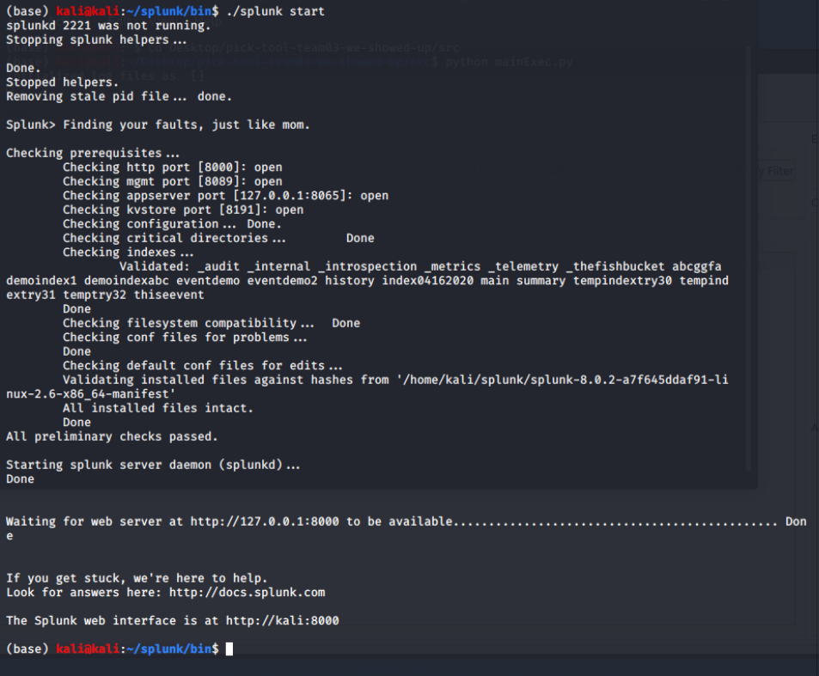

Appendix 2. SPLUNK web service login
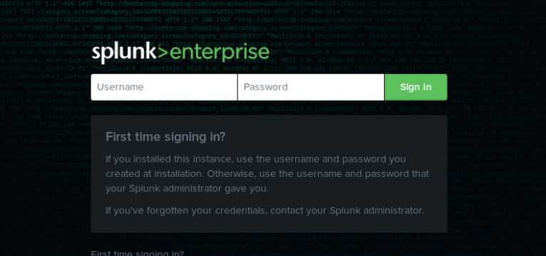

Appendix 3. SPLUNK web service main page
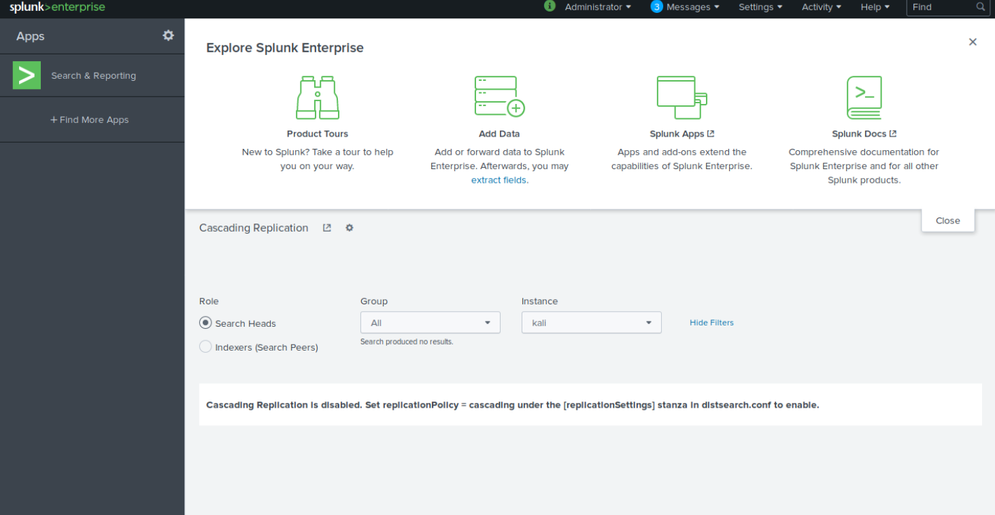

Appendix 4. Main window of the PICK Tool in the Event Tab
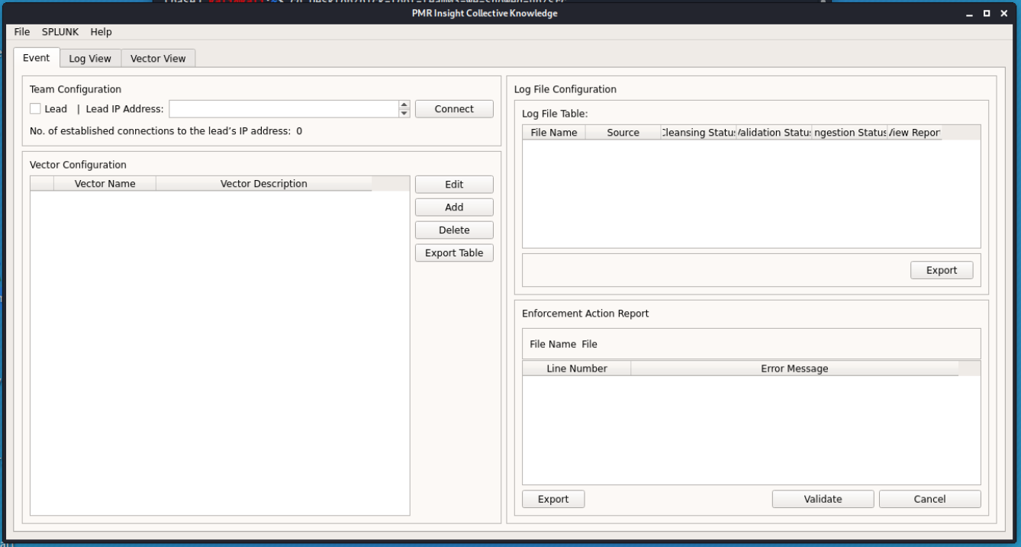

Appendix 5. Main window of the PICK Tool in the Log Entry View Tab
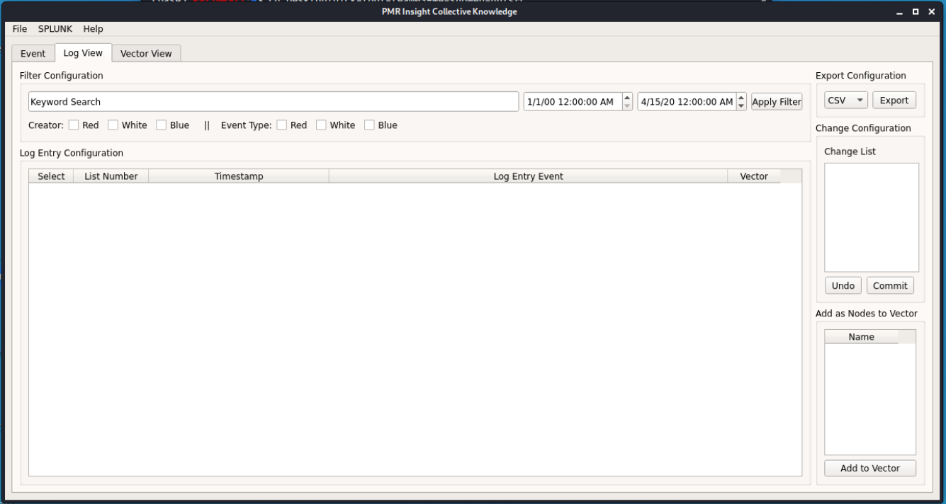

Appendix 6. Main window of the PICK Tool in the Vector View Tab
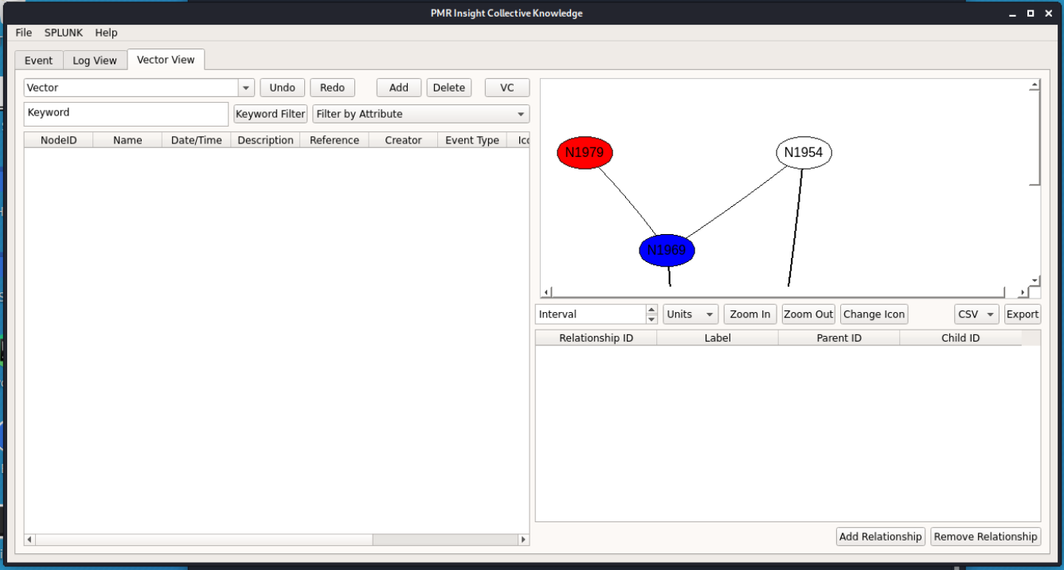

Appendix 7. SPLUNK login pop-up from the PICK Tool.
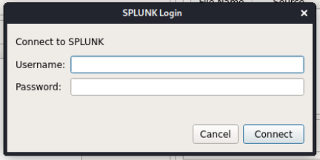

Appendix 8. New Event window
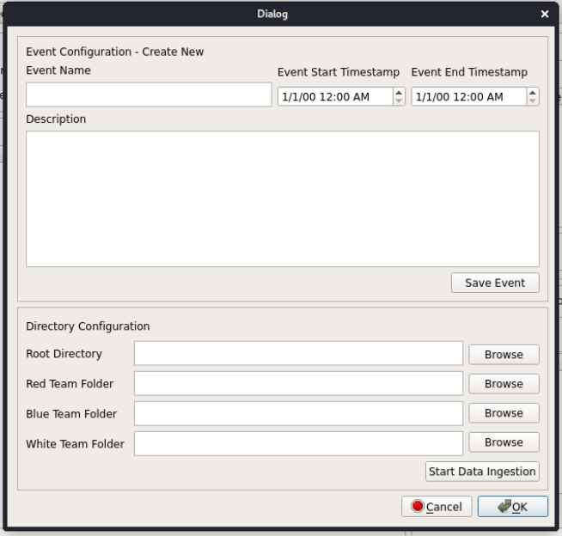
Appendix 9. Open Event window.
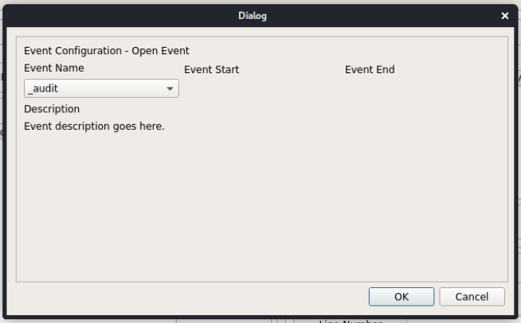

Appendix 10. Edit Event window.
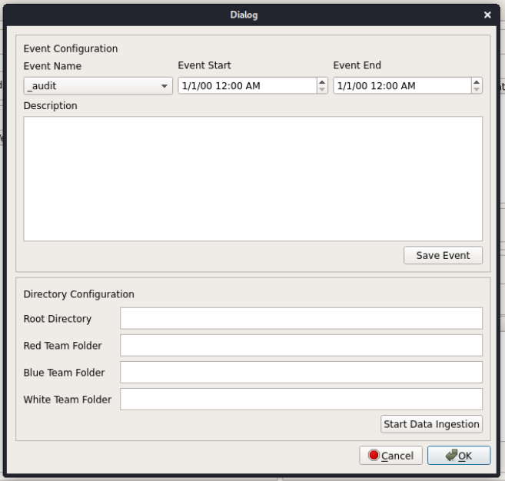

Appendix 11. Add Relationship pop-up
