Prevent, Mitigate, and Recover (PMR) Insight Collective Knowledge System (PICK)
Test plan
Version 2.0
04/28/2020
Document Control
Approval
The Guidance Team and the customer shall approve this document.
Document Change Control
Initial Release: | 04/14/2020
Current Release: | 04/28/2020
Indicator of Last Page in Document: | $
Date of Last Review: | 28 April 2020
Date of Next Review: | 01 May 2020
Target Date for Next Update: | 02/02/2020
Distribution List
This following list of people shall receive a copy of this document every time a new version of this document becomes available:
Guidance Team Members:
Dr. Steven Roach
Jake Lasley

Customer:
Dr. Oscar Perez
Vincent Fonseca
Herandy Denisse Vazquez
Baltazar Santaella
Florencia Larsen
Erick De Nava

Software Team Members:
Jacob Torres
Eddy Todd
Jorge Felix
Matt Montoya
Alejandro Zamora
Change Summary
The following table details changes made between versions of this document

Version | Date | Modifier | Description
1.0 | 04/14/2020 | Alex Z & Matt M | Initialized baseline
1.1 | 04/15/2020 | Matt Montoya | Updated Section 1
1.2 | 04/24/2020 | Alejandro Zamora | Updated Sections 2 & 3
1.3 | 04/24/2020 | Alejandro Zamora | Updated appendix; added Section 4
1.4 | 04/25/2020 | Alejandro Zamora | Added more tests to section 3 and 4
1.5 | 04/26/2020 | Matt Montoya | Fixed grammar & formatting issues
1.6 | 04/26/2020 | Matt Montoya | Reviewed current test cases
1.7 | 04/26/2020 | Alejandro Zamora | Added test cases to section 4
2.0 | 04/27/2020 | Matt Montoya | Fixed grammar & formatting issues

Table of Contents
Document Control ii
Approval ii
Document Change Control ii
Distribution List ii
Change Summary ii
1. Introduction 13
1.1. Purpose 13
1.2. Scope 13
1.3. System Overview 13
1.4. Suspension and Exit Criteria 13
1.5. Document Overview 13
1.5.1. Introduction 13
1.5.2. Test Items & Features 13
1.5.3. Testing Approach 14
1.5.4. GUI Functionality Test Suite 14
1.5.5. User Interface Testing 14
1.5.6. Test Schedule 14
1.5.7. Other Sections 14
1.5.8. Appendix 14
1.6. References 14
1.6.1. Document Template 14
1.6.2. PICK Tool SRS 14
1.6.3. PICK Tool SDD 14
2. Test Items and Features 16
3. Testing Approach 17
3.1. Configurations Diagram 17
3.2. Approach & Plan 17
4. GUI Functionality Test Suite 19
4.1. Test GF1 19
4.2. Test GF2 21
4.3. Test GF3 22
4.4. Test GF4 23
4.5. Test GF5 24
4.6. Test GF6 25
4.7. Test GF7 26
4.8. Test GF8 27
4.9. Test GF9 27
4.10. Test GF10 28
4.11. Test SF1 29
4.12. Test SF2 29
4.13. Test SF3 30
4.14. Test SF4 31
4.15. Test SF5 31
4.16. Test SF6 32
4.17. Test SF7 32
4.18. Test SF8 33
4.19. Test SF9 34
5. User Interface Testing 34
5.1. Testing Disclaimer 34
6. Test Schedule 35
6.1. Test Table 35
7. Other Sections 38
7.1. Disclosure 38
8. Appendix 39
8.1. Figure 1 39
8.2. Figure 2 39
8.3. Figure 3 40
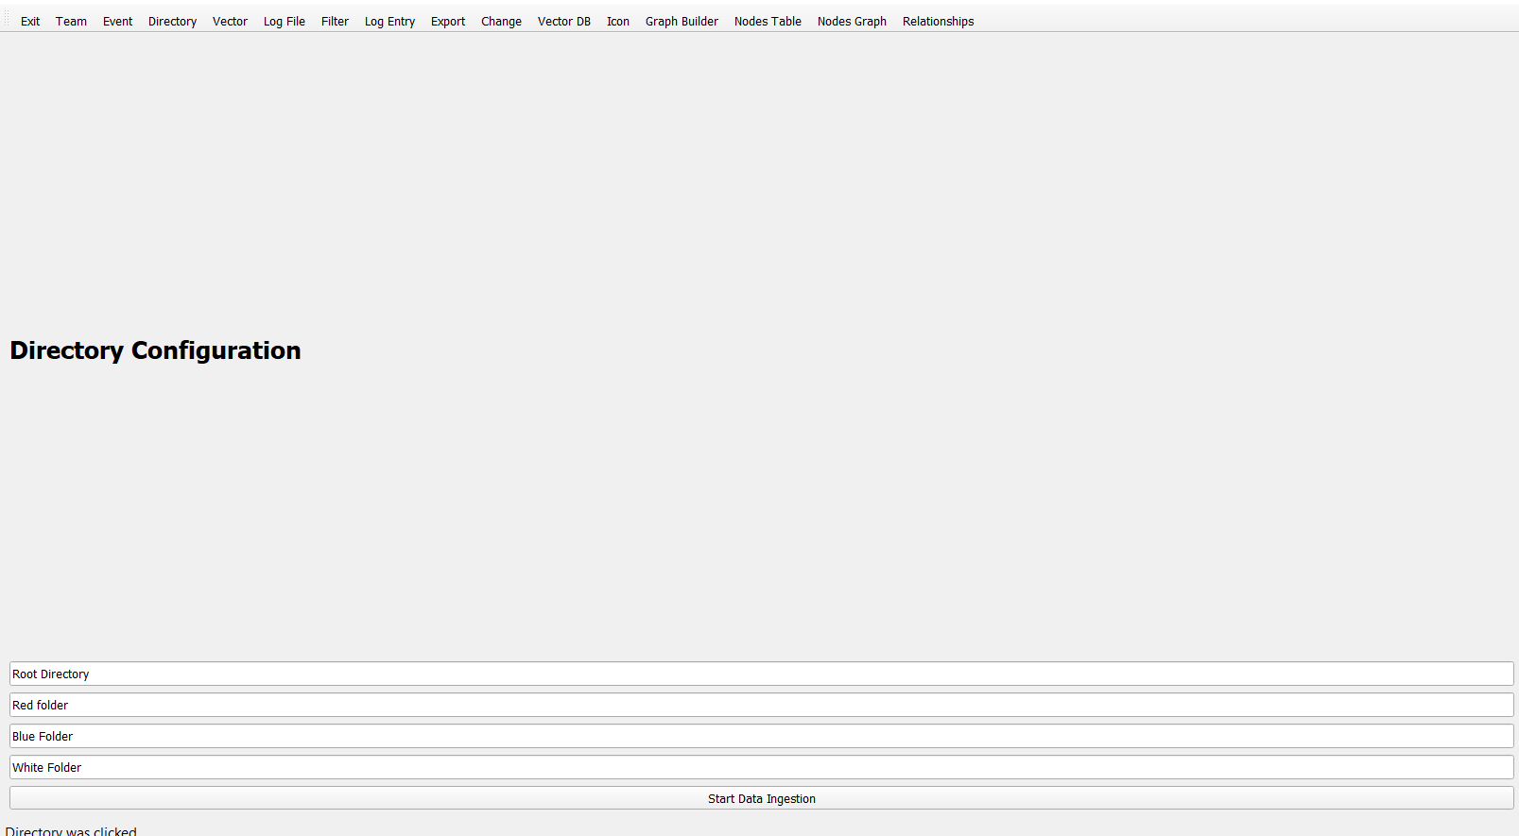 40
8.4. Figure 4 40
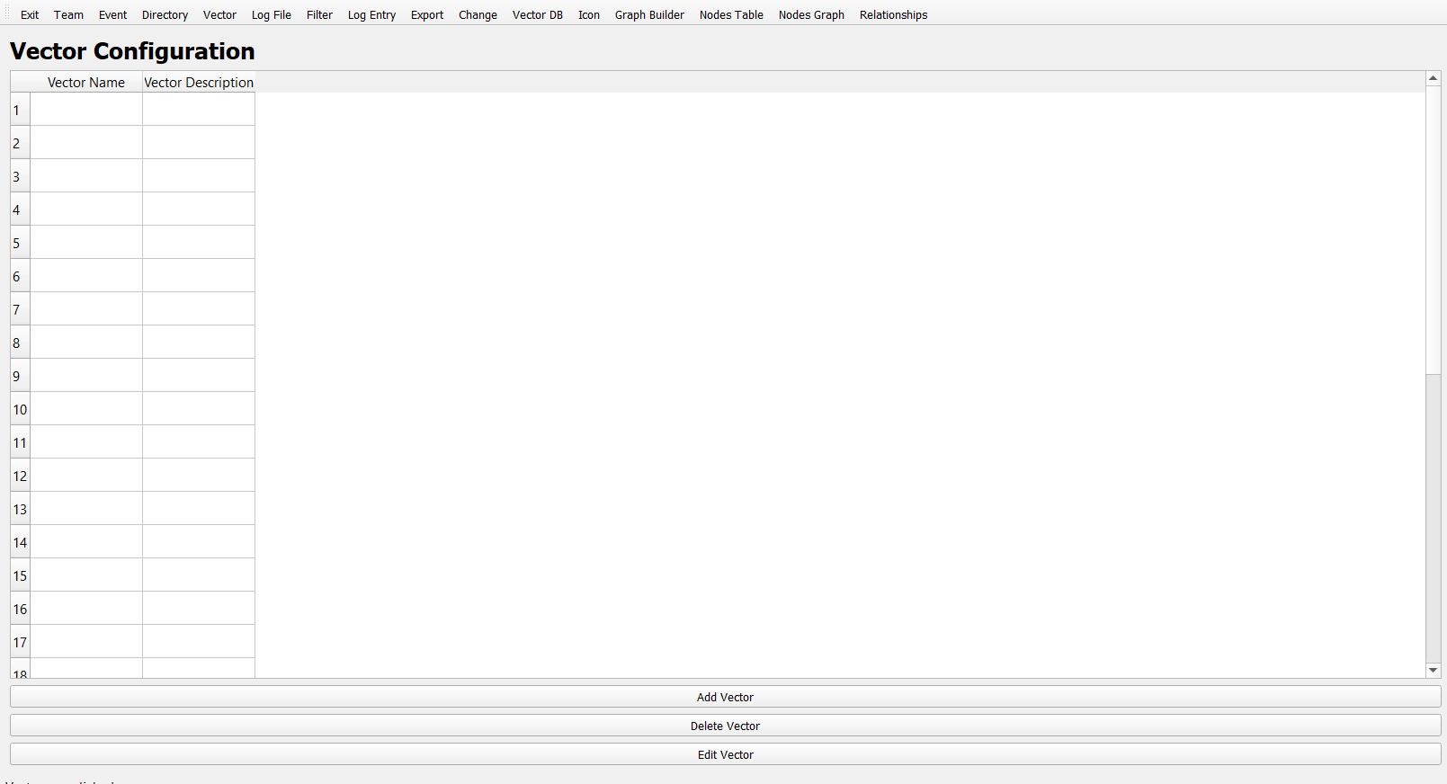 40
8.5. Figure 5 41
8.6. Figure 6 41
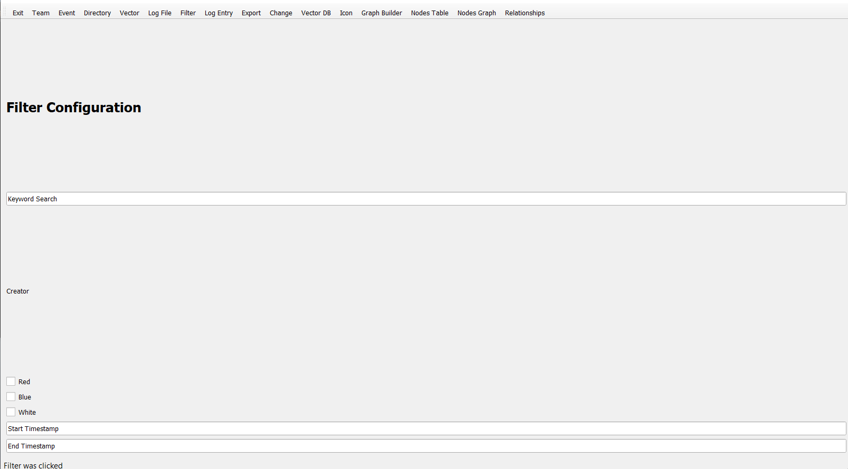 41
8.7. Figure 7 42
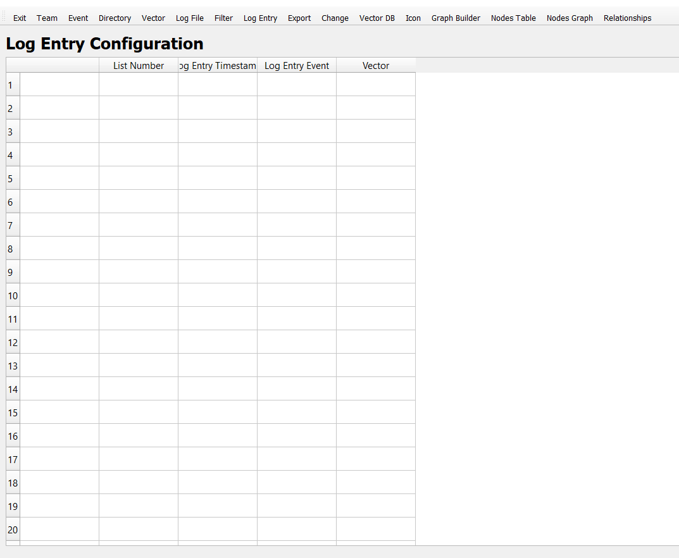 42
8.8. Figure 8 43
8.9. Figure 9 43
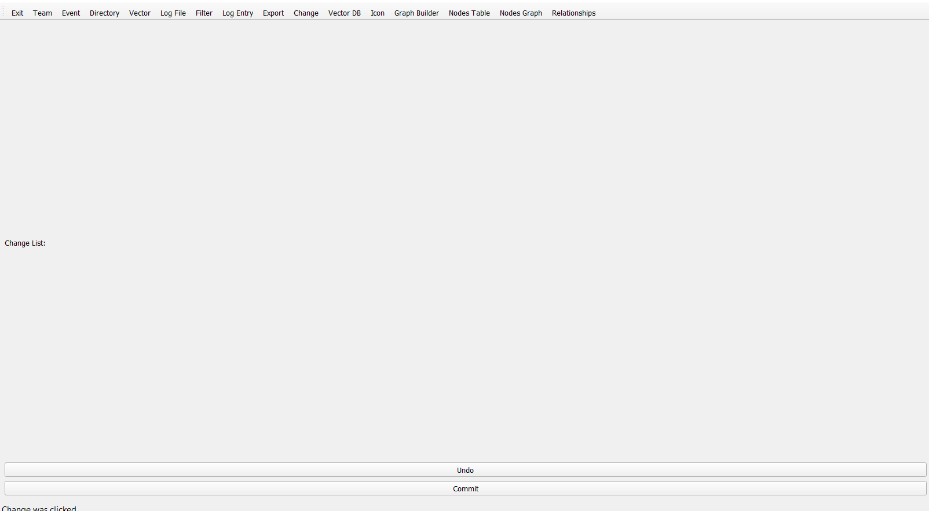 43
8.10. Figure 10 44
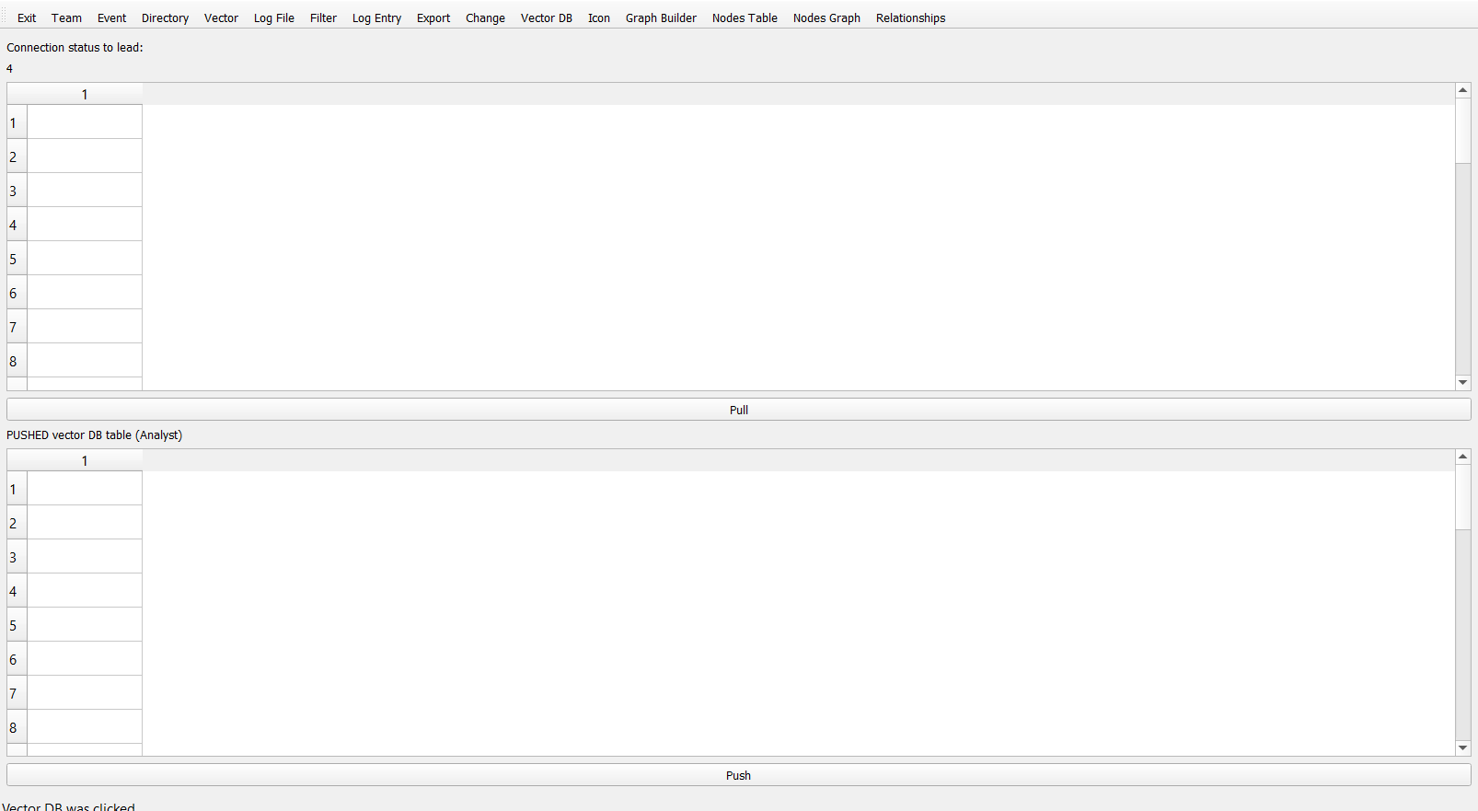 44
8.11. Figure 11 44
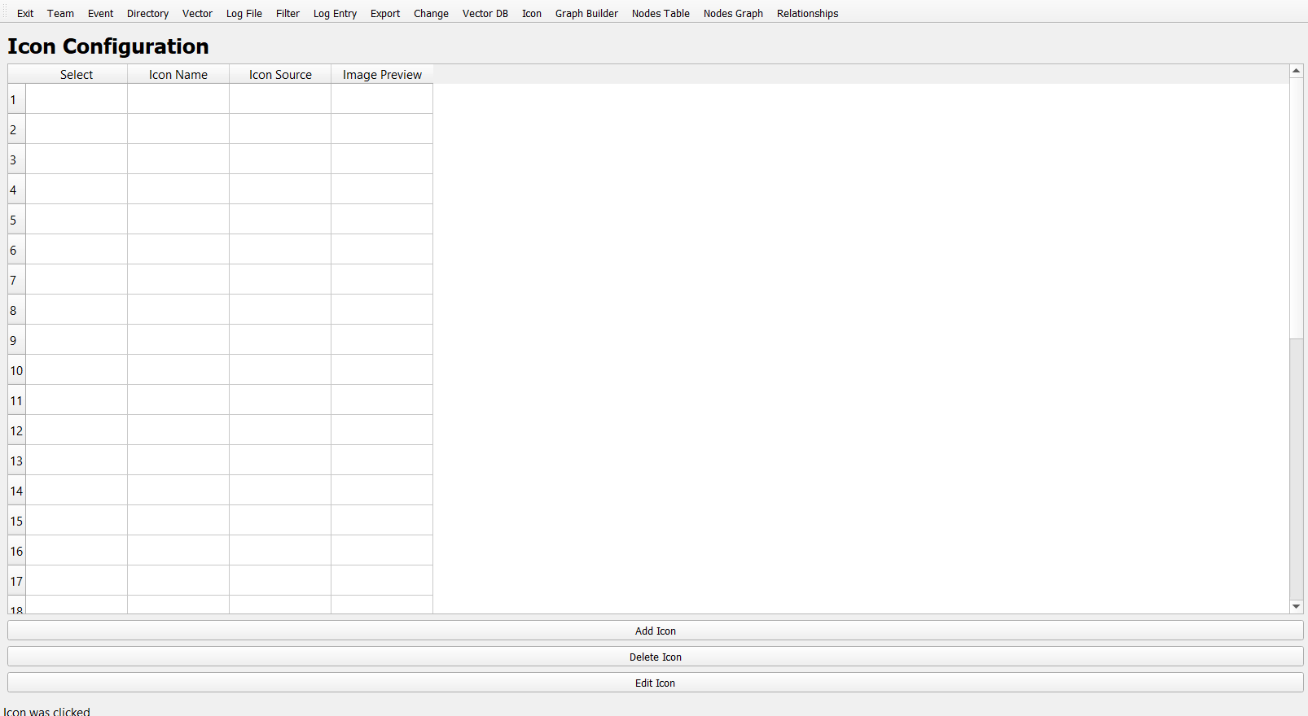 44
8.12. Figure 12 45
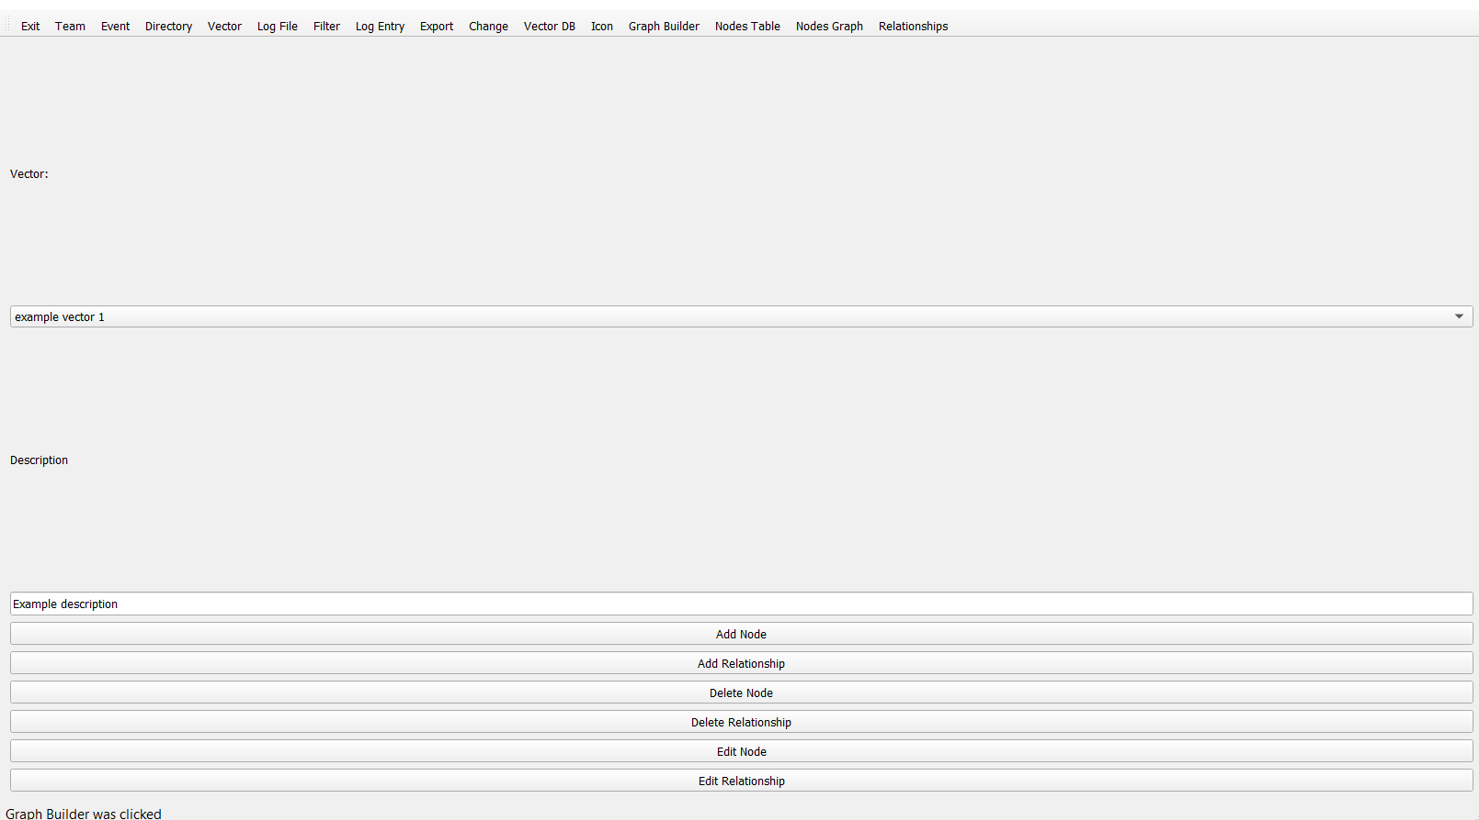 45
8.13. Figure13 45
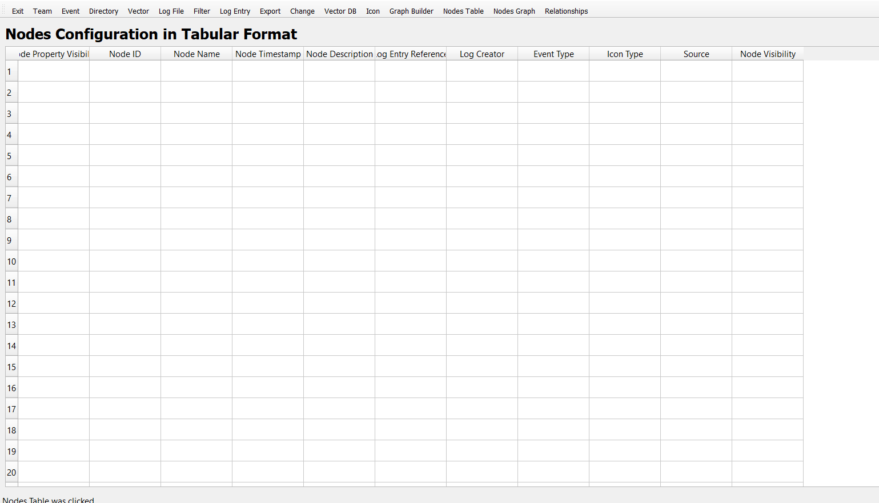 45
8.14. Figure 14 46
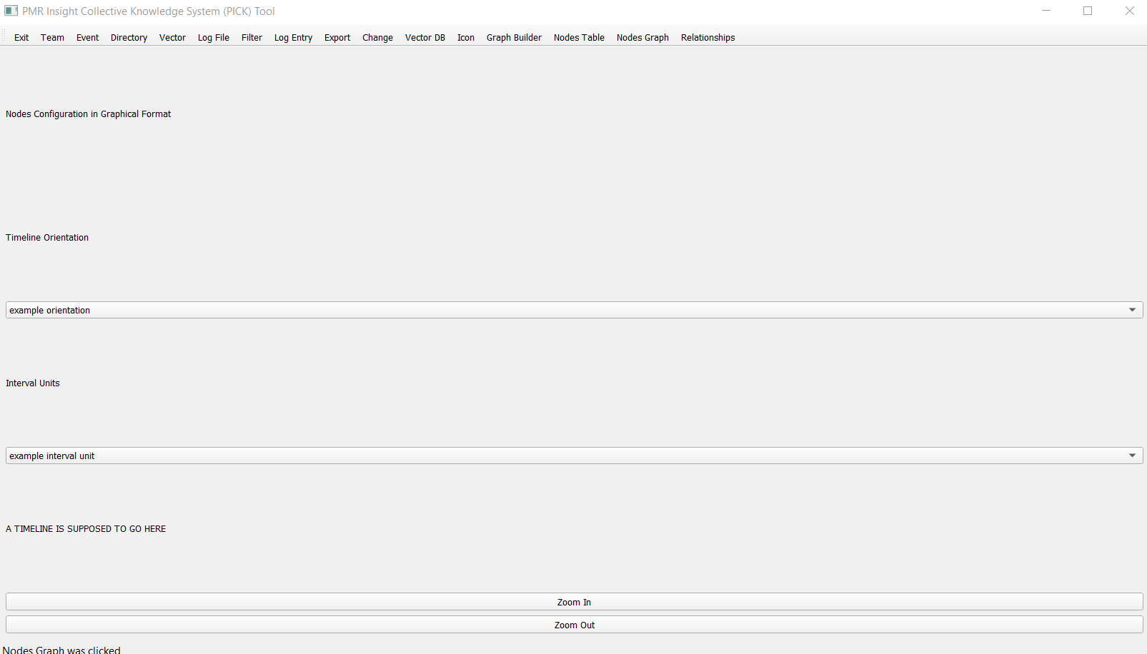 46
8.15. Figure 15 46
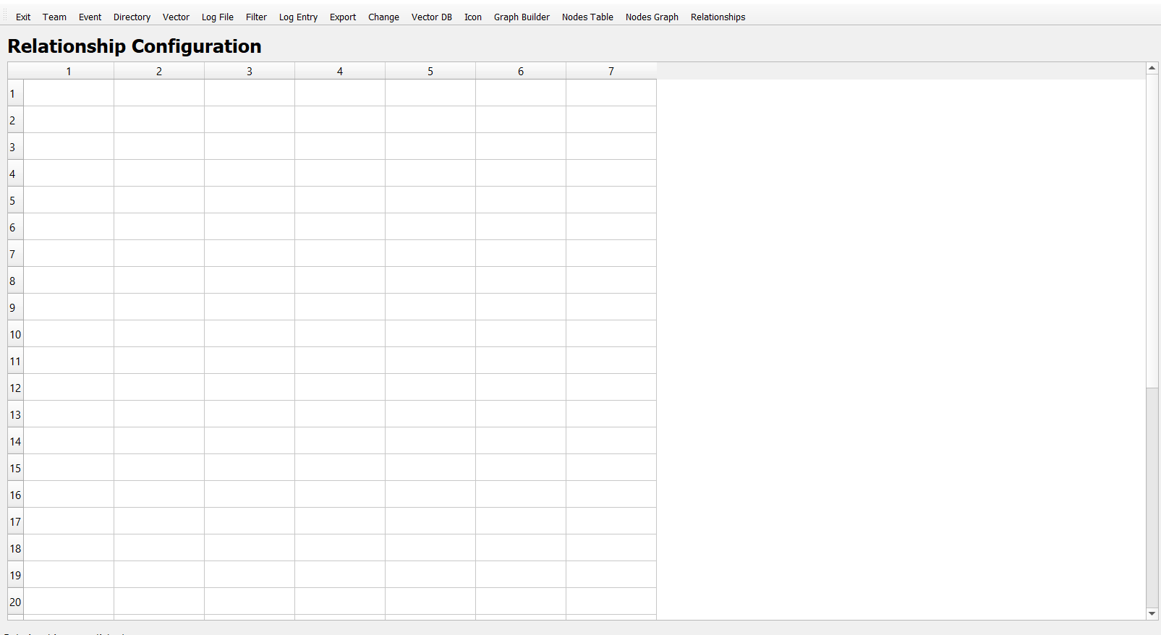 46
8.16. Figure 16 47
47
8.17. Figure 17 47
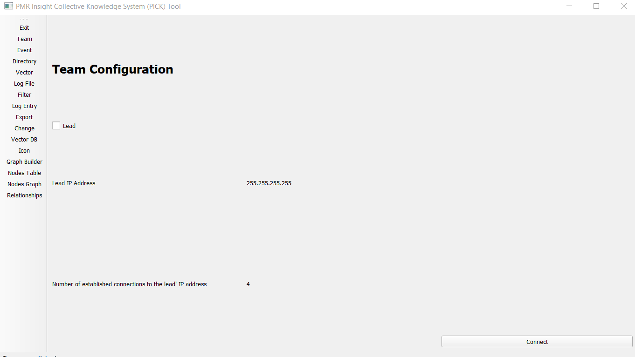 47
8.18. Figure 18 48
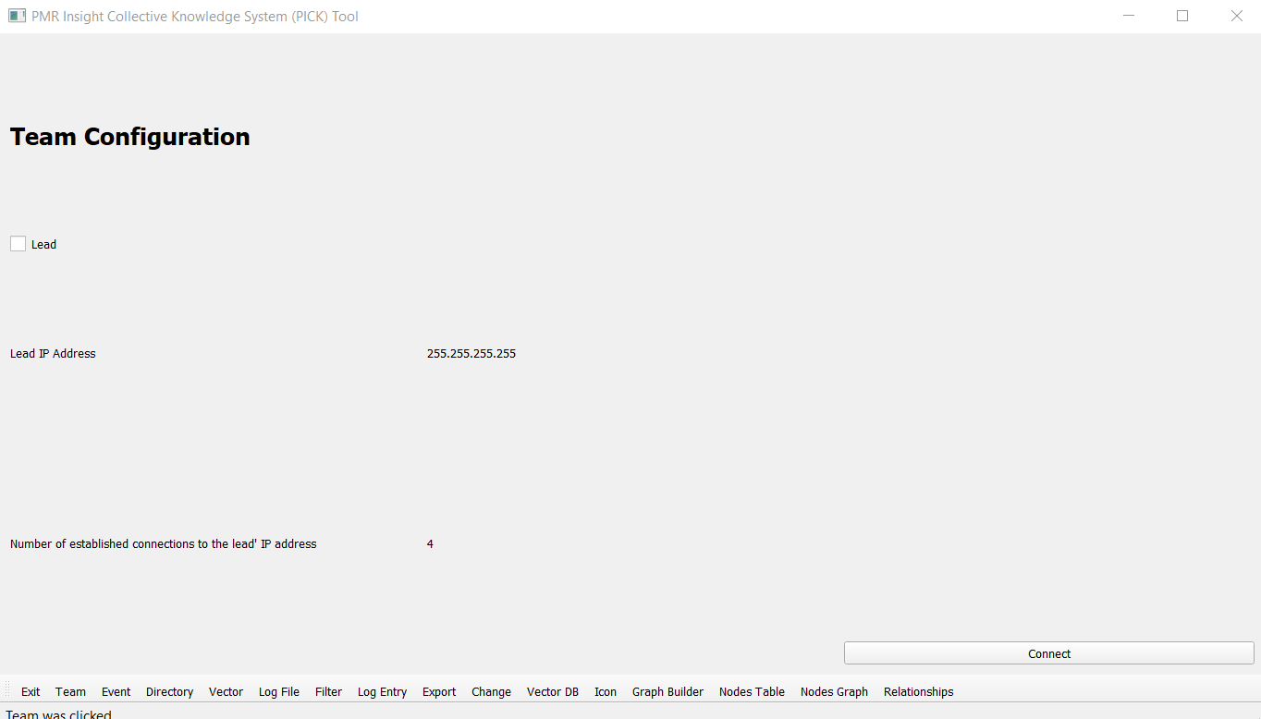 48
8.19. Figure 19 48
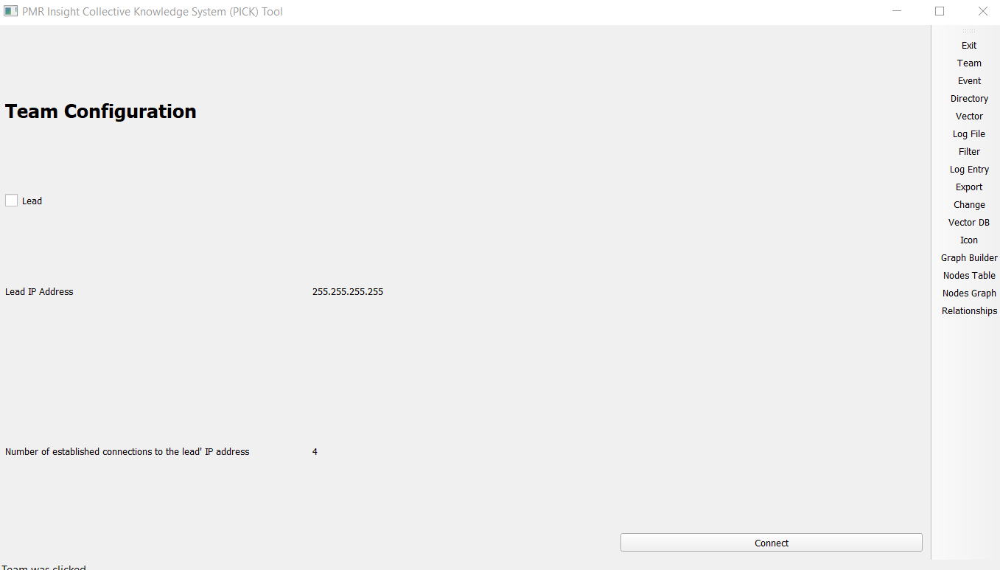 48
8.20. Figure 20 49
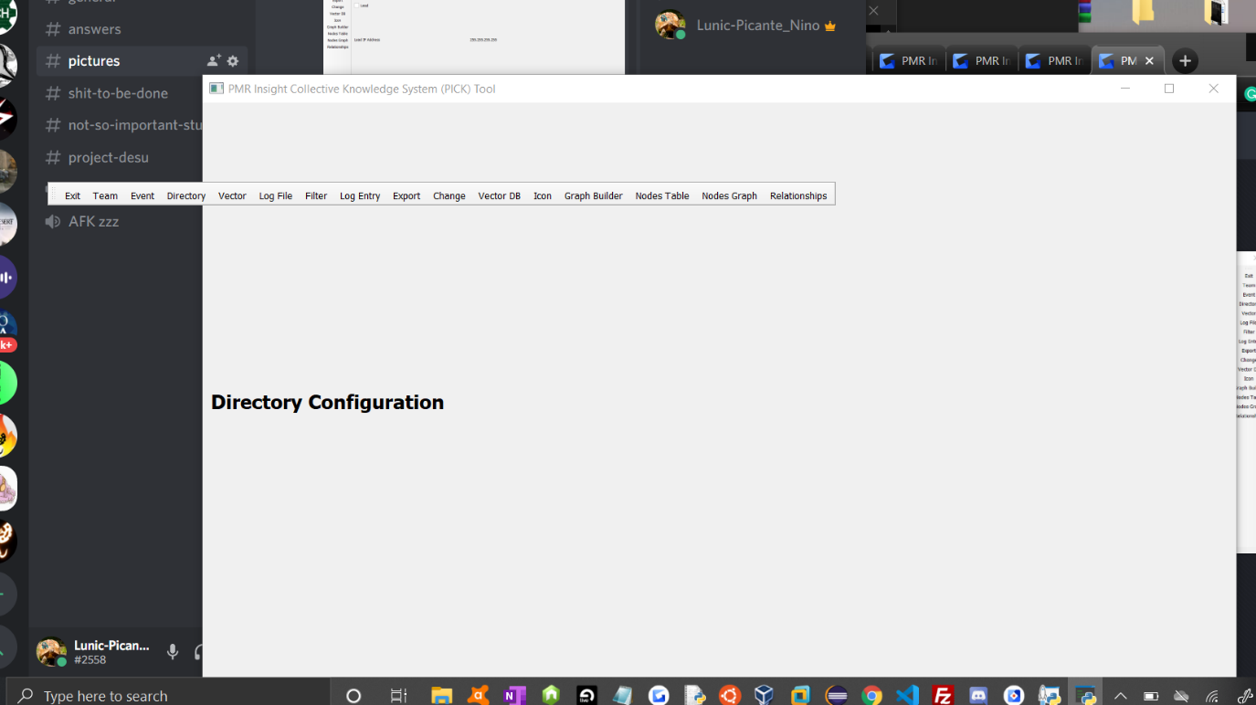 49
8.21. Figure 21 49
8.22. Text 1 50
8.23. Text 2 50
8.24. Text 3 50

Introduction
Section 1 introduces the PICK Tool Test Plan. This introduction includes the purpose and scope of the document, as well as an overview of the PICK system, and establishes the conditions that shall be met to suspend or exit a test. All references applicable to the test plan, including the SRS and SDD, can be found in this section.

Purpose
The purpose of this Project Test Plan is to formally define the kinds of tests to be run, the precise tests to be run on the PICK Tool system, and the approach to running these tests. Testing of PICK Tool is an element of producing and ensuring quality software. These tests should identify any errors in the software deliverable and serve as a basis for removing defects in the system. The end goal is to ensure that the program is correct; that is, the program satisfies the specification(s) set forth by the customer.

Scope
This software release (AKA Software Version) encompassed by this test plan includes version 1.0. This version is the version that will be presented to the customer on the final presentation date.

System Overview
PICK Tool is a system that allows for adversarial assessment when it comes to cyber-attacks. The system will be able to allow analysts to examine a red team's actions and blue team’s actions through this assessment. The PICK Tool will allow the user to add vectors, relations, and ingest logs into the system while also showing a visual representation which would be a graphing function.

Suspension and Exit Criteria
Team404 defines Suspension and Exit Criteria as follows—

Suspension of testing may occur if there is a hardware malfunction where data is unrecoverable or if a highly critical test fails; that is, it has less than a 100% pass rate.

Exit of testing may occur if a highly critical test has a 100% pass rate, if a low critical test has at least 90% pass rate, and if the overall system has at least a 97% pass rate.

Document Overview

Introduction
Section 1 introduces the PICK Tool Test Plan. This introduction includes the purpose and scope of the document, as well as an overview of the PICK system, and establishes the conditions that shall be met to suspend or exit a test. All references applicable to the test plan, including the SRS and SDD, can be found in this section.

Test Items & Features
Section 2 describes the test items (e.g., components, classes, functions or methods) and the features to be tested.

Testing Approach
Section 3 details the testing approach Team404 has selected. This description includes specifying the types of tests to be performed, e.g., tests designed to exercise system functions one by one; tests designed to exercise sequences of functions that approximate operational use of the system; tests designed to stress the system to its design and requirements limits.

GUI Functionality Test Suite
Section 4 documents test input, specific test procedures, and outcomes, as well as establish test methods, and explains the nature and extent of each test, as they relate to the GUI of PICK Tool.

User Interface Testing
Section 5 focuses on the interaction between the user and the system. This testing includes the following traits: Consistent terminology, menu selections, and presentation, grammar, and error handling that will inform user of critical operations.

Test Schedule
Section 6 specifies the schedule for testing activities as they pertain to PICK Tool.

Other Sections
Section 7 contains other sections. These requirements come from the SRS Document, written by the guidance team, and the code, written by Team404.

Appendix
Section 8 contains an appendix of figures (or images) depicting the GUI. These figures are referenced throughout the PICK Tool Test Plan.

References

Document Template
[1] Donaldson, S., and S. Siegel, Successful Software Development. Upper Saddle River, NJ: Prentice Hall, 2001, pp. 321-323.

[2] Donaldson, S., and S. Siegel, Successful Software Development. Upper Saddle River, NJ: Prentice Hall, 2001, pp. 321-323 and modified by Humberto Mendoza and Steve Roach.

[3] Supplementary information is from:
Pfleeger, S. Software Engineering, Theory and Practice. Upper Saddle River, NJ: Prentice Hall, 1998, p. 365.

PICK Tool SRS
[4] E. Tai-Ramirez & S. Roach, SRS_v7. Internet: https://github.com/CS4311-spring-2020/pick-tool-team06-team-404/blob/master/doc/SRSv7.pdf, 2020 (Jan. 30, 2020).

PICK Tool SDD
[5] A. Zamora, E. J. Todd, J. N. Torres, J. I. Felix, and M. S. Montoya, “Prevent, Mitigate, and Recover (PMR) Insight Collective Knowledge System (PICK) Tool Software Design Document,” 31-Mar-2020. [Online]. Available: https://github.com/CS4311-spring-2020/pick-tool-team06-team-404/blob/master/doc/sdd/Team6Team404SDD.pdf. [Accessed: 14-Apr-2020].

Test Items and Features
The test items down below describe the system. These items given below give more specific information on the picktool.py.
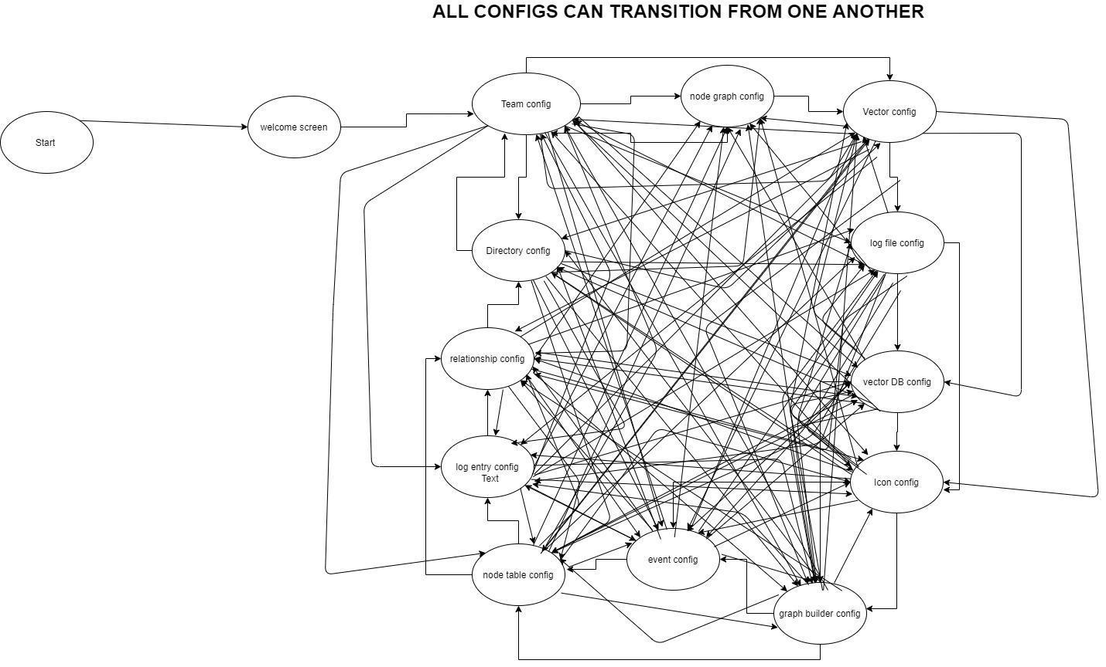
2.1 Configurations Diagram

Testing Approach
Section 3 details the testing approach Team404 has selected. This description includes specifying the types of tests to be performed, e.g., tests designed to exercise system functions one by one; tests designed to exercise sequences of functions that approximate operational use of the system; tests designed to stress the system to its design and requirements limits.

Approach & Plan
The testing approach selected by Team404 to test PICK Tool is Black Box testing. This approach examines the functionality of PICK TOOL without looking at the internal structure (or code) of the system. The types of tests to be performed are designed to exercise individual system functions. Table 1 (Test Plan [shown below]) describes the tests to be performed as well as their criticality, or level of importance.

GUI Functionality Test Suite
Description of Test Suite | This will test the GUI interactions with the user
Test Case Identifier | Objective | Criticality
GF1 | Traversability between views to another view | High
GF2 | Traversability of moving menu bar | Low
GF3 | Persistent Information held across tabs | High
GF4 | Resize of the PICK Tool window | Low
GF5 | Can run Multiple instances of PICK Tool | Low
GF6 | Menu bar functionality when PICK Tool window is set to minimal size | Low
GF7 | Can handle large paragraphs of text as input without messing up GUI formatting | Low
GF8 | Check to see if windows with tables are fully functional when PICK Tool window size is set to minimal | Low
GF9 | Can recover menu bar once it has been disabled for any reason | High
GF10 | When inputting information does undo and redo options in text fields work | Low

System Functionality Test Suite
Description of Test Suite | This will test the System functionality
Test Case Identifier | Objective | Criticality
SF1 | Connect to the lead IP address | High
SF2 | Creation of event | High
SF3 | Start data ingestion | High
SF4 | Add, edit, and delete vector | High
SF5 | Filter for specific key word | Low
SF6 | Export a project | High
SF7 | Push and pull a project | High
SF8 | Add, delete and edit Icon | High
SF9 | Build a graph | High

GUI Functionality Test Suite
Section 4 documents test input, specific test procedures, and outcomes, as well as establish test methods, and explains the nature and extent of each test, as they relate to the GUI of PICK Tool. The purpose of is to show the step by step process on how tests are performed while also listing the expected outcomes.

Test GF1
Objective: The objective of test GF1 is to ensure views are traversable; that is, going between views is allowed from any view to another view
Precondition: The PICK Tool (picktool.py) is visible inside its desired folder.
Test No.: GF1 |  |  |  | Current Status: Passed
Test title: Traversability between views to another view

Testing Approach: This test approach will see if you can navigate to the team configuration view to any other view and back to the team configuration view.
STEP  1 | OPERATOR ACTION  The user executes the PICK Tool application | PURPOSE  Starts PICK Tool session |  |  | EXPECTED RESULTS  The system displays the GUI | COMMENTS  Starts the system
2 | The user clicks “accept and continue” | Starts PICK Tool session |  |  | The system displays the views of a project | Starts a PICK Tool session
3 | The user clicks the tab “event” located in the top center of the window | allows transition to event configuration view |  |  | The system displays the view of event configuration | Figure 2
4 | The user clicks the tab “team” located in the top center of the window | allows transition to team configuration view |  |  | The system displays the view of team configuration | Figure 1
5 | The user clicks the tab “directory” located in the top center of the window | allows transition to directory configuration view |  |  | The system displays the view of directory configuration | Figure 3
6 | The user clicks the tab “team” located in the top center of the window | allows transition to team configuration view |  |  | The system displays the view of team configuration | Figure 1
7 | The user clicks the tab “vector” located in the top center of the window | allows transition to vector configuration view |  |  | The system displays the view of vector configuration | Figure 4
8 | The user clicks the tab “team” located in the top center of the window | allows transition to team configuration view |  |  | The system displays the view of team configuration | Figure 1
9 | The user clicks the tab “log file” located in the top center of the window | allows transition to log file configuration view |  |  | The system displays the view of log file configuration | Figure 5
10 | The user clicks the tab “team” located in the top center of the window | allows transition to team configuration view |  |  | The system displays the view of team configuration | Figure 1
11 | The user clicks the tab “filter” located in the top center of the window | allows transition to filter configuration view |  |  | The system displays the view of filter configuration | Figure 6
12 | The user clicks the tab “team” located in the top center of the window | allows transition to team configuration view |  |  | The system displays the view of team configuration | Figure 1
13 | The user clicks the tab “log entry” located in the top center of the window | allows transition to log entry configuration view |  |  | The system displays the view of log entry configuration | Figure 7
14 | The user clicks the tab “team” located in the top center of the window | allows transition to team configuration view |  |  | The system displays the view of team configuration | Figure 1
15 | The user clicks the tab “export” located in the top center of the window | allows transition to export configuration view |  |  | The system displays the view of export configuration | Figure 8
16 | The user clicks the tab “team” located in the top center of the window | allows transition to team configuration view |  |  | The system displays the view of team configuration | Figure 1
17 | The user clicks the tab “change” located in the top center of the window | allows transition to change configuration view |  |  | The system displays the view of change configuration | Figure 9
18 | The user clicks the tab “team” located in the top center of the window | allows transition to team configuration view |  |  | The system displays the view of team configuration | Figure 1
19 | The user clicks the tab “vector DB” located in the top center of the window | allows transition to vector DB configuration view |  |  | The system displays the view of vector DB configuration | Figure 10
20 | The user clicks the tab “team” located in the top center of the window | allows transition to team configuration view |  |  | The system displays the view of team configuration | Figure 1
21 | The user clicks the tab “icon” located in the top center of the window | allows transition to icon configuration view |  |  | The system displays the view of icon configuration | Figure 11
22 | The user clicks the tab “team” located in the top center of the window | allows transition to team configuration view |  |  | The system displays the view of team configuration | Figure 1
23 | The user clicks the tab “graph builder” located in the top center of the window | allows transition to graph builder configuration view |  |  | The system displays the view of graph builder configuration | Figure 12
24 | The user clicks the tab “team” located in the top center of the window | allows transition to team configuration view |  |  | The system displays the view of team configuration | Figure 1
25 | The user clicks the tab “nodes table” located in the top center of the window | allows transition to node configuration view |  |  | The system displays the view of node configuration | Figure 13
26 | The user clicks the tab “team” located in the top center of the window | allows transition to team configuration view |  |  | The system displays the view of team configuration | Figure 1
27 | The user clicks the tab “nodes graph” located in the top center of the window | allows transition to node graph configuration view |  |  | The system displays the view of node graph configuration | Figure 14
28 | The user clicks the tab “team” located in the top center of the window | allows transition to team configuration view |  |  | The system displays the view of team configuration | Figure 1
29 | The user clicks the tab “relationship” located in the top center of the window | allows transition to relationship configuration view |  |  | The system displays the view of relationship configuration | Figure 15
30 | The user clicks the tab “team” located in the top center of the window | allows transition to team configuration view |  |  | The system displays the view of team configuration | Figure 1
Concluding Remarks: This test is simple to check yet repetitive to check all of the cases.
Testing Team:  Lead: Alejandro Zamora  Members: Jacob Torres, Eddy Todd, Jorge Felix, Matt Montoya |  |  | Date Completed: 04/14/2020

Test GF2
Objective: The objective of this test is to check to see if the menu bar is functional when moved from its default position.
Precondition: The PICK Tool (picktool.py) is visible inside its desired folder.
Test No.: GF2 |  |  |  | Current Status: Passed
Test Title: Traversability of moving menu bar
Testing Approach: This test approach will see if changing the menu bar inside the application and outside the application still yield the same functionality.
STEP  1 | OPERATOR ACTION  The user executes the PICK Tool application | PURPOSE  Starts PICK Tool session |  |  | EXPECTED RESULTS  The system displays the GUI | COMMENTS  Starts the system
2 | The user clicks “accept and continue” | Starts PICK Tool session |  |  | The system displays the views of a project | Starts a PICK Tool session
3 | In the upper left-hand corner, you can see the menu bar. Next to the option “Exit” on the left side labeled with two columns of dots. Click and drag on those dots and to the left side of the PICK Tool window until the system displays a blue area where then you can drop the menu bar in. | Moves menu bar to left hand side of the application |  |  | The system will highlight the area where you can drag and drop the menu bar and will place the menu bar on the left side of the PICK Tool window | Figure 17
4 | Looking at the menu bar click the option” Icon” | Checks to see if the menu bar still works at different x, y position |  |  | The system will transition to the Icon configuration tab
5 | Click and drag the menu bar into the bottom of the PICK Tool window until the system displays a blue area where you can then drop the menu bar in | Moves menu bar to the bottom side of the application |  |  | The system will highlight the area where you can drag and drop the menu bar and will place the menu bar on the bottom side of the PICK Tool window | Figure 18
6 | Looking at the menu bar click the option” Filter” | Checks to see if the menu bar still works at different x, y position |  |  | The system will transition to the Filter configuration tab
7 | Click and drag the menu bar into the right of the PICK Tool window until the system displays a blue area where you can then drop the menu bar in | Moves menu bar to the right side of the application |  |  | The system will highlight the area where you can drag and drop the menu bar and will place the menu bar on the right side of the PICK Tool window | Figure 19
8 | Looking at the menu bar click the option” Directory” | Checks to see if the menu bar still works at different x, y position |  |  | The system will transition to the Directory configuration tab
9 | Click and drag the menu bar outside of the PICK Tool window and drop the menu bar outside of the pick tool window | Moves menu bar outside of the application |  |  | The system will place the menu bar wherever the user places it | Figure20
10 | Looking at the menu bar click the option” Log File” | Checks to see if the menu bar still works at different x, y position |  |  | The system will transition to the Log File configuration tab
Concluding Remarks: The dots to move the menu bar a hard to see. When you mouse hovers over the dots the cursor changes to the 4-vector cursor indicating that relocation of menu bar is available
Testing Team:  Lead: Alejandro Zamora  Members: Jacob Torres, Eddy Todd, Jorge Felix, Matt Montoya |  |  | Date Completed: 04/26/2020

Test GF3
Objective: The objective of this test is to check to see if persistent information is held across tabs.
Precondition: The PICK Tool (picktool.py) is visible inside its desired folder.
Test No.: GF3 |  |  |  | Current Status: Passed
Test Title: Persistent Information held across tabs

Testing Approach: This test approach checks if information that is input into a tab is held when going to different tabs
STEP  1 | OPERATOR ACTION  The user executes the PICK Tool application | PURPOSE  Starts PICK Tool session |  |  | EXPECTED RESULTS  The system displays the GUI | COMMENTS  Starts the system
2 | The user clicks “accept and continue” | Starts PICK Tool session |  |  | The system displays the views of a project | Starts a PICK Tool session
3 | Looking at the menu bar click the option” Vector” | Move to a window for user input |  |  | The system displays the vector configuration window
4 | Click on row 1, vector name column and populate it with “test1” | Populates the 1,1 with input |  |  | The system displays the input of the user
5 | Click on row 1, vector Description column and populate it with “test of test” | Populates the 1,2 with input |  |  | The system displays the input of the user
6 | Looking at the menu bar click the option” relationships” | Move to a window for user input |  |  | The system displays the Relationship configuration window
7 | Populate the 1st row with “1” | Populate entire first row with 1’s |  |  | The system displays the input of the user
8 | Looking at the menu bar click the option” Vector” | Check to see if information is held |  |  | The system displays the vector configuration window
6 | Looking at the menu bar click the option” relationships” | Check to see if information is held |  |  | The system displays the Relationship configuration window
Concluding Remarks:
Testing Team:  Lead: Alejandro Zamora  Members: Jacob Torres, Eddy Todd, Jorge Felix, Matt Montoya |  |  | Date Completed: 04/26/2020

Test GF4
Objective: The objective of this test is to check to see if the system is still functional when window size is change as well as the formatting of tables.
Precondition: The PICK Tool (picktool.py) is visible inside its desired folder.
Test No.: GF4 |  |  |  | Current Status: Passed
Test Title: Resize of the PICK Tool window

Testing Approach: This test approach checks if the formatting of the system along with its functionality is still able work.
STEP  1 | OPERATOR ACTION  The user executes the PICK Tool application | PURPOSE  Starts PICK Tool session |  |  | EXPECTED RESULTS  The system displays the GUI | COMMENTS  Starts the system
2 | The user clicks “accept and continue” | Starts PICK Tool session |  |  | The system displays the views of a project | Starts a PICK Tool session
3 | The user hovers the mouse over the bottom right hand side corner of the PICK Tool window and clicks and drag the window to the center of the screen | Resizes the PICK Tool window |  |  | The system displays the updated window to fit the new window size
4 | The user moves the mouse to the top of the window in the middle. Then clicks and drags the window to the to of their desktop screen | Resizes the PICK Tool window |  |  | The system displays the updated window to fit the new window size
5 | The user clicks the “Log File” option in the menu bar | Displays the log file configuration |  |  | The system displays the log file configuration window | Check to see if there are no formatting issues use  Figure 5 for reference
Concluding Remarks:
Testing Team:  Lead: Alejandro Zamora  Members: Jacob Torres, Eddy Todd, Jorge Felix, Matt Montoya |  |  | Date Completed: 04/27/2020

Test GF5
Objective: The objective of this test is to check to see if the system can run more than one instance without those instances interfering with one another.
Precondition: The PICK Tool (picktool.py) is visible inside its desired folder.
Test No.: GF5 |  |  |  | Current Status: Passed
Test Title: Can run two instances of PICK Tool

Testing Approach: This test approach checks if the system can run multiple instances of the PICK Tool without those instances interfering with one another
STEP  1 | OPERATOR ACTION  The user executes the PICK Tool application | PURPOSE  Starts PICK Tool session |  |  | EXPECTED RESULTS  The system displays the GUI | COMMENTS  Starts the system
2 | The user clicks “accept and continue” | Starts PICK Tool session |  |  | The system displays the views of a project | Starts a PICK Tool session
3 | The user opens the directory where the picktool.py is located and executed the PICK Tool application | Starts another instance of PICK Tool |  |  | The system displays the GUI | Starts the system
3 | The user clicks “accept and continue” | Starts PICK Tool session |  |  | The system displays the views of a project
4 | The User clicks on the first instance of PICK Tool and clicks the log entry option in the menu bar | Displays log entry configuration page |  |  | The system displays the log entry configuration window
5 | In row 1 column 1 the user types ABC inside | Populates 1,1 with ABC |  |  | The system populates the users input in desired location
6 | The User clicks on the second instance of PICK Tool and clicks the log entry | Displays log entry configuration page |  |  | The system displays the log entry configuration window without any information input from the first instance of pick tool
7 | In row 1 column 1 the user types 123 inside | Populates 1,1 with 123 |  |  | The system populates the users input in desired location
Concluding Remarks: if the second instance sees any information of the first instance such as user input the test is a failure
Testing Team:  Lead: Alejandro Zamora  Members: Jacob Torres, Eddy Todd, Jorge Felix, Matt Montoya |  |  | Date Completed: 04/27/2020

Test GF6
Objective: The objective of this test is to check to see if the Menu bar can run and have no functionality / formatting errors when window is set to minimal
Precondition: The PICK Tool (picktool.py) is visible inside its desired folder.
Test No.: GF6 |  |  |  | Current Status: Passed
Test Title: Menu bar functionality when PICK Tool window is set to minimal
Testing Approach: This test approach checks if the menu bar can display all options correctly when window of system is set to minimal size
STEP  1 | OPERATOR ACTION  The user executes the PICK Tool application | PURPOSE  Starts PICK Tool session |  |  | EXPECTED RESULTS  The system displays the GUI | COMMENTS  Starts the system
2 | The user clicks “accept and continue” | Starts PICK Tool session |  |  | The system displays the views of a project | Starts a PICK Tool session
3 | Using the bottom right hand corner of the window the user changes the size of the window to the smallest it can be. | Resizes the PICK Tool window to the smallest it can be |  |  | The system displays the updated window to fit the new window size
4 | The user clicks the option labled “>>” | This shows the rest of the menu bar options |  |  | The system will display more menu options that were to large to fit onto the window | Figure 21
5 | The user clicks on the option “Relationships” | Opens the relationships configuration table to check to see if the expanded menu options are working |  |  | The system will display Relationship configuration window
Concluding Remarks:
Testing Team:  Lead: Alejandro Zamora  Members: Jacob Torres, Eddy Todd, Jorge Felix, Matt Montoya |  |  | Date Completed: 04/27/2020

Test GF7
Objective: The objective of this test is to check to see if the system can handle large inputs of text without messing up the formatting of the window and keeping the information input without cutting out information.
Precondition: The PICK Tool (picktool.py) is visible inside its desired folder.
Test No.: GF7 |  |  |  | Current Status: Passed
Test Title: Can handle large paragraphs of text as input without messing up GUI formatting
Testing Approach: This test approach checks if the system can handle large inputs of text keeping the integrity of the input and the formatting of the window. This test you will copy and paste lyrics then ascii art checking to see if the system has truncated any information from those inputs.
STEP  1 | OPERATOR ACTION  The user executes the PICK Tool application | PURPOSE  Starts PICK Tool session |  |  | EXPECTED RESULTS  The system displays the GUI | COMMENTS  Starts the system
2 | The user clicks “accept and continue” | Starts PICK Tool session |  |  | The system displays the views of a project | Starts a PICK Tool session
3 | The user clicks log entry option in the menu bar | Move to a window that accepts input in small little boxes |  |  | The system displays the Log entry configuration
4 | The user paste text from section 8.22 Text1 into row 1 column 1 | Puts a large text inside a small text box |  |  | The system displays the user input in 1,1 with a … at the end of the input indicating there is more text to be viewed
5 | The user paste text from section 8.23 Text2 into row 2 column 1 | Puts a large text inside a small text box |  |  | The system displays the user input in 1,1 with a … at the end of the input indicating there is more text to be viewed
6 | The user clicks row 1 column 1 | Check to see if 1,1 has all the information that was pasted into it |  |  | The system will display all text that was pasted into it with no truncations
7 | The user clicks row 2 column 1 | Check to see if 2,1 has all the information that was pasted into it |  |  | The system will display all text that was pasted into it with no truncations
Concluding Remarks: Another good way to check too see if the text is the same is to copy the text 1,1 and 2,1 into a note pad and compare but checking inside the application window is fine as well.
Testing Team:  Lead: Alejandro Zamora  Members: Jacob Torres, Eddy Todd, Jorge Felix, Matt Montoya |  |  | Date Completed: 04/27/2020

Test GF8
Objective: The objective of this test is to check to see if the windows that tables are able to be navigated to view the whole table when menu size is set to minimal size.
Precondition: The PICK Tool (picktool.py) is visible inside its desired folder.
Test No.: GF8 |  |  |  | Current Status: Passed
Test Title: Check to see if windows with tables are fully functional when PICK Tool window size is set to minimal
Testing Approach: This test approach checks if the windows that contain tables are able to be traversed to see the all the information of the tables in those windows when window size is set to minimal size.
STEP  1 | OPERATOR ACTION  The user executes the PICK Tool application | PURPOSE  Starts PICK Tool session |  |  | EXPECTED RESULTS  The system displays the GUI | COMMENTS  Starts the system
2 | The user clicks “accept and continue” | Starts PICK Tool session |  |  | The system displays the views of a project | Starts a PICK Tool session
3 | The user clicks log entry option in the menu bar | Move to a window that contains a table |  |  | The system displays the Log entry configuration
4 | Using the bottom right hand corner of the window the user changes the size of the window to the smallest it can be. | Resizes the PICK Tool window to the smallest it can be |  |  | The system displays the updated window to fit the new window size
5 | Using the scroll bars on the window the user moves those scroll bars to see the entirety of the table | Displays information that is hidden due to small window size |  |  | The system displays the updated window allowing the user to scroll to view the rest of the table
Concluding Remarks:
Testing Team:  Lead: Alejandro Zamora  Members: Jacob Torres, Eddy Todd, Jorge Felix, Matt Montoya |  |  | Date Completed: 04/27/2020

Test GF9
Objective: The objective of this test is to check to see if the system allows ways to recover the menu bar once it has been disabled.
Precondition: The PICK Tool (picktool.py) is visible inside its desired folder.
Test No.: GF9 |  |  |  | Current Status: Fail
Test Title: Can recover menu bar once it has been disabled for any reason
Testing Approach: This test approach checks if the system allows the user to recover the menu bar once it has been purposefully disabled.
STEP  1 | OPERATOR ACTION  The user executes the PICK Tool application | PURPOSE  Starts PICK Tool session |  |  | EXPECTED RESULTS  The system displays the GUI | COMMENTS  Starts the system
2 | The user clicks “accept and continue” | Starts PICK Tool session |  |  | The system displays the views of a project | Starts a PICK Tool session
3 | User right clicks on menu bar | View menu bar options |  |  | The system displays a blank tab with a check mark inside a box
4 | User left clicks the check mark inside the box | This disables the menu bar |  |  | The system removes the menu bar from the window | Failure at this point since there is not option to return the menu bar
Concluding Remarks: Going through the system there is no way to recover the menu bar once disabled making the whole system unable to be used except for the current window opened.
Testing Team:  Lead: Alejandro Zamora  Members: Jacob Torres, Eddy Todd, Jorge Felix, Matt Montoya |  |  | Date Completed: 04/27/2020

Test GF10
Objective: The objective of this test is to check to see if the system allows for undo and redo when inputting text into a table.
Precondition: The PICK Tool (picktool.py) is visible inside its desired folder.
Test No.: GF10 |  |  |  | Current Status: Pass
Test Title: When inputting information does undo and redo options in text fields work
Testing Approach: This test approach checks if the system allows the undo and redo of text when being input into tables
STEP  1 | OPERATOR ACTION  The user executes the PICK Tool application | PURPOSE  Starts PICK Tool session |  |  | EXPECTED RESULTS  The system displays the GUI | COMMENTS  Starts the system
2 | The user clicks “accept and continue” | Starts PICK Tool session |  |  | The system displays the views of a project | Starts a PICK Tool session
3 | The user clicks on the log entry option on the menu bar | This moves into a place where we can input text |  |  | The system displays the Log entry configuration window
4 | The user paste text from section 8.24 Text3 into row 1 column 1. A total of 4 times | Populates 1,1 with input 4 separate times |  |  | The system displays input in 1,1
5 | The user presses Ctrl+Z on their keyboard once | This undoes the most recent paste |  |  | The system undo’s the most recent paste from the user in 1,1
6 | The user presses Ctrl+Y on their keyboard once | This puts back the string to original state |  |  | The system returns the most recent change back to its original state
Concluding Remarks:
Testing Team:  Lead: Alejandro Zamora  Members: Jacob Torres, Eddy Todd, Jorge Felix, Matt Montoya |  |  | Date Completed: 04/27/2020

Test SF1
Objective: The objective of this test is to check to see if the system can connect to a lead IP address
Precondition: The PICK Tool (picktool.py) is visible inside its desired folder.
Test No.: SF1 |  |  |  | Current Status: Fail
Test Title: Connect to the lead IP address
Testing Approach: This test approach checks if the system allows the user to connect to a lead IP
STEP  1 | OPERATOR ACTION  The user executes the PICK Tool application | PURPOSE  Starts PICK Tool session |  |  | EXPECTED RESULTS  The system displays the GUI | COMMENTS  Starts the system
2 | The user clicks “accept and continue” | Starts PICK Tool session |  |  | The system displays the Team configuration window | Starts a PICK Tool session  Figure 1
3 | The user clicks the connect button | The only action available to do in this page |  |  | The system should respond with more options to allow user to connect to Lead IP | Test fails right here since the connect button has no functionality
Concluding Remarks: The test fails since the team configuration page has no functionality.
Testing Team:  Lead: Alejandro Zamora  Members: Jacob Torres, Eddy Todd, Jorge Felix, Matt Montoya |  |  | Date Completed: 04/27/2020

Test SF2
Objective: The objective of this test is to check to see if the system can create an event
Precondition: The PICK Tool (picktool.py) is visible inside its desired folder.
Test No.: SF2 |  |  |  | Current Status: Fail
Test Title: Creation of event
Testing Approach: This test approach checks if the system allows the user can create an event
STEP  1 | OPERATOR ACTION  The user executes the PICK Tool application | PURPOSE  Starts PICK Tool session |  |  | EXPECTED RESULTS  The system displays the GUI | COMMENTS  Starts the system
2 | The user clicks “accept and continue” | Starts PICK Tool session |  |  | The system displays the Team configuration window | Starts a PICK Tool session  Figure 1
3 | The user clicks the event option on the menu bar | Open the window to create an event |  |  | The system displays the Event configuration window | Figure 2
4 | The user fills out the textbox parameters with  Event Name = test1  Event description = SF2  Start timestamp = 04/27/2020  End timestamp = 04/27/2021 | Populate an event with necessary information |  |  | The system displays current input back to user | After this is done there is no apparent way to create an event once information has been provided
Concluding Remarks: The test fails since the Event configuration page has no functionality other than allowing the user to provide input into a text box.
Testing Team:  Lead: Alejandro Zamora  Members: Jacob Torres, Eddy Todd, Jorge Felix, Matt Montoya |  |  | Date Completed: 04/27/2020

Test SF3
Objective: The objective of this test is to check to see if the system can ingest data
Precondition: The PICK Tool (picktool.py) is visible inside its desired folder.
Test No.: SF3 |  |  |  | Current Status: Fail
Test Title: Start data ingestion
Testing Approach: This test approach checks if the system allows the user can start data ingestion
STEP  1 | OPERATOR ACTION  The user executes the PICK Tool application | PURPOSE  Starts PICK Tool session |  |  | EXPECTED RESULTS  The system displays the GUI | COMMENTS  Starts the system
2 | The user clicks “accept and continue” | Starts PICK Tool session |  |  | The system displays the Team configuration window | Starts a PICK Tool session  Figure 1
3 | The user clicks the Directory option on the menu bar | Open the window to Directory configuration |  |  | The system displays the Directory configuration window | Figure 3
4 | The user manually types out a path to a text file on their system in the red team text box and clicks the option start data ingestion | Provides a path to a file so the system can ingest |  |  | The system will go to the path provided and ingest data in specified location | The test fails right here since there is no functionality to the window
Concluding Remarks: The test fails since the Directory configuration page has no functionality other than allowing the user to provide input into a text box.
Testing Team:  Lead: Alejandro Zamora  Members: Jacob Torres, Eddy Todd, Jorge Felix, Matt Montoya |  |  | Date Completed: 04/27/2020

Test SF4
Objective: The objective of this test is to check to see if the system can add, edit and delete vectors
Precondition: The PICK Tool (picktool.py) is visible inside its desired folder.
Test No.: SF4 |  |  |  | Current Status: Fail
Test Title: can add, edit and delete vectors
Testing Approach: This test approach checks if the system allows the user can add, edit and delete vectors
STEP  1 | OPERATOR ACTION  The user executes the PICK Tool application | PURPOSE  Starts PICK Tool session |  |  | EXPECTED RESULTS  The system displays the GUI | COMMENTS  Starts the system
2 | The user clicks “accept and continue” | Starts PICK Tool session |  |  | The system displays the Team configuration window | Starts a PICK Tool session  Figure 1
3 | The user clicks the Vector option on the menu bar | Open the window to Vector configuration |  |  | The system displays the Vector configuration window | Figure 4
4 | The user clicks the add vector option | Adds a vector to table |  |  | The system adds a vector the system | The test fails here turns out all buttons on this window have no functionality
Concluding Remarks: The test fails since the Vector configuration page has no functionality other than allowing the user to provide input into a text box.
Testing Team:  Lead: Alejandro Zamora  Members: Jacob Torres, Eddy Todd, Jorge Felix, Matt Montoya |  |  | Date Completed: 04/27/2020

Test SF5
Objective: The objective of this test is to check to see if the system can filter for specific key word Precondition: The PICK Tool (picktool.py) is visible inside its desired folder.
Test No.: SF5 |  |  |  | Current Status: Fail
Test Title: Filter for specific key word
Testing Approach: This test approach checks if the system allows the user can filter for specific key word
STEP  1 | OPERATOR ACTION  The user executes the PICK Tool application | PURPOSE  Starts PICK Tool session |  |  | EXPECTED RESULTS  The system displays the GUI | COMMENTS  Starts the system
2 | The user clicks “accept and continue” | Starts PICK Tool session |  |  | The system displays the Team configuration window | Starts a PICK Tool session  Figure 1
3 | The user clicks the filter option on the menu bar | Open the window to filter configuration |  |  | The system displays the Filter configuration window | Figure 6
4 | The user examines the window to see if there is any apparent way to filter a key word | Check for functionality |  |  | The system displays the Filter configuration window | From examining figure 6 you can determine this window has no functionality
Concluding Remarks: The test fails since the Filter configuration page has no functionality other than allowing the user to provide input into a text box.
Testing Team:  Lead: Alejandro Zamora  Members: Jacob Torres, Eddy Todd, Jorge Felix, Matt Montoya |  |  | Date Completed: 04/27/2020

Test SF6
Objective: The objective of this test is to check to see if the system can Export a project
Precondition: The PICK Tool (picktool.py) is visible inside its desired folder.
Test No.: SF6 |  |  |  | Current Status: Fail
Test Title: Export a project
Testing Approach: This test approach checks if the system allows the user can export a project
STEP  1 | OPERATOR ACTION  The user executes the PICK Tool application | PURPOSE  Starts PICK Tool session |  |  | EXPECTED RESULTS  The system displays the GUI | COMMENTS  Starts the system
2 | The user clicks “accept and continue” | Starts PICK Tool session |  |  | The system displays the Team configuration window | Starts a PICK Tool session  Figure 1
3 | The user clicks the Export option on the menu bar | Open the window to export |  |  | The system displays the export window | Figure 8
4 | The user clicks the option export located at the bottom of the window | Continues the process to export |  |  | The system will export the project | Test fails right here since there is no functionality
Concluding Remarks: The test fails since the Export page has no functionality.
Testing Team:  Lead: Alejandro Zamora  Members: Jacob Torres, Eddy Todd, Jorge Felix, Matt Montoya |  |  | Date Completed: 04/27/2020

Test SF7
Objective: The objective of this test is to check to see if the system can push and pull a project
Precondition: The PICK Tool (picktool.py) is visible inside its desired folder.
Test No.: SF7 |  |  |  | Current Status: Fail
Test Title: Push and pull a project
Testing Approach: This test approach checks if the system allows the user can push and pull a project
STEP  1 | OPERATOR ACTION  The user executes the PICK Tool application | PURPOSE  Starts PICK Tool session |  |  | EXPECTED RESULTS  The system displays the GUI | COMMENTS  Starts the system
2 | The user clicks “accept and continue” | Starts PICK Tool session |  |  | The system displays the Team configuration window | Starts a PICK Tool session  Figure 1
3 | The user clicks the vector DB option on the menu bar | Open the window to Vector DB |  |  | The system displays the Vector DB | Figure 10
4 | The user clicks the option Push located at the bottom of the window | Continues the process to push a project |  |  | The system will push the project | Test fails right here since there is no functionality
Concluding Remarks: The test fails since the Vector DB page has no functionality.
Testing Team:  Lead: Alejandro Zamora  Members: Jacob Torres, Eddy Todd, Jorge Felix, Matt Montoya |  |  | Date Completed: 04/27/2020

Test SF8
Objective: The objective of this test is to check to see if the system can Add, delete and edit Icon
Precondition: The PICK Tool (picktool.py) is visible inside its desired folder.
Test No.: SF8 |  |  |  | Current Status: Fail
Test Title: Add, delete and edit Icon
Testing Approach: This test approach checks if the system allows the user can Add, delete and edit Icon
STEP  1 | OPERATOR ACTION  The user executes the PICK Tool application | PURPOSE  Starts PICK Tool session |  |  | EXPECTED RESULTS  The system displays the GUI | COMMENTS  Starts the system
2 | The user clicks “accept and continue” | Starts PICK Tool session |  |  | The system displays the Team configuration window | Starts a PICK Tool session  Figure 1
3 | The user clicks the Icon option on the menu bar | Open the window to Icon configuration |  |  | The system displays the Icon configuration | Figure 11
4 | The user clicks the option Add Icon located at the bottom of the window | Add and Icon |  |  | The system will update and add an Icon to the system | Test fails right here since there is no functionality
Concluding Remarks: The test fails since the Icon configuration page has no functionality.
Testing Team:  Lead: Alejandro Zamora  Members: Jacob Torres, Eddy Todd, Jorge Felix, Matt Montoya |  |  | Date Completed: 04/27/2020

Test SF9
Objective: The objective of this test is to check to see if the system can Build a graph
Precondition: The PICK Tool (picktool.py) is visible inside its desired folder.
Test No.: SF9 |  |  |  | Current Status: Fail
Test Title: Build a graph
Testing Approach: This test approach checks if the system allows the user can build a graph
STEP  1 | OPERATOR ACTION  The user executes the PICK Tool application | PURPOSE  Starts PICK Tool session |  |  | EXPECTED RESULTS  The system displays the GUI | COMMENTS  Starts the system
2 | The user clicks “accept and continue” | Starts PICK Tool session |  |  | The system displays the Team configuration window | Starts a PICK Tool session  Figure 1
3 | The user clicks the Graph Builder option on the menu bar | Open the window to Graph Builder |  |  | The system displays the Graph Builder | Figure 12
4 | The user clicks the option add node located at the bottom of the window | Add a node to the graph |  |  | The system will update and add a node to the system | Test fails right here since there is no functionality
Concluding Remarks: The test fails since the Graph Builder page has no functionality.
Testing Team:  Lead: Alejandro Zamora  Members: Jacob Torres, Eddy Todd, Jorge Felix, Matt Montoya |  |  | Date Completed: 04/27/2020

User Interface Testing
Section 5 focuses on the interaction between the user and the system. This testing includes the following traits: Consistent terminology, menu selections, and presentation, grammar, and error handling that will inform user of critical operations.

Testing Disclaimer
Section 4 (GUI Functionality Test Suite) encompasses the totality of Section 5 in its tests.

Test Schedule
Section 6 specifies the schedule for testing activities as they pertain to PICK Tool.

Test Table
The table below shows the test schedule that Team404 will follow for the test plan process. The start date for testing is scheduled for April 22, 2020 and the target date to complete the tests is the same. A team member will be responsible for conducting one of the tests as described in each test suite.

Date | Task | People | Description
04/14/2020 | GF1 | Jacob Torres, Eddy Todd, Jorge Felix, Matt Montoya, Alejandro Zamora | Traversability between views to another view
04/26/2020 | GF2 | Alejandro Zamora, Jorge Felix | Test to see if menu bar works on different x/y coordinates
04/26/2020 | GF3 | Alejandro Zamora, Jorge Felix | Persistent Information held across tabs
04/27/2020 | GF4 | Jacob Torres, Eddy Todd, Jorge Felix, Matt Montoya, Alejandro Zamora | Resize of the PICK Tool window
04/27/2020 | GF5 | Jacob Torres, Eddy Todd, Jorge Felix, Matt Montoya, Alejandro Zamora | Can run multiple instances of PICK Tool
04/27/2020 | GF6 | Jacob Torres, Eddy Todd, Jorge Felix, Matt Montoya, Alejandro Zamora | Menu bar functionality when PICK Tool window is set to minimal
04/27/2020 | GF7 | Jacob Torres, Eddy Todd, Jorge Felix, Matt Montoya, Alejandro Zamora | Can handle large paragraphs of text as input without messing up GUI formatting
04/27/2020 | GF8 | Jacob Torres, Eddy Todd, Jorge Felix, Matt Montoya, Alejandro Zamora | Check to see if windows with tables are fully functional when PICK Tool window size is set to minimal
04/27/2020 | GF9 | Jacob Torres, Eddy Todd, Jorge Felix, Matt Montoya, Alejandro Zamora | Can recover menu bar once it has been disabled for any reason
04/27/2020 | GF10 | Jacob Torres, Eddy Todd, Jorge Felix, Matt Montoya, Alejandro Zamora | When inputting information does undo and redo options in text fields work
04/27/2020 | SF1 | Jacob Torres, Eddy Todd, Jorge Felix, Matt Montoya, Alejandro Zamora | Connect to the lead IP address
04/27/2020 | SF2 | Jacob Torres, Eddy Todd, Jorge Felix, Matt Montoya, Alejandro Zamora | Creation of event
04/27/2020 | SF3 | Jacob Torres, Eddy Todd, Jorge Felix, Matt Montoya, Alejandro Zamora | Start data ingestion
04/27/2020 | SF4 | Jacob Torres, Eddy Todd, Jorge Felix, Matt Montoya, Alejandro Zamora | Add, edit, and delete vector
04/27/2020 | SF5 | Jacob Torres, Eddy Todd, Jorge Felix, Matt Montoya, Alejandro Zamora | Filter for specific key word
04/27/2020 | SF6 | Jacob Torres, Eddy Todd, Jorge Felix, Matt Montoya, Alejandro Zamora | Export a project
04/27/2020 | SF7 | Jacob Torres, Eddy Todd, Jorge Felix, Matt Montoya, Alejandro Zamora | Push and pull a project
04/27/2020 | SF8 | Jacob Torres, Eddy Todd, Jorge Felix, Matt Montoya, Alejandro Zamora | Add, delete and edit Icon
04/27/2020 | SF9 | Jacob Torres, Eddy Todd, Jorge Felix, Matt Montoya, Alejandro Zamora | Build a graph

Other Sections
Section 7 contains other sections. These requirements come from the SRS Document, written by the guidance team, and the code, written by Team404.

Disclosure
At this time, Team404 does not have any other sections to add.

Appendix
Section 8 contains an appendix of figures (or images) depicting the GUI. These figures are referenced throughout the PICK Tool Test Plan

Figure 1
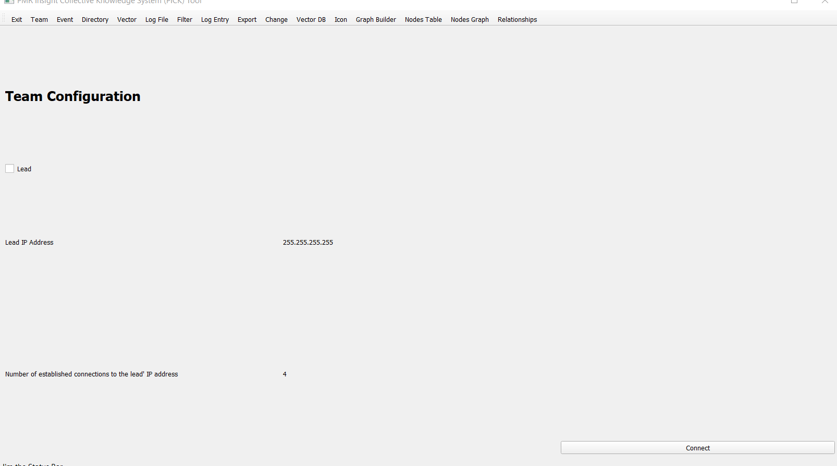

Figure 2
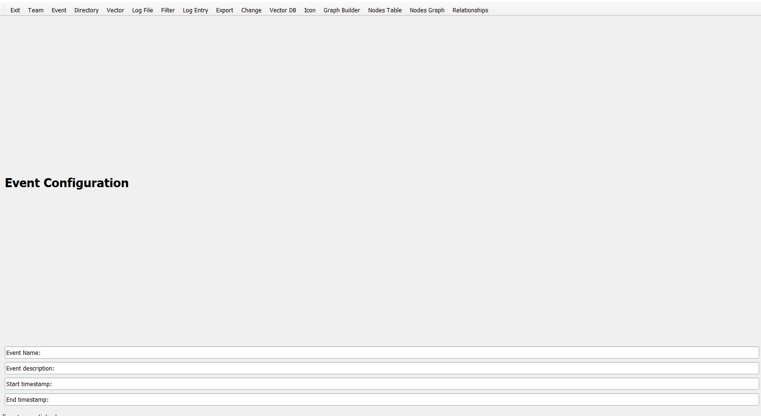

Figure 3

Figure 4

Figure 5

Figure 6

Figure 7

Figure 8
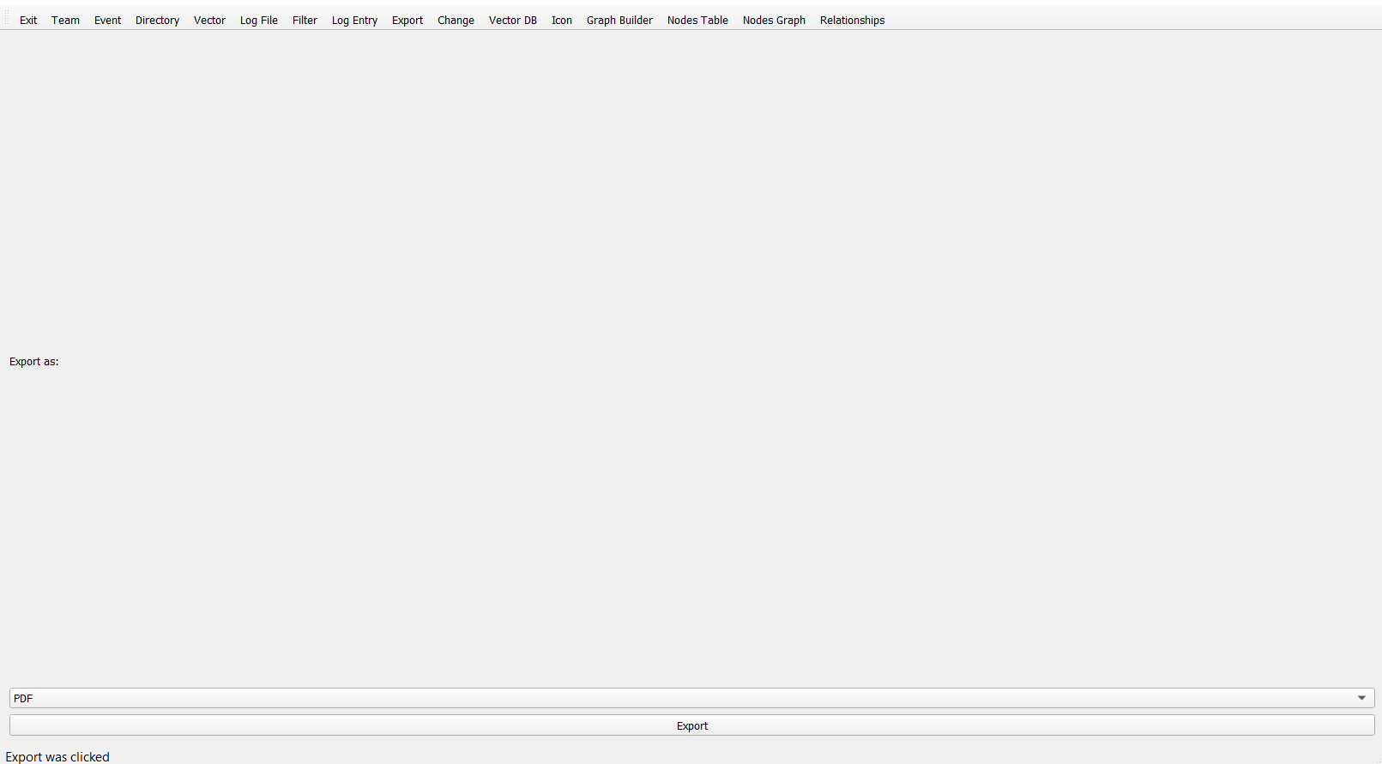

Figure 9

Figure 10

Figure 11

Figure 12

Figure13

Figure 14

Figure 15

Figure 16

Figure 17

Figure 18

Figure 19

Figure 20

Figure 21
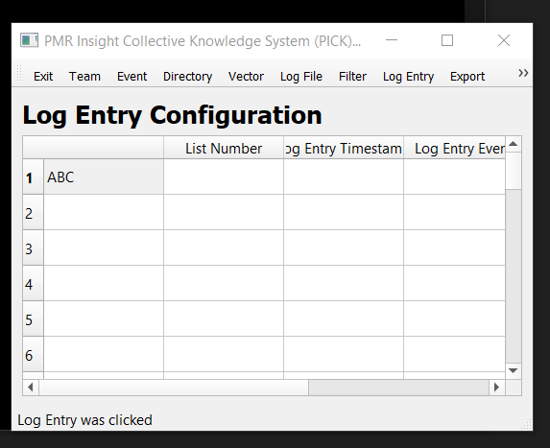

Text 1
Now, this is a story all about how
My life got flipped-turned upside down
And I'd like to take a minute
Just sit right there
I'll tell you how I became the prince of a town called Bel Air
In west Philadelphia born and raised
On the playground was where I spent most of my days
Chillin' out maxin' relaxin' all cool
And all shootin some b-ball outside of the school
When a couple of guys who were up to no good
Started making trouble in my neighborhood
I got in one little fight and my mom got scared
She said 'You're movin' with your auntie and uncle in Bel Air'
https://www.azlyrics.com/lyrics/djjazzyjeffthefreshprince/freshprinceofbelairthemesong.html

Text 2
░░░░░░░░░░░░░▄███▄▄▄░░░░░░░
░░░░░░░░░▄▄▄██▀▀▀▀███▄░░░░░
░░░░░░░▄▀▀░░░░░░░░░░░▀█░░░░
░░░░▄▄▀░░░░░░░░░░░░░░░▀█░░░
░░░█░░░░░▀▄░░▄▀░░░░░░░░█░░░
░░░▐██▄░░▀▄▀▀▄▀░░▄██▀░▐▌░░░
░░░█▀█░▀░░░▀▀░░░▀░█▀░░▐▌░░░
░░░█░░▀▐░░░░░░░░▌▀░░░░░█░░░
░░░█░░░░░░░░░░░░░░░░░░░█░░░
░░░░█░░▀▄░░░░▄▀░░░░░░░░█░░░
░░░░█░░░░░░░░░░░▄▄░░░░█░░░░
░░░░░█▀██▀▀▀▀██▀░░░░░░█░░░░
░░░░░█░░▀████▀░░░░░░░█░░░░░
░░░░░░█░░░░░░░░░░░░▄█░░░░░░
░░░░░░░██░░░░░█▄▄▀▀░█░░░░░░
░░░░░░░░▀▀█▀▀▀▀░░░░░░█░░░░░
░░░░░░░░░█░░░░░░░░░░░░█░░░░
https://www.twitchquotes.com/copypastas/1897

Text 3
ABC 123!

$

