Prevent, Mitigate, and Recover (PMR) Insight Collective Knowledge System (PICK) Tool
Software Design Document
Version 3.0
08 May 2020
Document Control
Approval
The Guidance Team and the customer shall approve this document.
Document Change Control
Initial Release: | 0.1
Current Release: | 3.0
Indicator of Last Page in Document: | $
Date of Last Review: | 07 May 2020
Date of Next Review: | 20 May 2020
Target Date for Next Update: | 21 May 2020
Distribution List
This following list of people shall receive a copy of this document every time a new version of this document becomes available:
Guidance Team Members:
Dr. Salamah Salamah
Dr. Steven Roach
Elsa Tai Ramirez
Peter Hanson
Jake Lasley

Customer:
Dr. Oscar Perez
Vincent Fonseca
Herandy Denisse Vazquez
Baltazar Santaella
Florencia Larsen
Erick De Nava

Software Team Members:
Eduardo A Jiménez Todd
Jacob N Torres
Jorge I Felix
Alejandro Zamora
Matthew S Montoya

Change Summary
The following table details changes made between versions of this document
Version | Date | Modifier | Description
0.1 | 26 February 2020 | Matt Montoya | Creation of Document
0.2 | 06 March 2020 | Alex Zamora | Uploaded Database Schema based on ER diagrams by Jorge & Matt
0.3 | 07 March 2020 | Jorge Felix | Finalized Collaboration Diagram with the help of Eddy & Jacob
0.4 | 08 March 2020 | Eddy Todd | Finished Introduction with the help of Jacob & Matt
0.5 | 09 March 2020 | Jacob Torres | Fixed Collaboration Diagram
1.0 | 09 March 2020 | Matt Montoya | Fixed grammar errors, updated DB schema
1.1 | 22 March 2020 | Matt Montoya | Updated Maltego Class Contract
1.2 | 22 March 2020 | Matt Montoya | Updated Log File Class Contract
1.3 | 22 March 2020 | Matt Montoya | Updated Significant Log Entry Class Contract
1.4 | 23 March 2020 | Jacob Torres | Updated Graph Class Contract
1.5 | 24 March 2020 | Alex Zamora | Updated Vector Class Contract
1.6 | 24 March 2020 | Eddy Todd | Updated OCR Class Contract
1.7 | 24 March 2020 | Eddy Todd | Updated Event Configuration Class Contract
1.8 | 24 March 2020 | Eddy Todd | Fixed Significant Log Entry Class Contract
1.9 | 24 March 2020 | Alex Zamora | Updated Enforcement Action Report Class Contract
1.10 | 24 March 2020 | Alex Zamora | Updated Icon Class Contract
1.11 | 24 March 2020 | Jorge Felix | Updated Directory Class Contract
1.12 | 24 March 2020 | Jorge Felix | Updated Search Class Contract
1.13 | 25 March 2020 | Matt Montoya | Added new introductions to Sections 2, 3, 4; Fixed grammar errors
2.0 | 30 March 2020 | Alex Zamora, Matt Montoya, Jorge Felix, Jacob Torres | Fixed issues based on TA feedback
2.5 | 01 May 2020 | Alex Zamora, Matt Montoya, Jorge Felix, Jacob Torres, Eddy Todd | Added notes based on further TA & Instructor Feedback
3.0 | 08 May 2020 | Alex Zamora, Matt Montoya, Jorge Felix, Jacob Torres, Eddy Todd | Update and finalized SDD for PICK Tool

Table of Contents
Document Control ii
Approval ii
Document Change Control ii
Distribution List ii
Change Summary iii
1. Introduction 1
1.1. Purpose and Intended Audience 1
1.2. Scope of Product 1
1.3. References 1
1.4. Definitions, Acronyms, and Abbreviations 1
1.4.1. Definitions 1
1.4.2. Acronyms 3
1.4.3. Abbreviations 3
1.5. Overview 4
1.5.1. Introduction 4
1.5.2. Decomposition Description 4
1.5.3. Detailed Description of Components 4
1.5.4. Database 4
2. Decomposition Description 5
2.1. System Collaboration Diagram 5
2.2. Subsystem and Component Descriptions 5
2.3. Dependencies 6
2.3.1. Dependency List 6
2.3.2. Dependency Descriptions 6
3. Detailed Description of Components 9
3.1. Splunk Helper 9
3.2. Graphing Tool Helper 10
3.3. Vector 10
3.4. Log File 11
3.5. Log Entry 12
3.6. Graph 13
3.7. Node 14
3.8. Relationship 15
3.9. Team Folder 16
3.10. Event Action (EA) Report 17
3.11. Splunk 17
3.12. User Interface 18
4. Database 19
4.1. Entity-Relationship Diagram 19
4.2. Database Schema 20

Introduction
Section 1 shall introduce Team404’s Software Design Document (SDD) document for the Spring 2020 Software II Project, PICK Tool, including the purpose and intended audience, overview, document references, as well as definitions, acronyms, and abbreviations.

Purpose and Intended Audience
The purpose of creating the software design document is to describe the Prevent, Mitigate Recover (PMR) Insight Collective Knowledge (PICK) Tool, providing the software development team guidance for the architecture of the project. This SDD details the specifications of the characteristics of the design components. The description of the design is necessary for Team404 to work under a single, guided vision of what PICK Tool shall be. Furthermore, the SDD shall act as a point of reference, outlining all parts of the software and the interactions between them.

Scope of Product
PICK Tool shall facilitate the job of analysts during an Adversarial Assessment of a simulated cyber-attack, reducing the time it currently takes analysts to perform an assessment to about two weeks. In doing so, PICK Tool shall assist analysts in telling the true story pertaining to these simulated attacks. To help satisfy these needs, analysts will utilize PICK Tool to search through and filter through logs, or recorded notes from the systems of attackers and defenders, as they may pertain to a simulated attack. Though PICK Tool, analysts can use PICK Tool to construct a vector or visual graph of events that satisfy an objective. More information regarding logs can be found in Section 2 of this document.

References
[1] Wirfs-Brock, R., Wilkerson, B. and Wiener, L. (1990). Designing object-oriented software. Englewood Cliffs, N.J.: Prentice-Hall.

Definitions, Acronyms, and Abbreviations

Definitions
TERM | DEFINITION
Active Scene | The scene that is currently displayed.
Actor | A user or external system that interacts with the system in the use case diagram.
Adversarial Assessment | Analysis of a simulated cyberattack by the White Team.
Analyst | The Analyst is the primary user of PICK Tool. Multiple Analysts can access PICK Tool simultaneously. The analyst primarily uses PICK Tool to ingest log files, correlate logs, and create graphs within the system.
Associated Log | Logs with a cause and consequence log linked together.
Audio Transcription Tool | A software program that takes audio logs and transcribes them into text files.
Blue Team | Defenders during the simulated cyber-attack; the team that will defend their system from attack.
Client(s)/Customer(s) | The U.S. Army Combat Capabilities Development Command Data & Analysis Center: Lethality, Survivability & Human System Integration (LSH) Directorate; individuals from this directorate include Dr. Oscar Perez, Mr. Vincent Fonseca, Mr. Baltazar Santaella, Ms. Herandy Vazquez, Ms. Florencia Larsen, & Mr. Erick De Nava.
Client-Server Model | PICK Tool running on a server in a closed system.
Commit | A button that confirms the actions of the analyst to save the project.
Correlated Logs | Two log entries connected through cause and effect by the analyst.
Database | A structured set of data held in a computer, especially one that is accessible in various ways.
ETL Tool/Log Management Tool | Software that combines the Extract, Transform, Load database functions into one tool to take data from one or many sources into a destination system.
Event Log | A detailed record of system events stored in the System Event Viewer by the computer’s operating system.
Filter | A way for the analyst to search for specific queries through specific conditions set by the analyst.
Filter Space | A certain condition set by the analyst.
Formatted Log Entry | A sanitized log entry that has been cleaned up based on a set configuration by the analyst.
Graph | A visual representation of the scenario between the BlueTeam and the Red Team shown through nodes and vectors. [1]
Graphing Tool | A software program that will construct the graph based on the vectors and correlations made by the analyst.
Graphical User Interface | The way that the system will display all components of the system to the user, the analyst.
Ingest/Ingestion | When files, specifically formatted log files, are put into our system to be correlated, edited and disregarded if need be.
Kali Linux | Operating System the clients will use.
Local Network | A data communications network within the system.
Log | An official record of events.
Log Entry | A log entry is the output of the log file. Log entries contain information from the log file and are recorded details of an ingested log.
Log File | A file is an input into the system that records either events that occur in an operating system or other software runs or messages between different users of communication software.
Natural Language Processor | An external software program that takes audio files and translates them into text files to be later validated.
Node | A node is a visual representation of a significant event that was marked for the current vector.
Normalize | To make rid of duplicate entries.
Objective | The goal of the attackers when they attack a system. It is the goal of the defenders to prevent attackers from achieving their goal(s).
Observer | A member of the white team that takes notes and assessments during the staged cyber-attack between the Blue Team and the Red Team.
Optical Character Reader | An external software program that takes image files and translates them into text files to later be validated.
PICK Tool | The software product which Team404 is tasked with constructing for the clients.
Red Team | The title given to the attackers in the simulated cyber-attack; The team that will attack the system the blue team will defend.
Sanitized Logs/Sanitized Log Entries | A log entry that has gone through validation.
Significant Event | Logs that are important to the overall cyber-attack scenario between the Blue Team and the Red Team.
Team404 | CS4311 Team 6, the software development team; this includes Mr. Alejandro Zamora, Mr. Eduardo Jiménez Todd, Mr. Jacob Torres, Mr. Jorge Felix, and Mr. Matt Montoya.
Timeline | A set of events, logs, that help convey the overall story of the events that took place between the Blue Team and the Red Team.
Timestamp | The time that a log was recorded in the system during the simulated cyber-attack.
User/Users | A person that interacts with the system; in PICK, the user will be an Analyst
Vector | The series of activities/steps an adversary executes or attempts to execute that is necessary to achieve an objective.
White Team | The title given to the observers during the simulated cyber-attack. They observe what happens between the Blue Team and the Red Team on the system.
Wildcard | Unsearchable characters, and any characters that can be searched through.
Zulu Time | The military and navigation parlance for the UTC time standard.

Acronyms
TERM | DEFINITION
AA | Adversarial Assessment
AKA | As Known As
CSV | Comma Separated Value.
DOD | Department of Defense.
ETL | Extract Transform Load.
GUI | Graphical User Interface
IEEE | Institute of Electrical and Electronics Engineers
JPG/JPEG | Joint Photographic Experts Group.
NLP | Natural Language Processor.
OCR | Optical Character Reader.
OS | Operating System
PDF | Portable Document Format.
PICK | PMR Insight Collective Knowledge.
PMR | Prevent, Mitigate Recover.
SDD | Software Design Document

Abbreviations
Admin | Administrator

Overview

Introduction
Section 1 shall introduce Team404’s Software Design Document (SDD) document for the Spring 2020 Software II Project, PICK Tool, including the purpose and intended audience, overview, document references, as well as definitions, acronyms, and abbreviations.

Decomposition Description
Section 2 (Decomposition Description) introduces the System Collaboration Diagram (SCD), the Subsystem and Component Descriptions (CRC Cards), as well as the dependencies of the system, defining the responsibilities entities have for specific functions, and tracing system requirements to design entities.

Detailed Description of Components
Section 3 (Detailed Description of Components) provides complete, detailed descriptions of all components listed within the System Collaboration Diagram (Section 2.1 of the SDD). These components include external as internal components, as they relate to PICK Tool.

Database
Section 4 introduces Team404’s database (DB) proposal for PICK Tool. During a previous demo session, the clients noted they were unsure if a database was needed. This section serves as Team404’s proposed database implementation, using knowledge from UTEP CS 4342 (Database Management) course. This proposal includes the Entity-Relationship (ER) Diagram and database schema that represent the graphical representation of entities and logical configuration of the relational database, respectively.

Decomposition Description
Section 2 introduces the System Collaboration Diagram (SCD), the Subsystem and Component Descriptions (CRC Cards), as well as the dependencies of the system, defining the responsibilities entities have for specific functions, and tracing system requirements to design entities.

System Collaboration Diagram
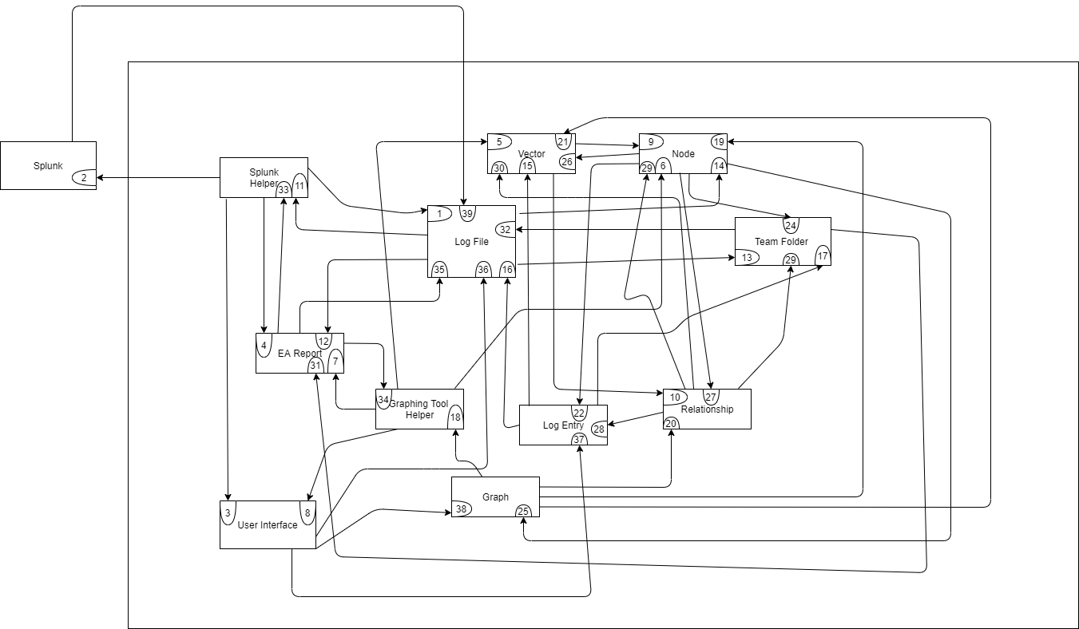

Subsystem and Component Descriptions
Splunk Interface - Communicates with Splunk
Graphing Tool Interface - third party software tool for graphing that communicates with graph
Vector - A description of a significant event communicates with nodes and relationships
Log File - Computer data object that stores logs
Log Entry - Logs that are important to the system to the overall scenario
Graph - Visual representation of a vector communicates with graphing tool interface
Node - Visual representation of a significant event communicates with log file
Relationship - stores details on relations between nodes
Filter - Allows the user to search for specific criteria
Change - Path and structure of the log files
Event Action (EA) Report - Handles errors
Splunk - Handles log ingestions and cleansing
OCR - recognize characters in images
User Interface - what the user interacts with.

Dependencies
Dependencies are external elements to the program. These dependencies are required by PICK Tool in order to work properly.

Dependency List
- Kali Linux OS
- Python 3 (version 3.7.5)
- Splunk Enterprise
- Splunk Python SDK (version 1.6.12)
- PyQt5 (version 5.14.2)
- QGraphViz (version 0.0.50)

Dependency Descriptions

Kali Linux is a Debian GNU / Linux based distribution designed primarily for general computer security and auditing.

Python is an interpreted programming language whose philosophy emphasizes the readability of its code. It is an interpreted, dynamic and cross platform language.

Splunk is a software to search, monitor and analyze big data generated through a web interface. Splunk Enterprise and the Splunk Python SDK enable for the development of Splunk-based applications.

PyQt is a binding of the Qt graphics library for the Python programming language.

QGraphViz is a PyQt5 widget that allows for the development of GraphViz graphs in python.

Dependency Installation Instructions

PICK Tool is built to run on Kali Linux. The Kali Linux ISO can be download directly from the Kali Linux website (https://www.kali.org/).

PICK Tool is built using Python 3.7.5 and requires this programming language to run. Python 3.7.5 can be downloaded from the python website (https://www.python.org/).

PICK Tool depends on Splunk Enterprise and requires dependency, which can be downloaded from the Splunk website (https://www.splunk.com/en_us/download/splunk-enterprise.html).

Users will need the following information to login to and Download Splunk Enterprise (note: This information expires July 1, 2020):

Username: jntorres217

Password: Jaconian@1520

PICK Tool depends on the Splunk Python SDK and requires this dependency

Most Linux users can install the SDK using one of the following commands:

pip install splunk-sdk==1.6.12

pip3 install splunk-sdk==1.6.12

Debian Users may need to clone the Github repo (https://github.com/splunk/splunk-sdk-python) and follow the instructions listed therein.
- PICK Tool depends on PyQt5 and requires this dependency

Most Linux users can install PyQt5 using the following command:

pip3 install PyQt5==5.14.1

Debian Users may need to use direct download links from PyPi (https://pypi.org/project/PyQt5/).

PICK Tool depends on the QGraphViz and requires this dependency

Most Linux users can install PyQt5 using the following command:

pip3 install QGraphViz==0.0.50

Debian Users may need to use other download links from PyPi (https://pypi.org/project/QGraphViz/).

Detailed Description of Components
Section 3 provides complete, detailed descriptions of all components listed within the System Collaboration Diagram (Section 2.1 of the SDD). These components include external components such as the Database and Splunk, as well as internal components including Splunk.

Splunk Helper
Class: Splunk Helper
Superclass: None
Subclasses: None
Description: A third party software tool for transforming log files into normalized log entries.
(1) Ingestion Contract
Responsibilities:  - Can ingest log files.  - Can transform a log file into normalized log entries.  - Can store log entries in the normalized data files.  - Can process incoming data into individual activities according to the nature of the data.  - Can export log entries  - Displays known information to the user | Collaborations:  1Log Files (1)Splunk (2)  2Log Files (1)Splunk (2)  3Log Files (1)Splunk (2)  4Log Files (1)Splunk (2)  5Log Files (1)Splunk (2)  6 User Interface(3)Log Files(1)Splunk(2)EA Report(4)

Graphing Tool Helper
Class: Graphing Tool Helper
Superclass: None
Subclasses: None
Description: A tool for creating graphs.
(3) Create Graph
Responsibilities:  - Knows export format.  - Can create graphs with nodes and relationships between nodes.  - Can export graph.  - Can display Known information to the user | Collaborations:  1  2vector(5) Node(6)  3EA Report(7)  4User Interface(8)vector(5) Node(6)EA Report(7)

Vector
Class: Vector
Superclass: None
Subclasses: None
Description: A description of a significant event.
(4) Vector Elements
Responsibilities:  - Knows Vector Name  - Knows Vector Description  - Knows Vector Entries | Collaborations:  1Nodes (9)  2Nodes (9)Relationship (10)  3Nodes (9)

Log File
Class: Log File
Superclass: None
Subclasses: None
Description: A computer data object that stores logs.
(5) Splunk Integration
Responsibilities:  1Stores Log File Name  2Stores Cleansing Status  3Stores Validation Status  4Stores Ingestion Status  5Stores Acknowledgment, as well Status  6Stores Can export log files | Collaborations:  1  2Splunk Helper(11)  3Splunk Helper(11)  4Splunk Helper(11)  5EA Report(12)  6Team Folder(13)
(7) Node Integration
Responsibilities:  - Can contain a timestamp per line, bounded by the start date, end date, start time, and end time specified in the event configuration. | Collaborations:  1Node(14)
(9) EA Report Integration
Responsibilities:  - When a timestamp property of a previously saved event is changed, the impact of the change shall be restricted to the “not-validated” log files. | Collaborations:  1EA Report(12)

Log Entry
Class: Log Entry
Superclass: Log Entry
Subclasses: None
Description: Logs that are important to the overall cyber-attack scenario between the Blue Team and the Red Team.
(10) Relational
Responsibilities:  1Knows relevant information for a vector. | Collaborations:  1Vector(15)
(11) Filter Log Entry
Responsibilities:  1Knows Log Entry Number  2Knows Log Entry Timestamp  3Knows Log Entry Content  4Knows Host  5Knows Source  6Knows Source Type | Collaborations:  1Log File(16)  2Log File(16)  3Log File(16)  4Team Folder(17)  5Team Folder(17)  6Team Folder(17)

Graph
Class: Graph
Superclass: None.
Subclasses: None.
Description: A visual representation of a vector.
(10) Graph Action Report
Responsibilities:  - A graph shall comprise at least one node.  - Can allow the analyst to add nodes, edit nodes, delete nodes, add relationships, edit relationships, and delete relationships.  - Can create a PNG of the graph.  - Knows how to export format:  - Knows orientation  - Knows Vector Name  - internal units  - Knows interval  - Knows position of nodes  - Knows position of relationships | Collaborations:  1graphing tool Helper(18)  2graphing tool Helper(18)Nodes(19) Relationship(20)  3graphing tool Helper(18)  4  5graphing tool Helper(18)  6Vector(21)  7  8  9graphing tool Helper(18)  10graphing tool Helper(18)

Node
Class: Node
Superclass: None
Subclasses: None
Description: Visual representation of a significant event that was marked for the current vector.
(11) Node Elements
Responsibilities:  1Can represent a log entry as part of the graph  2Knows Node ID  3Knows Node Name  4Knows Node Timestamp  5Knows Node Description  6Knows Log Entry Reference  7Knows Log Creator  8Knows Event Type  9Knows Icon Type  10Knows Source  11Knows Node Visibility | Collaborations:  1Log entry(22)  2  3  4  5  6log entry(22)  7log entry(22)  8  9  10Team Folder(24)  11

Relationship
Class: Relationship
Superclass: None
Subclasses: None
Description: Represent the relationship between nodes.
(18) Vector Relationships
Responsibilities:  - Knows the relationship ID  - Knows the parent ID  - Knows the child ID  - Knows the label  - Knows source of logs | Collaborations:  1  2  3  4  5log entry(28)Team Folder(29)
(19) Event Parameters
Responsibilities:  - Can correlate nodes to one another. | Collaborations:  1Node(30)

Team Folder
Class: Team Folder
Superclass: None
Subclasses: None
Description: Path and structure of the log files.
(23) Keeps Track of
Responsibilities:  1Can perform structure check when data ingestion starts  .  2Can generate root directory structure error if it fails to contain three folders or if the folder names specified in the event configuration don't match.  3Can store the log files in their corresponding folder.  4Knows Red Team Folder  5Knows Blue Team Folder  6Knows White Team Folder | Collaborations:  1EA Report(31)  2EA Report(31)  3Log Files(32)EA Report(31)  4  5  6

Event Action (EA) Report
Class: Enforcement Action Report
Superclass: None
Subclasses: None
Description: Handles errors when anomalous events happen.
(24) EA Elements
Responsibilities:  1Can track error codes  2Can display error code  3Can track description of error codes  4Can track the state of the system  5Knows the Line Number  6Knows the Error Message | Collaborations:  1  2Splunk Helper(33) Graphing Tool Helper(34)  3  4Log file(35)  5  6

Splunk
Class: Splunk
Superclass: None
Subclasses: None
Description: Handles log ingestion and cleansing.
(25) log handling
Responsibilities:  - handles log cleansing  - handles log ingestion | Collaborations:  1Log File(39)  2Log File(39)

User Interface
Class: User Interface
Superclass: None
Subclasses: None
Description: The view that the user sees and interacts with.
(27) display
Responsibilities:  - display current window user is interacting with  - keep track of parallel tasks | Collaborations:  1log file(36)log entry(37)graph(38)  2

Database
Section 4 introduces Team404’s database (DB) proposal for PICK Tool. During a previous demo session, the clients noted they were unsure if a database was needed. This section serves as Team404’s proposed database implementation, using knowledge from UTEP CS 4342 (Database Management) course. This proposal includes the Entity-Relationship (ER) Diagram and database schema that represent the graphical representation of entities and logical configuration of the relational database, respectively.

Entity-Relationship Diagram
The ER diagram, shown below, is a conceptual design of the relationship between entities, or things in the real-world as they pertain to PICK Tool. These entities are denoted by the rectangular shapes in the model. These entities may contain attributes that describe the entities, as well as relationships between entities. Attributes are housed within the oval shapes, where relationships are housed within the diamond shapes; both of which are connected to the entities.

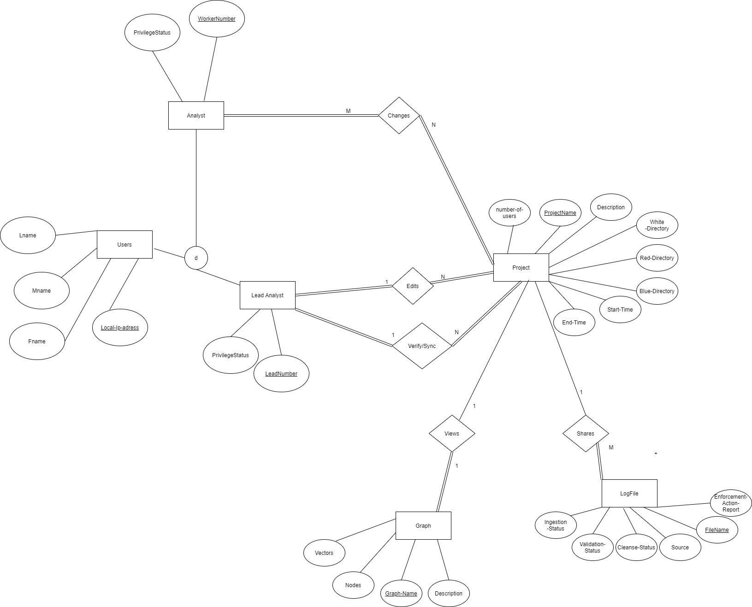

Database Schema
The Database Schema (or relational model) shown below, is another visual representation of the database, depicting the logical configuration of the database, including the set of rules that govern as they pertain to PICK Tool. This schema serves as a description of the database itself and is derived from the ER Diagram in Section 4.1. The conversion of high-level (ER diagram) to logical design (DB Schema) follows a seven-step algorithm: Mapping regular entities to relations, mapping weak entities to relations, identifying 1:1 binary relationship types, identifying binary 1:N relationship types, identifying M:N relationship types, separating multi-valued attributes, and creating new relations for N-ary relationships.




