Cyberminer – Web Search Engine

Preliminary Project Plan
Project phase 2-1

Parker Tate – pst170030
Fredrick Horn – fmh180000
Jacob Danel – jcd190000
Collin Matz – cam210003
Conner Carraher – csc210002
Joshua Brown – jsb220001
Pranit Konda – prk180003

[https://cs4376-team-a.github.io/Project/]

CS 4376.0U1 – OO Design
1. Introduction

1.1 Project overview
This project plan is used for the implementation of a simple web search engine, tentatively named “Cyberminer”. The project will include all aspects of a typical software development lifecycle. Where we aim to determine the proper requirements, analyze said requirements to determine what will need to be created in order to meet them, make proper designs with all that in mind. Then go on to create the actual project program and test it as needed until deployment. Throughout this process we aim to create a sophisticated enough search engine that will allow users to search for websites by having them give the system a list of keywords which will then generate a list of URLs which contain some or all of the keywords the user had given.

The first phase of this project will be primarily focused on creating the design documentation and other similar documentation (project plan, analysis documents, etc.) as well as the foundation of the program (building the site indices). Phase 2 will see more of the system being developed until completion. In other words, adding more functionality to the system is an actual functioning search engine. So, fulfilling the other requirements like implementing case sensitivity searching, hyperlink enforcement, etc.

Currently phase 1 of the project’s development is complete and we are currently in phase 2.

1.2 Project deliverables
The following are the deliverables for this project:
- Preliminary Project Plan ----------------------- Deliverable 1
- Interim project 1 –---------------------- Deliverable 2
- Final Project 1 ----------------------- Deliverable 3
- Interim Project 2 ----------------------- Deliverable 4
- Final Project 2 ----------------------- Deliverable 5

Deliverable descriptions:
a) Preliminary Project Plan – Project description, team members, etc.
b) Interim Project 1 – PPT and presentation discussing progress and current strategy
c) Final Project 1 – Completed program (build indices) and associated documents
d) Interim Project 2 – Updated project plan and current progress on program
e) Final Project 2 – presentation and demo of completed project program

1.3 Evolution of this document
This is a preliminary document with the scope of the project. This is a living document that will see considerable changes made to it as the project progresses. Current aspects of this document are likely to change due to this.

1.4 References
Referenced documents, documentation, etc.:
- Sample system design document found on Prof. Chung’s website:
- https://personal.utdallas.edu/~chung/CS6354/CS6354_U07_source/Team_1/CAD_Design__4.doc
- Another Sample system design document found on Prof. Chung’s website: https://personal.utdallas.edu/~chung/CS6354/CS6354_U07_source/Team_2/deliverable_1_Req_Specification.doc
- Prof. Chung’s personal webpage where slides and such are found: https://personal.utdallas.edu/~chung/OOD/syllabus.htm
- Phase 1 assignment document: https://personal.utdallas.edu/~chung/OOD/Project1.pdf
- Example project document, final document from previous semester’s class and the system they worked on, a compilation of all of their various system and design documents:
https://personal.utdallas.edu/~chung/CS6354/CS6354_U07_source/Team_1/CAD_ProjecDocument.doc

1.5 Definitions, acronyms, and abbreviations
- Search Engine – A program used to search for and access websites by using key words submitted to the program. Once key words are received the search engine will generate a list of relevant websites that the user can then connect to.
- UML – Unified Modeling Language, a means to visually represent ideas to help in the creation of software systems.
- Waterfall Lifecycle –

2. Project organization

2.1 Process model
The design process for this project will be primarily done using UML diagrams. Properly utilizing these UML diagrams will allow our team to form a good basis for the project’s desired system through having a better visual representation of how the various components should and will interact with one another. As for our development process we will primarily be using the waterfall lifecycle, with adjustments to this lifecycle process as needed.

2.2 Organizational structure
The members involved in developing this project are:
- Parker Tate
- Myles Horn
- Jacob Danel
- Collin Matz
- Conner Carraher
- Joshua Brown
- Pranit Konda

The Team member starting the team leader position rotation will be:

2.3 Organizational boundaries and interfaces
Deliverable 1 was created early on in the systems development so large portions of this document were left TBD as more of the design aspects for the system were created and fleshed out. Deliverables 2 and 3 saw significant design components created and realized as the project progressed, where the first four main artifacts were created and expanded upon (class diagram, sequence diagram(s), use case diagram(s), and requirements documentation). During this time a prototype version of the system was made using these documents. Where said system was able to populate and manipulate an index table that consisted of index entries for websites.

For further deliverables the expectation is to have an updated project plan as well as a system outline for deliverable 4. Then for deliverable 5 to finalize all design and system documentation as well as have the system completed to the point where it is able to function fully as a web browser.

2.4 Project responsibilities
All team members are responsible for participation in all phases of the project’s lifecycle. i.e., planning, program development, etc. to ensure that all members are on the same page. Level of participation varies depending on their roles in the system’s development. Some members will have more of an emphasis on working on design and documentation while others will focus more on implementation of the system.

3. Managerial process

3.1 Management objectives and priorities
The primary task for the managerial position is to schedule meeting timing, lead said meetings, and keep meetings on track. As well as staying on top of project due dates.

3.2 Assumptions, dependencies, and constraints
This relates primarily to time constraints for deliverables related to the project. Section 5 lists the due dates for each deliverable.

3.3 Risk management
Risk management is handled by the team lead for each expected deliverable. The team will communicate with one another some time before the expected due to ensure that all requirements are completed on time and correctly.

3.4 Monitoring and controlling mechanisms
The team’s monitoring and control mechanisms are primarily achieved through communication through discord, both through voice chat and text chat. Also, the version control provided by the team’s GitHub repository further facilitates this as it shows what team members have added or made changes to documents, what time they did so, and so on.

4. Technical process
4.1 Methods, tools, and techniques
As suggested in the course syllabus, Rational Rose will be used for the UML modeling for the project. As for the programming language used to develop the system, the chosen language will be Java. Primarily because that is the language that all members of the team are familiar with and would be able to complete the project using most effectively. All team communications will be done through Discord in a server created by one of the team members. All project deliverables will be posted on our team’s website.

4.2 Software documentation
Additional documentation is created as needed and can be found on the team website/GitHub repository. Current documentation includes:

Documentation:
- CyberMiner Search Engine Final Phase 1 document – overall design document for the CyberMiner system.
- CyberMiner Project Plan – This document.
- CyberMiner User Manual – Step by step guide on how to set up and use the CyberMiner system.
- CyberMiner Phase One Presentation PowerPoint – primarily shows design diagrams.

System Design Diagrams:
- CyberMiner General Overview – roadmap of the system.
- CyberMiner Domain Model – rough overview of system architecture.
- Requirements Model – sequence diagrams and use case diagrams with associated use case text, helps with system realization and understanding how actors and components interact.
- Design Model – More robust version of domain model.
- Implementation Model – Expands upon Design Model.
- Testing Diagram – Examples of potential test cases to run during system implementation.

4.3 Project support functions
All documentation, design diagrams, and other related documents can be found at our team’s website:
https://cs4376-team-a.github.io/Project/

5. Work elements, schedule, and budget
This project is scheduled to be completed by August 1st, 2023, for the final demo. Below is the outline of the timeline of the deliverables:
Deliverable 1 due by 06/01/2023
Deliverable 2 due by 06/15/2023
Deliverable 3 due by 06/29/2023
Deliverable 4 due by 07/13/2023
Deliverable 5 due by 08/01/2023

CyberMiner Outline

Domain Modeling and Requirements Specification
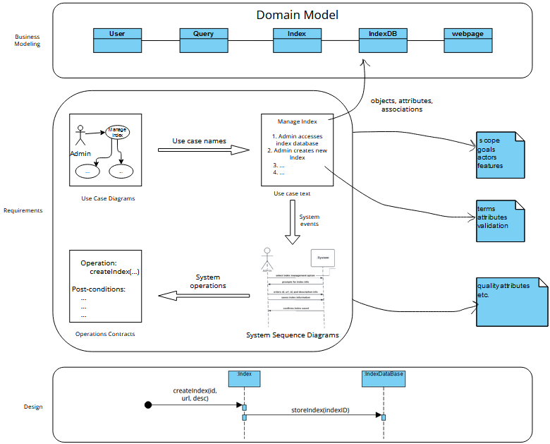
Current knowledge of the system is as follows. Known stakeholders of the system are general users and system administrators, there currently are no plans or expectations for other stakeholders, like advertisers, to be considered in the design and development of the CyberMiner Search Engine system. CyberMiner is expected to be completely open source and freeware so the need to accommodate advertising is unnecessary.
For the functional requirements specification, specifically regarding information related to input/output of the CyberMiner system. Input is currently expected to be received as a string that is to be separated on space delimiters, where the separate words from that string (stored in a list called keywords) are then compared against each indices’ description within the index table. Matches found between the keywords and words within the description will result in a positive match. Positive matches will result in the positively matched indices’ URLs to be put within another list that will be displayed on a webpage of results for users once the entire process is completed. That is, at the end the output will be a list of URLs that result in positive matches with the users input that is displayed on a webpage that the user can then click on any of the entries on the webpage to then connect to that specific URL.

Architectural Design Specification
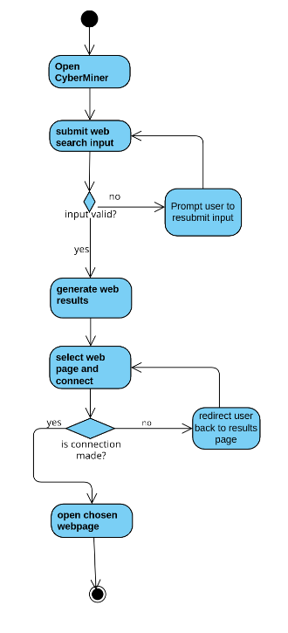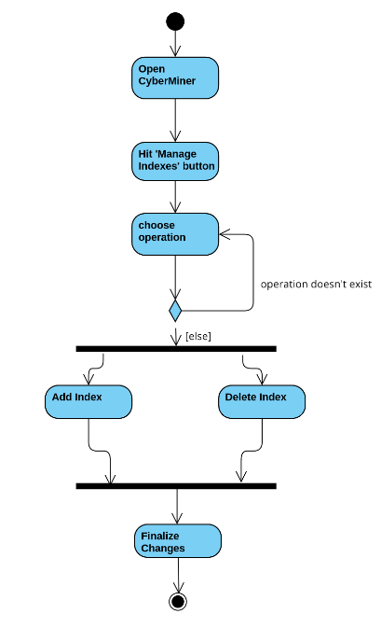
Above are some example activity diagrams of the expected series of events that will happen for a typical interaction between a user and the system (the image on the left) or one particular instance of an administrator making edits to the indices table within the system, i.e. clicking the manage indexes button to then go to the indices table where there are further options to add, delete, or modify an index or indices. These were examples taking from the early Requirements specification document (some use case examples) remade using activity diagrams.
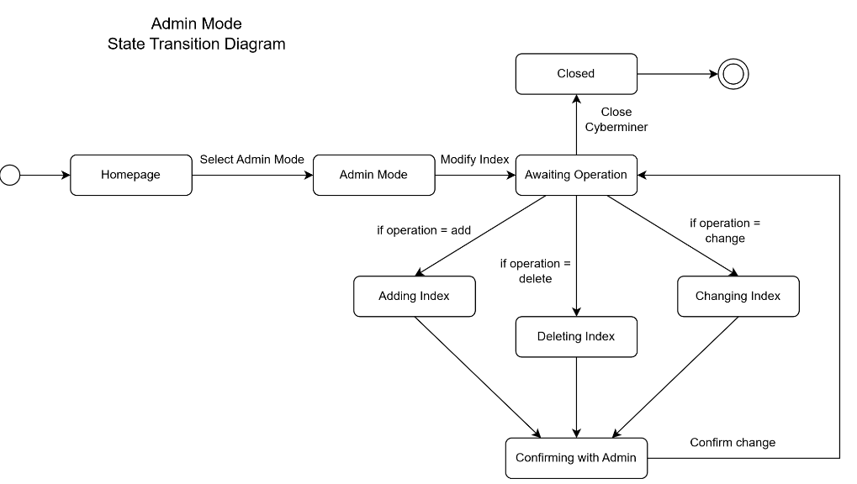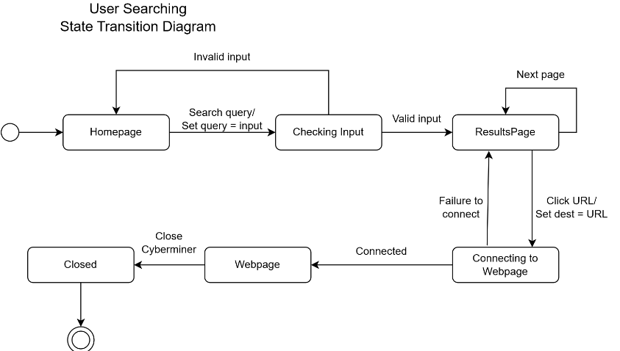
Above are some example state transition diagrams showing some interactions between the system and a user or administrator. It is the same series of events that occurred in our use case diagrams within the requirements specification, just with more detail with what specifically happens from action to action.

Prototype Implementation
A prototype of the system can be found at https://github.com/CS4376-Team-A/Project/tree/main. Instructions for installation and how to use the system can be found within the user manual. See the User Manual section below for further information regarding that.
User Manual
The user manual can be found at: https://github.com/CS4376-Team-A/Project/tree/main/docs/documents.

