**Space Rock**

*Ground Operator Display Documentation*

*Version 3.0*

Team #04/03

14 February 2017

***CS 460 Software Engineering***

**SpaceRock Ground** **Operator Display Documentation 2**

Introduction 2

Screen Design 2

Functional Design 3

Software Design 5

Networking 5

Processing 5

GUI 6

SpaceCraft Emulator 6

# SpaceRock Ground Operator Display Documentation

## Introduction

The SpaceRock system requires a Ground Operator Display in order to allow ground-based users to control and evaluate the system’s performance. It will do this by providing a display canvas that displays images from the SpaceRock System. You will also be able to select asteroids to bring up a popup window, displaying general information about the selected asteroid. The ground operation display will also have controls to change camera settings and parameters. This document will describe the layout, the design, and the internal workings of the SpaceRock Ground Operator Display.

## Screen Design

### Introduction

The screen design is shown in the following figures. Screen shots of the main GUI, and of the selected object information pop up are presented below. The various elements of the GUI will be detailed in the next section.

### Images of Design

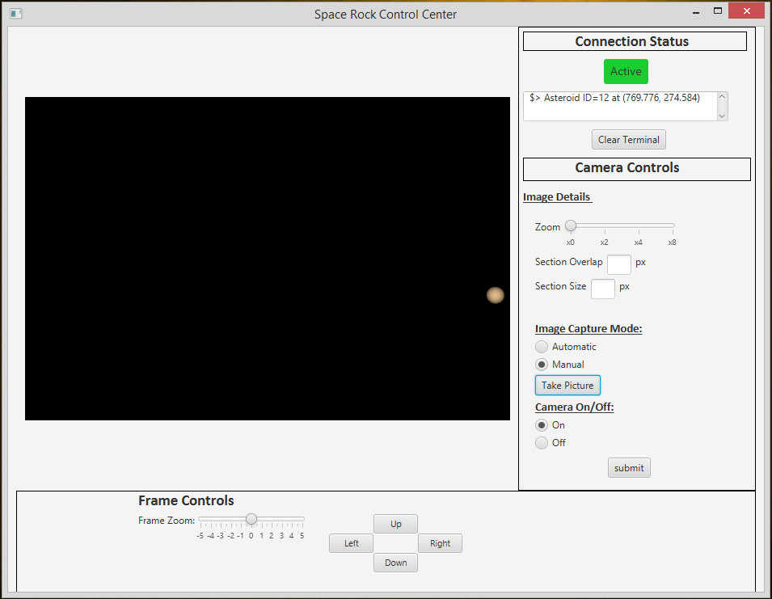

*Figure 1: Mock-Up of SpaceRock GUI*

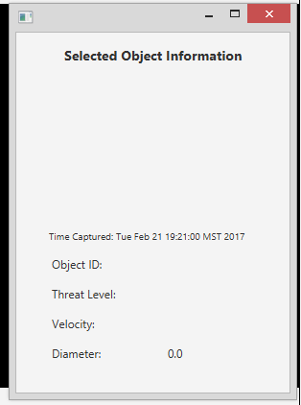

*Figure 2: Mock-Up of Selected Object Information Pop Up*

## Operator Interface Specification

|  |  |
| --- | --- |
| **UI Element** | **Function** |
| Object Display Canvas | Displays a grayscale image derived from the raw data sent by the satellite. This represents the last image captured by the camera and received by the operator interface. The grayscale image, its detected objects, and the zoom initially shown will be determined by the last camera settings at the time the submit button was pushed.  The image also contains a timestamp which details the time the image was taken.  Objects can be selected or hovered over and a pop up dialogue will appear to showcase their details. These details can be viewed from the Selected Object Information Panel. |
| Selected Object Information Panel | Displays the current object’s identification number, velocity, threat level, and size in text format while also providing an image of the object that has been selected and the timestamp detailing when the image was captured. |
| Satellite Camera Zoom | Adjusts the camera’s zoom toward the center of its field of view. This does not affect the frame that is currently displayed in the Object Information Panel. |
| Section Size | Adjusts the image processing section size. This does not update the current frame and changes will not be visible until the next image is received. |
| Section Overlap | Adjusts the amount of overlap each section is allowed to have with its neighbors. |
| Manual/Automatic Mode | Checking Manual Mode and clicking submit sends a signal to the satellite that instructs the camera to take a single image and return the data.  Checking Auto Mode and clicking submit sends a signal to the satellite which instructs it to continuously capture photographs and return the data. |
| Submit Button | The Submit button sends our currently selected settings to the satellite so that they will be utilized in the next frame capture. |
| Refresh Button | The Refresh Button allows us to manually capture a new image using the last settings in the event an image processing error is evident in the Object Display Canvas, such as a white screen or a noisy frame, and was not caught by the system’s automatic detection. |
| Status Indicator Light | The status indicator light resides near the top right of our GUI panel. It changes color depending on the connection status. If the operator interface has been in recent communication with the satellite or is currently receiving data, the indicator is green. If the Operator Interface has sent a signal and is waiting to receive something for longer than our set amount of time, the indicator light switches to yellow. If the connection has timed out entirely, the indicator light changes to red. The information provided by the status indicator light is supplemented by the text output that displays in the Status Output Console. |
| Status Output Console | The status console dynamically updates with messages to inform the user of the system’s connection status with the satellite. If the connection is lost(no message received after a given amount of time), a message indicating this will display. When the connection is active, this console displays the text “Connection is Active.” |
| Canvas Frame Zoom | The image object canvas frame slider allows you to zoom in on the last captured frame in the Object Display Canvas. This capability is also provided in the mouse controls |
| Up, Down, Left and Right Buttons | The Up, Down, Left, and Right buttons allow you to view different sections of the enlarged frame in the Object Display Canvas. This capability is also provided with a left mouse click and drag. |

|  |  |
| --- | --- |
| **Mouse Controls** | **Function** |
| Mouse Middle Button | Scrolling with the mouse middle button zooms in or out on the image in the Object Display Canvas. This zoom method only allows us to modify the last frame received by the ground control station. The camera zoom on the satellite is unaffected by this action. |
| Mouse Left Click | Mouse left click and drag lets you reposition the resized frame image in the Object Display Canvas. |

## Demo Software Design Overview

### Demo Software Components Diagram



*Figure 3: Demo Software Components Diagram*

### Software Components Diagram Overview

The diagram above outlines the software components used in the demo of the Ground Operator Display GUI. The canvas of the GUI is what the Simulation outputs are displayed on. Frame controls affect how the image displayed on the canvas is modified to zoom into a specific location as well as pan to a new location on the frame while zoomed in. Camera controls send the parameters that the camera will use to take a picture that will be returned for processing. Pop up data opens a new dialogue window when a rock is clicked in the canvas that shows the raw image of the rock as well as identifying information about it.

### Use case

To use the system the user will first launch the GUI client. Once loaded the user needs to turn on the camera, as it is default set to be off, to do this the user selects the On radio button under the Camera On/Off label and press the submit button. Without pressing the submit button no changes to the camera controls will be sent to the simulation. Once an image is available it is returned and the rocks are drawn on the canvas. Images will continue to be taken as soon as possible and with the same parameters until either the Image Capture Mode is changed to manual or a new Zoom Level, Section Overlap, or Section Size parameter is provided. If manual image capture mode is selected a new picture will only be taken when the Take Picture button is pressed. The new picture will be taken with the parameters set in the camera controls when the button is pressed.

## Interface Specification for Operator Display Software

### Introduction

The following is divided into incoming and outgoing data. Incoming data is the data that is coming in from the SpaceRock System. The outgoing data is data that we are sending from the Ground Operator Display

### Outgoing data

This is where we send commands to the camera. You can set the zoom level, sector height, sector width, set it on or off, and turn it to manual or automatic mode.

### Incoming Data

#### Frame Data

This is sent by the SpaceRock System. This includes a list of all the asteroids as well as a time stamp of when the data was received.

#### Asteroid Data

This is sent by the SpaceRock System. It contains the information of each asteroid. This includes the location, size and the id of the asteroid.