Many Voices Publishing Platform User Guide

June 2017

Version 1.10

Team Remix  
Josh Matteson  
Steven Powers  
Evan Tschuy

Table of Contents

1 Introduction 3

1.1 Scope and Purpose 3

1.2 Process Overview 3

2 New Textbook 5

2.1 New Textbook Details 5

3 Edit Textbook 6

3.1 Edit Textbook Details 6

4 Edit Chapter 8

4.1 Edit Chapter Details 8

5 New Scrap 10

5.1 New Scrap Details 10

6 Profile Settings 12

6.1 Profile Settings Details 12

7 Login 13

7.1 Login Details 13

# Introduction

## Scope and Purpose

The Many Voices Publishing Platform (MVP Platform) is a document creation tool aimed at professors looking to write a textbook for their courses but are short on availability. The MVP Platform allows a user to create their own **Textbooks**, **Chapters**, or **Scraps** or copy and modify existing textbooks, chapters, or scraps created by other users with the MVP Platform.

This user guide will provide basic guidelines for account login, textbook creation, editing a textbook, chapter creation, editing a chapter, scrap creation, creating an image scrap and profile settings.

## Process Overview

A user will typically follow the order of operations listed below, this user guide will cover these operations in this order.

1. New Textbook
2. Edit Textbook
3. New Chapter
4. Edit Chapter
5. New Scrap
6. New Image Scrap
7. Profile Settings

Process Flow Diagram:

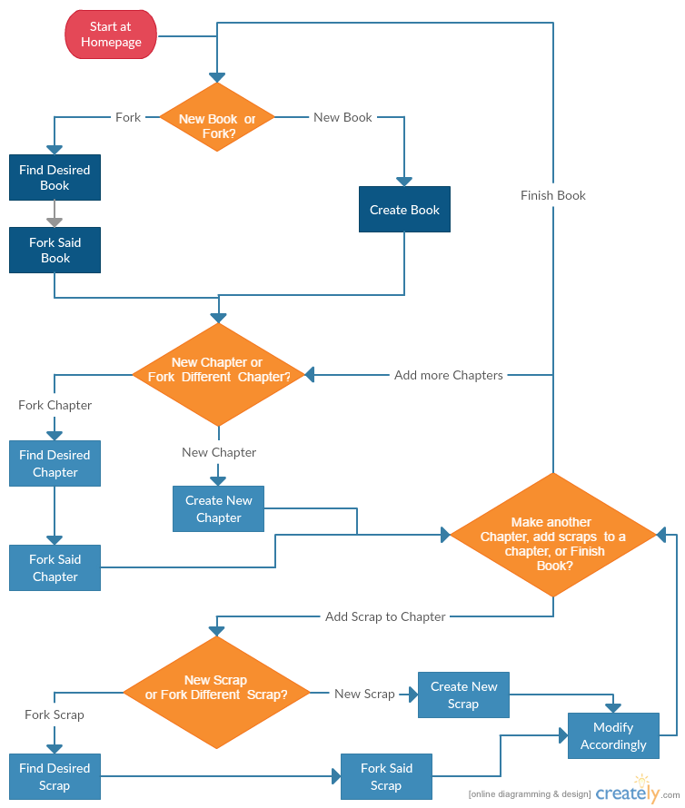

# New Textbook

Create a new textbook for your text creation or modification to take place.

The new textbook operation is a simple press of a button which will prompt you for a new book name.

## New Textbook

1. From the My Books page locate the Create New Book button

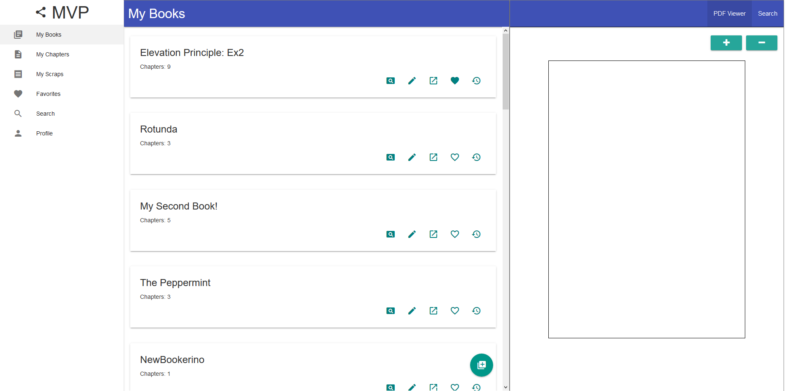

1. Click the Create New Book button
2. Input a book name

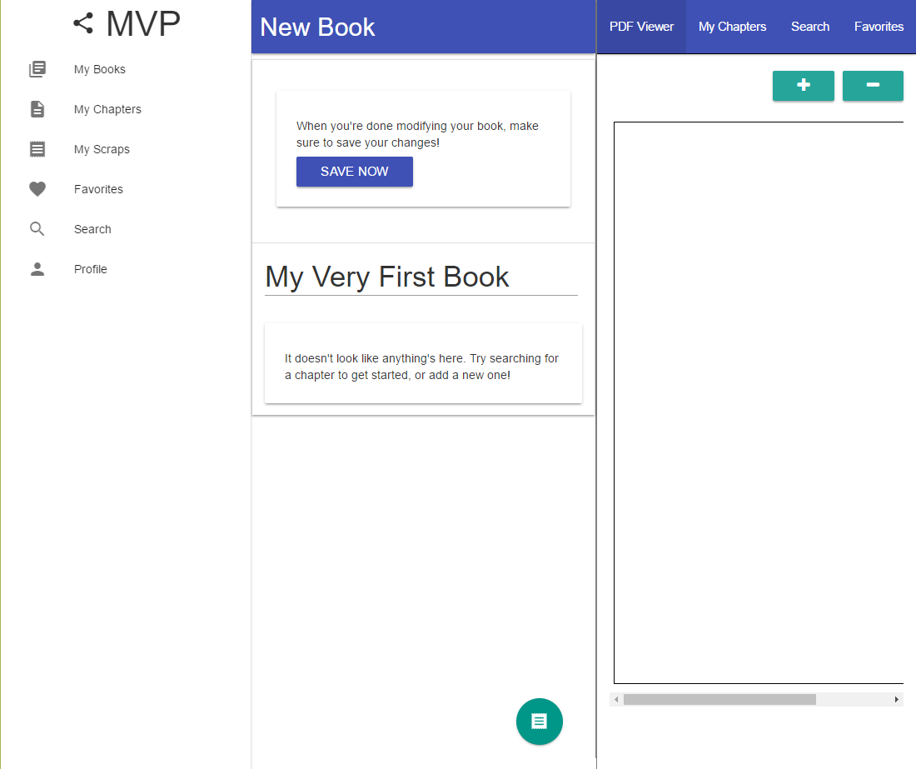

1. Click “Save Now”

# Edit Textbook

Edit an existing textbook for your text creation or modification to take place.

The edit textbook operation is a simple press of a button which will allow the user to edit the title of their book, rearrange chapters, search and drag chapters into their book.

## Edit Textbook

1. From the My Books page locate the Edit Book button

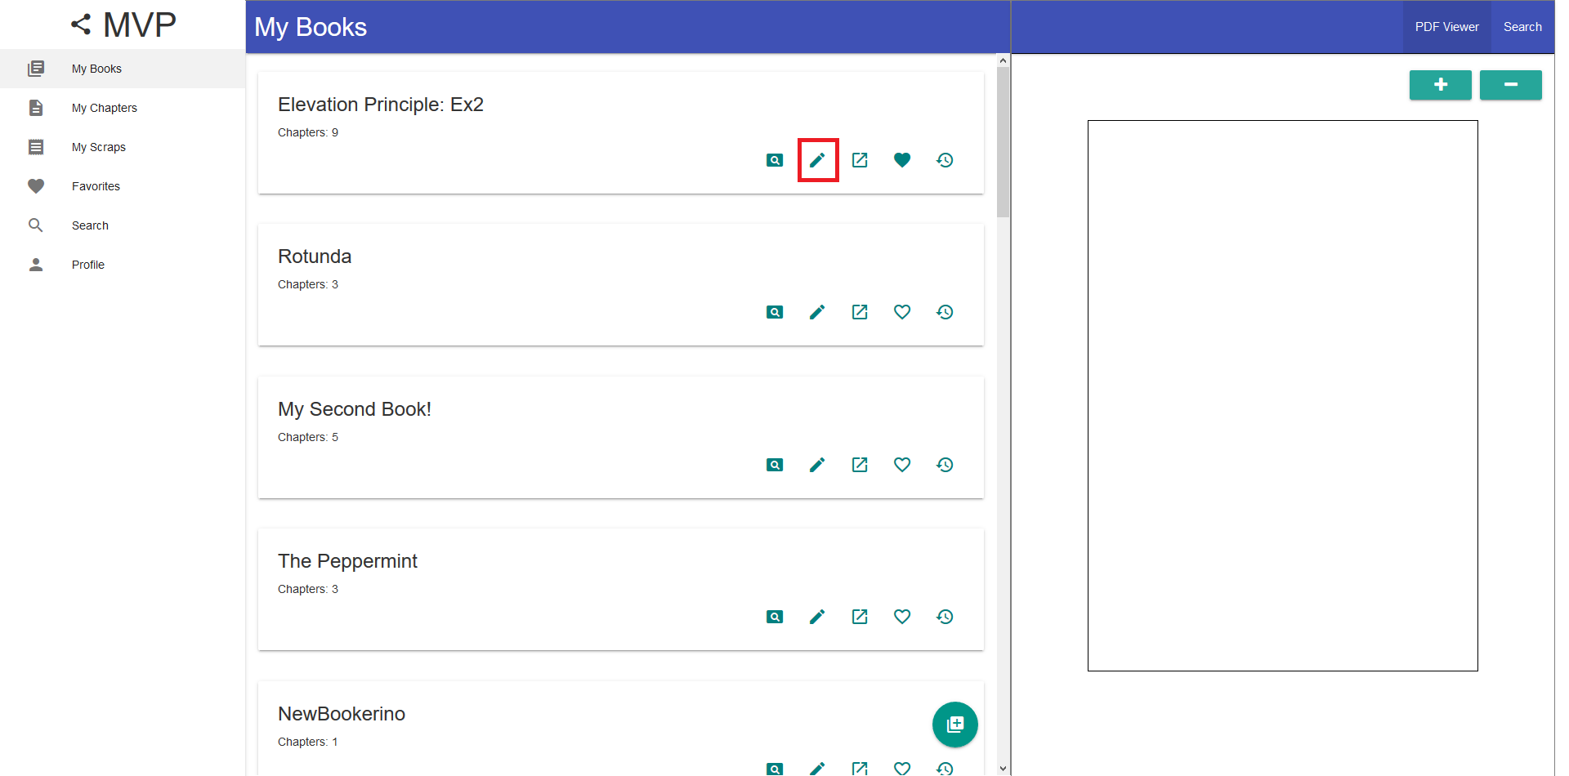

1. Click the Edit Book button
2. Options:
   1. Drag in a new chapter from My Chapters / Searched chapters

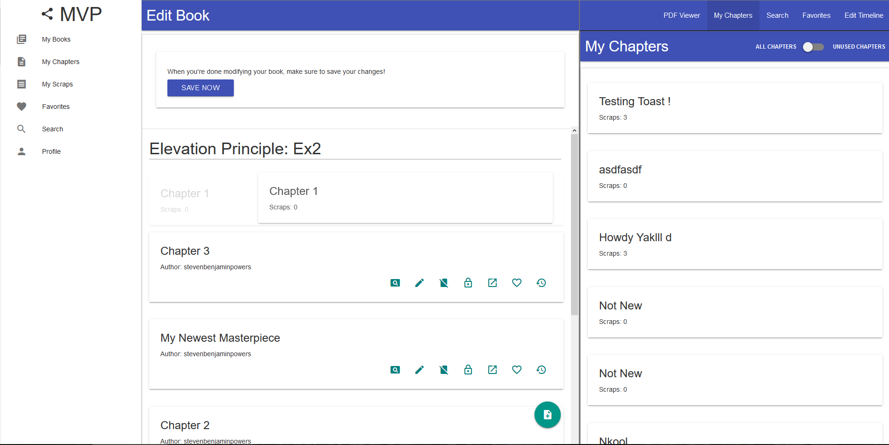

* 1. Rename the book
     1. Click on the book title to rename the book
  2. Create a new chapter

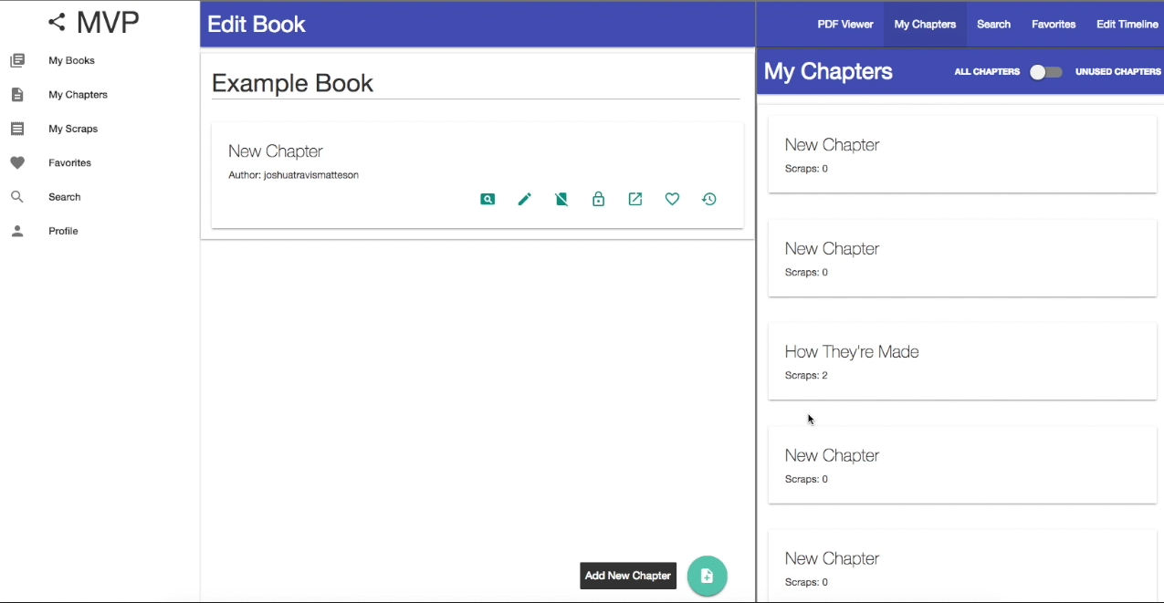

* 1. You will be prompted to enter a name for the chapter
  2. For more details see section 4

1. Click “Save Now”

# Edit Chapter

Edit an existing chapter for your text creation or modification to take place.

The edit chapter operation is a simple press of a button which will allow the user to edit the title of their chapter, rearrange scraps, search and drag scraps into their book.

## Edit Chapter

1. From the Edit Book page locate the Edit Chapter button

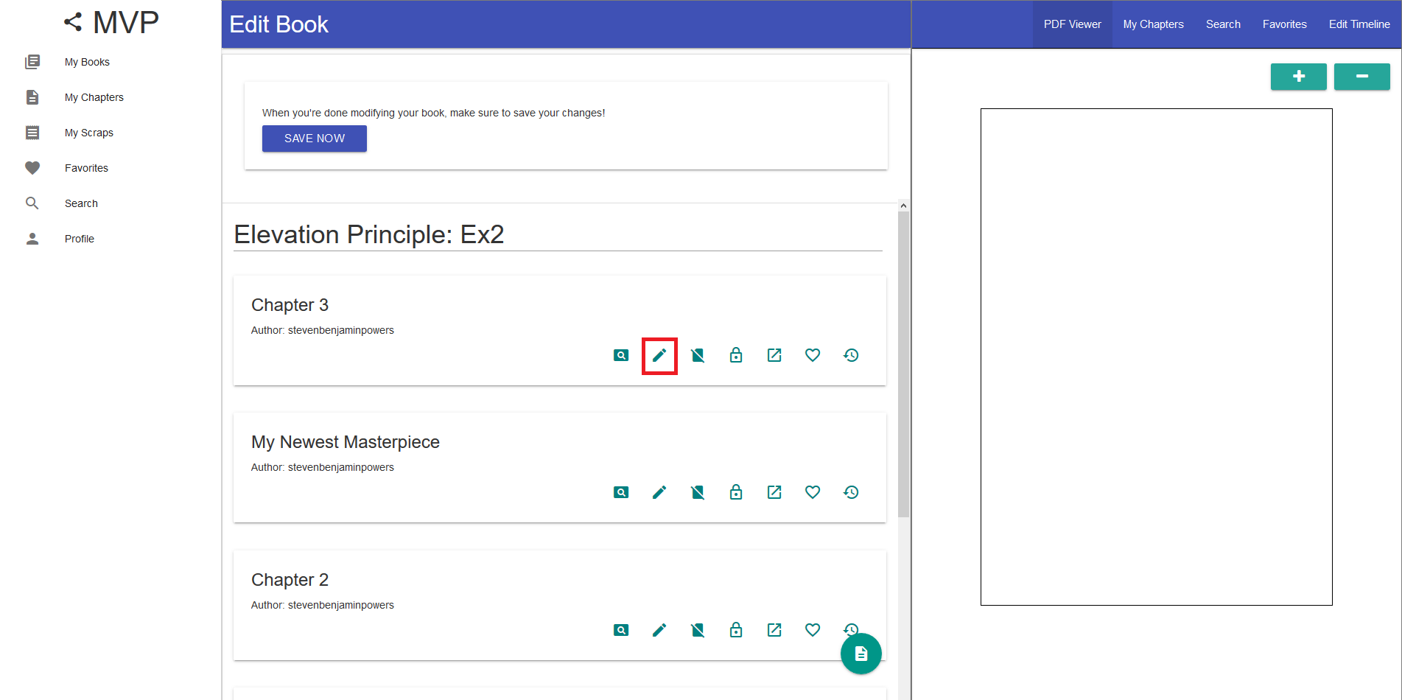

1. Click the Edit Chapter button
2. Options:
   1. Drag in a new scrap from My Scraps / Searched scraps

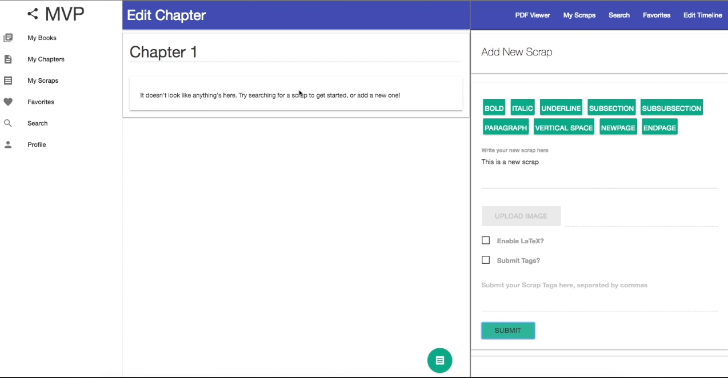

* 1. Rename the chapter
     1. Click on the chapter title to rename the chapter
  2. Create a new scrap



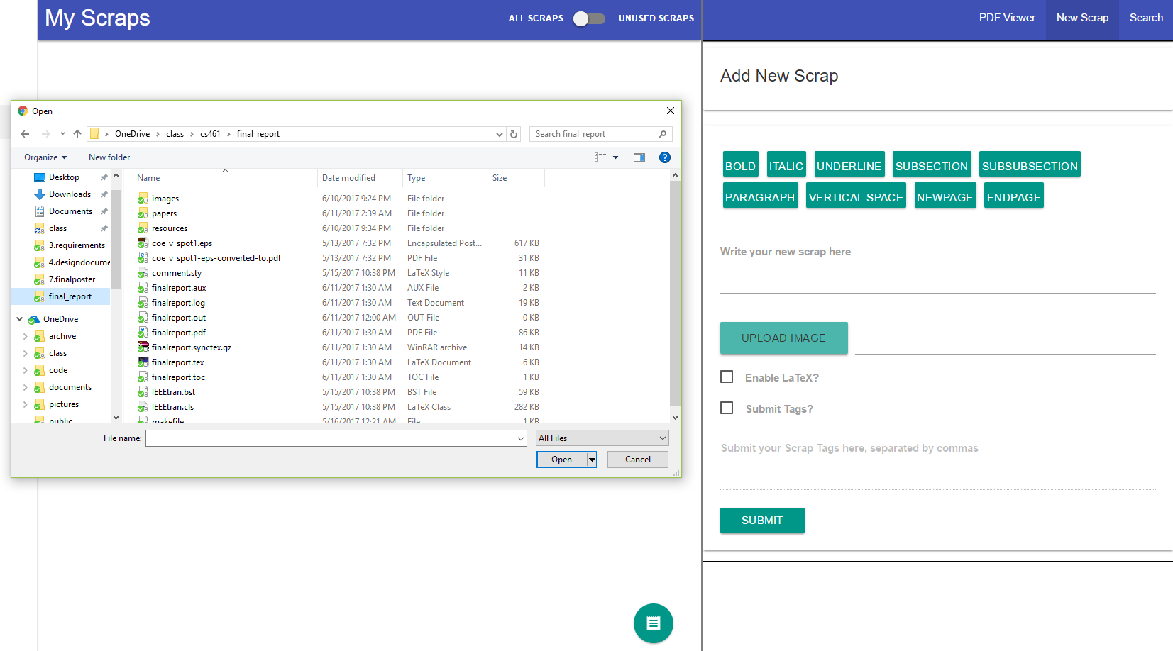

* 1. You will be prompted to enter either text or upload an image for the scrap
  2. For more details see section 5

1. Click “Save Now”

# New Scrap

Create a new scrap that chapter for your text creation or modification to take place.

The edit chapter operation is a simple press of a button which will allow the user to edit the title of their chapter, rearrange scraps, search and drag scraps into their book.

## New Scrap

1. From the Edit Chapter page locate the New Scrap button

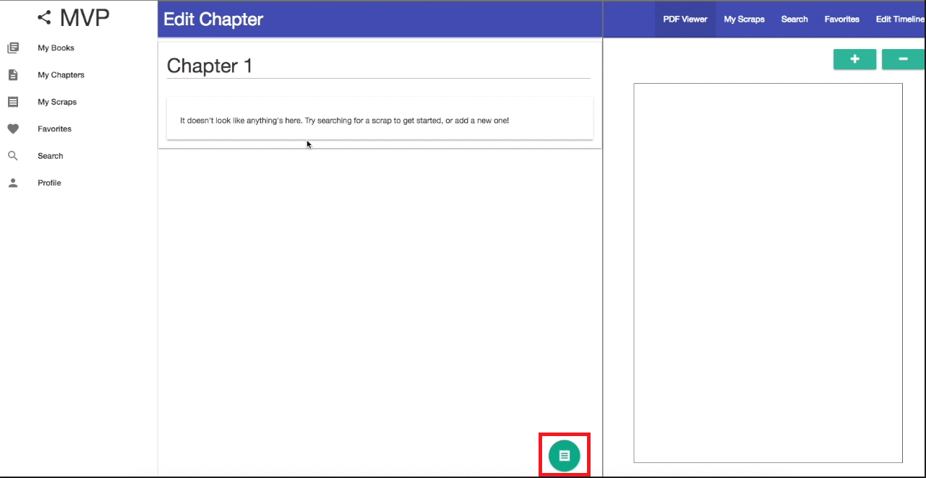

1. Click the New Scrap button
2. Options:
   1. Create a new scrap using text, enable LaTeX mode, or add tags

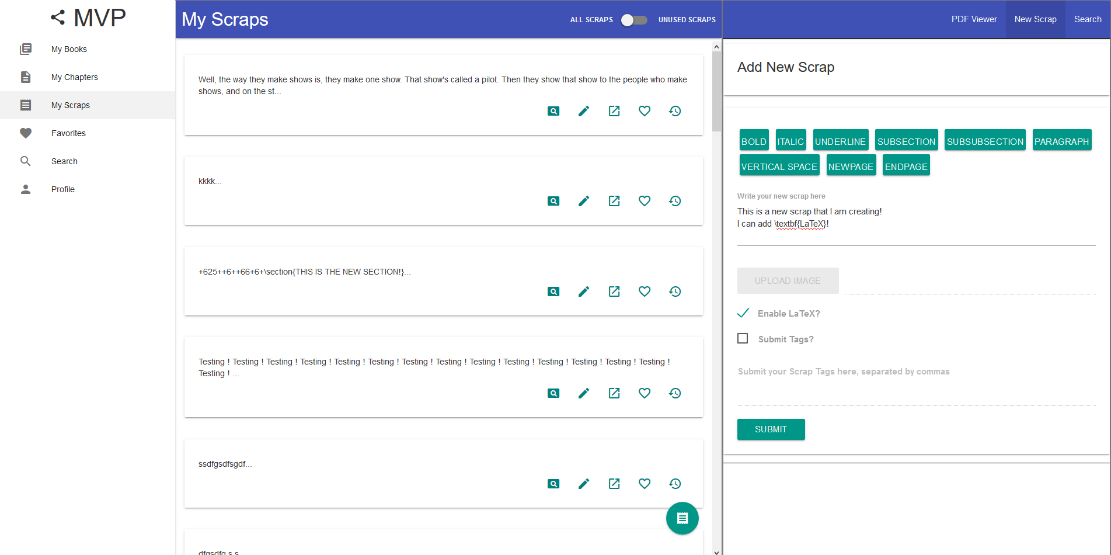

* 1. Or create a new image scrap



1. Click “Save Now”

# Profile Settings

Profile settings is a way to alter the name that appears on compiled documents or logout.

The profile settings page allows the user to view their account information, modify the name that appears on their compiled documents, or logout for another

## Profile Settings

1. On the left navigation, locate the Profile Settings button.   
   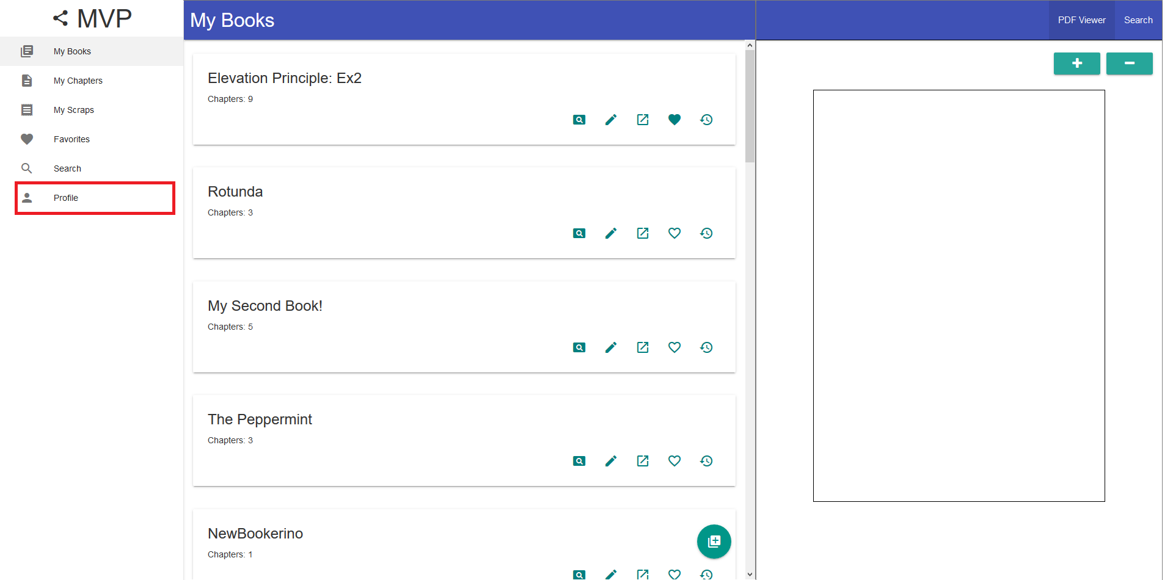
2. Click the Profile Settings button
3. Options
   1. Modify your display name and click “Submit” or logout by clicking “Logout”

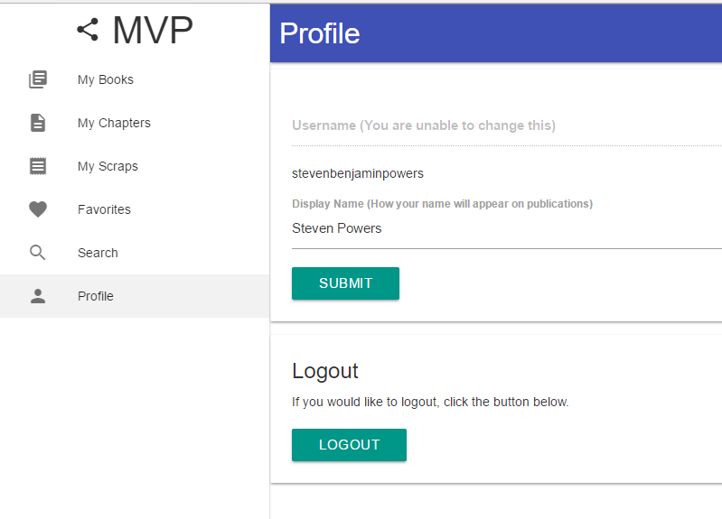

# Login

Login functionality is an essential part of any web application .

The profile settings page allows the user to view their account information, modify the name that appears on their compiled documents, or logout for another

## Profile Settings

1. When a user navigates to the website for the first time, or when no login is saved the user will be prompted with the following.   
   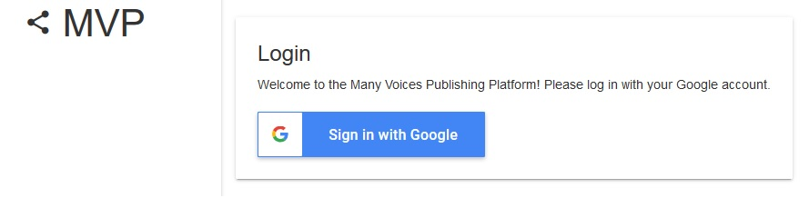
2. Click the “Sign in with Google” button
3. You will be prompted to select the account you want to use or you can create a new account with Google.
   1. 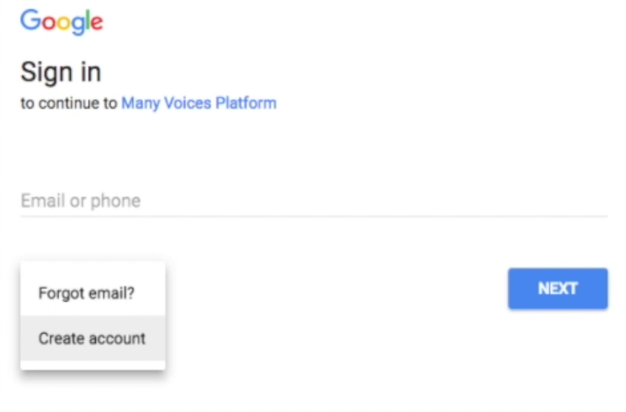
4. Once logged in, you will be presented with the MyBooks view.

If you encounter issues not addressed by this user guide, please contact your account manager for additional support.