CS 470

Introduction to Database Management Systems

Fall 2016

Project Report

Group 5

Daniel McNary

Isaac Jonas

Jack Taft

# **Milestone II**



## ER Diagram

## Database Architecture

This project will utilize the traditional three-tier client-server architecture. The database and web server will be stored on a single virtual machine and connections can be instantiated via an appropriate web client. Information should be collected via a user interface (web-based) from employees of the company. The database should then validate all fields to ensure continuity and proper compatibility.

This project will be implemented on a LAMP stack on Ubuntu Server 16.04. The database of choice will be MySQL and the webserver of choice will be Apache with PHP server side scripting. Users of the database will initialize a connection via their web browser to the web server, which will then allow certain queries to be made to the DBMS as appropriate.



## Data Dependencies

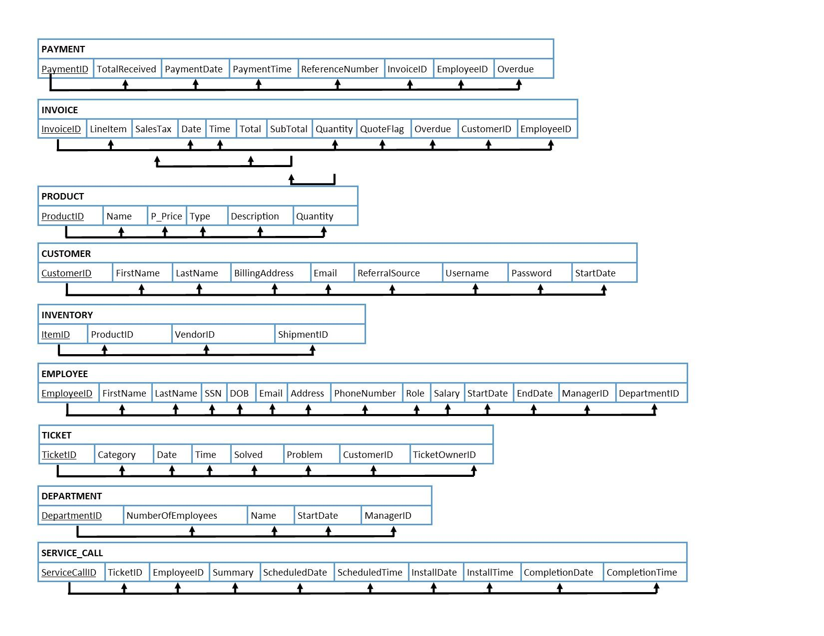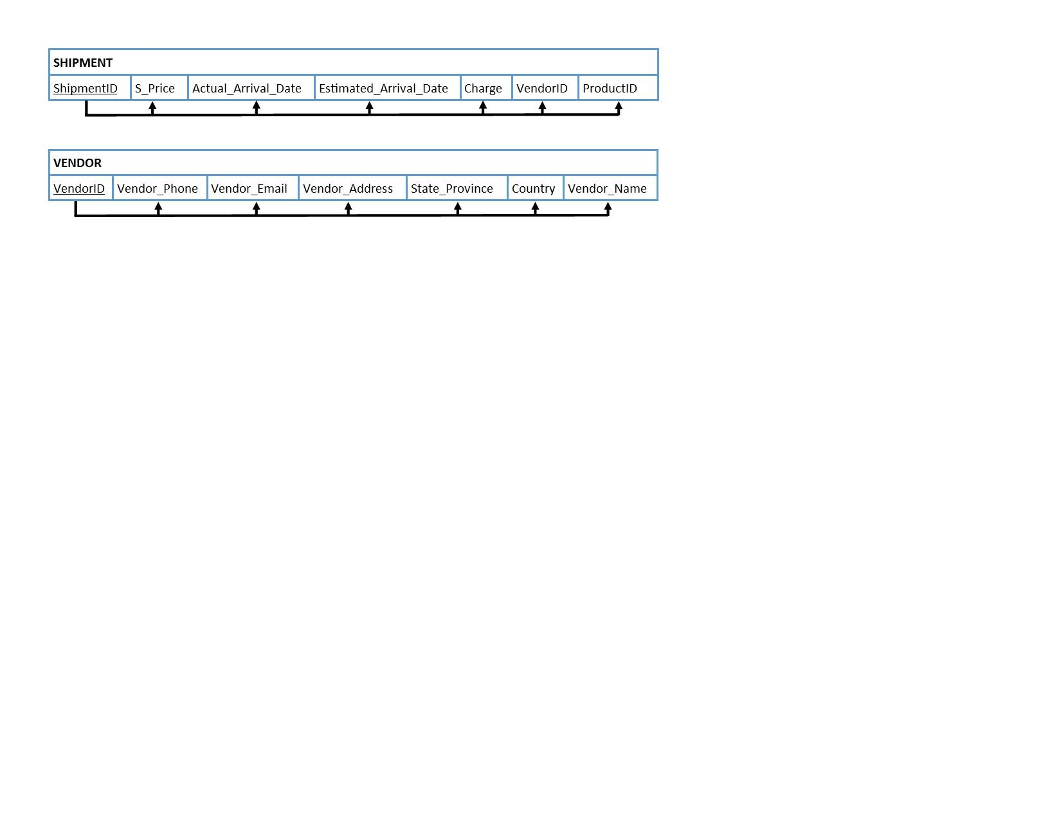

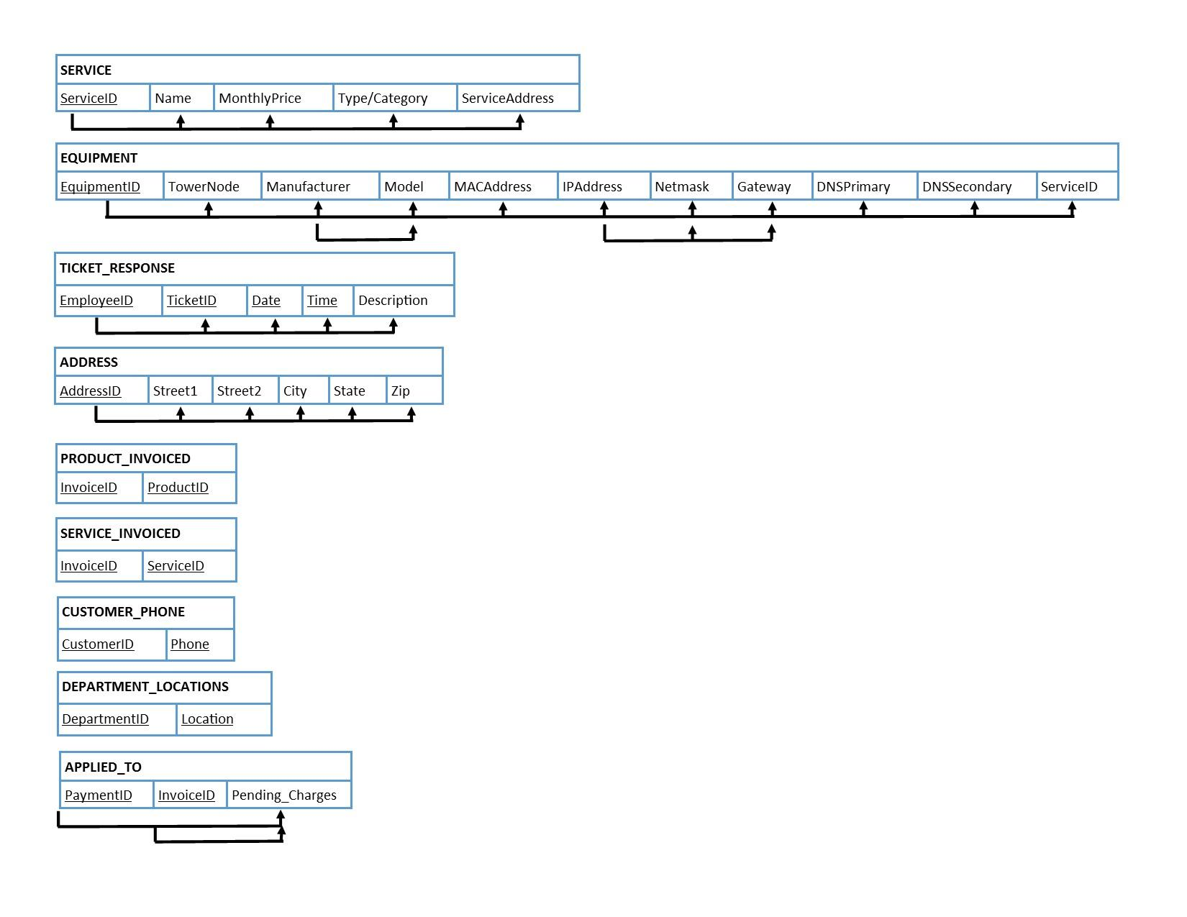

## DFD



## Front End Design Ideas

The front end of the database will consist of a webserver running PHP scripts on the server to customize the HTML code for each pages. The front end will consist of three major types of pages, detail/data entry, reporting, and searching. The detail/data pages will show the most pertinent details on a particular entity, such as a customer or employee. This page will also allow the user to modify the entry details and click save to update the database. These pages may include, Customer Information, Employee Information, Ticket Information, etc. Any error messages will be displayed at the top of the screen if there was a problem saving the information. The reporting pages will display items such as a list of current customers, a list of payments taken during a specific time period, a list of invoices created by a particular employee, among others. The last type of screen will allow employees to query the database on some particular attribute, such as all customers with last names beginning with the letter ‘X’. Other types of pages or reporting may be added as appropriate.

## Relational Algebraic Statements

**Following are a list of multiple possible queries that may be made for reporting or searching purposes:**

Display a list of all of the payments taken between Date1 and Date2:

$$Π_{PaymentDate, Username, ReferenceNumber, TotalReceived, EmployeeID}(σ_{PaymentDate≥Date1 AND PaymentDate≤Date2}$$ $$((PAYMENT)⋈_{InvoiceID}(INVOICE))⋈_{CustomerID}(CUSTOMER))$$

Display a list of all of the new accounts created between Date1 and Date2:

$$Π_{StartDate, Username, FirstName, LastName}(σ_{StartDate≥Date1 AND StartDate≤Date2}(Customer))$$

Display a list of all of the open tickets owned by a particular employee:

$$Π_{Category, Date,Problem, CustomerID}(σ_{Solved=False AND TicketOwnerID=123}(TICKET))$$

Display all of the responses to a particular ticket:

$$Π_{EmployeeId, TicketID, Date,Time, Description}(σ_{TicketID=123}$$ $$((TICKET)⋈_{TicketID}(TICKET_RESPONSE)))$$

Display a list of all quotes created between Date1 and Date2:

$$Π_{InvoiceID, Customer,IDQuantity, LineItem, Subtotal, SalexTax,Total}(σ_{Date≥Date1 AND Date≤Date2 AND QuoteFlag=True}$$ $$(INVOICE))$$

Display a list of all unpaid invoices:

$$Π_{InvoiceID,Total, TotalReceived, First,Last, BillingAddress,Email,Username, Date}(σ_{TotalReceived<Total}$$

$$(INVOICE)⋈_{InvoiceID}(PAYMENT)⋈_{CustomerID}(CUSTOMER))$$

Display a list of all employees who work for a particular department:

$$Π_{EmployeeID, FirstName,LastName, SSN,DOB,Email,Address,PhoneNumber,Role,Salary}(σ_{DepartmentID=123}(Employee))$$