**USER MANUAL**

*Animal Behaviour Tool*

*Student Edition*

**CS4820 UPEI School of Mathematics and Computational Sciences**

April 2021

Contents

1.0 GENERAL INFORMATION 3

1.1 System Overview 3

1.2 Authorized Use Permission 3

2.0 SYSTEM FEATURES 4

2.1 Registration 4

2.1.1 Successful Registration 5

2.1.2 Invalid Password 5

2.1.3 Mismatching Passwords 6

2.1.4 Empty Grad Year 6

2.1.5 Empty Horse Experience 7

2.2 Login 7

2.2.1 Successful Login 8

2.2.2 Not Using Email to Log In 8

2.2.3 Invalid Email Address 8

2.2.4 Invalid Password 9

2.2.5 Expired Password 9

2.3 Forgot Your Password 9

2.3.1 Successful Reset 10

2.3.2 Not Using Email for Password Reset 11

2.3.3 Incorrect Email Address 11

2.3.4 Invalid New Password 12

2.3.5 New Password Mismatch 12

2.4 Account Management 13

2.5 Change Your Name 14

2.5.1 Successful Name Change 14

2.6 Change Your Email 15

2.6.1 Successful Email Change 15

2.6.2 Invalid Current Email 15

2.6.3 Mismatching New Email 16

2.6.4 Empty New Email Fields 16

2.7 Change Your Password 17

2.7.1 Successful Password Change 17

2.7.2 Incorrect Current Password 18

2.7.3 Mismatching New Password 18

2.7.4 Empty New Password Fields 19

2.8 View Quizzes 19

2.9 Attempt Quiz 20

2.9.1 Successful Quiz Attempt 21

2.9.2 No Behaviours Selected 21

2.9.3 No Interpretation Selected 22

2.9.4 Leaving Quiz Without Submitting 22

2.10 Review Past Quiz Attempts 23

# 1.0 GENERAL INFORMATION

# 1.1 System Overview

In partnership with the Atlantic Veterinary College, Dr. William Montelpare and his team presented us with the task of developing an educational video hosting platform that is both user-friendly and easy to navigate. The videos will contain footage of equines displaying a variety of behaviours that must be identified by the user in quiz format. The goal of the Animal Behavior Tool is to improve equine welfare and enhance Veterinary Students’ knowledge of Animal Behavior. By working through the proposed self-directed learning module, students may improve their awareness and understanding of equine behaviors within various environments. The system provides performance scores such as number of correct behaviors identified, number of trials and time taken on task.

# 1.2 Authorized Use Permission

The Animal Behaviour Tool is available to those granted access by the system’s administrator. Users will require a registered account and password to be able to access the application. There are four different types of accounts a user may be assigned as: admin, teacher assistant, expert, or student. These roles affect the permissions of the account, and the tasks it will be able to perform.

# 2.0 SYSTEM FEATURES

# 2.1 Registration

Permitted Roles: All

Your account information must be provided to you via email from the website’s administrator. In your school email, check for the following email, then follow the provided link:

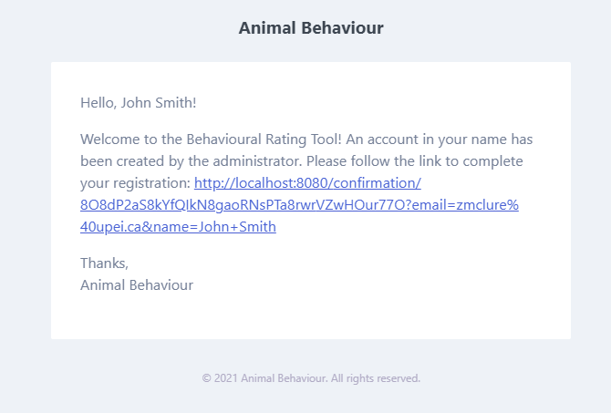

You will be taken to a web page where you may create the password you wish to use for the application. You must also fill in a mini survey, indicating your anticipated graduation year, as well as previous experience with horses.

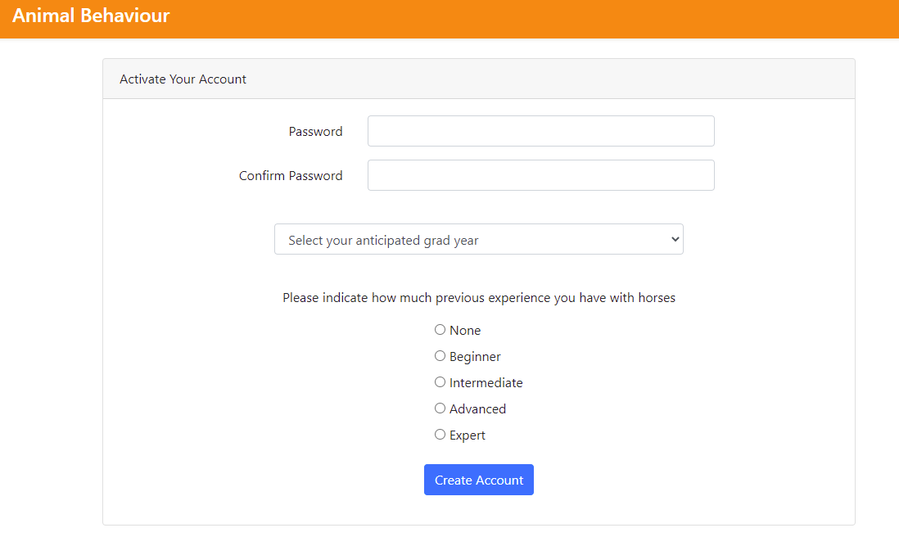

## 2.1.1 Successful Registration

You will be taken to the quizzes page.

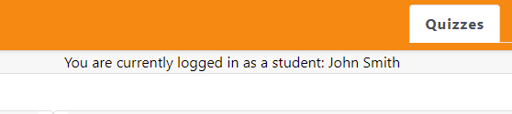

## 2.1.2 Invalid Password

Your password must follow the standards set by the website.

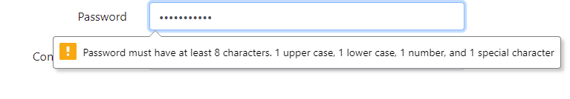

## 2.1.3 Mismatching Passwords

The “Password” and “Confirm Password” fields must match.

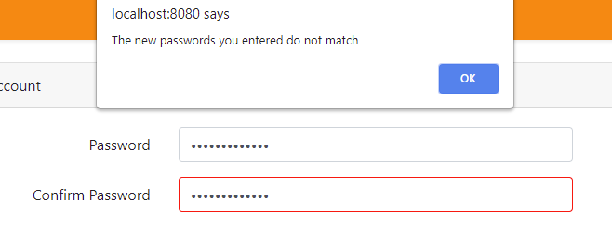

## 2.1.4 Empty Grad Year

It is required that you fill out the anticipated grad year section of the survey.

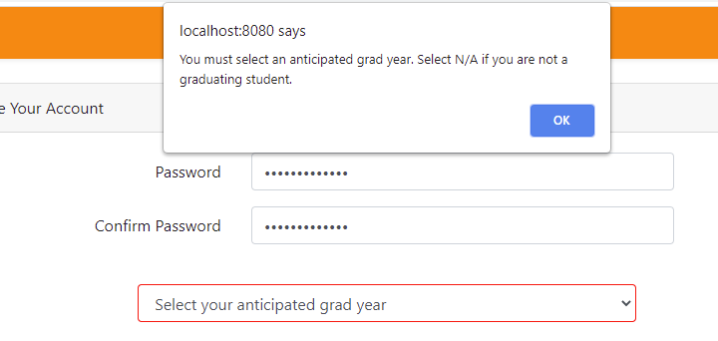

## 2.1.5 Empty Horse Experience

It is required that you fill out the Horse Experience section of the survey.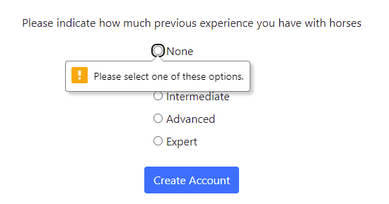

# 2.2 Login

Permitted roles: All

By logging in you will be able to access the Animal Behaviour Tool web application.

In your web browser, visit the following address:

animal-behaviour.ahs.upei.ca

The login page will be displayed.

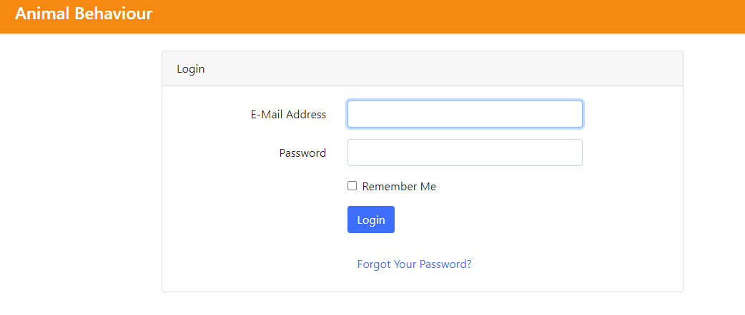

1) Fill out your account information, as provided by the administrator.

1. The username will be the email address from which you followed the registration link.
2. The password will be whatever you set it as during account registration.

2) Click on the Login button.

## 2.2.1 Successful Login

You will be taken to the quizzes page.



## 2.2.2 Not Using Email to Log In

You must use a whole email address to log in.

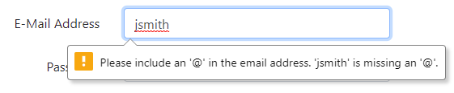

## 2.2.3 Invalid Email Address

You must use a registered email to be able to access the website.

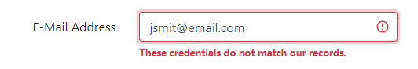

## 2.2.4 Invalid Password

Incorrect passwords will also display the mismatched credentials message.

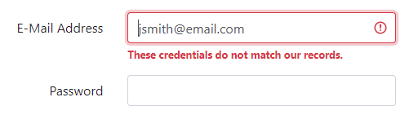

## 2.2.5 Expired Password

Password reset requests will expire after 30 minutes.

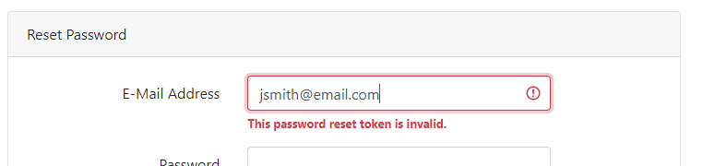

# 2.3 Forgot Your Password

Permitted Roles: All

Users are able to reset their password whenever they want, if they forgot it.

Visit the front page of the website animal-behaviour.ahs.upei.ca

Follow the link below the Login button:

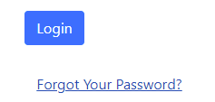

You will be taken to a password reset page. Enter your email address to be emailed a reset link.

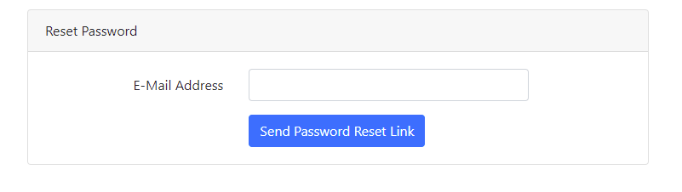

## 2.3.1 Successful Reset

A success message will show up, as well as an email sent to your email address.

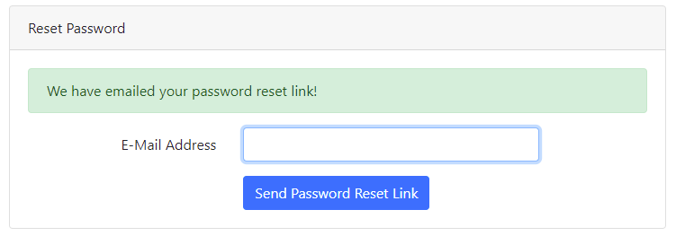

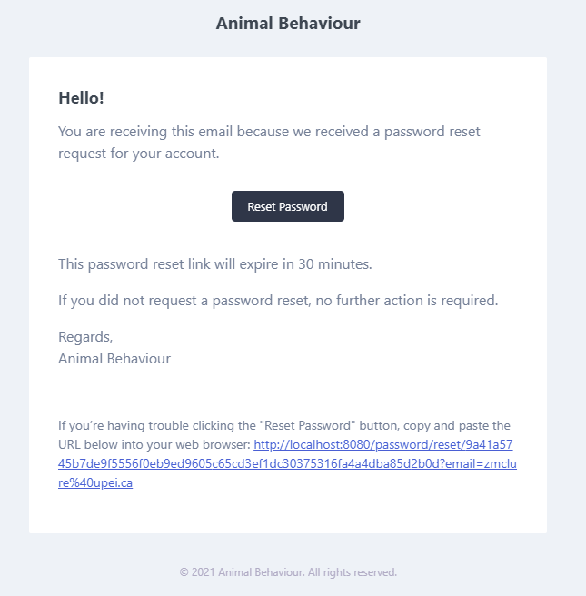

Clicking the Reset Password button will take you back to the website, where you must fill in a new password.

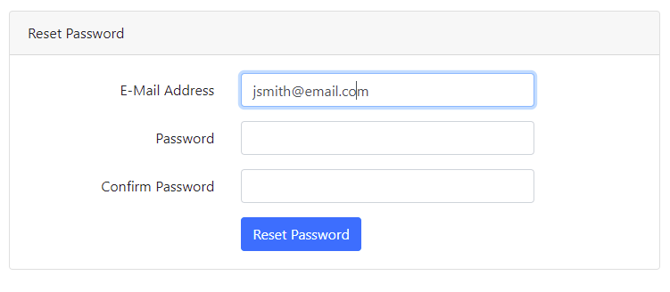

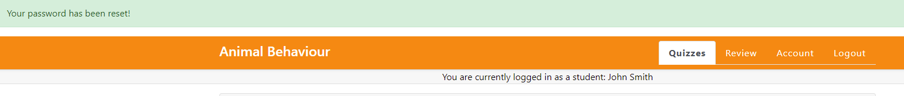

## 2.3.2 Not Using Email for Password Reset

You must use a whole email address to receive the password reset.

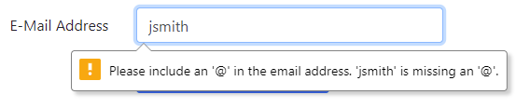

## 2.3.3 Incorrect Email Address

You must use a registered email address to be sent the reset link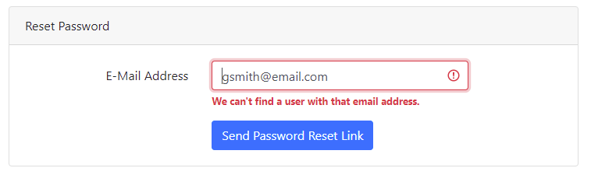

## 2.3.4 Invalid New Password

Your new password must follow the standards set by the website.

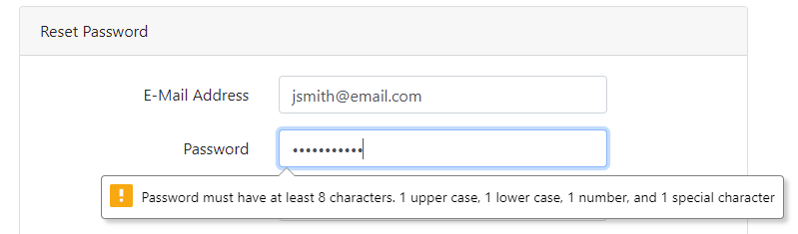

## 2.3.5 New Password Mismatch

The “Password” and “Confirm Password” fields must match..

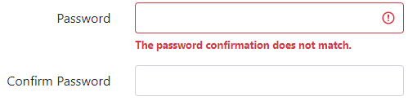

# 2.4 Account Management

Permitted Roles: All

Users may manage their account by selecting the “Account” tab on the top right of the screen.

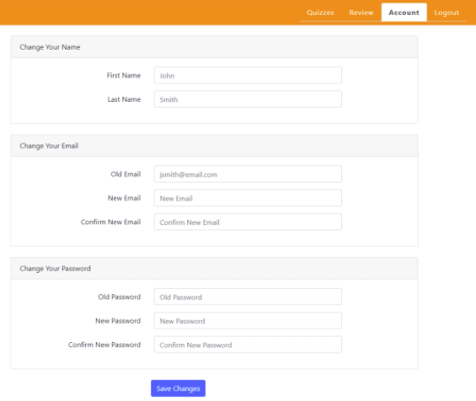

Here, users may change their name, their email address, or their password. You may do any of these tasks at the same time by filling in the appropriate fields, then clicking the “Save Changes” button.

# 2.5 Change Your Name

Permitted Roles: All

Users may change their name by selecting the “Account” tab on the top right of the screen, then fill out the fields in the Change Your Name section. Users may change their first name, last name, or both.

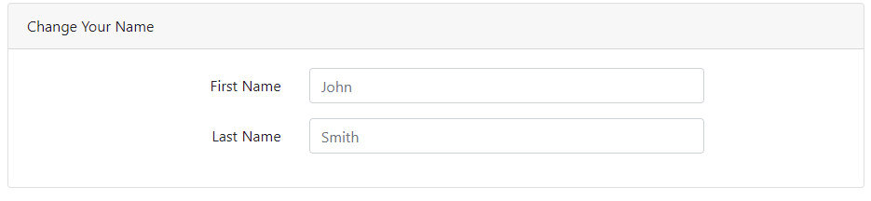

## 2.5.1 Successful Name Change

A success message will appear upon changing your name. You are also able to see your new name as a placeholder in the name fields.

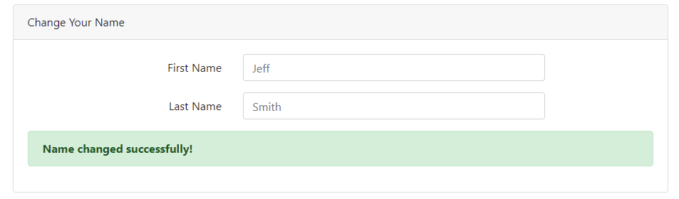

# 2.6 Change Your Email

Permitted Roles: All

Users may change their email by selecting the “Account” tab on the top right of the screen, then fill out the fields in the Change Your Email section.

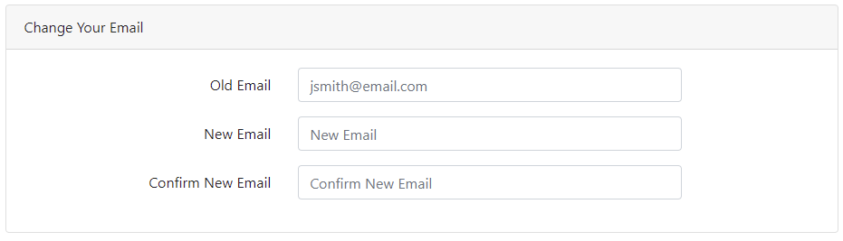

## 2.6.1 Successful Email Change

A success message will appear upon changing your email address. You are also able to see your new email as a placeholder in the Old Email field.

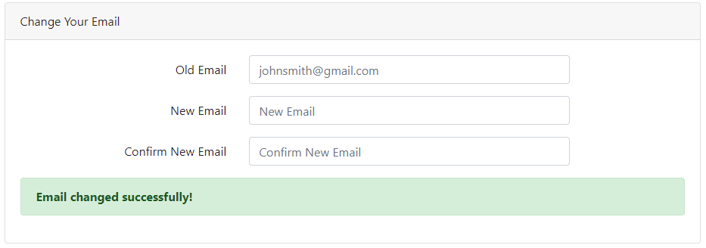

## 2.6.2 Invalid Current Email

An error message will display if what you put in the Old Email field does not match your current email.

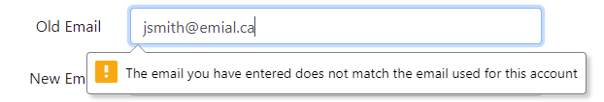

## 2.6.3 Mismatching New Email

An error message will display if the New Email and Confirm New Email fields do not mat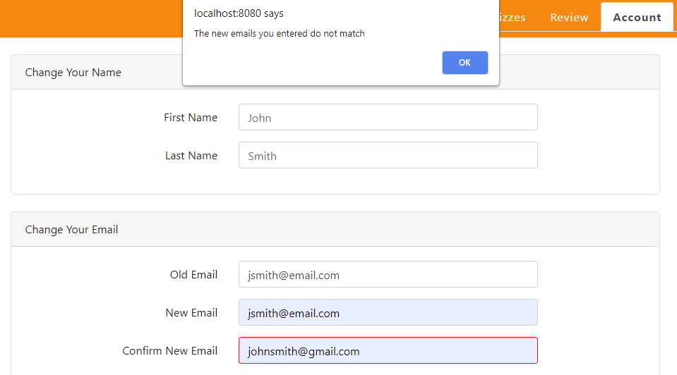

## 2.6.4 Empty New Email Fields

An error message will display if nothing is entered into the New Email fields.

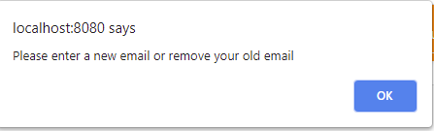

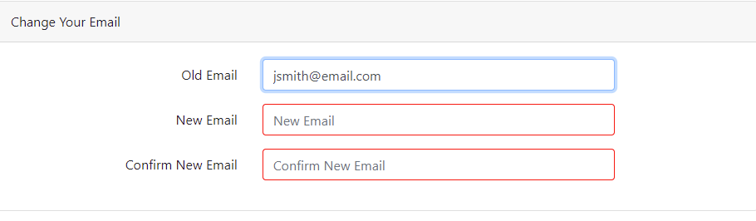

# 2.7 Change Your Password

Permitted Roles: All

Users may change their email by selecting the “Account” tab on the top right of the screen, then fill out the fields in the Change Your Email section.

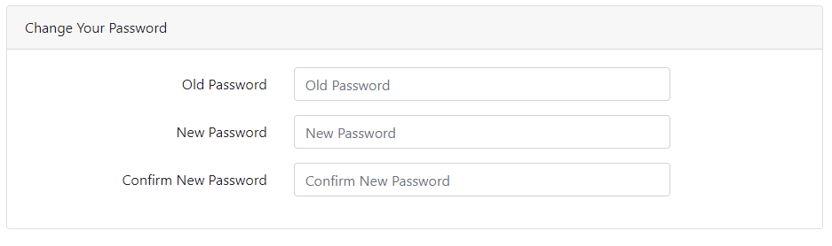

## 2.7.1 Successful Password Change

A success message will appear upon changing your password.

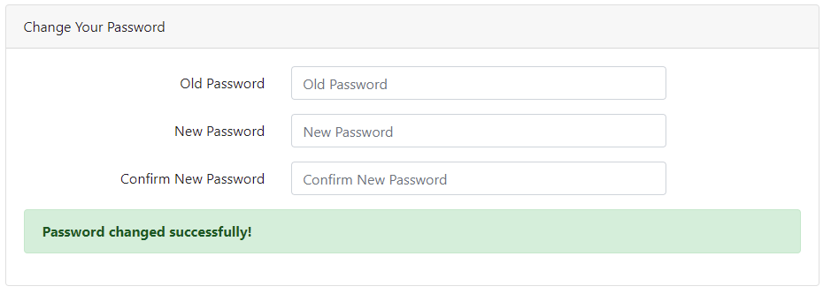

## 2.7.2 Incorrect Current Password

An error message will appear if the password you entered in the “Old Password” field does not match your current password.

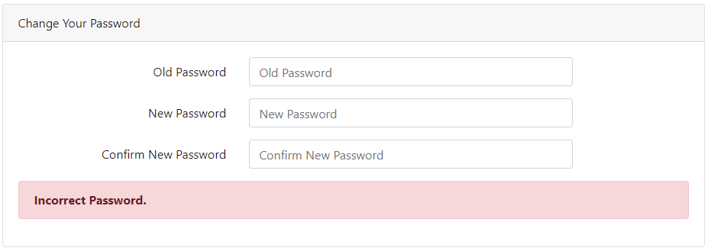

## 2.7.3 Mismatching New Password

An error message will appear if the passwords you entered in the “New Password” and “Confirm New Password” fields do not match.

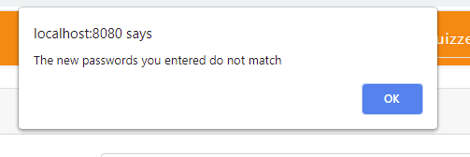

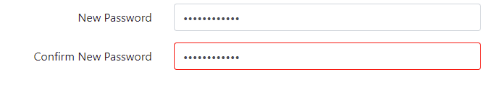

## 2.7.4 Empty New Password Fields

An error message will appear if you did not enter anything into the New Password fields.

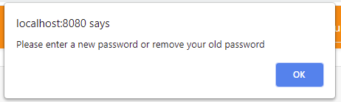

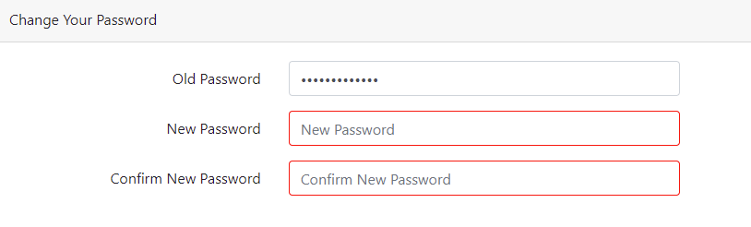

# 2.8 View Quizzes

Permitted Roles: All

Users may view quizzes by selecting the “Quizzes” tab on the top right of the screen. This is also the “home” page of the website, where the user is redirected upon logging in.

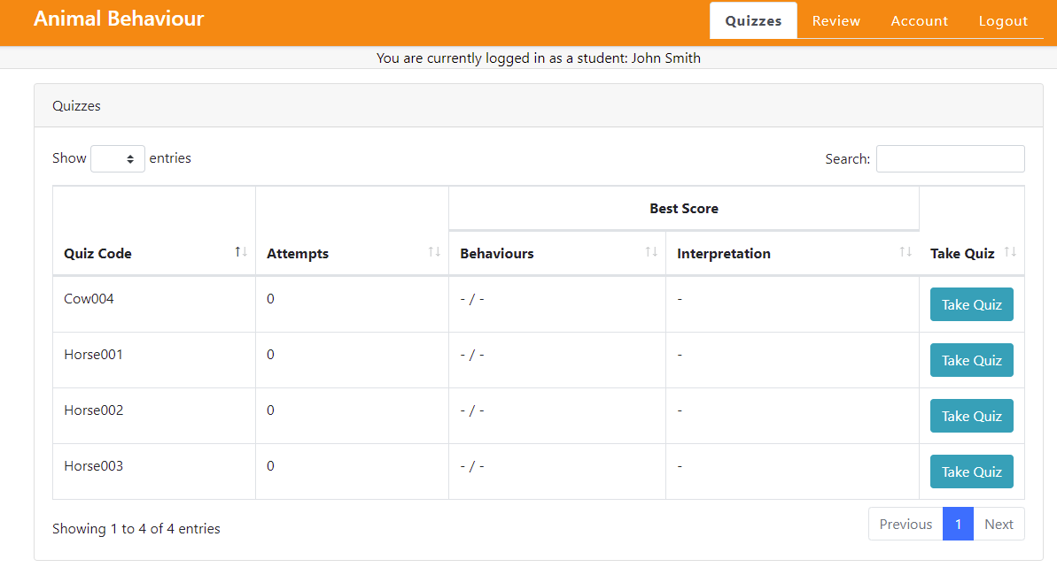

Here, users may search for specific quizzes by name, and select a quiz to attempt. They may also view their number of attempts on each quiz, as well as their best scores.

# 2.9 Attempt Quiz

Permitted Roles: All

Users may attempt a quiz by simply clicking on the Take Quiz button. The user will be taken to another page where they can see a video they must watch. Above the video the user can see the name of the quiz, the attempt number they are currently on, and the time elapsed since they first visited the page.

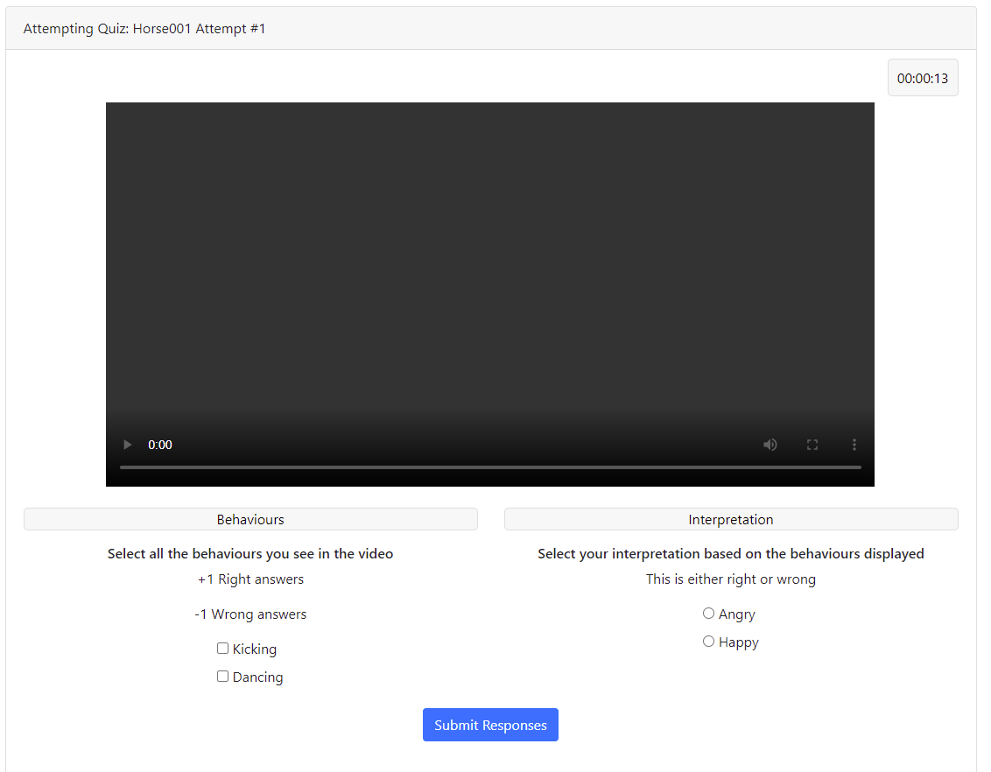

After watching the video, the user must fill in their quiz response, indicating which animal behaviours they observed in the clip, as well as selecting what they believe is the correct interpretation of what these behaviours mean. The user then must press the “Submit Responses” button to submit their quiz attempt. The user will earn 1 point for selecting a correct behaviour, or for leaving incorrect responses blank. Otherwise, points are deducted from the total. Interpretations are either right or wrong.

## 2.9.1 Successful Quiz Attempt

If the user fills out the quiz properly, they will be redirected back to the main Quizzes page, where a message will display their results. Additionally, the quiz data in the table will be updated with their number of attempts, and best scores.

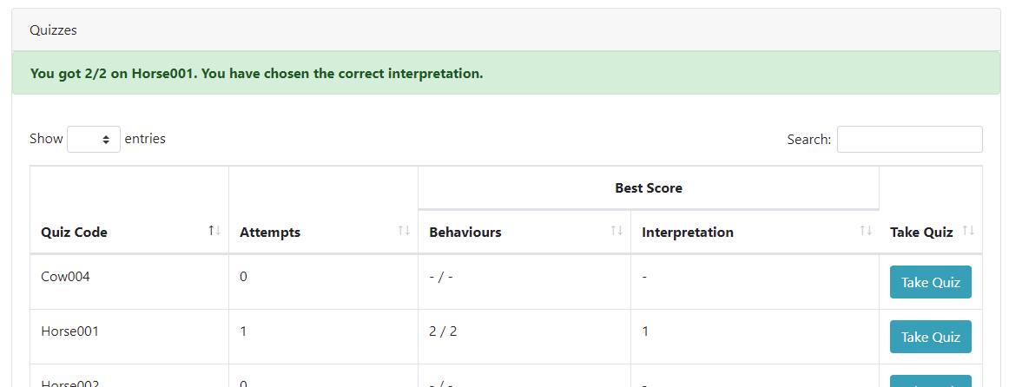

## 2.9.2 No Behaviours Selected

An error message will appear if the user did not select at least one observed behaviour.

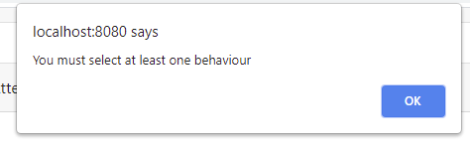

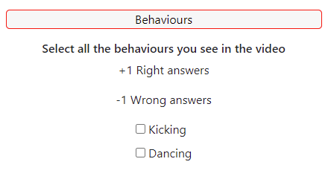

## 2.9.3 No Interpretation Selected

An error message will appear if the user did not select an interpretation of the meaning behind the observed behaviours.

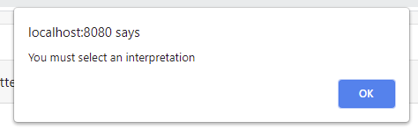

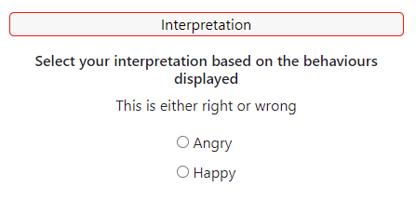

## 2.9.4 Leaving Quiz Without Submitting

A warning message will be displayed if you try to navigate away from the quiz without submitting your responses.

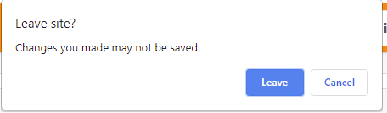

# 2.10 Review Past Quiz Attempts

Permitted Roles: All

Users may review past quiz attempts by selecting the “Review” tab on the top right of the page.

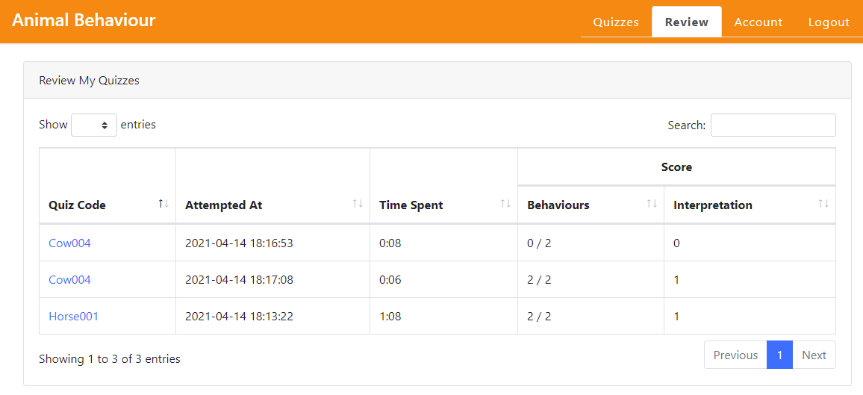

You may click on a Quiz Code to view what you entered for that particular attempt. Options that were answered correctly will be highlighted in green. Incorrect selections will not be highlighted.

