**Software Development Plan**

**Team Deathstar**

(team 3)

Emma Batchelor,

Lindsey Harris,

Joseph Noyes,

Zein Sleiman

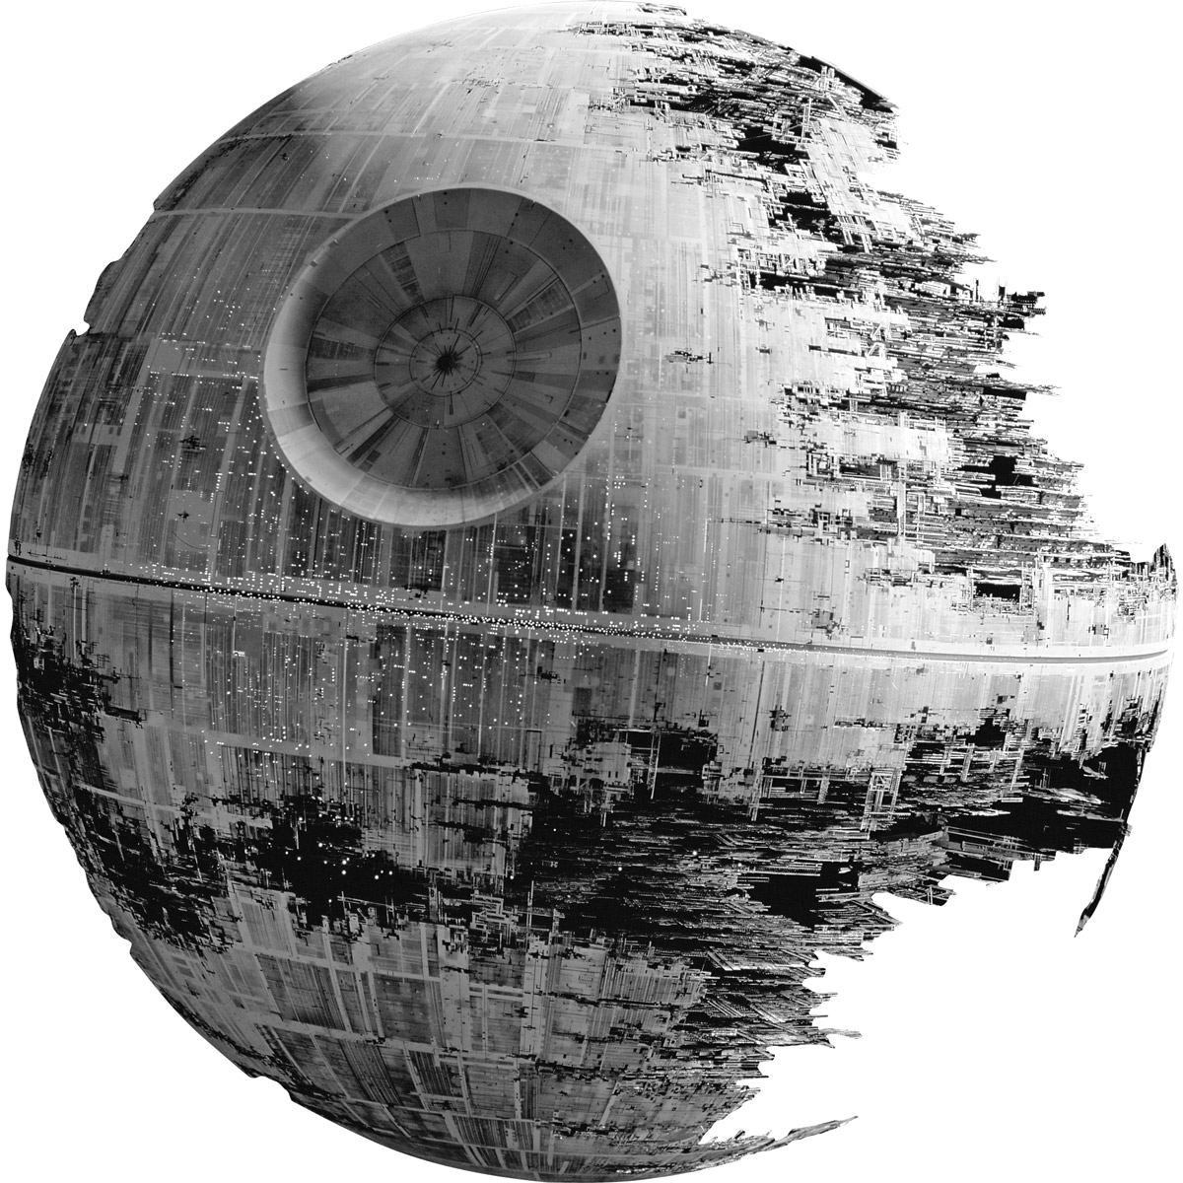

Project Overview

The purpose of the SkyMap project is to create a program that will generate a star map based on the stars’ visibility at a given latitude and longitude during any time between January 1, 1900 and January 1, 2100. Using this data, the program will calculate the position of the approximate 20,000 stars in the Yale Star Catalog and display the view of the sky as a JPEG image. In addition to the numerous stars, the program will also include the major planets, and all the Messier deep space objects.

The user will provide the date, time, latitude, and longitude as input, and then the program will use mathematical formulas to calculate the positions of the planets, stars, and other space objects that can be seen in the night sky. After calculating the position of the celestial bodies, the program will draw the position of the stars relative to the user’s location. The drawing will visually indicate the magnitude of a star, show the labels for all major objects, and display lines connecting the stars within a constellation.

Project Schedule

**Sprint 1**

Setting up tools - completed

Software Development Plan - delivered to customer January 20  
Software Development Plan Presentation - delivered to customer January 27

Familiarizing group members with Java - ongoing January 13 through February 1

Reading/familiarizing with Astronomy stuff - ongoing through February 1

Basic object skeletons - ongoing through February 1

CSV Reader - ongoing through February 1

Testing CSV Reader - ongoing through February 1

**Sprint 2**

Turning Formulas from math to Java - February 3 through February 17

Data Parser - February 3 through February 17

Expand object definitions - February 3 through February 17

Link Object to Parser - February 3 through February 17

Basic GUI Design - February 3 through February 17

Basic Implementation - February 3 through February 17

Testing math functions - February 3 through February 17

Testing data parser - February 3 through February 17 **Sprint 3**

JPEG Generator - February 22 through March 7

Drawing Functions - February 22 through March 7

Architectural Design - February 22 through March 7

Testing math functions - February 22 through March 7

Testing basic GUI functionality - February 22 through March 7

**Sprint 4**

Work on demo presentation - March 9 through March 30

Advanced GUI implementation - March 9 through March 30

Testing drawing functions - March 9 through March 30

Testing JPEG generator - March 9 through March 30 **Sprint 5**

Final testing/debugging - April 4 through April 24

Presentation preparations - April 4 through April 24

List of Deliverables

* **Software Development Plan**
  + A document that outlines the plan to follow for the development of the project.
  + Estimated delivery: January 27, 2016

* **First Version of the Backlog**
  + A list of Epics, which are the goals to be done in the project. Each Epic is broken down into user stories, which are smaller goals.
  + Estimated delivery: February 15, 2016.

* **Architectural Design and Update to the Backlog**
  + An overview of the architectural design, such as design patterns, implementation, etc.
  + Estimated delivery: March 2, 2016.

* **Presentation of the Preliminary GUI**
  + A demonstration of the preliminary GUI to the customer.
  + Estimated delivery: March 28, 2016

* **Product Delivery**
  + The final completed program delivered to the customer.
  + Estimated delivery: April 20, 2016.

Personnel

The members involved in this group effort include Lindsey Harris, Joseph Noyes, Zein Sleiman, and Emma Batchelor. The Lead Editor is Lindsey Harris, whose job is to edit documents on completion. The Git Master is Joseph Noyes, whose job is to maintain Github and make sure everyone is up to date with Git. The Trello Master is Zein Sleiman, whose job is to maintain Trello and make sure that the backlog items are in the proper place in workflow. The GUI Designer is Emma Batchelor, whose job is to lead the design and implementation of the GUI part of the project.

In addition to those roles, each group member has an equal amount of responsibility relative to other roles and tasks within the group. Each team member carries the role of Developer, which encompasses many tasks including Customer Liaison, Designer, Programmer, Requirements Analyst, Software Tester, and Software Lead. Additionally, when it comes to the team meetings, the team will take turns taking up the Mediator and Recorder roles as the meetings go along.

Risk Management Plan

The team has identified the following risks for the SkyMap project:

1. **Astronomical Mathematics** - There is a relatively high risk that the team will experience difficulties in programming the mathematical functions that provide the stellar movement calculations. Any difficulties encountered with the astronomical mathematics will be taken to Dr. Coleman and discussed to find a resolution.

1. **Drawing Functions** - There is a relatively high risk that the team will experience difficulties in implementing the code that will draw the stars and planets on screen. The team plans to research this aspect of the project, and if there are too many difficulties, the team plans to consult Dr. Coleman to find a resolution.

1. **Excessive Ambition** - There is a relatively high risk that the team will become overly ambitious and attempt to incorporate more than necessary for the project. To keep this in check the team plans to discuss priority and progress regularly. This will allow the team to downscale in a timely manner if need be.

1. **Cross-platform Difficulties** - There is a low risk that the team will experience difficulties in ensuring that the program will work on other platforms since the team is mostly utilizing the Windows operating system. To ease this concern, the team plans to test the program in the UNIX lab to make sure it meets the cross-platform requirement.

1. **Lack of Instructor Approval** - There is a low risk that Dr. Coleman will hate everything that the team produces. In this case, the team will strive to produce better software and refactor it into a version that Dr. Coleman approves.

1. **Scheduling Conflicts** - There is a moderate risk that team members will have difficulty meeting regularly with 100% attendance outside of class. The team plans on working around this by keeping up communication via email and phone when unable to all meet in person.

1. **Weather Conflicts** - There is a miniscule risk that “Snow-mageddon” shall strike Huntsville and cancel numerous classes, preventing the team from completing the project in a timely manner. The team plans to work from home if possible in this case to complete as much as possible despite bad weather conditions.

1. **Team Member Leaving** - There is a low risk that a team member will have to drop the course. In this case, the team plans to pick up the slack and make due.

1. **Losing Tools** - There is a miniscule risk that the team will lose access to Git, Trello, or the IDEs they plan to use. The team plans to make due with email and the lab computers as needed.

1. **Apocalypse** - There is a miniscule risk that the apocalypse will happen during this project. In which case, the team plans to complete the project and use it as a guidance system to survive on the run.

List of Milestones

* Documents:
  + Software Development Plan
  + Requirements Definition Document
  + Software Design Document
  + Software Test Plan
* Presentations:
  + Presentation of Software Development Plan 1/27
  + Presentation of first version of Backlog 2/15
  + Presentation of Architectural Design and updates to Backlog 3/2
  + Presentation of Preliminary GUI Design 3/28
  + Presentation of Final Product Delivery 4/18
* Software:
  + Setting up tools: Trello, GIT, Google Calendar, IDE
  + Learning Java
  + Preliminary GUI
  + Writing astronomy formulas into Java
  + JPEG Generator
  + Drawing functions
  + Final version of GUI