Database Editor
Test plan
Version 2.0
4/19/20
Document Control
Approval
The Guidance Team and the customer shall approve this document.
Document Change Control
Initial Release: | V 1.0
Current Release: | V 2.0
Indicator of Last Page in Document: | $
Date of Last Review: | 04/19/2020
Date of Next Review: | 04/21/2020
Target Date for Next Update: | 04/21/2020
Distribution List
This following list of people shall receive a copy of this document every time a new version of this document becomes available:
Customer:
Dr. Steve Roach

Software Team Members:
Charlie G. Juarez
Annadiley Gallegos
Diana L. Ramirez
Change Summary
The following table details changes made between versions of this document

Version | Date | Modifier | Description
1.0 | 04/06/20 | Annadiley Gallegos | Initial Release
2.0 | 04/19/2020 | Annadiley Gallegos | Added small fixes to format and filled remaining sections

Note: The template presented in this document was taken from:
Donaldson, S., and S. Siegel, Successful Software Development. Upper Saddle River, NJ: Prentice Hall, 2001, pp. 321-323.

Note: The template presented in this document was taken from: Donaldson, S., and S. Siegel, Successful Software Development. Upper Saddle River, NJ: Prentice Hall, 2001, pp. 321-323 and modified by Humberto Mendoza and Steve Roach.

Supplementary information is from:
Pfleeger, S. Software Engineering, Theory and Practice. Upper Saddle River, NJ: Prentice Hall, 1998, p. 365.

Table of Contents
Document Control ii
Approval ii
Document Change Control ii
Distribution List ii
Change Summary ii
1. Introduction 1
1.1. Purpose 1
1.2. Scope 1
1.3. System Overview 1
1.4. Exit Criteria 1
1.5. Document Overview 1
1.6. References 1
2. Test Items and Features 2
2.1. File Menu 2
2.1.1. Save as 2
2.1.2. Print to Fit 2
2.1.3. Print Normal 2
2.1.4. Print CSV 2
2.2. Search Menu 2
2.2.1. Find Files 2
3. Testing Approach 3
4. Tests Cases 4
4.1. High Criticality 4
4.1.1. Test 01 4
4.1.2. Test 02 4
4.1.3. Test 04 2
4.1.4. Test 03 2
4.1.5. Test 05 2
4.2. Medium Criticality 2
4.2.1. Test 06 2
4.2.2. Test 07 2
5. Test Schedule 4
6. Appendix 5

Introduction

Purpose

The purpose of this test plan is to assert the functionality of the database editor, with a specific focus on the file menu operations excluding compare file to other version, check for duplicate rows, and filter. This includes the search menu option on the database window as well.

Scope
Derived from the database tool provided by Dr. Roach

System Overview
The system consists of a simple database table editor. The program includes options to print csv, print to fit, search in the table and several options to edit the database.

Exit Criteria
At least 90% of the test that have a high criticality should be passed in order to verify the correctness of the program.

Document Overview
The document is composed of the following sections:
- Section 2- Test items and features
  - Describes the test items (e.g., components, classes, functions or methods) and the features to be tested. In this section we detail the functions of the database editor that we will be testing.
- Section 3- Testing Approach
  - This section describes the test suite and what approach we will be taking to conduct said test. It also provides a small description of the individual test cases.
- Section 4- Tests
  - This section provides a detailed outline of the test cases that will be ran on the selected functions.

References
The following resources were used in order to help make this test plan:
Test Case Knowledge: Spec.docx file inside the GitHub repository

Test Items and Features

File Menu
Provides several options regarding the current database that is being modified.

Save as
Allows the user to save the current table as another file extension the user wishes to.

Print to Fit
Provide the user several options to print the current table. These options include several default options set by the printer such as page setup, print range, copies sides, color, quality and page size orientation and size.

Print Normal
Provide the user several options to print the current table. These options include several default options set by the printer such as page setup, print range, copies sides, color, quality and page size orientation and size.

Print CSV
Exports the table as a coma separated list (.CVS) file that can be read on excel or other programs.

Search Menu
Provides the user with options regarding the search of specific files.

Find Files
Allows the user to enter a file filter, or a file name, as well as a file path and search for a specific string.

Testing Approach

The approach taken in this test plan is the black box testing through dynamic testing.

Table 1: Test Plan
TEST SUITE 01
Description of Test Suite | This test suite contains test cases that will assert the functionality of the  File menu and search menu
Test Case Identifier | Objective | Criticality
1 | Test Save as function by saving a table as a different extension other than .xml file through the save as function | High
2 | Test printing table function by sending the file to OneNote 2016 | High
3 | Test save to CVS file by saving current file and opening it | High
4 | Test Search menu by searching an invalid file filter | High
5 | Test search function by searching .xml in the file filter | High
6 | Test save as function by rewriting a currently existing file | Medium
7 | Test save as function by providing a filename but not a file extension | Medium

Tests Cases

High Criticality

Test 01
Objective: Test save as function by saving a table with a different extension other than .xml file through the save as function
Notes: The resources needed for this test case are the TEST_DB file

Test No.: 01 |  |  |  | Current Status: Pending
Test title: Save as Function Normal Test

Testing approach: To achieve this test, all that is needed is the dbEdit.jar application and the table TEST_DB.xml
STEP  01  02  03  04 | OPERATOR ACTION  By clicking on File>Open menu, select table TEST_DB  Select the first row, making sure it is highlighted in gray, then click on File>open  Click on File> save as and write “TEST_DB.doc”  On the file explorer open the newly created file. | PURPOSE  Open a test table  Open a row to work with  Test the save as function |  |  | EXPCTED RESULTS  The contents of TEST_DB appear on the program, as shown in figure 1.  Display the BIG_TABLE row, as shown in figure 2.  A TEST_DB.doc file is generated and saved on the local computer  The contents of the table are displayed on Microsoft word without any inconveniences. | COMMENTS
Concluding Remarks: Test is currently pending.
Testing Team:  PENDING |  |  | Date Completed:  PENDING

Test 02
Objective: Test printing table function by sending the file to OneNote 2016
Notes: The resources needed for this test case are the TEST_DB file and the rest of the test files, specifically BIG TABLE.xml

Test No.: 02 |  |  |  | Current Status: Pending
Test title: Print to Fit Normal Test

Testing approach: To achieve this test, all that is needed is the dbEdit.jar application and the table TEST_DB.xml
STEP  01  02  03  04 | OPERATOR ACTION  By clicking on File>Open menu, select table TEST_DB  Select the first row, making sure it is highlighted in gray, then click on File>open  Click on File> Print to Fit  On print Service name, select OneNote 2016 Then click on print | PURPOSE  Open a test table  Open a row to work with  Test the save as function  Test the printing function |  |  | EXPCTED RESULTS  The contents of TEST_DB appear on the program, as shown in figure 1.  Display the BIG_TABLE row as shown in figure 2.  The print pop up window appears, as shown in figure 3  The table should be sent to OneNote completely. | COMMENTS
Concluding Remarks: Test is currently pending.
Testing Team:  PENDING |  |  | Date Completed:  PENDING

Test 04
Objective: Test print to CVS functionality by saving a table.
Notes: The resources needed for this test case are the TEST_DB file and the rest of the test files, specifically BIG TABLE.xml

Test No.: 04 |  |  |  | Current Status: Pending
Test title: Print to CVS Normal Test

Testing approach: To achieve this test, all that is needed is the dbEdit.jar application and the table TEST_DB.xml
STEP  01  02  03  04 | OPERATOR ACTION  By clicking on File>Open menu, select table TEST_DB  Select the first row, making sure it is highlighted in gray, then click on File>open  Click on File> Print to CVS  On the file explorer, select the newly created .CVS file and open it | PURPOSE  Open a test table  Open a row to work with  Test the save as function  Test the correctness of the print to CVS function |  |  | EXPCTED RESULTS  The contents of TEST_DB appear on the program, as shown in figure 1.  Display the BIG_TABLE row, as shown in figure 2.  The file has been saved with a .CVS extension in the local computer  The table should be identical to the original one and, additionally it should be opened in a .CVS compatible program. | COMMENTS
Concluding Remarks: Test is currently pending.
Testing Team:  PENDING |  |  | Date Completed:  PENDING

Test 03
Objective: Test search function with an invalid file filter
Notes: The only resource needed is a running dbEdir.jar application.

Test No.: 03 |  |  |  | Current Status: Pending
Test title: Search invalid entry

Testing approach: To achieve this test, all that is needed is the dbEdit.jar application.
STEP  01  02 | OPERATOR ACTION  Click on Search>Find Files  On file filter enter. mlx | PURPOSE  Open the search menu |  |  | EXPCTED RESULTS  The search pop up window appears, as shown in figure 4.  No file appears on the window. | COMMENTS
Concluding Remarks: Test is currently pending.
Testing Team:  PENDING |  |  | Date Completed:  PENDING

Test 05
Objective: Test search function with a valid .xml file filter
Notes: The resources needed for this test is the dbEdit.jar application. When writing .xml instead of *.xml in the file filter the results will differ.

Test No.: 05 |  |  |  | Current Status: Pending
Test title: Search valid entry

Testing approach: To achieve this test, all that is needed is the dbEdit.jar application and the table TEST_DB.xml
STEP  01  02 | OPERATOR ACTION  Click on Search>Find Files  On file filter enter *.xml | PURPOSE  Open a test table  Verify the correctness of the function |  |  | EXPCTED RESULTS  The search pop up window appears, as shown in figure 4  Any file with the extension .xml appears on the search window. | COMMENTS
Concluding Remarks: Test is currently pending.
Testing Team:  PENDING |  |  | Date Completed:  PENDING

Medium Criticality

Test 06
Objective: Using the save as function replace an existing file.
Notes: The resources needed for this test case are the TEST_DB file

Test No.: 06 |  |  |  | Current Status: Pending
Test title: Replace existing file

Testing approach: To achieve this test, all that is needed is the dbEdit.jar application and the table TEST_DB.xml
STEP  01  02  03  04 | OPERATOR ACTION  By clicking on File>Open menu, select table TEST_DB  Select the first row, making sure it is highlighted in gray, then click on File>open  Click on File> save as and click on TEST_DB  On the file explorer open the newly created file. | PURPOSE  Open a test table  Open a row to work with  The field “Object Name” should now, automatically, have the same name as the current file. |  |  | EXPCTED RESULTS  The contents of TEST_DB appear on the program, as shown in figure 1  Display the BIG_TABLE row, as shown in figure 2  A warning should appear letting the user know that he is about to overwrite a file.  The file should have the same contents as the currently edited one. | COMMENTS
Concluding Remarks: Test is currently pending.
Testing Team:  PENDING |  |  | Date Completed:  PENDING

Test save as function by providing a filename but not a file extension’

Test 07
Objective: Using the save as function save a file without an extension.
Notes: The resources needed for this test case are the TEST_DB file

Test No.: 07 |  |  |  | Current Status: Pending
Test title: Test file name correctness

Testing approach: To achieve this test, all that is needed is the dbEdit.jar application and the table TEST_DB.xml
STEP  01  02  03  04 | OPERATOR ACTION  By clicking on File>Open menu, select table TEST_DB  Select the first row, making sure it is highlighted in gray, then click on File>open  Click on File> save as and name it TestTable  On the file explorer open the newly created file. | PURPOSE  Open a test table  Open a row to work with  Save a file without any extension |  |  | EXPCTED RESULTS  The contents of TEST_DB appear on the program, as shown in figure 1  Display the BIG_TABLE row, as shown in figure 2  The file should be saved with a default extension of .xml.  The file should have the same contents as the currently edited one. | COMMENTS
Concluding Remarks: Test is currently pending.
Testing Team:  PENDING |  |  | Date Completed:  PENDING

Test Schedule

Task and date | People | Description
Test 01 | To be determined | Complete and document test No.1
Test 02 | To be determined | Complete and document test No.2
Test 03 | To be determined | Complete and document test No.3
Test 04 | To be determined | Complete and document test No.4
Test 05 | To be determined | Complete and document test No.5
Test 06 | To be determined | Complete and document test No.6
Test 07 | To be determined | Complete and document test No 7.

Appendix

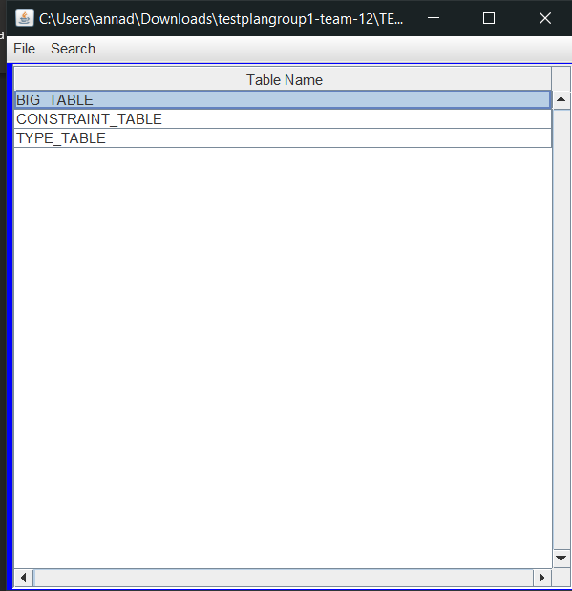
Figure 1: Contents of TEST_DB.xml inside the editor

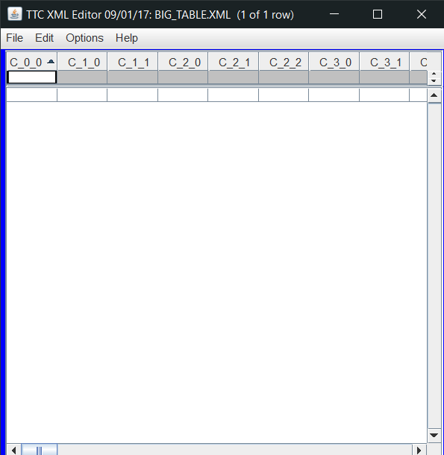
Figure 2: Contents of BIG_TABLE.xml inside the editor
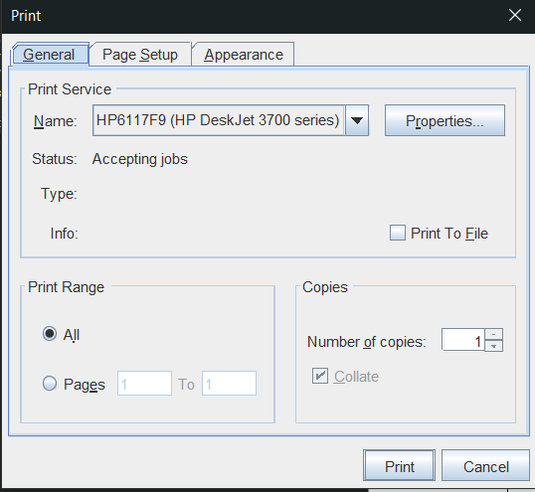
Figure 3: Print pop up window.

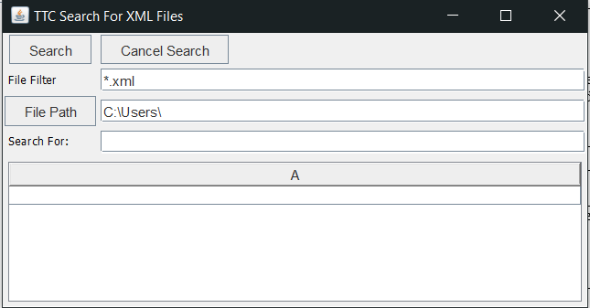
Figure 4: Search pop up window.

$$$$$

