Database Table Editor

Test plan

Version 2.0

04/19/2020

Document Control

Approval

The Guidance Team shall approve this document.

Document Change Control

|  |  |
| --- | --- |
| Initial Release: | 1.0 |
| Current Release: | 2.0 |
| Indicator of Last Page in Document: | * |
| Date of Last Review: | 04/13/2020 |
| Date of Next Review: | 04/20/2020 |
| Target Date for Next Update: | 04/22/2020 |

Distribution List

This following list of people shall receive a copy of this document every time a new version of this document becomes available:

Guidance Team Members:

Dr. Steven Roach

Test Plan Producer:

Bianca Alvarez

Test Plan Reviewers:  
Carlos Vargas  
Juan Gaucin

Change Summary

The following table details changes made between versions of this document

|  |  |  |  |
| --- | --- | --- | --- |
| Version | Date | Modifier | Description |
| 1.0 | 04/09/2020 | Bianca Alvarez | First version of test plan created |
| 2.0 | 04/19/2020 | Bianca Alvarez | Second version- comments addressed |
|  |  |  |  |

Note: The template presented in this document was taken from:

Donaldson, S., and S. Siegel, *Successful Software Development*. Upper Saddle River, NJ: Prentice Hall, 2001, pp. 321-323.

Note: The template presented in this document was taken from: Donaldson, S., and S. Siegel, *Successful Software Development*. Upper Saddle River, NJ: Prentice Hall, 2001, pp. 321-323 and modified by Humberto Mendoza and Steve Roach.

Supplementary information is from:

Pfleeger, S. *Software Engineering, Theory and Practice*. Upper Saddle River, NJ: Prentice Hall, 1998, p. 365.

Table of Contents

Document Control ii

Approval ii

Document Change Control ii

Distribution List ii

Change Summary ii

1. Introduction 4

1.1. Purpose 4

1.2. Scope 4

1.3. System Overview 4

1.4. Suspension and Exit Criteria 4

1.5. Document Overview 5

1.6. References 5

2. Test Items and Features 6

3. Testing Approach 7

4. Test Cases 9

4.1. Test Suite 1 9

4.1.1. T1-1 9

4.1.2. T1-2 10

4.1.3. T1-3 11

4.1.4. T1-4 12

4.1.5. T1-5 13

4.1.6. T1-6 14

4.2. Test Suite 2 15

4.2.1. T2-1 15

4.2.2. T2-2 16

4.2.3. T2-3 17

4.3. Test Suite 3 18

4.3.1. T3-1 18

4.3.2. T3-2 19

4.3.3. T3-3 20

4.3.4. T3-4 21

4.4. Test Suite 4 21

4.4.1. T4-1 22

4.4.2. T4-2 22

5. User Interface Testing 23

6. Test Schedule 26

7. Other Sections 27

7.1. Software Requirements 27

7.1.1. Open dbEdit 27

7.1.2. Open Database Description 27

# Introduction

The plan for this project is to produce a reasonable test plan for the program, database table editor.

## Purpose

The purpose of this document is to define a project test plan which will describe the overall strategy for testing.

## Scope

The test plan described in this document is draft by the producer and reviewers of Group 1, Team 2 and is intended to test some of the features of the application dbEdit by Dr Steven Roach. The features to be tested are the functionality of the File and Search Menu, detailed description is given on Section 2.

The following versions have been released:

* V1 – Initial Test Plan by Producer
* V2 – Second Version with comments addressed

## System Overview

The system to be tested is a simple database table editor. This editor allows to view and modify the data, the editor does not allow modification of the database schema. The configuration data is stored in XML tables, and the database is organized in XML documents.

Figure 1 Types of XML documents

The database description file contains a description of the data tables, including table name and columns for each of one of the tables. As an example, consider file TEST_DB.xml

The data tables names are included in the database description file after the tag <TABLE>. As an example, consider the file TEST_DB__BIG_TABLE.XML, which contains the data for the database table description described above.

Our objective is to focus on file menu operations excluding compare file to other version, check for duplicate rows, and filter. Also, including the search menu option on the database window.

## Suspension and Exit Criteria

There are no suspension criteria, all tests cases will be executed.

The exit criteria are met when all critical tests and 90% of the non-critical tests pass, this will ensure the pass rate is high.

## Document Overview

The following sections are included in this document:

Section 2 – Test Items and Features

Section 3 – Testing Approach

Section 4 – Test Cases

Section 5 – User Interface Testing

Section 6 – Test Schedules

Section 7 – Other Sections

## References

<<List all the references applicable to the test plan. Generally, this includes project standards, SRS, SDD, and a product assurance plan.>>

GitHub:

CS5387/testplangroup1-team-2. (2020). CS5387. <https://github.com/CS5387/testplangroup1-team-2>

Supported Documents:

*DbEditTestPlanAssign.pdf*. (n.d.). Retrieved April 19, 2020, from https://piazza.com/class_profile/get_resource/k55rbh37ri6be/k8hjj7sn7hu7n0

Test Plan template. Retrieved April 19, 2020, from https://piazza.com/class_profile/get_resource/k55rbh37ri6be/k607wywlx1h51l

# Test Items and Features

The features to be tested are the functionality of the File and Search Menu, detailed description is given below.

The File Menu has the options to open, close, and print tables. The following operations are included:

* Print to Fit
* Print Normal
* Print CSV
* Save as
* Exit
* Close
  + If the file has been modified and the user attempts to close the file, a save prompt should be displayed.
* Save(^s)
  + On file save, the user is prompted to enter a new history entry.
* Open – A user can open either a database description file or a data file
  + If a data file is opened, the corresponding data description is also opened
  + If a database description is opened, the window will display all the database tables
    - If selecting a table from this display, will open the data table display in a new window
    - It is possible to open more than one database at a time
    - Opening a database table file results in the database description also being opened.
    - All the windows associated with a specific database have the same color outline.
  + Opening an already-opened table should result in the table editor window for that table being raised to the top of the screen and being visible.

For Search Menu, the following operations are included:

* Search opens a file search dialog that allows a user to search specified directories for files that contain a given text string.
* Find Files
  + When using this option, files containing the text string are listed.
  + Selecting the file from the display will open the database table.

The following features are not to be tested:

* Compare file to other versions
* Check for duplicate rows
* Filter
* Edit Menu Operations
* Search function in the edit menu

# Testing Approach

To complete the test cases described in this document, the application dbEdit should be opened. Refer to section 7.1 software requirements on how to open the application dbEdit.

The criticality was classified as following:

* High – Functions required for other parts of the system to test
* Medium – Function that should be working but it is not required by another function
* Low – Display, appearance, colors,

Table 1: Test Plan 1

|  |  |  |
| --- | --- | --- |
| **TEST SUITE 1** | | |
| **Description of Test Suite** | Testing option Open under the File menu A user can open either a database description file or a data file. | |
| **Test Case Identifier** | **Objective** | **Criticality** |
| T1-1 | Test that the file menu option “Open” opens a database description and displays all database tables | High |
| T1-2 | After opening a database description, test if selecting a table from the window will open the data table display in a new window | High |
| T1-3 | Test when the data file is opened, the corresponding data description is also opened | High |
| T1-4 | Test when opening an already opened table should result in the table editor window for that table being raised to the top of the screen and being visible | Medium |
| T1-5 | Check that is possible to open more than one database at a time | High |
| T1-6 | Check that all windows associated with a specific database have the same color outline | Low |

Table 2: Test Plan 2

|  |  |  |
| --- | --- | --- |
| **TEST SUITE 2** | | |
| **Description of Test Suite** | Testing option Print under the File menu | |
| **Test Case Identifier** | **Objective** | **Criticality** |
| T2-1 | Test the Print to Fit option | Medium |
| T2-2 | Test the Print Normal option | Medium |
| T2-3 | Test the Print CSV option | Medium |

Table 3: Test Plan 3

|  |  |  |
| --- | --- | --- |
| **TEST SUITE 3** | | |
| **Description of Test Suite** | Testing options Save, and Close under the File menu | |
| **Test Case Identifier** | **Objective** | **Criticality** |
| T3-1 | Test when on file Save(^s), the user is prompted to enter a new history entry | Medium |
| T3-2 | Test option Save as | Medium |
| T3-3 | Test that if the file has been modified and the user attempts to close the file, a save prompt should be displayed | Medium |
| T3-4 | Test option Exit | Medium |

Table 4: Test Plan 4

|  |  |  |
| --- | --- | --- |
| **TEST SUITE 4** | | |
| **Description of Test Suite** | Testing Search Menu | |
| **Test Case Identifier** | **Objective** | **Criticality** |
| T4-1 | Test that Search opens a file search dialog that allows a user to search specified directions for files that contain a given text string | High |
| T4-2 | Test that when selecting the file from the display will open the database table | High |

# Test Cases

The following section describes the test suites with its tests to be executed for the system dbEdit.

Refer to section 7.1 software requirements on how to open the application dbEdit.

Note: If the tester modified a table, always refer to the original files given for each test case unless specified in the testing approach of each test.

## Test Suite 1

The purpose of this test suite is to test the option Open under the File menu and considering that a user can open either a database description file or a data file.

Ensure the testing team has the following files to proceed with the tests.

* dbEdit.jar
* TEST_DB.xml
* TEST_DB__BIG_TABLE.xml
* TEST_DB__CONSTRAINT_TABLE.xml
* TEST_DB__TYPE_TABLE.xml
* TEST16_DB.xml
* TEST16_DB__BIG_TABLE.xml
* TEST16_DB__CONSTRAINT_TABLE.xml
* TEST16_DB__TYPE_TABLE.xml

### T1-1

**Objective:** Test that the file menu option “Open” opens a database description and displays all database tables

|  |  |  |  |  |  |  |
| --- | --- | --- | --- | --- | --- | --- |
| **Test No.:** T1-1 | | | | **Current Status:** Pending | | |
| **Test title:** Open database description | | | | | | |
| **Testing approach:** Manual test, follow the steps below and compare with the expected results.  Files required: TEST_DB.xml | | | | | | |
| **STEP**  1. | **OPERATOR ACTION**  Ensure the application dbEdit is running | **PURPOSE**  Beginning of test | | | **EXEPCTED RESULTS**  Main window is displayed with no tables | **COMMENTS** |
| 2. | Click the “File” menu option located at the top left corner | Opens the file menu | | | The file menu is displayed |  |
| 3. | Click the button “Open” from the File menu | Option to open a file | | | The file search path window opens |  |
| 4. | Select an XML file, for this test case, select the file TEST_DB.xml | Test to prove that when opening a database description, all table names in this db are displayed | | | The window will display all the database tables |  |
| **Concluding Remarks:** Test is successful when opening a database description file, all tables names appear on the window display | | | | | | |
| **Testing Team:** | | | **Date Completed:** | | | |

### T1-2

**Objective:** After opening a database description, test if selecting a table from the window will open the data table display in a new window

|  |  |  |  |  |  |  |
| --- | --- | --- | --- | --- | --- | --- |
| **Test No.:** T1-2 | | | | **Current Status:** Pending | | |
| **Test title:** Open table from the window display | | | | | | |
| **Testing approach:** Manual test, follow the steps below and compare with the expected results.  Files required: TEST_DB.xml, TEST_DB__BIG_TABLE.xml, TEST_DB__CONSTRAINT_TABLE.xml, and TEST_DB__TYPE_TABLE.xml | | | | | | |
| **STEP**  1. | **OPERATOR ACTION**  Ensure the application is running and you have opened the file TEST_DB.xml | **PURPOSE**  Beginning of test | | | **EXEPCTED RESULTS**  The window will display all the database tables | **COMMENTS** |
| 2. | Select the table BIG_TABLE from the window display | Check that a table will open in a new window | | | Table BIG_TABLE opened in a new window |  |
| 3. | Select the table CONSTRAINT_NAME from the window display | Check that a table will open in a new window | | | Table CONSTRAINT_NAME opened in a new window |  |
| 4. | Select the table TYPE_TABLE from the window display | Ensure all tables from the database, will open in a new window | | | Table TYPE_TABLE opened in a new window |  |
| **Concluding Remarks:** All tables in the window display from the database description, opened in a new window.  From this test case we can also conclude that the file menu option “Open” opens a data file and database description at the same time. | | | | | | |
| **Testing Team:** | | | **Date Completed:** | | | |

### T1-3

**Objective:** Test when the data file is opened, the corresponding data description is also opened

|  |  |  |  |  |  |  |
| --- | --- | --- | --- | --- | --- | --- |
| **Test No.:** T1-3 | | | | **Current Status:** Pending | | |
| **Test title:** Open data file | | | | | | |
| **Testing approach:** Manual test, follow the steps below and compare with the expected results.  Files required: TEST_DB.xml and TEST_DB__TYPE_TABLE.xml | | | | | | |
| **STEP**  1. | **OPERATOR ACTION**  Ensure the application dbEdit is running | **PURPOSE**  Beginning of test | | | **EXEPCTED RESULTS**  Main window is displayed with no tables | **COMMENTS** |
| 2. | Click the “File” menu option located at the top left corner | Opens the file menu | | | The file menu is displayed |  |
| 3. | Click the button “Open” from the File menu | Option to open a file | | | The file search path window opens |  |
| 4. | Select an XML file, for this test case, select one of the data files, like TEST_DB_TYPE_TABLE.xml | Ensure that the corresponding data description is also opened when opening a data file | | | The application opens the database description TEST_DB and the data file TYPE_TABLE at the same time |  |
| **Concluding Remarks:** When opening a data file, the corresponding database description will open | | | | | | |
| **Testing Team:** | | | **Date Completed:** | | | |

### T1-4

**Objective:** Test when opening an already opened table should result in the table editor window for that table being raised to the top of the screen and being visible

|  |  |  |  |  |  |  |
| --- | --- | --- | --- | --- | --- | --- |
| **Test No.:** T1-4 | | | | **Current Status:** Pending | | |
| **Test title:** Opening an already opened table | | | | | | |
| **Testing approach:** Manual test, follow the steps below and compare with the expected results.  Files required: TEST_DB.xml, TEST_DB__BIG_TABLE.xml, TEST_DB__CONSTRAINT_TABLE.xml, and TEST_DB__TYPE_TABLE.xml | | | | | | |
| **STEP**  1. | **OPERATOR ACTION**  Ensure the application dbEdit is running and you have opened the file TEST_DB.xml | **PURPOSE**  Beginning of test | | | **EXEPCTED RESULTS**  Main window will display list of tables in database | **COMMENTS** |
| 2. | In the list of tables in the main window, click BIG_TABLE | Open fist table | | | BIG_TABLE will be displayed in a new window |  |
| 3. | In the list of tables in the main window, click CONSTRAINT_TABLE | Open second table | | | CONSTRAINT_TABLE will be displayed in a new window |  |
| 4. | In the list of tables in the main window, click TYPE_TABLE | Open third table | | | TYPE_TABLE will be displayed in a new window |  |
| 5. | In the list of tables in the main window, click again BIG_TABLE | Open an already opened table | | | BIG_TABLE window will appear in front of other windows |  |
| 6. | Click the button “File” located at the top left corner, then select Open and select the file TEST_DB_CONSTRAINT_TABLE.xml | Open an already opened table using the File Menu | | | CONSTRAINT_TABLE window will appear in front of other windows | To stop selecting a table name from the list, right click outside this list |
| **Concluding Remarks:** When opening an already opened table, this table window will appear to the top of the screen and being visible. | | | | | | |
| **Testing Team:** | | | **Date Completed:** | | | |

### T1-5

**Objective:** Test that is possible to open more than one database at a time

|  |  |  |  |  |  |  |
| --- | --- | --- | --- | --- | --- | --- |
| **Test No.:** T1-5 | | | | **Current Status:** Pending | | |
| **Test title:** Open more than one database | | | | | | |
| **Testing approach:** Manual test, follow the steps below and compare with the expected results.  Files required: TEST_DB.xml and TEST16_DB.xml | | | | | | |
| **STEP**  1. | **OPERATOR ACTION**  Ensure the application dbEdit is running and you have opened the file TEST_DB.xml | **PURPOSE**  Beginning of test | | | **EXEPCTED RESULTS**  Main window will display list of tables in database. The outline of this window is blue | **COMMENTS** |
| 2. | Click the “File” menu option located at the top left corner | Opens the file menu | | | The file menu is displayed |  |
| 3. | Click the button “Open” from the File menu | Option to open a file | | | The file search path window opens |  |
| 4. | Select an XML file, for this test case, select the db description TEST16_DB.xml | Ensure that more than one database can be opened at the same time | | | The application opens the database description TEST16_DB |  |
| **Concluding Remarks:** Test is successful if more than one database description can be opened at the same time. | | | | | | |
| **Testing Team:** | | | **Date Completed:** | | | |

### T1-6

**Objective:** Test that all windows associated with a specific database have the same color outline

**Notes:** Test T1-5 should pass before running this test.

|  |  |  |  |  |  |  |
| --- | --- | --- | --- | --- | --- | --- |
| **Test No.:** T1-6 | | | | **Current Status:** Pending | | |
| **Test title:** Color Outline | | | | | | |
| **Testing approach:** Manual test, follow the steps below and compare with the expected results.  Files required: TEST_DB.xml, TEST_DB__BIG_TABLE.xml, TEST_DB__CONSTRAINT_TABLE.xml, TEST_DB__TYPE_TABLE.xml, TEST16_DB.xml, TEST16_DB__BIG_TABLE.xml, TEST16_DB__CONSTRAINT_TABLE.xml, and TEST16_DB__TYPE_TABLE.xml | | | | | | |
| **STEP**  1. | **OPERATOR ACTION**  Ensure the application dbEdit is running and you have opened the file TEST_DB.xml and TEST16_DB.xml | **PURPOSE**  Beginning of test | | | **EXEPCTED RESULTS**  Main window will display list of tables in database. The outline of the window of the database TEST_DB is blue and the outline for TEST16_DB is green | **COMMENTS**  Complete T1-5 before continuing with the following steps |
| 2. | In the list of tables in the window TEST_DB, click BIG_TABLE | Open fist table | | | BIG_TABLE will be displayed in a new window. The outline of this window is blue |  |
| 3. | In the list of tables in the window TEST_DB, click CONSTRAINT_TABLE | Open second table | | | CONSTRAINT_TABLE will be displayed in a new window. The outline of this window is blue |  |
| 4. | In the list of tables in the window TEST_DB, click TYPE_TABLE | Open third table | | | TYPE_TABLE will be displayed in a new window. The outline of this window is blue. |  |
| 5. | In the list of tables in the window TEST16_DB, click BIG_TABLE | Open fist table | | | BIG_TABLE will be displayed in a new window. The outline of this window is green |  |
| 6. | In the list of tables in the window TEST16_DB, click CONSTRAINT_TABLE | Open second table | | | CONSTRAINT_TABLE will be displayed in a new window. The outline of this window is green |  |
| 7. | In the list of tables in the window TEST16_DB, click TYPE_TABLE | Open third table | | | TYPE_TABLE will be displayed in a new window. The outline of this window is green. |  |
| **Concluding Remarks:** Test is successful if all data files windows have the same outline color as the database description window.  Also we can notice that the outline color of the first database description opened will be blue, the second green, and the third color is pink. | | | | | | |
| **Testing Team:** | | | **Date Completed:** | | | |

## Test Suite 2

The purpose of this test suite is to test the option Print under the File menu.

Ensure the testing team has the following files to proceed with the tests.

* dbEdit.jar
* TEST_DB.xml
* TEST_DB__CONSTRAINT_TABLE.xml

### T2-1

**Objective:** Test the Print to Fit option

|  |  |  |  |  |  |  |
| --- | --- | --- | --- | --- | --- | --- |
| **Test No.:** T2-1 | | | | **Current Status:** Pending | | |
| **Test title:** Print to Fit | | | | | | |
| **Testing approach:** Manual test, follow the steps below and compare with the expected results.  Files required: TEST_DB.xml | | | | | | |
| **STEP**  1. | **OPERATOR ACTION**  Ensure the application dbEdit is running and you have opened the file TEST_DB.xml | **PURPOSE**  Beginning of test | | | **EXEPCTED RESULTS**  Main window will display list of tables in database | **COMMENTS** |
| 2. | Click the “File” menu option located at the top left corner, then select Print to Fit | Test Print to Fit option | | | The window Print will appear |  |
| 3. | On the option Name, select Microsoft to Print to PDF, then click on Print, and select the path destination to save the PDF file | Test Print to Fit option using PDF print | | | The file should be saved on the path indicated |  |
| 4. | Look for the file that was printed in the step before, open the file to see the printed file | Open file printed to PDF | | | The database description table is on the printed PDF file (the size of the font was increased to fit on the page) |  |
| **Concluding Remarks:** The option Print to Fit allows the user to have a print version of a data file or database description. | | | | | | |
| **Testing Team:** | | | **Date Completed:** | | | |

### T2-2

**Objective:** Test the Print Normal option

|  |  |  |  |  |  |  |
| --- | --- | --- | --- | --- | --- | --- |
| **Test No.:** T2-2 | | | | **Current Status:** Pending | | |
| **Test title:** Print Normal | | | | | | |
| **Testing approach:** Manual test, follow the steps below and compare with the expected results.  Files required: TEST_DB.xml | | | | | | |
| **STEP**  1. | **OPERATOR ACTION**  Ensure the application dbEdit is running and you have opened the file TEST_DB.xml | **PURPOSE**  Beginning of test | | | **EXEPCTED RESULTS**  Main window will display list of tables in database | **COMMENTS** |
| 2. | Click the “File” menu option located at the top left corner, then select Print Normal | Test Print Normal option | | | The window Print will appear |  |
| 3. | On the option Name, select Microsoft to Print to PDF, then click on Print, and select the path destination to save the PDF file | Test Print Normal option using PDF print | | | The file should be saved on the path indicated |  |
| 4. | Look for the file that was printed in the step before, open the file to see the printed file | Open file printed to PDF | | | The database description table is on the printed PDF file |  |
| **Concluding Remarks:** The option Print Normal allows the user to have a print version of a data file. | | | | | | |
| **Testing Team:** | | | **Date Completed:** | | | |

### T2-3

**Objective:** Test the Print CSV option

|  |  |  |  |  |  |  |
| --- | --- | --- | --- | --- | --- | --- |
| **Test No.:** T2-3 | | | | **Current Status:** Pending | | |
| **Test title:** Print CSV | | | | | | |
| **Testing approach:** Manual test, follow the steps below and compare with the expected results.  Files required: TEST_DB.xml and TEST_DB__CONSTRAINT_TABLE.xml | | | | | | |
| **STEP**  1. | **OPERATOR ACTION**  Ensure the application dbEdit is running and you have opened the file TEST_DB.xml | **PURPOSE**  Beginning of test | | | **EXEPCTED RESULTS**  Main window will display list of tables in database | **COMMENTS** |
| 2. | Open the data file CONSTRAINT_TABLE | Beginning of test | | | The table CONSTRAINT_TABLE will open |  |
| 3. | Click the button “File” located at the top left corner, then select Print CSV | Test Print CSV | | | A message will appear on top of the window with the message of the numbers of records found + the destination path |  |
| 4. | Look for the CSV file on the folder where the application is located, open the file | Open CSV file | | | When opening the csv file, the records of the CONSTRAINT_TABLE are visible |  |
| **Concluding Remarks:** The option Print CSV allows the user to have the records of a data file saved in a csv file. | | | | | | |
| **Testing Team:** | | | **Date Completed:** | | | |

## Test Suite 3

The purpose of this test suite is to test the option Save, Exit, and Close under the File menu.

Ensure the testing team has the following files to proceed with the tests.

* dbEdit.jar
* TEST_DB.xml
* TEST_DB__CONSTRAINT_TABLE.xml

### T3-1

**Objective:** Test when on file Save(^s), the user is prompted to enter a new history entry

|  |  |  |  |  |  |  |
| --- | --- | --- | --- | --- | --- | --- |
| **Test No.:** T3-1 | | | | **Current Status:** Pending | | |
| **Test title:** Save(^s) | | | | | | |
| **Testing approach:** Manual test, follow the steps below and compare with the expected results.  Files required: TEST_DB.xml and TEST_DB__CONSTRAINT_TABLE.xml | | | | | | |
| **STEP**  1. | **OPERATOR ACTION**  Ensure the application dbEdit is running and you have opened the file TEST_DB.xml | **PURPOSE**  Beginning of test | | | **EXEPCTED RESULTS**  Main window will display list of tables in database | **COMMENTS** |
| 2. | Open the data file CONSTRAINT_TABLE | Beginning of test | | | The table CONSTRAINT_TABLE will open |  |
| 3. | Change a value on the table, then on your keyboard press CTRL + S | Test Save ^s | | | The window XML history input opens |  |
| 4. | Fill the blanks on the window, entering the author and description, then press Okay | Save a new version of the table | | | A message will appear on top of the window with the destination path of the new table saved |  |
| 5. | Go to the main window, where all the table names are displayed Click on File > Open > Select the file TEST_DB_CONSTRAINT_TABLE  Repeat this step to open the file TEST_DB_CONSTRAINT_TABLE~ | Open the two versions of the table CONSTRAINT_TABLE | | | The two tables appear on different windows, the table with the (~) at the end of the name, is the table history | Compare both tables |
| **Concluding Remarks:** When modifying a value in the table, the option Save(^s) prompts the user to enter a new history entry. | | | | | | |
| **Testing Team:** | | | **Date Completed:** | | | |

### T3-2

**Objective:** Test option Save as

**Notes:**  The new table will not be saved on the XML file of the database description, for this table to appear on the database, the user will need to enter manually the name of the table to the database description XML file.

|  |  |  |  |  |  |  |
| --- | --- | --- | --- | --- | --- | --- |
| **Test No.:** T3-2 | | | | **Current Status:** Pending | | |
| **Test title:** Save as | | | | | | |
| **Testing approach:** Manual test, follow the steps below and compare with the expected results.  Files required: TEST_DB.xml and TEST_DB__CONSTRAINT_TABLE.xml | | | | | | |
| **STEP**  1. | **OPERATOR ACTION**  Ensure the application dbEdit is running and you have opened the file TEST_DB.xml | **PURPOSE**  Beginning of test | | | **EXEPCTED RESULTS**  Main window will display list of tables in database | **COMMENTS** |
| 2. | Open the data file CONSTRAINT_TABLE | Beginning of test | | | The table CONSTRAINT_TABLE will open |  |
| 3. | Click on File > Save as | Test Save as | | | The window XML history input opens |  |
| 4. | Fill the blanks on the window, entering the author and description, then press Okay | Save a new version of the table | | | A message will appear on top of the window with the destination path of the new table saved | The name for the new table should follow the convention name TEST_DB__CO  NSTRAINT_  TABLE2 |
| 5. | Go to the main window, where all the table names are displayed Click on File > Open > Select the file TEST_DB_CONSTRAINT_TABLE  Repeat this step to open the file TEST_DB_CONSTRAINT_TABLE2 | Open the two versions of the table CONSTRAINT_TABLE | | | The two tables appear on different windows | Compare both tables |
| **Concluding Remarks:** The option Save allows the user to save a new version of the data file. | | | | | | |
| **Testing Team:** | | | **Date Completed:** | | | |

### T3-3

**Objective:** Test that if the file has been modified and the user attempts to close the file, a save prompt should be displayed

|  |  |  |  |  |  |
| --- | --- | --- | --- | --- | --- |
| **Test No.:** T3-3 | | | **Current Status:** Pending | | |
| **Test title:** Close File | | | | | |
| **Testing approach:** Manual test, follow the steps below and compare with the expected results.  Files required: TEST_DB.xml and TEST_DB__CONSTRAINT_TABLE.xml | | | | | |
| **STEP**  1. | **OPERATOR ACTION**  Ensure the application dbEdit is running and you have opened the file TEST_DB.xml | **PURPOSE**  Beginning of test | | **EXEPCTED RESULTS**  Main window will display list of tables in database | **COMMENTS** |
| 2. | Open the data file CONSTRAINT_TABLE | Beginning of test | | The table CONSTRAINT_TABLE will open |  |
| 3. | Modify the first row, first column  From Start_Name to 10 | Modify data file | | The new modification is displayed |  |
| 4. | Close the data file without saving it | Ensure a save prompt is displayed before closing the file | | The save prompt is displayed |  |
| **Concluding Remarks:** If a file is modified and the user attempts to close the file without saving it, a window will appear asking the user if to save the file or close without saving or return to editor. | | | | | |

### T3-4

**Objective:** Test option Exit

|  |  |  |  |  |  |  |
| --- | --- | --- | --- | --- | --- | --- |
| **Test No.:** T3-4 | | | | **Current Status:** Pending | | |
| **Test title:** Exit Program | | | | | | |
| **Testing approach:** Manual test, follow the steps below and compare with the expected results.  Files required: TEST_DB.xml and TEST_DB__CONSTRAINT_TABLE.xml | | | | | | |
| **STEP**  1. | **OPERATOR ACTION**  Ensure the application dbEdit is running and you have opened the file TEST_DB.xml | **PURPOSE**  Beginning of test | | | **EXEPCTED RESULTS**  Main window will display list of tables in database | **COMMENTS** |
| 2. | Open the data file CONSTRAINT_TABLE | Beginning of test | | | The table CONSTRAINT_TABLE will open |  |
| 3. | Click on File > Exit | Ensure exit works | | | The table CONSTRAINT_TABLE is closed |  |
| 4. | Open the data file CONSTRAINT_TABLE again | Beginning of second part of test | | | The table CONSTRAINT_TABLE will open |  |
| 5. | Modify the second row, second column  From Start_Name to 10 | Modify data file | | | The new modification is displayed |  |
| 6. | Click on File > Exit | Ensure a save prompt is displayed before closing the file | | | The save prompt is displayed |  |
| **Concluding Remarks:** The exit option works, if a data file is modified and the user attempts to close the file without saving it, a window will appear asking the user if to save the file or close without saving or return to editor. | | | | | | |
| **Testing Team:** | | | **Date Completed:** | | | |

## Test Suite 4

The purpose of this test suite is to test the Find Files option under Search menu option.

Ensure the testing team has the following files to proceed with the tests.

* dbEdit.jar
* TEST_DB.xml
* TEST_DB__BIG_TABLE.xml
* TEST_DB__CONSTRAINT_TABLE.xml
* TEST_DB__TYPE_TABLE.xml
* TEST16_DB.xml
* TEST16_DB__CONSTRAINT_TABLE.xml
* TEST16_DB__TYPE_TABLE.xml

### T4-1

**Objective:** Test that Search opens a file search dialog that allows a user to search specified directions for files that contain a given text string

|  |  |  |  |  |  |  |
| --- | --- | --- | --- | --- | --- | --- |
| **Test No.:** T4-1 | | | | **Current Status:** Pending | | |
| **Test title:** Search and find files option | | | | | | |
| **Testing approach:** Manual test, follow the steps below and compare with the expected results.  Files required: TEST_DB__CONSTRAINT_TABLE.xml, TEST_DB__TYPE_TABLE.xml, TEST16_DB__CONSTRAINT_TABLE.xml, and TEST16_DB__TYPE_TABLE.xml  Ensure the file path selected in the search window is correct, this should be where your project is saved like:  C:\Users\User\Downloads\testplangroup1-team-2-master\testplangroup1-team-2-master | | | | | | |
| **STEP**  1. | **OPERATOR ACTION**  Ensure the application dbEdit is running | **PURPOSE**  Beginning of test | | | **EXEPCTED RESULTS**  Main window displayed | **COMMENTS** |
| 2. | In the menu bar, look for Search > Click on find files | Test search option | | | The file search dialog is displayed |  |
| 3. | In search for, write: 57  Click on search | Search a string | | | All files that contain the string “57” are displayed, which includes the files:  TEST_DB__CONSTRAINT_TABLE  TEST_DB__TYPE_TABLE  TEST16_DB__CONSTRAINT_TABLE  TEST16_DB__TYPE_TABLE |  |
| **Concluding Remarks:** When using the option find files, files containing the text string are listed | | | | | | |
| **Testing Team:** | | | **Date Completed:** | | | |

### T4-2

**Objective:** Test that when selecting the file from the display will open the database table

**Notes:** Test T4-1 should pass before running this test.

|  |  |  |  |  |  |  |
| --- | --- | --- | --- | --- | --- | --- |
| **Test No.:** T4-2 | | | | **Current Status:** Pending | | |
| **Test title:** Selecting a file from the Search Display | | | | | | |
| **Testing approach:** Manual test, follow the steps below and compare with the expected results.  Files required: TEST_DB__CONSTRAINT_TABLE.xml, TEST_DB__TYPE_TABLE.xml, TEST16_DB__CONSTRAINT_TABLE.xml, and TEST16_DB__TYPE_TABLE.xml  Ensure the file path selected in the search window is correct, this should be where your project is saved like:  C:\Users\User\Downloads\testplangroup1-team-2-master\testplangroup1-team-2-master | | | | | | |
| **STEP**  1. | **OPERATOR ACTION**  Ensure the application dbEdit is running and the search window is displayed | **PURPOSE**  Beginning of test | | | **EXEPCTED RESULTS**  Main window displayed | **COMMENTS**  Test T4-1 should pass before running this test. |
| 2. | In search for, write: 57  Click on search | Search a string | | | All files that contain the string “57” are displayed, which includes the files:  TEST_DB__CONSTRAINT_TABLE  TEST_DB__TYPE_TABLE  TEST16_DB__CONSTRAINT_TABLE  TEST16_DB__TYPE_TABLE |  |
| 3. | Double-click with the right mouse click each of the files | Open each data file and ensure the corresponding database description is opened | | | When opening a data file, the corresponding database description should also open in a new window |  |
| **Concluding Remarks:** When opening a data file from the find files window, the corresponding database description should be displayed. | | | | | | |
| **Testing Team:** | | | **Date Completed:** | | | |

# User Interface Testing

This section focuses on the interaction between the user and the system.

* Close Database Description File

The window that displays all tables, allows the user to change the name of the table name. But when closing this window, the new name is not saved. This should be fixed since it can cause confusion to the user. In the document given with the specifications of this program, the option to change a table name is not listed, therefore this issue is listed here.

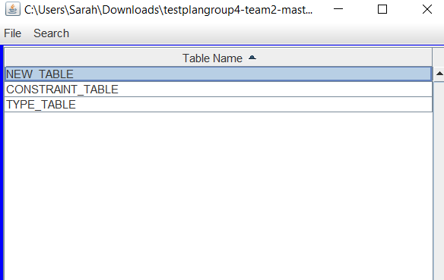

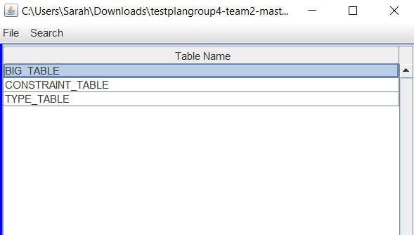

* Close and Exit Options

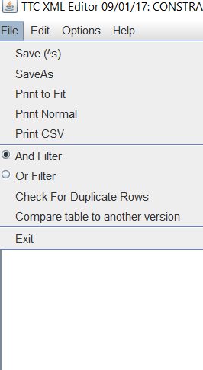Close and Exit perform the same function in both windows, consistent terminology is recommended.

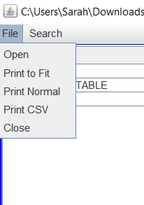

* Search Files Window

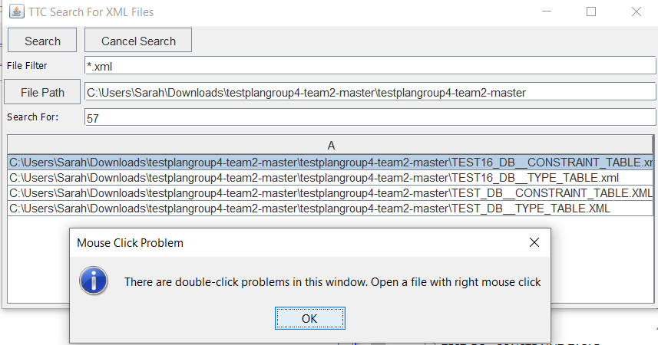Mouse Click Problem, in the rest of the windows, double-click works correctly.

This is not very user friendly, since to open each of the files, the user needs to double-click with the right mouse click. In addition is not possible to open the first file listed in the window.

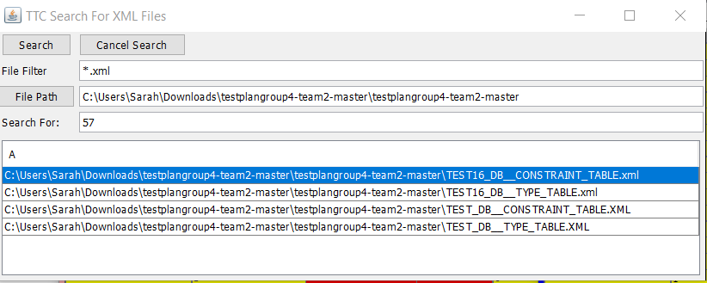

# Test Schedule

<< Specify the schedule for testing activities. A table with the order and completion dates of the tests is useful. The table below might be useful.>>

|  |  |  |
| --- | --- | --- |
| **Task and date** | **People** | **Description** |
|  |  |  |
|  |  |  |
|  |  |  |
|  |  |  |
|  |  |  |
|  |  |  |
|  |  |  |
|  |  |  |
|  |  |  |

# Other Sections

## Software Requirements

### Open dbEdit

Follow this guide on how to open the application dbEdit.jar

1-Download project from the GitHub Repository, link can be found in References Section

2-Extract all files

3-Open folder, double-click on dbEdit.jar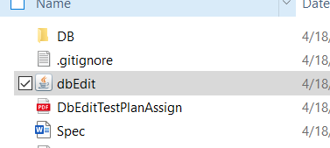

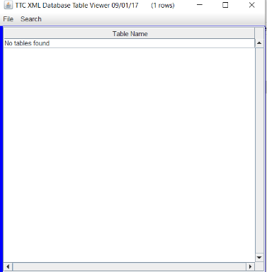4-The application is running

### Open Database Description

1-Go to the menu bar,

Click on File > Open

2-Selct a database description

The name convention is NAME_DB.xml

For this example, TEST_DB.xml was selected



