DBEdit: Database Table Editor
Test Plan
Version 1.0
04/11/2020
Document Control
Approval
The guidance team and the test plan reviewers shall approve this document.
Document Change Control
Initial Release: | v1.0
Current Release: | v1.0
Indicator of Last Page in Document: | !
Date of Last Review: | 04/11/2020
Date of Next Review: | 04/12/2020
Target Date for Next Update: | 04/13/2020
Distribution List
This following list of people shall receive a copy of this document every time a new version of this document becomes available:
Guidance Team Members:
- Dr. Steven Roach

Reviewers:
- Kevin Rodriguez
- Adrian Gonzalez

Producer:
- Valente Arellano
Change Summary
The following table details changes made between versions of this document

Version | Date | Modifier | Description
1.0 | 04/11/2020 | Valente Arellano | Completed initial draft of test plan.

Note: The template presented in this document was taken from:
Donaldson, S., and S. Siegel, Successful Software Development. Upper Saddle River, NJ: Prentice Hall, 2001, pp. 321-323.

Note: The template presented in this document was taken from: Donaldson, S., and S. Siegel, Successful Software Development. Upper Saddle River, NJ: Prentice Hall, 2001, pp. 321-323 and modified by Humberto Mendoza and Steve Roach.

Supplementary information is from:
Pfleeger, S. Software Engineering, Theory and Practice. Upper Saddle River, NJ: Prentice Hall, 1998, p. 365.

Table of Contents
Document Control ii
Approval ii
Document Change Control ii
Distribution List ii
Change Summary ii
1. Introduction 1
1.1. Purpose 1
1.2. Scope 1
1.3. System Overview 1
1.4. Suspension and Exit Criteria 1
1.5. Document Overview 1
1.6. References 1
2. Test Items and Features 2
3. Testing Approach 3
4. Test T-1 5
4.1. Test C-1 5
5. Test Schedule 7
6. Other Sections 8
6.1. Staffing and Training Needs 8
6.2. Environmental Requirements 8
6.3. Software Requirements 8
7. Appendix 9

Introduction
This test plan was written to validate functional requirements for DBEdit, a simple database table editor. It will be read and revised by the test plan reviewers and will be adjusted by the producer (see Distribution List, p. ii) until all team members are satisfied. This test plan does not require the individual performing the tests to examine any code; all tests are black box.

Purpose
The purpose of this test plan document is to provide a detailed description of the items in the system to be tested, the testing approach, the tests to be performed and the test schedule. The contents of this document will describe an overall strategy for testing the DBEdit system.

Scope
This plan encompasses the latest version of DBEdit, provided via GitHub Classroom to Dr. Steven Roach’s Spring 2020 CS 4387/5387 Software Integration/V&V class.

System Overview
The DBEdit system allows a user to view and modify data stored in XML tables. The editor’s view/modify functional requirements documented in the specification will be the focus of this plan’s testing approach.

Suspension and Exit Criteria
All test cases included in this test plan should be executed, if possible. If an error in the system preventing further use of the system is encountered by the tester, testing should be suspended and resumed later. When the system achieves a pass rate of 100%, testing may be concluded.

Document Overview
The remainder of this document will describe in further detail the components of the system to be exercised, the objectives of the tests to be run, and explicitly which tests are to be performed by the tester.

References
Software
[1] S. Roach, DBEdit. University of Texas at El Paso: 2020

Documents
[2] S. Roach, Spec. University of Texas at El Paso: 2020

Test Items and Features
The following is a list of system items to be tested.

Item ID | Item Description
I-1 | Database Edit Window
I-2 | File Menu
I-3 | Search Menu
I-4 | Options Menu
I-5 | Help Menu

The following is a list of system features to be tested.

Feature ID | Feature Description
F-1 | Open Table Description File
F-2 | Open Table Data File
F-3 | Close Table
F-4 | Print Table
F-5 | Open Multiple Files at One Time
F-6 | Save File
F-7 | Create History Entry
F-8 | Open Already-Opened File
F-9 | Modify File and Close (without Save)
F-10 | Search for File
F-11 | Access Help Menu
F-12 | Insert in Table
F-13 | Delete from Table
F-14 | Copy from Table
F-15 | Paste to Table
F-16 | Undo Operation
F-17 | Re-Order Columns
F-18 | OR Filter
F-19 | AND Filter
F-20 | Compare Table
F-21 | Compare Select Columns
F-22 | Check for Duplicate Rows
F-23 | Highlight Constraint Violation
F-24 | View Violation Description

Testing Approach

Table 1: Test Plan
TEST SUITE T-1
Description of Test Suite | This test suite will test the system’s ability to open/close different types of table files (description files and data files) and the system’s ability to have multiple tables open at once.
Test Case Identifier | Objective | Criticality
C-1 | Open a table description file.
C-2 | Open a table data file.
C-3 | Open already-opened table description file.
C-4 | Close table description file.
C-5 | Close table data file.
TEST SUITE T-2
Description of Test Suite | This test suite will test the system’s ability to print a table.
Test Case Identifier | Objective | Criticality
C-1 | Print an open table file.
TEST SUITE T-3
Description of Test Suite | This test suite will test the system’s ability to modify/save a table and create a history entry.
Test Case Identifier | Objective | Criticality
C-1 | Modify table data.
C-2 | Save modified table and create history entry.
C-3 | Modify table cell and close window without saving.
TEST SUITE T-4
Description of Test Suite | This test suite will test the system’s ability to search for a table file.
Test Case Identifier | Objective | Criticality
C-1 | Search for existent table file.
C-2 | Search for non-existent table file.
TEST SUITE T-5
Description of Test Suite | This test suite will test the system’s ability to filter table data.
Test Case Identifier | Objective | Criticality
C-1 | Perform an OR Filter.
C-2 | Perform an AND Filter.
TEST SUITE T-6
Description of Test Suite | This test suite will test the system’s ability to compare table data.
Test Case Identifier | Objective | Criticality
C-1 | Compare table to another table.
C-2 | Compare selected columns from a table to selected columns from another table.
C-3 | Check for duplicate rows in a selection of columns.
TEST SUITE T-7
Description of Test Suite | This test suite will test the system’s ability to detect constraint violations.
Test Case Identifier | Objective | Criticality
C-1 | Open a file containing a constraint violation.

Test T-1

Test C-1
Objective: Open a database description file.
Notes:

Test No.: 1.1 |  |  |  | Current Status: Pending
Test title: Open a database description file.

Testing approach: Tester must have the DBEdit program running on their machine to run this test.
STEP  1 | OPERATOR ACTION  Select the “File” menu located at the top-left of the program window. | PURPOSE  Access the ‘Open File’ function. |  |  | EXPECTED RESULTS  ‘File Search Path’ window appears.  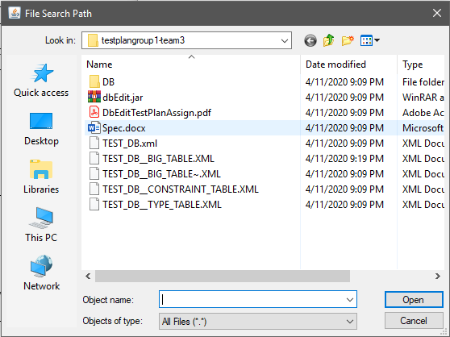 | COMMENTS  If the ‘File Search Path’ window appears, this test PASSES.  In any other case, this test FAILS.
STEP  2 | OPERATOR ACTION  Select the file named “TEST_DB.xml”. | PURPOSE  Open a file that is a database description. |  |  | EXPECTED RESULTS  A description table containing one column titled, “Table Name” and three rows,  “BIG_TABLE”, “CONSTRAINT_TABLE”, and  “TYPE_TABLE” appears.  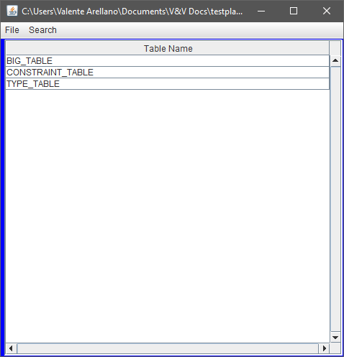 | COMMENTS  If the described table appears, this test PASSES.  In any other case, this test FAILS.
Concluding Remarks:
Testing Team: |  |  | Date Completed:

Test Schedule
The test schedule for this system is to be determined at a later date.

Task and date | People | Description

Other Sections

Staffing and Training Needs
The individual performing these tests must be familiar with basic computer operations.

Environmental Requirements
A computer is required to run the system being tested. The computer must connect to an internet network to retrieve the program files. Once the needed files are downloaded to the computer, an internet connection is no longer necessary. For clarification, the system being tested does not require an internet connection to run.

Software Requirements
The computer used for testing must have Java installed in order to run the DBEdit jar file.

Appendix
!

