DB Edit

Test plan

Version <3.0>

April 22, 2020

Document Control

Approval

The Guidance Team and the customer shall approve this document.

Document Change Control

|  |  |
| --- | --- |
| Initial Release: | 1.0 |
| Current Release: | 3.0 |
| Indicator of Last Page in Document: | ***Last Page*** |
| Date of Last Review: | 4/22/20 |
| Date of Next Review: | 4/24/20 |
| Target Date for Next Update: | TBD |

Distribution List

This following list of people shall receive a copy of this document every time a new version of this document becomes available:

Guidance Team Members: Dr. Roach

Customer: N/A

Software Team Members:

Producer: Bianca De La Cruz

Reviewers: Javier Soon, and Aaron Himan

Change Summary

The following table details changes made between versions of this document

|  |  |  |  |
| --- | --- | --- | --- |
| Version | Date | Modifier | Description |
| 1.0 | 04/01/2020 | Bianca De La Cruz | Added potential test cases and filled out some sections with relevant information. I used a testing tool called ‘TestComplete’. |
| 2.0 | 04/15/2020 | Bianca De La Cruz | Changed test plan. Completed all test cases and thoroughly completed each section. Addressed all comments from version 1. |
| 3.0 | 04/22/2020 | Bianca De La Cruz | Enhanced some formatting aspects of the document. Fixed the footer section and page numbering. Addressed all comments from version 2. |

Note: The template presented in this document was taken from:

Donaldson, S., and S. Siegel, *Successful Software Development*. Upper Saddle River, NJ: Prentice Hall, 2001, pp. 321-323.

Note: The template presented in this document was taken from: Donaldson, S., and S. Siegel, *Successful Software Development*. Upper Saddle River, NJ: Prentice Hall, 2001, pp. 321-323 and modified by Humberto Mendoza and Steve Roach.

Supplementary information is from:

Pfleeger, S. *Software Engineering, Theory and Practice*. Upper Saddle River, NJ: Prentice Hall, 1998, p. 365.

Table of Contents

Document Control ii

Approval ii

Document Change Control ii

Distribution List ii

Change Summary ii

1. Introduction 1

1.1. Purpose 1

1.2. Scope 1

1.3. System Overview 1

1.4. Suspension and Exit Criteria 1

1.5. Document Overview 1

1.6. References 1

2. Test Items and Features 2

2.1. Test Items 2

2.2. Test Features 2

2.2.1. Data Base Edit Window 2

2.2.2. Data Table Display Window 2

3. Testing Approach 3

4. Group 1 Team 9 Test Cases 4

4.1. Test 1: File>Open 4

4.2. Test 2: File>Exit 5

4.3. Test 3: Search>Find Files 7

4.4. Test 4: File>Save 8

4.5. Test 5: File>Print To Fit 10

5. User Interface Testing 12

6. Test Schedule 13

7. Other Sections 14

8. Appendix 15

8.1. Database Edit Window: File>Open 15

8.1.1. File>Open Action 15

8.1.2. Select .xml file to open 15

8.2. Data Table Display Window: File>Exit 16

8.2.1. Table Name 16

8.2.2. Column FIELD_SMALL_INT item ‘0’ 16

8.2.3. Column FIELD_SMALL_INT replace ‘0’ item with ‘20’ 16

8.2.4. File>Exit 17

8.2.5. ‘Save?’ Window 17

8.3. Database Edit Window: Search>Find Files 17

8.3.1. Search>Find Files Selection 17

8.3.2. TTC Search for XML Files Window 17

8.3.3. Search For “TEST_DB” & Results 18

8.4. Data Table Display Window: File>Save 18

8.4.1. ‘XML History Input” Window 18

8.4.2. ‘XML History Input” set information Window 18

8.4.3. ‘File Write” Window 18

8.5. Data Table Display Window: File> Print To Fit 19

8.5.1. File>Print To Fit Action 19

8.5.2. 1st print: Second half of the table 19

8.5.3. 2nd print: first half of the table 19

8.5.4. ‘Print’ Window 21

# Introduction

The system code to be tested is a simple database table editor. This test plan is a CS 5387 Software Integration and V&V assignment. It will focus on file menu operations excluding compare file to other version, check for duplicate rows, and filter. This includes the search menu option on the database window.

## Purpose

The project is a simple database table editor. The purpose of this test plan is to cover a small portion of black box testing. This document contains an introduction of the test plan, test items and features, testing approach, test cases, and an appendix. This test plan follows more closely a system test plan that describes the system from the customer’s point of view

## Scope

The database table editor is the only software release/version provided that will be encompassed by this plan.

## System Overview

The code is a simple database table editor. This test plan will focus on some of the file menu operations excluding compare file to other version, check for duplicate rows, and filter. This includes the search menu option on the database window.

## Suspension and Exit Criteria

All the tests will be executed. Testing will stop when 5/5 tests are run.

## Document Overview

The remainder of the document will show References, Test Item and Features, Testing Approach and Tests.

## References

1. DbEditTestPlanAssign.pdf
2. TestPlanAssign040120.pptx
3. Spec.docx
4. GitHub: <https://github.com/CS5387/testplangroup1-team-9>

# Test Items and Features

This section describes test items and features.

## Test Items

Test items can be found in the following repository on GitHub: <https://github.com/CS5387/testplangroup1-team-9>

1. dbEdit.jar: The jar file to run the database editing tool.
2. TEST_DB__BIG_TABLE
3. TEST_DB__CONSTRAINT_TABLE.XML
4. TEST_DB__TYPE_TABLE.XML
5. TEST_DB.xml

## Test Features

This test plan will focus on some of the file menu operations excluding compare file to other version, check for duplicate rows, and filter. This includes the search menu option on the database window.

### Data Base Edit Window

**File (Menu):** “File has the options to open, close, and print tables.”

* Open: “A user can open either a database description file or a data file”

**Search (Menu):**

* Find Files: “Search opens a file search dialog that allows a user to search specified directories for files that contain a given text string. When using this option, files containing the text string are listed. Selecting the file from the display will open the database table.”

### Data Table Display Window

**File (Menu)**

* Save: “On file save, the user is prompted to enter a new history entry.”
* Print to Fit: Print Tables
* Exit: “If the file has been modified and the user attempts to close the file, a save prompt should be displayed.”

# Testing Approach

The approach taken for this test plan is a user guided one that compares an expected input with an output. Tests designed to exercise sequences of functions in the interface.

Table 1: Test Plan

|  |  |  |
| --- | --- | --- |
| **TEST SUITE Group 1 Team 9** | | |
| **Description of Test Suite** | **The test will encompass tests that ensure the functionality of the File/Search menus in “Data Base Editor” window and the File menu in “Data Table Display.”** | |
| **Test Case Identifier** | **Objective** | **Criticality** |
| 1 | **File>Open** | **High** |
| 2 | **File>Exit** | **High** |
| 3 | **Search>Find Files** | **Medium** |
| 4 | **File>Save** | **High** |
| 5 | **File>Print To Fit** | **Medium** |

*Medium: The system needs it but it won’t affect other functions

*High: The system needs it and it can affect other functions without it.

# Group 1 Team 9 Test Cases

This sections documents the test case to be applied on the database editing tool. Group 1 Team 9 focuses on a set of test cases described on section 1.3 System Overview.

## Test 1: File>Open

**Objective:** The objective of Test 1 is to ensure that when the user clicks File>Open from the Database Edit Window, “A user can open either a database description file or a data file.”

**Notes:** The user will be required to have the .xml file they wish to open in their file system. Then, the user shall execute ‘dbEdit.jar’ and click ‘File>Open’. The user will then browse for an .xml file to open and select it and click open.

|  |  |  |  |  |  |  |
| --- | --- | --- | --- | --- | --- | --- |
| Test No.: 1 | | | | Current Status: Pending | | |
| Test title: File> Open | | | | | | |
| Testing approach:  First the user will need to clone the following data base to access the relevant files; <https://github.com/CS5387/testplangroup1-team-9.git>  In the folder you will find the file dbEdit.jar. Run this file.  In the folder you will find the files listed in section 2.1 under Test Items. They will be referenced in the steps below. | | | | | | |
| STEP | OPERATOR ACTION | PURPOSE | | | EXEPCTED RESULTS | COMMENTS |
|  | In the Database Edit Window Click File>Open.  Reference Appendix section 8.1.1 to view action. | This step is to open the file system in your computer to select a file. | | | This step will open the file system in your computer to select a file.  Reference Appendix 8.1.2 to view expected results. | None. |
|  | Select an .xml file to open: For this example open TEST_DB.xml. | This step is to select and open a file. | | | This step will display the Database Edit Window with Table Names.  Reference Appendix 8.2.1 to view expected results. | None. |
| Concluding Remarks: | | | | | | |
| Testing Team: | | | Date Completed: | | | |

## Test 2: File>Exit

**Objective:**

The objective of Test 2 is to ensure that when the user clicks File>Exit from the Data Table Display Window, “If the file has been modified and the user attempts to close the file, a save prompt should be displayed.”

**Notes:**

The user will be required to have the provided .xml files. Then, the user shall execute ‘dbEdit.jar’ and click ‘File>Open’ to browse for an ‘.xml’ file, select it and open. Finally, the user shall create one modification and click File>Exit without savings first.

|  |  |  |  |  |  |  |
| --- | --- | --- | --- | --- | --- | --- |
| Test No.: 2 | | | | Current Status: Pending | | |
| Test title: File > Exit | | | | | | |
| Testing approach:  First the user will need to clone the following data base to access the relevant files; <https://github.com/CS5387/testplangroup1-team-9.git>  In the folder you will find the file dbEdit.jar. Run this file.  In the folder you will find the files listed in section 2.1 under Test Items. They will be referenced in the steps below. | | | | | | |
| STEP | OPERATOR ACTION | PURPOSE | | | EXEPCTED RESULTS | COMMENTS |
|  | In the Database Edit Window Click File>Open.  Reference Appendix section 8.1.1 to view action. | This step is to open the file system in your computer to select a file. | | | This step will open the file system in your computer to select a file.  Reference Appendix 8.1.2 to view expected results. | None. |
|  | Select an .xml file to open: For this example open TEST_DB.xml. | This step is to select and open a file. | | | This step will display the Database Edit Window with Table Names.  Reference Appendix 8.2.1 to view expected results. | None. |
|  | Double click TYPE_TABLE. | This will select a table. | | | This step will open the TYPE_TABLE Data Table Display Window.  Reference Appendix 8.2.2 to views expected results. | None. |
|  | Under the column ‘FIELD_SMALLINT’ click on the filter section (grayed out) and search for the item ‘0’ by entering 0 and then pressing enter. Double click it and replace it with the integer ’20’ then press enter. Do not save the changes. | This step is to create a change in the table TYPE_TABLE | | | Item ‘0’ will now display ’20.’  Reference Appendix 8.2.2 and 8.2.3 to view expected results. | None. |
|  | Click File>Exit or the red ‘x’ button.  Reference Appendix 8.2.4 to view action. | This is to attempt to close the program. | | | This will prompt a window to ‘save changes, Return to Editor or Close without saving’.  Reference Appendix 8.2.5 to view expected results. | None |
| Concluding Remarks: | | | | | | |
| Testing Team: | | | Date Completed: | | | |

## Test 3: Search>Find Files

Objective: The objective of Test 3 is to ensure that when the user clicks Search>Find Files from the Database Edit Window, “Search opens a file search dialog that allows a user to search specified directories for files that contain a given text string. When using this option, files containing the text string are listed. Selecting the file from the display will open the database table.”

Notes:

The user will be required to have the provided .xml files. Then, the user shall execute dbEdit.jar and click Search>Find Files to browse for an .xml file, select it and open.

|  |  |  |  |  |  |  |
| --- | --- | --- | --- | --- | --- | --- |
| Test No.: 3 | | | | Current Status: Pending | | |
| Test title: Search > Find Files | | | | | | |
| Testing approach:  First the user will need to clone the following data base to access the relevant files; <https://github.com/CS5387/testplangroup1-team-9.git>  In the folder you will find the file dbEdit.jar. Run this file.  In the folder you will find the files listed in section 2.1 under Test Items. They will be references in the steps below. | | | | | | |
| STEP | OPERATOR ACTION | PURPOSE | | | EXEPCTED RESULTS | COMMENTS |
|  | In the Database Edit Window Click Search>Find Files.  Reference Appendix 8.3.1 to view action. | This step is to open the Find Files Window. | | | This step will open the ‘TTC Search For XML Files’ window.  Reference Appendix 8.3.2 to view expected results. | None. |
|  | In the ‘Search For’ entry, enter “TEST_DB” and press enter. | This step is to search for .xml files. | | | This step will display 4 file paths in column ‘A.’  Reference Appendix 8.3.3 to view expected results. | None. |
| Concluding Remarks: | | | | | | |
| Testing Team: | | | Date Completed: | | | |

## Test 4: File>Save

Objective: The objective of Test 4 is to ensure that when the user clicks File>Save from the Data table Edit Window, “On file save, the user is prompted to enter a new history entry.”

Notes:

The user will be required to have the provided .xml files. Then, the user shall execute ‘dbEdit.jar’ and click ‘File>Open’ to browse for an .xml file, select it and open. Finally, the user shall create one modification and click ‘File>Save’.

|  |  |  |  |  |  |  |
| --- | --- | --- | --- | --- | --- | --- |
| Test No.: 4 | | | | Current Status: Pending | | |
| Test title: File>Save | | | | | | |
| Testing approach:  First the user will need to clone the following data base to access the relevant files; <https://github.com/CS5387/testplangroup1-team-9.git>  In the folder you will find the file dbEdit.jar. Run this file.  In the folder you will find the files listed in section 2.1 under Test Items. They will be references in the steps below. | | | | | | |
| STEP | OPERATOR ACTION | PURPOSE | | | EXEPCTED RESULTS | COMMENTS |
|  | In the Database Edit Window Click File>Open. | This step is to open the file system in your computer to select a file. | | | This step will open the file system in your computer to select a file.  Reference Appendix 8.1.2to view expected results. | None. |
|  | Select an .xml file to open: For this example open “TEST_DB.xml.” | This step is to select and open a file. | | | This step will display the Database Edit Window with Table Names.  Reference Appendix 8.2.1 to view expected results. | None. |
|  | Double click TYPE_TABLE. | This is to select a table. | | | This step will open the TYPE_TABLE Data Table Display Window.  Reference Appendix 8.2.2 to views expected results. | None. |
|  | Under the column ‘FIELD_SMALLINT’ click on the filter section (grayed out) and search for the item ‘0’ by entering 0 and then pressing enter. Double click it and replace it with the integer ’20’ then press enter. | This step created a change in the table TYPE_TABLE | | | Item ‘0’ will now display ’20.’  Reference Appendix 8.2.2 and 8.2.3 to view expected results. | None. |
|  | In Data Table Edit Window Click File>Save | This step is to save the file. | | | ‘XML History Input’ pop up window will be displayed.  Reference Appendix 8.4.1 to view expected results. | None |
|  | Enter a Name and Description then click Save.  Reference Appendix 8.4.2 to view action. | This step is to input required information. | | | This will prompt a pop up box that will display that the file was saved.  Reference Appendix 8.4.3 to view expected results. | You can Check if the file was saved in the file system.  Change the value 20 back to 0 following similar steps in step 4 after you are done with test. |
| Concluding Remarks: | | | | | | |
| Testing Team: | | | Date Completed: | | | |

## Test 5: File>Print To Fit

Objective: The objective of Test 5 is to ensure that when the user clicks File>Print to Fit from the Data Table Edit Window, the table prints.

Notes: The user will be required to have the provided .xml files. Then, the user shall execute ‘dbEdit.jar’ and click ‘File>Open’ to browse for an .xml file, select it and open it. The user will double click on the TYPE_TABLE. Finally, the user shall click File> Print to Fit and print the table.

|  |  |  |  |  |  |  |
| --- | --- | --- | --- | --- | --- | --- |
| Test No.: 5 | | | | Current Status: Pending | | |
| Test title: File>Print To Fit | | | | | | |
| Testing approach:  First the user will need to clone the following data base to access the relevant files; <https://github.com/CS5387/testplangroup1-team-9.git>  In the folder you will find the file dbEdit.jar. Run this file.  In the folder you will find the files listed in section 2.1 under Test Items. They will be references in the steps below.  For this test you will also need to have access to a printer and connect it to your computer. | | | | | | |
| STEP | OPERATOR ACTION | PURPOSE | | | EXEPCTED RESULTS | COMMENTS |
|  | In the Database Edit Window Click File>Open. | This step will open the file system in your computer to select a file. | | | This step will open the file system in your computer to select a file.  Reference Appendix 8.1.2to view expected results. | None. |
|  | Select an .xml file to open: For this example open TEST_DB.xml. | This step will select open a file. | | | This step will display the Database Edit Window with Table Names.  Reference Appendix 8.2.1 to view expected results. | None. |
|  | Double click TYPE_TABLE. | This is to select a table. | | | This step will open the TYPE_TABLE Data Table Display Window.  Reference Appendix 8.2.2 to view expected results. | None. |
|  | In the Data Table Edit Window click File > Print To Fit  Reference Appendix 8.5.1 to view expected results. | This is to open the print window. | | | This step will open the ‘Print’ Display Window.  Reference Appendix 8.5.4 to view expected results. | Make sure to enter the name of the corresponding printer. |
|  | Click Print | This is to print. | | | This step will prompt your printer to start printing. The print out will print the second half of the table first and then the first half without the header columns.  Reference Appendix 8.5.2 and 8.5.3 to view expected results. | None |
| Concluding Remarks: | | | | | | |
| Testing Team: | | | Date Completed: | | | |

# User Interface Testing

This section is not applicable for this test plan.

# Test Schedule

This section is to be determined and at the moment it’s not applicable because the outcomes will not be recorded by the reviewers. In the future, however, this section will specify the schedule for testing activities. A table with the order and completion dates of the tests is useful. The table below might be useful.

|  |  |  |
| --- | --- | --- |
| **Task and date** | **People** | **Description** |
| TBD | TBD | TBD |

# Other Sections

Other sections that may appear in a test plan (but not required for this course) are:

* Test Management Requirements: how testing is to be managed; a delineation of responsibilities of each project organization involved with testing
* Staffing and training needs: delineate the responsibilities of those individuals who are to perform the testing, level of skill required, and training to be provided
* Environmental Requirements: describe the hardware (including communication and network equipment) needed to support testing; describe configuration of hardware components on which software and database to be tested are to operate.
* Software Requirements: describe the software needed to support testing; include the software code and databases that are object of the testing. Also include software tools such as compilers, CASE instruments and simulators that are needed to model the user’s operational environment.
* Risk and contingencies
* Cost: include an estimate of costs.
* Approvals
* Test Deliverables

# Appendix

This section will include images, tables or other supporting material for this test plan.

## Database Edit Window: File>Open

### File>Open Action

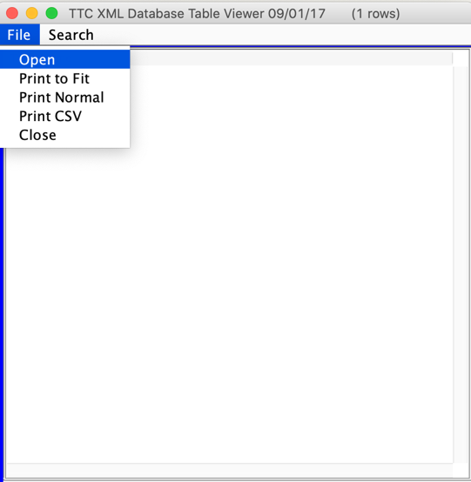

### Select .xml file to open

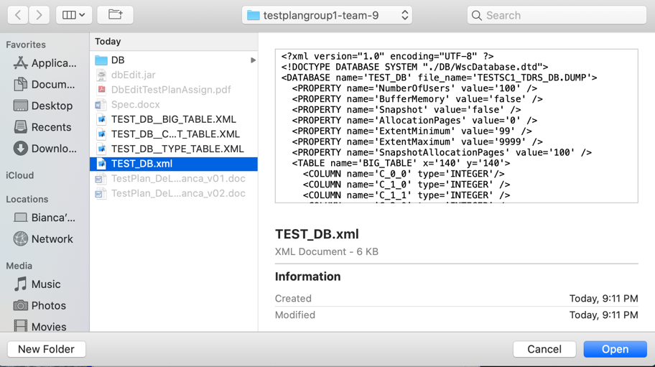

## Data Table Display Window: File>Exit

### Table Name

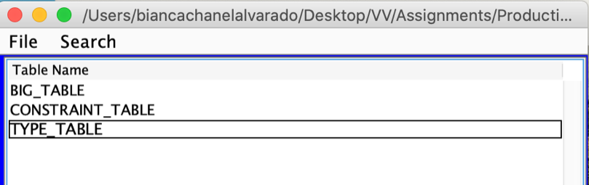

### Column FIELD_SMALL_INT item ‘0’

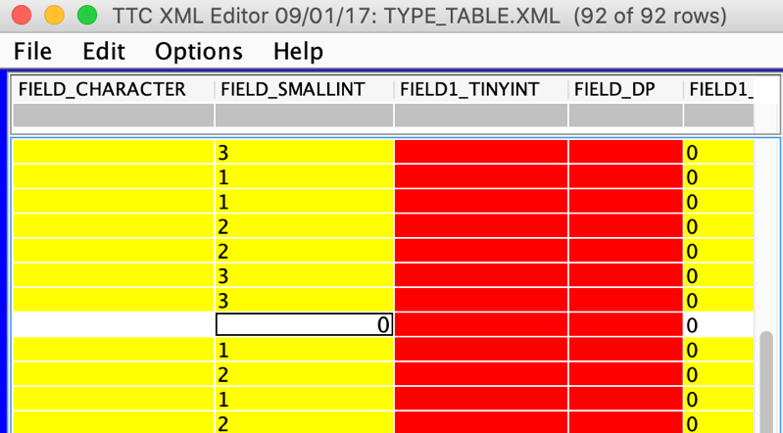

### Column FIELD_SMALL_INT replace ‘0’ item with ‘20’

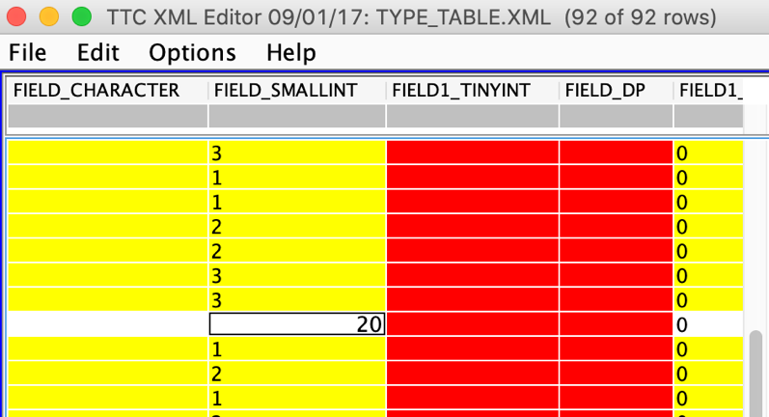

### File>Exit

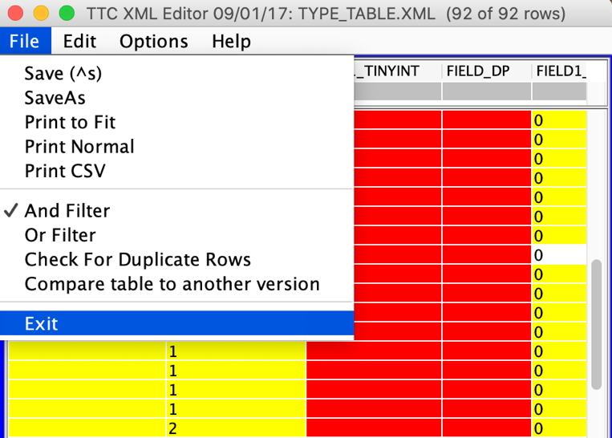

### ‘Save?’ Window

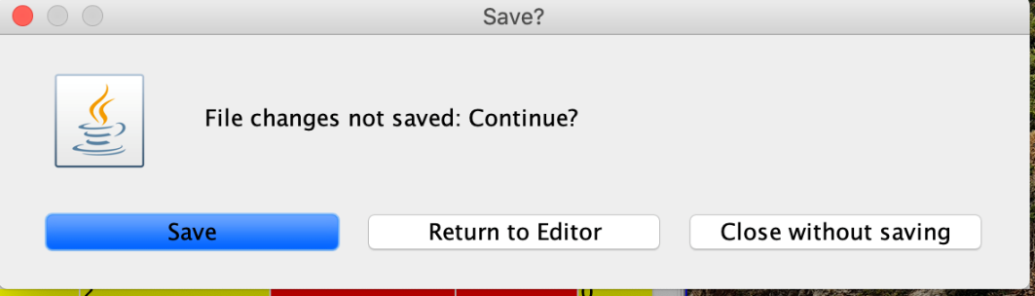

## Database Edit Window: Search>Find Files

### Search>Find Files Selection

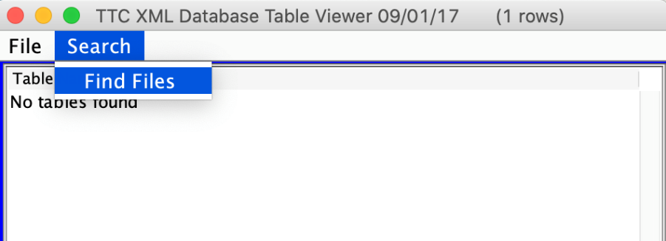

### TTC Search for XML Files Window

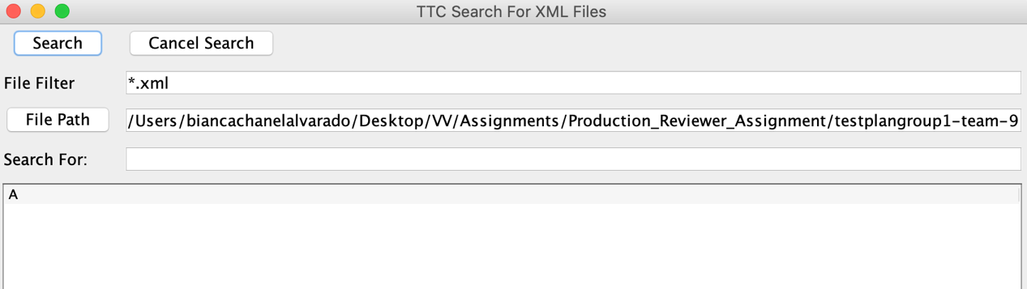

### Search For “TEST_DB” & Results

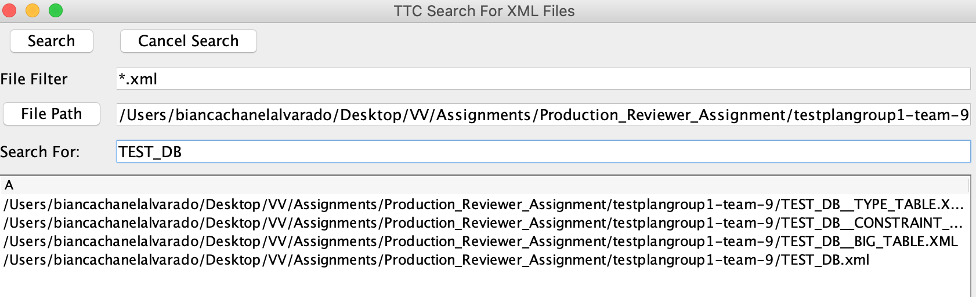

## Data Table Display Window: File>Save

### ‘XML History Input” Window

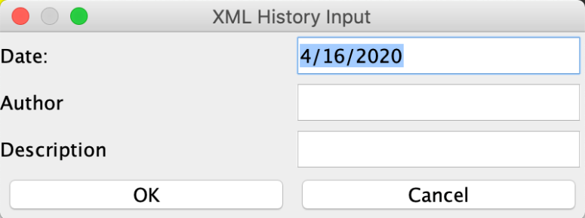

### ‘XML History Input” set information Window

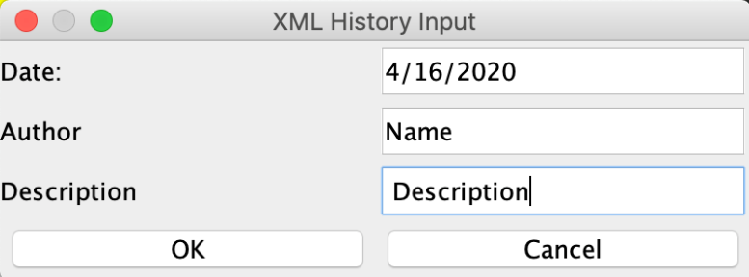

### ‘File Write” Window



## Data Table Display Window: File> Print To Fit

### File>Print To Fit Action

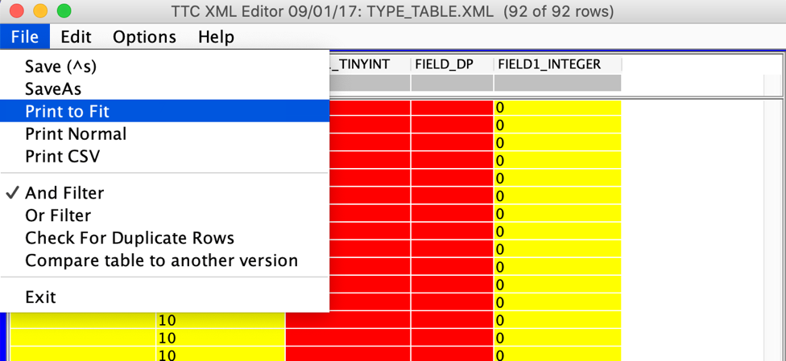

### 1st print: Second half of the table

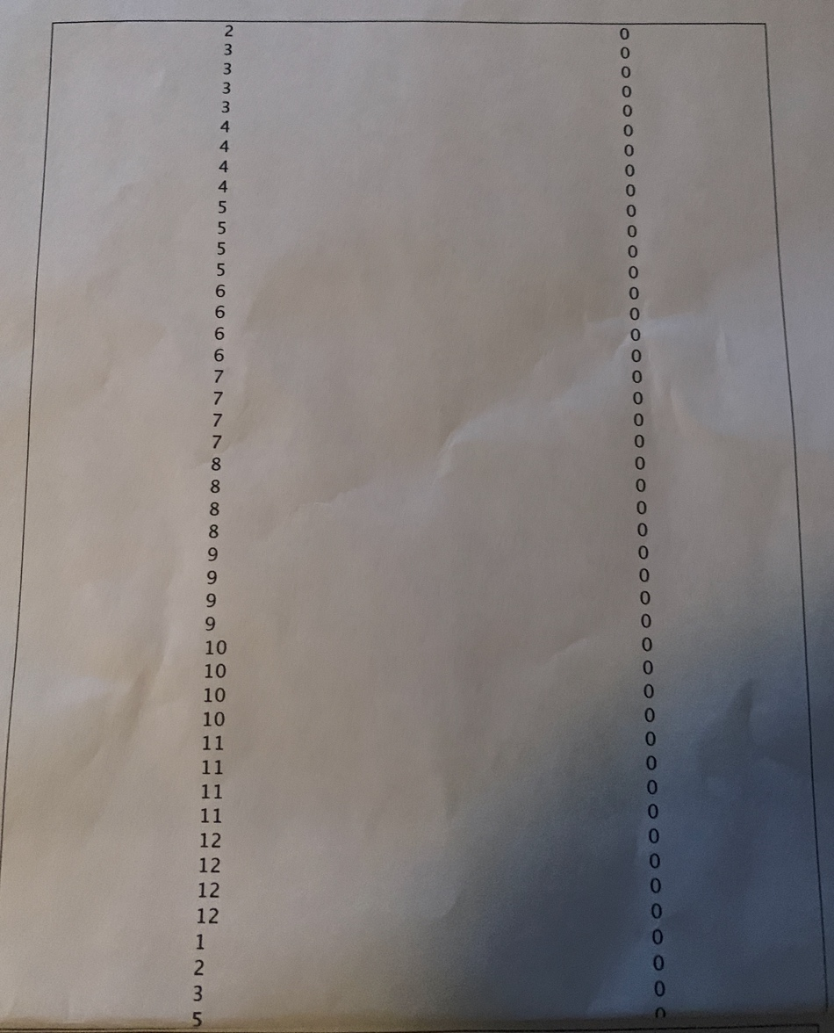

### 2nd print: first half of the table

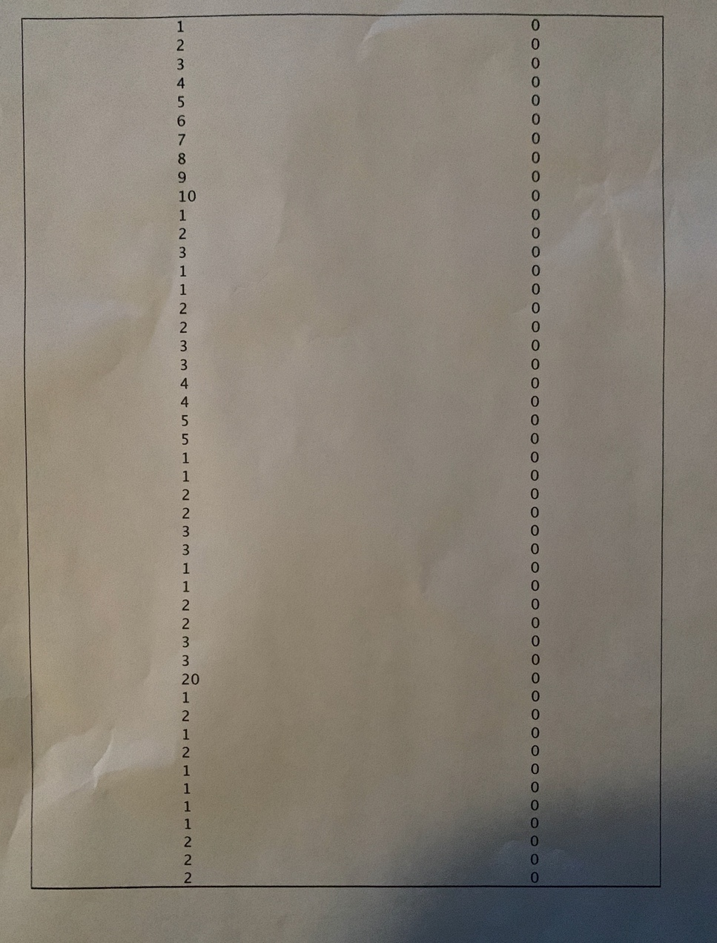

### ‘Print’ Window

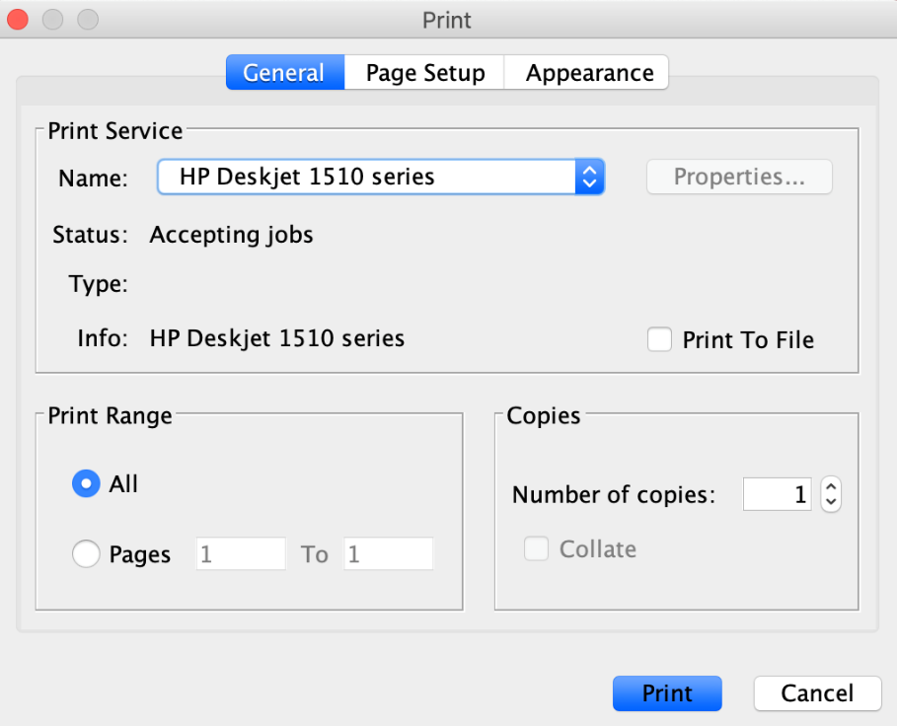

***Last Page***