Database Editor
Test plan
Version 3.0
April 24, 2020
Document Control
Approval
The Guidance Team and the customer shall approve this document.
Document Change Control
Initial Release: | 1.0
Current Release: | 3.0
Indicator of Last Page in Document: | $
Date of Last Review: | 04/21/2020
Date of Next Review: | 04/24/2020
Target Date for Next Update: | 04/24/2020
Distribution List
This following list of people shall receive a copy of this document every time a new version of this document becomes available:
Guidance Team Members:
Dr. Steven Roach
Reviewer:
Ivan Gastelum
Diego A. Rivera
Producer:
Dima AbdelJaber
Change Summary
The following table details changes made between versions of this document

Version | Date | Modifier | Description
1.0 | 04/13/2020 | Dima AbdelJaber | Completed version 1.0 of test plan
1.0 | 04/15/2020 | Diego Rivera | Completed 1st review
1.0 | 04/16/2020 | Ivan Gastelum | Completed 1st review
2.0 | 04/17/2020 | Dima AbdelJaber | Completed version 2.0 of test plan
2.0 | 04/21/2020 | Ivan Gastelum | Completed 2nd review
3.0 | 04/24/2020 | Dima AbdelJaber | Completed version 3.0 test plan

Note: The template presented in this document was taken from:
Donaldson, S., and S. Siegel, Successful Software Development. Upper Saddle River, NJ: Prentice Hall, 2001, pp. 321-323.

Note: The template presented in this document was taken from: Donaldson, S., and S. Siegel, Successful Software Development. Upper Saddle River, NJ: Prentice Hall, 2001, pp. 321-323 and modified by Humberto Mendoza and Steve Roach.

Supplementary information is from:
Pfleeger, S. Software Engineering, Theory and Practice. Upper Saddle River, NJ: Prentice Hall, 1998, p. 365.

Table of Contents
Document Control ii
Approval ii
Document Change Control ii
Distribution List ii
Change Summary ii
1. Introduction 4
1.1. Purpose 4
1.2. Scope 4
1.3. System Overview 4
1.4. Suspension and Exit Criteria 4
1.5. Document Overview 4
1.6. References 4
2. Test Items and Features 5
3. Testing Approach 6
4. Test Cases 7
4.1. Test TC1 7
4.2. Test TC2 2
4.3. Test TC3 3
4.4. Test TC4 4
4.5. Test TC5 2
4.6. Test TC6 3
4.7. Test TC7 4
4.8. Test TC8 5
4.9. Test TC9 5
5. Test Schedule 7
6. Appendix 8
6.1. GitHub Repository 8

Introduction
The following section will provide detailed information pertaining to the testing of the system.

Purpose
The purpose of the test plan is to provide documentation regarding the testing of the system. A test plan shows the testing items and features, the testing approach, and it addresses any issues within the system that are to be fixed in accordance to their criticality. The purpose of this test plan is to document all testing strategies and details for the DbEdit system.

Scope
The software version is the current version provided by Dr. Roach. This test plan targets the current versions of the software. The functionalities tested are Save, Save As, Print to Fit, Print Normal, Print CSV, Exit, Close, Open, and Find Files. No other functionality will be included.

System Overview
The system consists of a simple database table editor. The following are the functions that will be tested.
- Save
- Save As
- Print to Fit
- Print Normal
- Print CSV
- Exit
- Close
- Open
- Find Files

Suspension and Exit Criteria
The testing of the system will be done based on the described approaches in section 3. If a high criticality test fails, the testing will be suspended until corrections are made to the source code. If the overall test success rate is below 80% testing will be suspended until issues are corrected. For the testing phase to exit, all the test with a criticality level of high must pass the testing, as well as at least an overall success rate of 90%.

Document Overview
This test plan will be broken into five sections. The following is the document overview.
- Section 1 is used to introduce the test plan and the system.
- Section 2 is used to describe test items and features.
- Section 3 is used to layout the types of tests to be performed, the objectives of the test, and the type of criticality.
- Section 4 is used to layout specific test cases by documenting test input, specific test procedures, and outcomes.
- Section 5 is used to keep track of test schedule.
- Section 6 is used for all extra information.

References
[1] S. Roach, DBEdit. University of Texas at El Paso: 2020
[2] S. Roach, Spec. University of Texas at El Paso: 2020

Test Items and Features
The following information within the table will provide information pertaining to the test items/features that will be focused on when the system will be tested, as well provide a description of the item or feature.
Table 1: Test Items and Features
Test Case ID | Item/Feature | Item/Feature Description
TC1 | Save | Save the current table.
TC2 | Save As | Save the current table as another file extension.
TC3 | Print to Fit | Print the table to fit.
TC4 | Print Normal | Print the table with normal settings.
TC5 | Print CSV | Exports the table as a CSV file.
TC6 | Exit | Exit Table.
TC7 | Close | Close Table.
TC8 | Open | Open Table.
TC9 | Find Files | Enter file filter, file path and search for a string.

Testing Approach
The following Section will provide information concerning the approach that will be used to test the application. The table below provides grouped test suites that were created. Criticality will be defined by the degree of impact that defects within the test case will have on the overall system.

Table 2: Test Plan
TEST SUITE <DbEdit>
Description of Test Suite | This test suite contains 9 test cases to test the DbEdit system.
Test Case Identifier | Objective | Criticality
TC1 | Save | Normal
TC2 | Save As | High
TC3 | Print to Fit | Normal
TC4 | Print Normal | High
TC5 | Print CSV | High
TC6 | Exit | High
TC7 | Close | Normal
TC8 | Open | High
TC9 | Find Files | Normal

Test Cases
The following section gives detailed descriptions of how to test each test case.

Test TC1
Objective: Save

Table 3: Test TC1
Test No.: TC1 |  |  |  | Current Status: Pending
Test title: Save

Testing approach: To achieve this test, you need the dbEdit.jar application and the ‘TEST_DB_TYPE_TABLE’ table to work with.
STEP  1  2  3  4  5  6  7 | OPERATOR ACTION  Open DbEdit.jar  Go to File > Open, then select table you want to work on (one of the given options chosen for this test was ‘TEST_DB_TYPE_TABLE’)  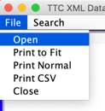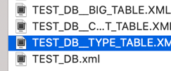  Add “3” to row 1 column 1.  When you would like to save, Click on File > save  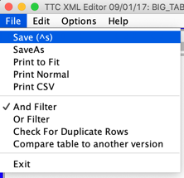  Enter Date, Author, and Description, then click OK  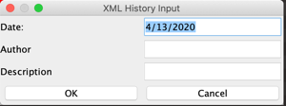  Click OK on the File saved message.  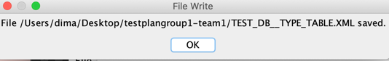  Open the saved ‘TEST_DB_TYPE_TABLE’ table to check it was saved | PURPOSE  Open Software  Open table to work with  Edit the table  Find Save Button  Enter your information to be saved with the table  Receive saved message  Verify table is saved. |  |  | EXEPCTED RESULTS  The Software opens  The Table opens  ‘3’ is added  History input window opens  Table saves with history inputs  Table Saved.  Table is saved | COMMENTS
Concluding Remarks:
Testing Team: |  |  | Date Completed:

Test TC2
Objective: Save As

Table 4: Test TC2
Test No.: TC2 |  |  |  | Current Status: Pending
Test title: Save As

Testing approach: To achieve this test, you need the dbEdit.jar application and the ‘TEST_DB_TYPE_TABLE’ table to work with.
STEP  1  2  3  4  5  6  7  8 | OPERATOR ACTION  Open dbEdit.jar  Go to File > Open, then select table you want to work on (one of the given options chosen for this test was ‘TEST_DB_TYPE_TABLE’)  Add “3” to row 1 column 1.  When you would like to save in a specific location, Click on File > save As  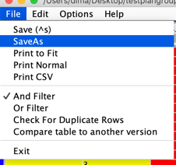  Select directory you would like the table saved in and save as a specific name you choose then click save.  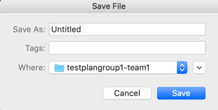  Enter Date, Author, and Description, then click OK  Click OK on the File saved message.  Open the saved ‘TEST_DB_TYPE_TABLE’ table to check it was saved | PURPOSE  Open Software  Open table to work with  Edit the table  Find Save As Button  Save as in your preferred location  Enter your information to be saved with the table  Receive saved message  Verify table is saved. |  |  | EXEPCTED RESULTS  The Software opens  The Table opens  “3” is added  Opens a save file pop up to select directory  Table saved in desired directory  Table saves with history inputs  Table Saved  Table is Saved | COMMENTS
Concluding Remarks:
Testing Team: |  |  | Date Completed:

Test TC3
Objective: Print to Fit

Table 5: Test TC3

Test No.: TC3 |  |  |  | Current Status: Pending
Test title: Print to Fit

Testing approach: To achieve this test, you need the dbEdit.jar application and the ‘TEST_DB_TYPE_TABLE’ table to work with.
STEP  1  2  3  4  5 | OPERATOR ACTION  Open dbEdit.jar  Go to File > Open, then select table you want to work on (one of the given options chosen for this test was ‘TEST_DB_TYPE_TABLE’)  When you would like to print, Click on File > Print to Fit  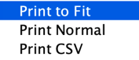  Select print service name and click Print  Verify the table printed to fit by checking that the table modified the size to fit the page | PURPOSE  Open Software  Open table to work with  Find Print to Fit Button  Test print to fit functionality  Verify passed |  |  | EXEPCTED RESULTS  The Software opens  The Table opens  Open print methods pop up window  Table is sent to print  Table is modified to fit | COMMENTS
Concluding Remarks:
Testing Team: |  |  | Date Completed:

Test TC4
Objective: Print Normal

Table 6: Test TC4

Test No.: TC4 |  |  |  | Current Status: Pending
Test title: Print Normal

Testing approach: To achieve this test, you need the dbEdit.jar application and the ‘TEST_DB_TYPE_TABLE’ table to work with.
STEP  1  2  3  4  5 | OPERATOR ACTION  Open dbEdit.jar  Go to File > Open, then select table you want to work on (one of the given options chosen for this test was ‘TEST_DB_TYPE_TABLE’)  When you would like to print, Click on File > Print Normal  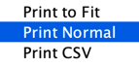  Select print service name and click Print  Verify the table printed normal by checking that the table was not modified to a different size to fit the page | PURPOSE  Open Software  Open table to work with  Find Print Normal Button  Test print normal functionality  Verify print normal passed |  |  | EXEPCTED RESULTS  The Software opens  The Table opens  Open print methods pop up window  Table is sent to print  Table is not modified | COMMENTS
Concluding Remarks:
Testing Team: |  |  | Date Completed:

Test TC5
Objective: Print CSV
Table 7: Test TC5
Test No.: TC5 |  |  |  | Current Status: Pending
Test title: Print CSV

Testing approach: To achieve this test, you need the dbEdit.jar application and the ‘TEST_DB_TYPE_TABLE’ table to work with.
STEP  1  2  3  4  5 | OPERATOR ACTION  Open dbEdit.jar  Go to File > Open, then select table you want to work on (one of the given options chosen for this test was ‘TEST_DB_TYPE_TABLE’)  When you would like to print, Click on File > Print CSV  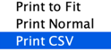  Click OK on CSV printed message  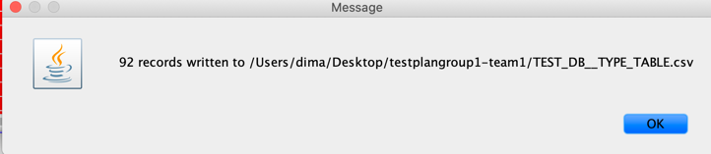  Verify a .csv file of your table existing  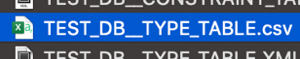 | PURPOSE  Open Software  Open table to work with  Find Print CSV Button  Close CSV message window  Verify .csv was exported |  |  | EXEPCTED RESULTS  The Software opens  The Table opens  Show csv printed message when clicked  Table is exported as .csv file  Show .csv file | COMMENTS
Concluding Remarks:
Testing Team: |  |  | Date Completed:

Test TC6

Objective: Exit

Table 8: Test TC6
Test No.: TC6 |  |  |  | Current Status: Pending
Test title: Exit
Testing approach: To achieve this test, you need the dbEdit.jar application and the ‘TEST_DB_TYPE_TABLE’ table to work with.
STEP  1  2  3 | OPERATOR ACTION  Open dbEdit.jar  Go to File > Open, then select table you want to work on (one of the given options chosen for this test was ‘TEST_DB_TYPE_TABLE’)  When you would like to Exit, Click on File > Exit  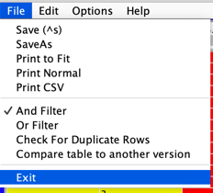 | PURPOSE  Open Software  Open table to work with  Find Exit button to exit |  |  | EXEPCTED RESULTS  The Software opens  The Table opens  Exit once clicked and return to previous window. All windows related to the table are closed and you can open other tables now in the main window. | COMMENTS
Concluding Remarks:
Testing Team: |  |  | Date Completed:

Test TC7
Objective: Close
Table 9: Test TC7
Test No.: TC7 |  |  |  | Current Status: Pending
Test title: Close

Testing approach: To achieve this test, you need the dbEdit.jar application.
STEP  1  2 | OPERATOR ACTION  Open dbEdit.jar  When you would like to Close, Click on File > Close  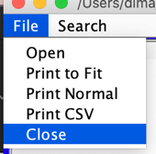 | PURPOSE  Open Software  Find Close button to close software |  |  | EXEPCTED RESULTS  The Software opens  Close software once clicked. All processes related to the application are terminated. | COMMENTS
Concluding Remarks:
Testing Team: |  |  | Date Completed:

Test TC8
Objective: Open

Table 10: Test TC8

Test No.: TC8 |  |  |  | Current Status: Pending
Test title: Open

Testing approach: To achieve this test, you need the dbEdit.jar application and the ‘TEST_DB_TYPE_TABLE’ table to open.
STEP  1  2  3 | OPERATOR ACTION  Open dbEdit.jar  Go to File > Open and click open  Select ‘TEST_DB_TYPE_TABLE’ table to open and click open | PURPOSE  Open Software  Test open button  Open table |  |  | EXEPCTED RESULTS  The Software opens  Receive a file directory to pick table to open from  Selected table opens  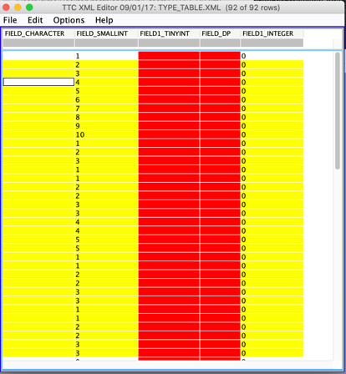 | COMMENTS
Concluding Remarks:
Testing Team: |  |  | Date Completed:

Test TC9
Objective: Find Files
Table 11: Test TC9

Test No.: TC9 |  |  |  | Current Status: Pending
Test title: Find Files
Testing approach: To achieve this test, you need the dbEdit.jar application and the ‘TEST_DB_TYPE_TABLE’ table to work with.
STEP  1  2  3  4 | OPERATOR ACTION  Open dbEdit.jar  Go to Search > Find Files and click Find Files  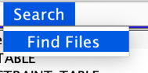  Specify file name to filter for it, file path, and what you are searching for, then click search.  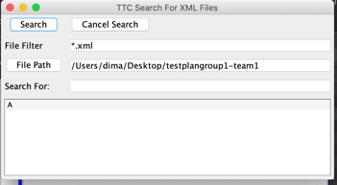  Right click on the file you want  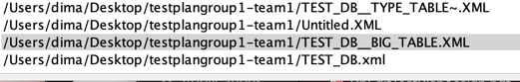 | PURPOSE  Open Software  Test Find Files Button  Search for specific file  Open searched table |  |  | EXEPCTED RESULTS  The Software opens  TTC Search For XML Files Window opens  Specified file will be displayed  Selected table opens to work with  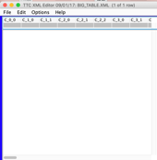 | COMMENTS
Concluding Remarks:
Testing Team: |  |  | Date Completed:

Test Schedule
The following displays the testing schedule.

Table 12: Test TC1
Task and date | People | Description
TC1 | TBD | Complete all testing and document it.
TC2 | TBD | Complete all testing and document it.
TC3 | TBD | Complete all testing and document it.
TC4 | TBD | Complete all testing and document it.
TC5 | TBD | Complete all testing and document it.
TC6 | TBD | Complete all testing and document it.
TC7 | TBD | Complete all testing and document it.
TC8 | TBD | Complete all testing and document it.
TC9 | TBD | Complete all testing and document it.

Appendix

GitHub Repository
All the files used (including the software and the tables used for testing) can be found on github.

https://github.com/CS5387/testplangroup1-team1

$

