Database Editor
Test Plan
Version 3.0
April 15, 2020
Document Control
Approval
The Guidance Team and the customer shall approve this document.
Document Change Control
Initial Release: | 1
Current Release: | 3
Indicator of Last Page in Document: | $$$
Date of Last Review: | 4-15-20
Date of Next Review: | 4-25-20
Target Date for Next Update: | 4-25-20
Distribution List
This following list of people shall receive a copy of this document every time a new version of this document becomes available:
Guidance Team Members: M Gabel Wright, Alan Uribe, Emmanuel Jacquez

Customer: Dr. Roach

Software Team Members: N/A
Change Summary
The following table details changes made between versions of this document

Version | Date | Modifier | Description
1 | 4-8 | MGW | Filled in sections 1-3
1 | 4-9 | MGW | Filled in section 4
2 | 4-15 | MGW | Made revisions based on feedback
3 | 4-21 | MGW | Made revisions based on feedback

Note: The template presented in this document was taken from:
Donaldson, S., and S. Siegel, Successful Software Development. Upper Saddle River, NJ: Prentice Hall, 2001, pp. 321-323.

Note: The template presented in this document was taken from: Donaldson, S., and S. Siegel, Successful Software Development. Upper Saddle River, NJ: Prentice Hall, 2001, pp. 321-323 and modified by Humberto Mendoza and Steve Roach.

Supplementary information is from:
Pfleeger, S. Software Engineering, Theory and Practice. Upper Saddle River, NJ: Prentice Hall, 1998, p. 365.

Table of Contents
Document Control ii
Approval ii
Document Change Control ii
Distribution List ii
Change Summary ii
1. Introduction 1
1.1. Purpose 1
1.2. Scope 1
1.3. System Overview 1
1.4. Suspension and Exit Criteria 1
1.5. Document Overview 1
1.6. References 1
2. Test Items and Features 2
3. Testing Approach 3
4. Test XX 4
4.1. Test 1 4
4.2. Test 2 4
4.3. Test 3 5
4.4. Test 4 6
4.5. Test 5 6
5. User Interface Testing 7
6. Test Schedule 8
7. Other Sections 9
8. Appendix 10

Introduction

The system to be tested is a database viewer/editor that stores simple databases (no relations allowed) as XML files. Each database consists of a set of XML files, one file that describes all of the tables within the database as well as one file per table that contains the actual data. The system allows for basic viewing and editing table data but does not allow for editing the database schema (creating new tables, adding new columns, etc).

Purpose
This document contains a unit test plan that targets a portion of the above-mentioned system.

Scope
This plan targets the current release of the dbEdit.jar program. The specific functionality to be tested includes the Find Files, Open, Save, Print, and Exit functions within the program. No other functionality will be included.

System Overview
The following are the functions that will be tested as well as a brief description of what the function should do:

- Find File- Searches the specified file path for a file matching the given criteria.
- Open- If the database description file is selected, the database is opened. If a table file is selected, the database is opened, and the table is opened in a new window.
- Save- Saves any changes made to a database table.
- Print- Prints the table in the specified format
- Exit/Close- Closes the specified window. If that window is the database view (shows all tables within the database), then all other windows are closed, and the program is exited.

Suspension and Exit Criteria
This test plan does not have any suspension criteria. Thus, all tests should be run. Testing will continue until all tests are passed.

Document Overview
This document describes how to carry out testing the above-mentioned features of the database program.

References
None

Test Items and Features
The following are the functions that will be tested as well as a brief description of what the function should do:

- Find File- Searches the specified file path for a file matching the given criteria.
- Open- If the database description file is selected, the database is opened. If a table file is selected, the database is opened, and the table is opened in a new window.
- Save- Saves any changes made to a database table.
- Print- Prints the table in the specified format
- Exit/Close- Closes the specified window. If that window is the database view (shows all tables within the database), then all other windows are closed, and the program is exited.

Features that are not included in this test are the filtering options, checking for duplicate rows, comparing to previous versions, editing, or the constraints options because they fall outside of the scope provided by the client, Dr. Roach.

Testing Approach

All of the following tests will be black box tests. The tester will be given a set of XML files that contain a database. The tester will need to open the provided database and carry out the given steps. After completion, the tester will need to inspect the files to verify if the test was passed or failed.

Table 1: Test Plan
TEST SUITE File Menu Options
Description of Test Suite
Test Case Identifier | Objective | Criticality
- Open | To test the functionality of opening both a database and a database table | High
- Find_File | To test the functionality of the Find File functionality to locate a file within the filepath | Low
- Save | To test the Save functionality. After a file is edited, it needs to write those changes properly to the proper file. | High
- Print | To test the print functionalities. Tables should be properly printed in the three specified formats | Medium
- Exit | Tests the exit/close functionality within the program to verify that the proper action is taken. | Medium

Test XX
This section outlines how to carry out each individual test as well as the purpose of each step/test.

Test 1

Objective: To test the open function within the program
Notes: This test will use folder Test_1. See Figure 1 in section 8 for example output.

Test No.: 1 |  |  |  | Current Status: Pending
Test title: Open

Testing approach: This is a high priority test. It will use the files in folder Test_1.
STEP | OPERATOR ACTION | PURPOSE |  |  | EXEPCTED RESULTS | COMMENTS
1 | Start the program under test. From the file menu, select open and select Test_1/database__table.xml. | To open a database by opening a table file. |  |  | The table described in the specified file should be opened in a new window. In the original window the database view should open.
2 | Repeat step 1 except use the file Test_1/database.xml instead. | To open a database by opening the database file. |  |  | The database described in the specified file should be opened in the window.
Concluding Remarks: The window from step 1 does not need to be closed before moving on to step 2. Multiple windows can be opened and operated at the same time.
Testing Team:  N/A |  |  | Date Completed: N/A

Test 2
Objective: To test the Find File function within the program
Notes: This test will use folder Test_1.

Test No.: 2 |  |  |  | Current Status: Pending
Test title: Find File

Testing approach: This is a low priority test because even if it does not work, there is an alternate way to open files/tables. It will use the files in folder Test_1. Before beginning this test, ensure that the program jar file is located in the root test directory.
STEP | OPERATOR ACTION | PURPOSE |  |  | EXEPCTED RESULTS | COMMENTS
1 | Start the program under test. Under the Search menu, select Find Files. In the dialog that opens, put database in the Search For field. Select Search. | Testing that that any file named database.xml in the specified file path is found and displayed. |  |  | The program should search the file path and display any file named database.xml located in the file path is displayed in the bottom window. | The file path field should prepopulate with the file path to the running jar file. If it does not, click File Path and select the proper file path.
2 | Repeat step 1 except for File Path select the directory one level higher than the root directory. | Testing that the same file can be found from a higher folder level |  |  | The database described in the specified file should be opened in the window.
3 | Repeat step 2 but search for data instead. | Testing that that partial matches are found. |  |  | Same as step 2.
Concluding Remarks: This test may find other files on the file system. This is acceptable as long as they match the given criteria.
Testing Team:  N/A |  |  | Date Completed: N/A

Test 3
Objective: To test the save function within the program
Notes: This test will use folder Test_3.

Test No.: 3 |  |  |  | Current Status: Pending
Test title: Save
Testing approach: This is a high priority test. It will use the files in folder Test_3.
STEP | OPERATOR ACTION | PURPOSE |  |  | EXEPCTED RESULTS | COMMENTS
1 | Start the program under test. From the file menu, select open and select Test_3/ database__table.xml. | To open a database by opening a table file. |  |  | The table described in the specified file should be opened in a new window. In the original window the database view should open.
2 | In the table that opens, enter the text “edit” into cell 1x1 and the number 7 into cell 2x1. Then select File -> Save. Lastly, close the table. | To change the table so that the save function can be tested. |  |  | The table reflects the edits made.
3 | Open the file Test_3/ database__table.xml and inspect the file to ensure your changes are accurately reflected. | To verify that the changes were properly written to the file. |  |  | The file should have been updated to reflect the edits made while still maintaining its formatting. | The above changes should be reflected in lines 5 and 6. The new values should appear between the brackets.
Concluding Remarks: None
Testing Team:  N/A |  |  | Date Completed: N/A

Test 4
Objective: To test the print function within the program
Notes: This test will use folder Test_4.

Test No.: 4 |  |  |  | Current Status: Pending
Test title: Print

Testing approach: This is a high priority test. It will use the files in folder Test_4.
STEP | OPERATOR ACTION | PURPOSE |  |  | EXEPCTED RESULTS | COMMENTS
1 | Start the program under test. From the file menu, select open and select Test_4/ database__table.xml. | To open a database by opening a table file. |  |  | The table described in the specified file should be opened in a new window. In the original window the database view should open.
2 | In the table window, select File->Print to Fit and then select Print. | To test the Print to Fit function. |  |  | The displayed table should scale and print so that the entire table fits on the page.
3 | Repeat step 2 but select Print Normal. | To test the Print Normal function. |  |  | The displayed table should print without any scaling.
 | Repeat step 2 but select Print CSV. | To test the Print CSV function. |  |  | The displayed table should print in a comma separated value format.
Concluding Remarks: None
Testing Team:  N/A |  |  | Date Completed: N/A

Test 5
Objective: To test the exit function within the program
Notes: This test will use folder Test_4.

Test No.: 5 |  |  |  | Current Status: Pending
Test title: Exit
Testing approach: This is a medium priority test. It will use the files in folder Test_4.
STEP | OPERATOR ACTION | PURPOSE |  |  | EXEPCTED RESULTS | COMMENTS
1 | Start the program under test. From the file menu, select open and select Test_4/ database__table.xml. | To open a database by opening a table file. |  |  | The table described in the specified file should be opened in a new window. In the original window the database view should open.
2 | In the window that displays the database view, select File -> Exit. | To test the closing function when a table is open. |  |  | Both the database window and the table window should close, and the program should exit cleanly.
3 | Repeat steps 1 and 2 but instead select File -> Exit from the window showing the table. | To test the exit function from the table window. |  |  | Only the table window should close. | The database window should remain open.
Concluding Remarks: None
Testing Team:  N/A |  |  | Date Completed: N/A

User Interface Testing

Not Applicable

Test Schedule
Not Applicable

Other Sections
Not Applicable

Appendix
Example output for Test 1:

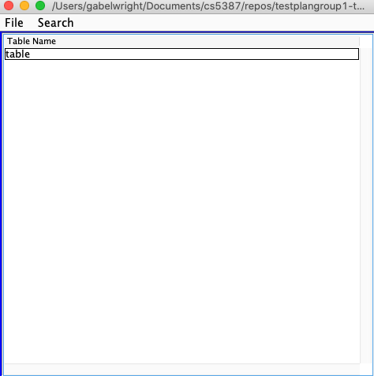
Figure 1: Test 1 example output part 1

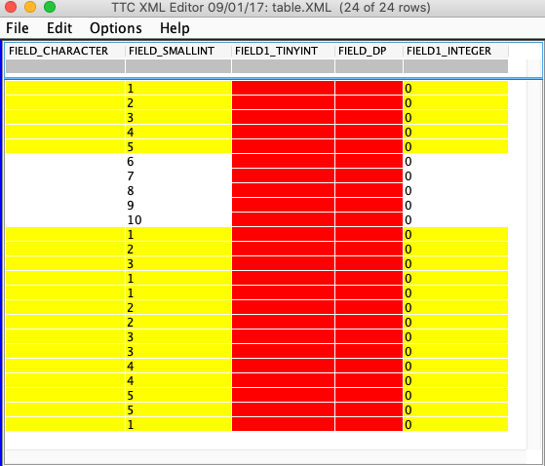
Figure 2: Test 1 example output part 2

$$$

