Database Table Editor
Test plan
Version <1.0>
04/11/2020
Document Control
Approval
The Guidance Team and the customer shall approve this document.
Document Change Control
Initial Release: | 04/11/2020
Current Release: | 04/11/2020
Indicator of Last Page in Document:
Date of Last Review: | 04/12/2020
Date of Next Review:
Target Date for Next Update: | 04/14/2020
Distribution List
This following list of people shall receive a copy of this document every time a new version of this document becomes available:
Guidance Team Members:
Steve Roach

Customer:

Software Team Members:
Stephanie Medina
Quentin L. Armstrong
Raquel B. Gonzalez
Jonathan Roman

Change Summary
The following table details changes made between versions of this document

Version | Date | Modifier | Description
0.1 | 04/11/2020 | Raquel Gonzalez | Document Control
0.2 | 04/11/2020 | Raquel Gonzalez | Section 1
0.3 | 04/11/2020 | Raquel Gonzalez | Section 2-8
1.1 | 04/11/2020 | Raquel Gonzalez | Updated Section 1.1 and Section 4

Note: The template presented in this document was taken from:
Donaldson, S., and S. Siegel, Successful Software Development. Upper Saddle River, NJ: Prentice Hall, 2001, pp. 321-323.

Note: The template presented in this document was taken from: Donaldson, S., and S. Siegel, Successful Software Development. Upper Saddle River, NJ: Prentice Hall, 2001, pp. 321-323 and modified by Humberto Mendoza and Steve Roach.

Supplementary information is from:
Pfleeger, S. Software Engineering, Theory and Practice. Upper Saddle River, NJ: Prentice Hall, 1998, p. 365.

Table of Contents
Document Control ii
Approval ii
Document Change Control ii
Distribution List ii
Change Summary ii
1. Introduction 1
1.1. Purpose 1
1.2. Scope 1
1.3. System Overview 1
1.4. Suspension and Exit Criteria 3
1.5. Document Overview 3
1.6. References 3
2. Test Items and Features 4
2.1. Filter 4
2.2. Search 4
3. Testing Approach 5
4. Test XX 6
4.1. Test Case 1 6
4.2. Test Case 2 2
4.3. Test Case 3 2
4.4. Test Case 4 2
4.5. Test Case 5 2
4.6. Test Case 6 2
5. User Interface Testing 3
6. Test Schedule 4
7. Other Sections 5
8. Appendix 6

Introduction

The project is a database table editor and that allows users access to view and modify the data. The editor does not allow any changes to be made to the database schema. There are several aspects of the project that will be inspected and tested, which have been split into 4 groups. The breakdown will be further explained in the document.

Purpose
The purpose of this document is to test the functionalities of the database table editor by focusing on four specific aspects of the application. The first test plan of the application will be for is file menu operations excluding compare file to other version, check for duplicate rows, and filter. The second is the filter and search function in the edit menu. The third is to focus on the edit menu options. The last is to compare file to other version and check for duplicate rows. This document will focus on testing the filter and search function in the edit menu.

Scope
The test plan and reviews will start on April 8th. Teams will be required to review, and revise test plans each week. The test plan will be done by April 21st.

System Overview
In this system, configuration data is stored in XML tables. We've provided a simple editor to allow access to view and modify the data. The editor does not allow modification of the database schema.

A database is a set of flat files organized as rows and columns. A collection of related files are contained in a database. The database is organized in XML documents. There are two kinds of XML documents: a database description and the data tables. The description file contains a description of the data tables: the table name and columns for each table. The format is
<DATABASE name='databasename'>
<TABLE name='tablename'>
<COLUMN name='columnname' type='columntype'/>
...
</TABLE>
...
</DATABASE>

A data table is named "databasename__tablename.xml". For example, if the database description is in 'TEST_DB.XML', the <DATABASE> tag inside that document should have as its name attribute 'TEST_DB'. If that file has a <TABLE> tag with an attribute 'BIG_TABLE', there should be a file 'TEST_DB__BIG_TABLE.XML' that contains the data for the BIG_TABLE database table. This file must be in the same directory as the database file.

The format of a data table XML file is
<DATABASE name='databasename'>
<TABLE name='tablename'>
<ROW>
<columnname> value </columnname>
...
</ROW>
...
</TABLE>
</DATABASE>

Any xml file in the database can have a history section, usually at the bottom of the file. The history section is
<HISTORY>
<ITEM date='mm/dd/yyyy' author='authorname' comment='note' />
</HISTORY>

When started, the editor opens a database edit window. This window displays the tables in a database. Initially, no database is loaded. There is a menu with File and Search. File has the options to open, close, and print tables. A user can open either a database description file or a data file. If a data file is opened, the corresponding database description is also opened. The database description window displays all the database tables. Selecting a table from this display opens the data table display in a new window. It is possible to open more than one database at a time. Opening a database table file results in the database description also being opened. It is possible to open more than one database at a time. All the windows associated with a specific database have the same color outline. Opening an already-opened table should result in the table editor window for that table being raised to the top of the screen and being visible.

The Options/History option displays the history data section. On file save, the user is prompted to enter a new history entry.

If the file has been modified and the user attempts to close the file, a save prompt should be displayed.

Search opens a file search dialog that allows a user to search specified directories for files that contain a given text string. When using this option, files containing the text string are listed. Selecting the file from the display will open the database table.

In the data table display, data is displayed and is editable. The menu has File, Edit, Options, and Help. The Help option describes the editor features. The Edit menu option allows the user to insert, delete, copy, paste, and undo. The create and delete options are row operations: entire rows are affected. Undo is any operation that affects the data. It is also possible to modify rows from the table. It is not allowed to change the column headers. It is possible to re-order columns by dragging them to a new location. Duplicate rows are highlighted in yellow. Fields violating field constraints specified in the database description file are highlighted in red.

In data table display, the column names are displayed across the top row. Just below this is a blank row. This row is the display filter row. Entering data in this row will result in only the matching data rows to be displayed. In the File menu, there are options for OR FILTER or AND FILTER. If AND FILTER is selected, the display is restricted to rows that match all of the filters entered. If the OR FILTER is selected, the display should contain rows that match any of the filters entered. The filters allow a limited type of regular expression matching described on the Help pages.

The File/Compare option allows a user to compare two versions of a table. This compare can be restricted to selected columns by using the Options/Column Selection feature. The output is rather crude and is not intended for large change lists.

File/Check for Duplicate Rows should list rows that have identical contents. This check is restricted to the columns selected in Options/Select Columns.

Constraints
A constraint on a column is specified in the database table description inside the column description. For example:
<COLUMN name='FIELD_DP' type='DOUBLE_PRECISION' >
<CONSTRAINT name='NN_0' type='NotNull'/>
</COLUMN>

The constraint name must be unique in the table. Types of constraints are
NotNull
Unique
Check
For NotNull, the entry in the data table must have some value. For Unique, the value must not be duplicated anywhere else in the table (e.g., the table's key value). For Check, the value must match one of the OPTION fields. For example:
<CONSTRAINT name='EN_1' type='Check'>
<OPTION>OPT01</OPTION>
<OPTION>OPT02</OPTION>
</CONSTRAINT>
Constraint violations are highlighted in red in the data table display, and hovering the mouse cursor over the highlighted column should display a message describing the violation. Multiple constraints are allowed for each column.

Suspension and Exit Criteria
There are no suspension criteria in this document. The exit criteria for this test will be 80% must pass.

Document Overview
Section 2. Test Items and Features: describes the test items (e.g., components, classes, functions or methods) and the features to be tested
Section 3. Testing Approach: describes the approach to be used to the test the system
Section 4. Test “x”: information about what each test consists of such as materials, data, expected input and output, etc.
Section 5. User interface testing: not applicable due to the focus being the edit menu operations
Section 6. Test Schedule: this is where the schedule for testing activities are specified
Section 7. Other Sections: not applicable for this scenario
Section 8. Appendix: further details for expected output and/or visuals needed for the sections in this document

References
CS5387. (2020, April 8). CS5387/testplangroup2-team-4. Retrieved from https://github.com/CS5387/testplangroup2-team-4

Test Items and Features
The filter and search option opens a file search dialog that allows a user to search for files in a specific directory that have a given text string. Selecting a file from the display will open the database table. In the File menu, there are options for OR FILTER or AND FILTER. If AND FILTER is selected, the display is restricted to rows that match all of the filters entered. If the OR FILTER is selected, the display should contain rows that match any of the filters entered. The filters allow a limited type of regular expression matching described on the Help pages.

Filter
The filter option allows the user to enter a text string, which will filter out the files that do not contain that given text string.

Search
The search option allows the user to search from all the files in a specific directory.

Testing Approach
The code was not given, therefore all tests are being tested through Black Box testing. These tests are testing for the search and filter operations in the application. This section lists the tests and the objectives and criticality of each one. The criticality will be numbered 1-3, where 1 represents the lowest criticality and 3 is the highest.

Table 1: Test Plan
TEST SUITE 1
Description of Test Suite | This test suite tests the basic functionality of the Filter and Search functions of the application.
Test Case Identifier | Objective | Criticality
1 | Tests the functionality of the Search and Filter with a string that all files contain | 3
2 | Tests the functionality of Search and Filter with a string that only one file contains | 2
3 | Tests the functionality of Search and Filter with a specific filename | 1
4 | Tests the functionality of OR FILTER | 3
5 | Tests the functionality of AND FILTER | 2
6 | Tests the functionality of AND FILTER with results | 3

Test XX
The purpose of this section is to:
- document test input, specific test procedures, and outcomes.
- establish test methods,
- explain the nature and extent of each test
For each test case, complete the following:

Test Case 1

Objective: Search for an XML file that contains the string “test”.
Notes: All of the XML files contain the string “test,” but this test will show if the filter is case sensitive or if all the XML files will appear in the search.

Test No.: 1 |  |  |  | Current Status: Pass
Test title: Testing Case Sensitive Filter

Testing approach: The code has not been shared, so this test is Black Box testing. The only thing needed is XML files in a specific directory together.

STEP  1.  2.  3. | OPERATOR ACTION  Go to the Search tab, then click Find Files.  Enter the string “test” in the “Search For:” text box.  Click the search button. | PURPOSE  This is to the dialog to search for specific files.  This is to search for specific files that contain the string “test”  This is to initiate the search in the specific directory. |  |  | EXEPCTED RESULTS  A dialog page opens, with the file path, the specific file type, and a text box that allows them to filter the files.  Nothing in the GUI will be different, but the filter should be set.  All the XML files in the directory should show up | COMMENTS  Make sure you are in the correct directory.  Make sure the word is spelled correctly.  The filter may be case sensitive and may result in no matches that contain that string.
Concluding Remarks:
Test appears to have passed. All the files that contain the word test appeared. See appendix section for screenshot of results.
Testing Team:  Stephanie Medina |  |  | Date Completed:  04/17/2020

Test Case 2

Objective: Search for an XML file that contains the string “CONSTRAINT”.
Notes: Only one of the XML files given as an example contained the string “CONSTRAINT” or “constraint,” because the filter is not case sensitive.

Test No.: 2 |  |  |  | Current Status: Pass
Test title: Search for specific file with specific string

Testing approach: The code has not been shared, so this test is Black Box testing. The only thing needed is XML files in a specific directory together.

STEP  1.  2.  3. | OPERATOR ACTION  Go to the Search tab, then click Find Files.  Enter the string “CONSTRAINT” in the “Search For:” text box.  Click the search button. | PURPOSE  This is to the dialog to search for specific files.  This is to search for specific files that contain the string “CONSTRAINT”  This is to initiate the search in the specific directory. |  |  | EXEPCTED RESULTS  A dialog page opens, that allows the user to see the directory they are in, the specific file type they are searching for and a text box that allows them to filter the files.  Nothing in the GUI will be different, but the filter should be set.  Only the file named “TEST_DB_  CONSTRAINT_TABLE” should appear in the results. | COMMENTS  Make sure you are in the correct directory.  Make sure the word is spelled correctly.  The filter may be case sensitive.
Concluding Remarks:

The test appears to pass however, one unexpected result appeared. There’s an additional file that comes up that does not contain the word constraint.
Testing Team:  Stephanie Medina |  |  | Date Completed:  04/12/2020  04/17/2020

Test Case 3

Objective: Search for an XML file that contains the specific file name “TEST_DB__TYPE_TABLE”.
Notes: Only one of the XML files is named “TEST_DB__TYPE_TABLE.” The filter is not case sensitive.

Test No.: 3 |  |  |  | Current Status: Fail
Test title: Search for specific file with name

Testing approach: The code has not been shared, so this test is Black Box testing. The only thing needed is XML files in a specific directory together.

STEP  1.  2.  3. | OPERATOR ACTION  Go to the Search tab, then click Find Files.  Enter the string “TEST_DB_  _TYPE_TABLE” in the “Search For:” text box.  Click the search button. | PURPOSE  This is to the dialog to search for specific files.  This is to search for specific files that contain the whole file name “TEST_DB_  _TYPE_TABLE”  This is to initiate the search in the specific directory. |  |  | EXEPCTED RESULTS  A dialog page opens, that allows the user to see the directory they are in, the specific file type they are searching for and a text box that allows them to filter the files.  Nothing in the GUI will be different, but the filter should be set.  Only the file named “TEST_DB_  TYPE_TABLE” should appear in the results. | COMMENTS  Make sure you are in the correct directory.  Make sure the word is spelled correctly.  The filter may be case sensitive.
Concluding Remarks:
Although there was only one file that contained the string “TEST_DB_TYPE_TABLE,” another file would appear.
The test appears to fail since it did not find the file even though it is in the directory. See appendix for screenshot of results.
Testing Team:  Stephanie Medina |  |  | Date Completed:  04/12/2020  04/17/2020

Test Case 4

Objective: In a specific XML file test the OR FILTER
Notes: Should test a XML file with multiple rows and multiple fields

Test No.: 4 |  |  |  | Current Status: Pass
Test title: OR FILTER

Testing approach: The code has not been shared, so this test is Black Box testing. The only thing needed is XML files in a specific directory together.

STEP  1.  2.  3.  4.  5. | OPERATOR ACTION  Go to File, then click Open.  Select the “TEST_DB_  CONSTRAINT_TABLE”  XML file.  Go to File, then select OR FILTER.  In the INDEX column enter “57” in the row under it in the grey part and press enter.  In the ATTENTION1 column enter “CORRECT” in the row under it and press enter. | PURPOSE  Get access to XML file to open  This file contains multiple rows and fields that allows for filtering.  Make sure it is filtering if a row contains either given string.  This is to filter out rows that don’t contain the string “57”  This is to check if rows that contain either string in the fields appear. |  |  | EXEPCTED RESULTS  A dialog opens that shows all XML files in a specific directory  The XML editor page opens, with all the info from the specific XML file.  Dot appears next to OR FILTER to show it has been selected.  The rows that contain “57” in the INDEX column appear.  The rows that contain “57” in the INDEX column appear or “CORRECT” in ATTENTION1 should appear. | COMMENTS  Make sure the xml has multiple rows and fields  Make sure the text is entered correctly.  Make sure the text is entered correctly.
Concluding Remarks:
Test appears to pass. The rows that contain a “57” or a “CORRECT” string to appear. See appendix for screenshot of results.
Testing Team:  Stephanie Medina |  |  | Date Completed:  04/17/2020

Test Case 5

Objective: In a specific XML file test the AND FILTER
Notes: Should test a XML file with multiple rows and multiple fields

Test No.: 5 |  |  |  | Current Status: Pass
Test title: AND FILTER

Testing approach: The code has not been shared, so this test is Black Box testing. The only thing needed is XML files in a specific directory together.

STEP  1.  2.  3.  4.  5. | OPERATOR ACTION  Go to File, then click Open.  Select the “TEST_DB_  CONSTRAINT_TABLE”  XML file.  Go to File, then select AND FILTER  In the INDEX column enter “57” in the row under it in the grey part and press enter.  In the ATTENTION1 column enter “CORRECT” in the row under it and press enter. | PURPOSE  Get access to XML file to open.  This file contains multiple rows and fields that allows for filtering.  Make sure it is filtering if a row contains all given strings (if there are 2 or more).  This is to filter out rows that don’t contain the string “57”  This is to check if rows that contain either string in the fields appear. |  |  | EXEPCTED RESULTS  A dialog opens that shows all XML files in a specific directory  The XML editor page opens, with all the info from the specific XML file.  Dot appears next to AND FILTER to show it has been selected.  The rows that contain “57” in the INDEX column appear.  No rows should appear. | COMMENTS  Make sure the xml has multiple rows and fields  Make sure the text is entered correctly.  Make sure the text is entered correctly.
Concluding Remarks:
The test appears to pass. No rows appeared when entering the key strings. See appendix for screenshot of results.
Testing Team:  Stephanie Medina |  |  | Date Completed:  04/17/2020

Test Case 6

Objective: In a specific XML file test the AND FILTER with results
Notes: Should test a XML file with multiple rows and multiple fields

Test No.: 6 |  |  |  | Current Status: Pass
Test title: AND FILTER

Testing approach: The code has not been shared, so this test is Black Box testing. The only thing needed is XML files in a specific directory together.

STEP  1.  2.  3.  4.  5. | OPERATOR ACTION  Go to File, then click Open.  Select the “TEST_DB_  CONSTRAINT_TABLE”  XML file.  Go to File, then select AND FILTER  In the INDEX column enter “Start_Name” in the row under it in the grey part and press enter.  In the DESCRIPTION column enter “1” in the row under it and press enter. | PURPOSE  Get access to XML file to open  This file contains multiple rows and fields that allows for filtering.  Make sure it is filtering if a row contains all given strings (if there are 2 or more).  This is to filter out rows that don’t contain the string “Start_Name”  This is to check if rows that contain either string in the fields appear. |  |  | EXEPCTED RESULTS  A dialog opens that shows all XML files in a specific directory  The XML editor page opens, with all the info from the specific XML file.  Dot appears next to AND FILTER to show it has been selected.  The rows that contain “Start_Name” in the INDEX column appear.  The rows that contain “Start_Name” in the INDEX column appear and “1” in DESCRIPTION should appear. | COMMENTS  Make sure the xml has multiple rows and fields  Make sure the text is entered correctly.  Make sure the text is entered correctly.
Concluding Remarks:
The test appears to pass. The resulting columns that contain the key strings that were entered do appear. See appendix for screenshot of results.
Testing Team:  Stephanie Medina |  |  | Date Completed:  04/17/2020

User Interface Testing
This is not applicable to the test plan, because the target of the document is not to test the interaction between the user and the interface.

Test Schedule
Schedule for testing.

Task and date | People | Description
Task 1 – 04/08/2020 | Raquel Gonzalez | Create test plan for Filter and Search functions.
Task 2-  04/11/2020-  04/21/2020 | Team | Review and comment team’s test plans.
Task 3-  04/14/2020- 04/20/2020 | Raquel Gonzalez | Revise Test plan based off feedback.
Task 4- 04/21/2020 | Team | Turn in test plan.

Other Sections
No other sections.

Appendix
Refer to GitHub.

Test Case 1 Results:

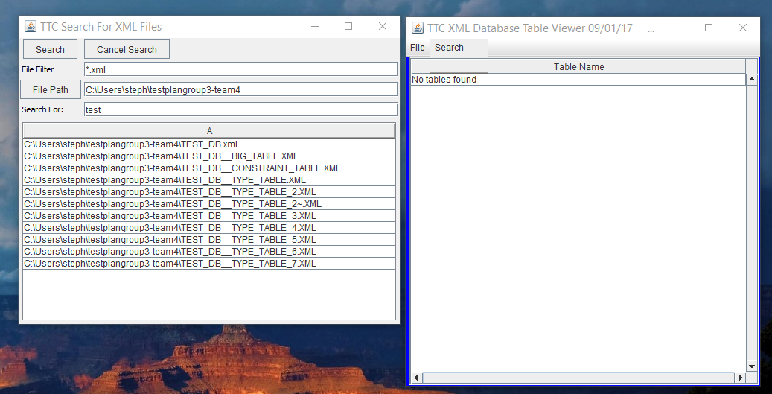

Test Case 2 Result:

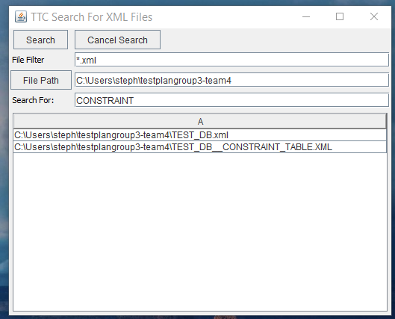

Test Case 3 Results:

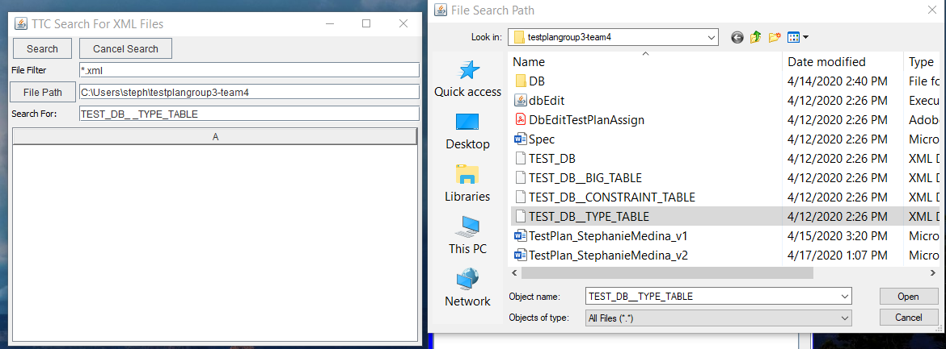

Test Case 4 Results:

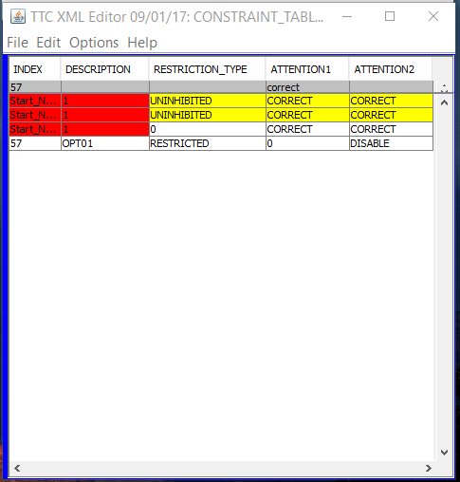

Test Case 5:

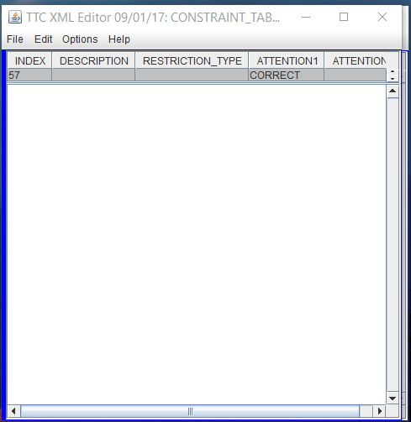

Test Case 6:

