Test Plan Group 2-Team_12
Test plan
Version 1.0
4/7/20
Document Control
Approval
The Guidance Team and the customer shall approve this document.
Document Change Control
Initial Release: | V1.0
Current Release: | V1.0
Indicator of Last Page in Document: | ##################
Date of Last Review:
Date of Next Review:
Target Date for Next Update: | 4/11/20
Distribution List
This following list of people shall receive a copy of this document every time a new version of this document becomes available:
Customer: Dr. Roach

Software Team Members: Charlie G. Juarez, Annadiley Gallegos Garcia, Diana L. Ramirez
Change Summary
The following table details changes made between versions of this document

Version | Date | Modifier | Description
V1.0 | 4/7/20 | Charlie Juarez | Initial version
V2.0 | 4/21/20 | Charlie Juarez | Revision 1 of version “V1.0”

Note: The template presented in this document was taken from:
Donaldson, S., and S. Siegel, Successful Software Development. Upper Saddle River, NJ: Prentice Hall, 2001, pp. 321-323.

Note: The template presented in this document was taken from: Donaldson, S., and S. Siegel, Successful Software Development. Upper Saddle River, NJ: Prentice Hall, 2001, pp. 321-323 and modified by Humberto Mendoza and Steve Roach.

Supplementary information is from:
Pfleeger, S. Software Engineering, Theory and Practice. Upper Saddle River, NJ: Prentice Hall, 1998, p. 365.

Table of Contents
Document Control ii
Approval ii
Document Change Control ii
Distribution List ii
Change Summary ii
1. Introduction 4
1.1. Purpose 4
1.2. Scope 4
1.3. System Overview 4
1.4. Suspension and Exit Criteria 4
1.5. Document Overview 4
1.6. References 4
2. Test Items and Features 5
3. Testing Approach 8
4. Test Suite 01 9
4.1. Test 01 9
4.2. Test 02 9
4.3. Test 03 10
4.4. Test 04 10
4.5. Test 05 11
5. Test Schedule 13
6. Appendix 14

Introduction

The project is a program that displays data stored in XML tables. This program allows access to view and modify the data in XML tables. The system that will be tested regarding this program is the search and filter functionality that has been implemented. The testing approach for this system will implemented through unit testing, each unit test will test a subset of functionalities regarding the search or filter functionality.

Purpose
The purpose of unit testing in this test plan is to ensure the functionality of searching and filtering results from the XML tables. These tests will ensure that the search and filter functionality produce the correct results.

Scope
The scope of this test plan will encompass the initial release provided by Dr. Roach.

System Overview
In this system, configuration data is stored in XML tables. This system provides a simple editor to allow access to view and modify the data. The editor does not allow modification of the database schema. The search and filter system functionalities to be tested will all be respective to their functionality. The search functionality that will be tested will be when searching for a file as well as searching in a table for a value. The filter that will be tested will be when filtering in a search for a file as well as filtering in a table for a value.

Suspension and Exit Criteria
In this test plan there will be no exit criteria, which means that all test cases will need to be executed. The exit criteria will be when the pass rate is 100%.

Document Overview
Following section 1.6, section 2 will talk about test items and features in the system, serving as background knowledge that will be needed to better understand the test cases in the test plan. After section 2, section 3 will follow about the testing approach applied to the test cases along with a table containing all the test cases tied to their respective objective and criticality. In section 4 the cases will be provided to then run, if there are any test cases that require interface testing, they will be under section 5. Section 6 will then describe the testing schedule regarding the test cases along with any information relevant to the testing timing. If there are anymore sections needed to be covered but that are not relevant by the release of this version of the test plan, section 7 will be empty. At the end the Appendix will be present with any output information regarding any of the afore mention sections.

References
For any references regarding the test plan itself or for more information on the test cases, the following resources can help:

Test Plan: https://piazza.com/class_profile/get_resource/k55rbh37ri6be/k8hjj7sn7hu7n0
Test Case Knowledge: Spec.docx file inside the GitHub repository
Test Case resources: If any test cases reference a custom file, it can be found in the GitHub repository: https://github.com/CS5387/testplangroup2-team_12

Test Items and Features
Search opens a file search dialog that allows a user to search specified directories for files that contain a given text string. When using this option, files containing the text string are listed. Selecting the file from the display will open the database table.

The following figures will represent where the items and features will be tested in the test cases described in section 4.

Fig. 1 is the window regarding the test cases when searching for an XML file on a computer. The file filter is the regex search bar when looking for a file. The file path is where the selection of a directory will be chosen from which the file filter will be implemented. The search for is used when looking for a file that contains the prescribed text. At the bottom of the window is a table that shows all results when the search button is clicked from the afore mentioned search criteria.
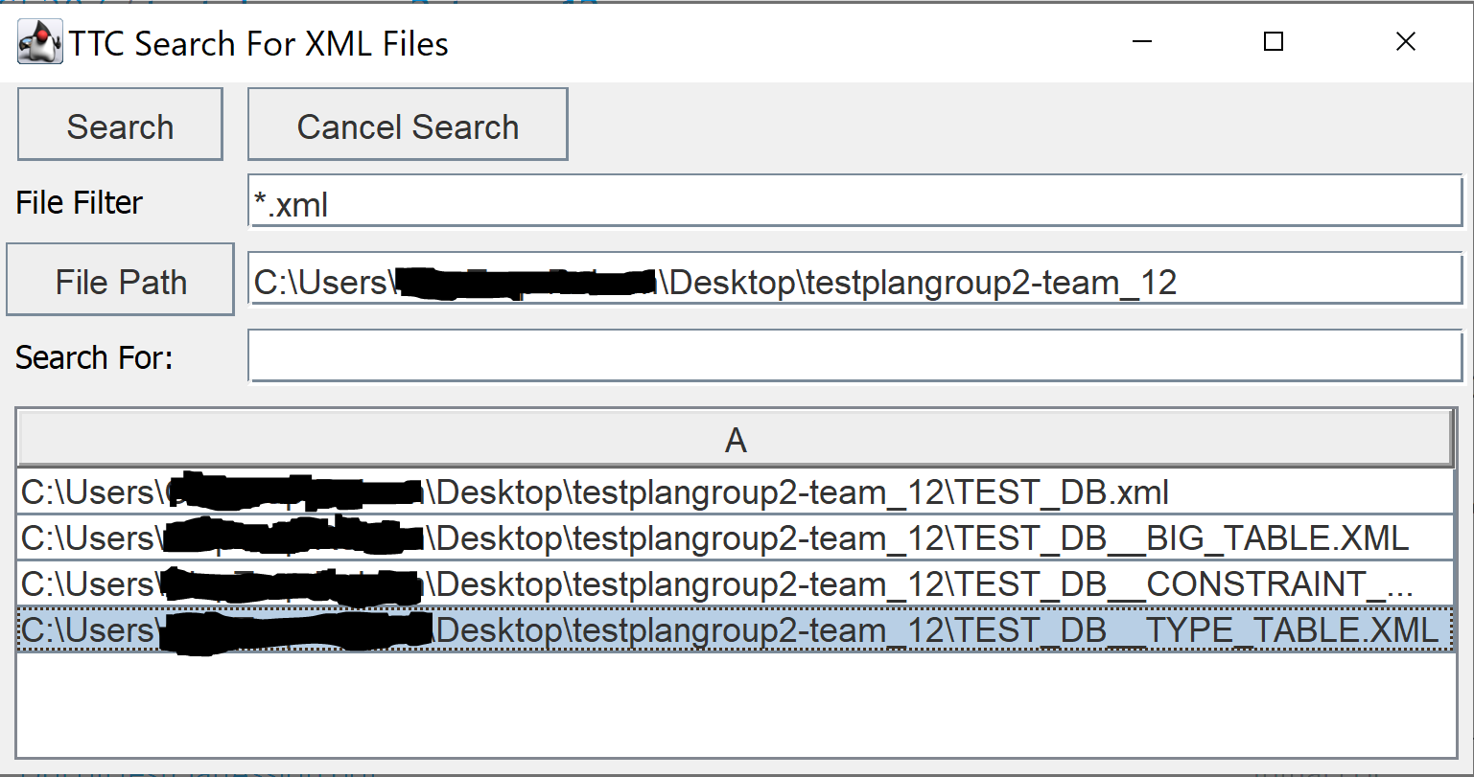
Fig. 1: Search window for an XML file

Fig.2 is the menu bar regarding test cases that test for the “and” and “or” filter when a table is already open. These filters will be applied to the search functionality implemented within the tables.
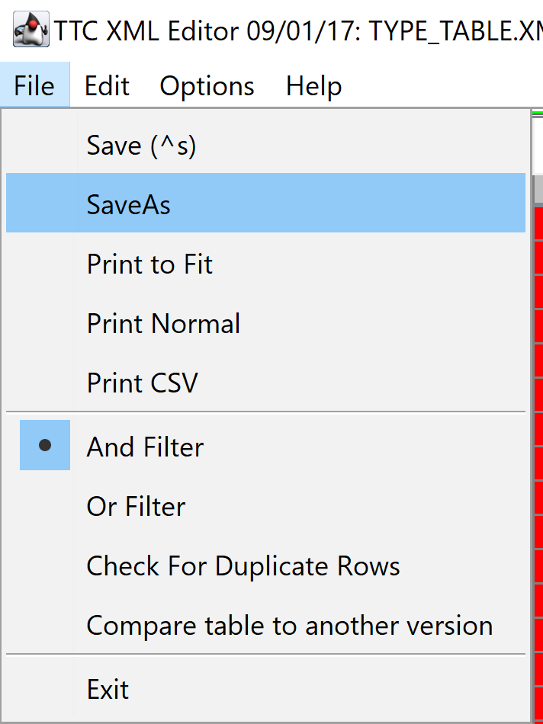
Fig. 2: Menu bar, file menu selected
Fig. 3 is the search window regarding test cases with information when a table has been selected. It can be found in the same menu bar, however instead of the file menu selected, edit menu was selected and the the “search” item was selected. The search filter is the regex search bar when looking for something within the opened table. The replace function is what you want to replace the search word with, within the table. The match case is whether you want to enable case sensitivity in the search filter. The “This Column Only” is used for when you only want the search functionality to apply to an already selected column. The find button is used when the search item has been provided in which the program will highlight the searched item in the table. The replace button will initiate the action to replace the first word that matches the search item and will replace it with the replace item. The replace all button will initiate the action to replace all words that match the search item with the replace item.
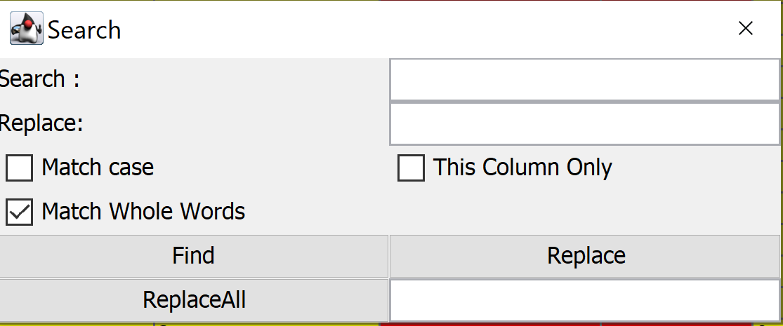
Fig. 3: Search window for information in an XML table

Fig. 4 is the same menu bar as in Fig. 2 regarding test cases for clearing filter fields on filter close when a table is already open. The figure can be found in the menu bar when a table is already open and the “options” menu was selected, revealing the “Clear Filter Fields on Filter Close” item. This will get rid of any filters that have been implement on the table.
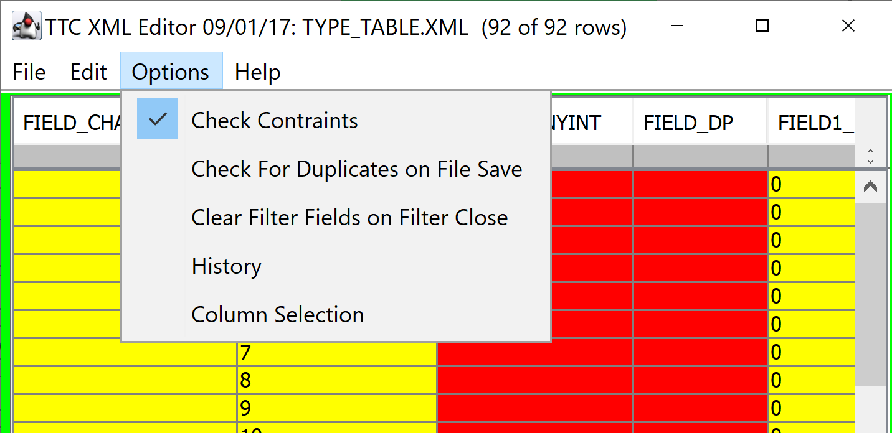
Fig. 4: Clearing filter fields on filter close

Fig. 5: is the same menu bar as in Fig. 2 regarding test cases with user interfaces that correspond to finding more information on the filter and search functionality inside the program. This figure can be found in the menu bar when a table is already open, and the “Help” menu has been selected revealing the “Filter” and “Search” items.
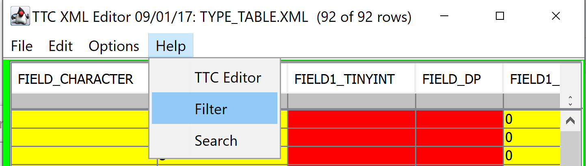
Fig. 5: Help for filter and search functionality

Testing Approach
The following table describes the test suite that implements the all the test cases in the rest of the test plan along with general information about each individual test case.

Table 1: Test Plan
TEST SUITE 01
Description of Test Suite | This test suite will contain all test cases regarding the search and filter functionality.
Test Case Identifier | Objective | Criticality
01 | The objective for this test is to be able to correctly search for all XML files in the specified file path. | Critical
02 | The objective for this test is to be able to correctly search for all XML files in the specified file path along with a “Search For” value. | Critical
03 | The objective for this test is to be able to correctly search for values inside the XML table. | Critical
04 | The objective for this test is to be able to correctly search for values inside the XML table and replace the searched value with a new value. | Critical
05 | The objective for this test is to be able to correctly search for values inside the XML table and replace the searched value with a new value. | Critical

Test Suite 01

Test 01

Objective: The objective for this test is to be able to correctly search for all XML files in the specified file path.
Notes: This test case is assuming there are XML files in the directory that is being searched.
Test No.: 01 |  |  |  | Current Status: Pending
Test title: Searching for XML files
Testing approach: The tester will have a blank program started up with the XML Database Table Viewer window open.
STEP  1 | OPERATOR ACTION  On the menu bar the tester will select the “Search” menu and select the “Find Files” item. | PURPOSE  See if the program can open the search file window. |  |  | EXPECTED RESULTS  The program should respond with displaying the “Search for XML Files” (Section 2, Fig. 1). | COMMENTS
2 | The tester selects the file filter, “*.xml”, with a file path. | See if the search functionality can find all the “.xml” files. |  |  | The program should do nothing but make note of the file filter that has been specified.
3 | The tester selects the file path where he knows there is an “.xml” file. | See if the file path functionality can be used. |  |  | The program should do nothing but make note of the file path that has been specified.
4 | The tester selects the “Search” button. | See if the program can display the correct search results respective to the search criteria. |  |  | The program should respond with displaying all the “.xml” files in the search window(Section 2, Fig. 1).
Concluding Remarks:
Testing Team:  << List members of testing team and lead >> |  |  | Date Completed:

Test 02

Objective: The objective for this test is to be able to correctly search for all XML files in the specified file path along with a “Search For” value.
Notes: This test case is assuming there are XML files in the directory that is being searched.
Test No.: 02 |  |  |  | Current Status: Pending
Test title: Searching for XML files with a “Search For” value
Testing approach: The tester will have a blank program started up with the XML Database Table Viewer window open.
STEP  1 | OPERATOR ACTION  On the menu bar the tester will select the “Search” menu and select the “Find Files” item. | PURPOSE  See if the program can open the search file window. |  |  | EXPECTED RESULTS  The program should respond with displaying the “Search for XML Files” window (Section 2, Fig. 1). | COMMENTS
2 | The tester selects the file filter, “*.xml”, with a file path. | See if the search functionality can find all the “.xml” files. |  |  | The program should do nothing but make note of the file filter that has been specified.
3 | The tester selects the file path where he knows there is an “.xml” file. | See if the file path functionality can be used. |  |  | The program should do nothing but make note of the file path that has been specified.
4 | The tester types in “Restricted” for the “Search For” text box. | See if the search for functionality can be used. |  |  | The program should do nothing but make note of the search for that has been specified.
5 | The tester selects the “Search” button. | See if the program can display the correct search results respective to the search criteria. |  |  | The program should respond with displaying all the “.xml” files in the search window(Fig. 1) that contain the “Restricted” value in the table.
Concluding Remarks:
Testing Team:  << List members of testing team and lead >> |  |  | Date Completed:

Test 03

Objective: The objective for this test is to be able to correctly search for values inside the XML table.
Notes: This test case is assuming a table is already open.
Test No.: 03 |  |  |  | Current Status: Pending
Test title: Searching for a value in a table
Testing approach: The tester will have the program already running with an XML table already open that contains the value, “CORRECT” anywhere on the table.
STEP  1 | OPERATOR ACTION  On the menu bar the tester will select the “Edit” menu and select the “Search” item. | PURPOSE  See if the program can open the search file window. |  |  | EXPECTED RESULTS  The program should respond with displaying the “Search” (Section 2, Fig. 3) window. | COMMENTS
2 | The tester will then type in “CORR” in the “Search” text box. | See if the find functionality can find any words that match the word “CORR”. |  |  | The program should do nothing but make note of the search value that has been specified.
3 | The tester will uncheck the “Match Whole Words” checkbox. | See if the find functionality can find any words that contain the string “CORR”. |  |  | The program should do nothing but make note of the unchecked “Match Whole Words”. | If the “Match Whole Words” is already unchecked, make sure to check the box.
4 | The tester will make sure to have the checkboxes that are “Match case” and “This Column Only” be unchecked. | See if the program can still work as intended respectively to the rest of this test case. |  |  | The program should do nothing but make not of the unchecked boxes, “Match case” and “This Column Only”. | If the checkboxes are already checked make sure to uncheck the boxes.
5 | The tester presses the “Find” button. | See if the search functionality can find the value specified in the XML table with the correct search criteria. |  |  | The program should respond with highlighting “CORRECT” value in the XML table.
Concluding Remarks:
Testing Team:  << List members of testing team and lead >> |  |  | Date Completed:

Test 04

Objective: The objective for this test is to be able to correctly search for values inside the XML table and replace the searched value with a new value.
Notes: This test case is assuming a table is already open.
Test No.: 04 |  |  |  | Current Status: Pending
Test title: Searching for a value in a table and replacing it with another
Testing approach: The tester will have the program already running with an XML table already open that contains the value, “CORRECT” anywhere on the table.
STEP  1 | OPERATOR ACTION  On the menu bar the tester will select the “Edit” menu and select the “Search” item. | PURPOSE  See if the program can open the search file window. |  |  | EXPECTED RESULTS  The program should respond with displaying the “Search” (Section 2, Fig. 3) window. | COMMENTS
2 | The tester will then type in “CORRECT” in the “Search” text box. | See if the find functionality can find any words that match the word “CORRECT”. |  |  | The program should do nothing but make note of the search value that has been specified.
3 | The tester will then type in “INVALID” in the “Replace” text box. | See if the replace functionality can replace the search value, “CORRECT”, with the replace value “INVALID”. |  |  | The program should do nothing but make note of the unchecked “Match Whole Words”.
4 | The tester will make sure to have the check box of “Match Whole Words” to be checked. | See if the “Match Whole Words” checkbox is working. |  |  | The program should do nothing but make note of the “Match Whole Words” checkbox. | If the “Match Whole Words” is already unchecked, make sure to check the box.
5 | The tester will make sure to have the checkboxes that are “Match case” and “This Column Only” be unchecked. | See if the program can still work as intended respectively to the rest of this test case. |  |  | The program should do nothing but make note of the unchecked boxes, “Match case” and “This Column Only”. | If the checkboxes are already checked make sure to uncheck the boxes.
6 | The tester presses the “Find” button | See if the search functionality can find the value specified in the XML table with the correct search criteria. |  |  | The program should respond with highlighting “CORRECT” value in the XML table.
7 | The tester then presses “Replace” button. | See if the “Replace” functionality in the search window does replace the “CORRECT” value in the XML table with the value “INVALID”. |  |  | The program should respond with changing the highlighted value, “CORRECT”, with the specified “Replace” value, “INVALID”. | The tester will do this step right after step 6 as the first value matching the “Search” value will already be highlighted.
Concluding Remarks:
Testing Team:  << List members of testing team and lead >> |  |  | Date Completed:

Test 05

Objective: The objective for this test is to be able to correctly search for values inside the XML table and replace all the searched values with new values.
Notes: This test case is assuming a table is already open.
Test No.: 05 |  |  |  | Current Status: Pending
Test title: Searching for values in a table and replacing all of them
Testing approach: The tester will have the program already running with an XML table already open that contains the value, “CORRECT” anywhere on the table.
STEP  1 | OPERATOR ACTION  On the menu bar the tester will select the “Edit” menu and select the “Search” item. | PURPOSE  See if the program can open the search file window. |  |  | EXPECTED RESULTS  The program should respond with displaying the “Search” (Section 2, Fig. 3) window. | COMMENTS
2 | The tester will then type in “CORRECT” in the “Search” text box. | See if the find functionality can find any words that match the word “CORRECT”. |  |  | The program should do nothing but make note of the search value that has been specified.
3 | The tester will then type in “INVALID” in the “Replace” text box. | See if the replace functionality can replace the search value, “CORRECT”, with the replace value “INVALID”. |  |  | The program should do nothing but make note of the unchecked “Match Whole Words”.
4 | The tester will make sure to have the check box of “Match Whole Words” to be checked. | See if the “Match Whole Words” checkbox is working. |  |  | The program should do nothing but make note of the “Match Whole Words” checkbox. | If the “Match Whole Words” is already unchecked, make sure to check the box.
5 | The tester will make sure to have the checkboxes that are “Match case” and “This Column Only” be unchecked. | See if the program can still work as intended respectively to the rest of this test case. |  |  | The program should do nothing but make note of the unchecked boxes, “Match case” and “This Column Only”. | If the checkboxes are already checked make sure to uncheck the boxes.
6 | The tester presses the “Find” button | See if the search functionality can find the value specified in the XML table with the correct search criteria. |  |  | The program should respond with highlighting “CORRECT” value in the XML table.
7 | The tester then presses “ReplaceALL” button. | See if the “Replace” functionality in the search window does replace all the “CORRECT” values in the XML table with the value “INVALID”. |  |  | The program should respond with changing all the “CORRECT” values in the table, with the specified “Replace” value, “INVALID”.
Concluding Remarks:
Testing Team:  << List members of testing team and lead >> |  |  | Date Completed:

Test Schedule
The following table contains the testing order for the test to be completed. The table contains that task and date on the left column for when and what to be completed. Along with the respective people who will be completing the task. Appended by a description of what the people will do corresponding to their task.

TBD
Task and date | People | Description

Appendix
<< possibly more readable to put the expected output here and refer to it in the previous sections. Might also provide explicit directions for analysis of output, if it’s easier to read as an appendix or if analysis is post execution. >>

##################

