Test Plan Group 2-Team_12
Test plan
Version 1.0
4/7/20
Document Control
Approval
The Guidance Team and the customer shall approve this document.
Document Change Control
Initial Release: | V1.0
Current Release: | V1.0
Indicator of Last Page in Document: | ##################
Date of Last Review:
Date of Next Review:
Target Date for Next Update: | 4/11/20
Distribution List
This following list of people shall receive a copy of this document every time a new version of this document becomes available:
Guidance Team Members: Annadiley Gallegos Garcia, Diana L. Ramirez

Customer: Dr. Roach

Software Team Members: Charlie G. Juarez
Change Summary
The following table details changes made between versions of this document

Version | Date | Modifier | Description

Note: The template presented in this document was taken from:
Donaldson, S., and S. Siegel, Successful Software Development. Upper Saddle River, NJ: Prentice Hall, 2001, pp. 321-323.

Note: The template presented in this document was taken from: Donaldson, S., and S. Siegel, Successful Software Development. Upper Saddle River, NJ: Prentice Hall, 2001, pp. 321-323 and modified by Humberto Mendoza and Steve Roach.

Supplementary information is from:
Pfleeger, S. Software Engineering, Theory and Practice. Upper Saddle River, NJ: Prentice Hall, 1998, p. 365.

Table of Contents
Document Control ii
Approval ii
Document Change Control ii
Distribution List ii
Change Summary ii
1. Introduction 4
1.1. Purpose 4
1.2. Scope 4
1.3. System Overview 4
1.4. Suspension and Exit Criteria 4
1.5. Document Overview 4
1.6. References 4
2. Test Items and Features 5
3. Testing Approach 7
4. Test Suite 01 8
4.1. Test 01 8
4.2. Test 02 8
4.3. Test 03 9
4.4. Test 04 9
4.5. Test 05 10
5. User Interface Testing 11
6. Test Schedule 12
7. Other Sections 13
8. Appendix 14

Introduction

The project is a program that displays data stored in XML tables. This program allows access to view and modify the data in XML tables. The system that will be tested regarding this program is the search and filter functionality that has been implemented. The testing approach for this system will implemented through unit testing, each unit test will test a subset of functionalities regarding the search or filter functionality.

Purpose
The purpose of unit testing in this test plan is to ensure the functionality of searching and filtering results from the XML tables. These tests will ensure that the search and filter functionality produce the correct results.

Scope
The scope of this test plan will encompass the initial release provided by Dr. Roach.

System Overview
The search and filter system functionalities to be tested will all be respective to their functionality. The search functionality that will be tested will be when searching for a file as well as searching in a table for a value. The filter that will be tested will be when filtering in a search for a file as well as filtering in a table for a value.

Suspension and Exit Criteria
In this test plan there will be no exit criteria, which means that all test cases will need to be executed. The exit criteria will be when the pass rate is 100%.

Document Overview
Following section 1.6, section 2 will talk about test items and features in the system, serving as background knowledge that will be needed to better understand the test cases in the test plan. After section 2, section 3 will follow about the testing approach applied to the test cases along with a table containing all the test cases tied to their respective objective and criticality. In section 4 the cases will be provided to then run, if there are any test cases that require interface testing they will be under section 5. Section 6 will then describe the testing schedule regarding the test cases along with any information relevant to the testing timing. If there are anymore sections needed to be covered but that are not relevant by the release of this version of the test plan, section 7 will be empty. At the end the Appendix will be present with any output information regarding any of the afore mention sections.

References
For any references regarding the test plan itself or for more information on the test cases, the following resources can help:

Test Plan: https://piazza.com/class_profile/get_resource/k55rbh37ri6be/k8hjj7sn7hu7n0
Test Case Knowledge: Spec.docx file inside the GitHub repository
Test Case resources: If any test cases reference a custom file, it can be found in the GitHub repository: https://github.com/CS5387/testplangroup2-team_12

Test Items and Features
The following figures will represent where the items and features will be tested in the test cases described in section 4.

Fig. 1 is the window regarding the test cases when searching for an XML file on a computer.
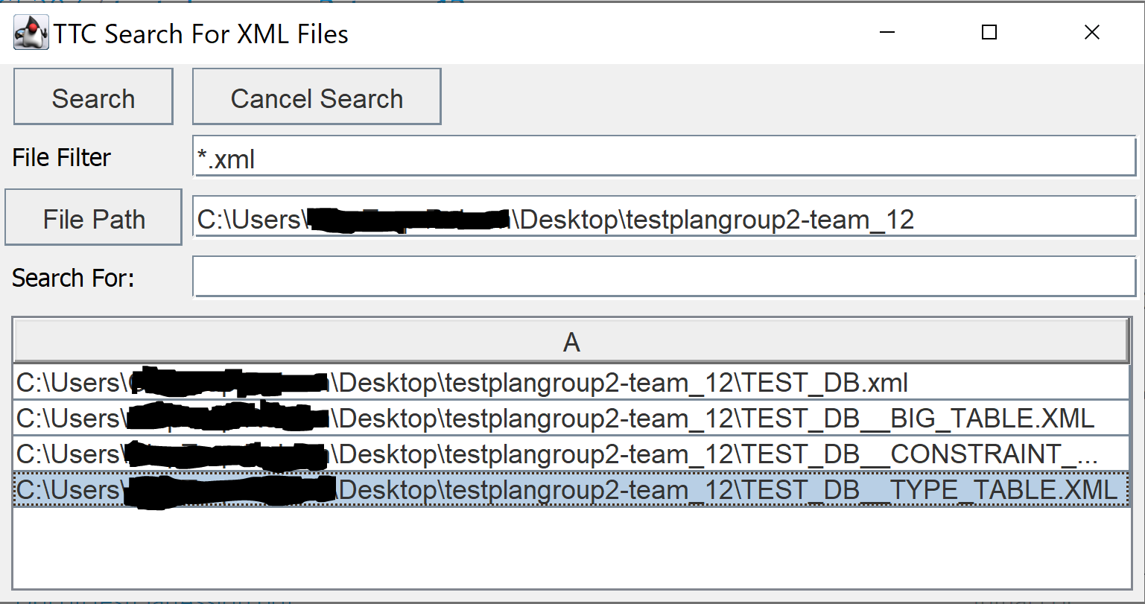
Fig. 1: Search window for an XML file

Fig. 2 is the menu bar regarding test cases that test for the “and” and “or” filter when a table is already open.
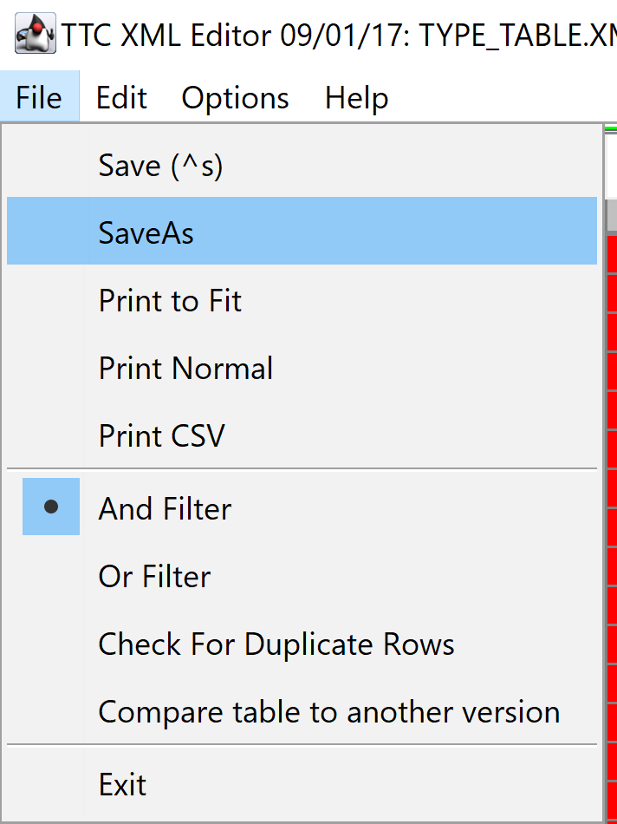
Fig. 2: Menu bar, file menu selected

Fig. 3 is the search window regarding test cases with information when a table has been selected. It can be found in the menu bar, same as Fig. 2, however instead of the file menu selected, edit menu was selected and the the “search” item was selected.
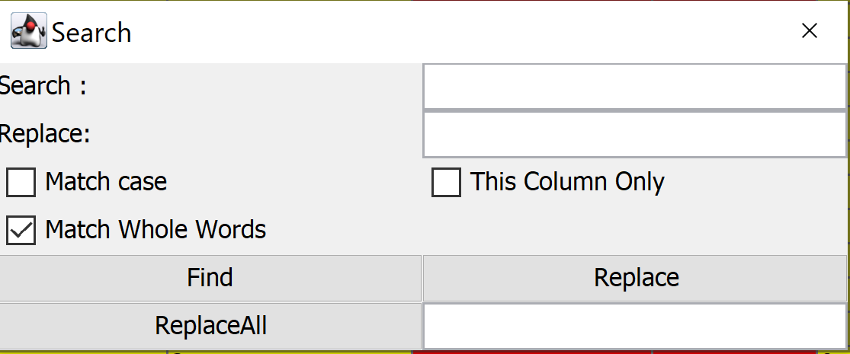
Fig. 3: Search window for information in an XML table

Fig. 4 is the same menu bar as in Fig. 2 regarding test cases for clearing filter fields on filter close when a table is already open. The figure can be found in the menu bar when a table is already open and the “options” menu was selected, revealing the “Clear Filter Fields on Filter Close” item.
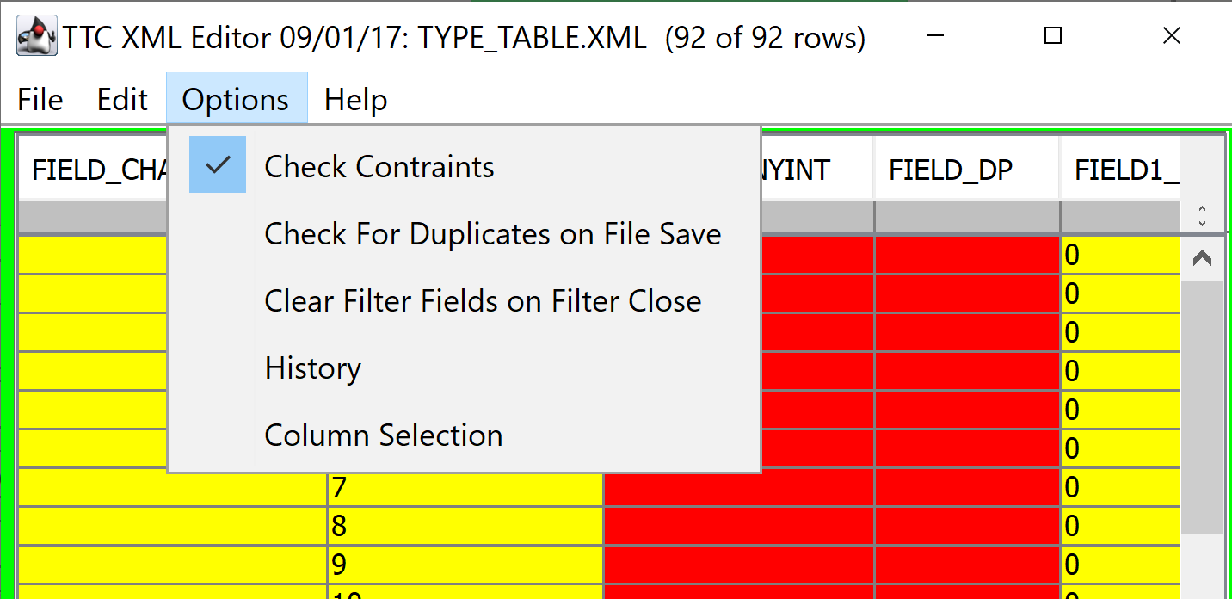
Fig. 4: Clearing filter fields on filter close

Fig. 5: is the same menu bar as in Fig. 2 regarding test cases with user interfaces that correspond to finding more information on the filter and search functionality inside the program. This figure can be found in the menu bar when a table is already open, and the “Help” menu has been selected revealing the “Filter” and “Search” items.
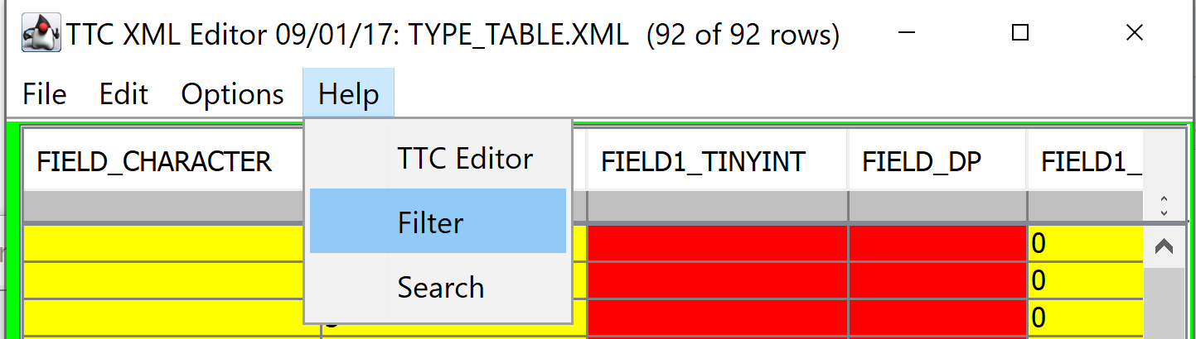
Fig. 5: Help for filter and search functionality

Testing Approach
The following table describes the test suite that implements the all the test cases in the rest of the test plan along with general information about each individual test case.

Table 1: Test Plan
TEST SUITE 01
Description of Test Suite | This test suite will contain all test cases regarding the search and filter functionality.
Test Case Identifier | Objective | Criticality
01 | The objective for this test is to be able to correctly search for all XML files in the specified file path. | Critical
02 | The objective for this test is to be able to correctly search for all XML files in the specified file path along with a “Search For” value. | Critical
03 | The objective for this test is to be able to correctly search for values inside the XML table. | Critical
04 | The objective for this test is to be able to correctly search for values inside the XML table and replace the searched value with a new value. | Critical
05 | The objective for this test is to be able to correctly search for values inside the XML table and replace the searched value with a new value. | Critical

Test Suite 01

Test 01

Objective: The objective for this test is to be able to correctly search for all XML files in the specified file path.
Notes: This test case is assuming there are XML files in the directory that is being searched.
Test No.: 01.1 |  |  |  | Current Status: Pending
Test title: Searching for XML files
Testing approach: The tester will have the program already running with a search window(Fig. 1) already open
STEP  1 | OPERATOR ACTION  The tester selects the file filter, “*.xml”, with a file path. | PURPOSE  See if the search functionality can find all the “.xml” files in the specified file path. |  |  | EXPECTED RESULTS  The program should respond with displaying all the “.xml” files in the search window(Fig. 1). | COMMENTS
Concluding Remarks:
Testing Team:  << List members of testing team and lead >> |  |  | Date Completed:

Test 02

Objective: The objective for this test is to be able to correctly search for all XML files in the specified file path along with a “Search For” value.
Notes: This test case is assuming there are XML files in the directory that is being searched.
Test No.: 02.1 |  |  |  | Current Status: Pending
Test title: Searching for XML files with a “Search For” value
Testing approach: The tester will have the program already running with a search window(Fig. 1) already open
STEP  1 | OPERATOR ACTION  The tester selects the file filter, “*.xml”, with a file path along with a “Search For” value. | PURPOSE  See if the search functionality can find all the “.xml” files in the specified file path. |  |  | EXPECTED RESULTS  The program should respond with displaying all the “.xml” files in the search window(Fig. 1) that contain the “Search For” value in the name. | COMMENTS
Concluding Remarks:
Testing Team:  << List members of testing team and lead >> |  |  | Date Completed:

Test 03

Objective: The objective for this test is to be able to correctly search for values inside the XML table.
Notes: This test case is assuming a table is already open.
Test No.: 03.1 |  |  |  | Current Status: Pending
Test title: Searching for values in a table
Testing approach: The tester will have the program already running with an XML table already open as well as have the search window already open.
STEP  1 | OPERATOR ACTION  The tester selects to search for a value inside the XML table and then selects “Find”. | PURPOSE  See if the search functionality can find the value specified in the XML table. |  |  | EXPECTED RESULTS  The program should respond with highlighting the search value in the XML table. | COMMENTS
Concluding Remarks:
Testing Team:  << List members of testing team and lead >> |  |  | Date Completed:

Test 04

Objective: The objective for this test is to be able to correctly search for values inside the XML table and replace the searched value with a new value.
Notes: This test case is assuming a table is already open.
Test No.: 04.1 |  |  |  | Current Status: Pending
Test title: Searching for values in a table and replacing the value
Testing approach: The tester will have the program already running with an XML table already open as well as have the search window already open.
STEP  1 | OPERATOR ACTION  The tester selects to search for a value inside the XML table and then selects “Find”. | PURPOSE  See if the search functionality can find the value specified in the XML table. |  |  | EXPECTED RESULTS  The program should respond with highlighting the search value in the XML table. | COMMENTS
2 | The tester then finds the value he/she wants to replace, and presses “Replace” button. | See if the “Replace” functionality in the search window does replace a value in the XML table. |  |  | The program should respond with changing the previously highlighted value with the specified “Replace” value.
Concluding Remarks:
Testing Team:  << List members of testing team and lead >> |  |  | Date Completed:

Test 05

Objective: The objective for this test is to be able to correctly search for values inside the XML table and replace the searched value with a new value.
Notes: This test case is assuming a table is already open.
Test No.: 05.1 |  |  |  | Current Status: Pending
Test title: Searching for values in a table
Testing approach: The tester will have the program already running with an XML table already open as well as have the search window already open.
STEP  1 | OPERATOR ACTION  The tester selects to search for a value inside the XML table and then selects “Find”. | PURPOSE  See if the search functionality can find the value specified in the XML table. |  |  | EXPECTED RESULTS  The program should respond with highlighting the search value in the XML table. | COMMENTS
2 | The tester then finds the value he/she wants to replace, and presses “ReplaceAll” button. | See if the “ReplaceAll” functionality in the search window does replace a value in the XML table. |  |  | The program should respond with changing all the searched for values with “Replace” value.
Concluding Remarks:
Testing Team:  << List members of testing team and lead >> |  |  | Date Completed:

User Interface Testing

<<This section focuses on the interaction between the user and the system. For testing the user interface, consider the following traits:
- Consistent terminology, shortcut keys, menu selections, and presentation
- Correct language, spelling, and grammar.
- Flexibility in navigation between windows and interface elements.
- Error handling that will inform user of critical operations.
- Follows standards and guidelines such as placement of scroll bars, windows, and menu items.
This section could be integrated into Section 4.
>>

Test Schedule
The following table contains the testing order for the test to be completed. The table contains that task and date on the left column for when and what to be completed. Along with the respective people who will be completing the task. Appended by a description of what the people will do corresponding to their task.

Task and date | People | Description

Other Sections
<< Other sections that may appear in a test plan (but not required for this course) are:

- Test Management Requirements: how testing is to be managed; a delineation of responsibilities of each project organization involved with testing
- Staffing and training needs: delineate the responsibilities of those individuals who are to perform the testing, level of skill required, and training to be provided
- Environmental Requirements: describe the hardware (including communication and network equipment) needed to support testing; describe configuration of hardware components on which software and database to be tested are to operate.
- Software Requirements: describe the software needed to support testing; include the software code and databases that are object of the testing. Also include software tools such as compilers, CASE instruments and simulators that are needed to model the user’s operational environment.
- Risk and contingencies
- Cost: include an estimate of costs.
- Approvals
- Test Deliverables
>>

Appendix
<< possibly more readable to put the expected output here and refer to it in the previous sections. Might also provide explicit directions for analysis of output, if it’s easier to read as an appendix or if analysis is post execution. >>

##################

