Database Edit Assignment
Test plan
Version 1.1
4/18/2020
Document Control
Approval
The Guidance Team and the customer shall approve this document.
Document Change Control
Initial Release: | 1.0
Current Release: | 1.1
Indicator of Last Page in Document: | ***
Date of Last Review: | 4/18/2020
Date of Next Review: | 4/21/2020
Target Date for Next Update: | 4/22/2020
Distribution List
This following list of people shall receive a copy of this document every time a new version of this document becomes available:
Guidance Team Members: Steve Roach

Customer: Steve Roach

Software Team Members: Cesar Lopez

Reviewers – Diego Rincon
Blanca Galvan
Change Summary
The following table details changes made between versions of this document

Version | Date | Modifier | Description
1.0 | 4/11 | Cesar Lopez | Test plan written
1.1 | 4/18 | Cesar Lopez | Added recommendations from comments
1.2 | 4/21 | Cesar Lopez | Followed comments again

Note: The template presented in this document was taken from:
Donaldson, S., and S. Siegel, Successful Software Development. Upper Saddle River, NJ: Prentice Hall, 2001, pp. 321-323.

Note: The template presented in this document was taken from: Donaldson, S., and S. Siegel, Successful Software Development. Upper Saddle River, NJ: Prentice Hall, 2001, pp. 321-323 and modified by Humberto Mendoza and Steve Roach.

Supplementary information is from:
Pfleeger, S. Software Engineering, Theory and Practice. Upper Saddle River, NJ: Prentice Hall, 1998, p. 365.

Table of Contents
Document Control ii
Approval ii
Document Change Control ii
Distribution List ii
Change Summary ii
1. Introduction 1
1.1. Purpose 1
1.2. Scope 1
1.3. System Overview 1
1.4. Suspension and Exit Criteria 1
1.5. Document Overview 1
1.6. References 1
2. Test Items and Features 2
3. Testing Approach 3
4. Test XX 4
4.1. Test <<test id>> 4
5. Test Schedule 6
6. Appendix 8

Introduction
In this test plan we will be conducting black box testing on the dbEdit software provided. This test plan is organized by introduction, test items and features, testing approach, the test suite, and lastly the testing schedule.

Purpose
In this test plan we are solely searching for issues with the dbEdit software, what works, what doesn’t work, and overall, what causes the software to break. For this test plan we will focus on finding problems/issues/errors/bugs with search and filter in the edit menu. The approach we are taking is black box because we only have the software and not the code.

Scope
This software is currently in version 1.0, no changes are planned for this software. For the testing plan however, there will be updates to meet criteria of group.

System Overview
The software system dbEdit is a table editor for xml files which allows the user to remove, add, filter, print, and more with data in tables. The software testing will consist of testing 2 functions of the system: search and filter. Search allows the user to input data into the search bar which will go through the XML tables in the directory that have data that matches the search criteria. Filter allows the user to input information in the column AND will show results for columns that match all inputted data, while OR shows any data that matches any column meaning that all row data doesn’t have to match.

Suspension and Exit Criteria
We will suspend testing if more than 20% of tests fail, and we will exit if we receive 80% passing percentage.

Document Overview
The rest of the sections in this document are:
Section 2 – Test Items and Features. Consisting of what items and features of the system are being tested.
Section 3 - Testing Approach. How the testing was conducted, and the type of testing conducted.
Section 4 – Test Suite – The test suite used to test the system.
Section 5 – Test Schedule – when the testing should be done.
Section 6 – Appendix – Non-essential information

References
Spec.docx

Test Items and Features
Search | Search allows the user to input a search criterion, then proceeds to search for the search criteria in the XML files.
AND Filter | The user inputs data into the columns that they would like to filter for, AND filter matches the inputted row with a row already in the database that matches completely, if it does not match the inputted row, no results appear.
OR Filter | The user inputs data into the columns that they would like to filter for, OR matches the inputted column with a row that has a matching column, no longer filtering by row.

Testing Approach
The testing approach used for this software is black box because we do not have access to the source code, so we shall conduct testing not knowing how the software is constructed. The tests will all look at the output the system is doing, matching it to what passing criteria is.

Table 1: Test Plan
AND, OR, Search Testing
Description of Test Suite | In this test suite we test for the functionality of the functions we were required to test.
Test Case Identifier | Objective | Criticality
01 | Verify that the AND filter is working according to passing AND specifications | Critical
02 | Verify that the AND filter is working according to failing AND specifications | Critical
03 | Verify that the OR filter is working according to OR specifications | Critical
04 | Verify that the search function is working according to specifications | Critical

AND, OR, Search Testing
The purpose of this section is: documentation, test procedures, outcomes, establishing test methods, and to explain the nature of each test.

Test <<01>>

Objective: This test is a test of the AND filter settings, to verify that it works according to passing AND specifications.
Notes: Go to software directory and double click dbEdit

Test No.: 01 |  |  |  | Current Status: Pending
Test title: AND Filter - Pass

Testing approach: This test will look at the output given from the system and see if it meets passing criteria.
STEP  1 | OPERATOR ACTION  On the top left, click on ‘file’ tab, and click on ‘open’ on the drop-down menu. | PURPOSE  This open file explorer allowing us to insert an xml file of our choosing |  |  | EXEPCTED RESULTS  Windows file explorer shall open where the software is stored. | COMMENTS  See Image 1
2 | In the directory opened, double click on ‘TEST_DB__CONSTRAINT_TABLE.xml’ file to open the table being used for this test. | This is the smallest table given on the github, easier to view results. |  |  | A new window with a 5x10 table shall appear. | See Image 2
3 | On the top left of the new window that opened with the table, click on the top left ‘file’ tab, and make sure to click the ‘And filter’ setting on. | Verify that we are filtering using AND |  |  | Table remains the same, and the system just turns on AND filter | See Image 3
4 | Input ‘1’ under the ‘description’ column, in the grey box and hit enter. | This filters out all the rows that do not have ‘1’ in their ‘description’ column. |  |  | There are now 8 rows instead of 10.
5 | Input ‘0’ under the ‘RESTRICTION_TYPE’ column, in the grey box and hit enter. | This filters out all the rows that do not have ‘0’ in their ‘RESTRICTION_TYPE’ column. |  |  | There is now 1 row instead of 8.
Concluding Remarks:
Testing Team: |  |  | Date Completed: Pending

Test <<02>>

Objective: This test is a test of the AND filter settings, to verify that it works according to failing AND specifications.
Notes: Go to software directory and double click dbEdit

Test No.: 02 |  |  |  | Current Status: Pending
Test title: AND Filter - Fail

Testing approach: This test will look at the output given from the system and see if it meets failing criteria.
STEP  1 | OPERATOR ACTION  On the top left, click on ‘file’ tab, and click on ‘open’ on the drop-down menu. | PURPOSE  This open file explorer allowing us to insert an xml file of our choosing |  |  | EXEPCTED RESULTS  Windows file explorer shall open where the software is stored. | COMMENTS  See Image 1
2 | In the directory opened, double click on ‘TEST_DB__CONSTRAINT_TABLE.xml’ file to open the table being used for this test. | This is the smallest table given on the github, easier to view results. |  |  | A new window with a 5x10 table shall appear. | See Image 2
3 | On the top left of the new window that opened with the table, click on the top left ‘file’ tab, and make sure to click the ‘And filter’ setting on. | Verify that we are filtering using AND |  |  | Table remains the same, and the system just turns on AND filter | See Image 3
4 | Input ‘1’ under the ‘description’ column, in the grey box and hit enter. | This filters out all the rows that do not have ‘1’ in their ‘description’ column. |  |  | There are now 8 rows instead of 10.
5 | Input ‘1’ under the ‘RESTRICTION_TYPE’ column, in the grey box and hit enter. | This filters out all the rows that do not have ‘1’ in their ‘RESTRICTION_TYPE’ column. |  |  | There are now 0 rows instead of 8.
Concluding Remarks:
Testing Team: |  |  | Date Completed: Pending

Test <<03>>

Objective: This test is a test of the OR filter settings, to verify that it works according to OR specifications.
Notes: Go to software directory and double click dbEdit

Test No.: 03 |  |  |  | Current Status: Pending
Test title: OR Filter

Testing approach: This test will look at the output given from the system and see if it meets failing criteria.
STEP  1 | OPERATOR ACTION  On the top left, click on ‘file’ tab, and click on ‘open’ on the drop-down menu. | PURPOSE  This open file explorer allowing us to insert an xml file of our choosing |  |  | EXEPCTED RESULTS  Windows file explorer shall open where the software is stored. | COMMENTS  See Image 1
2 | In the directory opened, double click on ‘TEST_DB__CONSTRAINT_TABLE.xml’ file to open the table being used for this test. | This is the smallest table given on the github, easier to view results. |  |  | A new window with a 5x10 table shall appear. | See Image 2
3 | On the top left of the new window that opened with the table, click on the top left ‘file’ tab, and make sure to click the ‘Or filter’ setting on. | Verify that we are filtering using OR |  |  | Table remains the same, and the system just turns on OR filter | See Image 4
4 | Input ‘1’ under the ‘description’ column, in the grey box and hit enter. | This filters out all the rows that do not have ‘1’ in their ‘description’ column. |  |  | There are now 8 rows instead of 10.
5 | Input ‘RESTRICTED’ under the ‘RESTRCTION_TYPE’ column, in the grey box and hit enter. | This filters now for both rows with ‘1’ in their ‘description’ column and for rows with ‘RESTRICTED’ in their ‘RESTRICTION_TYPE’ column. |  |  | There are now 10 rows instead of 8.
Concluding Remarks:
Testing Team: |  |  | Date Completed: Pending

Test <<04>>

Objective: This test is a test of the Search function, and to verify that it meets specifications.
Notes: Go to software directory and double click dbEdit

Test No.: 04 |  |  |  | Current Status: Pending
Test title: Search Test

Testing approach: This test will look at the output given from the system and see if it meets failing criteria.
STEP  1 | OPERATOR ACTION  On the top left, click on the ‘search’ tab, and click on the ‘find files’ tab. | PURPOSE  This opens up the ‘TTC Search For XML Files’ window. |  |  | EXEPCTED RESULTS  ‘TTC Search For XML Files’ window opens | COMMENTS  See Image 5
2 | Click on the rectangular box to the right of the ‘Search For:’ text. | Here is where the searching is done. |  |  | Awaiting input. | See Image 6
3 | Input ‘57’ in the rectangular box and hit enter. | Search for files with ’57’ in any column are searched for |  |  | 2 files shall be found. | 57 is used because we know it is in the constraint file we used in earlier testing.
4 | Double click “TEST_DB__TYPE_TABLE.XML” file | This will allow us to open a file from the search. |  |  | The file double clicked shall open to show us that it indeed had 57 in one of the columns
Concluding Remarks:
Testing Team: |  |  | Date Completed: Pending

Test Schedule

Task and date | People | Description
Test<<01>> 4/22/2020 | Testers | Begin testing on AND filter using test 1.
Test<<02>>  4/22/2020 | Testers | Begin testing on AND filter using test 2.
Test<<03>>  4/22/2020 | Testers | Begin testing on OR filter using test 3.
Test<<04>>  4/22/2020 | Testers | Begin testing on Search function using test 4.

Appendix
The system was required for testing which was located on the given github to be downloaded.

Image 1
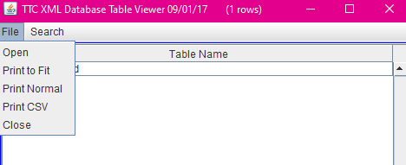

Image 2
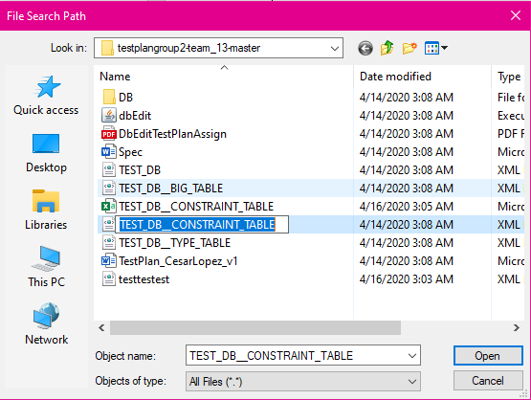

Image 3
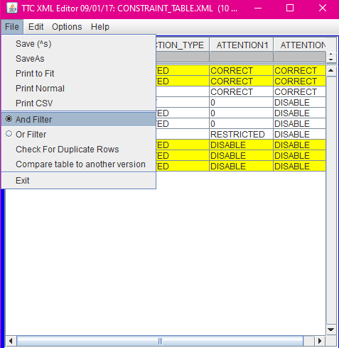

Image 4
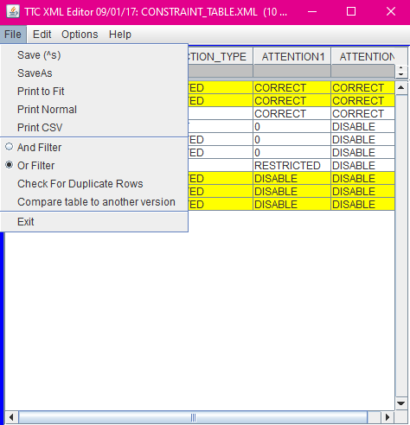

Image 5
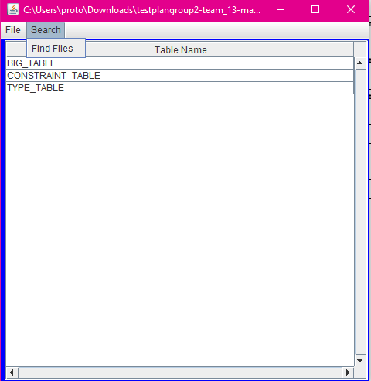

Image 6




