Database (Filter and Search Function)

Test plan

Version <2.0>

04/11/2020

Document Control

Approval

The Guidance Team and the customer shall approve this document.

Document Change Control

|  |  |
| --- | --- |
| Initial Release: | 1.0 |
| Current Release: | 04/11/2020 |
| Indicator of Last Page in Document: | @@@ |
| Date of Last Review: | 04/11/2020 |
| Date of Next Review: |  |
| Target Date for Next Update: |  |

Distribution List

This following list of people shall receive a copy of this document every time a new version of this document becomes available:

Guidance Team Members: Dr. Roach

Customer: Dr. Roach

Software Team Members: Adrian Gonzalez, Valente Arellano, Roman Martinez

Change Summary

The following table details changes made between versions of this document

|  |  |  |  |
| --- | --- | --- | --- |
| Version | Date | Modifier | Description |
| 1.0 | 04/11/2020 | Adrian Gonzalez | First release |
| 2.0 | 04/20/2020 | Adrian Gonzalez | Fixed reviewer comments, and completed sections |
|  |  |  |  |

Note: The template presented in this document was taken from:

Donaldson, S., and S. Siegel, *Successful Software Development*. Upper Saddle River, NJ: Prentice Hall, 2001, pp. 321-323.

Note: The template presented in this document was taken from: Donaldson, S., and S. Siegel, *Successful Software Development*. Upper Saddle River, NJ: Prentice Hall, 2001, pp. 321-323 and modified by Humberto Mendoza and Steve Roach.

Supplementary information is from:

Pfleeger, S. *Software Engineering, Theory and Practice*. Upper Saddle River, NJ: Prentice Hall, 1998, p. 365.

Table of Contents

Document Control ii

Approval ii

Document Change Control ii

Distribution List ii

Change Summary ii

1. Introduction 1

1.1. Purpose 1

1.2. Scope 1

1.3. System Overview 1

1.4. Suspension and Exit Criteria 1

1.5. Document Overview 1

1.6. References 1

2. Test Items and Features 2

3. Testing Approach 3

3.1. System set up 3

4. Test Procedures 4

4.1. Test SR_1 4

4.2. Test SR_2 5

4.3. Test SR_3 6

4.4. Test SR_4 7

4.5. Test SR_5 9

4.6. Test OR_1 2

4.7. Test AND_1 4

5. Appendix 2

# Introduction

The purpose of the project is to assure the right conditions in the software. It will ensure that all processes, and procedures are suitable and implemented properly.

## Purpose

This document will provide the set of test cases used to focus on the input that goes into the application, and the output that it will produce. These test cases ensure the quality of the software from the stakeholders’ perspective. The test approached for this application is Black Box Testing. This approach is done to validate the functional requirements.

## Scope

The scope is to execute a set of test cases into the software and document negative and positive results. Then, they can be modified to suit the expected outcome. They later can be compared and see the progress in between the versions.

## System Overview

The system organizes a set of documents in XML. The system contains two set of documents, a description of the database and the data tables. The system has two functionalities, a search and filter option. For the filter option, the system displays the table as an “AND” or an “OR” function. For the search option, the system allows the user to search for a specific item by matching whole words, match case or by searching on a specific column.

## Suspension and Exit Criteria

Testing should be suspended if 90% of the test cases fail, or if the objective and expected results are not met.

The criteria to suspend and exit the activity and to determine that we have completed all testing, both, the producer and the reviewers must agree that all critical test must pass, and 95% of the non-critical must be successful. This is to guarantee the functionality of the software is within the standards of quality and accurately implemented.

## Document Overview

The remainder of the document provides guidance on the test items in a step by step document to ensure the test plan executes accordingly. It also provides the expected results and a detail description on how to run the test. It also provides the criticality of each of these tests and the feature we are testing for this application.

## References

dbEdit provided by Dr. Roach

Spec.docx provided by Dr. Roach.

# Test Items and Features

The following is a list of the features that will be tested:

* AND Filter
* OR Filter
* Search

# Testing Approach

The approach to be used to test the software is to start from the level of criticality, starting from highest to lowest. The following table describes a list of the specific test to be performed with its respective objective.

Table 1: Test Plan

|  |  |  |
| --- | --- | --- |
| **TEST SUITE <Search Function>** | | |
| **Description of Test Suite** |  | |
| **Test Case Identifier** | **Objective** | **Criticality** |
| SR_1 | **To search for a file** | **High** |
| SR_2 | **Search for items that match case** | **High** |
| SR_3 | **Search for items that match whole words** | **High** |
| SR_4 | **Search and replace item** | **Medium** |
| SR_5 | **Replace all** | **Low** |

|  |  |  |
| --- | --- | --- |
| **TEST SUITE <Filter Function>** | | |
| **Description of Test Suite** |  | |
| **Test Case Identifier** | **Objective** | **Criticality** |
| OR_1 | **To test the OR functionality** | **Medium** |
| AND_1 | **To test the AND functionality** | **Medium** |

## System set up

Before beginning with the test case, the tester must run dbEdit.jar and click on the file tab. Once there, the tester needs to open the desire file i.e. TEST_DB.xml. After selecting the file, a list of table names appears. The tester then can select the desire table.

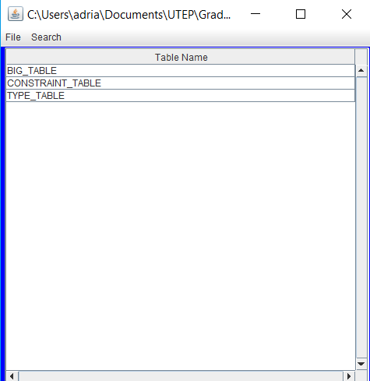

# Test Procedures

This section is to document the performed test cases for the filter and search functionality.

## Test SR_1

**Objective:** Search for a specific file

**Notes:** Once the desired file is identified, the application opens say file and give a new set of tabs

|  |  |  |  |  |  |  |
| --- | --- | --- | --- | --- | --- | --- |
| Test No.: SR_1 | | | | Current Status: Pending | | |
| Test title: Search File | | | | | | |
| Testing approach: This test is to identify the search tab and to make sure it opens the specific file | | | | | | |
| STEP  1  2 | OPERATOR ACTION  Once dbEdit.jar is running, click the “Search” tab  Click on “Find Files” and enter the name of desire table in the search box | PURPOSE  For the user to identify the tab  The system must properly return the name of table | | | EXEPCTED RESULTS  The system must return a list of the files that contains say name | COMMENTS |
| Concluding Remarks: | | | | | | |
| Testing Team:  << List members of testing team and lead >> | | | Date Completed: | | | |

## Test SR_2

**Objective: Search for items that match whole words**

**Notes:** Once the desired file is identified, the application opens say file and give a new set of tabs

|  |  |  |  |  |  |  |
| --- | --- | --- | --- | --- | --- | --- |
| Test No.: SR_2 | | | | Current Status: pending | | |
| Test title: Match Case words | | | | | | |
| Testing approach: Test ensures that the word that needs to be search, is properly return | | | | | | |
| STEP  1  2  3  4 | OPERATOR ACTION  Open desire file and click the “Edit” tab  Click “Search” and enter desire word or integer in the search box  Select the box next to Match Case  Click on “Find” button | PURPOSE  To ensure that the user finds the right option.  To guide the user to the right place  To guide the user to the right place  To guide the user to the right place | | | EXEPCTED RESULTS  The application must return the location of desire word or integer. | COMMENTS |
| Concluding Remarks: | | | | | | |
| Testing Team:  << List members of testing team and lead >> | | | Date Completed: | | | |

## Test SR_3

**Objective:** To ensure that a word or integer can be found with proper capitalization

**Notes:** Operator must enter item in the same box as step 2

|  |  |  |  |  |  |  |
| --- | --- | --- | --- | --- | --- | --- |
| Test No.: SR_3 | | | | Current Status: Pending | | |
| Test title: Match Whole Words | | | | | | |
| Testing approach: In the same box as test two, operator need to enter desire word as is with all capital letters | | | | | | |
| STEP  1  2  3 | OPERATOR ACTION  Once in the desire file, click on “Edit” tab and select search  Click on the search word and enter the word “ReStricTed”  Select “Match Whole Words” and click “Find” button | PURPOSE  To ensure operator is in the proper place  Operator must enter a word as is in the file to ensure the system ignores capitalization  To ensure operator is in the proper place | | | EXEPCTED RESULTS  The application must return the location of say word if found. | COMMENTS |
| Concluding Remarks: | | | | | | |
| Testing Team:  << List members of testing team and lead >> | | | Date Completed: | | | |

## Test SR_4

**Objective:** To test that the replace option properly works

**Notes:** Operator must be in a proper file

|  |  |  |  |  |  |  |
| --- | --- | --- | --- | --- | --- | --- |
| Test No.: SR_4 | | | | Current Status: Pending | | |
| Test title: Search and replace item | | | | | | |
| Testing approach: Operator must run the dbEdit application and open the desire file. | | | | | | |
| STEP  1  2  3  4  5 | OPERATOR ACTION  Once in the desire file, click on “Edit” tab and select search  Click on the search word and enter the word or integer to be replaced  Select “Match Whole Words”  In the replace box, enter word or item to be replace with  Click “Replace” button | PURPOSE  To ensure operator is in the proper place  To ensure operator is in the proper place  This ensures that any word that operator enters is in the file  To ensure operator is in the proper place  To ensure operator is in the proper place | | | EXEPCTED RESULTS  The application must update the table with the new replaced word. | COMMENTS |
| Concluding Remarks: | | | | | | |
| Testing Team:  << List members of testing team and lead >> | | | Date Completed: | | | |

## Test SR_5

**Objective:** This test ensures that the operator is able to replace a word or item when the “Replace” button is clicked (to replace all items)

**Notes:** Operator must be in a proper file

|  |  |  |  |  |  |  |
| --- | --- | --- | --- | --- | --- | --- |
| Test No.: SR_5 | | | | Current Status: Pending | | |
| Test title: Replace all Test | | | | | | |
| Testing approach: Operator must run the dbEdit application and open the desire file. | | | | | | |
| STEP  1  2  3  4  5 | OPERATOR ACTION  Once in the desire file, click on “Edit” tab and select search  Click on the search word and enter the word or integer to bel replaced  Select “Match Whole Words”  In the replace box, enter word or item to be replace with  Click “ReplaceAll” button | PURPOSE  To ensure operator is in the proper place  To ensure operator is in the proper place  This ensures that any word that operator enters is in the file  To ensure operator is in the proper place  To ensure operator is in the proper place | | | EXEPCTED RESULTS  Once the operator clicks “ReplaceAll” the application must find all the words with say word and replace it with the item that the operator entered. | COMMENTS |
| Concluding Remarks: | | | | | | |
| Testing Team:  << List members of testing team and lead >> | | | Date Completed: | | | |

## Test OR_1

**Objective:** This test ensures that the operator can test the functionality of the OR option.

**Notes:** Operator must be in a proper file. The OR filter, will display the rows that contain the criteria

|  |  |  |  |  |  |  |
| --- | --- | --- | --- | --- | --- | --- |
| Test No.: OR_1 | | | | Current Status: Pending | | |
| Test title: Testing OR functionality | | | | | | |
| Testing approach: Operator must run the dbEdit application and open the desire file. | | | | | | |
| STEP  1  2  3 | OPERATOR ACTION  Once in the desire file, click on “File” tab and select “Or Filter”  Under the “Index” column, there is a blank cell in gray color. In that black cell type “57” and press the “Enter” Key  Under the column “Attention1” is a blank gray cell. Type “0” and press the “Enter” key | PURPOSE  To be in the proper place, and enable the “OR” filter option  To ensure that the table displays the proper information  To make sure that the table displays more than one option | | | EXEPCTED RESULTS  The system should display the updated table with the desire values. Then the table will return the row that contains the 57, and finally the table should return a list of rows containing “0” | COMMENTS |
| Concluding Remarks: | | | | | | |
| Testing Team:  << List members of testing team and lead >> | | | Date Completed: | | | |

## Test AND_1

**Objective:** This test is to verify that the functionality of the filter “AND” works properly

**Notes:** Operator must be in a proper file. The OR filter, will display the rows that contain the criteria

|  |  |  |  |  |  |  |
| --- | --- | --- | --- | --- | --- | --- |
| Test No.: AND_1 | | | | Current Status: Pending | | |
| Test title: Testing AND functionality | | | | | | |
| Testing approach: Operator must run the dbEdit application and open the desire file. | | | | | | |
| STEP  1  2  3 | OPERATOR ACTION  Once in the desire file, click on “File” tab and select “And Filter”  Under the “Index” column, there is a black cell in gray color. In that blank cell type “start” and press the “Enter” Key  Under the column “RESTRICTION_TYPE” is a blank gray cell. Type “UNINHIBITED” and press the “Enter” key | PURPOSE  To be in the proper place, and enable the “AND” filter option  This is to ensure that the table is displaying the proper value  To ensure that two or more options are selected | | | EXEPCTED RESULTS  The table should return all the rows that contain the word start. There is a total of eight rows. Once those rows are display, the system should return two rows containing “Start” and “UNINHIBITED” | COMMENTS |
| Concluding Remarks: | | | | | | |
| Testing Team:  << List members of testing team and lead >> | | | Date Completed: | | | |

# Appendix

The appendix will give a visual representation on the expected outcomes of each test.

**Figure 1:**

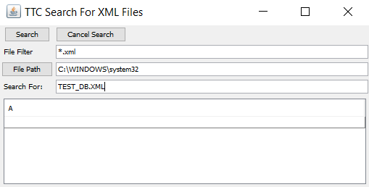

**Figure 2:**

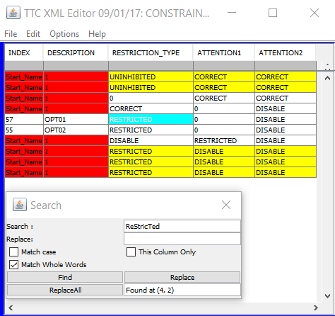

**Figure 3:**

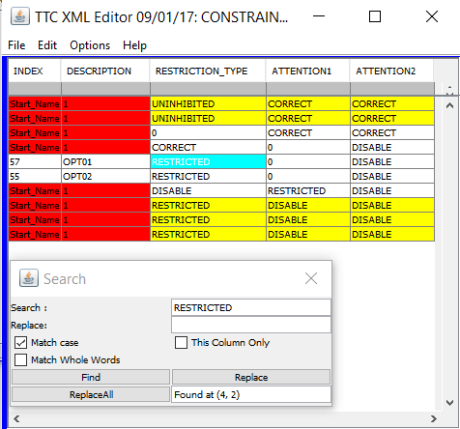

**Figure 4:**

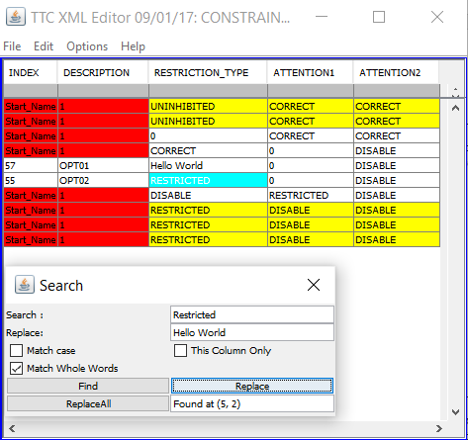

**Figure 5:**

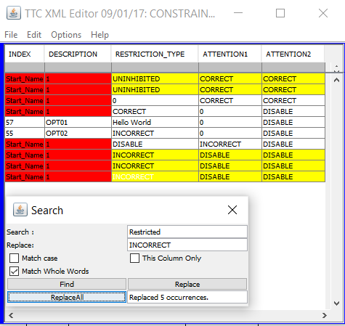

**Figure 6:**

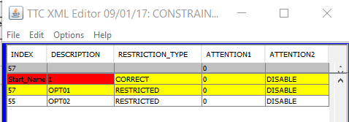

**Figure 7:**

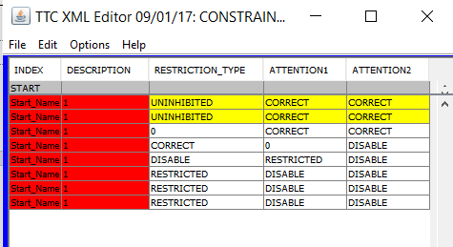

**Figure 8:**



