Julio A Hernandez

88382550

**Pre-Lecture 4/8/20**

1. Consider the threaded code below. Assume that thread1 runs, then thread2, then thread3. What is the final state (i.e., what are the values of the global variables)?

**Am I assuming that there is a wait in between? If there is not, then it will be difficult to know the value since they will run at different times.**

**If they are sequential**

**X=1 Y=2 R=3**

**T1: p = X q=Y z=R**

**T2: r=X p =y y = z**

**T3: a=y a* =y a** 12**

**Y = 3 X=2 R=12**

int x=1, y=2, r=3;

int *p, *q, *z;

int **a;

thread1 (void) /* init p, q, z */

{ p = &x; q=&y; z=&r; }

thread2 (void) /* swap x and y */

{ r = *p; *p = *q; *q = r; }

thread3 (void) /* access z via a and p */

{ a = &p; *a = z; **a = 12; }

2. For the example above, if the threads are not synchronized, how many different interleavings are there, if we assume that each assignment statement is atomic?

**3*3*3**

**27 different combinations**

3. Consider the two unsynchronized FSMs below. How many different interleavings are there?

**2*2= 4 interleaves**

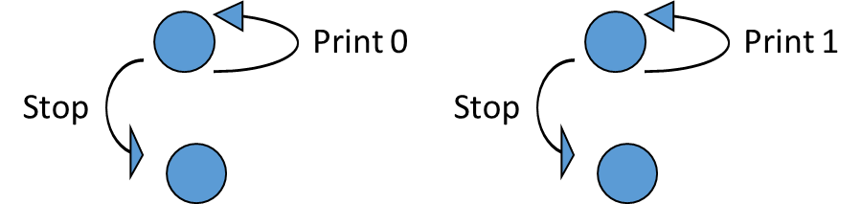

4. In the code below, we have two threads for adding and removing things from a queue. Walk through the scenario where thread1 dequeues and thread2 enqueues.

class Notifying_queue {

private static final queue_size = 10;

private Object[] queue = new Object[ queue_size ];

private int head = 0, tail = 0;

public void synchronized enqueue( Object item ) {

queue[++head %= queue_size ]= item;

this.notify();

}

public Object synchronized dequeue( ) {

try { if( head == tail ) this.wait();

} catch( InterruptedException e ) { // If we get here, we were not actually notified.

return null; // null indicates wait was abandoned, not that queue is empty

}

return queue[++tail %= queue_size ];

}

}

5. Write tests for this code.

|  |  |  |
| --- | --- | --- |
| Description | Test | Expected result |
| Check if correct result is derived | Object | Queue_size = 9 |
| Check for Null object | Null | Queue_size = 10 |
| Check bound | Object with key 0 | Queue_size = 9 |
|  |  |  |