DbEditTestPlanAssign

Test plan

Version <1.0>

4/12/20

Document Control

Approval

The Guidance Team and the customer shall approve this document.

Document Change Control

|  |  |
| --- | --- |
| Initial Release: | 4/1/2020 |
| Current Release: | 4/12/2020 |
| Indicator of Last Page in Document: | ^ |
| Date of Last Review: |  |
| Date of Next Review: |  |
| Target Date for Next Update: | 4/14/2020 |

Distribution List

This following list of people shall receive a copy of this document every time a new version of this document becomes available:

Producer: Hernandez, Julio

Reviewers: Cervantes, Gerardo

Ortiz, Alejandro

Change Summary

The following table details changes made between versions of this document

|  |  |  |  |
| --- | --- | --- | --- |
| Version | Date | Modifier | Description |
| 1.0 | 4/12/2020 | Julio A Hernandez | Initial test plan creation |
|  |  |  |  |
|  |  |  |  |

Note: The template presented in this document was taken from:

Donaldson, S., and S. Siegel, *Successful Software Development*. Upper Saddle River, NJ: Prentice Hall, 2001, pp. 321-323.

Note: The template presented in this document was taken from: Donaldson, S., and S. Siegel, *Successful Software Development*. Upper Saddle River, NJ: Prentice Hall, 2001, pp. 321-323 and modified by Humberto Mendoza and Steve Roach.

Supplementary information is from:

Pfleeger, S. *Software Engineering, Theory and Practice*. Upper Saddle River, NJ: Prentice Hall, 1998, p. 365.

Table of Contents

Document Control ii

Approval ii

Document Change Control ii

Distribution List ii

Change Summary ii

1. Introduction 1

1.1. Purpose 1

1.2. Scope 1

1.3. System Overview 1

1.4. Suspension and Exit Criteria 1

1.5. Document Overview 1

1.6. References 1

2. Test Items and Features 2

3. Testing Approach 3

4. Test XX 4

4.1. Test 1 9

4.2. Test 2 9

4.3. Test 3 10

4.4. Test 4 11

4.5. Test 5 11

5. User Interface Testing 5

6. Test Schedule 6

# Introduction

This test plan is based on the Jar file created by Dr. Roach. The intention is to create a testing plan for the requirements sent up Group 2 Team 8. After the test plans are created they are to be reviewed by two peers and will go through a cycle to improve the quality,

## Purpose

The purpose of this test plan is to test the filter and search function in the edit menu.

## Scope

The scope is the JAR file created by Dr. Roach.

## System Overview

The system analyzed is the database provided.

## Suspension and Exit Criteria

The termination of testing will be done when all test cases are run successfully.

## Document Overview

Test plan to test filter and search function in edit menu.

## References

https://piazza.com/class_profile/get_resource/k55rbh37ri6be/k8hjj7sn7hu7n0

# Test Items and Features

The test encapsulates the search and filter option of dbEdit jar file.

Search: search database by certain keyword

Filter: search and filter results by distinct criteria.

Search Function:

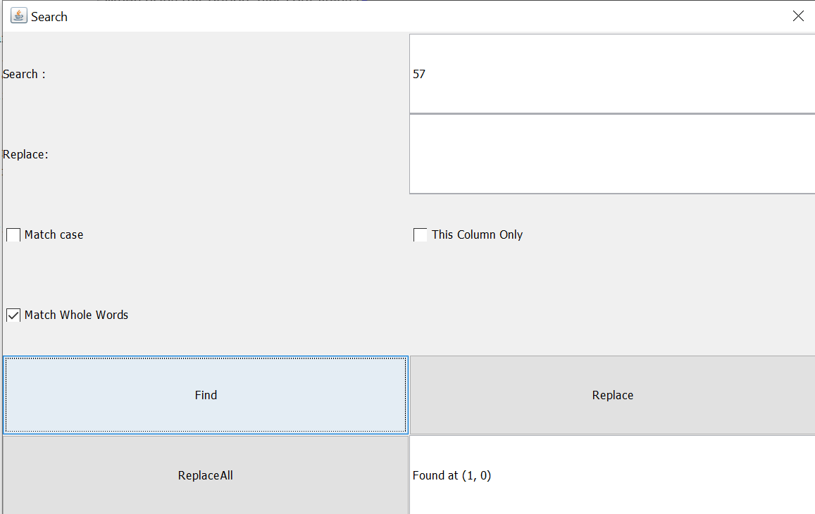

Filter Function:

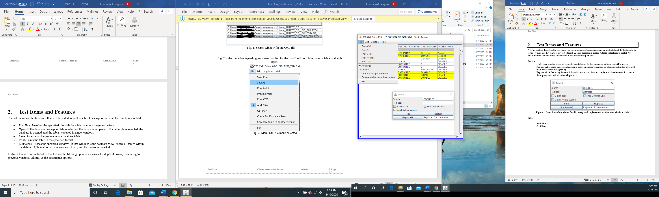

# Testing Approach

The following test will test the functionality of the search and filter function using black box testing.

Table 1: Test Plan

|  |  |  |
| --- | --- | --- |
| **TEST SUITE 1** | | |
| **Description of Test Suite** | **Plan to test functionality of edit and search function.** | |
| **Test Case Identifier** | **Objective** | **Criticality** |
| 1 | **Search a given input** |  |
| 2 | **Search a nonexistent input** |  |
| 3 | **Search and input with duplicate entries** |  |
| 4 | **Functionality of AND filter** |  |
| 5 | **Functionality of OR filter** |  |

# Test Suite 1

Procedure to set up test environment.

1. Run Jar file called dbEdir.jar
2. Click on open, browse and select TEST_DB.xml
3. Double click on CONSTRAINT_TABLE
4. Testing environment has been successfully set up and you should see the following

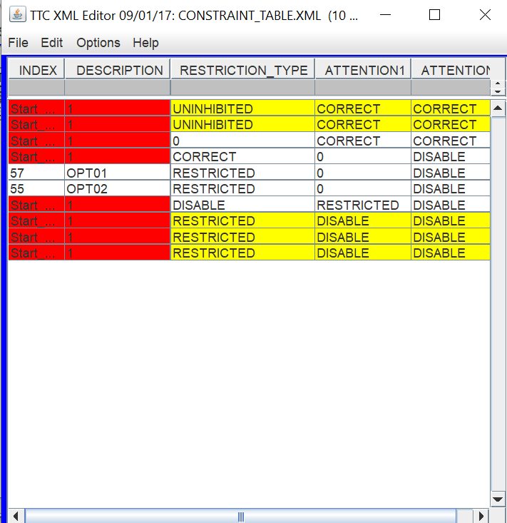

Prerequisites:

* Test environment must be set up
* The Test_DB.XML must be used
* Java must be installed in testing computer

## Test 1

**Objective:** Searcha given input

**Notes:** Meet the perquisites stated to be able to run the test.

Be sure to use the TEST_DB.xml and the CONSTRAINTS_TABLE

|  |  |  |  |  |  |  |
| --- | --- | --- | --- | --- | --- | --- |
| Test No.: 1 | | | | Current Status: Pending | | |
| Test title: Test a input that is expected in a normal basis. An input that exists and will be found | | | | | | |
| Testing approach: Test a use case and make sure all pre-requisites have been met. The Use case in question is the functionality of the search function. The test is intended to test the search function when there is duplicate results. | | | | | | |
| STEP  1 | OPERATOR ACTION  Click on Edit followed by the option labeled search. | PURPOSE  Set up test environment and open the search screen. | | | EXEPCTED RESULTS  The search window will launch. | COMMENTS |
| 2 | Input “OPT02” in the search dialog box and press find. | Test the behavior of the find function. | | | The search will conclude and display the location of the given input. (9,1) |  |
|  | | | | | | |
| Testing Team:  N/A | | | Date Completed:  N/A | | | |

## Test 2

**Objective:** Search a nonexistent input

**Notes:** Meet the perquisites stated to be able to run the test.

Be sure to use the TEST_DB.xml and the CONSTRAINTS_TABLE

|  |  |  |  |  |  |  |
| --- | --- | --- | --- | --- | --- | --- |
| Test No.: 2 | | | | Current Status: Pending | | |
| Test title: Search for a non-existent value | | | | | | |
| Testing approach: Test a use case and make sure all pre-requisites have been met. The Use case in question is the functionality of the search function. The test is intended to test the search function when there is duplicate results. | | | | | | |
| STEP  1 | OPERATOR ACTION  Click on Edit followed by the option labeled search. | PURPOSE  Set up test environment and open the search screen. | | | EXEPCTED RESULTS  The search window will launch. | COMMENTS |
| 2 | Input “123” in the search dialog box and press find. | Test the behavior of the find function. | | | The search will conclude. Return no results and present the user with a message dictating “Search wrapped” |  |
|  | | | | | | |
| Testing Team:  N/A | | | Date Completed:  N/A | | | |

## Test 3

**Objective:** Search a input with multiple duplicate values

**Notes:** Meet the perquisites stated to be able to run the test.

Be sure to use the TEST_DB.xml and the CONSTRAINTS_TABLE

|  |  |  |  |  |  |  |
| --- | --- | --- | --- | --- | --- | --- |
| Test No.: 3 | | | | Current Status: Pending | | |
| Test title: Search an input with duplicate results | | | | | | |
| Testing approach: Test a use case and make sure all pre-requisites have been met. The Use case in question is the functionality of the search function. The test is intended to test the search function when there is duplicate results. | | | | | | |
| STEP  1 | OPERATOR ACTION  Click on Edit followed by the option labeled search. | PURPOSE  Set up test environment and open the search screen. | | | EXEPCTED RESULTS  The search window will launch. | COMMENTS |
| 2 | Input “1” in the search dialog box and press find | Test the behavior of the find function | | | The location of the first occurrence of the given input will be displayed. |  |
|  | | | | | | |
| Testing Team:  N/A | | | Date Completed:  N/A | | | |

## Test 4

**Objective:** Test functionality of AND filter

**Notes:** Meet the perquisites stated to be able to run the test.

Be sure to use the TEST_DB.xml and the CONSTRAINTS_TABLE

|  |  |  |  |  |  |  |
| --- | --- | --- | --- | --- | --- | --- |
| Test No.: 4 | | | | Current Status: Pending | | |
| Test title: AND Filter | | | | | | |
| Testing approach: Test a use case and make sure all pre-requisites have been met. The Use case in question is the functionality of the AND filter. | | | | | | |
| STEP  1 | OPERATOR ACTION  Click on file and select the and filter. | PURPOSE  Sets up the AND filter test. | | | EXEPCTED RESULTS  The environment shall remain the same and instead it will display a checkmark next to the AND field. | COMMENTS |
| 2 | Enter the term “1” in the gray box right below description and “CORRECT” in the gray box below Attention press enter. | Activate the AND filter as soon as enter is pressed. | | | Only the rows with the field “1” AND “correct will be displayed.  3 Rows for the given table will displayed. |  |
|  | | | | | | |
| Testing Team:  N/A | | | Date Completed:  N/A | | | |

## Test 5

**Objective:** Test the OR functionality of the filter function

**Notes:** Meet the perquisites stated to be able to run the test.

Be sure to use the TEST_DB.xml and the CONSTRAINTS_TABLE

|  |  |  |  |  |  |  |
| --- | --- | --- | --- | --- | --- | --- |
| Test No.: 5 | | | | Current Status: Pending | | |
| Test title: OR Filter Function | | | | | | |
| Testing approach: Test a use case and make sure all pre-requisites have been met. The Use case in question is the functionality of the OR filter. | | | | | | |
| STEP  1 | OPERATOR ACTION  Click on file and select the and filter. | PURPOSE  Sets up the OR filter test. | | | EXEPCTED RESULTS  The environment shall remain the same and instead it will display a checkmark next to the OR field. | COMMENTS |
| 2 | Enter the term “1” in the gray box right below description and “CORRECT” in the gray box below Attention press enter. | Activate the OR filter as soon as enter is pressed. | | | Only the rows with the field “1” or “correct will be displayed. As long as they have one of the fields they will be included.  8 Rows for the given table will be displayed. |  |
|  | | | | | | |
| Testing Team:  N/A | | | Date Completed:  N/A | | | |

# User Interface Testing

N/A

# Test Schedule

|  |  |  |
| --- | --- | --- |
| **Task and date** | **People** | **Description** |
|  |  |  |
|  |  |  |
|  |  |  |
|  |  |  |
|  |  |  |
|  |  |  |
|  |  |  |
|  |  |  |
|  |  |  |