DbEditTestPlanAssign

Test plan

Version <1.0>

4/12/20

Document Control

Approval

The Guidance Team and the customer shall approve this document.

Document Change Control

|  |  |
| --- | --- |
| Initial Release: | 4/1/2020 |
| Current Release: | 4/12/2020 |
| Indicator of Last Page in Document: | ^ |
| Date of Last Review: |  |
| Date of Next Review: |  |
| Target Date for Next Update: | 4/14/2020 |

Distribution List

This following list of people shall receive a copy of this document every time a new version of this document becomes available:

Producer: Hernandez, Julio

Reviewers: Cervantes, Gerardo

Ortiz, Alejandro

Change Summary

The following table details changes made between versions of this document

|  |  |  |  |
| --- | --- | --- | --- |
| Version | Date | Modifier | Description |
| 1.0 | 4/12/2020 | Julio A Hernandez | Initial test plan creation |
|  |  |  |  |
|  |  |  |  |

Note: The template presented in this document was taken from:

Donaldson, S., and S. Siegel, *Successful Software Development*. Upper Saddle River, NJ: Prentice Hall, 2001, pp. 321-323.

Note: The template presented in this document was taken from: Donaldson, S., and S. Siegel, *Successful Software Development*. Upper Saddle River, NJ: Prentice Hall, 2001, pp. 321-323 and modified by Humberto Mendoza and Steve Roach.

Supplementary information is from:

Pfleeger, S. *Software Engineering, Theory and Practice*. Upper Saddle River, NJ: Prentice Hall, 1998, p. 365.

Table of Contents

Document Control ii

Approval ii

Document Change Control ii

Distribution List ii

Change Summary ii

1. Introduction 1

1.1. Purpose 1

1.2. Scope 1

1.3. System Overview 1

1.4. Suspension and Exit Criteria 1

1.5. Document Overview 1

1.6. References 1

2. Test Items and Features 2

3. Testing Approach 3

4. Test XX 4

4.1. Test 1 9

4.2. Test 2 9

4.3. Test 3 10

4.4. Test 4 11

4.5. Test 5 11

5. User Interface Testing 5

6. Test Schedule 6

# Introduction

This test plan is based on the Jar file created by Dr. Roach. The intention is to fully test the functionality of the filter and search function. The strategy followed will be unit testing.

## Purpose

The purpose of this test create adequate tests that will make sure the edit function works.

## Scope

The scope is the JAR file created by Dr. Roach. No further versions will be provided. Only this version will be tested.

## System Overview

The system analyzed is the Jar file provided by DR. roach. This JAR file implements functions that alter the contents of a database.

## Suspension and Exit Criteria

The termination of testing will be done when all test cases are run successfully.

## Document Overview

Test plan to test filter and search function in edit menu.

## References

<https://piazza.com/class_profile/get_resource/k55rbh37ri6be/k8hjj7sn7hu7n0>

https://github.com/CS5387/testplangroup2-team_8

# Test Items and Features

The test encapsulates the search and filter option of dbEdit jar file.

This function can search the selected database by a keyword that resides anywhere in the database.

In addition, the search can be focused even more so by checking the following criteria:

* Match case
* This column only
* Match whole words

Search: search database by certain keyword

Filter: search and filter results by distinct criteria.

Search Function:

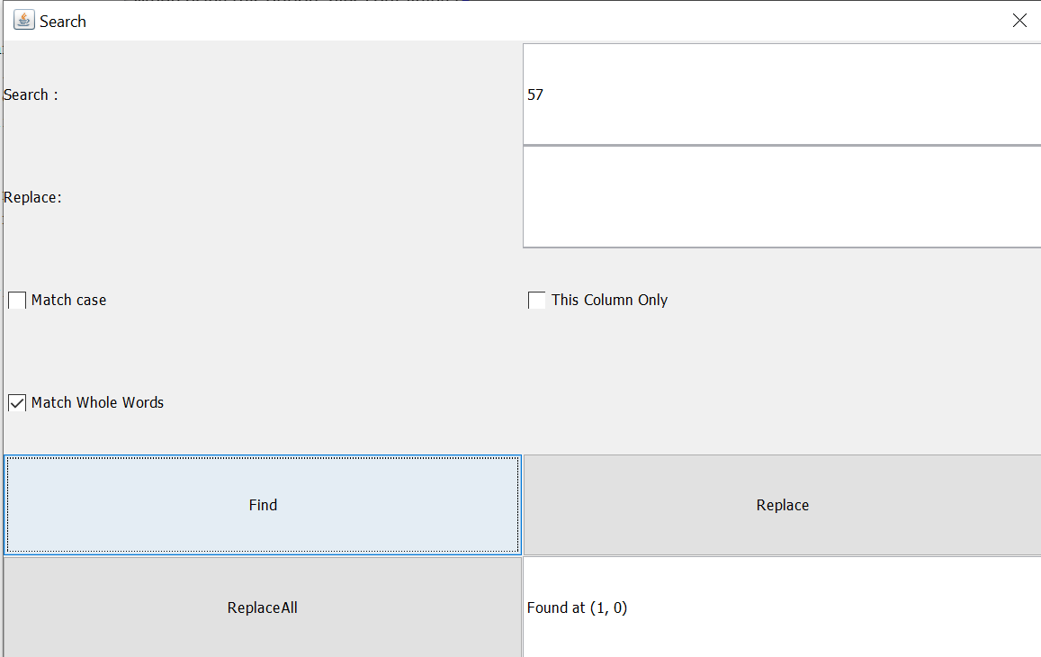

Filter Function:

This function uses boolean logic to filter currently displayed results by either an OR or an AND. By selecting that option and adding a word on a colum the view alters to match all the entered field.

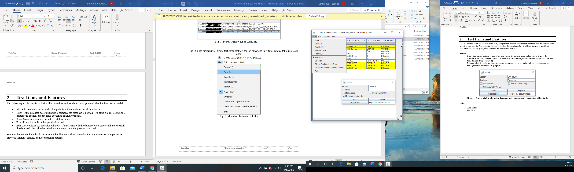

# Testing Approach

The following test will test the functionality of the search and filter function using black box testing.

Table 1: Test Plan

|  |  |  |
| --- | --- | --- |
| **TEST SUITE 1** | | |
| **Description of Test Suite** | **Test functionality of edit and search function.** | |
| **Test Case Identifier** | **Objective** | **Criticality** |
| 1 | **Search with a valid input** | **Medium** |
| 2 | **Search a nonexistent input** | **Medium** |
| 3 | **Search and input with duplicate entries** | **Medium** |
| 4 | **Functionality of AND filter** | **Medium** |
| 5 | **Functionality of OR filter** | **Medium** |

# Test Suite 1

Procedure to set up test environment.

1. Run Jar file called dbEdir.jar
2. Click on open, browse and select TEST_DB.xml
3. Double click on CONSTRAINT_TABLE
4. Testing environment has been successfully set up and you should see the following

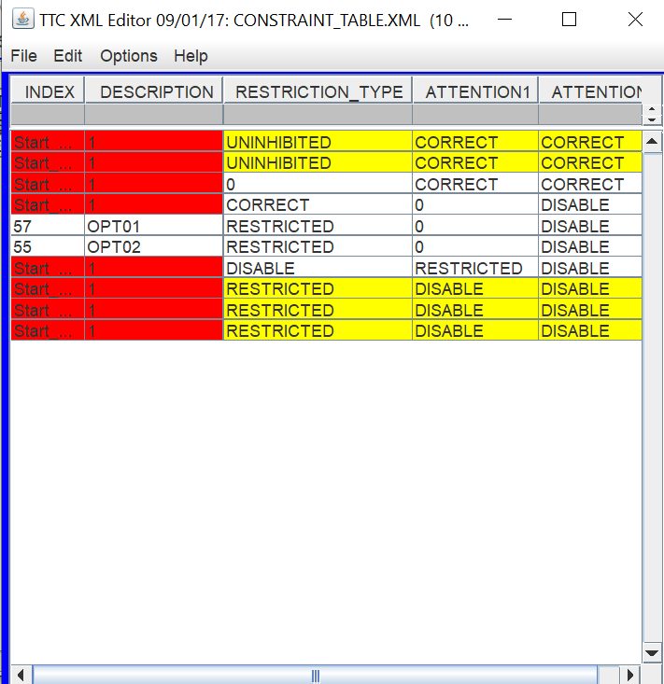

Prerequisites:

* Test environment must be set up
* The Test_DB.XML must be used
* Java must be installed in testing computer

## Test 1

**Objective:** Searcha given input

**Notes:** Meet the perquisites stated to be able to run the test.

Be sure to use the TEST_DB.xml and the CONSTRAINTS_TABLE

|  |  |  |  |  |  |  |
| --- | --- | --- | --- | --- | --- | --- |
| Test No.: 1 | | | | Current Status: Pending | | |
| Test title: Test a input that is expected in a normal basis. An input that exists and will be found | | | | | | |
| Testing approach: Test a use case and make sure all pre-requisites have been met. The use case in question is the functionality of the search function. The test is intended to test the search function when there is duplicate results. | | | | | | |
| STEP  1 | OPERATOR ACTION  Click on Edit followed by the option labeled search. | PURPOSE  Set up test environment and open the search screen. | | | EXEPCTED RESULTS  The search window will launch. | COMMENTS |
| 2 | Input “OPT02” in the search dialog box and press find. | Test the behavior of the find function. | | | The search will conclude and display the location of the given input. (9,1) |  |
| **Figure 1: Expected output Test No. 1** | | | | | | |
| Testing Team:  TBA | | | Date Completed:  TBA | | | |

## Test 2

**Objective:** Search a nonexistent input

**Notes:** Meet the perquisites stated to be able to run the test.

Be sure to use the TEST_DB.xml and the CONSTRAINTS_TABLE

|  |  |  |  |  |  |  |
| --- | --- | --- | --- | --- | --- | --- |
| Test No.: 2 | | | | Current Status: Pending | | |
| Test title: Search for a non-existent value | | | | | | |
| Testing approach: Test a use case and make sure all pre-requisites have been met. The use case in question is the functionality of the search function. The test is intended to test the search function when there is duplicate results. | | | | | | |
| STEP  1 | OPERATOR ACTION  Click on Edit followed by the option labeled search. | PURPOSE  Set up test environment and open the search screen. | | | EXEPCTED RESULTS  The search window will launch. | COMMENTS |
| 2 | Input “123” in the search dialog box and press find. | Test the behavior of the find function. | | | The search will conclude. Return no results and present the user with a message dictating “Search wrapped” |  |
| **Figure 2: Expected output Test No. 2** | | | | | | |
| Testing Team:  TBA | | | Date Completed:  TBA | | | |

## Test 3

**Objective:** Search a input with multiple duplicate values

**Notes:** Meet the perquisites stated to be able to run the test.

Be sure to use the TEST_DB.xml and the CONSTRAINTS_TABLE

|  |  |  |  |  |  |  |
| --- | --- | --- | --- | --- | --- | --- |
| Test No.: 3 | | | | Current Status: Pending | | |
| Test title: Search an input with duplicate results | | | | | | |
| Testing approach: Test a use case and make sure all pre-requisites have been met. The use case in question is the functionality of the search function. The test is intended to test the search function when there is duplicate results. | | | | | | |
| STEP  1 | OPERATOR ACTION  Click on Edit followed by the option labeled search. | PURPOSE  Set up test environment and open the search screen. | | | EXEPCTED RESULTS  The search window will launch. | COMMENTS |
| 2 | Input “1” in the search dialog box and press find | Test the behavior of the find function | | | The location of the first occurrence of the given input will be displayed. |  |
| **Figure 3: Expected output Test No. 3** | | | | | | |
| Testing Team:  TBA | | | Date Completed:  TBA | | | |

## Test 4

**Objective:** Test functionality of AND filter

**Notes:** Meet the perquisites stated to be able to run the test.

Uses boolean logic to change the displayed information. A filter word will be added and the filter option will AND it.

Be sure to use the TEST_DB.xml and the CONSTRAINTS_TABLE

|  |  |  |  |  |  |  |
| --- | --- | --- | --- | --- | --- | --- |
| Test No.: 4 | | | | Current Status: Pending | | |
| Test title: AND Filter | | | | | | |
| Testing approach: Test a use case and make sure all pre-requisites have been met. The use case in question is the functionality of the AND filter. | | | | | | |
| STEP  1 | OPERATOR ACTION  Click on file and select the and filter. | PURPOSE  Sets up the AND filter test. | | | EXEPCTED RESULTS  The environment shall remain the same and instead it will display a checkmark next to the AND field. | COMMENTS |
| 2 | Enter the term “1” in the gray box right below description and “CORRECT” in the gray box below Attention press enter. | Activate the AND filter as soon as enter is pressed. | | | Only the rows with the field “1” AND “correct will be displayed.  3 Rows for the given table will displayed. |  |
| **Figure 4: Expected output Test No. 4** | | | | | | |
| Testing Team:  TBA | | | Date Completed:  TBA | | | |

## Test 5

**Objective:** Test the OR functionality of the filter function

**Notes:** Meet the perquisites stated to be able to run the test.

Uses boolean logic to change the displayed information. A filter word will be added and the filter option will OR it.

Be sure to use the TEST_DB.xml and the CONSTRAINTS_TABLE

|  |  |  |  |  |  |  |
| --- | --- | --- | --- | --- | --- | --- |
| Test No.: 5 | | | | Current Status: Pending | | |
| Test title: OR Filter Function | | | | | | |
| Testing approach: Test a use case and make sure all pre-requisites have been met. The use case in question is the functionality of the OR filter. | | | | | | |
| STEP  1 | OPERATOR ACTION  Click on file and select the and filter. | PURPOSE  Sets up the OR filter test. | | | EXEPCTED RESULTS  The environment shall remain the same and instead it will display a checkmark next to the OR field. | COMMENTS |
| 2 | Enter the term “1” in the gray box right below description and “CORRECT” in the gray box below Attention press enter. | Activate the OR filter as soon as enter is pressed. | | | Only the rows with the field “1” or “correct will be displayed. As long as they have one of the fields they will be included.  8 Rows for the given table will be displayed. |  |
| **Figure 5: Expected output Test No. 5** | | | | | | |
| Testing Team:  TBA | | | Date Completed:  TBA | | | |

# Test Schedule

|  |  |  |
| --- | --- | --- |
| **Task and date** | **People** | **Description** |
| TBD | TBD | TBD |
|  |  |  |
|  |  |  |
|  |  |  |
|  |  |  |
|  |  |  |
|  |  |  |
|  |  |  |
|  |  |  |