Db Edit Test Plan Assignment

Test plan

Version 2.0

April 16, 2020

Document Control

Approval

The Guidance Team and the customer shall approve this document.

Document Change Control

|  |  |
| --- | --- |
| Initial Release: | 1.0 |
| Current Release: | 2.0 |
| Indicator of Last Page in Document: | $ |
| Date of Last Review: | 13 APR 20 |
| Date of Next Review: | TBD |
| Target Date for Next Update: | TBD |

Distribution List

This following list of people shall receive a copy of this document every time a new version of this document becomes available:

Guidance Team Members: Dr. Steve Roach

Customer: N/A

Software Team Members: Aaron Himan (author),

Bianca De La Cruz (reviewer),

Ricardo Pena (reviewer)

Change Summary

The following table details changes made between versions of this document

|  |  |  |  |
| --- | --- | --- | --- |
| Version | Date | Modifier | Description |
| 1.0 | 8 APR 20 | Aaron Himan | Initial Test Plan |
| 2.0 | 16 APR 20 | Aaron Himan | Revised |
|  |  |  |  |

Note: The template presented in this document was taken from:

Donaldson, S., and S. Siegel, *Successful Software Development*. Upper Saddle River, NJ: Prentice Hall, 2001, pp. 321-323.

Note: The template presented in this document was taken from: Donaldson, S., and S. Siegel, *Successful Software Development*. Upper Saddle River, NJ: Prentice Hall, 2001, pp. 321-323 and modified by Humberto Mendoza and Steve Roach.

Supplementary information is from:

Pfleeger, S. *Software Engineering, Theory and Practice*. Upper Saddle River, NJ: Prentice Hall, 1998, p. 365.

Table of Contents

Document Control ii

Approval ii

Document Change Control ii

Distribution List ii

Change Summary ii

1. Introduction 1

1.1. Purpose 1

1.2. Scope 1

1.3. System Overview 1

1.4. Suspension and Exit Criteria 1

1.5. Document Overview 1

1.6. References 1

2. Test Items and Features 2

2.1. Test Items 2

2.2. Test Features 2

3. Testing Approach 3

4. Group 2 Test Cases 4

4.1. Test 1 4

4.2. Test 2 5

4.3. Test 3 6

4.4. Test 4 7

4.5. Test 5 8

5. Test Schedule 9

6. Other Sections 10

6.1. Software Requirements 10

7. Appendix 11

7.1. Opening Database Files with File -> Open 11

7.2. Database Edit and Table Edit Windows 11

7.3. Filter Search 11

7.4. Filter Types 12

7.5. Filter Help Screen Logic Example 12

# Introduction

Db Edit Test Plan Assignment is a CS 5387 Software Integration and V&V assignment. The project is the test plan assignment, which is to test Dr. Roach’s database table editor. Students are to complete the assignment in order to learn and practice creating test plans as well as performing inspections.

## Purpose

The project is Dr. Roach’s database table editor. Included in this document is the description of the test items and features, testing approach, test cases, and test schedule. This document will cover a small portion of black box system testing which will be explained in more detail under section 1.2 Scope.

## Scope

The scope of the project is of Dr. Roach’s database table editor filter row and edit menu search function. It is intended as a class assignment so only the provided version is to be considered. These portions to be tested will be explained in more detail in section 1.3 System Overview.

## System Overview

The system to be tested is Dr. Roach’s database table editor. Since the test plan is for group 2, the test plan will contain test cases to test the filter row of the database table display as well as the search function in the edit menu. The display filter row is the black row just under the column names. Entering data in this row should result in only the matching data rows to be displayed. The edit search function allows search and replace of an entire database table.

## Suspension and Exit Criteria

There are not suspension criteria or exit criteria for this project.

## Document Overview

The remainder of this document is the description of the test items and features, testing approach, test cases, and test schedule.

## References

* DbEditTestPlanAssign.pdf
* TestPlanAssign040120.pptx
* Spec.docx

# Test Items and Features

This section will describe test items and features to be tested.

## Test Items

Test items include everything found in our group 2 team 9 repository, located at <https://github.com/CS5387/testplangroup2-team_9.git>. The directly used files for testing are the following:

* dbEdit.jar: The executable to run the database editing tool.
* TEST_DB.xml: The database file.
* TEST_DB__CONSTRAINT_TABLE.XML: The xml file for the constraint table.
* TEST_DB__TYPE_TABLE.XML: The xml file for the type table.

A more detailed description of the software can be found in Spec.docx, DbEditTestPlanAssign.docx, and TestPlanAssign040120.pptx provided by Dr. Roach.

## Test Features

The features of the program to be tested are the filter and the search function in the edit menu. The display filter row is the black row just under the column names. Entering data in this row should result in only the matching data rows to be displayed. The edit search function allows search and replace of an entire database table. The tests are limited to five test cases.

# Testing Approach

The approach used in this test plan is to test the functionality of the data base editing tool. The testing is limited to the filter functionality and the edit search functionality since the test plan is for group 2. This test plan is limited to only five tests, so the tests that cover what may be specification errors or tests that cover main parts of the filter or search functionality are used.

Table 1: Test Plan

|  |  |  |
| --- | --- | --- |
| **TEST SUITE Group 2 Test Cases** | | |
| **Description of Test Suite** | The test suite is intended to test the filter functionality and the edit search functionality of the database editing tool. | |
| **Test Case Identifier** | **Objective** | **Criticality** |
| 1 | To test the logic of the filter help screen example of “< 12”. | *low |
| 2 | To test the OR functionality of the filter. | *low |
| 3 | To test the AND functionality of the filter. | *low |
| 4 | To test the grammar of the filter as well as single values being converted to double precision. | *low |
| 5 | To test the replace all functionality. | *low |

* Criticality is low as this test plan is only for class/assignment purposes.

# Group 2 Test Cases

This section documents the tests to be ran on the database table editing tool. This section will document specific test input, procedures, and outcomes.

## Test 1

**Objective:** To test the logic of the filter help screen example of “< 12”.

**Notes:** The specification states the filters allow a limited amount of regular expression matching described on the help pages. The example in question is highlighted in Appendix 7.5 Filter Help Screen Logic Example. The filter help screen can be viewed in the application from the table view screen by selecting help -> filter.

|  |  |  |  |  |  |  |
| --- | --- | --- | --- | --- | --- | --- |
| Test No.: 1 | | | | Current Status: Pending | | |
| Test title: Filter Help Screen Logic Example | | | | | | |
| Testing approach:  Clone the data base editing tool/repository from the team repository located at <https://github.com/CS5387/testplangroup2-team_9.git>, and open dbEdit.jar. | | | | | | |
| STEP | OPERATOR ACTION | PURPOSE | | | EXEPCTED RESULTS | COMMENTS |
| 1. | Choose, File -> Open and select TEST_DB. | To populate the database edit window. | | | The database edit window is populated with BIG_TABLE, CONSTRAINT_TABLE, and TYPE_TABLE. |  |
| 2. | Double click Type_Table. | To open Type_TABLE table edit window. | | | TYPE_TABLE table edit window is shown. |  |
| 3. | Enter < 12 in the filter section under the FIELD_SMALLINT column name. Push enter. | To check if the program selects all cells greater than 12 as specified in the filter help screen. | | | No rows should be displayed since no value in the column is over 12. |  |
| Concluding Remarks: | | | | | | |
| Testing Team:  TBD | | | Date Completed: | | | |

## Test 2

**Objective:** To test the OR functionality of the filter.

**Notes:** The filter help screen can be viewed from the table view screen by selecting help -> filter.

|  |  |  |  |  |  |
| --- | --- | --- | --- | --- | --- |
| Test No.: 2 | | | Current Status: Pending | | |
| Test title: OR Filter | | | | | |
| Testing approach:  Clone the data base editing tool/repository from the team repository located at <https://github.com/CS5387/testplangroup2-team_9.git>, and open dbEdit.jar. | | | | | |
| STEP | OPERATOR ACTION | PURPOSE | | EXEPCTED RESULTS | COMMENTS |
| 1. | Choose, File -> Open and select TEST_DB. | To populate the database edit window. | | The database edit window is populated with BIG_TABLE, CONSTRAINT_TABLE, and TYPE_TABLE. |  |
| 2. | Double click CONSTRAINT_TABLE | To open CONSTRAINT_TABLE table edit window. | | CONSTRAINT_TABLE table edit window is shown. |  |
| 3. | In the table edit window, select File -> Or Filter | To ensure using the “or filter” | | A mark is to the left of “Or Filter” in the file menu. |  |
| 4. | Enter “55” into the INDEX filter, “OPT01” in the DESCRIPTION filter, “2” in the RESTRICTION_TYPE filter, “2” in the ATTENTION1 filter, and “2” in the ATTENTION2 filter. | To select rows matching INDEX:55 OR DESCRIPTION: OPT01 OR RESTRICTION_TYPE:2 OR ATTENTION1:2 or ATTENTION2:2 | | Only the rows with index 57 and index 55 should be selected. |  |
| Concluding Remarks: | | | | | |
| Testing Team:  TBD | | | Date Completed: | | |

## Test 3

**Objective:** To test the AND functionality of the filter.

**Notes:** The filter help screen can be viewed from the table view screen by selecting help -> filter.

|  |  |  |  |  |  |
| --- | --- | --- | --- | --- | --- |
| Test No.: 3 | | | Current Status: Pending | | |
| Test title: AND Filter | | | | | |
| Testing approach:  Clone the data base editing tool/repository from the team repository located at <https://github.com/CS5387/testplangroup2-team_9.git>, and open dbEdit.jar. | | | | | |
| STEP | OPERATOR ACTION | PURPOSE | | EXEPCTED RESULTS | COMMENTS |
| 1. | Choose, File -> Open and select TEST_DB. | To populate the database edit window. | | The database edit window is populated with BIG_TABLE, CONSTRAINT_TABLE, and TYPE_TABLE. |  |
| 2. | Double click CONSTRAINT_TABLE | To open CONSTRAINT_TABLE table edit window. | | CONSTRAINT_TABLE table edit window is shown. |  |
| 3. | In the table edit window, select File -> And Filter | To ensure using the “AND filter” | | A mark is to the left of “And Filter” in the file menu. |  |
| 4. | Enter “55” into the INDEX filter, “OPT02” in the DESCRIPTION filter, “RESTRICTED” in the RESTRICTION_TYPE filter, “0” in the ATTENTION1 filter, and “DISABLE” in the ATTENTION2 filter. | Only the rows matching every filter should show for AND condition | | Only the row with index 55 should be selected. |  |
| 5. | Change the ATTENTION2 filter to “CORRECT” | Make one filter not match (ATTENTION2 column filter) to make sure it isn’t just checking the first filter only and displaying the row since then. | | No rows should be showing. |  |
| Concluding Remarks: | | | | | |
| Testing Team:  TBD | | | Date Completed: | | |

## Test 4

**Objective:** To test the grammar of the filter as well as single values being converted to double precision.

**Notes:** This tests grammar described in the filter help section with different operations as well as checking single values are converted to double precision. The filter help screen can be viewed from the table view screen by selecting help -> filter.

|  |  |  |  |  |  |
| --- | --- | --- | --- | --- | --- |
| Test No.: 4 | | | Current Status: Pending | | |
| Test title: Filter grammar and double test | | | | | |
| Testing approach:  Clone the data base editing tool/repository from the team repository located at <https://github.com/CS5387/testplangroup2-team_9.git>, and open dbEdit.jar. | | | | | |
| STEP | OPERATOR ACTION | PURPOSE | | EXEPCTED RESULTS | COMMENTS |
| 1. | Choose, File -> Open and select TEST_DB. | To populate the database edit window. | | The database edit window is populated with BIG_TABLE, CONSTRAINT_TABLE, and TYPE_TABLE. |  |
| 2. | Double click TYPE_TABLE | To open TYPE_TABLE table edit window. | | TYPE_TABLE table edit window is shown. |  |
| 3. | In the second filter (under FIELD_SMALLINT column) enter “((< 6 && > 3) && !5.0)” and press enter. | To filter out numbers between 3 and 6 that are not 5. | | Only the seven rows with 4 in the FIELD_SMALLINT column should be showing. |  |
| Concluding Remarks: | | | | | |
| Testing Team:  TBD | | | Date Completed: | | |

## Test 5

**Objective:** To test the replace all functionality.

**Notes:** The search help screen which assists in explaining the replacing functionality can be viewed from the table view screen by selecting help -> Search.

|  |  |  |  |  |  |
| --- | --- | --- | --- | --- | --- |
| Test No.: 5 | | | Current Status: Pending | | |
| Test title: Replace All | | | | | |
| Testing approach:  Clone the data base editing tool/repository from the team repository located at <https://github.com/CS5387/testplangroup2-team_9.git>, and open dbEdit.jar. | | | | | |
| STEP | OPERATOR ACTION | PURPOSE | | EXEPCTED RESULTS | COMMENTS |
| 1. | Choose, File -> Open and select TEST_DB. | To populate the database edit window. | | The database edit window is populated with BIG_TABLE, CONSTRAINT_TABLE, and TYPE_TABLE. |  |
| 2. | Double click CONSTRAINT_TABLE | To open CONSTRAINT_TABLE table edit window. | | CONSTRAINT_TABLE table edit window is shown. |  |
| 3. | Click Edit->Search | To open the edit search window | | The search window is shown. |  |
| 6. | Enter “UNINHIBITED” into the search box and click Find | To search for UNINHIBITED | | Found at (0,2) should appear in the bottom of the search window. |  |
| 7. | Enter “DISABLE” in the Replace box and click ReplaceAll |  | | Section (0,2) and (1,2) should now say DISABLE |  |
| Concluding Remarks: | | | | | |
| Testing Team:  TBD | | | Date Completed: | | |

# Test Schedule

A test schedule is not applicable since this test plan is meant for only creating/reviewing. The assignment states reviewers cannot modify the content of this test plan and can only comment on it. The test outcomes will not be recorded on this document and the reviewers may or may not run the tests on their own schedule. The test plan itself is to be completely reviewed and revised by April 21st.

# Other Sections

## Software Requirements

The software required for testing is included in the Github Group 2 Team 9 repository found at <https://github.com/CS5387/testplangroup2-team_9>. A description of the software can be found in DbEditTestPlanAssign.docx, Spec.docx, and TestPlanAssign040120.pptx.

# Appendix

This section contains images to help navigate the database editing tool.

## Opening Database Files with File -> Open

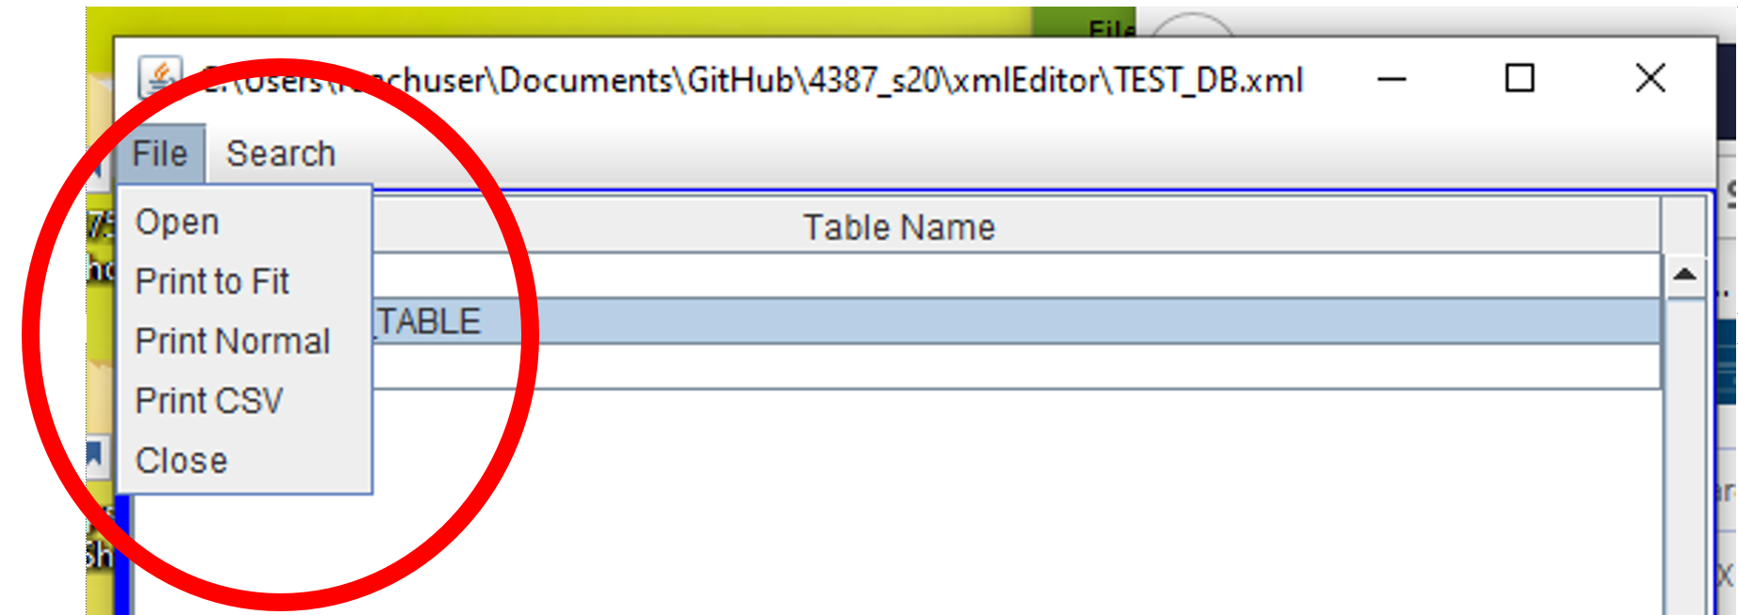

## Database Edit and Table Edit Windows

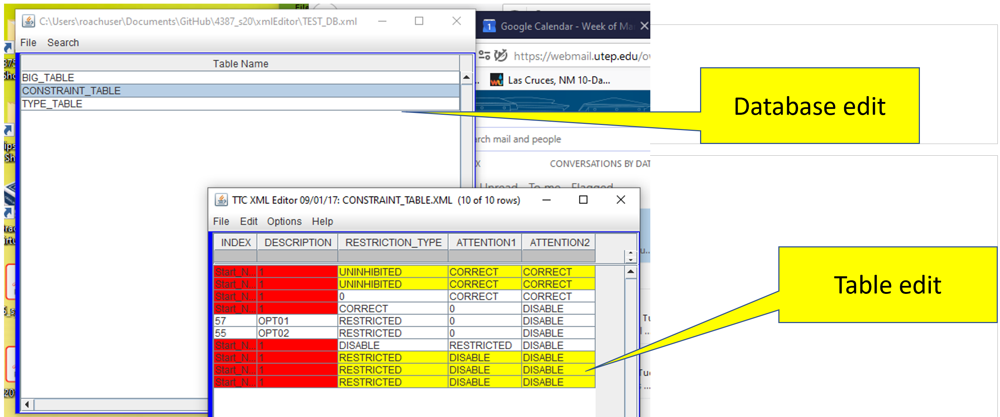

## Filter Search

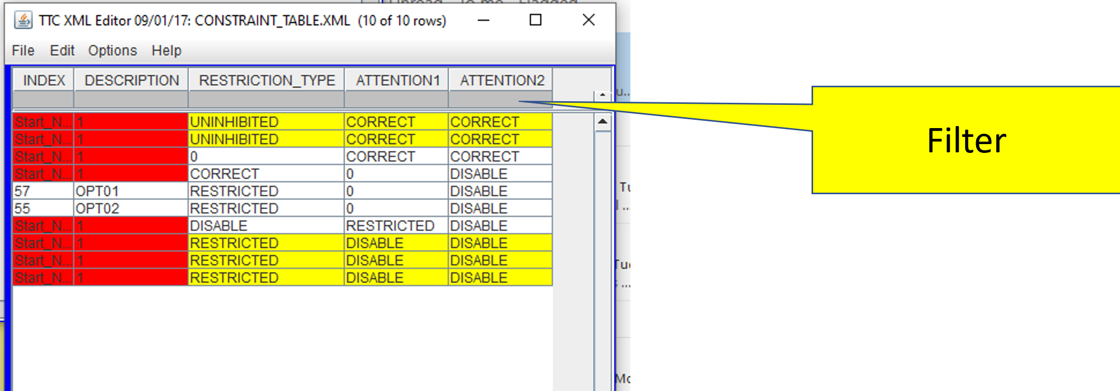

## Filter Types

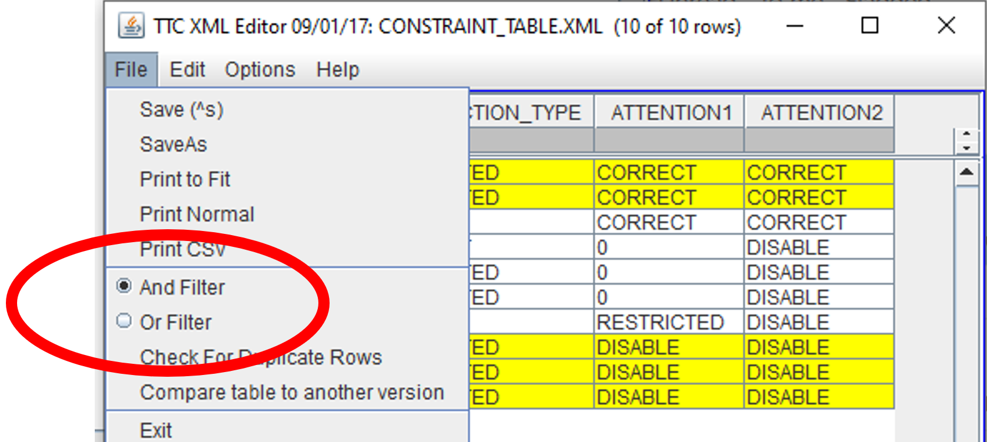

## Filter Help Screen Logic Example



