TestPlan_DianaRamirez_v1.0
Version 1.2
04/014/2020
Document Control
Approval
The Guidance Team and the customer shall approve this document.
Document Change Control
Initial Release: | 1.0
Current Release: | 1.2
Indicator of Last Page in Document:
Date of Last Review: | 04/14/2020
Date of Next Review: | 04/17/2020
Target Date for Next Update: | 04/19/2020
Distribution List
This following list of people shall receive a copy of this document every time a new version of this document becomes available:

Customer: Dr. Roach

Software Team Members: Charly Juarez
Diana L. Ramirez
Ernesto Vazquez
Change Summary
The following table details changes made between versions of this document

Version | Date | Modifier | Description
1.0 | 04/02/2020 | Diana Ramirez | Introduction: Purpose & System Overview
1.1 | 04/05/2020 | Diana Ramirez | Section 3 and 4
1.2 | 04/14/2020 | Diana Ramirez | Comments updates

Note: The template presented in this document was taken from:
Donaldson, S., and S. Siegel, Successful Software Development. Upper Saddle River, NJ: Prentice Hall, 2001, pp. 321-323.

Note: The template presented in this document was taken from: Donaldson, S., and S. Siegel, Successful Software Development. Upper Saddle River, NJ: Prentice Hall, 2001, pp. 321-323 and modified by Humberto Mendoza and Steve Roach.

Supplementary information is from:
Pfleeger, S. Software Engineering, Theory and Practice. Upper Saddle River, NJ: Prentice Hall, 1998, p. 365.

Table of Contents
Document Control ii
Approval ii
Document Change Control ii
Distribution List ii
Change Summary ii
1. Introduction 1
1.1. Purpose 1
1.2. Scope 1
1.3. System Overview 1
1.4. Suspension and Exit Criteria 1
1.5. Document Overview 1
1.6. References 1
2. Test Items and Features 2
3. Testing Approach 4
4. Test XX and User Interface Testing 5
4.1. Test A 5
4.2. Test B 7
4.3. Test C 9
4.4. Test D 10
4.5. Test E 11
5. Test Schedule 14
6. Appendix 15

Introduction

Purpose
The purpose of this unit test plan is to provide test cases for the dbEdit(Database Editor) system’s edit operations for validation and verification purposes. The dbEdit system is a database table editor and viewer. The test cases will focus on the edit menu operations in the user’s interface part of this system.

Scope
The scope of this test plan encompasses the initial release of the dbEdit (Database Editor) system provided by Dr. Roach.

System Overview
The dbEdit system is a database table editor and viewer. The system’s configuration data is stored in XML files, and it does not allow modifications to the database’s schema. The XML files either describe the database or contain the data tables. In this system, a database is defined as a “set of flat files organized as rows and columns [and] collection of related files are contained in a database.”

Suspension and Exit Criteria
To be determined.

Document Overview
This document contains a unit test plan for the dbEdit (Database Editor) system’s table edit operations. The following sections describe the test items and the edit menu features. In the testing approach section 3, test case objectives are listed along with their unique identified and a corresponding criticality label. Section 4 includes a detailed description and testing approach of all 5 tests conducted for the edit unit, including detailed steps to conduct each test, the purpose of each step, their expected results and some comments for certain steps. The last section of this document, section 5, includes a testing schedule table used by management for test assignment.

References
dbEdit (Database Editor) system spec document Spec.docx
Github repository: https://github.com/CS5387/testplangroup3-team12

Test Items and Features
The following figures represent the location of test items and features of the edit menu to be tested. Test cases are described in section 4.

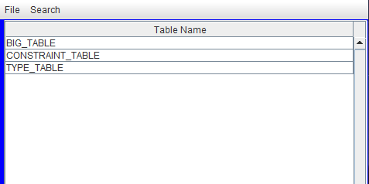

Figure 1. Window showing the dbEdit system running with xml files already loaded onto it.

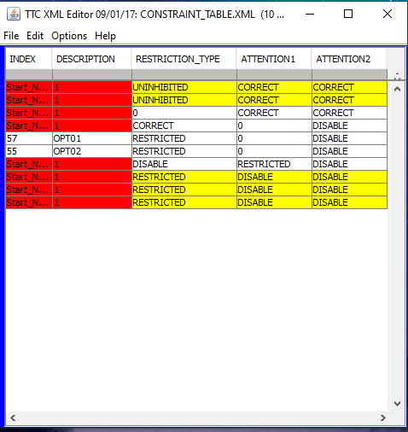

Figure 2. Window showing the CONSTRAINT_TABLE.XML table opened and ready to use with the dbEdit system.

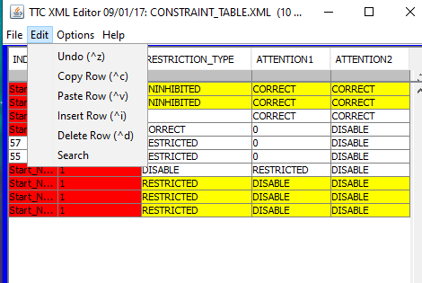

Figure 3. Operations to be tested are located under the Edit menu of a table viewer window.

The Edit menu is only accessible through a table viewer window, therefore a selected XML file should be loaded onto and opened on the dbEdit system. Also, it is important to note that most of the operations in the menu have an assigned keyboard shortcut.

Testing Approach

This document contains tests to evaluate the edit operations that could be performed on a table in the dbEdit (Data Editor) system. The following table describes the objectives of their respective test case, identified by a unique identifier. Each test is composed of a series of steps described in section 4 of this document. The criticality of each test was determined based on their importance for performing operations on a table.

Table 1: Test Plan
TEST SUITE 1
Description of Test Suite | This test suite will cover the operations of the edit menu in a table.
Test Case Identifier | Objective | Criticality
A | Test Undo and its keyboard shortcut for different table alterations.
B | Test Copy and Paste Row operations and their respective keyboard shortcuts
C | Test Insert Row operation and its keyboard shortcut
D | Test Delete Row operation and its keyboard shortcut
E | Test the Search operations.

Test XX and User Interface Testing

Test A

Objective: The objective of this test is to test the Undo operation after altering the table and its keyboard shortcut
Notes: This test will be conducted using the dbEdit jar file and the TEST_DB XML document. The TEST_DB File should already be loaded on the jar file and ready to use. Table Name section on the window should include BIG_TABLE, CONSTRAINT_TABLE and TYPE_TABLE (See Figure 1). All tables should be opened in their own separate window and a mouse and a keyboard should be available to operate the jar file.

Test No.: A.1.1 |  |  |  | Current Status: Pending
Test title: Undo text alteration in table cell using the edit menu options.

Testing approach: For this test case, the table named CONSTRAINT_TABLE.XML should be used to conduct all the following steps.
STEP  1 | OPERATOR ACTION  Double-click on any cell in table, this cell should contain text. | PURPOSE  Select an appropriate cell to conduct the test. |  |  | EXPECTED RESULTS  The text inside the cell should be highlighted and text cursor (flashing vertical line) should appear. | COMMENTS  See figure 4.
2 | Delete the text inside the cell using the Backspace key on your keyboard. | Produce a change in the table. |  |  | The text inside the cell should be deleted and the cell color should change to red.
3 | Select the Edit menu and click on the undo option. | Test that the undo option in the menu works. |  |  | The text inside the cell should be reestablished, and the cell color should change to its original color.
Concluding Remarks: All referenced figures are contained in the Appendix.
Testing Team:  << List members of testing team and lead >> |  |  | Date Completed:

Test No.: A.1.2 |  |  |  | Current Status: Pending
Test title: Undo text alteration in table cell using the keyboard shortcut.

Testing approach: For this test case, the table named CONSTRAINT_TABLE.XML should be used to conduct all the following steps.
STEP  1 | OPERATOR ACTION  Double-click on any cell in table, this cell should contain text. | PURPOSE  Select an appropriate cell to conduct the test. |  |  | EXPECTED RESULTS  The text inside the cell should be highlighted and text cursor (flashing vertical line) should appear. | COMMENTS  See figure 4.
2 | Delete the text inside the cell using the Backspace key on your keyboard. | Produce a change in the table. |  |  | The text inside the cell should be deleted and the cell color should change to red.
3 | Using the keyboard, press and hold “CTRL”, followed by pressing the “z” key in that order. | Demonstrate keyboard shortcut for undo is functional. |  |  | The contents of the previously selected cell should be reestablished. | If MacOs used to conduct tests, replace “CTRL” key with “Command” key.
Concluding Remarks: All referenced figures are contained in the Appendix.
Testing Team:  << List members of testing team and lead >> |  |  | Date Completed:

Test No.: A.2.1 |  |  |  | Current Status: Pending
Test title: Undo row copy and paste.

Testing approach: The table used does not matter in this test case.
STEP  1 | OPERATOR ACTION  Using a mouse, select any cell in the table. | PURPOSE  Define which row is to be copied |  |  | EXPECTED RESULTS  A cell in the table should be highlighted, with a gray color in its borders. | COMMENTS  If a white cell is selected, it will change color to aqua blue. See figure 5.
2 | In the edit menu select the “Copy Row” option. | Copy row values. |  |  | No change in table.
3 | In the edit menu select the “Paste Row” option. | Paste the copied row. |  |  | A new row containing the values in the selected cell’s row, should be appended to the bottom of the table | See figures 4 and 6 for a before and after example.
4 | In the edit menu select the “Undo” option. | Undo the change in the table. |  |  | The newly added row should be deleted. The table should show the rows in their original order.
Concluding Remarks: All referenced figures are contained in the Appendix.
Testing Team:  << List members of testing team and lead >> |  |  | Date Completed:

Test No.: A.2.2 |  |  |  | Current Status: Pending
Test title: Undo row copy and paste.

Testing approach: The table used does not matter in this test case.
STEP  1 | OPERATOR ACTION  Using a mouse, select any cell in the table. | PURPOSE  Define which row is to be copied |  |  | EXPECTED RESULTS  A cell in the table should be highlighted, with a gray color in its borders. | COMMENTS  If a white cell is selected, it will change color to aqua blue. See figure 5.
2 | Using the keyboard, press and hold “CTRL”, followed by pressing the “c” key in that order. | Copy row values. |  |  | No change in table. | If MacOs used to conduct tests, replace “CTRL” key with “Command” key
3 | Using the keyboard, press and hold “CTRL”, followed by pressing the “v” key in that order. | Paste the copied row. |  |  | A new row containing the values in the selected cell’s row, should be appended to the bottom of the table | See figures 4 and 6 for a before and after example.
4 | Using the keyboard, press and hold “CTRL”, followed by pressing the “z” key in that order. | Undo the change in the table and demonstrate that the undo keyboard shortcut is functional. |  |  | The newly added row should be deleted. The table should show the rows in their original order.
Concluding Remarks: All referenced figures are contained in the Appendix.
Testing Team:  << List members of testing team and lead >> |  |  | Date Completed:

Test B
Objective: The objective of this test is to test the Copy and Paste Row operations and their respective keyboard shortcuts
Notes: This test will be conducted using the dbEdit jar file and the TEST_DB XML document. The TEST_DB File should already be loaded on the jar file and ready to use. Table Name section on the window should include BIG_TABLE, CONSTRAINT_TABLE and TYPE_TABLE (See Figure 1). All tables should be opened in their own separate window and a mouse and a keyboard should be available to operate the jar file.

Test No.: B.1.1 |  |  |  | Current Status: Pending
Test title: Copy and Paste row on table.

Testing approach: The table used does not matter in this test case.
STEP  1 | OPERATOR ACTION  Using the mouse, select a non-empty cell on the table. | PURPOSE  Select row to be copied and pasted. |  |  | EXPECTED RESULTS  A cell in the table should be highlighted, with a gray color in its borders | COMMENTS  If a white cell is selected, it will change color to aqua blue. See figure 5.
2 | On the edit menu, select the “Copy Row” option. | Copy row that will be pasted later. |  |  | There should be no change in the table contents.
3 | On the edit menu, select the “Paste Row” option. | Paste row that was previously copied. |  |  | The whole row from where you previously selected the cell should be added to the bottom of the table.
Concluding Remarks: All referenced figures are contained in the Appendix.
Testing Team:  << List members of testing team and lead >> |  |  | Date Completed:

Test No.: B.1.2 |  |  |  | Current Status: Pending
Test title: Copy and Paste row on table using the keyboard shortcuts.

Testing approach: The table used does not matter in this test case.
STEP  1 | OPERATOR ACTION  Using the mouse, select a non-empty cell on the table. | PURPOSE  Select row to be copied and pasted. |  |  | EXPECTED RESULTS  A cell in the table should be highlighted, with a gray color in its borders | COMMENTS  If a white cell is selected, it will change color to aqua blue. See figure 5.
2 | Using the keyboard, press and hold “CTRL”, followed by pressing the “c” key in that order. | Copy row that will be pasted later and demonstrate that the key shortcut is functional. |  |  | There should be no change in the table contents. | If MacOs used to conduct tests, replace “CTRL” key with “Command” key.
5 | Using the keyboard, press and hold “CTRL”, followed by pressing the “v” key in that order. | Paste row that was previously copied using and demonstrate that the keyboard shortcut is functional. |  |  | The whole row from where you previously selected the cell should be added to the bottom of the table.
Concluding Remarks: All referenced figures are contained in the Appendix.
Testing Team:  << List members of testing team and lead >> |  |  | Date Completed:

Test C
Objective: The objective of this test is to test the Insert Row operation and its keyboard shortcut
Notes: This test will be conducted using the dbEdit jar file and the TEST_DB XML document. The TEST_DB File should already be loaded on the jar file and ready to use. Table Name section on the window should include BIG_TABLE, CONSTRAINT_TABLE and TYPE_TABLE (See Figure 1). All tables should be opened in their own separate window and a mouse and a keyboard should be available to operate the jar file.

Test No.: C.1.1 |  |  |  | Current Status: Pending
Test title: Insert new row at the bottom of the table.

Testing approach: The table used does not matter in this test case.
STEP  1 | OPERATOR ACTION  From the edit menu, select the “Insert Row” option. | PURPOSE  Demonstrate that a new row can be added to table. |  |  | EXPECTED RESULTS  A new row should be appended to the bottom of the table | COMMENTS  See figure 7 for expected results example.
Concluding Remarks: All referenced figures are contained in the Appendix.
Testing Team:  << List members of testing team and lead >> |  |  | Date Completed:

Test No.: C.1.1 |  |  |  | Current Status: Pending
Test title: Insert new row on table under a selected cell using the keyboard shortcut.

Testing approach: The table used does not matter in this test case.
STEP  1 | OPERATOR ACTION  Select a cell in the table from any row except the bottom row. | PURPOSE  Select a row to insert a new row under. |  |  | EXPECTED RESULTS  A cell in the table should be highlighted, with a gray color in its borders | COMMENTS  If a white cell is selected, it will change color to aqua blue. See figure 5.
2 | Using the keyboard, press and hold “CTRL”, followed by pressing the “i” key in that order. | Demonstrate that the keyboard shortcut for the operation is functional and that a row can be inserted anywhere in the table. |  |  | A new row should be appended under the selected cell. | If MacOs used to conduct tests, replace “CTRL” key with “Command” key.
Concluding Remarks: All referenced figures are contained in the Appendix.
Testing Team:  << List members of testing team and lead >> |  |  | Date Completed:

Test D
Objective: The objective of this test is to test the Delete Row operation and its keyboard shortcut
Notes: This test will be conducted using the dbEdit jar file and the TEST_DB XML document. The TEST_DB File should already be loaded on the jar file and ready to use. Table Name section on the window should include BIG_TABLE, CONSTRAINT_TABLE and TYPE_TABLE (See Figure 1). All tables should be opened in their own separate window and a mouse and a keyboard should be available to operate the jar file.

Test No.: D.1.1 |  |  |  | Current Status: Pending
Test title: Deleting row from table.

Testing approach: The table used does not matter in this test case.
STEP  1 | OPERATOR ACTION  Using the mouse select a non-empty cell in the table. | PURPOSE  Preselect row to delete. |  |  | EXPECTED RESULTS  A cell in the table should be highlighted, with a gray color in its borders | COMMENTS  If a white cell is selected, it will change color to aqua blue. See figure 5.
2 | In the edit menu, select the option “Delete Row” | Demonstrate that the delete row operation is functional. |  |  | Entire row from which the selected cell was part of should be deleted. The rows underneath it will shift up one position.
Concluding Remarks: All referenced figures are contained in the Appendix.
Testing Team:  << List members of testing team and lead >> |  |  | Date Completed:

Test No.: D.1.2 |  |  |  | Current Status: Pending
Test title: Deleting row from table using the keyboard shortcut.

Testing approach: The table used does not matter in this test case.
STEP  1 | OPERATOR ACTION  Using the mouse select a non-empty cell in the table. | PURPOSE  Preselect row to delete. |  |  | EXPECTED RESULTS  A cell in the table should be highlighted, with a gray color in its borders | COMMENTS  If a white cell is selected, it will change color to aqua blue. See figure 5.
2 | Using the keyboard, press and hold “CTRL”, followed by pressing the “d” key in that order. | Dele row and demonstrate that the keyboard shortcut to delete row is functional. |  |  | Entire row from which the selected cell was part of should be deleted. The rows underneath it will shift up one position. | If MacOs used to conduct tests, replace “CTRL” key with “Command” key. See figure 8 for example of expected results.
Concluding Remarks: All referenced figures are contained in the Appendix.
Testing Team:  << List members of testing team and lead >> |  |  | Date Completed:

Test E
Objective: The objective of this test is to test the Search operations from the edit menu.
Notes: This test will be conducted using the dbEdit jar file and the TEST_DB XML document. The TEST_DB File should already be loaded on the jar file and ready to use. Table Name section on the window should include BIG_TABLE, CONSTRAINT_TABLE and TYPE_TABLE (See Figure 1). All tables should be opened in their own separate window and a mouse and a keyboard should be available to operate the jar file.

Test No.: E.1.1 |  |  |  | Current Status: Pending
Test title: Find a whole word in the table.

Testing approach: For this test case, a table that contains words should be used.
STEP  1 | OPERATOR ACTION  From the edit menu, select the “Search” option. | PURPOSE  Initiate search operation. |  |  | EXPECTED RESULTS  A new search window should open. | COMMENTS  See Figure 9 for expected results.
2 | In the Search field’s white box located to the right of the “Search:” label, type in a word found in any of the cells in the table. | Define the word to be searched. |  |  | The typed in word should fill in the white-box. | If a search operation was conducted prior, delete the word in the Search white box if any and replace.
3 | Check the “Match Whole Words” option from the check boxes and click on the Find button. | Demonstrate the search for whole predefined words operation is successful. |  |  | The empty white box underneath the “Replace” button should contain the location of the first appearance of the word in the table from left to right and top to bottom order. If whole word is found, the format of the location is as follows “Found at (X,Y)”. If whole word is not found, a “Search Wrapped” message should appear instead. | X and Y represent cell indexes in the table. If a search operation was conducted prior, the white box underneath the “Replace” button will not be empty and will contain some text. See Figure 10 for example output if whole word is found. See Figure 11 for example output if whole word is not found.
Concluding Remarks: All referenced figures are contained in the Appendix.
Testing Team:  << List members of testing team and lead >> |  |  | Date Completed:

Test No.: E.1.2 |  |  |  | Current Status: Pending
Test title: Find a partial text within a single column in the table.

Testing approach: For this test case, a table that contains words should be used.
STEP  1 | OPERATOR ACTION  Using the mouse select a non-empty cell in the table. | PURPOSE  Select column to search from. |  |  | EXPECTED RESULTS  A cell in the table should be highlighted, with a gray color in its borders | COMMENTS  If a white cell is selected, it will change color to aqua blue. See figure 5.
2 | From the edit menu, select the “Search” option. | Initiate search operation. |  |  | A new search window should open. | See Figure 9 for expected results.
3 | In the Search field’s white box located to the right of the “Search:” label, type in a word found in any of the cells in the table. | Define the word to be searched. |  |  | The typed in word should fill in the white-box. | If a search operation was conducted prior, delete the word in the Search white box if any and replace.
3 | Check the “This Column Only” and “Match Case” options from the check boxes and click on the Find button. | Demonstrate the search within a selected column operation is successful. |  |  | The empty white box underneath the “Replace” button should contain the location, if any, of the word in the column where the selected cell resides. If the text is found, the format of the location is as follows “Found at (X,Y)”. If text is not found, a “Search Wrapped” message should appear instead. | X and Y represent cell indexes in the table. If a search operation was conducted prior, the white box underneath the “Replace” button will not be empty and will contain some text. See Figure 10 for example output if text is found. See Figure 11 for example output if text is not found.
Concluding Remarks: All referenced figures are contained in the Appendix.
Testing Team:  << List members of testing team and lead >> |  |  | Date Completed:

Test Schedule
The following table represents the schedule for the testing activities. This table should be defined by management later.

Task and date | People | Description

Appendix

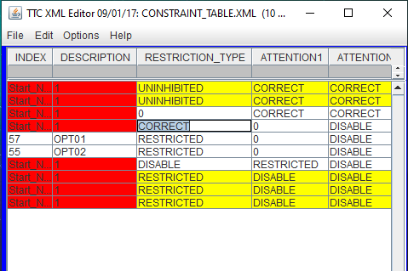

Figure 4. Original CONSTRAINT_TABLE.XML contents. A selected cell highlighted with a text cursor.

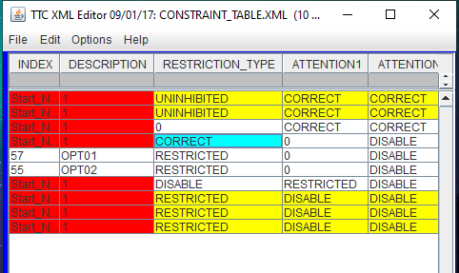

Figure 5. Original CONSTRAINT_TABLE.XML contents. Selected white cell changes color.

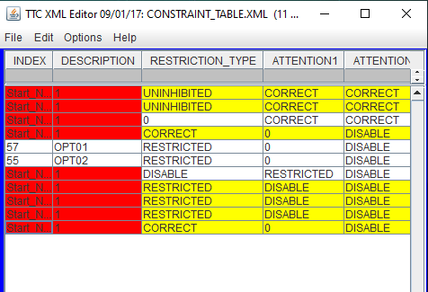

Figure 6. Altered CONSTRAINT_TABLE.XML contents. A copied row was pasted.

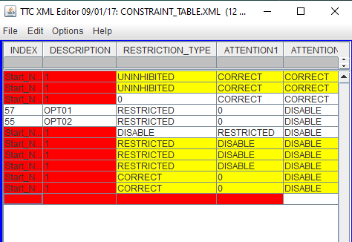

Figure 7. Insertion of a new row at the bottom of CONSTRAINT_TABLE.XML table.

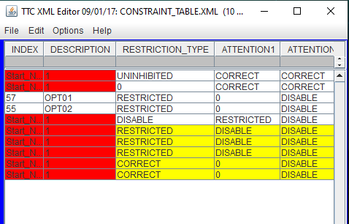

Figure 8. Example deletion of row located at index 1 from the original CONSTRAINT_TABLE.XML table.

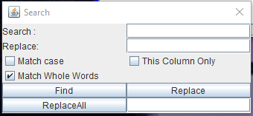

Figure 9. Search option window.

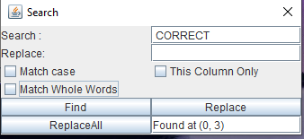

Figure 10. Example location after find operation of the word CORRECT in the original CONSTRAINT_TABLE.XML table.

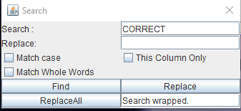

Figure 11. Example output if Find operation is unsuccessful.

