DbEditTestPlanAssign
Test plan
Version <1.0>
04/06/2020
Document Control
Approval
The Guidance Team and the customer shall approve this document.
Document Change Control
Initial Release: | 04/01/2020
Current Release: | 04/06/2020
Indicator of Last Page in Document:
Date of Last Review:
Date of Next Review:
Target Date for Next Update: | 04/14/2020
Distribution List
This following list of people shall visit the GitHub repository in order to get a copy of this document every time a new version of this document becomes available:
Reviewers:
- Hernandez, Julio A.
- Serrano, Fernando J.
Change Summary
The following table details changes made between versions of this document

Version | Date | Modifier | Description
1.0 | 04/06.202 | Alejandro Ortiz | Test plan document created

Note: The template presented in this document was taken from:
Donaldson, S., and S. Siegel, Successful Software Development. Upper Saddle River, NJ: Prentice Hall, 2001, pp. 321-323.

Note: The template presented in this document was taken from: Donaldson, S., and S. Siegel, Successful Software Development. Upper Saddle River, NJ: Prentice Hall, 2001, pp. 321-323 and modified by Humberto Mendoza and Steve Roach.

Supplementary information is from:
Pfleeger, S. Software Engineering, Theory and Practice. Upper Saddle River, NJ: Prentice Hall, 1998, p. 365.

Table of Contents
Document Control ii
Approval ii
Document Change Control ii
Distribution List ii
Change Summary ii
1. Introduction 4
1.1. Purpose 4
1.2. Scope 4
1.3. System Overview 4
1.4. Suspension and Exit Criteria 4
1.5. Document Overview 4
1.6. References 4
2. Test Items and Features 5
3. Testing Approach 6
4. Test suite 1 7
4.1. Test 1 9
4.2. Test 2 9
4.3. Test 3 10
4.4. Test 4 11
4.5. Test 5 11
5. User Interface Testing 12
6. Test Schedule 13

Introduction

This test plan focuses on testing a jar file provided by the instructor of the class. The testers will follow this plan as a guide to execute the corresponding test cases that are provided in this file. This document contains 5 test cases focusing on the edit menu operations.

Purpose

This test plan a project test plan, the strategy that will be used to test the tool is black box testing because the objective is to test the functionality of the tool and there is no code provided, only an executable file.

Scope

This plan encompasses version 1.0

System Overview

The system is a database editor with no relations.

Suspension and Exit Criteria

Suspension of testing would take in place when all test cases are run.

Document Overview
<<Describe the remainder of the document.>>

References

https://piazza.com/class_profile/get_resource/k55rbh37ri6be/k8hjj7sn7hu7n0

Test Items and Features

This test plan focuses on testing the edit menu operations.

Features | Description
Undo | Modify an element in the table an revert the change
Copy Row/Paste Row | Copy Row and Paste it in another row.
Insert Row | Create a new row in the table
Delete Row | Delete a new row in the table
Search | Search for an element in the table

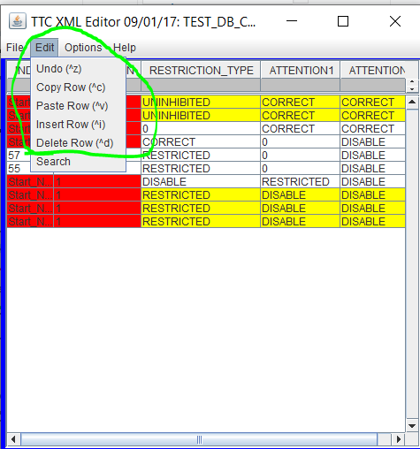

Testing Approach

Table 1: Test Plan
TEST SUITE 1
Description of Test Suite | Test designs to exercise the functionality of the edit menu operations.
Test Case Identifier | Objective | Criticality
1 | Test functionality of Undo operation
2 | Test functionality of Copy/Paste row operation
3 | Test the functionality of Insert row operation
4 | Test the functionality of Delete row operation
5 | Test the functionality of Search operation

Test suite 1
The tests are going to be done using the application provided by the instructor and the table “TEST_DB_CONSTRAINT_TABLE.xml” as our input. We will validate the functionality of the edit menu options.
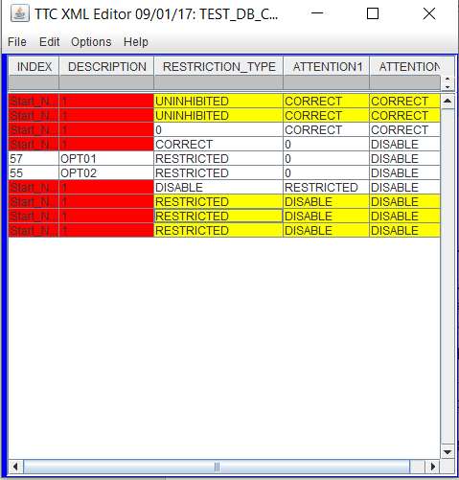

More specifically the test will be done in the third row.
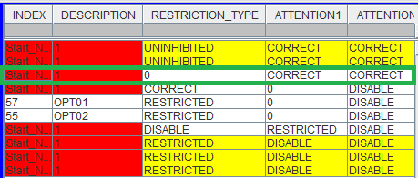

*For each test case is required that you have all the table files and the program.

Follow this steps to open the TEST_DB_CONSTRAINT_TABLE.xml table.

- Open the program. Click on File -> Open
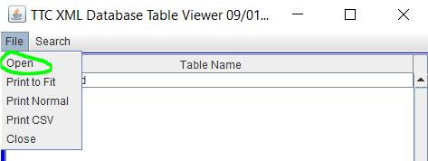
- Select TEST_DB.xml
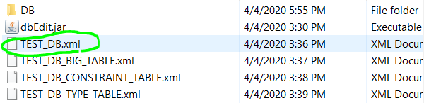

- Double click on TEST_DB_CONSTRAINT_TABLE.xml
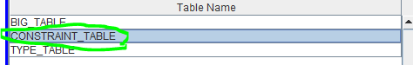

- Click on “Yes” when the pop-up appears
- Select the TEST_DB_CONSTRAINT_TABLE.xml table and open it.
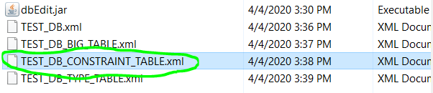
- A new window should appear showing our table, and we are ready to start testing.

Test 1

Objective: Validate the proper functionality of the undo operation.
Notes:
The tool provided by the instructor must be running.
For this test to be properly executed, our program must have the “TEST_DB_CONSTRAINT_TABLE.xml” opened.

Test No.: 1 |  | Current Status: Pending
Test title: Undo operation test
Testing approach: Select the third row of the TEST_DB_CONSTRAINT_TABLE.xml table.
STEP  1 | OPERATOR ACTION  Double click on the third element of the third row under the column RESTRICTION_TYPE which value is 0. | PURPOSE  Be able to edit the value | EXPECTED RESULTS  The cell will allow to change its value.  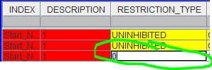 | COMMENTS
2 | Change the value to “1” | Change the value in order to test the undo operation | The cell now holds the value 1 instead of 0.  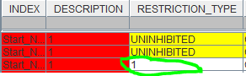
3 | Click on edit > Undo located on the tool bar | Revert the changed done. | The cell should have the value 0 which was the value before the change.  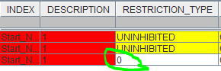
Concluding Remarks: N/A
Testing-Team: N/A |  | Date Completed: 04/06/2020

Test 2

Objective: Validate the proper functionality of the Copy/Paste row operation.
Notes:
The tool provided by the instructor has to be running.
For this test to be properly executed, our program must have the “TEST_DB_CONSTRAINT_TABLE.xml” opened.
Test No.: 2 |  | Current Status: Pending
Test title: Copy/Paste operation test
Testing approach: These two operations are coupled in order to validate their functionality. Select the third row of the TEST_DB_CONSTRAINT_TABLE.xml table.
STEP  1 | OPERATOR ACTION  Click on any element under the third row | PURPOSE  Select the row to be copy | EXPECTED RESULTS | COMMENTS
2 | Click on edit > Copy located on the tool bar | Copy the selected row | The row is copied in the buffer.  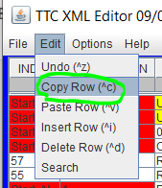
3 | Click on edit > Paste located on the tool bar | Paste the selected row at the bottom of the table | The row is pasted at the bottom of the table.  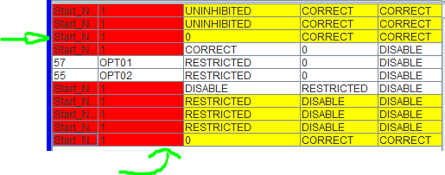
Concluding Remarks: N/A
Testing-Team: N/A |  | Date Completed: 04/06/2020

Test 3

Objective: Validate the proper functionality of the insert row operation.
Notes:
The tool provided by the instructor has to be running.
For this test to be properly executed, our program must have the “TEST_DB_CONSTRAINT_TABLE.xml” opened.
Test No.: 3 |  | Current Status: Pending
Test title: Insert row operation test.
Testing approach: Select the third row of the TEST_DB_CONSTRAINT_TABLE.xml table.
STEP  1 | OPERATOR ACTION  Click on edit > Insert Row located on the tool bar | PURPOSE  Insert a row to the table | EXPECTED RESULTS  A new empty row is inserted at the bottom of the table.  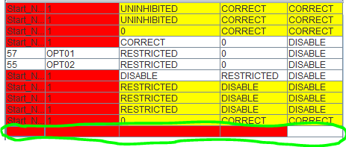 | COMMENTS
Concluding Remarks: N/A
Testing-Team: N/A |  | Date Completed: 04/06/2020

Test 4

Objective: Validate the proper functionality of the delete row operation.
Notes:
The tool provided by the instructor has to be running.
For this test to be properly executed, our program must have the “TEST_DB_CONSTRAINT_TABLE.xml” opened.
Test No.: 4 |  | Current Status: Pending
Test title: Delete row operation test
Testing approach: Select the third row of the TEST_DB_CONSTRAINT_TABLE.xml table. The table should have at least one row.
STEP  1 | OPERATOR ACTION  Click on any element under the third row | PURPOSE  Select the row to be deleted | EXPECTED RESULTS  The row is selected | COMMENTS
2 | Click on edit > Delete Row located on the tool bar | Delete the selected row from step 1. | The third row is deleted.  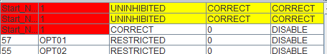
Concluding Remarks: N/A
Testing-Team: N/A |  | Date Completed: 04/06/2020

Test 5

Objective: Validate the proper functionality of the search operation.
Notes:
The tool provided by the instructor has to be running.
For this test to be properly executed, our program must have the “TEST_DB_CONSTRAINT_TABLE.xml” opened.
Test No.: 5 | Current Status: Pending

Test title: Search operation test
Testing approach: Select the third row of the TEST_DB_CONSTRAINT_TABLE.xml table. The table should have at least one row and the value searched should be in the row.
STEP  1 | OPERATOR ACTION  Click on edit > search located on the tool bar | PURPOSE  Enable the search menu. | EXPECTED RESULTS  Search pop-up appears  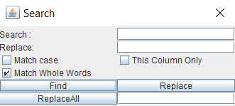 | COMMENTS
2 | Fill in the input box next to “Search” the word “OPT01” and click “Find” | Insert a value that is in the table in order to find it. | 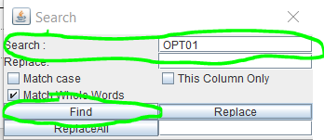  The pop-up Search menu will indicate the coordinates of the value that was searched if it is found.  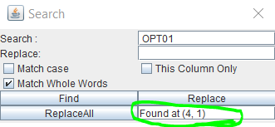  In addition, the table will highlight the value found.  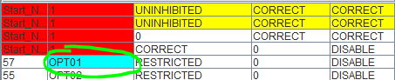
Concluding Remarks: N/A
Testing-Team: N/A |  | Date Completed: 04/06/2020

User Interface Testing

N/A

Test Schedule
<< Specify the schedule for testing activities. A table with the order and completion dates of the tests is useful. The table below might be useful.>>

Task and date | People | Description

