DbEditTestPlanAssign
Test plan
Version <4.0>
04/22/2020
Document Control
Approval
The Guidance Team and the customer shall approve this document.
Document Change Control
Initial Release: | 04/01/2020
Current Release: | 04/22/2020
Indicator of Last Page in Document: | ♣
Date of Last Review: | 04/22/2020
Date of Next Review: | 04/22/2020
Target Date for Next Update: | 04/23/2020
Distribution List
This following list of people shall visit the GitHub repository in order to get a copy of this document every time a new version of this document becomes available:
Reviewers:
- Hernandez, Julio A.
- Serrano, Fernando J.
Change Summary
The following table details changes made between versions of this document

Version | Date | Modifier | Description
1.0 | 04/06/2020 | Alejandro Ortiz | Test plan document created
2.0 | 04/15/2020 | Alejandro Ortiz | Test plan updated, and addressed Julio’s comments
3.0 | 04/21/2020 | Alejandro Ortiz | Test suite fix and added one more test.  Addressed Fernando’s comments
4.0 | 04/22/2020 | Alejandro Ortiz | Addressed Julio’s and Fernando’s comments

Note: The template presented in this document was taken from:
Donaldson, S., and S. Siegel, Successful Software Development. Upper Saddle River, NJ: Prentice Hall, 2001, pp. 321-323.

Note: The template presented in this document was taken from: Donaldson, S., and S. Siegel, Successful Software Development. Upper Saddle River, NJ: Prentice Hall, 2001, pp. 321-323 and modified by Humberto Mendoza and Steve Roach.

Supplementary information is from:
Pfleeger, S. Software Engineering, Theory and Practice. Upper Saddle River, NJ: Prentice Hall, 1998, p. 365.

Table of Contents
Document Control ii
Approval ii
Document Change Control ii
Distribution List ii
Change Summary ii
1. Introduction 4
1.1. Purpose 4
1.2. Scope 4
1.3. System Overview 4
1.4. Suspension and Exit Criteria 4
1.5. Document Overview 4
1.6. References 4
2. Test Items and Features 5
3. Testing Approach 6
4. Test suite 1 7
4.1. Test 1 9
4.2. Test 2 10
4.3. Test 3 10
4.4. Test 4 11
4.5. Test 5 11
4.6. Test 6 12
5. Test Schedule 14

Introduction

This test plan focuses on testing a jar file provided by the instructor of the class. The program displays data stored in XML tables provided in the GitHub repository. This program allows access to view and modify the data in the tables. The testers will follow this plan as a guide to execute the corresponding test cases that are provided in this file. This document contains 5 test cases focusing on the edit menu operations.

Purpose

The purpose of unit testing by using black box testing in this test plan is to ensure the functionality of the edit menu operations.

Scope

The scope of this test plan will encompass the initial release provided by Dr. Roach.

System Overview

The system is a database editor with no relations.

Suspension and Exit Criteria

In this test plan there will be no exit criteria, which means that all test cases will need to be executed. The exit criteria will be when the pass rate is 100%.

Document Overview
Section 2 will talk about test items and features in the system, indicating what items are going to be tested to better understand the test cases in the test plan. Section 3 describes the testing approach applied to the test cases with a table containing all the test cases tied to their respective objective and criticality. Section 4, describes how to execute the test cases along with images for better understanding. Section 5, doesn’t apply to this document. Section 6 TBD.

References

Test plan assignment https://piazza.com/class_profile/get_resource/k55rbh37ri6be/k8hjj7sn7hu7n0
Spec.docx file inside the GitHub repository for the specification of the software.
Test file can be found in the GitHub repository https://github.com/CS5387/testplangroup3-team8

Test Items and Features

This test plan focuses on testing the edit menu operations.

Features | Description
Undo | Modify an element in the table an revert the change
Undo using key shortcut | Modify an element in the table an revert the change using the undo’s key shortcut.
Copy Row/Paste Row | Copy Row and Paste it in another row.
Insert Row | Create a new row in the table
Delete Row | Delete a new row in the table
Search | Search for an element in the table

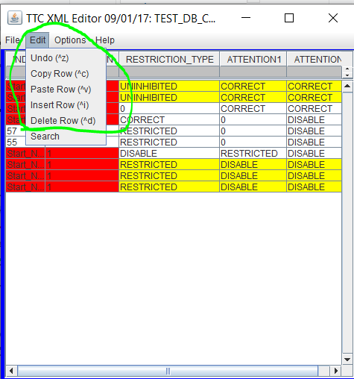Figure 2.1

Testing Approach

Table 1: Test Plan
TEST SUITE 1
Description of Test Suite | Test designs to exercise the functionality of the edit menu operations.
Test Case Identifier | Objective | Criticality
1 | Test functionality of Undo operation | Critical
2 | Test functionality of Undo operation using its keyboard shortcut | Critical
3 | Test functionality of Copy/Paste row operation | Critical
4 | Test the functionality of Insert row operation | Critical
5 | Test the functionality of Delete row operation | Critical
6 | Test the functionality of Search operation | Critical

Test suite 1
The tests are going to be done using the application provided, Windows operating system by the instructor and the table “TEST_DB_CONSTRAINT_TABLE.xml” as our input. We will validate the functionality of the edit menu options.
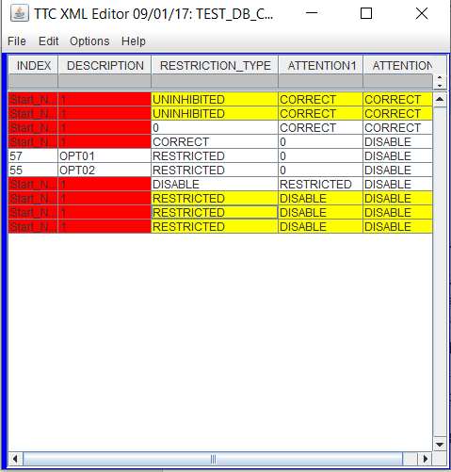 Figure 4.1

More specifically the test will be done in the third row.
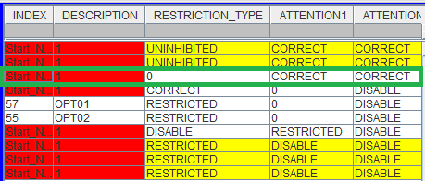 Figure 4.2

*For each test case is required that you have all the table files and the program.

Follow this steps to open the TEST_DB_CONSTRAINT_TABLE.xml table.

- Open the program. Click on File -> Open
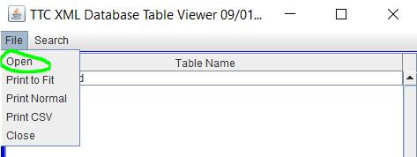 Figure 4.3
- Select TEST_DB.xml
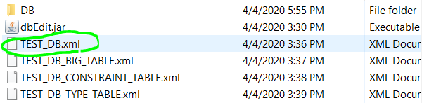

- Double click on TEST_DB_CONSTRAINT_TABLE.xml
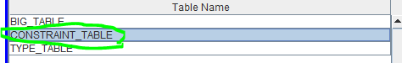Figure 4.4

- Click on “Yes” when the pop-up appears
- Select the TEST_DB_CONSTRAINT_TABLE.xml table and open it.
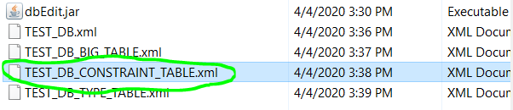Figure 4.5
- A new window should appear showing our table, and we are ready to start testing.

Test 1

Objective: Validate the proper functionality of the undo operation.
Notes:
This test will be performed using the tool provided by the instructor named “dbEdit.jar” and the “TEST_DB_XML” file. The “TEST_DB_XML” should be loaded on the application and ready to be use. In the “Table Name” section of the application the tables are shown as BIG_TABLE, CONSTRAINT_TABLE and TYPE_TABLE (Figure.4.4). The table CONSTRAINT_TABLE should be opened.

Test No.: 1 |  | Current Status: Pending
Test title: Undo operation test
Testing approach: The table CONSTRAINT_TABLE.xml should be used to perform the following steps.
STEP  1 | OPERATOR ACTION  Double click on the third element of the third row under the column RESTRICTION_TYPE which value is 0. | PURPOSE  Be able to edit the value | EXPECTED RESULTS  The cell will allow to change its value.  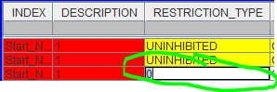 | COMMENTS
2 | Change the value to “1” | Change the value in order to test the undo operation | The cell now holds the value 1 instead of 0.  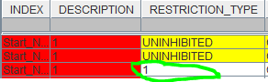
3 | Click on edit > Undo located on the tool bar | Revert the changed done. | The cell should have the value 0 which was the value before the change.  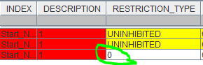
Concluding Remarks: N/A
Testing-Team: N/A |  | Date Completed: 04/06/2020

Test 2
Objective: Validate the proper functionality of the undo operation using its keyboard shortcut.
Notes:
This test will be performed using the tool provided by the instructor named “dbEdit.jar” and the “TEST_DB_XML” file. The “TEST_DB_XML” should be loaded on the application and ready to be use. In the “Table Name” section of the application the tables are shown as BIG_TABLE, CONSTRAINT_TABLE and TYPE_TABLE (Figure.4.4). The table CONSTRAINT_TABLE should be opened.
Test No.: 1 |  | Current Status: Pending
Test title: Undo operation using keyboard shortcut test.
Testing approach: The table CONSTRAINT_TABLE.xml should be used to perform the following steps.
STEP  1 | OPERATOR ACTION  Double click on the third element of the third row under the column RESTRICTION_TYPE which value is 0. | PURPOSE  Be able to edit the value | EXPECTED RESULTS  The cell will allow to change its value. | COMMENTS
2 | Change the value to “1” and press enter. | Change the value in order to test the undo operation | The cell now holds the value 1 instead of 0.
3 | Press and hold “CTRL”, followed by pressing the “z” key | Revert the changed done by using the keyboard shortcut. | The cell should have the value 0 which was the value before the change. | If you are using Mac Os use the “Commnad” key instead of the “CTRL”
Concluding Remarks: N/A
Testing-Team: N/A |  | Date Completed: 04/06/2020

Test 3

Objective: Validate the proper functionality of the Copy/Paste row operation.
Notes:
This test will be performed using the tool provided by the instructor named “dbEdit.jar” and the “TEST_DB_XML” file. The “TEST_DB_XML” should be loaded on the application and ready to be use. In the “Table Name” section of the application the tables are shown as BIG_TABLE, CONSTRAINT_TABLE and TYPE_TABLE (Figure.4.4). The table CONSTRAINT_TABLE should be opened.
Test No.: 2 |  | Current Status: Pending
Test title: Copy/Paste operation test
Testing approach: The table CONSTRAINT_TABLE.xml should be used to perform the following steps.
STEP  1 | OPERATOR ACTION  Click on any element under the third row | PURPOSE  Select the row to be copy | EXPECTED RESULTS | COMMENTS
2 | Click on edit > Copy located on the tool bar | Copy the selected row | The row is copied in the buffer.  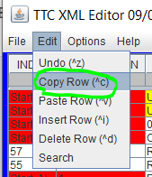
3 | Click on edit > Paste located on the tool bar | Paste the selected row at the bottom of the table | The row is pasted at the bottom of the table.  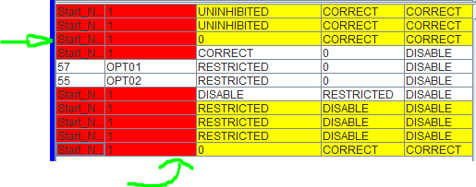
Concluding Remarks: N/A
Testing-Team: N/A |  | Date Completed: 04/06/2020

Test 4

Objective: Validate the proper functionality of the insert row operation.
Notes:
This test will be performed using the tool provided by the instructor named “dbEdit.jar” and the “TEST_DB_XML” file. The “TEST_DB_XML” should be loaded on the application and ready to be use. In the “Table Name” section of the application the tables are shown as BIG_TABLE, CONSTRAINT_TABLE and TYPE_TABLE (Figure.4.4). The table CONSTRAINT_TABLE should be opened.
Test No.: 3 |  | Current Status: Pending
Test title: Insert row operation test.
Testing approach: The table CONSTRAINT_TABLE.xml should be used to perform the following steps.
STEP  1 | OPERATOR ACTION  Click on edit > Insert Row located on the tool bar | PURPOSE  Insert a row to the table | EXPECTED RESULTS  A new empty row is inserted at the bottom of the table.  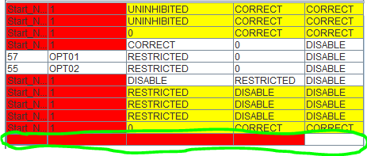 | COMMENTS
Concluding Remarks: N/A
Testing-Team: N/A |  | Date Completed: 04/06/2020

Test 5

Objective: Validate the proper functionality of the delete row operation.
Notes:
This test will be performed using the tool provided by the instructor named “dbEdit.jar” and the “TEST_DB_XML” file. The “TEST_DB_XML” should be loaded on the application and ready to be use. In the “Table Name” section of the application the tables are shown as BIG_TABLE, CONSTRAINT_TABLE and TYPE_TABLE (Figure.4.4). The table CONSTRAINT_TABLE should be opened.
Test No.: 4 |  | Current Status: Pending
Test title: Delete row operation test
Testing approach: The table CONSTRAINT_TABLE.xml should be used to perform the following steps
STEP  1 | OPERATOR ACTION  Click on any element under the third row | PURPOSE  Select the row to be deleted | EXPECTED RESULTS  The row is selected | COMMENTS
2 | Click on edit > Delete Row located on the tool bar | Delete the selected row from step 1. | The third row is deleted.  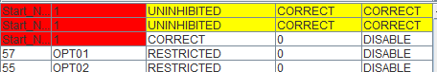
Concluding Remarks: N/A
Testing-Team: N/A |  | Date Completed: 04/06/2020

Test 6

Objective: Validate the proper functionality of the search operation.
Notes:
This test will be performed using the tool provided by the instructor named “dbEdit.jar” and the “TEST_DB_XML” file. The “TEST_DB_XML” should be loaded on the application and ready to be use. In the “Table Name” section of the application the tables are shown as BIG_TABLE, CONSTRAINT_TABLE and TYPE_TABLE (Figure.4.4). The table CONSTRAINT_TABLE should be opened.
Test No.: 5 | Current Status: Pending

Test title: Search operation test
Testing approach: The table CONSTRAINT_TABLE.xml should be used to perform the following steps
STEP  1 | OPERATOR ACTION  Click on edit > search located on the tool bar | PURPOSE  Enable the search menu. | EXPECTED RESULTS  Search pop-up appears  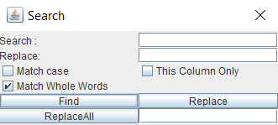 | COMMENTS
2 | Fill in the input box next to “Search” the word “OPT01” and click “Find” | Insert a value that is in the table in order to find it. | 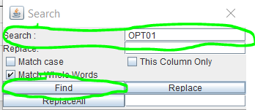  The pop-up Search menu will indicate the coordinates of the value that was searched if it is found.  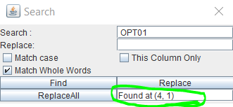  In addition, the table will highlight the value found.  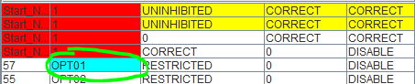
Concluding Remarks: N/A
Testing-Team: N/A |  | Date Completed: 04/06/2020

Test Schedule

TBD

Task and date | People | Description

♣

