dbEdit Program

Test plan

Version 1.0

04/07/2020

Document Control

Approval

The Guidance Team and the customer shall approve this document.

Document Change Control

|  |  |
| --- | --- |
| Initial Release: | Version 1.0 |
| Current Release: | Version 1.0 |
| Indicator of Last Page in Document: |  |
| Date of Last Review: |  |
| Date of Next Review: |  |
| Target Date for Next Update: |  |

Distribution List

This following list of people shall receive a copy of this document every time a new version of this document becomes available:

Guidance Team Members:

Customer:

* Dr. Steven Roach

Software Team Members:

* Aaron M. Himan (Reviewer)
* Javier I. Soon (Reviewer)

Change Summary

The following table details changes made between versions of this document

|  |  |  |  |
| --- | --- | --- | --- |
| Version | Date | Modifier | Description |
| 1.0 | 04/07/2020 | Ricardo Pena | Initial Release |
|  |  |  |  |
|  |  |  |  |

Note: The template presented in this document was taken from:

Donaldson, S., and S. Siegel, *Successful Software Development*. Upper Saddle River, NJ: Prentice Hall, 2001, pp. 321-323.

Note: The template presented in this document was taken from: Donaldson, S., and S. Siegel, *Successful Software Development*. Upper Saddle River, NJ: Prentice Hall, 2001, pp. 321-323 and modified by Humberto Mendoza and Steve Roach.

Supplementary information is from:

Pfleeger, S. *Software Engineering, Theory and Practice*. Upper Saddle River, NJ: Prentice Hall, 1998, p. 365.

Table of Contents

Document Control ii

Approval ii

Document Change Control ii

Distribution List ii

Change Summary ii

1. Introduction 4

1.1. Purpose 4

1.2. Scope 4

1.3. System Overview 4

1.4. Suspension and Exit Criteria 4

1.5. Document Overview 4

1.6. References 4

2. Test Items and Features 5

3. Testing Approach 6

4. Test 1-5 7

4.1. Test 1 7

4.2. Test 2 8

4.3. Test 3 9

4.4. Test 4 10

4.5. Test 5 11

5. User Interface Testing 12

6. Test Schedule 14

7. Other Sections 15

8. Appendix 16

# Introduction

This test plan outlines test cases needed to evaluate “dbEdit” program, per the requirements set forth by the stakeholders.

## Purpose

This test plan details the most critical test cases identified to evaluate the functionality of the “dbEdit” program. The testers shall perform every test outlined in this test plan to ensure all requirements are met.

## Scope

Testing shall performed on “dbEdit” program version created on 04/02/2020.

## System Overview

<<Describe the system to be exercised by the testing approach specified in the plan. This overview serves to identify aspects of the system operation that will be the focus of the plan’s testing approach. This should align with the systems overview of other documents in the project.>>

## Suspension and Exit Criteria

Tests 1 & 2 as denoted in Section 3.0 are identified as the most critical tests in this plan. Failure during any of these two tests shall result in the suspension of all other tests until the failures are adequately addressed.

## Document Overview

The tests deemed the most critical are listed in Section 3.0 of this test plan. The procedure for conducting these is detailed in Section 4.0.

## References

Not applicable

# Test Items and Features

This test plan is strictly concerned with evaluating the EDIT features of the “dbEdit” program. The table below lists the specific features to be evaluated and defines their functionality.

|  |  |
| --- | --- |
| **Operation** | **Functionality** |
| INSERT | Inserts a new row after the last row in the table |
| DELETE | Removes the current row from the table |
| UNDO | Reverses the last data operation performed on the table |
| COPY | Copies the values of the current row into temporary memory. Used in conjunction with the PASTE operation |
| PASTE | Inserts new row with all the values from a previously copied row. Values must have been previously stored in temporary memory by using the COPY operation. |

# Testing Approach

In order to verify each of the EDIT operations (UNDO, COPY, PASTE, INSERT, DELETE) each of these operations shall be evaluated independently, with the exception of the COPY and PASTE operations, which are performance dependent.

An additional test has been incorporated to assess the persistence of an error in the header row, which causes abnormal behavior in the other operations. This test shall only be performed if tests 1-3 are deemed successful.

Table 1: Test Plan

|  |  |  |
| --- | --- | --- |
| **TEST SUITE <Identifier>** | | |
| **Description of Test Suite** | **Test the edit features for Undo, Copy, Paste, Insert, and Delete** | |
| **Test Case Identifier** | **Objective** | **Criticality** |
| 1 | **Test functionality of INSERT edit feature** | **5** |
| 2 | **Test functionality of DELETE edit feature** | **5** |
| 3 | **Test functionality of UNDO edit feature** | **5** |
| 4 | **Test functionality of COPY/PASTE edit feature** | **5** |
| 5 | **Test for glitch found in the header row space** | **5** |

# Test 1-5

This section outlines the setup and steps needed to complete the test cases highlighted in the previous section.

Each of the tests will be performed one time for each of the table values provided along with this test plan. This will yield a total of three evaluations per test case. Any abnormal behavior should be noted in the comment section for each step or in the concluding remarks.

Section 5.0 lists some shortcut keys which may be used to perform certain operations with more ease. Use of these tools is completely optional and to the discretion of the test personnel.

## Test 1

**Objective:** This test will identify the independent functionality of the INSERT operation.

**Notes:** All test cases shall be performed independently of the results of the other test cases.

|  |  |  |  |  |  |  |
| --- | --- | --- | --- | --- | --- | --- |
| Test No.: 1a-1c | | | | Current Status: Pending | | |
| Test title: Test INSERT operation | | | | | | |
| Testing approach: Open the tables in the following order and perform the steps below.  1a: TEST_DB  1b: TEST_DB_BIG_TABLE  1c: TEST_CONSTRAINT_TABLE  1d: TEST_DB_TYPE_TABLE | | | | | | |
| STEP | OPERATOR ACTION | PURPOSE | | | EXEPCTED RESULTS | COMMENTS |
| 1 | Press and hold Insert shortcut (CRTL+I) the number of rows equals 100, 200, 500, 1000. | Test the size limit on the number of rows | | | A total of 1000 rows should be available |  |
| Concluding Remarks: | | | | | | |
| Testing Team: | | | Date Completed: | | | |

## Test 2

**Objective:** This test will identify the independent functionality of the DELETE operation.

**Notes:** All test cases shall be performed independently of the results of the other test cases.

|  |  |  |  |  |  |  |
| --- | --- | --- | --- | --- | --- | --- |
| Test No.: 2a-2d | | | | Current Status: Pending | | |
| Test title: Test DELETE operation | | | | | | |
| Testing approach: Open the tables in the following order and perform the steps below.  2a: TEST_DB  2b: TEST_DB_BIG_TABLE  2c: TEST_CONSTRAINT_TABLE  2d: TEST_DB_TYPE_TABLE | | | | | | |
| STEP | OPERATOR ACTION | PURPOSE | | | EXEPCTED RESULTS | COMMENTS |
| 1 | Use CTRL+D shortcut to delete all rows | Test functionality of DELETE operation | | | All rows (except header) should be deleted. |  |
| 2 | Use CTRL+D shortcut to delete header rows | Attempt to remove header row | | | Operation should not work |  |
| Concluding Remarks: | | | | | | |
| Testing Team:  << List members of testing team and lead >> | | | Date Completed: | | | |

## Test 3

**Objective:** This test will identify the independent functionality of the UNDO operation.

**Notes:** All test cases shall be performed independently of the results of the other test cases.

|  |  |  |  |  |  |  |
| --- | --- | --- | --- | --- | --- | --- |
| Test No.: 3a-3d | | | | Current Status: << Passed / Failed / Pending >> | | |
| Test title: Test UNDO operation | | | | | | |
| Testing approach: Open the tables in the following order and perform the steps below.  3a: TEST_DB  3b: TEST_DB_BIG_TABLE  3c: TEST_CONSTRAINT_TABLE  3d: TEST_DB_TYPE_TABLE | | | | | | |
| STEP | OPERATOR ACTION | PURPOSE | | | EXEPCTED RESULTS | COMMENTS |
| 1 | Use CTRL+D shortcut to delete header rows | Attempt to remove header row | | | Operation should not work |  |
| Concluding Remarks: | | | | | | |
| Testing Team: | | | Date Completed: | | | |

## Test 4

**Objective:** This test will identify the independent functionality of the COPY/PASTE operations.

**Notes:** If the table is already populated, then step 1 becomes optional, and the tester may proceed to step 2.

|  |  |  |  |  |  |  |
| --- | --- | --- | --- | --- | --- | --- |
| Test No.: 4a-4d | | | | Current Status: Pending | | |
| Test title: Test COPY/PASTE operations | | | | | | |
| Testing approach: Open the tables in the following order and perform the steps below.  3a: TEST_DB  3b: TEST_DB_BIG_TABLE  3c: TEST_CONSTRAINT_TABLE  3d: TEST_DB_TYPE_TABLE | | | | | | |
| STEP | OPERATOR ACTION | PURPOSE | | | EXEPCTED RESULTS | COMMENTS |
| 1 (optional) | Insert integer values into the first 5 columns of the first row. | Fill table to allow for operations to be performed | | | Row is populated with values. |  |
| 2 | Perform COPY operation on the first row | Copy the values to be inserted | | | N/A |  |
| 3 | Perform PASTE operation | Insert a row with the previously copied values | | | New Row inserted. All values in the new row shall correspond with the first row. |  |
| Concluding Remarks: | | | | | | |
| Testing Team: | | | Date Completed: | | | |

## Test 5

**Objective:** This test will be used to evaluate the persistence of a glitch found in the header row of the tables.

**Notes:** This test shall only be concluded if tests 1-3 are deemed successful.

In the event a step may not be completed due to the results of the previous step, the tester shall make note of such occurrence and move on to the next step. All steps shall be performed whenever possible.

|  |  |  |  |  |  |  |
| --- | --- | --- | --- | --- | --- | --- |
| Test No.: 5a-5d | | | | Current Status: Pending | | |
| Test title: Test header error effect on all edit operations | | | | | | |
| Testing approach: <<Included in this section is a description of test harnesses, testing frameworks, environmental requirements, test tools and test automation that will be employed to achieve testing. Include naming conventions for tests and test scripts if appropriate. Provide requirements traceability and test priority.  >> | | | | | | |
| STEP | OPERATOR ACTION | PURPOSE | | | EXEPCTED RESULTS | COMMENTS |
| 1 | Add value in the first cell of the header row and press ENTER | Test whether the delete operation works on the header row. | | | Value should not be allowed. |  |
| 2 | Click in the space below the header rows | Deselect header row space | | | Header cell and/or row unselected |  |
| 3 | INSERT five new rows. | Show INSERT operation functions properly | | | Five new rows inserted | All new cells should be blank. |
| 4 | Perform UNDO operation | Show UNDO operation functions properly | | | Row should be removed |  |
| 5 | Perform DELETE operation on last row | Show DELETE operation functions properly | | | Last row is removed |  |
| Concluding Remarks: | | | | | | |
| Testing Team: | | | Date Completed: | | | |

# User Interface Testing

To open a new table, the user shall select a new table as show below.

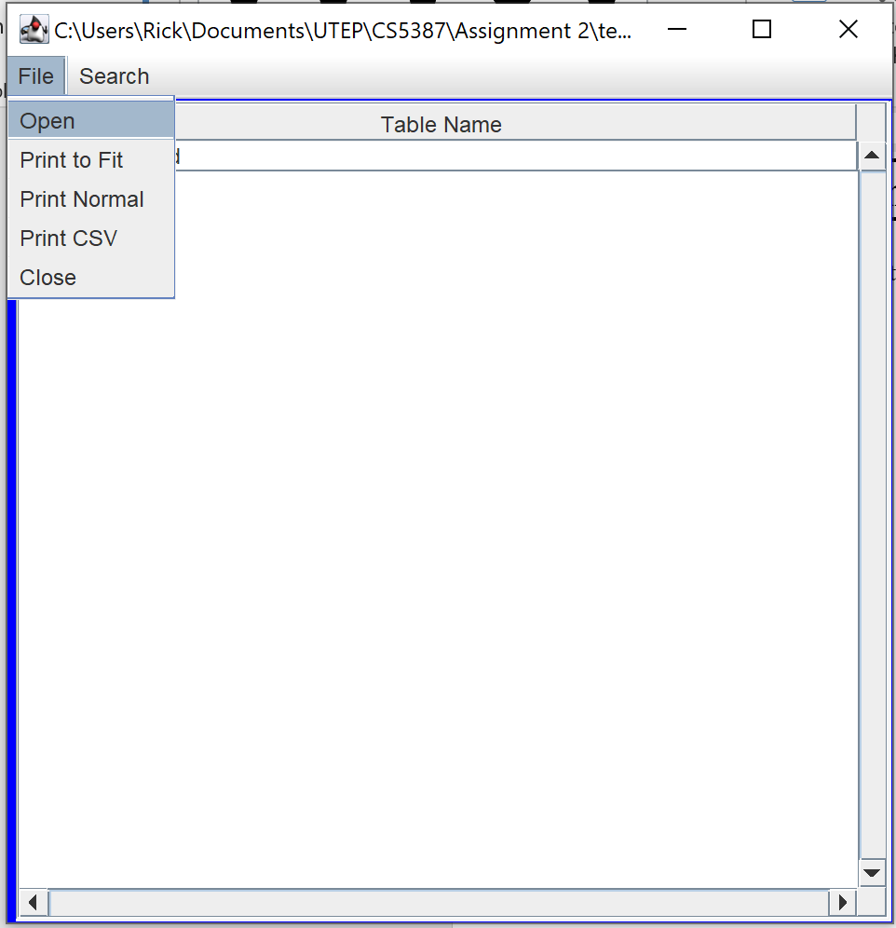



Select the file to be edited.

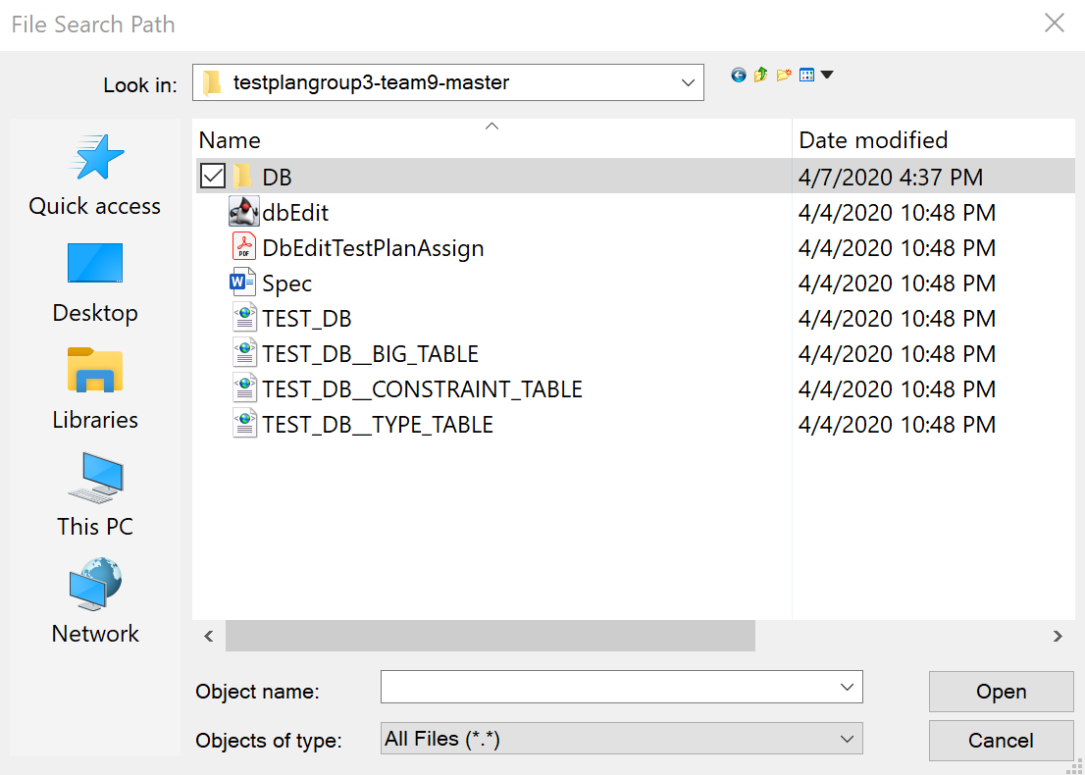



The following are shortcuts which may be used to perform some of the operations outlined in this test plan. Any use of these shortcuts is left to the discretion of the test personnel.

|  |  |
| --- | --- |
| **Operation** | **Shortcut Keys** |
| INSERT | CTRL + I |
| DELETE | CTRL + D |
| UNDO | CTRL + Z |
| COPY | CTRL + C |
| PASTE | CTRL + V |

# Test Schedule

The table below outlines the schedule for the tests to be performed. Any changes to the schedule should be noted in a future revision of this document, otherwise it shall be reported in the test report.

|  |  |  |
| --- | --- | --- |
| **Task and date** | **People** | **Description** |
|  |  |  |
|  |  |  |
|  |  |  |
|  |  |  |
|  |  |  |
|  |  |  |
|  |  |  |
|  |  |  |
|  |  |  |

# Other Sections

Not Applicable.

# Appendix

Not Applicable.