dbEdit Program

Test plan

Version 2.0

04/16/2020

Document Control

Approval

The Guidance Team and the customer shall approve this document.

Document Change Control

|  |  |
| --- | --- |
| Initial Release: | Version 1.0 |
| Current Release: | Version 2.0 |
| Indicator of Last Page in Document: |  |
| Date of Last Review: |  |
| Date of Next Review: |  |
| Target Date for Next Update: |  |

Distribution List

This following list of people shall receive a copy of this document every time a new version of this document becomes available:

Guidance Team Members:

Customer:

* Dr. Steven Roach

Software Team Members:

* Ricardo Pena (Author)
* Aaron M. Himan (Reviewer)
* Javier I. Soon (Reviewer)

Change Summary

The following table details changes made between versions of this document

| Version | Date | Modifier | Description |
| --- | --- | --- | --- |
| 1.0 | 04/07/2020 | Ricardo Pena | Initial Release |
| 2.0 | 04/16/2020 | Ricardo Pena | Revised document per reviewer comments as follows:   * Revised date and version information across document. * Added author information under “Distribution List” section (p. ii) * Updated Table of Contents. * Revised sections 1.3, 1.4, 1.6 * Revised Table 1 in Section 3.0. Added clarification for criticality ratings. * Revised section 4.0 and all subsections to provide clarification on all tests, include relevant tests and remove unnecessary tests. * Move Section 5.0 information to Section 8.0 (appendix) as it is more pertinent to the content. |

Note: The template presented in this document was taken from:

Donaldson, S., and S. Siegel, *Successful Software Development*. Upper Saddle River, NJ: Prentice Hall, 2001, pp. 321-323.

Note: The template presented in this document was taken from: Donaldson, S., and S. Siegel, *Successful Software Development*. Upper Saddle River, NJ: Prentice Hall, 2001, pp. 321-323 and modified by Humberto Mendoza and Steve Roach.

Supplementary information is from:

Pfleeger, S. *Software Engineering, Theory and Practice*. Upper Saddle River, NJ: Prentice Hall, 1998, p. 365.

Table of Contents

Document Control ii

Approval ii

Document Change Control ii

Distribution List ii

Change Summary iii

1. Introduction 1

1.1. Purpose 1

1.2. Scope 1

1.3. System Overview 1

1.4. Suspension and Exit Criteria 1

1.5. Document Overview 1

1.6. References 1

2. Test Items and Features 2

3. Testing Approach 3

4. Test 1-5 4

4.1. Test 1 4

4.2. Test 2 5

4.3. Test 3 6

4.4. Test 4 7

4.5. Test 5 8

4.6. Test 6 10

5. User Interface Testing 11

6. Test Schedule 12

7. Other Sections 13

8. Appendix 14

# Introduction

This test plan outlines test cases needed to evaluate “dbEdit” program, per the requirements set forth by the stakeholders.

## Purpose

This test plan details the most critical test cases identified to evaluate the functionality of the “dbEdit” program. The testers shall perform every test outlined in this test plan to ensure all requirements are met.

## Scope

Testing shall performed on “dbEdit” program version created on 04/02/2020.

## System Overview

In this system, configuration data is stored in XML tables. We've provided a simple editor to allow access to view and modify the data. The editor does not allow modification of the database schema.

In this test plan we will focus on evaluating the EDIT operations, which are explained in section 2.0.

## Suspension and Exit Criteria

Tests 1 & 2 as denoted in Section 3.0 are identified as the most critical tests in this plan. Failure during any of these two tests shall result in the suspension of all other tests until the failures are adequately addressed.

## Document Overview

Section 1.0 provides general information about his document and the overall project.

Section 2.0 defines the features and items to be tested.

Section 3.0 defines the tests to be performed per this test plan and the criticality level for each test.

Section 4.0 describes the procedure for conducting each of the tests.

Section 5.0 defines the user interface testing.

Section 6.0 defines the test schedule for every test.

Section 7.0 provides any additional documentation to support this test plan.

Section 8.0 provides relevant information and clarifications about the program execution.

## References

|  |  |
| --- | --- |
| Reference | Purpose |
| Spec.docx | Defines functionality of |
| DbEditTestPlanAssign.pdf | Defines the tasks to be addressed and accomplished in this test plan. |
| TestPlanTemplate2019.docx | Template layout for a test plan. |
|  |  |

# Test Items and Features

This test plan is strictly concerned with evaluating the EDIT features of the “dbEdit” program. The table below lists the specific features to be evaluated and defines their functionality.

|  |  |
| --- | --- |
| **Operation** | **Functionality** |
| INSERT | Inserts a new row after the last row in the table |
| DELETE | Removes the current row from the table |
| UNDO | Reverses the last data operation performed on the table |
| COPY | Copies the values of the current row into temporary memory. Used in conjunction with the PASTE operation |
| PASTE | Inserts new row with all the values from a previously copied row. Values must have been previously stored in temporary memory by using the COPY operation. |

# Testing Approach

In order to verify each of the EDIT operations (UNDO, COPY, PASTE, INSERT, DELETE) each of these operations shall be evaluated independently, with the exception of the COPY and PASTE operations, which are performance dependent.

Since no specific criteria about the criticality of each function is provided this project, the functionality of all EDIT operations is considered equally important.

Table 1: Test Plan

|  |  |  |
| --- | --- | --- |
| **TEST SUITE <Identifier>** | | |
| **Description of Test Suite** | **Test the edit features for Undo, Copy, Paste, Insert, and Delete** | |
| **Test Case Identifier** | **Objective** | **Criticality** |
| 1 | **Test functionality of INSERT edit feature** | **5** |
| 2 | **Test functionality of INSERT edit feature** | **5** |
| 3 | **Test functionality of INSERT edit feature** | **5** |
| 4 | **Test functionality of DELETE edit feature** | **5** |
| 5 | **Test functionality of UNDO edit feature** | **5** |
| 6 | **Test functionality of COPY/PASTE edit feature** | **5** |

# Test 1-5

This section outlines the setup and steps needed to complete the test cases highlighted in the previous section.

Each of the tests will be performed in the order denoted. Any abnormal behavior should be noted in the comment section for each step or in the concluding remarks.

Some tests are grouped together, since they follow the same procedure but operate on multiple data. For these special cases, an explanation is provided in the “Test Approach” Section of the test procedure.

The Appendix (Section 8.0) provides guidance and a general layout of the program window, as well as provides a list of some shortcut keys which may be used to perform certain operations with more ease. Use of these tools is completely optional and to the discretion of the test personnel.

## Test 1

**Objective:** This test will identify the independent functionality of the INSERT operation.

**Notes:** See Appendix (Section 8.0) on general setup before starting the test.

|  |  |  |  |  |  |  |
| --- | --- | --- | --- | --- | --- | --- |
| Test No.: 1 | | | | Current Status: Pending | | |
| Test title: Test INSERT operation | | | | | | |
| Testing approach:  The test shall be performed in an empty table. This will test the functionality when no other values or rows are present on the table. This will confirm the consistent functionality of the operation.  1a: BIG_TABLE  1b: TEST_DB_TYPE_TABLE | | | | | | |
| STEP | OPERATOR ACTION | PURPOSE | | | EXEPCTED RESULTS | COMMENTS |
| 1 | Select and double-click the <BIG_TABLE> table | Open Table | | | Table is opened on a new window. |  |
| 2 | Click on the first cell of the first row | To select row | | |  |  |
| 3 | On the top left menu select  EDIT-> DELETE ROW | To remove all rows from the table | | | Table is now empty |  |
| 4 | Click inside the Table space | Ensure table space is selected. | | |  |  |
| 5 | On the top left menu select  EDIT-> INSERT ROW | Insert new row | | | New blank row should appear at the end of the table |  |
| Concluding Remarks: | | | | | | |
| Testing Team: | | | Date Completed: | | | |

## Test 2

**Objective:** This test will identify the independent functionality of the INSERT operation.

**Notes:** See Appendix (Section 8.0) on general setup before starting the test.

|  |  |  |  |  |  |  |
| --- | --- | --- | --- | --- | --- | --- |
| Test No.: 2 | | | | Current Status: Pending | | |
| Test title: Test INSERT operation | | | | | | |
| Testing approach:  The test shall be performed in a populated table. This will test the functionality when other values or rows are already present in the table. This will confirm the consistent functionality of the operation.  2: TEST_DB_TYPE_TABLE | | | | | | |
| STEP | OPERATOR ACTION | PURPOSE | | | EXEPCTED RESULTS | COMMENTS |
| 1 | Select and double-click the <TYPE_TABLE> | Open Table | | | Table is opened on a new window. |  |
| 2 | Click inside the Table space | Ensure table space is selected. | | |  |  |
| 3 | On the top left menu select  EDIT-> INSERT ROW | Insert new row | | | New blank row should appear at the end of the table |  |
| Concluding Remarks: | | | | | | |
| Testing Team: | | | Date Completed: | | | |

## Test 3

**Objective:** This test will identify the independent functionality of the INSERT operation.

**Notes:** See Appendix (Section 8.0) on general setup before starting the test.

|  |  |  |  |  |  |  |
| --- | --- | --- | --- | --- | --- | --- |
| Test No.: 1-2 | | | | Current Status: Pending | | |
| Test title: Test INSERT operation | | | | | | |
| Testing approach:  The test shall be performed in a populated with filter functionality already active on the table. Since only filtered values should appear on the screen, all newly inserted rows should match the filtered requirements. And the values/rows should remain even after the filter has been removed. This will confirm the consistent functionality of the operation.  BIG_TABLE | | | | | | |
| STEP | OPERATOR ACTION | PURPOSE | | | EXEPCTED RESULTS | COMMENTS |
| **TEST 1** | | | | | | |
| 1 | Select and double-click the <BIG_TABLE> table | Open Table | | | Table is opened on a new window. |  |
| 2 | Click on the first cell of the FILTER row | To select row | | |  |  |
| 3 | Enter the value “12345” and press ENTER | Filter the values to be displayed | | | No rows should be displayed |  |
| 4 | On the top left menu select  EDIT-> INSERT ROW | Insert new row | | | New row with the filter values should appear at the end of the table |  |
| 5 | Click on the first cell of the FILTER row | To select row | | |  |  |
| 6 | Delete value from FILTER row and press ENTER | Clear filter | | | All previously hidden rows should be displayed, including inserted row from Step 5 |  |
| Concluding Remarks: | | | | | | |
| Testing Team: | | | Date Completed: | | | |

## Test 4

**Objective:** This test will identify the independent functionality of the DELETE operation.

**Notes:** See Appendix (Section 8.0) on general setup before starting the test.

|  |  |  |  |  |  |  |
| --- | --- | --- | --- | --- | --- | --- |
| Test No.: 4 | | | | Current Status: Pending | | |
| Test title: Test DELETE operation | | | | | | |
| Testing approach:  This test will evaluate the DELETE operation.  TYPE_TABLE | | | | | | |
| STEP | OPERATOR ACTION | PURPOSE | | | EXEPCTED RESULTS | COMMENTS |
| 1 | Select and double-click the <TYPE_TABLE> table | Open Table | | | Table is opened on a new window. |  |
| 2 | Click on the first cell of the first row | To select row | | |  |  |
| 3 | On the top left menu select  EDIT-> DELETE ROW | Remove selected row from Table | | | Table is now empty |  |
| Concluding Remarks: | | | | | | |
| Testing Team: | | | Date Completed: | | | |

## Test 5

**Objective:** This test will identify the independent functionality of the UNDO operation.

**Notes:** See Appendix (Section 8.0) on general setup before starting the test.

|  |  |  |  |  |  |  |
| --- | --- | --- | --- | --- | --- | --- |
| Test No.: 5 | | | | Current Status: Pending | | |
| Test title: Test UNDO operation | | | | | | |
| Testing approach:  This test will evaluate the functionality of the UNDO operation for all value editing conditions. This will also confirm the consistent functionality of the UNDO operation.  TEST_DB_BIG_TABLE | | | | | | |
| STEP | OPERATOR ACTION | PURPOSE | | | EXEPCTED RESULTS | COMMENTS |
| 1 | Select and double-click the <BIG_TABLE> table | Open Table | | | Table is opened on a new window. |  |
| 2 | Click on the first cell of the first row and enter the value “12345” and press ENTER | Enter a value in the cell | | | The value “12345” should be stored in the cell |  |
| 3 | Click inside the Table space | Ensure table space is selected. | | |  |  |
| 4 | On the top left menu select  EDIT-> INSERT ROW | Insert new row | | | New blank row should appear at the end of the table |  |
| 5 | Click and Select the cell with the value “12345” | To select row | | |  |  |
| 6 | On the top left menu select  EDIT-> COPY ROW | Copy selected rows in Table | | |  |  |
| 7 | On the top left menu select  EDIT-> PASTE ROW | Paste previously copied rows | | | The row copied should appear at the end of the Table |  |
| 8 | Click on the first cell of the first row and enter the value “99999” and press ENTER | Enter a new value in the cell to differ row from newly pasted row | | | The value “99999” should be stored in the cell |  |
| 9 | Select the all the rows by clicking on the first row and dragging the mouse to the last row before releasing the mouse click | To select all rows | | |  |  |
| 10 | On the top left menu select  EDIT-> DELETE ROW | To remove the first rows from the table | | | Table is now empty |  |
| 11 | On the top left menu select  EDIT-> UNDO  Repeat 9 times or until buffer notification is shown. Pause each time to observe results. | Undo previous operations | | | The operations from all previous steps should be reversed one by one, until one empty row remains. |  |
| Concluding Remarks: | | | | | | |
| Testing Team: | | | Date Completed: | | | |

## Test 6

**Objective:** This test will identify the independent functionality of the COPY/PASTE operations.

**Notes:** See Appendix (Section 8.0) on general setup before starting the test.

|  |  |  |  |  |  |  |
| --- | --- | --- | --- | --- | --- | --- |
| Test No.: 6 | | | | Current Status: Pending | | |
| Test title: Test COPY/PASTE operations | | | | | | |
| Testing approach:  The COPY/PASTE operations have a functionality dependency, therefore, both of these operations have been grouped together into a single test case.  TEST_CONSTRAINT_TABLE | | | | | | |
| STEP | OPERATOR ACTION | PURPOSE | | | EXEPCTED RESULTS | COMMENTS |
| 1 | Select and double-click the <CONSTRAINT_TABLE> table | Open Table | | | Table is opened on a new window. |  |
| 2 | Click and Select the cells with the values “55” and “57” | To select row | | |  |  |
| 3 | On the top left menu select  EDIT-> COPY ROW | Copy selected rows in Table | | |  |  |
| 4 | On the top left menu select  EDIT-> PASTE ROW | Paste previously copied rows | | | The two rows copied should appear at the end of the Table |  |
| Concluding Remarks: | | | | | | |
| Testing Team: | | | Date Completed: | | | |



# User Interface Testing

The user interface functionality is outside of the testing scope for this particular test plan. Therefore, this section is not applicable.

|  |  |
| --- | --- |
|  |  |
|  |  |
|  |  |
|  |  |
|  |  |
|  |  |

# Test Schedule

The table below outlines the schedule for the tests to be performed. Any changes to the schedule should be noted in a future revision of this document, otherwise it shall be reported in the test report.

|  |  |  |
| --- | --- | --- |
| **Task and date** | **People** | **Description** |
|  |  |  |
|  |  |  |
|  |  |  |
|  |  |  |
|  |  |  |
|  |  |  |
|  |  |  |
|  |  |  |
|  |  |  |

# Other Sections

Not Applicable.

# Appendix

**Test Setup**



The following tables should be available to view and edit. Double-click on any table to open on separate window.

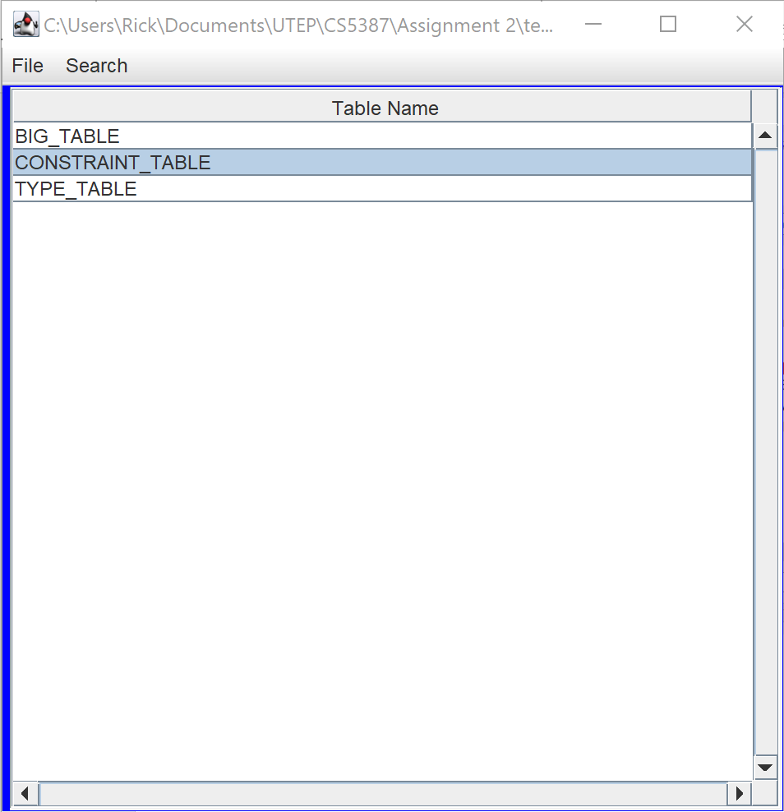

**Window Layout:**

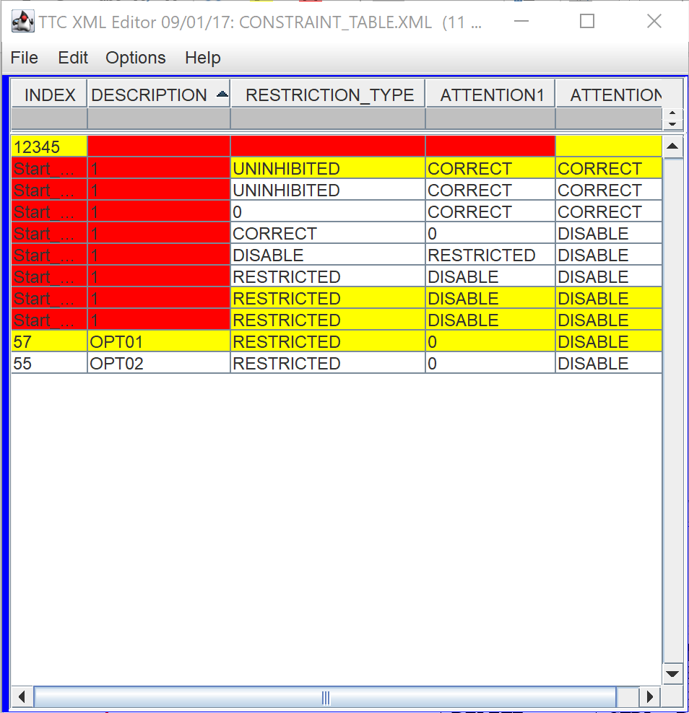

Table Space

Filter

Menu



**Shortcuts**

|  |  |
| --- | --- |
|  |  |
|  |  |
|  |  |
|  |  |
|  |  |
|  |  |