Database (Edit and Menu Operations)
Test plan
Version <3.0>
4/24/2020
Document Control
Approval
The Guidance Team and the customer shall approve this document.
Document Change Control
Initial Release: | 1.0
Current Release: | 4/12/2020
Indicator of Last Page in Document: | &&&
Date of Last Review: | 4/24/2020
Date of Next Review:
Target Date for Next Update:
Distribution List
This following list of people shall receive a copy of this document every time a new version of this document becomes available:
Author: Roman Martinez

Customer: Dr. Roach

Reviewers: Adrian A. Gonzalez, Kevin Rodriguez
Change Summary
The following table details changes made between versions of this document

Version | Date | Modifier | Description
1.0 | 4/12/2020 | Roman Martinez | First Release
2.0 | 4/23/2020 | Roman Martinez | Second release after both reviewers’ comments
3.0 | 4/24/2020 | Roman Martinez | Third and final release, adding edit details to document

Note: The template presented in this document was taken from:
Donaldson, S., and S. Siegel, Successful Software Development. Upper Saddle River, NJ: Prentice Hall, 2001, pp. 321-323.

Note: The template presented in this document was taken from: Donaldson, S., and S. Siegel, Successful Software Development. Upper Saddle River, NJ: Prentice Hall, 2001, pp. 321-323 and modified by Humberto Mendoza and Steve Roach.

Supplementary information is from:
Pfleeger, S. Software Engineering, Theory and Practice. Upper Saddle River, NJ: Prentice Hall, 1998, p. 365.

Table of Contents
Document Control ii
Approval ii
Document Change Control ii
Distribution List ii
Change Summary ii
1. Introduction 1
1.1. Purpose 1
1.2. Scope 1
1.3. System Overview 1
1.4. Suspension and Exit Criteria 1
1.5. Document Overview 1
1.6. References 1
2. Test Items and Features 2
3. Testing Approach 3
4. Test Edit Menu 4
4.1. Test Undo 4
4.2. Test Copy/Paste 1
4.3. Test Insert 3
4.4. Test Delete 2
5. Appendix 7

Introduction

The purpose of this project is to assure the functionality and requirements for this piece of software. It will determine that all everything is executed correctly within the standards of the stakeholder.

Purpose

The purpose of this document is to provide a set of test cases to ensure the functionality of the application. The test plan will ensure that the application works to the standards desired by the stakeholder and by testing and evaluating the outputs given. The test being done in this application will be Black Box. The reason for this test is to better evaluate the software to the system requirements that it is trying to fulfill.

Scope
Testing the edit menu operations portion for dbEdit.jar program.

System Overview
The system is a basic database editor, that can show and edit XML files that hold database information by graphical interface.

Suspension and Exit Criteria
To suspend further testing an agreement between the producer of this document and its reviewers have to come into conclusion that 90% of the tests pass. Taking into priority high critical tests that will determine main functionality must pass and non-critical don’t if the percentile is reached. Reviewers will then determine if the test plan is set to standards to be used in a formal manner and can be reliable for testing the software.

Document Overview
The remainder of the document include the test that were done in the system, their result and how to reproduce them.

References
https://ff.tu-sofia.bg/~bogi/knigi/SE/Software%20Engineering-PH-Successful-Software-Development-2nd-Edition.pdf

https://piazza.com/class_profile/get_resource/k55rbh37ri6be/k8hjj7sn7hu7n0

Test Items and Features
This test plan is concentrating on only the edit menu operations within the dbEdit.jar software. The table below will list the operations and their functionality that will be tested.

Operation | Function
Undo | Cancels the most recent action made to the table
Copy Row | Saves the current row in the buffer
Paste Row | Places the current saved row from the buffer into the table
Insert Row | Creates a new row within the table
Delete Row | Erases the data within the row and moves all rows under upwards

Testing Approach

The tests that will be done on the software can be viewed on the table below. It will enumerate, describe the objective and the criticality of the tests being done. The tests being done will be divided in sections depending on the different edit menu operations.

Table 1: Test Plan
TEST SUITE Edit Menu Operations
Description of Test Suite | This test suite is designed to test the functionality of the Edit Menu Operations within dbEdit.jar
Test Case Identifier | Objective | Criticality
Undo | To test the functionality and effect of Undo operation | 5
Copy Row | To test the functionality and effect of Copy operation | 5
Paste Row | To test the functionality and effect of the Paste operation | 5
Insert Row | To test the functionality effect of the Insert operation | 5
Delete Row | To test the functionality of the Delete operation | 5

Test Edit Menu
Within this section the different edit menu options will have their own section each representing a different test case and containing different test, evaluating functionality. The name of the jar file being tested was dbEdit, using the database description file TEST_DB.xml which contained all the databases that will be used during testing. The following portion of the document contains the different tests being done on the software including the steps taken for documentation, the expected results and the actual results. The testing method we are implementing is the black box method, to evaluate if the software is fulfilling the system requirements stablished by the stakeholders. For the test process be successful 90% of all tests must pass, this confirms that the software is meeting the system requirements.

Test Undo

Objective: To test the functionality and effect of the Undo operation in the edit menu
Notes: For the tests being conducted involving the edit operations, any database being selected is valid for testing. The Undo operation will display the previous done action by the user that was saved in the buffer of the software. The test being done will be done in a unit approach, by having a set of inputs and outputs, corresponding on the expected result to the actual result.

Test No.: U001 |  |  |  | Current Status: Pending
Test title: Undo copy/paste operation

Testing approach: For this test you must run the dbEdit.jar (figure 1) file and open the TEST_DB.xml file (figure 2), when testing, follow the next steps to test the operation.
STEP  1 | OPERATOR ACTION  On the Database Edit Window, click on the “File” tab on the top left-hand corner | PURPOSE  Display the parent directory where the software resides |  |  | EXEPCTED RESULTS  A file search path window pop-up with the parent folder files displayed | COMMENTS
2 | Select and Open the TEST_DB.xml file | Open the file that holds the databases description |  |  | The database description window pops up displaying all the databases in the file
3 | On the Database Description Window, double click on the “CONSTRAINT_TABLE” (figure 3) Database | Open the table editor window displaying the information from “CONSTRAINT_TABLE” |  |  | Table Editor Window pop-up showing the information in the database “CONSTRAINT_TABLE”
4 | Click on first cell of the first row to copy | This will select the row that will be used to copy |  |  | First cell of the database is highlighted
5 | Click on the top left-hand corner “Edit” tab | Open the edit menu operations list |  |  | The drop down edit menu displays
6 | Click on the copy option | Copy the row that was previously selected |  |  | Dropdown menu disappears and the highlighted cell is not highlighted
7 | Click on the “Edit tab | Open the edit menu operations list |  |  | The drop down edit menu displays
8 | Click on the paste option | To Paste the previously copied row and paste data onto the database |  |  | After the last row, the copied data is later displayed
9 | Click on the “Edit tab | Open the edit menu operations list |  |  | The drop down edit menu displays
10 | Click on the Undo option | To remove the operation done to the database |  |  | The pasted row is now removed
Concluding Remarks: N/A
Testing Team:  Roman Martinez |  |  | Date Completed:

Test No.: U002 |  |  |  | Current Status: Pending
Test title: Undo insert row operation

Testing approach: For this test you must run the dbEdit.jar (figure 1) file and open the TEST_DB.xml file (figure 2), when testing, follow the next steps to test the operation.
STEP  1 | OPERATOR ACTION  On the Database Edit Window, click on the “File” tab on the top left-hand corner | PURPOSE  Display the parent directory where the software resides |  |  | EXEPCTED RESULTS  A file search path window pop-up with the parent folder files displayed | COMMENTS
2 | Select and Open the TEST_DB.xml file | Open the file that holds the databases description |  |  | The database description window pops up displaying all the databases in the file
3 | On the Database Description Window, double click on the “CONSTRAINT_TABLE” (figure 3) Database | Open the table editor window displaying the information from “CONSTRAINT_TABLE” |  |  | Table Editor Window pop-up showing the information in the database “CONSTRAINT_TABLE”
4 | Click on the top left-hand corner “Edit” tab | Open the edit menu operations list |  |  | The drop down edit menu displays
5 | Click on the Insert Row option | Add a row to the end of the database being showed |  |  | New blank row is added to the end of the database
6 | Click on the top left-hand corner “Edit” tab | Open the edit menu operations list |  |  | The drop down edit menu displays
7 | Click on the Undo option | To remove the operation done to the database |  |  | Blank row at the bottom of the database disappears
Concluding Remarks: N/A
Testing Team:  Roman Martinez |  |  | Date Completed:

Test No.: U003 |  |  |  | Current Status: Pending
Test title: Undo delete row operation

Testing approach: For this test you must run the dbEdit.jar (figure 1) file and open the TEST_DB.xml file (figure 2), when testing, follow the next steps to test the operation.
STEP  1 | OPERATOR ACTION  On the Database Edit Window, click on the “File” tab on the top left-hand corner | PURPOSE  Display the parent directory where the software resides |  |  | EXEPCTED RESULTS  A file search path window pop-up with the parent folder files displayed | COMMENTS
2 | Select and Open the TEST_DB.xml file | Open the file that holds the databases description |  |  | The database description window pops up displaying all the databases in the file
3 | On the Database Description Window, double click on the “CONSTRAINT_TABLE” (figure 3) Database | Open the table editor window displaying the information from “CONSTRAINT_TABLE” |  |  | Table Editor Window pop-up showing the information in the database “CONSTRAINT_TABLE”
4 | Click on first cell of the first row to copy | This will select the row that will be deleted |  |  | First cell of the database is highlighted
5 | Click on the top left-hand corner “Edit” tab | Open the edit menu operations list |  |  | The drop down edit menu displays
6 | Click on the Delete Row option | Remove row of the cell that was selected |  |  | A row is removed from the database
6 | Click on the top left-hand corner “Edit” tab | Open the edit menu operations list |  |  | The drop down edit menu displays
7 | Click on the Undo option | To remove the operation done to the database |  |  | Row that was removed from the database appears in the same position and with the same information
Concluding Remarks: N/A
Testing Team:  Roman Martinez |  |  | Date Completed:

Test No.: U004 |  |  |  | Current Status: Pending
Test title: Undo cell value change

Testing approach: For this test you must run the dbEdit.jar (figure 1) file and open the TEST_DB.xml file (figure 2), when testing, follow the next steps to test the operation.
STEP  1 | OPERATOR ACTION  On the Database Edit Window, click on the “File” tab on the top left-hand corner | PURPOSE  Display the parent directory where the software resides |  |  | EXEPCTED RESULTS  A file search path window pop-up with the parent folder files displayed | COMMENTS
2 | Select and Open the TEST_DB.xml file | Open the file that holds the databases description |  |  | The database description window pops up displaying all the databases in the file
3 | On the Database Description Window, double click on the “CONSTRAINT_TABLE” (figure 3) Database | Open the table editor window displaying the information from “CONSTRAINT_TABLE” |  |  | Table Editor Window pop-up showing the information in the database “CONSTRAINT_TABLE”
4 | Click on a blank colored cell of with an integer | This will select the cell that will be manipulated |  |  | Selected cell of the database is highlighted
5 | Write “55” or any different value from the current one | Change the value of the cell to a new value |  |  | A new value is displayed on the database cell
6 | Click on the top left-hand corner “Edit” tab | Open the edit menu operations list |  |  | The drop down edit menu displays
7 | Click on the Undo option | To bring back the original data from the database |  |  | Original values before the change is displayed
Concluding Remarks: N/A
Testing Team:  Roman Martinez |  |  | Date Completed:

Test Copy/Paste

Objective: To test the functionality and effect of the Copy and Paste operations in the edit menu
Notes: For the tests being conducted involving the edit operations, any database being selected is valid for testing. The copy and paste edit operations should be testing concurrently from a user standpoint we cannot determine if they worked correctly without the two. The Copy and Paste operations will make a copy of a row or multiple rows in the database into the buffer of the software and the paste operation will paste back in the database adding more of the same information to the current database. The test being done will be done in a unit approach, by having a set of inputs and outputs, corresponding on the expected result to the actual result.

Test No.: CP001 |  |  |  | Current Status: Pending
Test title: Copy last row and paste in first row

Testing approach: For this test you must run the dbEdit.jar (figure 1) file and open the TEST_DB.xml file (figure 2), when testing, follow the next steps to test the operation.
STEP  1 | OPERATOR ACTION  On the Database Edit Window, click on the “File” tab on the top left-hand corner | PURPOSE  Display the parent directory where the software resides |  |  | EXEPCTED RESULTS  A file search path window pop-up with the parent folder files displayed | COMMENTS
2 | Select and Open the TEST_DB.xml file | Open the file that holds the databases description |  |  | The database description window pops up displaying all the databases in the file
3 | On the Database Description Window, double click on the “TYPE_TABLE” (figure 5) Database | Open the table editor window displaying the information from “TYPE_TABLE” |  |  | Table Editor Window pop-up showing the information in the database “TYPE_TABLE”
4 | Click on the first cell on the last row | This will select the row that will be copied |  |  | Highlight a cell in the dataset
5 | Click on the top left-hand corner “Edit” tab | Open the edit menu operations list |  |  | The drop down edit menu displays
6 | Click on the Copy option | Copy the row that was previously selected |  |  | Dropdown menu disappears and the highlighted cell is not highlighted
7 | Click on the first cell on the first row in the database | Select where the rows copied will be placed |  |  | First cell in the first row is highlighted
8 | Click on the paste option | To Paste the previously copied row onto the database |  |  | The copied data is later displayed on the first row
Concluding Remarks: N/A
Testing Team:  Roman Martinez |  |  | Date Completed:

Test No.: CP002 |  |  |  | Current Status: Pending
Test title: Copy first five rows and paste in final row

Testing approach: For this test you must run the dbEdit.jar (figure 1) file and open the TEST_DB.xml file (figure 2), when testing, follow the next steps to test the operation.
STEP  1 | OPERATOR ACTION  On the Database Edit Window, click on the “File” tab on the top left-hand corner | PURPOSE  Display the parent directory where the software resides |  |  | EXEPCTED RESULTS  A file search path window pop-up with the parent folder files displayed | COMMENTS
2 | Select and Open the TEST_DB.xml file | Open the file that holds the databases description |  |  | The database description window pops up displaying all the databases in the file
3 | On the Database Description Window, double click on the “TYPE_TABLE” (figure 5) Database | Open the table editor window displaying the information from “TYPE_TABLE” |  |  | Table Editor Window pop-up showing the information in the database “TYPE_TABLE”
4 | Click and highlight the first 5 rows in the database | This will select the rows that will be copied |  |  | Highlight the first 5 rows in the database
5 | Click on the top left-hand corner “Edit” tab | Open the edit menu operations list |  |  | The drop down edit menu displays
6 | Click on the Copy option | Copy the row that was previously selected |  |  | Dropdown menu disappears and the highlighted cell is not highlighted
7 | Click on the first cell in the last row in the database | Select where the rows copied will be placed |  |  | First cell in the last row is highlighted
8 | Click on the paste option | To Paste the previously copied row onto the database |  |  | After the last row, the copied data is later displayed
Concluding Remarks: N/A
Testing Team:  Roman Martinez |  |  | Date Completed:

Test Insert

Objective: To test the functionality and effect of the Insert operation in the edit menu
Notes: For the tests being conducted involving the edit operations, any database being selected is valid for testing. The Insert operation will insert a new row to the displayed database. The test being done will be done in a unit approach, by having a set of inputs and outputs, corresponding on the expected result to the actual result.

Test No.: I001 |  |  |  | Current Status: Pending
Test title: Insert new row to top of the database

Testing approach: For this test you must run the dbEdit.jar (figure 1) file and open the TEST_DB.xml file (figure 2), when testing, follow the next steps to test the operation.
STEP  1 | OPERATOR ACTION  On the Database Edit Window, click on the “File” tab on the top left-hand corner | PURPOSE  Display the parent directory where the software resides |  |  | EXEPCTED RESULTS  A file search path window pop-up with the parent folder files displayed | COMMENTS
2 | Select and Open the TEST_DB.xml file | Open the file that holds the databases description |  |  | The database description window pops up displaying all the databases in the file
3 | On the Database Description Window, double click on the “BIG_TABLE” (figure 4) Database | Open the table editor window displaying the information from “BIG_TABLE” |  |  | Table Editor Window pop-up showing the information in the database “BIG_TABLE”
4 | Click on the first cell in the first row | This will select the rows that will be copied |  |  | Highlight the first cell in the database
5 | Click on the top left-hand corner “Edit” tab | Open the edit menu operations list |  |  | The drop down edit menu displays
6 | Click on the Insert option | Insert a new blank row on the database |  |  | New row appears on the databases
Concluding Remarks: N/A
Testing Team:  Roman Martinez |  |  | Date Completed:

Test Delete

Objective: To test the functionality and effect of the Delete operation in the edit menu
Notes: For the tests being conducted involving the edit operations, any database being selected is valid for testing. The Delete operation will remove a row within the database. The test being done will be done in a unit approach, by having a set of inputs and outputs, corresponding on the expected result to the actual result.

Test No.: D001 |  |  |  | Current Status: Pending
Test title: Delete first row

Testing approach: For this test you must run the dbEdit.jar (figure 1) file and open the TEST_DB.xml file (figure 2), when testing, follow the next steps to test the operation.
STEP  1 | OPERATOR ACTION  On the Database Edit Window, click on the “File” tab on the top left-hand corner | PURPOSE  Display the parent directory where the software resides |  |  | EXEPCTED RESULTS  A file search path window pop-up with the parent folder files displayed | COMMENTS
2 | Select and Open the TEST_DB.xml file | Open the file that holds the databases description |  |  | The database description window pops up displaying all the databases in the file
3 | On the Database Description Window, double click on the “TYPE_TABLE” (Figure 5) Database | Open the table editor window displaying the information from “TYPE_TABLE” |  |  | Table Editor Window pop-up showing the information in the database “TYPE_TABLE”
4 | Click on the first cell in the first row | This will select the rows that will be copied |  |  | Highlight the first cell in the database
5 | Click on the top left-hand corner “Edit” tab | Open the edit menu operations list |  |  | The drop down edit menu displays
6 | Click on the Delete option | To delete the first row in the database |  |  | First row in the database disappears
Concluding Remarks: N/A
Testing Team:  Roman Martinez |  |  | Date Completed:

Test No.: D002 |  |  |  | Current Status: Pending
Test title: Delete last row

Testing approach: For this test you must run the dbEdit.jar (figure 1) file and open the TEST_DB.xml file (figure 2), when testing, follow the next steps to test the operation.
STEP  1 | OPERATOR ACTION  On the Database Edit Window, click on the “File” tab on the top left-hand corner | PURPOSE  Display the parent directory where the software resides |  |  | EXEPCTED RESULTS  A file search path window pop-up with the parent folder files displayed | COMMENTS
2 | Select and Open the TEST_DB.xml file | Open the file that holds the databases description |  |  | The database description window pops up displaying all the databases in the file
3 | On the Database Description Window, double click on the “TYPE_TABLE” (Figure 5) Database | Open the table editor window displaying the information from “TYPE_TABLE” |  |  | Table Editor Window pop-up showing the information in the database “TYPE_TABLE”
4 | Click on the first cell in the last row | This will select the rows that will be copied |  |  | Highlight the first cell in the last row the database
5 | Click on the top left-hand corner “Edit” tab | Open the edit menu operations list |  |  | The drop down edit menu displays
6 | Click on the Delete option | To delete the first row in the database |  |  | Last row in the database disappears
Concluding Remarks: N/A
Testing Team:  Roman Martinez |  |  | Date Completed:

Test No.: D003 |  |  |  | Current Status: Pending
Test title: Delete middle row
Testing approach: For this test you must run the dbEdit.jar (figure 1) file and open the TEST_DB.xml file (figure 2), when testing, follow the next steps to test the operation.
STEP  1 | OPERATOR ACTION  On the Database Edit Window, click on the “File” tab on the top left-hand corner | PURPOSE  Display the parent directory where the software resides |  |  | EXEPCTED RESULTS  A file search path window pop-up with the parent folder files displayed | COMMENTS
2 | Select and Open the TEST_DB.xml file | Open the file that holds the databases description |  |  | The database description window pops up displaying all the databases in the file
3 | On the Database Description Window, double click on the “TYPE_TABLE” (Figure 5) Database | Open the table editor window displaying the information from “TYPE_TABLE” |  |  | Table Editor Window pop-up showing the information in the database “TYPE_TABLE”
4 | Click on the first cell in the middle row | This will select the rows that will be copied |  |  | Highlight the first cell in the middle row in the database
5 | Click on the top left-hand corner “Edit” tab | Open the edit menu operations list |  |  | The drop down edit menu displays
6 | Click on the Delete option | To delete the first row in the database |  |  | Middle row selected is removed from the database
Concluding Remarks: N/A
Testing Team:  Roman Martinez |  |  | Date Completed:

Test No.: D004 |  |  |  | Current Status: Pending
Test title: Delete five rows

Testing approach: For this test you must run the dbEdit.jar (figure 1) file and open the TEST_DB.xml file (figure 2), when testing, follow the next steps to test the operation.
STEP  1 | OPERATOR ACTION  On the Database Edit Window, click on the “File” tab on the top left-hand corner | PURPOSE  Display the parent directory where the software resides |  |  | EXEPCTED RESULTS  A file search path window pop-up with the parent folder files displayed | COMMENTS
2 | Select and Open the TEST_DB.xml file | Open the file that holds the databases description |  |  | The database description window pops up displaying all the databases in the file
3 | On the Database Description Window, double click on the “TYPE_TABLE” (Figure 5) Database | Open the table editor window displaying the information from “TYPE_TABLE” |  |  | Table Editor Window pop-up showing the information in the database “TYPE_TABLE”
4 | Click and highlight the first 5 rows in the database | This will select the rows that will be copied |  |  | Highlight the first 5 rows in the database
5 | Click on the top left-hand corner “Edit” tab | Open the edit menu operations list |  |  | The drop down edit menu displays
6 | Click on the Delete option | To delete the 5 rows selected |  |  | 5 rows selected are removed from the database
Concluding Remarks: N/A
Testing Team:  Roman Martinez |  |  | Date Completed:

Test No.: D005 |  |  |  | Current Status: Pending
Test title: Delete all rows

Testing approach: For this test you must run the dbEdit.jar (figure 1) file and open the TEST_DB.xml file (figure 2), when testing, follow the next steps to test the operation.
STEP  1 | OPERATOR ACTION  On the Database Edit Window, click on the “File” tab on the top left-hand corner | PURPOSE  Display the parent directory where the software resides |  |  | EXEPCTED RESULTS  A file search path window pop-up with the parent folder files displayed | COMMENTS
2 | Select and Open the TEST_DB.xml file | Open the file that holds the databases description |  |  | The database description window pops up displaying all the databases in the file
3 | On the Database Description Window, double click on the “TYPE_TABLE” (Figure 5) Database | Open the table editor window displaying the information from “TYPE_TABLE” |  |  | Table Editor Window pop-up showing the information in the database “TYPE_TABLE”
4 | Click and highlight all the rows in the database | This will select the rows that will be copied |  |  | Highlight the first all of rows in the database
5 | Click on the top left-hand corner “Edit” tab | Open the edit menu operations list |  |  | The drop down edit menu displays
6 | Click on the Delete option | To delete all of the rows in the database |  |  | All rows in the database are removed
Concluding Remarks: N/A
Testing Team:  Roman Martinez |  |  | Date Completed:

Appendix
In the appendix we will hold the images to be referred by the test document.

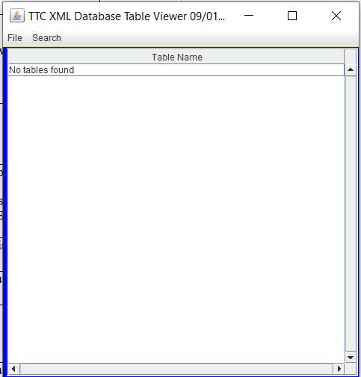

Figure 1

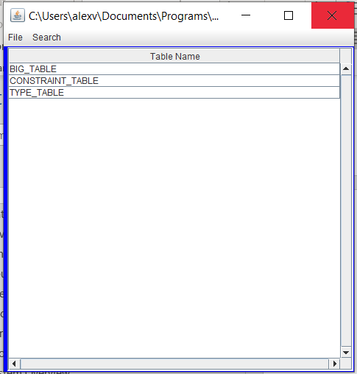

Figure 2

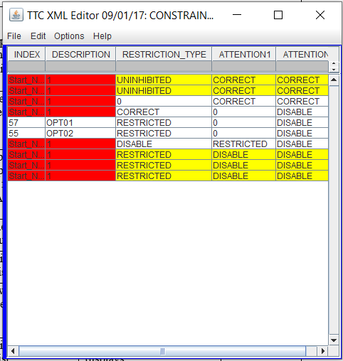

Figure 3

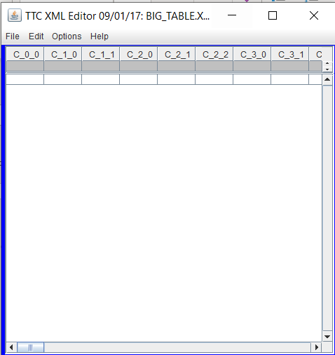

Figure 4

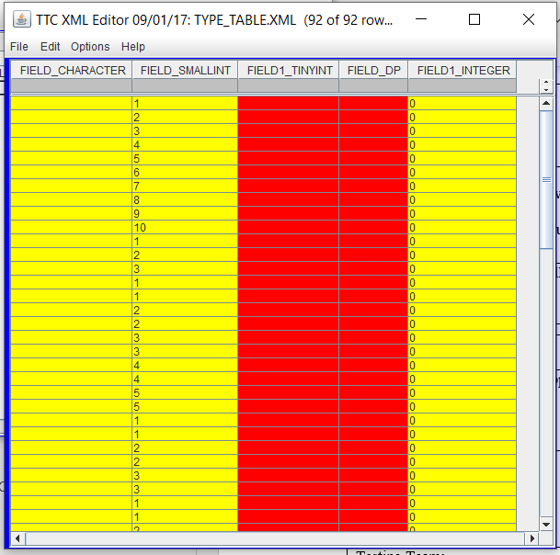

Figure 5

&&&

