# Database Edit

# Test plan

Version 1.0

04/21/2020

Document Control

Approval

The Guidance Team and the customer shall approve this document.

Document Change Control

|  |  |
| --- | --- |
| Initial Release: | 1.0 |
| Current Release: | 2.0 |
| Indicator of Last Page in Document: | * |
| Date of Last Review: | 4/15/2020 |
| Date of Next Review: |  |
| Target Date for Next Update: | 4/20/2020 |

Distribution List

This following list of people shall receive a copy of this document every time a new version of this document becomes available:

Guidance Team Members: Dr Steve Roach

Customer: Dr Steve Roach

Software Team Members:   
 Author: Ernesto Vazquez

Reviewer: Diana L Ramirez

Reviewer: Annadiley Gallegos Garcia

Change Summary

The following table details changes made between versions of this document

|  |  |  |  |
| --- | --- | --- | --- |
| Version | Date | Modifier | Description |
| 1.0 | 4/10/2020 | Ernesto Vazquez | Created initial test plan, includes initial test cases |
| 2.0 | 4/15/2020 | Ernesto Vazquez | Added suggested enhancements from Annadiley’s comments. |
| 2.0 | 4/15/2020 | Ernesto Vazquez | Added test case 6 to the test plan |
| 3.0 | 4/17/202 | Ernesto Vazquez | Addressed Diana L Ramirez comments on the Scope section |
| 3.0 | 4/17/2020 | Ernesto Vazquez | Corrected typos and grammar errors pointed out by Diana L Ramirez |
| 3.0 | 4/17/2020 | Ernesto Vazquez | Changed all Test cases’ statuses to “pending”, since apparently software team is not supposed to run test, as suggested by Diana L Ramirez |
| 3.0 | 4/17/2020 | Ernesto Vazquez | Created new Test case suggested by Diana L Ramirez |

Note: The template presented in this document was taken from:

Donaldson, S., and S. Siegel, *Successful Software Development*. Upper Saddle River, NJ: Prentice Hall, 2001, pp. 321-323.

Note: The template presented in this document was taken from: Donaldson, S., and S. Siegel, *Successful Software Development*. Upper Saddle River, NJ: Prentice Hall, 2001, pp. 321-323 and modified by Humberto Mendoza and Steve Roach.

Supplementary information is from:

Pfleeger, S. *Software Engineering, Theory and Practice*. Upper Saddle River, NJ: Prentice Hall, 1998, p. 365.

Table of Contents

Document Control ii

Approval ii

Document Change Control ii

Distribution List ii

Change Summary ii

1. Introduction 1

1.1. Purpose 1

1.2. Scope 1

1.3. System Overview 1

1.4. Suspension and Exit Criteria 1

1.5. Document Overview 1

1.6. References 1

2. Test Items and Features 1

3. Testing Approach 5

4. Test Suite 1 6

4.1. Test 1 6

4.2. Test 2 8

4.3. Test 3 10

4.4. Test 4 13

4.5. Test 5 15

4.6. Test 6 18

5. Test Schedule 21

6. Other Sections 22

7. Appendix 23

# Introduction

## Purpose

The purpose of this document is to describe in a clear and concise manner the test plan for the database editor system, provided by Dr Steve Roach (customer).

## Scope

The scope of this document is to identify the testing strategy and test set that will be used to verify and validate the specifications on specification document provided by the customer of the database edit testing system. The test plan will focus on the compare file to other versions and the check for duplicate rows detection functionalities on the database edit system.

## System Overview

The database table editor is a system that can access, view and modify database and tables files. The system can take input of data files in the form of XML files, and these can be either a database description file or a or a data table file. Once a user provides a valid file, the system will display all tables available.

## Suspension and Exit Criteria

The suspension and stop of the test set will occur when one of the test cases fails by any reason. However, the exit criteria will be met once all test cases are successful after the7 have been executed over the database editor system.

## Document Overview

The remainder of the document will address the document test plan, which contains test cases with their outputs.

## References

[1] Spec.docx provided by Dr Steve Roach.

# Test Items and Features

This Test Plan will only focus on the following functionality of the database editor system, based on the specification document provided by the customer. Other functionality will be excluded from this test plan. Figure 1 is a screenshot of the database editor system.

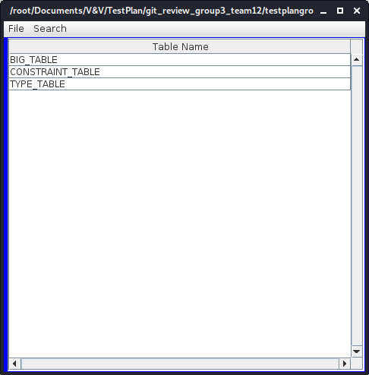  
Figure 1: This is the Graphical Interface of the database editor system, please note that TEST_DB.XML has been opened here.

1. File comparison for other version  
   “*The File/Compare option allows a user to compare two versions of a table. This compare can be restricted to selected columns by using the Options/Column Selection feature. The output is rather crude and is not intended for large change lists*.” Figure 2 contains a screenshot of the file comparison.

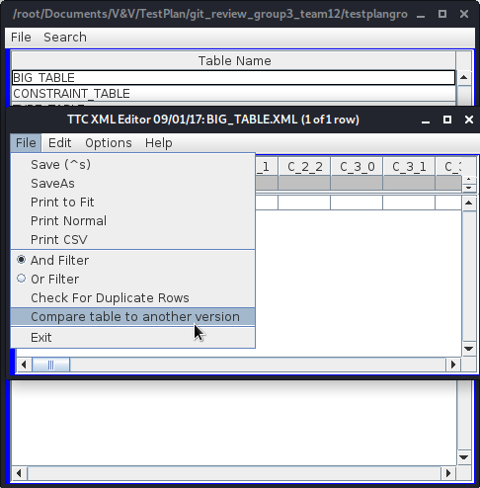  
Figure 2: The compare table to another version can be accessed from File menu item.

1. Check for duplicate rows  
   *“File/Check for Duplicate Rows should list rows that have identical contents. This check is restricted to the columns selected in Options/Select Columns.”* Figure 3 contains a screenshot of this functionality.

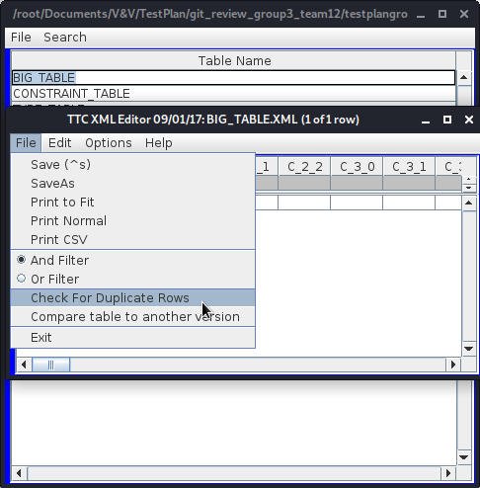  
Figure 3: The "Check For Duplicate Rows" functionality on the database editor system.

# Testing Approach

This test plan will perform a black box test while performing a dynamic testing approach. The following table describes the test plan.

Table 1: Test Plan

|  |  |  |
| --- | --- | --- |
| **TEST SUITE 1** | | |
| **Description of Test Suite** | **This Test suite will focus on file comparison to other versions and check for duplicate rows** | |
| **Test Case Identifier** | **Objective** | **Criticality** |
| **1** | **Compare two same tables to verify version detection functionality** | **CRITICAL** |
| **2** | **Compare two same tables and restricting different columns from Options/Column feature to verify version detection functionality with restricted columns** | **CRITICAL** |
| **3** | **Compare two different tables to verify version detection functionality** | **CRITICAL** |
| **4** | **Provide table to verify rows duplicate detection functionality** | **CRITICAL** |
| **5** | **Provide table and select columns in Options/Select Columns to verify functionality of the row duplicate detection while restricted to not all columns** | **CRITICAL** |
| **6** | **Provide invalid XML file to compare version detection** | **CRITICAL** |
| **7** | **Provide update a table file and compare its version with the file comparison to another version functionality** | **CRITICAL** |

# Test Suite 1

This section describes input, procedures, outputs and status of each of the test cases in the test set.

## Test 1

**Objective: Compare two same tables to verify version detection functionality**

**Notes:** As pre-requisite, the Data System Edit must be running, have open the TEST_DB.xml database and have opened the TEST_DB__BIG_TABLE.xml table.

|  |  |  |  |  |  |  |
| --- | --- | --- | --- | --- | --- | --- |
| Test No.: 1 | | | | Current Status: Pending | | |
| Test title: Table version comparison | | | | | | |
| Testing approach: This testing will compare the TEST_DB__BIG_TABLE.XML with itself to verify if the system is able to identify the same version. | | | | | | |
| STEP  1 | OPERATOR ACTION  On the new window, Click the File Menu Item form the top Menu. Then click on “Compare table to another version”, when the Open Dialog opens, select the TEST_DB__BIG_TABLE.XML file. | PURPOSE  The purpose of this step is to open the file to be compared with the current table that has been opened. | | | EXPECTED RESULTS  The system is expected to open the TEST_DB__BIG_TABLE.XML file and compare the version with the file that we have currently open. | COMMENTS  The TEST_DB__BIG_TABLE.XML file is expected to have no alterations since provided by the customer. |
| STEP  2 | OPERATOR ACTIONS  Collect results from the system by reading the Message Window with the number of mismatches. | PURPOSE  To collect the result of the comparison | | | EXPECTED RESULTS  The system is expected to find zero mismatches from both versions on each XML file. |  |
| Concluding Remarks:  The test will executed by the guidance team. | | | | | | |
| Testing Team:  Ernesto Vazquez  Diana L Ramirez  Annadiley Gallegos | | | Date Completed:  4/11/2020 | | | |

## Test 2

**Objective: Compare two same tables and restricting different columns from Options/Column feature to verify version detection functionality with restricted columns**

**Notes:** As pre-requisite, the Data System Edit must be running, have open the TEST_DB.xml database and have opened the TEST_DB__BIG_TABLE.xml table.

|  |  |  |  |  |  |  |
| --- | --- | --- | --- | --- | --- | --- |
| Test No.: 2 | | | | Current Status: Pending | | |
| Test title: Table version comparison with Column selection restriction | | | | | | |
| Testing approach: This testing will compare the TEST_DB__BIG_TABLE.XML with itself to verify if the system is able to identify the same version. However, by utilizing the Options > Column Selection functionality, only compare the first and last columns. | | | | | | |
| STEP  1 | OPERATOR ACTION  Click on Options on the Top Menu item, and then click on Column Selection. Once the new Window opens, ensure only columns C_0_0 and S_8_8 are “enabled” by click on the checkbox and having a check mark. All other columns must be unchecked. Then close the new window. | PURPOSE  The purpose of this step is to filter the rows by only “enabling” the first and last columns, that is C_0_0 and S_8_8 columns. | | | EXPECTED RESULTS  The system will maintained enable columns C_0_0 and S_8_8 for comparison, while disabling all other columns. | COMMENTS |
| STEP  2 | OPERATOR ACTION  On the TEST_DB__BIG_TABLE window, click the File Menu Item form the top Menu. Then click on “Compare table to another version”, when the Open Dialog opens, select the TEST_DB__BIG_TABLE.XML file. | PURPOSE  The purpose of this step is to open the file to be compared with the current table that has been opened. | | | EXPECTED RESULTS  The system is expected to open the TEST_DB__BIG_TABLE.XML file and compare the version with the file that we have currently open. | COMMENTS  The TEST_DB__BIG_TABLE.XML file is expected to have no alterations since provided by the customer. |
| STEP  3 | OPERATOR ACTIONS  Collect results from the system by reading the 2 message windows with the number of mismatches. | PURPOSE  To collect the results of the comparison | | | EXPECTED RESULTS  The system is expected to complain about not being able to find the filtered columns, however it will find zero mismatches from both versions on each XML file on the enabled columns. |  |
| Concluding Remarks:  The test will be executed by the guidance team. | | | | | | |
| Testing Team:  Ernesto Vazquez  Diana L Ramirez  Annadiley Gallegos | | | Date Completed:  4/11/2020 | | | |

## Test 3

**Objective: Compare two different tables to verify version detection functionality**

**Notes:** As pre-requisite, the Data System Edit must be running, have open the TEST_DB.xml database and have opened the TEST_DB__BIG_TABLE.xml table.

|  |  |  |  |  |  |  |
| --- | --- | --- | --- | --- | --- | --- |
| Test No.: 3 | | | | Current Status: Pending | | |
| Test title: Table version comparison with different tables | | | | | | |
| Testing approach: This testing will compare the TEST_DB__BIG_TABLE.XML against TEST_DB__TYPE_TABLE.XML to verify if the system is able to identify the same version. | | | | | | |
| STEP  1 | OPERATOR ACTION  On the new window, Click the File Menu Item form the top Menu. Then click on “Compare table to another version”, when the Open Dialog opens, select the TEST_DB__TYPE_TABLE.XML file. | PURPOSE  The purpose of this step is to open the file to be compared with the current table that has been opened. | | | EXPECTED RESULTS  The system is expected to open the TEST_DB__TYPE_TABLE.XML file and compare the version with the file that we have currently open. | COMMENTS  The TEST_DB__TYPE_TABLE.XML file is expected to have no alterations since provided by the customer. |
| STEP  2 | OPERATOR ACTIONS  Collect results from the system by reading the Message Window with the number of mismatches. | PURPOSE  To collect the result of the comparison | | | EXPECTED RESULTS  The system is expected to find 95 mismatches from both XML files. |  |
| Concluding Remarks:  The test will be executed by the guidance team. | | | | | | |
| Testing Team:  Ernesto Vazquez  Diana L Ramirez  Annadiley Gallegos | | | Date Completed:  4/11/2020 | | | |

## Test 4

**Objective: Verify rows duplicate detection functionality by providing a table with duplicates**

**Notes:** As pre-requisite, the Data System Edit must be running, have open the TEST_DB.xml database and have opened the TEST_DB__CONTRAINT_TABLE.xml table.

|  |  |  |  |  |  |  |
| --- | --- | --- | --- | --- | --- | --- |
| Test No.: 4 | | | | Current Status: Pending | | |
| Test title: Table rows duplicate detection test | | | | | | |
| Testing approach: This test verify the number of duplicates in the TEST_DB__CONTRAINT_TABLE.XML data table file. | | | | | | |
| STEP  1 | OPERATOR ACTION  On the new window, Click the File Menu Item form the top Menu. Then click on “Check For Duplicate Rows” | PURPOSE  The purpose of this step is to stimulate the system to perform the duplicate detection. | | | EXPECTED RESULTS  The system is expected to complete the duplicate row detection process and return a report of findings | COMMENTS |
| STEP  2 | OPERATOR ACTIONS  Collect results from the system by reading the Message Window with the number of duplicates | PURPOSE  To collect the result of the comparison | | | EXPECTED RESULTS  The system is expected to find 3 duplicate rows on the CONSTRAINT_TABLE file. |  |
| Concluding Remarks:  The test will be executed by the guidance team. | | | | | | |
| Testing Team:  Ernesto Vazquez  Diana L Ramirez  Annadiley Gallegos | | | Date Completed:  4/11/2020 | | | |

## Test 5

**Objective: Verify the duplicate row functionality with the selected row restriction**

**Notes:** As pre-requisite, the Data System Edit must be running, have open the TEST_DB.xml database and have opened the TEST_DB__CONTRAINT_TABLE.xml table.

|  |  |  |  |  |  |  |
| --- | --- | --- | --- | --- | --- | --- |
| Test No.: 5 | | | | Current Status: Pending | | |
| Test title: Table Row Duplicate with Column Restriction test | | | | | | |
| Testing approach: This test will run the duplicate row detection functionality on the TEST_DB__CONSTRAINT_TABLE.XML table file, however columns will be filtered using the Options/Columns Selection functionality by using only enabling the first and last row.. | | | | | | |
| STEP  1 | OPERATOR ACTION  On the top Menu, Click Options, then click on Column Selection. Once the new window open, click on the check for the columns INDEX and ATTENTION2. Ensure that only these two columns are enabled and the rest are not enabled, therefore in order to disable the columns, they should be unchecked. Then close the window. | PURPOSE  The purpose of this step is to filter the selection of columns, by only enabling the first and last columns, that is INDEX and ATTENTION2 columns. | | | EXPECTED RESULTS  The system is expected to save the filter to be used for the next step. | COMMENTS |
| STEP  2 | OPERATOR ACTION  On the Table window, click on the File button on the top Menu, and then click on “Check For Duplicate Rows” | PURPOSE  The purpose of this step is to provide stimuli to the system to execute the duplicate row detection functionality. | | | EXPECTED RESULTS  The system is expected to execute the duplicate row detection functionality. | COMMENTS |
| STEP  3 | OPERATOR ACTIONS  Collect results from the system by reading the Message Window with the number of duplicate rows. | PURPOSE  To collect the result of the comparison | | | EXPECTED RESULTS  The system is expected to find 6 duplicate rows. Which are the exact number of duplicated in the table |  |
| Concluding Remarks:  The test will be executed by the guidance team. | | | | | | |
| Testing Team:  Ernesto Vazquez  Diana L Ramirez  Annadiley Gallegos | | | Date Completed:  4/11/2020 | | | |

## Test 6

**Objective: Provide invalid XML file to compare version detection**

**Notes:** As pre-requisite, the Data System Edit must be running, have open the TEST_DB.xml database and have opened the TEST_DB__BIG_TABLE.xml table.

|  |  |  |  |  |  |  |
| --- | --- | --- | --- | --- | --- | --- |
| Test No.: 6 | | | | Current Status: Pending | | |
| Test title: Invalid File to compare version functionality | | | | | | |
| Testing approach: This test will run the file version comparison functionality on the TEST_DB__BIG_TABLE.XML table file, however the file to compare will be a bogus file called bogus._file.xml, which contains nothing but little text. | | | | | | |
| STEP  1 | OPERATOR ACTION  On the top Menu, Click File, then “Compare table to another version”, once the open dialog opens, select the bogus_file.xml file and click Open. | PURPOSE  The purpose of this step is to open the bogus file to be compared to the BIG_TABLE.XML file. | | | EXPECTED RESULTS  the system is expected to open the bogus_file.xml file. | COMMENTS  The bogus_file.xml file must be available for this test. |
| STEP  2 | OPERATOR ACTIONS  Collect results from the system by reading the Message Window with the number of duplicate rows. | PURPOSE  To collect the result of the comparison | | | EXPECTED RESULTS  The system is expected to raise an error about parsing a file. |  |
| Concluding Remarks:  The test will be executed by the guidance team. | | | | | | |
| Testing Team:  Ernesto Vazquez  Diana L Ramirez  Annadiley Gallegos | | | Date Completed:  4/15/2020 | | | |

## Test 7

**Objective: Provide update a table file and compare its version with the file comparison to another version functionality**

**Notes:** As pre-requisite, the Data System Edit must be running, have open the TEST_DB.xml database and have opened the TEST_DB__CONSTRAINT_TABLE.xml table.

|  |  |  |  |  |  |  |
| --- | --- | --- | --- | --- | --- | --- |
| Test No.: 7 | | | | Current Status: Pending | | |
| Test title: Compare table with updated version of the same table. | | | | | | |
| Testing approach: This test will run the file version comparison functionality on the TEST_DB__CONSTRAINT_TABLE.XML table file, however the file to compare will be a bogus file called TEST_DB__CONSTRAINT_TABLE_2.XML, which will have an extra row. | | | | | | |
| STEP  1 | OPERATOR ACTION  On the top Menu, Click File, then “Compare table to another version”, once the open dialog opens, select the TEST_DB__ CONSTRAINT_TABLE_2.XML file and click Open. | PURPOSE  The purpose of this step is to open the updated table to be compared for version to the BIG_TABLE.XML file. | | | EXPECTED RESULTS  the system is expected to open the TEST_DB__ CONSTRAINT_TABLE_2.XML file. | COMMENTS  The TEST_DB__ CONSTRAINT_ TABLE_2.XML file must be available for this test. |
| STEP  2 | OPERATOR ACTIONS  Collect results from the system by reading the Message Window with the number of duplicate rows. | PURPOSE  To collect the result of the comparison | | | EXPECTED RESULTS  The system is expected to identify different version of this file. |  |
| Concluding Remarks:  The test will be executed by the guidance team. | | | | | | |
| Testing Team:  Ernesto Vazquez  Diana L Ramirez  Annadiley Gallegos | | | Date Completed:  4/17/2020 | | | |

# Test Schedule

The following table describes the schedule that has been followed to run the test cases.

|  |  |  |
| --- | --- | --- |
| **Task and date** | **People** | **Description** |
| **Run Tests 1 – 5 4/11/2020** | **Ernesto Vazquez** | **Run Tests 1 through 5** |
| **Run Test 6 4/15/2020** | **Ernesto Vazquez** | **Run test 6 since was added late to the document** |
|  |  |  |
|  |  |  |
|  |  |  |
|  |  |  |
|  |  |  |
|  |  |  |
|  |  |  |

# Appendix

The team has made use of github to collaborate on a producer-reviewer mode, the link to the github repository is the following:

<https://github.com/CS5387/testplangroup4-group_4_team_12>

The following figures will point the results from tests and some of the configuration necessary to produce the tests.

Figure This is the results of test case 1, where the BIG_TABLE is compared to itself.

Figure This is the filter columns configuration for test case 2, where only columns C_0_0 and S_8_8 were enabled.

Figure After executing test case 2, Database Edit system complains about the filter columns not being found

Figure This is the result for test case 2.

Figure This is the result for test case 6, after proving the bogus file.

Figure This is the result for test case 4.

Figure This is the configuration needed for test case 5, where columns INDEX and ATTENTION 2 where enabled.

Figure This is the result for test case 5

Figure This are the contents of the bogus_file.xml

Figure This is the contents of the TEST_DB__CONSTRAINT_TABLE.XML file that will used on test case 7. Please note that the highlighted area was an appended to the original file.

Figure This is the result for test case 7.

*