<Enter project name here>er
Test plan
Version 3.0
04/08/2020

Document Control
Approval
The Guidance Team and the customer shall approve this document.
Document Change Control
Initial Release: | v1.0
Current Release: | v3.0
Indicator of Last Page in Document: | ~`
Date of Last Review: | 04/21/2020
Date of Next Review: | 04/22/2020
Target Date for Next Update:
Distribution List
This following list of people shall receive a copy of this document every time a new version of this document becomes available:
Guidance Team Members: Dr. Steven Roach

Software Team Members: Fernando Serrano, Alejandro Ortiz, Gerardo Cervantes
Change Summary
The following table details changes made between versions of this document

Version | Date | Modifier | Description
1 | 04/08/2020 | Fernando Serrano | Created draft of initial Test Plans
2 | 04/15/2020 | Fernando Serrano | Edits and clarification

Note: The template presented in this document was taken from:
Donaldson, S., and S. Siegel, Successful Software Development. Upper Saddle River, NJ: Prentice Hall, 2001, pp. 321-323.

Note: The template presented in this document was taken from: Donaldson, S., and S. Siegel, Successful Software Development. Upper Saddle River, NJ: Prentice Hall, 2001, pp. 321-323 and modified by Humberto Mendoza and Steve Roach.

Supplementary information is from:
Pfleeger, S. Software Engineering, Theory and Practice. Upper Saddle River, NJ: Prentice Hall, 1998, p. 365.

Table of Contents
Document Control 2
Approval 2
Document Change Control 2
Distribution List 2
Change Summary 2
1. Introduction 4
1.1. Purpose 4
1.2. Scope 4
1.3. System Overview 4
1.4. Suspension and Exit Criteria 6
1.5. Document Overview 6
1.6. References 6
2. Test Items and Features 7
3. Testing Approach 8
4. Tests 9
4.1. Test 1 9
4.2. TEST 2 11
4.3. TEST 3 12
4.4. TEST 4 13
4.5. TEST 5 14
4.6. TEST 6 16
4.7. TEST 7 17
4.8. TEST 8 18
5. Test Schedule 19

Introduction

Purpose

This test plan will be focusing on the functionality of the DbEdit program. This program was designed to allow a user to edit, search, and compare databases that are in xml format and for these tests we will be focusing on the compare file and check for duplicates functionality of the program. This will be done with Black Box testing as we will not have access to the source code and this test plan will focus on ensuring the program is effective and does not have faults in its implementation or any occurrence of failures.

Scope
The scope of this test plan will encompass the initial release provided by Dr. Roach.

System Overview
The system that will be tested is contained of the compare and the duplicate checking of files. The File/Compare option allows a user to compare two versions of a table. This compare can be restricted to selected columns by using the Options/Column Selection feature. The output is rather crude and is not intended for large change lists. File/Check for Duplicate Rows should list rows that have identical contents. This check is restricted to the columns selected in Options/Select Columns. When you open the system and have selected a database to view the system will display a new window with its information as displayed in Figure 2. In this view one clicks File and will see the options to “compare table to another version” and for “Check for duplicate rows” as displayed in Figure 3 marked by the red box. This is what this test plan will be checking and focusing on.

Figure 1.
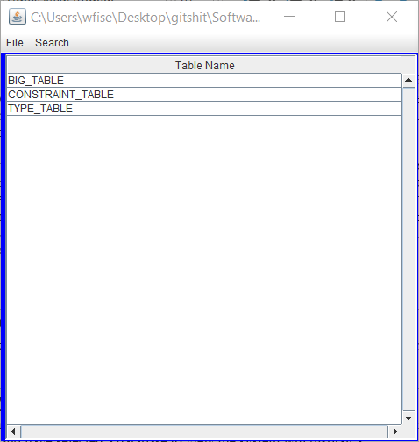

Figure 2.
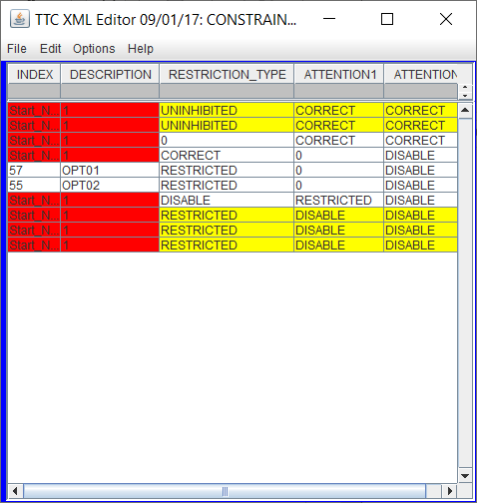

Figure 3.
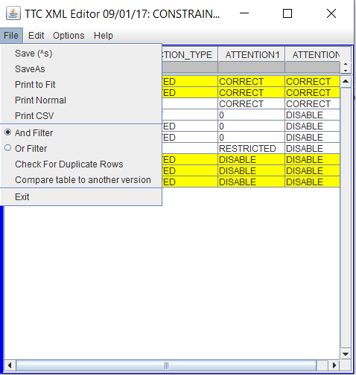

Suspension and Exit Criteria

The suspension criteria for this test plan includes if 50% of the test cases fail as this shows that there is an error in the compare and duplicate functionality that will not allow it to be effective. The exit criteria for this test plan is that all critical tests must pass and 75% of high criticality must pass due to the number of test cases in the test plan.

Document Overview

Section 2: What will be covered by the test plan.
Section 3: Contains the tests names, objectives, and criticality of each test.
Section 4: Lists all the tests in detail, so they may be performed by someone not familiar with the system.
Section 5: has the testing schedule

References

https://github.com/CS5387/testplangroup4-group_4_team_8
Includes example XML files, jar file (program), and a spec giving details on the program

Test Items and Features
The Features that will be included in the testing include
- File/Compare option
  - Allows a user to compare two versions of a table. This compare can be restricted to selected columns by using the Options/Column Selection feature.
- File/Check for Duplicate Rows
  - Lists rows that have identical contents. This check is restricted to the columns selected in Options/Select Columns.
- Options/Select Columns
  - Allows a user to select specific options in columns to be compared or checked for duplicates.

Testing Approach

Table 1: Test Plan
TEST SUITE <Identifier>
Description of Test Suite
Test Case Identifier | Objective | Criticality
1.0 | Test for 0 differences in the comparisons. | Critical
2.0 | Test for accurate detection of differences in tables. | Critical
3.0 | Test for mismatch in table boundary values. | High
4.0 | Test for large difference in tables | High
5.0 | Test functionality of specific selection comparison. | Critical
6.0 | Test for behavior in comparison with different types of information. | Critical
7.0 | Test for duplicate boundary values. | High
8.0 | Test functionality of specific selection duplication. | High

Tests

Test 1
Objective: Validate the functionality of the comparison function.
Notes: This test will be performed on the dbEdit.java program, along with the TEST_DB_CONSTRAINT_TABLE.xml file and the TEST_DB_CONSTRAINT_TABLE_IDENT.xml file. These should be in the same directory in order to ensure proper function of the program.
Test No.: 1.0 |  |  | Current Status: Pending
Test title: Test two identical tables

Testing approach: This test will be conducted in an attempt to find errors in both boundary, and input values in the comparison that may be introduced into the system.
STEP  1.  2.  3.  4. | OPERATOR ACTION  Select File tab then Open and select the TEST_DB_CONSTRAINT_TABLE file from the provided xml documents into the dbEdit program  Double click CONSTRAINT_TABLE selection in the main menu to open table.  On CONSTRAINT_TABLE editor, click on file, then on “compare table to another version”  Select TEST_DB_CONSTRAINT_TABLE_IDENT to compare the file | PURPOSE  To make the table that will tested visible to the tester, and loaded into the program.  Opens the table and allows the selection to compare to be selected.  Clicks for the operation of comparison between the two tables to be performed  Selects the table that will be compared |  | EXEPCTED RESULTS  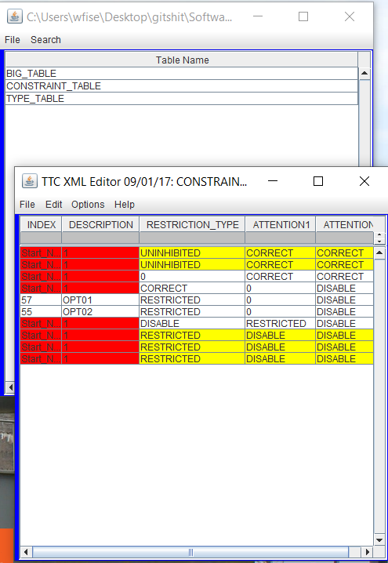  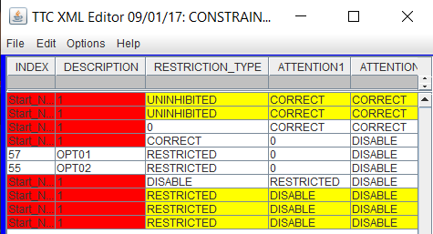  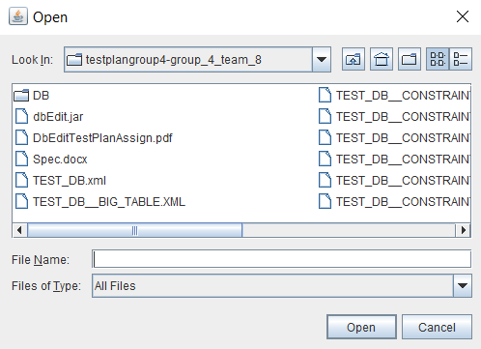  Due to the two tables being identical, except in name of the file, it should return 0 mismatches found as it is similar to was is displayed in TEST_DB_CONSTRAINT_TABLE edit. | COMMENTS  This result is not the one that is shown after running the program. This indicates that there is an error in this comparison.
Concluding Remarks:
Testing Team:  << List members of testing team and lead >> |  |  | Date Completed:

TEST 2
Objective: Test for accurate results of the comparison function.
Notes: This test will be performed on the dbEdit.java program, along with the TEST_DB_CONSTRAINT_TABLE.xml file and the TEST_DB_CONSTRAINT_TABLE_2.xml file. These should be in the same directory in order to ensure proper function of the program.
Test No.: 2.0 |  |  | Current Status: Pending
Test title: Test two tables, only one column is different

Testing approach: This test will be conducted in an attempt to find errors in both outer boundaries, and input values in the comparison that may be introduced into the system.
STEP  1.  2.  3.  4. | OPERATOR ACTION  Open TEST_DB_CONSTRAINT_TABLE from the provided xml documents into the dbEdit program  Double click CONSTRAINT_TABLE selection in the main menu to open table.  On CONSTRAINT_TABLE editor, click on file, then on “compare table to another version”  Select TEST_DB_CONSTRAINT_TABLE_2 to compare the file | PURPOSE  To make the table that will tested visible to the tester, and loaded into the program.  Opens the table and allows the selection to compare to be selected.  Clicks for the operation of comparison between the two tables to be performed  Selects the table that will be compared |  | EXEPCTED RESULTS  The expected results would be 7 mis-matching results and would display from element 57 to the second to last element in either table. | COMMENTS  These are the only ones with matching elements in each column as selected by default comparison in the program.
Concluding Remarks:
Testing Team:  << List members of testing team and lead >> |  |  | Date Completed:

TEST 3
Objective: Test for boundary value errors in the comparison.
Notes: This test will be performed on the dbEdit.java program, along with the TEST_DB_CONSTRAINT_TABLE.xml file and the TEST_DB_CONSTRAINT_TABLE_3.xml file. These should be in the same directory in order to ensure proper function of the program.
Test No.: 3.0 |  |  | Current Status: Pending
Test title: Test two tables, where only the first or last element match

Testing approach: This test will be conducted in an attempt to find errors in both outer boundaries, and input values in the comparison that may be introduced into the system.
STEP  1.  2.  3.  4. | OPERATOR ACTION  Open TEST_DB_CONSTRAINT_TABLE from the provided xml documents into the dbEdit program  Double click CONSTRAINT_TABLE selection in the main menu to open table.  On CONSTRAINT_TABLE editor, click on file, then on “compare table to another version”  Select TEST_DB_CONSTRAINT_TABLE_3 to compare the file | PURPOSE  To make the table that will tested visible to the tester, and loaded into the program.  Opens the table and allows the selection to compare to be selected.  Clicks for the operation of comparison between the two tables to be performed  Selects the table that will be compared |  | EXEPCTED RESULTS  The comparison results should only show the first element in both tables along with the last element, as these are the only ones with matching elements in each column. | COMMENTS  These should be the only one’s to be selected as all columns are currently selected for comparison as default by the program.
Concluding Remarks:
Testing Team:  << List members of testing team and lead >> |  |  | Date Completed:

TEST 4
Objective: Test for large result detections by the comparison function.
Notes: This test will be performed on the dbEdit.java program, along with the TEST_DB_CONSTRAINT_TABLE.xml file and the TEST_DB_CONSTRAINT_TABLE_SINGLE.xml file. These should be in the same directory in order to ensure proper function of the program.
Test No.: 4.0 |  |  | Current Status: Pending
Test title: Test two tables where one only has one element

Testing approach: This test will be conducted in an attempt to find errors in both boundary, and input values in the comparison that may be introduced into the system.
STEP  1.  2.  3.  4. | OPERATOR ACTION  Open TEST_DB_CONSTRAINT_TABLE from the provided xml documents into the dbEdit program  Double click CONSTRAINT_TABLE selection in the main menu to open table.  On CONSTRAINT_TABLE editor, click on file, then on “compare table to another version”  Select TEST_DB_CONSTRAINT_TABLE_SINGLE to compare the file | PURPOSE  To make the table that will tested visible to the tester, and loaded into the program.  Opens the table and allows the selection to compare to be selected.  Clicks for the operation of comparison between the two tables to be performed  Selects the table that will be compared |  | EXEPCTED RESULTS  This should show 8 mis - matches with the one element that exists in TEST_DB_CONSTRAINT_TABLE_SINGLE as this is the only element being compared. This should include only the first two elements from the other table. | COMMENTS  This result is not the one that is shown after running the program. This indicates that there is an error in this comparison.
Concluding Remarks:
Testing Team:  << List members of testing team and lead >> |  |  | Date Completed:

TEST 5
Objective: Tests to validate the selection function and comparison work as intended.
Notes: This test will be performed on the dbEdit.java program, along with the TEST_DB_CONSTRAINT_TABLE.xml file and the TEST_DB_CONSTRAINT_TABLE_2.xml file. These should be in the same directory in order to ensure proper function of the program.
Test No.: 5 |  |  | Current Status: Pending
Test title: Test two tables with selected column/row comparison

Testing approach: This test will be conducted in an attempt to find errors in both boundary, and input values in the comparison that may be introduced into the system.
STEP  1.  2.  3.  4.  5. | OPERATOR ACTION  Open TEST_DB_CONSTRAINT_TABLE from the provided xml documents into the dbEdit program  Double click CONSTRAINT_TABLE selection in the main menu to open table.  On CONSTRAINT_TABLE editor select Options then Column selection and unselect Description and Restriction type  On CONSTRAINT_TABLE editor, click on file, then on “compare table to another version”  Select TEST_DB_CONSTRAINT_TABLE_2 to compare the file | PURPOSE  To make the table that will tested visible to the tester, and loaded into the program.  Opens the table we wish to use.  This selects the specified table elements we wish to compare.  Clicks for the operation of comparison between the two tables to be performed  Selects the table that will be compared |  | EXEPCTED RESULTS  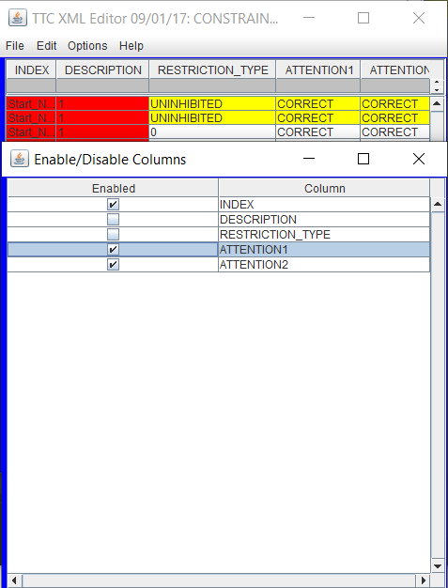  This should result in 9 comparisons being matched as this only eliminates the description and Restrictions from the comparisons. The only table element not matching is the last element in the table by this comparison. | COMMENTS  .
Concluding Remarks:
Testing Team:  << List members of testing team and lead >> |  |  | Date Completed:

TEST 6
Objective: Tests for behavior of program when given tables that do not match in values.
Notes: This test will be performed on the dbEdit.java program, along with the TEST_DB_CONSTRAINT_TABLE.xml file and the TEST_DB_CONSTRAINT_TABLE_4.xml. These should be in the same directory in order to ensure proper function of the program.
Test No.: 6.0 |  |  | Current Status: Pending
Test title: Test two tables with different value types in the same column

Testing approach: This test will be conducted in an attempt to find errors in input value type checking in the comparison that is done by the system. The values that will be checked are int string comparisons and double int comparisons.
STEP  1.  2.  3.  4. | OPERATOR ACTION  Open TEST_DB_CONSTRAINT_TABLE from the provided xml documents into the dbEdit program  Double click CONSTRAINT_TABLE selection in the main menu to open table.  On CONSTRAINT_TABLE editor, click on file, then on “compare table to another version”  Select TEST_DB_CONSTRAINT_TABLE_4 to compare the file | PURPOSE  To make the table that will tested visible to the tester, and loaded into the program.  Opens the table we wish to use.  Clicks for the operation of comparison between the two tables to be performed  Selects the table that will be compared |  | EXEPCTED RESULTS  This should result in program handling of the mismatch error, or in not showing the result in the table as they have different values in the comparison. | COMMENTS
Concluding Remarks:
Testing Team:  << List members of testing team and lead >> |  |  | Date Completed:

TEST 7
Objective: Tests for boundary values in the duplicate check function.
Notes: This test will be performed on the dbEdit.java program, along with the TEST_DB_CONSTRAINT_TABLE_FIRST_LAST.xml file. These should be in the same directory in order to ensure proper function of the program.
Test No.: 7.0 |  |  | Current Status: Pending
Test title: Test a table for duplicates in first and last element of table

Testing approach: This test will be conducted in an attempt to find errors in both boundary, and input values in the comparison that may be introduced into the system.
STEP  1.  2.  3.  4. | OPERATOR ACTION  Open TEST_DB_CONSTRAINT_TABLE  _FIRST_LAST from the provided xml documents into the dbEdit program  Double click CONSTRAINT_TABLE_FIRST_LAST selection in the main menu to open table.  On CONSTRAINT_TABLE editor select Options then Column selection and unselect each option except for Restriction Type.  Click on File, then “Check for Duplicates” | PURPOSE  To make the table that will tested visible to the tester, and loaded into the program.  Opens the table that will be reviewed for this test.  Selects the columns or options that we wish to check for duplicates by, to ensure we are looking for what we want to check  Clicks for the operation of check for duplicates to be performed. |  | EXEPCTED RESULTS  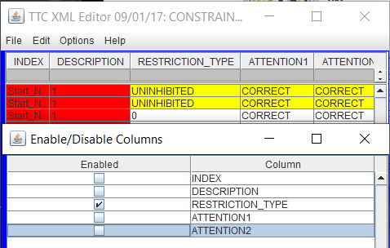  This should show the duplicates of the first and last element being the same, displaying that there is only 1 duplicate. | COMMENTS
Concluding Remarks:
Testing Team:  << List members of testing team and lead >> |  |  | Date Completed:

TEST 8
Objective: Validates the functionality of the duplicate checking with added restrictions.
Notes: This test will be performed on the dbEdit.java program, along with the TEST_DB_CONSTRAINT_TABLE.xml file. These should be in the same directory in order to ensure proper function of the program.
Test No.: 8.0 |  |  | Current Status: Pending
Test title: Test a table for duplicate in selected options/columns

Testing approach: This test will be conducted in an attempt to find errors in both boundary, and input values in the comparison that may be introduced into the system.
STEP  1.  2.  3.  4. | OPERATOR ACTION  Open TEST_DB_CONSTRAINT_TABLE from the provided xml documents into the dbEdit program  Double click CONSTRAINT_TABLE selection in the main menu to open table.  On CONSTRAINT_TABLE editor select Options then Column selection and unselect each option except for Restriction Type.  Click on File, then “Check for Duplicates” | PURPOSE  To make the table that will tested visible to the tester, and loaded into the program.  Opens the table that will be reviewed for this test.  Selects the columns or options that we wish to check for duplicates by, to ensure we are looking for what we want to check  Clicks for the operation of check for duplicates to be performed. |  | EXEPCTED RESULTS  This should display a total of 5 duplicates, as every row is deselected except for Restriction Type. | COMMENTS  This result is not the one that is shown after running the program. This indicates that there is an error in this comparison.
Concluding Remarks:
Testing Team:  << List members of testing team and lead >> |  |  | Date Completed:

Test Schedule
TBD

Task and date | People | Description
TBD

~`

